3GPP TSG RAN WG1 Meeting #120bis R1-2501718
Wuhan, China, April 7th – 11th, 2025
Agenda Item: 9.1.4.1
Source: Futurewei
Title: Discussion of CSI compression on AI/ML for NR air interface
Document for: Discussion

Introduction
During RAN1#120, companies have made good progress on inter-vendor collaboration aspects, standardized model structure for Case 0, the options/alternatives for identifying scalable model structure over feature, token and CSI payload dimension/configuration. For model structure related aspects, the agreements shown below have been reached [1].
Agreement
For studying the standardized model structure, for temporal domain Case 0, in case of spatial-frequency domain input, adopt the following model structure as one example structure for study purpose,
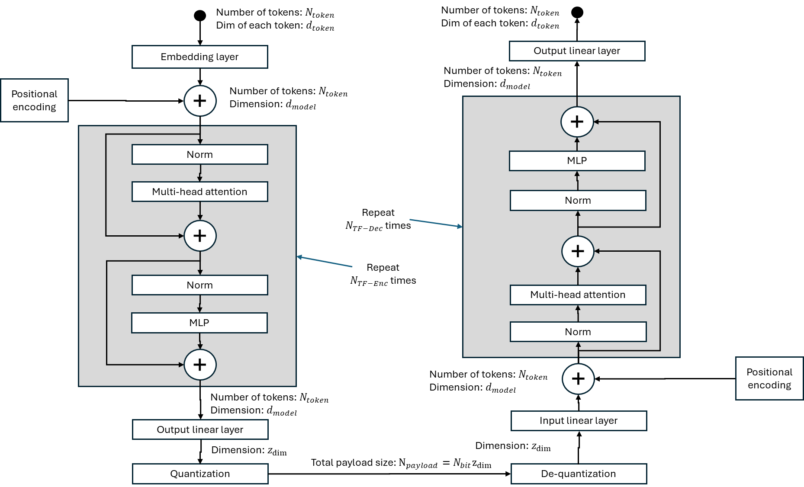
Encoder description:
Embedding layer  (Note: linear embedding in above figure to be revised to Embedding layer) | Number of tokens  Feature dimension of each token  Output dimension $d_{model}$ per token
Positional encoding | Number of tokens positions  Dimension of positional encoding for each token position: $d_{model}$
Transformer blocks | Number of transformer blocks $N_{TF}$  Dimension of transformer block $d_{model}$  Number of self-attention heads $N_{head}$  Dimension of attention head $d_{head}$  Dimension of latent space inside feedforward module $d_{FF}$  Activation function choice
Output linear layer | Reshape the matrix to a vector  Output dimension $z_{dim}$
Quantization | Scalar quantization:  - Number of bits per latent dimension: N_{bit}  - Total payload size for Scalar quantization = N_{bit} * Z_{dim}  Vector quantization  - segment size = N_{seg}  - Number of bits per latent dimension: N_{bit}  - bits per segment = N_{bit} * N_{seg}  - Number of segments = Z_{dim} / N_{seg}  - Total payload size for Vector quantization = Number of segments * bits per segment
Decoder description:
The decoder has a mirroring design as the encoder. Details are to be discussed.

Agreement
For model structure scalability study for temporal domain Case 0,
- For the choice of token dimension and feature dimension,
  - Alt 1: Use subband as the token dimension and Tx port as a feature dimension
    - The number of tokens varies with the number of subbands.
  - Alt 2: Use Tx port as the token dimension and subband as a feature dimension
    - The number of tokens varies with the number of Tx ports.
  - Alt 3: Use a fixed-size sub-block of Tx ports and subbands matrix (e.g., n_Tx_ports*m_Subbands) as a token and represent the input as a sequence of tokens.
    - The number of tokens varies with the number of Tx ports and the number of subbands.
- For scalability over the feature dimension,
  - Alt1: specific embedding layer for each feature size
  - Alt2: a common embedding layer with padding (e.g., zero-padding or other techniques for padding values)
- For scalability over the token dimension,
  - Alt1: positional embedding specific to each token index
    - $N_{token,active}$ tokens out of $N_{token}$ token positions are used as input.
  - Alt2: Padding at the input
- For scalability over payload configurations,
  - Alt1: specific output linear layer for each payload configuration
  - Alt2: truncation/masking of the output linear layer output
  - Alt3: by varying quantization parameters
- Notes
  - Other Alternatives are not precluded.
  - Different Alternatives may be used in combination.
  - Same/similar approach is applied at the decoder side.
- Evaluations to consider:
  - Case 1 (scalable structure): Scalable model structure described above
    - Using model structure as indicated in above diagram with fixed hyperparameters, companies may train a single parameter set or different parameter sets across different {number of Tx ports, CSI feedback payload size, bandwidth} assuming a common model structure.
    - To report whether a single parameter set or different parameter sets were used across different {number of Tx ports, CSI feedback payload size, bandwidth}. (e.g., single parameter set across different payload sizes and bandwidths, different parameter set across different number of Tx ports)
  - Case 2 (dedicated structure): Using model structure as indicated in above diagram with different hyperparameters, where the input and the output related hyperparameters are chosen optimally corresponding to each specific {number of Tx ports, CSI feedback payload size, bandwidth} without scalability considerations.
    - Different parameter sets are trained across different number of Tx ports, CSI feedback payload sizes, and bandwidths.
  - For each scalable model structure choice, to evaluate the SGCS performance of the non-AI/ML benchmark (e.g., Rel-16 eType2), Case 1, and Case 2, for each of {number of Tx ports, CSI feedback payload size, bandwidth}, and report the average gain (%) in SGCS of Case 1 and Case 2 over the non-AI/ML benchmark, as well as the loss (%) in the average gain of Case 1 w.r.t. Case 2. The average is performed by first calculating the SGCS gain (%) for each {number of Tx ports, CSI feedback payload size, bandwidth} and then averaging the SGCS gain (%) values over {number of Tx ports, CSI feedback payload size, bandwidth}.

Agreement
For model structure scalability study for temporal domain Case 0, for the choice of {number of Tx ports, CSI feedback payload size, bandwidth}, take the following as baseline values.
- Number of Tx ports
  - [N1, N2, P] = [2, 8, 2] (32 CSI-RS ports)
  - [N1, N2, P] = [4,4,2] (32 CSI-RS ports)
  - [N1, N2, P] = [2, 4, 2] (16 CSI-RS ports)
- CSI feedback payload size
  - Multiple values, encouraged to pick at least one value from each of small, medium, and large payload regions X, Y, and Z.
- Bandwidth & subband size
  - All subbands
  - A subset of all the subbands
In addition, one of the study objectives for CSI compression is to study ways to improve trade-off between performance and complexity as specified in the WID [2] and captured below:
  - For CSI compression (two-sided model), further study ways to:
    - Improve trade-off between performance and complexity/overhead
…
In RAN1#120, the following related agreement was reached among companies to study different AI/ML model structures and evaluate the corresponding performance.
Agreement
Study performance-complexity trade-off by comparing different AI/ML models, e.g. by optimizing existing designs, and/or by comparing different precoder representation in (spatial-frequency and angle-delay) or (spatial-frequency-time and angle-delay-doppler), by considering the following aspects
- Performance comparison between different AI/ML designs and benchmark schemes
- Complexity numbers (FLOP, calculated/projected latency or power consumption if available, measured latency or power consumption if available) of different AI/ML designs and benchmark schemes
Besides the above, there was some discussion related to CSI Processing Unit during RAN1#120, as this topic is relevant to multiple use cases, the agenda [5] posted by RAN1 chair added this topic to CSI compression agenda item as well:
- For any processing unit related discussions on normative work, handle under agenda items 9.1.1, 9.1.2, and 9.1.3.
- For any processing unit related discussions headed for TR, handle under agenda item 9.1.4.1
  - 9.1.4.1 CSI compression and any other aspects on AI/ML model/data
Including any remaining discussions on “Processing Unit”.
In this contribution, we first discuss our view regarding scalable model structure and our evaluation results on some of the aspects. We will also discuss our study related to performance vs. model complexity trade-off by comparing performance among different model structure options. Both topics are suggested by FL [3]. In addition, in this document, we discuss our view on CSI Processing Unit related to CSI compression use case.

Discussion on scalable model structure
In our contribution for RAN1#120 [4], we discussed our suggestions for scalable model structure in handling different Tx ports, sub-bands and CSI payload sizes. In this section we discuss our evaluation results based on the agreed alternatives from [1] for handling scalability over payload configurations. For performance-complexity tradeoff, we share and discuss our results across models with different complexities and their performance. In addition, we also discuss the remaining open issues that haven’t been agreed.

Scalable model structure over payload configurations
For the case of adapting to various sizes in the CSI payload, the following alternatives were agreed from RAN1#120.
Agreement
For model structure scalability study for temporal domain Case 0,
…
- For scalability over payload configurations,
  - Alt1: specific output linear layer for each payload configuration
  - Alt2: truncation/masking of the output linear layer output
  - Alt3: by varying quantization parameters
…

For model training, in our study, we adopted Alt2 and/or Alt3. First, in Alt2, masks were applied to the output of the linear layer at the encoder side. The model was trained with equal number of samples for each CSI encoder size, e.g., 16 and 32 in our study and proper mask/truncation operation was applied depending on the intended payload size. Next, Alt3 was leveraged to generate different CSI payloadsizes, e.g., 80 bits, 128 bits, 256 bits. On the decoder side, depending on the size of the recovered encoder output, if the size is smaller than the expected size, those elements with missing values will be filled in with 0’s.
Once the model is trained, during the inference phase, no specific operation, i.e., masking or truncation is needed. The encoder would generate desired output size (e.g., either 16 or 32) depending on the configuration and the decoder will try to reconstruct the original CSI using the received input (which assumes the larger size, i.e., 64 by filling in 0’s for the missing elements).
Figure 2.1-1 shows the masking operation during model training (Alt2) for using a scalable model architecture in handling multiple CSI payload sizes. For easier illustration, only 2 encoder output sizes (using 2 masks to control) are shown in the figure. For example, if the desired encoder output is either 16 or 32, we assume the encoder output can accommodate the larger size, i.e., 32, mask#1 will mask out the last 16 elements of the original encoder output while mask#2 will keep all the elements in the original encoder output.

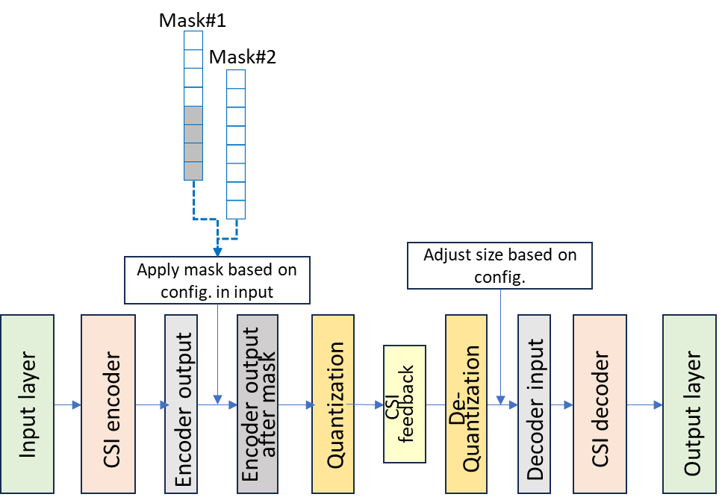
Figure 2.1-1: CSI payload size adaptation using masks/truncation operations (Alt2)
For Alt2, we assume the same quantization granularity (i.e., 8 bits per encoder output element) is applied to different encoder output sizes (i.e., 16 and 32 in our study) to generate the actual CSI feedback payload with different sizes (i.e., 128 bits and 256 bits in our study). We consider the benchmark is using CSI payload specific model (including quantization part). The SGCS comparisons between the benchmark and Alt2 are shown in Table 2.1-1.

Table 2.1-1: SGCS performance comparison between Alt2 and the benchmark
Payload category | Payload size | Approach | SGCS (Alt2/Alt3) | SGCS change against benchmark
Medium | 128 bits | Benchmark | 0.906 | -
 |  | Alt2 | 0.874 | -3.53%
Large | 256 bits | Benchmark | 0.915 | -
 |  | Alt2 | 0.887 | -3.06%
Results in Table 2.1-1 show that there is small SGCS performance degradation (~3.06% - 3.53%) when using a scalable model structure approach Alt2 to support multiple CSI payload sizes compared to the benchmarks in which CSI payload size-specific models were trained.
For Alt3, we assume a fixed size encoder (16 in our experiment) while different quantization granularities are applied (i.e., 5 bits per encoder output element and 8 bits per encoder output element) to generate different actual CSI feedback payload sizes (i.e., 80 bits and 128 bits). The SGCS comparisons between the benchmark and Alt3 are shown in Table 2.1-2.

Table 2.1-2: SGCS performance comparison between Alt3 and the benchmark
Payload category | Payload size | Approach | SGCS (Alt2/Alt3) | SGCS change against benchmark
Small | 80 bits | Benchmark | 0.883 | -
 |  | Alt3 | 0.870 | -1.47%
Medium | 128 bits | Benchmark | 0.915 | -
 |  | Alt3 | 0.887 | -3.06%
When applying Alt3, results in Table 2.1-2 show that there is only very small SGCS performance degradation (<1.5%) for small CSI payload size category (80bits) while there is small SGCS performance impact for medium CSI payload size category (128 bits) compared to the benchmarks.
In summary, the above results indicate that there is only small SGCS performance degradation when leveraging scalable model structure approach, either Alt2 or Alt3 to support multiple CSI payload sizes compared to the benchmarks in which CSI payload size-specific models were trained. The results suggest that using a scalable model structure can potentially save significant overhead in model training, managing model storage and the associated LCM burden and storage needed on both UE-side and NW-side.
Observation 1: In model structure scalability study for temporal domain Case 0 of CSI compression using two-sided model, when handling scalability over payload configurations using Alt2 (truncation/masking of the output linear layer output) and/or Alt3 (by varying quantization parameters), performance evaluation shows there is small SGCS performance loss compared to payload size-specific models.
- Alt2 has 1.5% - 3.5% SGCS performance degradation compared to the payload size-specific models.
Observation 2: In model structure scalability study for temporal domain Case 0 of CSI compression using two-sided model, using scalable model structure can potentially save significant overhead in model training, the associated LCM burden and the storage concern on both UE-side and NW-side while achieving comparable SGCS performance compared to the benchmark (payload size-specific models), at least for Alt2 and Alt3.

Discussion on complexity-performance trade-off
In the new SID for FS_NR_AIML_air_Ph2 [2], one of the objectives for CSI compression is to improve the trade-off between performance and complexity/overhead as captured below.
- For CSI compression (two-sided model), further study ways to:
  - Improve trade-off between performance and complexity/overhead
    - e.g., considering extending the spatial/frequency compression to spatial/temporal/frequency compression, cell/site specific models, CSI compression plus prediction (compared to Rel-18 non-AI/ML based approach), etc.
In RAN1#120, agreement shown below was reached [1] to study the performance-complexity trade-off by comparing performance among different AI/ML model structures with different complexities like FLOPs, number of parameters, etc.
Agreement
Study performance-complexity trade-off by comparing different AI/ML models, e.g. by optimizing existing designs, and/or by comparing different precoder representation in (spatial-frequency and angle-delay) or (spatial-frequency-time and angle-delay-doppler), by considering the following aspects
- Performance comparison between different AI/ML designs and benchmark schemes
- Complexity numbers (FLOP, calculated/projected latency or power consumption if available, measured latency or power consumption if available) of different AI/ML designs and benchmark schemes
In this section, we discuss our performance evaluation by comparing models with different structures with the benchmark which is mainly based on the agreed model structure in RAN1#120, i.e., Transformer-based structure as discussed earlier in this document.

Performance comparison across models with various complexities
For CSI compression using 2-sided model, achieving better performance is typically considered more important compared to other factors. However, model complexity is also a very important goal as it will impact not only the storage required (reflected by model space complexity measured by number of model of parameters) but also the latency during inference time, i.e., higher latency when using a complex model, particularly the encoder at UE side with higher number of FLOPs (computational complexity); thus, we think companies should strive to develop the 2-sided CSI compression model(s) considering not just the performance but also the associated complexity.
For model structure, we adopted Atl 1 that uses subband as the token dimension and Tx port as a feature dimension as agreed in RAN1#120.
  - Alt 1: Use subband as the token dimension and Tx port as a feature dimension
    - The number of tokens varies with the number of subbands.

In our experiment, we compare the SGCS performance among models with different model structures, all are based on the agreed model structure from RAN1#120. For simplicity, our study focuses on Case 0 only without considering the temporal-domain features.
Space/computational complexities
We implemented a benchmark model whose structure is consistent with the agreement. For comparison purpose, we also identified 2 additional encoder/decoder architectures which are also based on the agreement but with less complexity. We denote them as Small_1 and Small_2 in the subsequent sections for discussion purpose. The two smaller NN architectures have significantly different space complexity (i.e., model parameters) and computational complexity (i.e., FLOPs) from the benchmark model as captured in Table 3.1-1. All three models apply vector quantization (VQ) technique.

Table 3.1-1: model parameters and FLOPs for models under evaluation
Model | Encoder/decoder | Number of model parameters (in millions) | FLOPs (in millions)
Benchmark | encoder_benchmark +  decoder_benchmark | 8.52 | 28.72
Small_1 | encoder_small_1 +  decoder_small_1 | 7.10  (83% of Benchmark) | 14.43  (50% of Benchmark)
Small_2 | encoder_small_2 +  decoder_small_2 | 0.92  (11% of Benchmark) | 5.42  (19% of Benchmark)

As shown in Table 3.1-1 above, both Small_1 and Small_2 have significantly lower complexity (FLOPs, in particular) vs. the Benchmark model. Small_1 model has ~83% of model parameters and 50% of FLOPs compared to the Benchmark model while Small_2 model has ~11% of model parameters and 19% of FLOPs compared to the Benchmark.
SGCS performance evaluation
For performance evaluation, the following scenarios are considered:
- Benchmark: (encoder_benchmark, decoder_benchmark) pair is trained using dataset A and the same dataset is used for inference.
- Small_1: (encoder_small_1, decoder_small_1) pair is trained using dataset A. and the same dataset is used for inference.
- Small_2: (encoder_small_2, decoder_small2) pair is trained using dataset A. and the same dataset is used for inference.
Table 3.1-2 below depicts the SGCS results for the above 3 models.
Table 3.1-2: SGCS comparison between benchmark vs. models with different complexities
Model at UE side | Model at NW side | Testing SGCS | SGCS change against benchmark
Benchmark |  | 0.733
encoder_small_1 | decoder_small_1 | 0.733 | 0%
encoder_small_2 | decoder_small_2 | 0.693 | -5.46%

The relationship between model complexity and SGCS performance is shown in Figure 3.1-1. The left diagram depicts total number of model parameters vs. SGCS, and the right diagram depicts total number of FLOPs vs. SGCS.
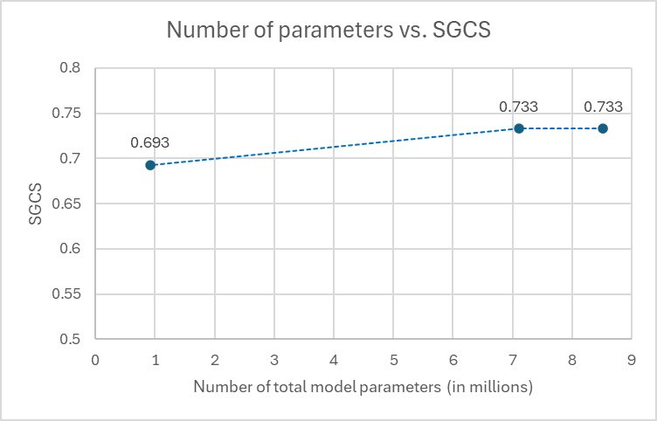
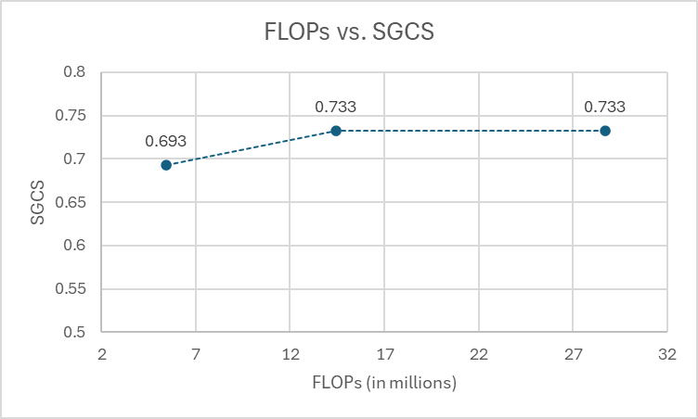
From Table 3.1-2 and Figure 3.1-1, we observe the following:
Figure 3.1-1: Model complexity vs. SGCS performance
- When using less complex model that has fewer model parameters and FLOPs, i.e., Small_1, or Small_2, from no performance degradation to small performance degradation is observed compared to using more complex model, i.e., the Benchmark model.
- When using Small_1 which has 50% FLOPs compared to the Benchmark, no SGCS performance difference is observed.
- When using Small_2 which has only 19% FLOPs compared to the Benchmark, some SGCS performance degradation is observed, i.e., ~5.5%.
- Even though the study/comparison is still preliminary from model complexity-performance trade-off perspective as there are various mechanisms to improve the performance for less complex model(s) to achieve more comparable performance as the benchmark model, the results indicate it is feasible to achieve reasonable/comparable performance with much less complex models.
Observation 3: For CSI compression using two-sided model, when comparing SGCS performance across models with different space and computational complexities, minor to medium performance degradation is observed on the less complex models (from 0% to ~5.5% from our study), compared to the benchmark model with much higher complexity.
Observation 4: For CSI compression using two-sided model, it is feasible for less complex models to achieve reasonable performance that is comparable with a more complex benchmark model.
Proposal 1: For CSI compression using 2-sided model, regarding the trade-off between performance and complexity/overhead, consider adopting model structure with less complexity to reduce both space and computational overhead.

Discussion on other topics related to further study of CSI compression
A few other topics that have been discussed during the past few meetings, but companies haven’t reached consensus yet, including data collection, NW-side and UE-side performance monitoring on other aspects during the inference. In this section, we discuss these topics.

Discussion on parameter/model exchange and dataset exchange
Agreements have been reached in RAN1#118bis [1] to further study Option 3a-1 and 4-1 for Direction A as captured below.
Agreement
For Directions of addressing inter-vendor collaboration complexity for two-sided CSI compression,
- For Direction A:
  - Further study the following options with potential down-selection
    - 4-1: dataset is {target CSI, CSI feedback},
    - 3a-1: encoder parameter exchange, with {target CSI}
    - Note: Additional information beyond what’s listed above may need to be exchanged if necessary.

Option 3a-1 involves encoder parameter exchange together with {target CSI} training data samples from NW-side to UE-side. Option 4-1 involves dataset exchange from NW-side to UE-side and the dataset consists of {target CSI, CSI feedback}.
For Direction B, the following agreement has been reached in RAN1#118bis to further study the overhead and how often the parameters need to be transferred.
Agreement
For issues listed for inter-vendor collaboration direction B, further study the overhead in Direction B based on the size of the encoder (i.e., number of parameters and quantization level), the number of encoders, and how often the parameters need to be transferred.

Regarding parameter/model and dataset exchange, the following agreement was reached in RAN1#117 [4] that standardized signaling can be used for Option 3a/3b/4 as captured below.
From the agreements related to inter-vendor training collaboration options, Option 3a-1/4-1 in Direction A involve parameter/dataset exchange, and Option 3b in Direction B involves parameter exchange.
Conclusion
Standardized signalling, if feasible and specified, can be used for parameter / model exchange in option 3a/5a and 3b to alleviate/resolve the inter-vendor training collaboration complexity.
- Standardized signalling may be reused for exchanging CSI generation part, CSI reconstruction part, or both, etc, when necessary and feasible.
- Standarized signalling may be over-the-air, or other approaches.
Standardized signalling, if feasible and specified, can be used for dataset exchange in option 4 to alleviate/resolve the inter-vendor training collaboration complexity.
- Standardized signalling may be reused for dataset exchanging, when necessary and feasible.
- Standardized signalling may be over-the-air, or other approaches.
Note: feasibility will be discussed separately.

For Option 3b in Direction B, if supported, the purpose is for UE-side to directly use the received encoder parameters (for the specified reference encoder architecture) for inference operation. In the case that NW-side performs retraining or fine-tuning of the encoder model using new data samples, e.g., to include samples from new data distribution, the newly trained/tuned encoder parameters should be adopted by the UE-side as soon as possible to alleviate potential performance degradation. In such situation, over-the-air delivery method can be considered to ensure timely delivery.
For Option 3a-1 and 4-1, the purpose is to allow UE-side to perform offline engineering, e.g., by training a more suitable encoder if applicable for the device; thus, the latency requirement for the associated parameter/dataset delivery is more relaxed compared to Direction B, i.e., Option 3b. In such case, we may also consider other delivery options, like offline approach (e.g., via upper layer signalling) or other 3GPP-transparent approaches.
Observation 5: If Option 3b in Direction B is supported, it is preferrable for UE-side to start using the encoder or encoder parameters as soon as possible, especially for model (parameter) update case.
Observation 6: For Option 3a-1 and Option 4-1 in Direction A, the latency requirement for model parameter/dataset exchange/transfer can be more relaxed compared to Option 3b in Direction B if supported.
Proposal 2: If inter-vendor training collaboration option 3b in Direction B is supported, consider adopting over-the-air delivering method(s).
Proposal 3: If inter-vendor training collaboration option 3a-1 and/or 4-1 in Direction A are/is supported, consider adopting standardized signalling in upper layers or other offline method(s) as delivery options.

Discussion on potential specification impact related to quantization of CSI feedback
As indicated in the revised WID [2] for additional study on AI/ML for air interface, addressing necessary specification impact is part of the scope in Rel-19 study. Related to quantization of feedback for Option 3a-1/3b/4-1, companies had some discussions in past meetings, but no agreement has been reached yet. To make sure the expected E2E performance can be achieved, the following configurations/exchanges can be considered.
- Scalar quantization: configuration of quantization granularity (e.g., number of bits), and the corresponding range in each quantization bucket, or exchanging quantization dictionary.
- Vector quantization: exchanging vector quantization (VQ) codebook(s) and the vector segmentation information if used in order for the recipient side to determine how to use the received VQ codebook(s).
Proposal 4: For AI/ML-based CSI compression using two-sided model, further study the following potential specification impact related to quantization of CSI feedback at least for Option 3a-1/4-1 in Direction A and Option 3b in Direction B in alleviating/resolving the issues related to inter-vendor training collaboration:
- Vector quantization:
  - Exchange of vector quantization codebook(s).
  - Segmentation information (if segmentation is used) of the CSI output.
- Scalar quantization:
  - Configuration of quantization granularity and the corresponding range values.
  - Exchange of scalar quantization dictionary.

Discussion on other inference aspects
CQI determination
The topic of CQI determination has been discussed during Rel-18 and the following options have been identified and specified in the TR [5] and captured below.
For the evaluation of CSI compression, the specific CQI determination method(s) for AI/ML can be reported by introducing an additional field in the template, e.g.,
- Option 1a: CQI is calculated based on the target CSI from the realistic channel estimation.
- Option 1b: CQI is calculated based on the target CSI from the realistic channel estimation and potential adjustment.
- Option 1c: CQI is calculated based on traditional codebook.
- Option 2a: CQI is calculated based on CSI reconstruction output, if CSI reconstruction model is available at the UE and UE can perform reconstruction model inference with potential adjustment.
o Option 2a-1: The CSI reconstruction part for CQI calculation at the UE same as the actual CSI reconstruction part at the NW.
o Option 2a-2: The CSI reconstruction part for CQI calculation at the UE is a proxy model, which is different from the actual CSI reconstruction part at the NW.
- Option 2b: CQI is calculated using two stage approach, UE derives CQI using precoded CSI-RS transmitted with a reconstructed precoder.

In general, whether to use Option 1 or Option 2 depends on whether CSI reconstruction part of the 2-sided model is available at UE. As companies are evaluating inter-vendor training collaboration options (Option 3a-1/4-1 in Direction A, 3b in Direction B, and 1 in Direction C), in the case that CSI reconstruction model is available at UE, using Option 2a in determining CQI would be feasible and accurate when using AI/ML-based CSI compression as it would better match the output of the actual decoder at NW-side.
Proposal 5: In AI/ML-based CSI compression using two-sided model, for CQI determination, if the actual or reference CSI reconstruction model is available at UE, adopt Option 2a to determine CQI at UE.

Discussion on CSI processing unit
During RAN1 meeting #120, CSI processing unit was discussed in AI 9.1.3 (CSI prediction) and the following agreement was made.
Agreement
For CSI prediction using UE-side model, for CSI processing criteria and timeline, at least for inference further study on
- Whether the CPU should be shared or separately counted between legacy CSI reporting and AI/ML-based CSI reporting
- Whether the Processing Unit should be shared or separately counted among AI/ML related features/functionalities.
- Whether new timeline is needed/updated for inference, and whether a different timeline is needed when functionality switches/activates.
- Whether legacy framework for active CSI-RS resource and port counting can be reused
Note: Strive to study CSI processing criteria considering both BM and CSI case, and take the existing solutions as starting point.

As this topic is relevant to multiple use cases, the agenda [5] posted by RAN1 chair added this topic to CSI compression agenda item as well:
- For any processing unit related discussions on normative work, handle under agenda items 9.1.1, 9.1.2, and 9.1.3.
- For any processing unit related discussions headed for TR, handle under agenda item 9.1.4.1
  - 9.1.4.1 CSI compression and any other aspects on AI/ML model/data
Including any remaining discussions on “Processing Unit”.

In this contribution, we share our views on the first three FFSs, i.e.,
- Whether the CPU should be shared or separately counted between legacy CSI reporting and AI/ML-based CSI reporting
- Whether the Processing Unit should be shared or separately counted among AI/ML related features/functionalities.
- Whether new timeline is needed/updated for inference, and whether a different timeline is needed when functionality switches/activates.

Before discussing CPU sharing and counting between legacy CSI reporting and AI/ML-based CSI reporting, it is important to have a common understanding of what processing resources are needed for AI/ML-based CSI reporting.
AI/ML-based CSI reporting still needs to perform legacy CSI processing including measurement, channel estimation on CSI-RS, and potentially derivation of eigen vectors of channel covariance matrix. This legacy part of the CSI processing can be done using the same type of processing resource / hardware as the legacy CSI reporting. In addition, AI/ML-specific processing is then performed utilizing potentially dedicated ML processing resources which may be done using special AI/ML engines / hardware. Furthermore, these special AI/ML engines / hardware is likely also used for other AI/ML-based features at the UE.
Observation 7: AI/ML-based CSI reporting needs both legacy CSI processing resources and AI/ML-specific processing resources.
Observation 8: For AI/ML-based CSI reporting, the needed legacy CSI processing part can share CPU with legacy CSI reporting.
Observation 9: The AI/ML engines / hardware on the UE are likely shared among different AI/ML-based features on the UE.

Shared or separately counted CPU between legacy CSI reporting and AI/ML-based CSI reporting
In last meeting, multiple companies proposed to support the separate counting approach. It is also our opinion that the separate counting approach is a better one as it offers several advantages due to the following reasons.
- Accounts for Different Computational Characteristics: AI/ML algorithms typically have different computational profiles compared to traditional signal processing methods used in legacy CSI reporting. AI/ML model inference involves complex matrix operations, non-linear functions, and potentially model loading and activation, which may require specialized hardware than legacy codebook-based feedback. Separating the accounting allows for a more accurate representation of the UE's processing load and capabilities for each type of operation.
- Supports Dedicated Processing Units: Several companies mentioned the possibility of dedicated processing units (like an APU) or enhanced CPU capabilities specifically for AI/ML tasks. If AI/ML processing occurs on dedicated hardware, it is logical and necessary to account for its resource usage separately from the main CPU responsible for legacy tasks.
- Allows Better and More Accurate Resource Management and Prioritization: With separate accounting, the UE and network can better understand the resource consumption of AI/ML-based operations vs. conventional/legacy operations. This can aid in defining priority rules, e.g., between CSI reporting types (legacy vs. AI/ML) and properly managing resources across different types of operations, and among various AI/ML functionalities. It allows for more granular control over resource allocation and can help prevent AI/ML processes from unduly impacting the resource management and/or performance of essential legacy functions or vice versa.
- Enables Accurate UE Capability Reporting: To effectively utilize AI/ML for CSI-related use cases, the network needs to know the UE's AI/ML processing capabilities. Reporting separate CPU or processing unit pools, along with potential scaling factors per AI/ML functionality, provides the network with more precise information about the UE's capacity for these advanced features. This allows the network to configure AI/ML-based features appropriately without overloading the UE's processing resources.
- Supports Efficient Sharing Among Different AI/ML Functionalities: By considering the ML/model inference processing unit resources for AI/ML as a shared pool among CSI-related AI/ML features (like CSI prediction and CSI compression), or even among different AI/ML-related features (like BM and CSI), this approach acknowledges that these functionalities might utilize the same underlying (dedicated) AI/ML processing units. This approach can lead to more efficient utilization of the dedicated AI/ML processing resources within the UE. We will discuss this further in its own section about shared resource pool for AI/ML features/functionalities.
- Addresses Concerns about Timeline and Activation Delay: Separate CPU accounting can help in understanding the resource utilization implications of AI/ML features to properly determine if additional timeline considerations are needed for AI/ML-based CSI reporting. We will elaborate this in the timeline discussion later in this document.
Based on the above discussion, we observed the following.
Observation 10: Separating the CPU counting for legacy and AI/ML-based CSI reporting provides a more accurate, flexible, and manageable approach to handling the computational demands of this new technology. It aligns with the potential for dedicated AI/ML processing hardware, facilitates better resource management and prioritization, enables more informative UE capability reporting, and supports efficient sharing of AI/ML resources within the UE.
We therefore propose that for UE-sided AI/ML-based CSI use cases, RAN1 should adopt a mechanism where the CPU resources utilized for legacy (non-AI/ML) CSI reporting are counted separately from the CPU resources utilized for AI/ML-based CSI reporting. In addition, we need to define a basic unit for measuring AI/ML-based computing power for inference (e.g., Machine-Learning Processing Unit, MPU).
Proposal 6: Support to separate CPU Counting for Legacy and AI/ML-based CSI Reporting, i.e., legacy CPU and AI/ML-based CPU are from different resource pools.

Sharing AI/ML computing resources among different AI/ML-based features
As we discussed above, by considering the processing resources for AI/ML as a shared pool among CSI-related AI/ML features (like CSI prediction and CSI compression), or even among different AI/ML-related features (like BM and CSI), more efficient management and utilization of the dedicated AI/ML processing resources within the UE can be achieved. In fact, sharing AI/ML-based computing resources among different AI/ML features and functionalities offers several significant advantages and is a better method for resource utilization due to the following reasons:
- Efficient Resource Utilization: UE devices often have limited hardware resources. Managing resource for each AI/ML feature/function separately can lead to inefficient utilization and increased implementation complexity and cost. A shared pool, i.e., considering AI/ML resources as common resources across AI/ML features, allows for dynamic allocation of resources based on the active functionalities and their current demands, leading to better overall efficiency.
- Flexibility and Scalability: As the number of AI/ML-based features in wireless systems grows, managing dedicated resources for each can become cumbersome (imagine the processing resources dedicated for BM, for CSI prediction, for CSI compression, and many other future use cases). A shared resource pool provides a more flexible and scalable architecture. New AI/ML functionalities can be introduced without requiring a complete overhaul of the resource allocation strategy.
- Reduced Power Consumption: By sharing a common AI resource pool/management, UE can potentially reduce overall power consumption compared to having multiple dedicated processing units that require separate management tasks. Efficient resource sharing allows for a more streamlined and power-aware operations across AI/ML features.
- Simplified UE Capability Reporting: Instead of reporting the AI/ML processing capability for each individual feature separately, UE can report the characteristics of the shared AI/ML resource pool and potentially a complexity factor for each functionality. This simplifies the UE capability reporting mechanism and provides the network with a clear understanding of the overall AI/ML processing power available on the device.
- Alignment with Industry Trends: Modern mobile devices and chipsets are increasingly incorporating dedicated AI engines or accelerators that are designed to be shared across various AI applications. Adopting a shared resource framework in the wireless standard aligns with these industry trends and can facilitate the implementation and commercialization of AI/ML-based features.
- Support for Concurrent AI/ML Operations more efficiently: A shared AI/ML resource pool can enable the UE to handle concurrent AI/ML operations more efficiently as it can reduce the complexity of handling interactions among AI/ML features/operations. This is crucial as UEs might need to perform tasks like CSI prediction and beam management simultaneously.
- Considerations for AI/ML processing unit Counting: When AI/ML tasks are executed on shared, potentially dedicated, AI processing units, it becomes more logical to account for the utilization of this shared resource separately from the main CPU used for legacy functions. This provides a more accurate picture of the processing load associated with AI/ML operations and avoids conflating it with the demands of traditional wireless protocols. The network can then manage and configure AI/ML features based on the reported capacity of this shared pool.
Observation 11: Supporting the sharing of AI/ML-based computing resources among different AI/ML features and functionalities is a more efficient, flexible, and scalable approach. It optimizes resource utilization, potentially reduces power consumption, simplifies UE capability reporting, and aligns with industry trends in AI hardware design. Counting the resources of this shared pool separately from legacy CPU usage provides a clearer understanding of the processing demands of AI/ML-based operations, facilitating better network management and configuration.
We therefore propose, for UE-sided AI/ML operations, including but not limited to CSI prediction, CSI compression, and beam management, RAN1 should adopt a framework where a common pool of AI/ML-based computing resources (e.g., processing units, AI engine, APU) is shared among different AI/ML features and functionalities. UE should report the capabilities of this shared AI/ML resource pool to the network, potentially including a scaling factor per functionality or model based on the associated complexity.
Proposal 7: Support the sharing of AI/ML-based computing resources among different AI/ML features and functionalities.

New/updated timeline for model inference
As we discussed in the advantages of separately counted CPU between legacy CSI reporting and AI/ML-based CSI reporting, one of the advantages of separate CPU accounting is that it can address concerns about timeline and activation delay. Separate CPU accounting can help in understanding the resource utilization implications of these factors to properly determine if additional timeline considerations are needed for AI/ML-based CSI reporting.
To support separate CPU accounting, it is necessary and important to adopt a new or updated timeline for AI/ML model inference, separate from or as an extension of the legacy timeline, due to the following reasons.
- Different Computational Characteristics of AI/ML: As discussed in our previous proposal for separate CPU counting, AI/ML model inference involves fundamentally different computations compared to legacy CSI feedback mechanisms. These computations, including complex matrix operations and non-linear functions, can have processing timelines that deviate significantly from those of traditional codebook-based approaches.
- Model Loading and Activation Delays: Unlike legacy processes, AI/ML models might need to be loaded into a dedicated AI engine or activated before inference can occur. This model loading and activation process can introduce significant delays that are not accounted for in the legacy CSI processing timeline. A new timeline framework can explicitly incorporate these potential delays.
- Functionality Activation/Deactivation: When the UE activates/deactivates an AI/ML-based CSI reporting mode, additional time offsets or delays might be necessary. An updated timeline framework can accommodate these transitions, ensuring accurate and timely CSI reporting.
- UE Capability Dependence: The time required for model inference and loading can vary significantly based on the UE's processing capabilities (determined mostly by its hardware), the specific AI/ML model used, and the overall AI/ML workload on the device. A new timeline framework could potentially allow the UE to report its AI/ML inference processing capabilities, enabling the network to configure CSI reporting parameters accordingly.
- Impact on Active/Inactive States: CSI processing timeline can be affected by the active or inactive state of a functionality. An updated timeline can provide a more precise definition of the processing time associated with each state for AI/ML-based CSI processing/reporting, including potential activation delays when transitioning from an inactive state.
- Facilitates Performance Monitoring: Accurate timelines for inference are also important for effective performance monitoring of the AI/ML models. Knowing the expected inference time allows the network to better interpret monitoring metrics and identify potential issues with the model or its execution.
In addition, a new/updated timeline brings the following benefits for resource management.
- Accurate Resource Allocation: A more precise understanding of the time required for AI/ML inference allows both the UE and the network to allocate processing resources (including CPU, memory, and potentially dedicated AI hardware) more efficiently.
- Network Optimization: The network can use information about the UE's AI/ML inference timeline to optimize scheduling and resource grants. For instance, knowing that an AI/ML report might take longer to generate due to model complexity can influence when the network expects the feedback.
- Better Coexistence with Legacy Processes: A dedicated timeline for AI/ML inference helps in understanding how these new processes coexist with legacy CSI reporting and other UE operations. By accurately accounting for the time resources consumed by AI/ML, the UE can better manage its overall processing load and avoid impacting the performance of critical legacy functionalities.
In conclusion, a new or updated timeline framework tailored to the specific characteristics of AI/ML model inference is essential for the successful implementation and optimization of AI/ML-based CSI-related features. This framework provides a more accurate understanding of the temporal resource requirements of AI/ML inference, which is crucial for efficient overall resource management, including a more realistic view of potential CPU utilization durations.
Proposal 8: Adopt a new/updated timeline for model inference for the AI/ML-based counting approach of CPU and model inference processing resource.

Conclusions
In this contribution, we discussed our evaluation results for scalable model structure and complexity-performance tradeoff by using different model structures. In addition, we shared our views regarding remaining issues and potential specification impact. Our observations and proposals are as follows.
For evaluation of scalable model structure:
Observation 1: In model structure scalability study for temporal domain Case 0 of CSI compression using two-sided model, when handling scalability over payload configurations using Alt2 (truncation/masking of the output linear layer output) and/or Alt3 (by varying quantization parameters), performance evaluation shows there is small SGCS performance loss compared to payload size-specific models.
- Alt2 has 1.5% - 3.5% SGCS performance degradation compared to the payload size-specific models.
Observation 2: In model structure scalability study for temporal domain Case 0 of CSI compression using two-sided model, using scalable model structure can potentially save significant overhead in model training, the associated LCM burden and the storage concern on both UE-side and NW-side while achieving comparable SGCS performance compared to the benchmark (payload size-specific models), at least for Alt2 and Alt3.
For evaluation of tradeoff between complexity and performance:
Observation 3: For CSI compression using two-sided model, when comparing SGCS performance across models with different space and computational complexities, minor to medium performance degradation is observed on the less complex models (from 0% to ~5.5% from our study), compared to the benchmark model with much higher complexity.
Observation 4: For CSI compression using two-sided model, it is feasible for less complex models to achieve reasonable performance that is comparable with a more complex benchmark model.
Proposal 1: For CSI compression using 2-sided model, regarding the trade-off between performance and complexity/overhead, consider adopting model structure with less complexity to reduce both space and computational overhead.
For other topics in the study:
Observation 5: If Option 3b in Direction B is supported, it is preferrable for UE-side to start using the encoder or encoder parameters as soon as possible, especially for model (parameter) update case.
Observation 6: For Option 3a-1 and Option 4-1 in Direction A, the latency requirement for model parameter/dataset exchange/transfer can be more relaxed compared to Option 3b in Direction B if supported.
Proposal 2: If inter-vendor training collaboration option 3b in Direction B is supported, consider adopting over-the-air delivering method(s).
Proposal 3: If inter-vendor training collaboration option 3a-1 and/or 4-1 in Direction A are/is supported, consider adopting standardized signalling in upper layers or other offline method(s) as delivery options.
Proposal 4: For AI/ML-based CSI compression using two-sided model, further study the following potential specification impact related to quantization of CSI feedback at least for Option 3a-1/4-1 in Direction A and Option 3b in Direction B in alleviating/resolving the issues related to inter-vendor training collaboration:
- Vector quantization:
  - Exchange of vector quantization codebook(s).
  - Segmentation information (if segmentation is used) of the CSI output.
- Scalar quantization:
  - Configuration of quantization granularity and the corresponding range values.
  - Exchange of scalar quantization dictionary.
Proposal 5: In AI/ML-based CSI compression using two-sided model, for CQI determination, if the actual or reference CSI reconstruction model is available at UE, adopt Option 2a to determine CQI at UE.
For CSI processing unit:
Observation 7: AI/ML-based CSI reporting needs both legacy CSI processing resources and AI/ML-specific processing resources.
Observation 8: For AI/ML-based CSI reporting, the needed legacy CSI processing part can share CPU with legacy CSI reporting.
Observation 9: The AI/ML engines / hardware on the UE are likely shared among different AI/ML-based features on the UE.
Observation 10: Separating the CPU counting for legacy and AI/ML-based CSI reporting provides a more accurate, flexible, and manageable approach to handling the computational demands of this new technology. It aligns with the potential for dedicated AI/ML processing hardware, facilitates better resource management and prioritization, enables more informative UE capability reporting, and supports efficient sharing of AI/ML resources within the UE.
Observation 11: Supporting the sharing of AI/ML-based computing resources among different AI/ML features and functionalities is a more efficient, flexible, and scalable approach. It optimizes resource utilization, potentially reduces power consumption, simplifies UE capability reporting, and aligns with industry trends in AI hardware design. Counting the resources of this shared pool separately from legacy CPU usage provides a clearer understanding of the processing demands of AI/ML-based operations, facilitating better network management and configuration.
Proposal 6: Support to separate CPU Counting for Legacy and AI/ML-based CSI Reporting, i.e., legacy CPU and AI/ML-based CPU are from different resource pools.
Proposal 7: Support the sharing of AI/ML-based computing resources among different AI/ML features and functionalities.
Proposal 8: Adopt a new/updated timeline for model inference for the AI/ML-based counting approach of CPU and model inference processing resource.

References
- R1-2501546, Session notes for 9.1 (Artificial Intelligence (AI)/Machine Learning (ML) for NR Air Interface), Ad-hoc Chair (CMCC), RAN1#120.
- RP-234039, New WID on Artificial Intelligence (AI)/Machine Learning (ML) for NR Air Interface, Qualcomm (Moderator), RAN#102.
- R1-2501474, Final summary of Additional study on AI/ML for NR air interface: CSI compression, Qualcomm (Moderator), RAN1#120.
- R1-2500051, Discussion of CSI compression on AI/ML for NR air interface, FUTUREWEI, RAN1#120.
- R1-2501680, Draft agenda, RAN1#120bis, RAN1 chair.

