3GPP TSG-RAN WG1 Meeting #122 R1-2505203
Bengaluru, India, August 25 – 29, 2025

Agenda Item: 8.1.2
Source: Huawei, HiSilicon
Title: Maintenance of Rel-19 AI/ML for positioning accuracy enhancement
Document for: Discussion and Decision

Introduction
In RAN1#121 [1], the work item on Rel-19 AI/ML for positioning accuracy enhancement was completed. In this paper, we discuss some maintenance issues related to Case 1 and Case 3a.

Model output for assisted positioning
In RAN1#116, the following agreements were made regarding the report based on the model output for Case 3a and Case 2a.
Agreement
For AI/ML assisted positioning Case 3a, at least LOS/NLOS indicator and/or timing information are supported for reporting.
- If LOS/NLOS indicator is reported, the indicator can be reported as soft indicator or hard indicator as defined in 38.214.
- If timing information is reported, the timing information at least can be reported via UL RTOA or gNB Rx-Tx time difference as defined in 38.215.
- Note: details of the report are pending further discussion.
Agreement
For AI/ML assisted positioning Case 2a, at least LOS/NLOS indicator and/or timing information are supported for reporting.
- If LOS/NLOS indicator is reported, the indicator can be reported as soft indicator or hard indicator as defined in 38.214.
- If timing information is reported, the timing information at least can be reported via DL RSTD or UE Rx-Tx time difference as defined in 38.215.
- Note: details of the report are pending further discussion.
In the RAN#107 plenary meeting [2], the Release 19 work item on AI/ML for air-interface was revised, where the second priority cases were removed from the working objectives on AI/ML for positioning accuracy enhancement:
Provide specification support for the following aspects:
….
- Positioning accuracy enhancements, encompassing [RAN1/RAN2/RAN3]:
  - Direct AI/ML positioning:
    - (1st priority) Case 1: UE-based positioning with UE-side model, direct AI/ML positioning
    - (2nd priority) Case 2b: UE-assisted/LMF-based positioning with LMF-side model, direct AI/ML positioning
    - (1st priority) Case 3b: NG-RAN node assisted positioning with LMF-side model, direct AI/ML positioning
  - AI/ML assisted positioning
    - (2nd priority) Case 2a: UE-assisted/LMF-based positioning with UE-side model, AI/ML assisted positioning
    - (1st priority) Case 3a: NG-RAN node assisted positioning with gNB-side model, AI/ML assisted positioning
  - Specify necessary measurements, signalling/mechanism(s) to facilitate LCM operations specific to the Positioning accuracy enhancements use cases, if any
  - Investigate and specify the necessary signalling of necessary measurement enhancements (if any)
  - Enabling method(s) to ensure consistency between training and inference regarding NW-side additional conditions (if identified) for inference at UE for relevant positioning sub use cases
  - Note: RAN1 will not discuss any proposals targeting 2nd priority issues in Q4 of 2024.
….
For gNB Rx-Tx time difference based on model output at the gNB, there are two issues which hinder its usability. On the one hand, it is not clear how the gNB can generate a Rel-19 gNB Rx-Tx time difference without knowing the Tx time of the SRS at the UE. Consider the example depicted in Figure 1, where the gNB receives an SRS from the UE in a NLOS scenario. The model output for Case 3a consists of the timing information of the SRS subject to a virtual direct path between the UE and the gNB, e.g., it corresponds to the propagation delay/RTOA of the virtual direct path (assuming the training label is also in forms of propagation delay/RTOA). To obtain a Rel-19 gNB Rx-Tx time difference, the Tx time at the gNB is the actual Tx time known by gNB, while the Rx time should correspond to the Rx time of SRS subject to the virtual direct path (instead of the actual Rx time which corresponds to NLOS). The Rx time can be denoted as the inferred propagation delay + the actual Tx time of the SRS. However, since the gNB does not know the actual Tx time of SRS and hence, it cannot generate a Rel-19 gNB Rx-Tx time difference.
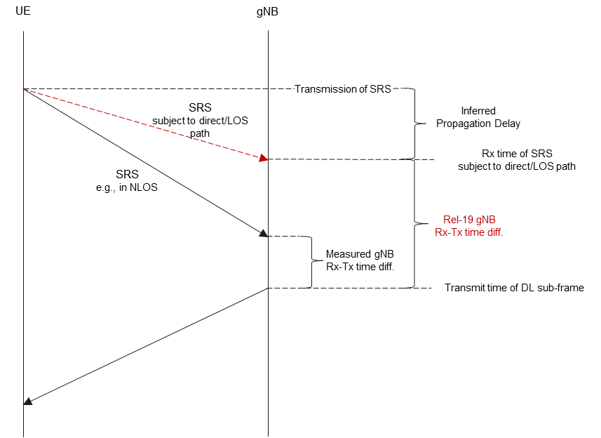
Figure 1 – Determination of Rel-19 gNB Rx-Tx time difference
On the other hand, if gNB assumes a Tx time of the SRS (e.g., boundary of subframe), it is actually different from the actual Tx time of the SRS. In addition, given that in Rel-19 there is no support for UE Rx-Tx time difference based on model output at the UE (i.e., based on Case 2a), the measured Rx-Tx time difference at UE is not accurate either. Thus, the calculated Rel-19 gNB Rx-Tx time difference is still different from the actual Rx-Tx time difference assuming an ideal LOS path, and may lead to an erroneous RTT estimation.
Based on the above points, in our view there is no need to support gNB Rx-Tx time difference based on model output at the gNB.
Proposal 1: For Case 3a, preclude the reporting of gNB Rx-Tx time difference based on model output.

Model training
In the following, we discuss some maintenance issues related to model training for Case 3a and Case 1.

Format of timing information label for Case 3a
In RAN1#120b, the following agreement regarding the label for Case 3a, when Part B includes timing information, was made:
Agreement
For training data collection of Part B in AI/ML based positioning Case 3a, for the case when Part B label includes timing information, support the following for providing label and quality indicator of label,
- The corresponding label is provided by LMF to gNB in the format of timing information. “Timing Measurement Quality” in 38.455 can serve as quality indicator of the label.
Note: It is assumed that user data privacy of non-PRU UE is preserved.
In our view, the format of the timing information for the label when Part B includes timing information may not be clear. For Case 3a, if the Part B includes timing information, the type of label for the timing information in Case 3a should correspond to the propagation delay (i.e., time of flight) between the PRU/UE and the TRP. The format can be subject to UL RTOA/ToF between the PRU/UE and the TRP. In addition, there is no need to mention the purpose of the timing information provided from the LMF to the gNB.
Proposal 2: For Case 3a, the format for the timing information generated from LMF can correspond to the UL RTOA/ToF between the TRP and the PRU/UE.
- Note: the purpose of the provided timing information is not specified.

Pairing of Part A and Part B
In RAN1#120, the following agreement was made regarding the pairing for Part A and Part B when Part A and Part B are generated by different entities:
Agreement
- For training data collection of AI/ML based positioning 3a/3b, if Part A and Part B are generated by different entities, for pairing between a Part A entry and a Part B entry, the following is needed:
- The time stamp of Part A (if Part A is transmitted) and the time stamp of Part B (if Part B is transmitted).
- FFS: other information is not precluded (e.g., if Part B is valid for a duration)
Note: Purpose such as “training data collection” will not necessarily be specified in RAN1 specifications.
Case 3a
For Case 3a, the measurement is generated by the gNB/TRP, while the label may be generated by the LMF. In this case, Part A and Part B cannot be generated by the same entity. For Case 3a, the LMF can provide Part B to the gNB/TRP for gNB side training. As agreed in RAN1#120, the pairing can be done at the gNB side based on the time stamp of Part B sent together with the content of Part B via NRPPa. However, considering the time stamp of Part B corresponds to a past time instance of T0 in prior to the Part B delivery at T1, the gNB may fail generating Part A corresponding to T0, or may have already discarded/flushed the Part A subject to T0 when it receives the Part B at the later time instance T1, since the gNB cannot predict when will the LMF generate Part B before the gNB receives the delivered Part B. As one candidate, the gNB needs to store all past measurements during the data collection phase, but it incurs higher complexity on storage. As another candidate, after the reception of Part B (at T1) the gNB generates Part A (at a later time instance T2, where T2 is later than T1), then the Part B is outdated and the Part A (at T2) and Part B (at T0) cannot be paired, as shown in the example in Figure 2(a).
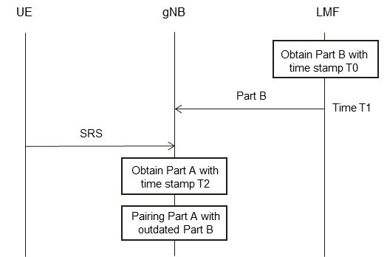 | 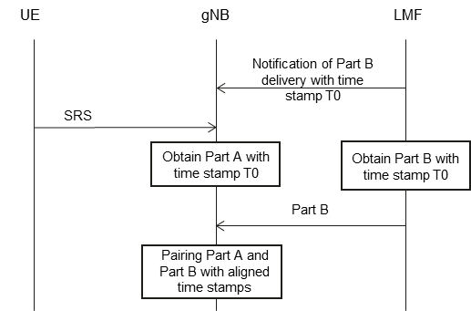
(a) Provision of outdated Part B | (b) Pairing with aligned time stamp
Figure 2 – Pairing of Part A and Part B
Observation 1: For Case 3a data collection, if the gNB is not aware of the time instance T0 when Part B is expected to be generated at the LMF in advance, it may fail to generate the measurements corresponding to T0 since it receives the Part B from LMF at a later T1.
- If gNB is supposed to store all measured Part A during the data collection phase, it will incur higher gNB complexity on storage.
- If gNB is supposed to do the measurement for Part A at T2 later than T1, Part A subject to T2 may be mis-aligned with the delivered Part B subject to T0.
Due to the above issues, it would be beneficial for the gNB and LMF to align the anticipated time stamp of the Part B to be delivered by the LMF. For example, the LMF can indicate to the gNB the time stamp (i.e., T0) for anticipated Part B in advance. This would allow the gNB to measure and store the Part A also subject to T0 as shown in the example in Figure 2(b). Thus, Part A and Part B will correspond to the aligned time T0. In another example, the LMF can indicate to the gNB multiple time stamps (range of time stamps) for anticipated Part B in advance, allowing the LMF to provide a label with an aligned time stamp within the indicated multiple time stamps (indicated range).
Proposal 3: For Case 3a data collection, when Part A is generated by the gNB/TRP and Part B is delivered from LMF to gNB/TRP, to enable the pairing of Part A and Part B at gNB side, the LMF indicates to the gNB the anticipated time stamp in which Part B is expected to be generated.
- The gNB can perform channel measurement to derive and store Part A according to the anticipated time instance for Part B, and pair Part A with Part B after Part B is delivered.
Case 1
For Case 1, the measurements can be generated by the PRU or UE, while the label can be generated by the PRU, UE or LMF. When Part A is generated by the UE and Part B is generated by the LMF, the LMF can provide Part B to the UE. As discussed above for Case 3a, the UE may not be able to pair Part A and Part B if their time stamps are not aligned, e.g., the delivered Part B is outdated. To this end, it would be beneficial for the UE and LMF to align the anticipated time stamp of the Part B to be delivered by the LMF similar as for Case 3a above.
Proposal 4: For Case 1 data collection, when Part A is generated by the UE and Part B is delivered from LMF to UE, to enable the pairing of Part A and Part B at UE side, the LMF indicates to the UE the anticipated time stamp in which Part B is expected to be generated.
- The UE can perform channel measurement to derive and store Part A according to the anticipated time instance for Part B, and pair Part A with Part B after Part B is delivered.

Consistency between training and inference with NW-side information
During the WI, the following agreements and working assumption were made related to the implicit indication of the TRP locations:
Agreement (RAN1#119)
For AI/ML based positioning Case 1, all assistance information from legacy UE-based DL-TDOA, other than info #7, can be provided from LMF to UE. For info #7, RAN1 study, if necessary, choose one alternative from the following:
- Alternative 1. Info #7 is provided implicitly via associated ID.
  - Associated ID is signaled by LMF to indicate whether info #7 is consistent between training and inference.
- Alternative 2. Info #7 can be provided either implicitly or explicitly by LMF. Note: no UE capability is introduced on whether info #7 is provided implicitly or explicitly, and the UE can request info #7 to be provided explicitly or implicitly.
  - If provided implicitly, associated ID is signaled by LMF to indicate whether info #7 is consistent between training and inference.
- Alternative 3. Info #7 is not be provided from LMF to UE.
  - If info #7 is not provided, UE may assume info #7 is consistent between training and inference.
- Alternative 4. Info #7 is provided explicitly from LMF to UE.
7 | Geographical coordinates of the TRPs served by the gNB (include a transmission reference location for each DL-PRS Resource ID, reference location for the transmitting antenna of the reference TRP, relative locations for transmitting antennas of other TRPs)
Working Assumption (RAN1#121)
For AI/ML based positioning Case 1, regarding info #7 in the assistance information from legacy UE-based DL-TDOA, it can be provided as in legacy UE-based DL-TDOA or implicitly.
Agreement (RAN1#121)
Above Working Assumption is confirmed.
Agreement (RAN1#121)
For AI/ML based positioning Case 1, regarding Info #7 in the assistance information from legacy UE-based DL-TDOA,
- If implicitly provided, the implicit indication of Info #7 is via associated ID.
  - For given TRP(s), same associated ID implies that geographical coordinates of the TRP(s) can be understood as consistent by the UE.
  - The associated ID is not expected to provide the real value of Info #7 (i.e., geographical coordinates of the TRP(s) are not disclosed).
  - an associated ID is configured per-cell (e.g., NCGI-r15)
    - UE does not expect to receive different values of associated ID for TRPs belonging to the same NCGI-r15
  - Associated ID can be realized by an identifier of N bits (e.g., 8 bits)
In the RAN1#121 post-meeting discussions regarding LPP parameters [3], different companies have different understandings regarding the above working assumption, indicating that further clarification of the confirmed working assumption is needed.
In our understanding, the TRP locations, i.e., Info #7, are not explicitly provided for Case 1 since the model input is the measurement rather than the explicit TRP location. For consistency, it suffices to check whether there has been a change regarding the TRP locations. To this end for Case 1, the location of the TRPs can be provided in forms of associated ID to the UE, as per the RAN1#121 confirmed working assumption. From the interpretation of the confirmed WA, the explicit TRP location is provided in legacy UE-based DL-TDOA if needed, but not provided in Case 1. In our view, there is no difference in the wording "by legacy" or "as in legacy" in the text of the confirmed working assumption.
Proposal 5: For the confirmed working assumption from RAN1#121, for crystal clear interpretation:
- For AI/ML based positioning Case 1, regarding info #7 in the assistance information from legacy UE-based DL-TDOA, it can be provided as in legacy UE-based DL-TDOA or implicitly.

Model monitoring for Case 3a
In the following, we discuss maintenance issues for model monitoring for Case 3a.
In RAN1#118, the following agreement was made regarding model monitoring for Case 3a.
Agreement
For AI/ML positioning Case 3a, for performance monitoring metric calculation in label-based monitoring, from RAN1 perspective, Option A and Option B are feasible,
- Option A. NG-RAN node performs monitoring metric calculation for its own model.
- Option B. LMF performs monitoring metric calculation for the model located at the NG-RAN node.
Note: Final selection of Option A and Option B is out of RAN1 scope. Potential support of Option A and/or Option B is pending RAN3 confirmation.
Note: Exact method to perform monitoring metric calculation is up to implementation.
Note: For Option A, RAN1 assumes that user data privacy needs to be preserved.
In RAN3#126, the following agreement was made regarding the model monitoring for Case 3a.
RAN3 will proceed with Option A: NG-RAN node performs monitoring metric calculation for its own model
For Option A, the gNB can compute the monitoring metric and determine the monitoring decision. However, outcome after the monitoring has not been discussed. In case the monitoring decision, from the gNB’s perspective, is to recommend to fallback to a legacy positioning method, i.e., to report a measured UL RTOA, the gNB will not follow the LMF request to report the non-measured result, e.g., non-measured UL RTOA based on Case 3a. Instead, the gNB reverts the request (e.g. to report non-measured UL RTOA), and reports instead a measured result (e.g., it reports measured UL RTOA). On the other hand, in case the monitoring decision is to keep the model activated, the gNB reports a non-measured result, e.g., non-measured UL RTOA, as requested by the LMF.
Proposal 6: For performance monitoring of AI/ML positioning Case 3a, the report of a measured or non-measured result can be used to imply the monitoring outcome activation/fallback between LMF and gNB.
- When NG-RAN node performs monitoring metric calculation, gNB can report LMF with measured result (implying fallback) or non-measured result (implying activation).

Conclusions
In this contribution, we have the following observations and proposals.
Proposal 1: For Case 3a, preclude the reporting of gNB Rx-Tx time difference based on model output.
Proposal 2: For Case 3a, the format for the timing information generated from LMF can correspond to the UL RTOA/ToF between the TRP and the PRU/UE.
- Note: the purpose of the provided timing information is not specified.
Observation 1: For Case 3a data collection, if the gNB is not aware of the time instance T0 when Part B is expected to be generated at the LMF in advance, it may fail to generate the measurements corresponding to T0 since it receives the Part B from LMF at a later T1.
- If gNB is supposed to store all measured Part A during the data collection phase, it will incur higher gNB complexity on storage.
- If gNB is supposed to do the measurement for Part A at T2 later than T1, Part A subject to T2 may be mis-aligned with the delivered Part B subject to T0.
Proposal 3: For Case 3a data collection, when Part A is generated by the gNB/TRP and Part B is delivered from LMF to gNB/TRP, to enable the pairing of Part A and Part B at gNB side, the LMF indicates to the gNB the anticipated time stamp in which Part B is expected to be generated.
- The gNB can perform channel measurement to derive and store Part A according to the anticipated time instance for Part B, and pair Part A with Part B after Part B is delivered.
Proposal 4: For Case 1 data collection, when Part A is generated by the UE and Part B is delivered from LMF to UE, to enable the pairing of Part A and Part B at UE side, the LMF indicates to the UE the anticipated time stamp in which Part B is expected to be generated.
- The UE can perform channel measurement to derive and store Part A according to the anticipated time instance for Part B, and pair Part A with Part B after Part B is delivered.
Proposal 5: For the confirmed working assumption from RAN1#121, for crystal clear interpretation:
- For AI/ML based positioning Case 1, regarding info #7 in the assistance information from legacy UE-based DL-TDOA, it can be provided as in legacy UE-based DL-TDOA or implicitly.
Proposal 6: For performance monitoring of AI/ML positioning Case 3a, the report of a measured or non-measured result can be used to imply the monitoring outcome activation/fallback between LMF and gNB.
- When NG-RAN node performs monitoring metric calculation, gNB can report LMF with measured result (implying fallback) or non-measured result (implying activation).

References
- R1-2504955, “Final summary of specification support for positioning accuracy enhancement”, Moderator (Ericsson), RAN1#121, St Julian’s, Malta, May 19 – 23, 2025.
- RP-250792, “Revised WID: Artificial Intelligence (AI)/Machine Learning (ML) for NR Air Interface.”
- R1-2505071, “Summary of discussion on LPP/NRPPa parameters for Rel-19 AI/ML positioning”, Moderator (Ericsson), RAN1#121, St Julian’s, Malta, May 19 – 23, 2025.

