# Lab 5: Graphics

|  |  |
| --- | --- |
| Assigned date | 2017-11-08 |
| Due date | 2017-11-13 |
| Estimate required time | 2 hour |

This is an individual assignment.

* You may consult with professor and TA about any aspect of the assignment.
* You may consult with other students only in a general way, e.g., about debugging or Python issues, or questions about wording on the assignment.
* You cannot actively work with someone unless the assignment specifically grants permission to work together with another student.

## Purpose

Have some experience in drawing programmatically.

## Instructions

1. Clone the repo: <https://github.com/TWU-2017-3-cmpt140/lab5.git>
2. Read through the codes in example.py and try out the codes. Make sure you understand how the code works. Please refer to graphics.py for more details. Additional information is found in the pdf file “graphics.pdf” which is from <http://mcsp.wartburg.edu/zelle/python/graphics/graphics.pdf>
3. Make an animation of a running man. The following two screen shots show various positions of a running man. You need a minimum of two positions. You can draw more if you wish.

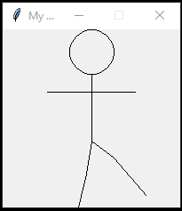 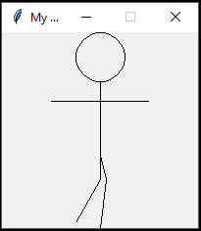

Use iteration (e.g. for loop or while loop) to make an animation of a running man. The animation should be at least 5 seconds long.

1. BONUS ALERT: You will get a 10% bonus if you draw the man so that it scales to fill up the graphics window (which can be variable size).

## Deliverables

* Please write a single Python script that shows the animation: lab5_LastnameFirstname.py. Please submit this file at <https://learn.twu.ca/> (100%)

Grading scheme for codes: cocumentation (20%), correct execution (60%); correct style and structure (20%)