**What the Research Tells Us about   
Higher Education’s Temporary Shift to Remote Teaching**

**What the Public Needs to Know, from the SoTL Community**

**Written & Compiled by**

|  |  |
| --- | --- |
| **Nancy Chick** | Co-President Elect of International Society for the Scholarship of Teaching and Learning ([ISSOTL](https://issotl.com/)), co-editor of *SoTL as Public Scholarship* (Stylus, forthcoming 2020), and Director of Endeavor Foundation Center for Faculty Development (Rollins College, USA) |
| **Jennifer Friberg** | Co-Chair of the International Society for the Scholarship of Teaching and Learning’s Advocacy and Outreach Committee, co-editor of *SoTL as Public Scholarship* (Stylus, forthcoming 2020), and Cross Endowed Chair in the Scholarship of Teaching and Learning (Illinois State University, USA) |
| **Lee Skallerup Bessette** | Learning Design Specialist, Center for New Designs in Learning and Scholarship/CNDLS (Georgetown University, USA), editor of *Terms of Service: Affective Labor and Alt-Ac Careers* (UKansas Press, forthcoming 2021), columnist for *The National Teaching and Learning Forum*, and former regular contributor at *ProfHacker* |

*The views below are our own and do not express the opinions of our employers.*

**Share this page:** [**http://bit.ly/3a3NhFz**](http://bit.ly/3a3NhFz)

|  |
| --- |
| Please see our “[Public Statement of Response to Higher Education’s Temporary Shift to Remote Instruction](https://docs.google.com/document/d/1VU7g8JKNQQDU1T6TEVSsiRvQkBfyZGNewBAwOqh4Ckc/edit?usp=sharing).”  You may also endorse it if you wish. |

***Preamble***

***This document is intended to support course instructors, educational developers and technologists, and other higher education colleagues with shared messaging for the public-facing conversations in response to the COVID-19 pandemic. While we are in unprecedented times, we are prepared for the work ahead. As a community of professionals, we draw on a wealth of research to support our practice (and our praxis) and are equipped to continue meeting the academic needs of our students and facilitating their progress as engaged learners.***

**OUTLINE OF THIS DOCUMENT**

**We care, and we’re dealing with our very human responses, as well.**2

There’s a sense of grief about the sudden ending of regular campus/class interactions with and among students. 2

At the same time, we take our teaching and our students very seriously, so we’re mobilizing in an initial phase of pedagogical triage. 2

**We’re ready for the challenge. As a community of professionals, we draw on a large body of research. Good teaching is good teaching.**3

We are guided by the research on how students learn and the resulting principles of good teaching, and we can adapt them to different learning environments. We also draw from the research on how to do distance learning well. 3

We know what students need in times of crisis. 5

We have support--if not locally, then globally. 9

## 

## **We care, and we’re dealing with our very human responses, as well.**

### There’s a sense of **grief** about the sudden ending of regular campus/class interactions with and among students.

**We feel deeply for students** and know that shifting to remote teaching isn’t easy for them. 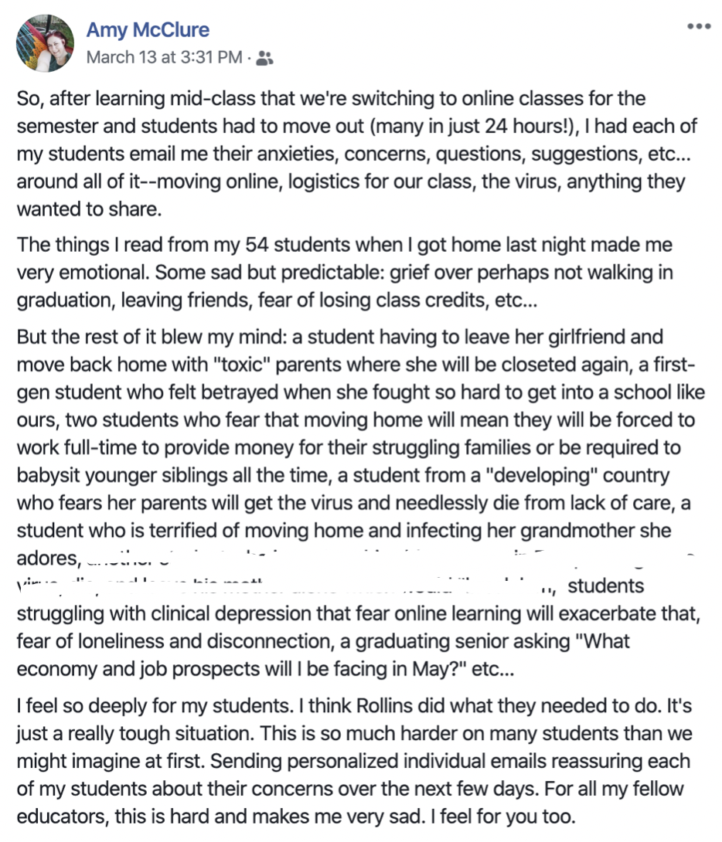

Amy McClure’s (sociology professor at Rollins College) illustrates her awareness of the difficulty facing many students via her Facebook post to the right. In another example, three science professors (Rollins College) woke up early on the suddenly-last-day-of-F2F-classes to hold an **impromptu graduation ceremony** for their seniors, complete with cap and gown, quickly drafted diplomas, and applause and tears. There are many, many more examples to share.

**Students and educators are feeling it** -- in their personal and academic lives.

“Communal crises, such as the unexpected death of a fellow student or teacher, the shock of 9/11, the devastation of Hurricanes Katrina and Sandy, the tragedy of the shootings at Virginia Tech, or the bombing of the Boston Marathon, can **affect everyone’s well-being—personal and academic**” (Chick, “[Teaching in Times of Crisis](https://cft.vanderbilt.edu/guides-sub-pages/crisis/)”).

### At the same time, we take our teaching and our students very seriously, so **we’re mobilizing in an initial phase of pedagogical triage**.

**This sudden move to remote teaching and learning contexts is *not “moving to online classes.”***

1. Teaching and learning experiences that happen in online or remote environments are (generally) carefully and purposefully designed well in advance of the term. **We simply don’t have the luxury of time right now.**
2. Rather, higher education is in a time of “pedagogical triage.” Most course instructors are tasked with quickly changing how and where they teach, which affects course content, assessment of learning, teacher/learner relationships, etc.
3. Even though many of us aren’t experts in online teaching, this is something different--and we’ve got this. The **majority of postsecondary institutions have mobilized units on campus to assist faculty with this unprecedented transition. Librarians** are negotiating with publishers to allow greater online access to materials**. Educational technology** units are working with companies to ensure stable access to tools. **Learning designers** are working around the clock creating materials and programming for faculty and students. **Faculty developers** are reaching out to faculty to help them through the transition and sharing available resources that foreground good teaching at a distance. **Student support services** are working around the clock to support students as many of them relocate and adjust to the new learning environments. We are all working together towards a common goal of helping each other and our students through this extraordinary situation.
4. Courses are shifting to distance learning in a variety of ways, **using different tools to support the range of activities that make up teaching and learning**, such as the following:
   * Sharing content through their learning management systems/LMS (e.g., Blackboard, Canvas, D2L)
   * Asynchronous interactions (class discussions, group work, interactive lectures) in their LMS
   * Synchronous class sessions through web conferencing (e.g., Skype, Zoom, WebEx)
   * Synchronous office hours through web conferencing and/or chat functions in their LMS
   * Individual communication with and among students through email, phones, and the chat functions in their LMS or web conference system

The global postsecondary community is also starting to share options for “[low-bandwidth teaching](https://www.iddblog.org/videoconferencing-alternatives-how-low-bandwidth-teaching-will-save-us-all/),” such as [this guide](https://www.vanderbilt.edu/brightspace/2020/03/17/low-bandwidth-teaching-tools-on-brightspace/) goes beyond any single platform, so we make responsive and smart decisions.

## **We’re ready for the challenge. As a community of professionals, we draw on a large body of research. Good teaching is good teaching.**

### **We are guided by the research** on how students learn **and the resulting principles** **of good teaching**, and we can adapt them to different learning environments. We also draw from the research on how to do distance learning *well*.

|  |  |
| --- | --- |
| **A Few Research-Based Principles of Good Teaching** | **How They’re Applied to Virtual Learning Environments** |
| **Good teaching is based on what we know about how students learn.** For example,   * *Learning activities should be aligned with our goals for learning--and how we assess their learning (i.e., constructive alignment).* * *Students’ prior knowledge affects how well they learn, so we need to know (e.g., formative assessment, below).* * *Learning happens when students practice, make mistakes, interact with each other and us, so they need lots of practice of key concepts/skills (their practice, not ours), and low-stakes feedback on that practice.* * *There are evidence-based ways to motivate students.* * *There is excellent research on how to study effectively (e.g., retrieval practice).* * *And much more….*   These books (among others) contain a lot of this information and are widely read in faculty book groups:   * *How Learning Works Seven Research-Based Principles for Smart Teaching,* Susan A. Ambrose, Michael W. Bridges, Michele DiPietro, Marsha C. Lovett, Marie K. Norman ([2010](https://www.wiley.com/en-us/How+Learning+Works%3A+Seven+Research+Based+Principles+for+Smart+Teaching-p-9780470484104)) * James Lang, *Small Teaching: Everyday Lessons from the Science of Teaching* (2016) * *How Humans Learn*, Joshua Eyler | Others have been working on this adaptation already.  For example, Darby & Lang in *Small Teaching Online: Applying Learning Science in Online Classes* (2019) suggest prioritizing the following considerations that reflect those principles emerging from the research:   * Designing for learning (e.g., backward learning, guiding learning through engagement, and using media and technology tools) * Teaching Humans (e.g., building community, giving feedback, and fostering student persistence and success) * Motivating online students and instructors (e.g., creating autonomy, making connections, and developing as an online instructor) |
| Good teaching, while based on the research on how students learn, is also **responsive to the specific students in class right now and in our specific contexts**, not an abstracted or idealized “student.”  This means that, first, the **instructor is present** with the students in front of them.  Second, the i**nstructor is aware of and responsive** to these students’   * prior knowledge ([Ambrose et al, 2010](https://www.wiley.com/en-us/How+Learning+Works%3A+Seven+Research+Based+Principles+for+Smart+Teaching-p-9780470484104)), and * thinking in the intermediate stages of learning ([Shute, 2008](http://projects.ict.usc.edu/dlxxi/materials/Sept2009/Research%20Readings/Shute%202008%20Focus%20on%20formative%20feedback.pdf)).   And the instructor responds to the above by providing timely feedback throughout the learning process, not just in summative or graded work ([Hattie & Timperley, 2007](http://www.columbia.edu/~mvp19/ETF/Feedback.pdf); [Shute, 2008](http://projects.ict.usc.edu/dlxxi/materials/Sept2009/Research%20Readings/Shute%202008%20Focus%20on%20formative%20feedback.pdf); [Ambrose et al, 2010](https://www.wiley.com/en-us/How+Learning+Works%3A+Seven+Research+Based+Principles+for+Smart+Teaching-p-9780470484104)). | **What does this principle of responsiveness look like in a virtual environment?** This isn’t about posting lectures and going about our merry way.  Instructor **presence** in virtual learning environments is essential.  A [small study](https://journalhosting.ucalgary.ca/index.php/TLI/article/view/57407) of an instructor who had to move three of his geography courses into Skype/web conferencing for a week gives us a glimpse into what we may experience and some guidance on the importance of the professor’s “presence” for students. He aimed to “replicate the face-to-face experience as much as possible” to “stay true to the teaching values and objectives.” By looking at quiz and exam grades, he found that **learning wasn’t affected**, but his male students experienced the Skyped week more positively than his female students. He also found that **students missed the student-professor interaction** and the physical presence of the professor, which tended to “convey enthusiasm and explanations” in the regular F2F class. (They didn’t report missing each other because the students still met in the classroom, while the professor was ‘Skyped in.’) (Terence Day, “[Academic Continuity: Staying True to Teaching Values and Objectives in the Face of Course Interruptions](https://journalhosting.ucalgary.ca/index.php/TLI/article/view/57407),” 2015)  This remote teaching or virtual learning will be **interactive, focused on facilitating two-way communication** between instructor and student.  Here are a few examples:   * Asynchronous LMS quizzing tools and synchronous chat features lend themselves to formative assessments like minute papers, muddiest points, preconception checks * Feedback can be given individually or to the class as a whole by email, webconference, screencast, posting in the LMS, et al |
| **Student connectedness contributes to a positive learning experience in a variety of ways**, such as the following:   * higher levels of persistence (Pascarella & Terenzini, 1978), * engagement with coursework (Umbach & Wawrzynski, 2005), * effort (Kuh & Hu, 2001), as well as increases in confidence in their own potential (Vogt, Hocevar, & Hagedorn, 2007), and * academic performance (Anaya & Cole, 2001; Kim & Sax, 2009). | Relationships matter. Students can feel isolated in online learning contexts. **Today’s technology, however, offers ways to maintain a sense of connectedness**:   * Opportunities for student-student and student-instructor interactions must be purposefully planned in online learning environments ([Slagter van Tyron & Bishop, 2009](https://www.tandfonline.com/doi/abs/10.1080/01587910903236312)). Frameworks exist to help plan for these types of interactions ([Dikkers, Whiteside, & Lewis, 2012](https://eric.ed.gov/?id=EJ991230)). * Connectedness can be fostered through **purposeful designs of discussion groups** ([Woods & Ebersole, 2010](https://www.tandfonline.com/doi/abs/10.1207/S15389286AJDE1702_3)), the creation of **virtual learning communities** ([Thurston, 2007](https://www.tandfonline.com/doi/abs/10.1080/14759390500200211)). * Instructors and learners prefer different methods of being connected. Across both groups, **varied forms of discussion (via email, discussion groups, synchronous chat) seemed to be the most effective in developing connected relationships** ([Martin & Bollinger, 2018](https://files.eric.ed.gov/fulltext/EJ1179659.pdf)). |
| **Good teaching is equity-minded in adopting policies, process, and procedures that demonstrate an awareness of the need to include *\*all\** learners in *\*all\** aspects of course design and implementation.** This is also the foundation of Universal Design for Learning.  Equity-minded faculty work to   * **identify** patterns of inequity in student learning outcomes * **demystify** norms, practices, processes that are part of the traditional college classroom * **validate** students’ successes and efforts in learning * **partner** with students to support their learning * Utilize materials that are **representative** of students’ in a course * **deconstruct** notions of a singular “norm” for the student experience   See the helpful blog post “[4 Practices to Promote Equity in the Classroom](https://www.northeastern.edu/graduate/blog/equity-in-the-classroom/),” as well as articles by [Bensimon, Dowd, & Witham, 2016](https://www.aacu.org/diversitydemocracy/2016/winter/bensimon) and T[anner, 2013](https://www.ncbi.nlm.nih.gov/pmc/articles/PMC3762997/).  [Universal Design for Learning](http://udlguidelines.cast.org/more/frequently-asked-questions) (UDL) is an evidence-informed approach to course design that accounts for individual learner needs and adheres to an equity-minded perspective in teaching/learning. Basic tenants of UDL include:   * Providing multiple means of engagement * Providing multiple ways in which knowledge can be represented * Providing multiple ways of action and expression to encourage learning | **We can be intentional about addressing issues of equity in virtual teaching contexts**.  First, moving courses to remote learning environments requires students and faculty to have **access to relevant technologies**.   * To understand issues with access to technology and/or connectivity, this [survey of accessibility](https://docs.google.com/document/d/1yPbbjxSDLVxHtLCv0jkzqZSs4QpwQqMRXSPhmBHeLGY/edit) helps instructors find out about their students’ specific circumstances. * Questions like “Can students do this work from a phone?” or “How much data is needed to download and upload course content” become relevant to ask.   To include all students in important learning processes, [many recommend that **courses not be taught in an exclusively synchronous format**](https://continuity.commons.gc.cuny.edu)**.** Internet providers (e.g., [Comcast](https://corporate.comcast.com/covid-19)) are offering low-cost support to increase student access to wifi connectivity.  Various sources have outlined other specific issues related to [equity](https://cte.rice.edu/blogarchive/2020/3/13/inclusion-equity-and-access-while-teaching-remotely?fbclid=IwAR0iPUyiOl6NwpPBamgGSrB277G7N3MbNUT1kF2WopOAkbq5EBBkvmMHfJA), [access](https://onezero.medium.com/coronavirus-school-closures-reveal-a-stark-digital-divide-bfa03f69a54a) and [prioritization of academics in a rapidly changing landscape](https://anygoodthing.com/2020/03/12/please-do-a-bad-job-of-putting-your-courses-online/), suggesting that course instructors   * identify and prioritize the most critical content for focus while teaching/learning remotely * consider open-book, open-note tests/quizzes * use technologies that students can easily secure and use at low or no cost * explain how to use and trouble-shoot with any technologies utilized   Rebecca Barrett-Fox’s [blog post](https://anygoodthing.com/2020/03/12/please-do-a-bad-job-of-putting-your-courses-online/) also offers the following equity-focused advice:   * Be flexible with assessments. Allow students to re-take them and correct their mistakes. * Communicate frequently about due dates, assignment procedures, and other important concepts/information. * Make expectations clear, evident, and kind to varied student needs (e.g., access to wifi, familiarity with technology).   Finally, for applying principles of UDL to support all learners in virtual learning contexts, [Dell, Dell, and Blackwell (2015)](https://files.eric.ed.gov/fulltext/EJ1068401.pdf) suggest the following:   * create content first, then design the course * include an accommodation statement in all relevant course documents * model and teach good discussion board etiquette * use color and fonts with care * utilize accessible document formats * make auditory content visual -- and vice versa |

### We know **what students need in times of crisis**.

Students need us to ‘do *something’* to acknowledge what’s happening and its impact on the students and ourselves.

A 2007 survey [given to students about what happened in classes immediately after September 11] by Therese A. Huston and Michelle DiPietro reveals “from the students’ perspective, **it is best to do something**. Students often complained when faculty did not mention the attacks at all, and they expressed gratitude when faculty acknowledged that something awful had occurred” (Huston & DiPietro, [2007](https://podnetwork.org/content/uploads/In_the_Eye.pdf), p. 219,). -- from Chick, “[Teaching in Times of Crisis](https://cft.vanderbilt.edu/guides-sub-pages/crisis/)”

*We can facilitate a conversation about how the circumstances are affecting all of us.*

**Acknowledge** our own emotions and inquire about our students’.

* Something like this [#COVIDCANCELLATION Conversation Form](https://docs.google.com/forms/d/e/1FAIpQLSe9cwwV_-1RCuJspsDdczkTBTORp3WGMk8BvH_0trfPEgFHsg/viewform) developed by Chelsea Ebin (Political Science, Rollins College) can help us privately collect their responses and determine what might need to be said or done.

Creating academic **environments that are trauma-informed** can have lasting benefits for students, staff, and the community alike. [Trauma-informed teaching](https://traumainformedoregon.org/trauma-informed-care-classrooms-higher-education/)

* realizes the widespread impact of trauma and understands potential paths for recovery
* recognizes the signs and symptoms of trauma in students
* responds by integrating knowledge about trauma into policies, procedures, and practices

Trauma-informed teaching resists re-traumatization, chronic stress, burnout, and compassion fatigue ([Harris & Fallot, 2011](https://www.researchgate.net/publication/272167009_Creating_Cultures_of_Trauma-Informed_Care_A_Self-Assessment_and_Planning_Protocol)).

*If appropriate, we can assign relevant activities or materials.*

Huston and DiPietro cite specific activities that helped students cope after 9/11: “College students who participated in a **journal writing exercise** or who **listened to a story that addressed themes relevant** to the terrorist attacks showed greater improvements and fewer signs of trauma” ([2007](https://podnetwork.org/content/uploads/In_the_Eye.pdf), p. 209). Consider how we may “**use the lens of [your] discipline to examine the events surrounding the tragedy**,” such as assigning a relevant poem, or connecting it to a similar historical moment (p. 219). -- from Chick, “[Teaching in Times of Crisis](https://cft.vanderbilt.edu/guides-sub-pages/crisis/)”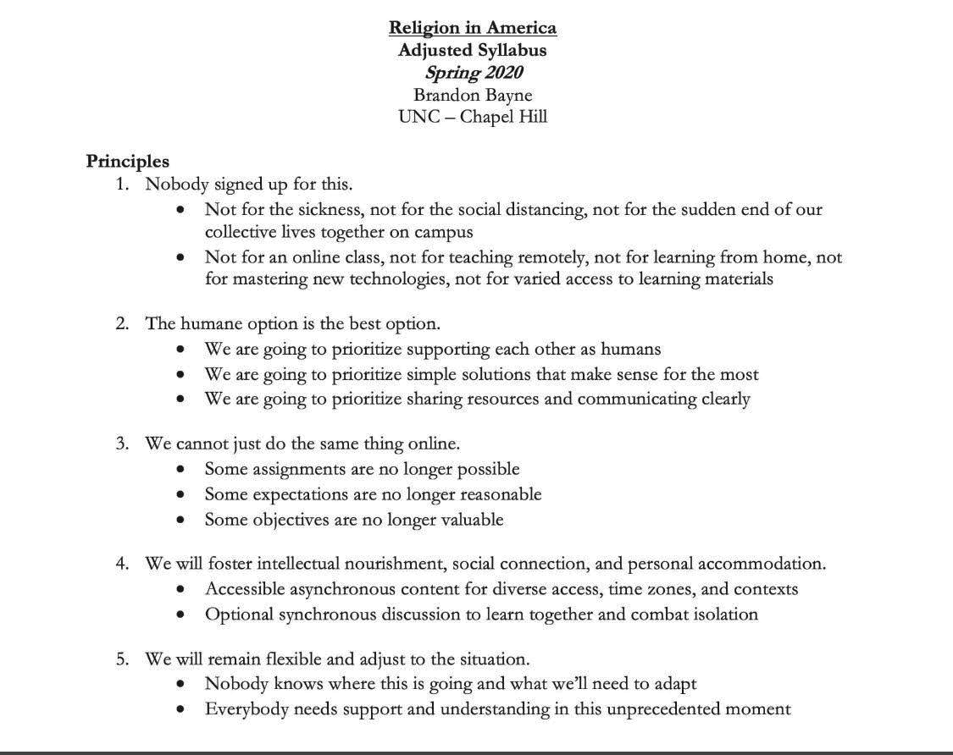

This image (right) shares a set of **principles added to a course syllabus to orient students to the unique needs of this time** for their own learning and for the organization of the course for the remainder of the semester.

Lots of academic communities are providing potential course materials connected to the COVID-19 pandemic.

* The Coursera MOOC from Public Health professors: “[Science Matters: Let's Talk About COVID-19](https://www.coursera.org/learn/covid-19)” starts today (March 15) -- it’s full, but they’ve made course materials available to all.
* This crowd-sourced document has lots of resources for online teaching/learning: <https://bit.ly/2wWMTtK>
* A crowd-sourced [#coronavirussyllabus](https://docs.google.com/document/d/1dTkJmhWQ8NcxhmjeLp6ybT1_YOPhFLx9hZ43j1S7DjE/edit) has excellent resources relevant for use in our contemporary global context.
* Librarianshave worked together to write a public statement on **copyright law’s flexibility** to legally make “materials available and accessible to students in this time of crisis”: “The fair use doctrine accommodates the flexibility required by our shared public health crisis, enabling society to function and progress while protecting human life and safety” ([Public Statement of Library Copyright Specialists: Fair Use & Emergency Remote Teaching & Research](https://docs.google.com/document/d/10baTITJbFRh7D6dHVVvfgiGP2zqaMvm0EHHZYf2cBRk/edit?fbclid=IwAR1Fz8bdqlCsW-TKyH-sNKs516rFmz-cY-P08b_eRAPVDdlHDdEJ1bKGySY#heading=h.yrwelxtxcfgr)).
* There are many, many virtual communities of practice on social media. (See later in this document for a few examples, and reach out to colleagues to find more.)
* Here’s a crowdsourced syllabus called “[Teaching COVID-19: A Collaborative Anthropology Syllabus Project](http://teachinglearninganthro.com/teaching-covid-19-an-anthropology-syllabus-project/?et_fb=1&PageSpeed=off)” through *Teaching and Learning Anthropology Journal.*
* The Modern Language Association has provide this powerful resource: *“*[Bringing Your Course Online: Resources Compiled by the Modern Language Association (MLA), March 2020](https://teachingresources.hcommons.org/)”
* And many more.

We can embrace imperfection. These are *extraordinary* times.

*“Higher Ed folks: Deep breath. It's okay: you don't have to have all the answers. You can be honest with students & tell them that you're just as sad/confused/upset as they are but--step by step--you will get through this together. They will always remember your honesty & humanity”. --* Tweet by *How Humans Learn* author [Josh Eyler](https://twitter.com/joshua_r_eyler)

Parker Palmer stated in his foundational work *The Courage to Teach* (1998, p. 17): “...a good teacher must stand where personal and public meet, dealing with the thundering flow of traffic at an intersection where ‘weaving a web of connectedness’ feels more like crossing a freeway on foot. As we try to connect ourselves and our subjects with our students, we make ourselves, as well as our subjects, vulnerable to indifference, judgment, and ridicule.” 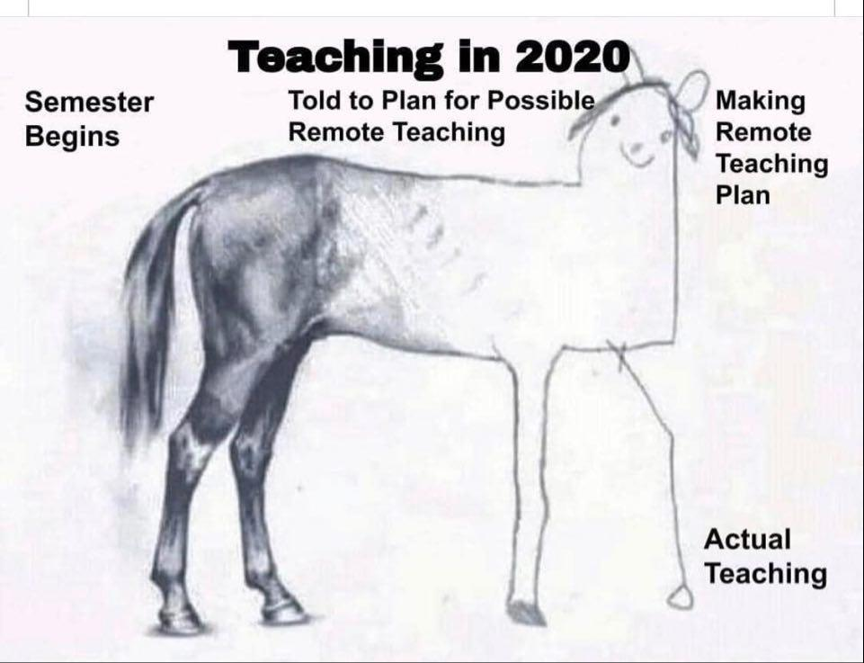

The intersection we are standing in currently in higher education is one that requires an element of **faith in our abilities to reach our students in unfamiliar ways, connecting them to content, and caring for their needs -- all at the same time.** It is important that we talk about this with our students to mediate the change process we find ourselves in.

* **Teacher self-disclosure** has been shown to increase student engagement and interest in a course, promote a willingness to communicate outside of routine course settings, and (for the current times, perhaps the most important) build positive and responsive relationships between instructors and students ([Cayanus, 2004](https://nca.tandfonline.com/doi/pdf/10.1080/1740462032000142095?needAccess=true)). In online classes, research suggests that the positive impacts of teacher self-disclosure is stronger than in traditional course environments ([Song, Kim, & Luo, 2016](https://www.sciencedirect.com/science/article/pii/S0747563215300480)). **Sharing with students that things will be a little messy as the new normal emerges is not shameful. In fact, it just might be helpful.**

There is a [survey being circulated at Indiana U](https://www.change.org/p/president-michael-a-mcrobbie-reimburse-iu-students-for-loss-of-in-person-instruction-and-use-of-campus?recruiter=906499572&recruited_by_id=4e2307e0-d316-11e8-bcb4-ff714def5ca9&utm_source=share_petition&utm_medium=copylink&utm_campaign=psf_combo_share_initial&utm_term=psf_combo_share_abi) by students asking for a tuition refund because online education is “substandard” to in-person. There may be room in this conversation to acknowledge that while imperfect, all teaching really is. And, while there's a learning curve in “remote teaching,” **course instructors are well-equipped as content experts and have access to plenty of research-supported resources to help make sure student learning is prioritized. This can and should be made clear to students.**

We should stay flexible, and focus on what’s important.

Mind the cognitive load.

“Such events affect students’ cognitive load, as ‘working memory capacity is reduced immediately following an acutely stressful experience’ ([Huston & DiPietro, 2007](https://podnetwork.org/content/uploads/In_the_Eye.pdf), p. 218; [Ambrose et al, 2010](https://www.wiley.com/en-us/How+Learning+Works%3A+Seven+Research+Based+Principles+for+Smart+Teaching-p-9780470484104), p. 103+; [Cavanaugh, 2016](https://wvupressonline.com/node/642); [Eyler, 2018, ch. 3](https://wvupressonline.com/node/758)). This awareness may lead you to be **lenient with due dates** or adapt your syllabus for the week following the crisis to accommodate a **reduced workload**, both in terms of introducing new concepts and expecting students to exercise typical study habits. **Holding a review session** for material covered during the crisis may also be helpful.” (Chick, “[Teaching in Times of Crisis](https://cft.vanderbilt.edu/guides-sub-pages/crisis/)”)

“Covering content” is something talked about in higher education with regularity. Scholars have long been encouraging us to think not of “coverage” (cramming in as much content as possible) but instead of “uncoverage,” or **focusing on the essential questions and ways of thinking that we want to *endure*** (Wiggins & McTighe, [1998](https://www.worldcat.org/title/understanding-by-design/oclc/39539420), [2005](http://www.ascd.org/Publications/Books/Overview/Understanding-by-Design-Expanded-2nd-Edition.aspx); [Calder, 2006](http://www.indiana.edu/~tchsotl/part3/calder%20uncoverage_files/ContentServer_data/20248906.pdf)). Given the abrupt pivot many course instructors are making to their course delivery and design, it may be time to focus on “uncoverage”:

* **What do you want your students to remember about your course five years from now?** Look at your course calendar. Identify the MOST necessary skills/competencies your students need to know. Prioritize those. Consider the best ways to teach those skills/competencies well.
* **Change your syllabus in response to your reprioritization and explain WHY you’ve made changes to your students**. They will appreciate that type of transparency.

Nicki Monahan illustrates this process in her blog post, “[More Content Doesn’t Equal Learning](https://www.facultyfocus.com/articles/effective-teaching-strategies/more-content-doesnt-equal-more-learning/).”

We should highlight what’s being done to help, and give students a way to help, a sense of agency.

*Teach hope. Mitigate any sense of helplessness.*

We know the importance--even in ‘normal’ times--of **teaching a sense of hope**. Two fantastic books are the following: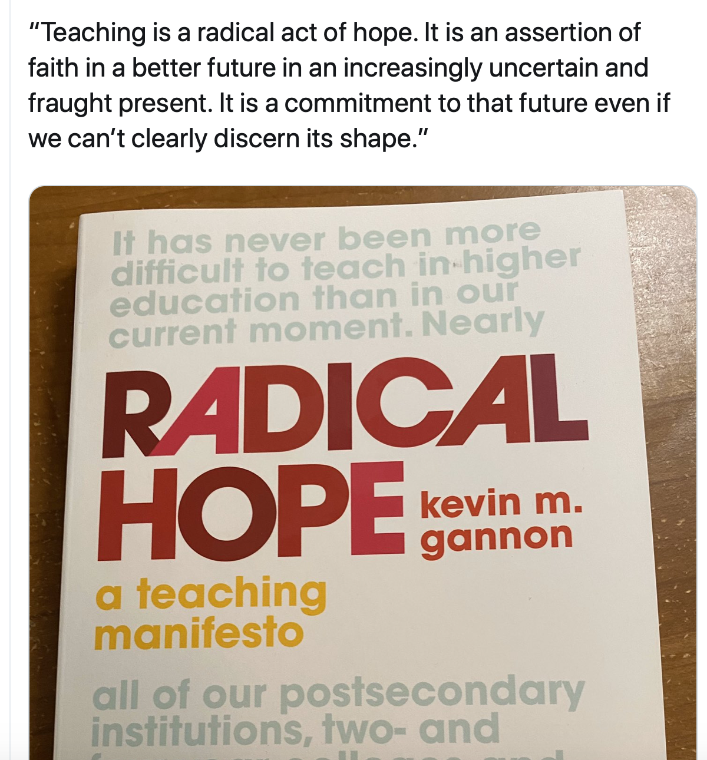

* + - * Rebecca Solnit’s *Hope in the Dark: Untold Histories, Wild Possibilities* (2016)
      * Kevin Gannon’s new book [*Radical Hope: A Teaching Manifesto*](https://wvupressonline.com/node/823) (2020) -- see image and quote to the right.

We know, for instance, that many seniors are **worried that they won’t graduate**. We’re hearing from many, many colleges and universities that they’re committed to ensuring that the seniors who finish the semester *will graduate*.

* Mays Imad’s “[Hope Matters](https://www.insidehighered.com/advice/2020/03/17/10-strategies-support-students-and-help-them-learn-during-coronavirus-crisis?utm_source=Inside+Higher+Ed&utm_campaign=7cbfbb6184-DNU_2019_COPY_02&utm_medium=email&utm_term=0_1fcbc04421-7cbfbb6184-198582105&mc_cid=7cbfbb6184&mc_eid=273b10a011)” article offers 10 specific strategies for giving students hope, including using language that’s optimistic and forward-looking, like “When you graduate…” or “when you come back this fall.”

Hope comes also by **looking to the helpers**, by noticing the outpouring of community and good will and action.

* + - Fred Rogers famously talked about his mother’s advice during a tragedy to “[Always look for the helpers.](https://www.youtube.com/watch?v=-LGHtc_D328)"
    - Notice the **heightened humanity, kindness, community** (e.g., [#COVIDkindness](https://twitter.com/hashtag/covidkindness?ref_src=twsrc%5Egoogle%7Ctwcamp%5Eserp%7Ctwgr%5Ehashtag) on Twitter).

Hope also comes by empowering the students, helping them develop **a sense of agency**.

* Mitigate “learned helplessness,” potential sense of apathy resulting from being overwhelmed when learning (or hearing) about large-scale societal or environmental problems.
  + We know from research on teaching about climate change ([Salomon & Tannenbaum, 2017](http://wrap.warwick.ac.uk/83331/19/WRAP-climate-change-helplessness-individual-energy-behavior-Preston-2017.pdf)) and gender and racial inequality (Tatum, [1992](https://pdfs.semanticscholar.org/2fe7/9d71cf23f777978cfad561f3748ba5fff8c8.pdf), [1994](https://psycnet.apa.org/record/1995-03559-001); [Chick, Kernahan, & Karis, 2009](https://digitalcommons.georgiasouthern.edu/ij-sotl/vol3/iss1/16/); [Kernahan, 2019](https://wvupressonline.com/node/802)) that **if we don’t include examples of how individuals can actually make a difference, student motivation and sense of efficacy--the sense that their “actions will have meaningful effects”--suffer.**
* ... **identify or even facilitate a way to help those most affected by the crisis**, such as collecting money, donating goods, volunteering to help at the crisis site, or other ways of supporting rescue and relief efforts. Such “problem-focused coping” is among the most helpful responses identified by students and one explanation for the “lower levels of long-term stress” among people “indirectly affected” by 9/11 (Huston & DiPietro, 2007, p. 216-218).
  + Opportunities for help right now will vary by community in terms of need and situation. Many communities will have restrictions on what individuals can do. **Look to local authorities for guidance on where help might be** (e.g., donations to school/campus/community food banks, purchasing gift cards online from shuttered local businesses).

### **We have support**--if not locally, then globally.

Many campuses have teaching and learning centers with faculty/educational/academic developers, instructional designers, educational technologists, and other colleagues who are a key part of the institutional support for teaching and student learning. These colleagues draw from the research and research-based principles to support teaching and learning in their institutions.

In reflecting on his own experience when he had to move his courses into Skype/web conferencing for a week, Terence Day concludes by emphasizing the **need for this institutional support**:

*Successful implementation of an academic continuity plan requires the encouragement of strong and collegial interpersonal relations. These relations fuel willingness to confront and overcome the challenges of working in a difficult environment. Nothing can happen without goodwill and commitment on the part of faculty, students, and the people around them.* (Terence Day, “[Academic Continuity: Staying True to Teaching Values and Objectives in the Face of Course Interruptions](https://journalhosting.ucalgary.ca/index.php/TLI/article/view/57407),” 2015)

Not all campuses have such institutional support. Fortunately, the global community of stakeholders in higher education has mobilized to provide mentorship, resources, and support to guide our efforts in teaching through this crisis. Many are contributing to these public and private platforms in support of peers and students so that course instructors can meet their immediate and future remote teaching needs. A very small sampling of this unprecedented sharing is below:

*A Few of the Many Facebook Groups*

[Pandemic Pedagogy](https://www.facebook.com/groups/502137283803469/)

[Teaching College-Level Arts and Humanities in a Pandemic](https://www.facebook.com/groups/225778738614195/)

[Online School Educator Support for Science](https://www.facebook.com/groups/200443041212331/)

*Other Community Resource Sharing Sites*

[Bringing Your Course Online on Humanities Commons](https://teachingresources.hcommons.org/)

[Keep Teaching Resources for Higher Ed](https://keep-teaching-resources-for-higher-ed.mn.co/feed)

[Online Learning Collective](https://sites.google.com/view/online-learning-collective/home?authuser=0)

*A Sampling of Topical Twitter Hashtags*

#courseinterruption

#KeepTeaching

#CovidLibrary

#AcademicChatter

#coronavirussyllabus

#pandemicpedagogy

**Share this page:** [**http://bit.ly/3a3NhFz**](http://bit.ly/3a3NhFz)

|  |
| --- |
| Please see our “[Public Statement of Response to Higher Education’s Shift Temporary to Remote Instruction](https://docs.google.com/document/d/1VU7g8JKNQQDU1T6TEVSsiRvQkBfyZGNewBAwOqh4Ckc/edit?usp=sharing).”  You may also endorse it if you wish. |