COURSE NAME

TWU Online

Mar 13, 2025

# Welcome

This is the course book for **COURSE NUMBER**. This book is divided into thematic units of study to help you engage with the materials. The course resources and learning activities are designed not only to help prepare you for the course assessments, but also to give you opportunities to practice various skills.

**<Begin note-with-icon>**

Please read the full course syllabus located on the Course Home page in Moodle. It includes key information about the course schedule, assignments, and policies.

**<End note-with-icon>**

## Course Activities

Below is some key information on features you may see throughout the course.

**<Begin learning-activity>**

**Estimated Time:**

This box will prompt you to engage in course concepts by:

* Viewing resources and reflecting on your experience and/or learning.
* Checking your understanding to make sure you are ready for what follows. Ways to check your learning might include self-check quizzes or questions for discussion.

**<Begin note-with-icon>**

Working through course activities will help you to meet the learning outcomes and successfully complete your assessments.

**<End note-with-icon>**

**<End learning-activity>**

Below is an accordion.

**<Begin accordion>**

**Title:** This is an accordion. Click/tap this banner to show/hide the content.

An accordion may contain extra content such as worked examples or sample answers.

**<End accordion>**

# Text-to-Speech Support

## Text-to-Speech Support

Text-to-speech (TTS) tools are increasingly available and can enhance your learning experience by allowing you to listen to text on a webpage. These tools are especially helpful for individuals with low or no vision, as well as anyone who prefers listening while commuting, multitasking, or reinforcing understanding through audio.

If you’re interested in trying out a TTS tool, follow the instructions below based on your device and browser.

### For Microsoft Edge Users

Microsoft Edge includes a built-in **Read Aloud** feature that supports better comprehension and accessibility by letting you listen to webpage content. It’s ideal for hands-free learning or for reading along with the spoken text.

Note: *These instructions only apply if you’re using Microsoft Edge as your browser.*

#### On Desktop (Windows/macOS):

1. Open your Moodle course page using Microsoft Edge.
2. Click the **Read Aloud** icon located in the top right corner of the browser.

**<Begin dec-image>**

**Alt Text:** Find the shortcut key to Read Aloud on the top right corner.  
**Has Lightbox:** yes  
**Source Text:**   
**Source URL:**   
**Author:**   
**Author URL:**   
**Copyright:**   
**License Text:**   
**License URL:**

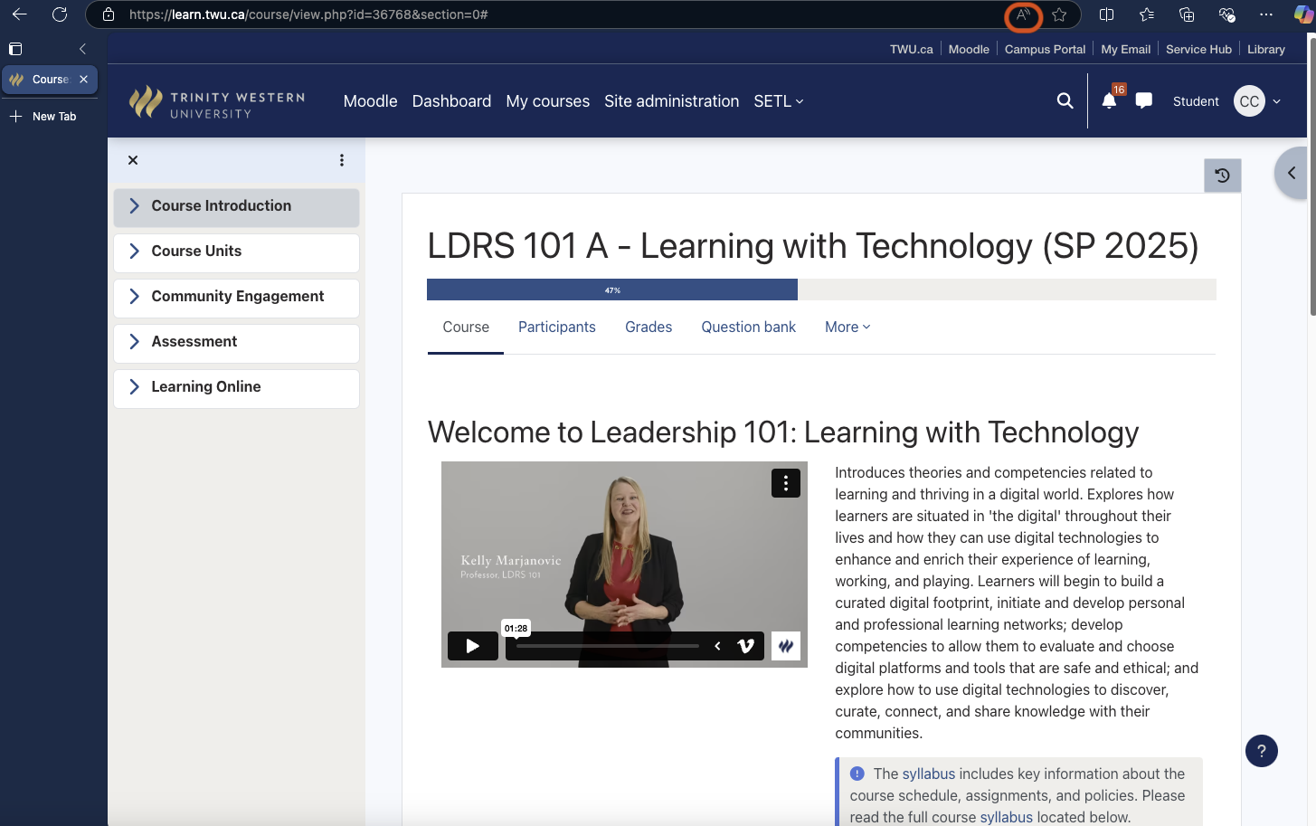

**<End dec-image>**

1. Click **Voice Options** to adjust the reading speed and voice preferences.

**<Begin dec-image>**

**Alt Text:** Voice Options  
**Has Lightbox:** yes  
**Source Text:**   
**Source URL:**   
**Author:**   
**Author URL:**   
**Copyright:**   
**License Text:**   
**License URL:**

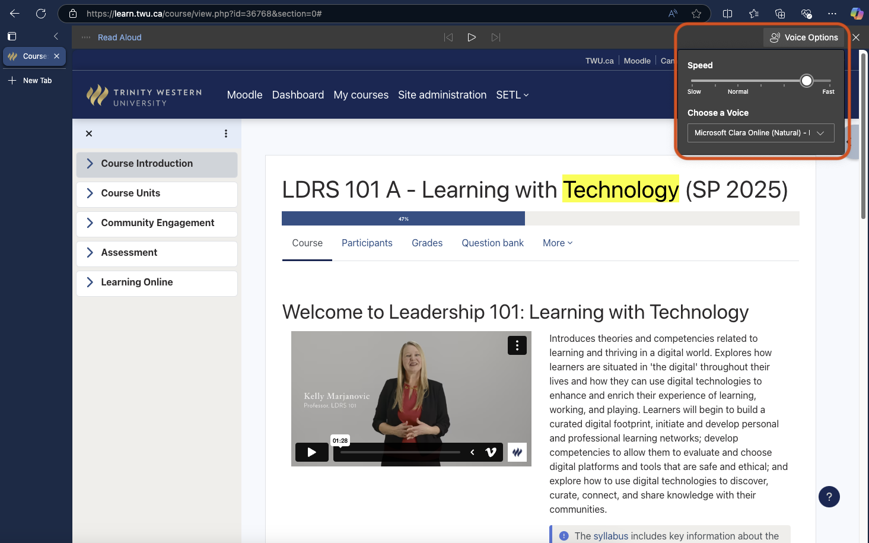

**<End dec-image>**

#### On Android Devices:

1. Install **Microsoft Edge** from the [Google Play Store](https://play.google.com/store/search?q=edge&c=apps&hl=en).
2. Open your Moodle course page in the Edge browser.

**<Begin dec-image>**

**Alt Text:** MS Edge - Android Use  
**Has Lightbox:** yes  
**Source Text:**   
**Source URL:**   
**Author:**   
**Author URL:**   
**Copyright:**   
**License Text:**   
**License URL:**

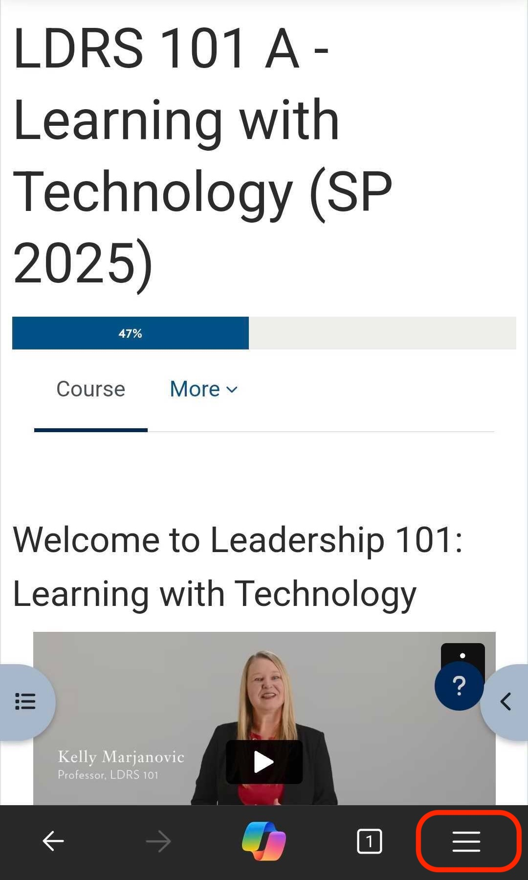

**<End dec-image>**

1. Tap the **Read Aloud** icon.

**<Begin dec-image>**

**Alt Text:** Reading Page  
**Has Lightbox:** yes  
**Source Text:**   
**Source URL:**   
**Author:**   
**Author URL:**   
**Copyright:**   
**License Text:**   
**License URL:**

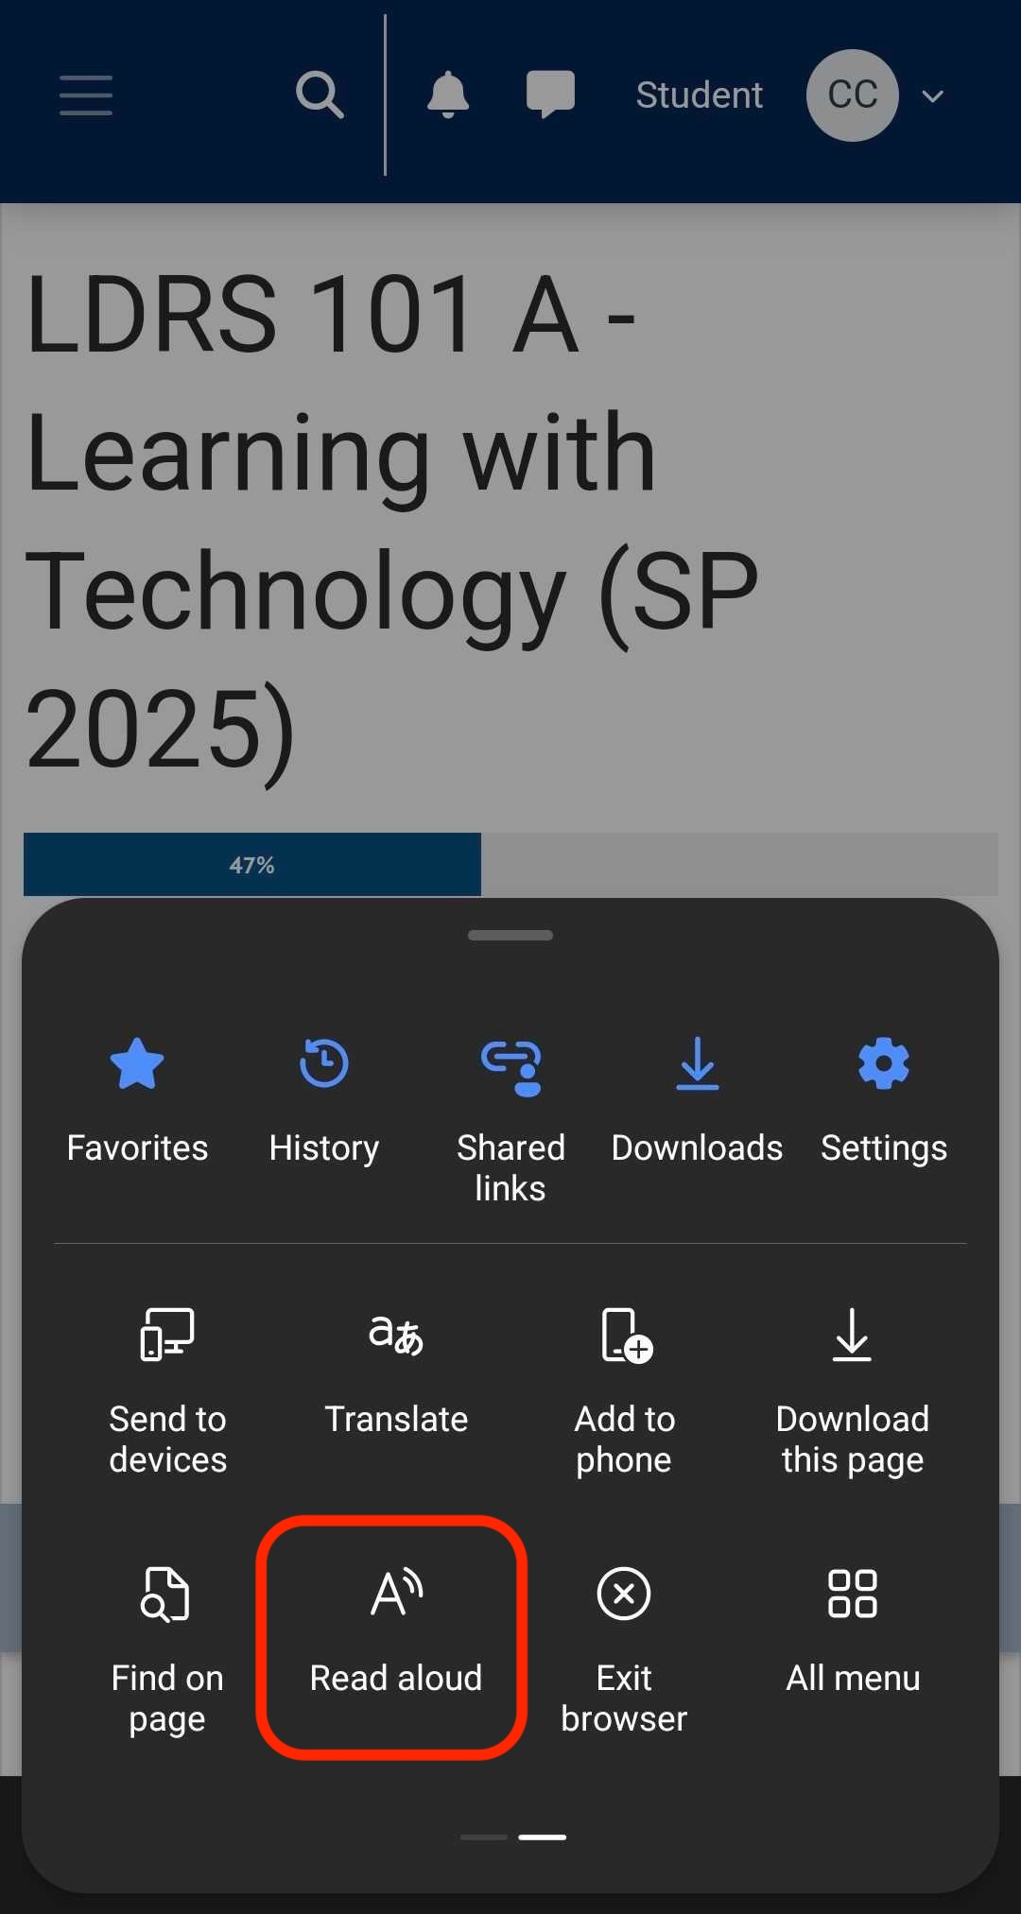

**<End dec-image>**

1. Use the top-right menu to adjust **speed**, **voice**, and other **settings**.

**<Begin dec-image>**

**Alt Text:** Adjust Speed and Voice  
**Has Lightbox:** yes  
**Source Text:**   
**Source URL:**   
**Author:**   
**Author URL:**   
**Copyright:**   
**License Text:**   
**License URL:**

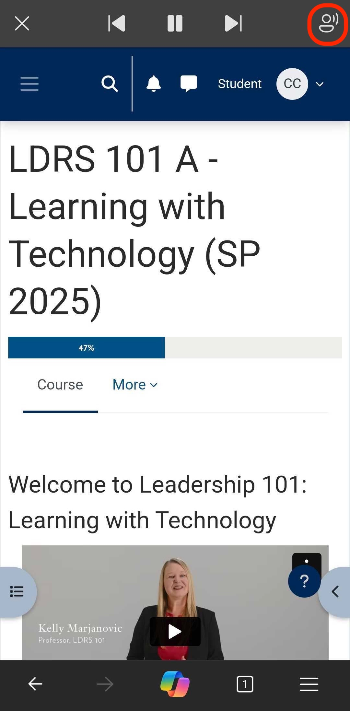

**<End dec-image>**

**<Begin dec-image>**

**Alt Text:** More Settings  
**Has Lightbox:** yes  
**Source Text:**   
**Source URL:**   
**Author:**   
**Author URL:**   
**Copyright:**   
**License Text:**   
**License URL:**

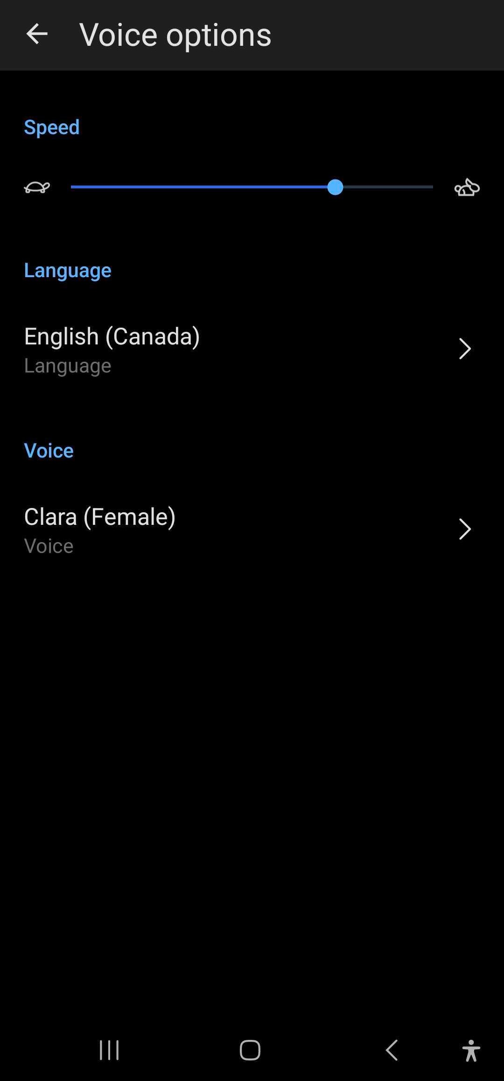

**<End dec-image>**

### For iPhone/iPad Users (Safari)

Apple devices have built-in text-to-speech support via Accessibility settings.

1. Go to **Settings > Accessibility > Spoken Content**.

**<Begin dec-image>**

**Alt Text:** iOS Settings - Accessibility  
**Has Lightbox:** yes  
**Source Text:**   
**Source URL:**   
**Author:**   
**Author URL:**   
**Copyright:**   
**License Text:**   
**License URL:**

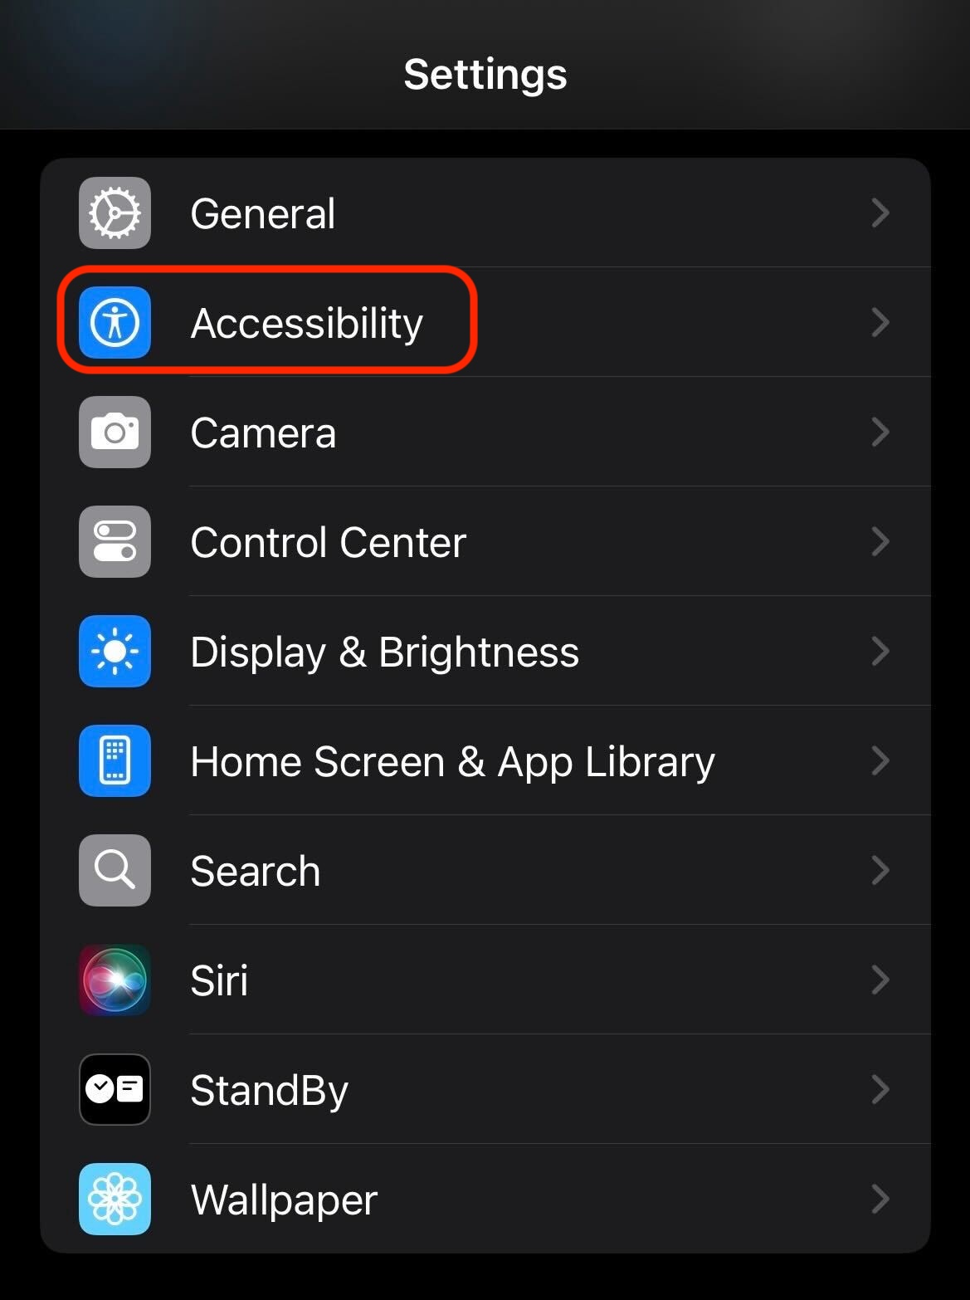

**<End dec-image>**

**<Begin dec-image>**

**Alt Text:** iOS Settings - Spoken Content  
**Has Lightbox:** yes  
**Source Text:**   
**Source URL:**   
**Author:**   
**Author URL:**   
**Copyright:**   
**License Text:**   
**License URL:**

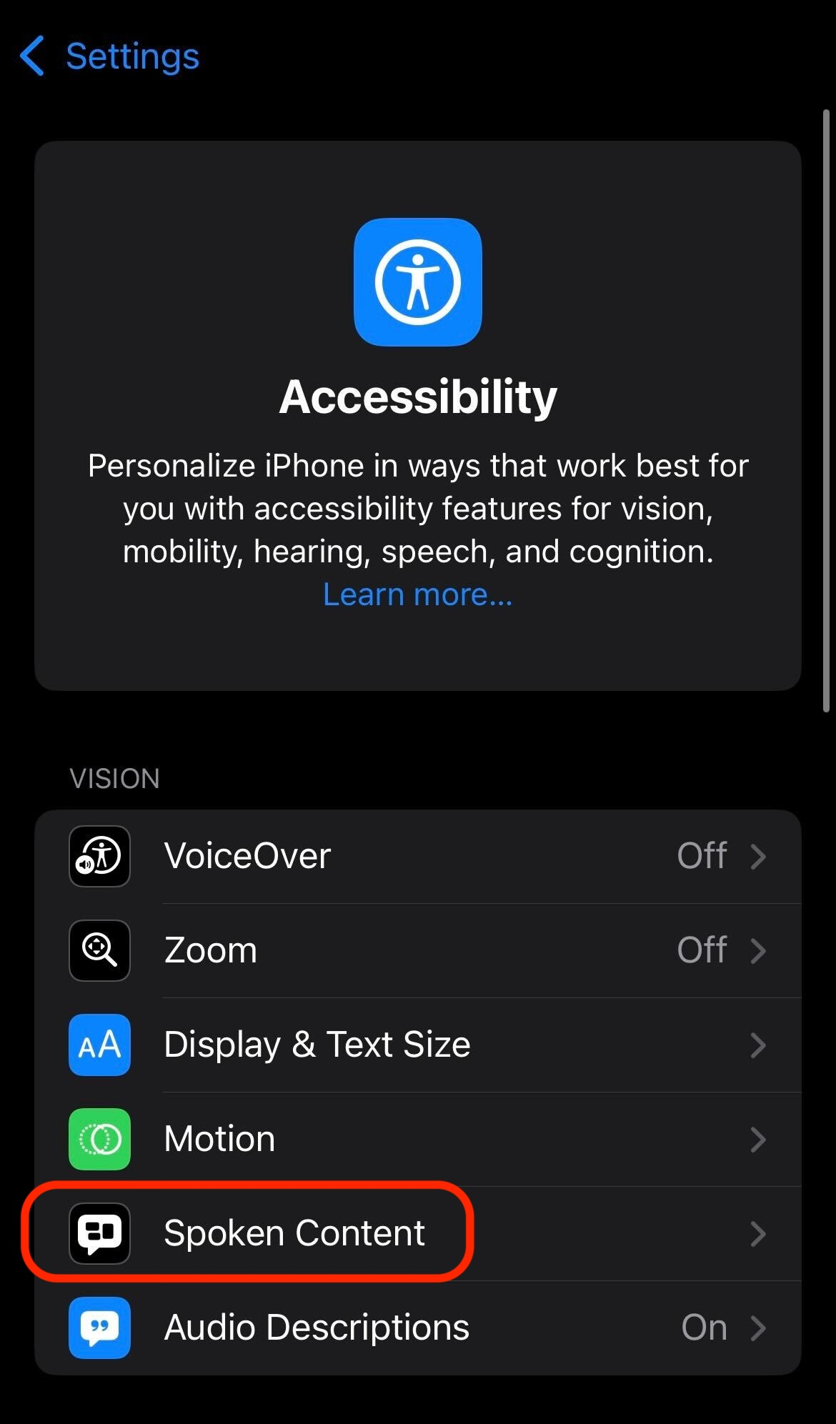

**<End dec-image>**

1. Turn on **Speak Selection** and/or **Speak Screen**.

**<Begin dec-image>**

**Alt Text:** iOS Settings - Speak Selection  
**Has Lightbox:** yes  
**Source Text:**   
**Source URL:**   
**Author:**   
**Author URL:**   
**Copyright:**   
**License Text:**   
**License URL:**

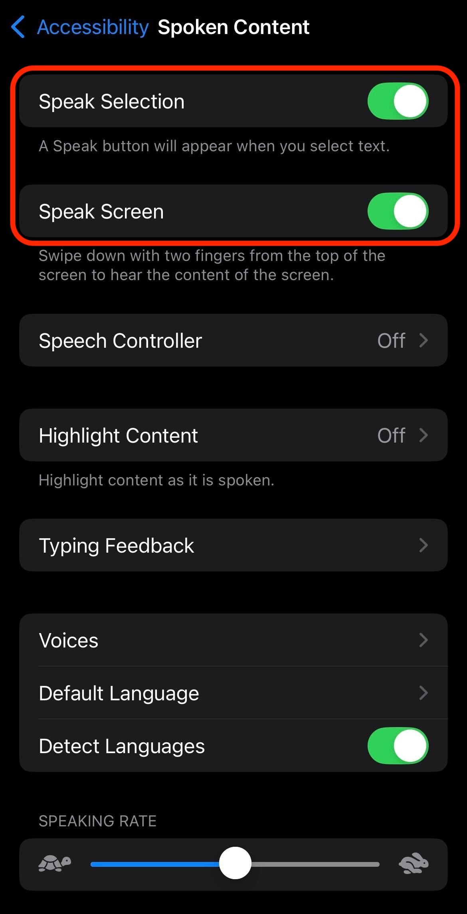

**<End dec-image>**

1. Open your Moodle course page in Safari.
2. To use:
   * **Speak Selection**: Select text and tap Speak.

* **<Begin dec-image>**
* **Alt Text:** Speak Button  
  **Has Lightbox:** yes  
  **Source Text:**   
  **Source URL:**   
  **Author:**   
  **Author URL:**   
  **Copyright:**   
  **License Text:**   
  **License URL:**
* 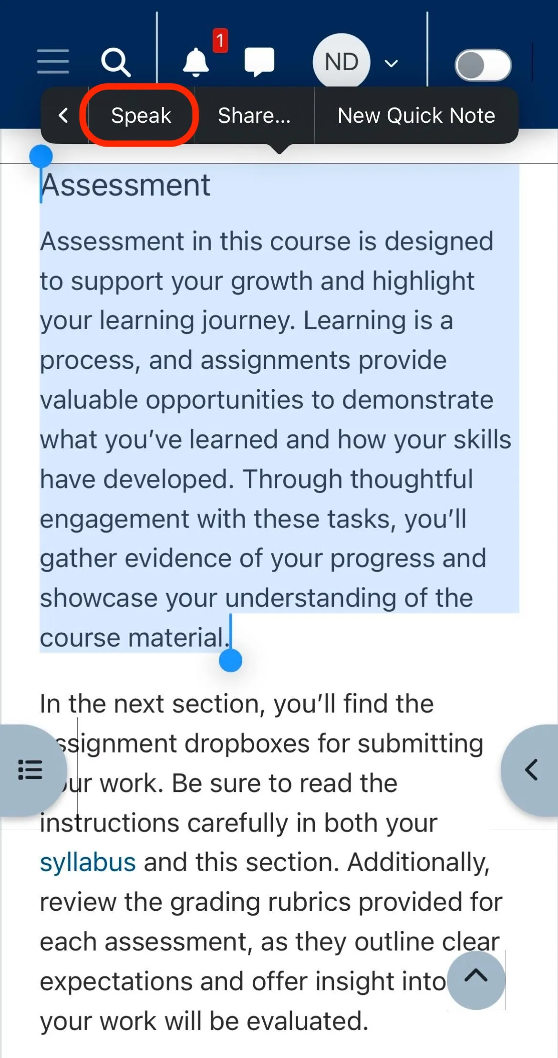
* **<End dec-image>**
  + **Speak Screen**: Swipe down with two fingers from the top of the screen to have the full screen read aloud.
* **<Begin dec-image>**
* **Alt Text:** Swipe Down  
  **Has Lightbox:** yes  
  **Source Text:**   
  **Source URL:**   
  **Author:**   
  **Author URL:**   
  **Copyright:**   
  **License Text:**   
  **License URL:**
* 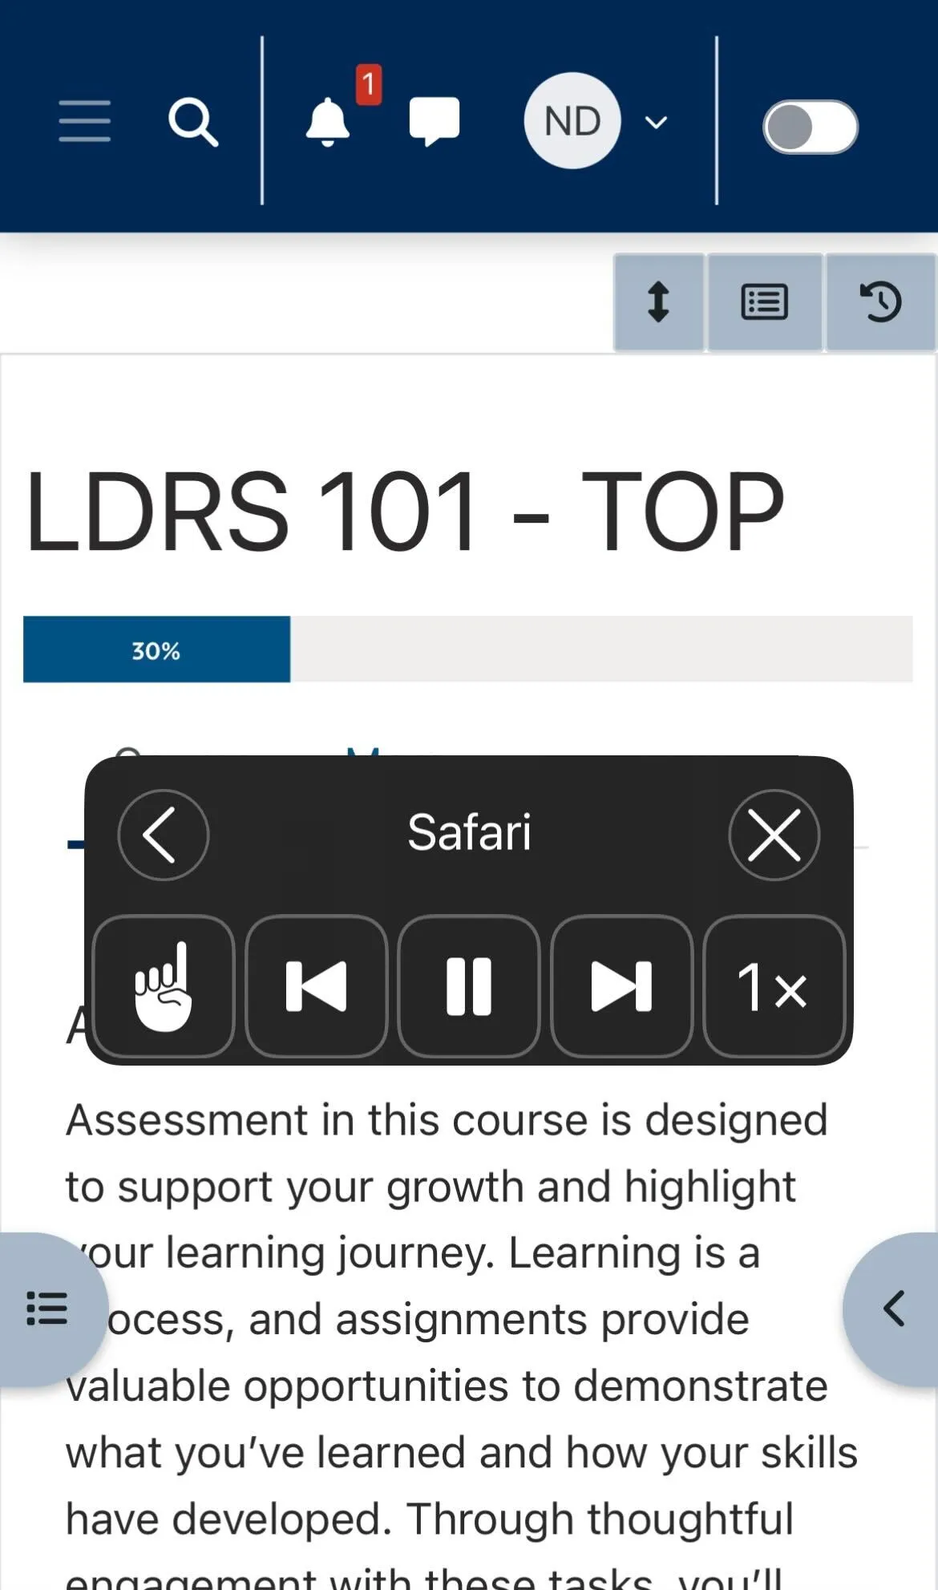
* **<End dec-image>**

**<Begin note-with-icon>**

If you want information on another tool, please reach out to [elearning@twu.ca](mailto:elearning@twu.ca).

**<End note-with-icon>**

# Community Engagment

**<Begin dec-image>**

**Alt Text:**   
**Has Lightbox:** no  
**Source Text:**   
**Source URL:**   
**Author:**   
**Author URL:**   
**Copyright:**   
**License Text:**   
**License URL:**



**<End dec-image>**

## Engage With Your Community

Community is key to learning at TWU, even in online courses. Connecting with others enhances your experience, provides support, and fosters a sense of belonging.

**The Learning Community (Discourse)** is TWU Online’s discussion platform where you can:

* Connect with fellow students, ask course-related questions, and share insights.
* Participate in course, program, and university-wide discussions.
* Engage with **Global Educational Facilitators** for resources, study skills, and live support.

**Ways to Connect:**

* **Online Discussions** – Join course forums, seek advice, and collaborate.
* **Instructor Interaction** – Check Discourse for updates, ask questions, and get feedback.
* **University Events & Workshops** – See information for upcoming virtual events, webinars, and interest groups.
* **Virtual Study Groups** – Form or join study groups using MS Teams.

Take the initiative to connect, learn, and grow—your engagement will enrich your academic journey and help build lasting relationships.

## Community Links

Click the link below to go to the Learning Community on Discourse.

   Learning Community