Colin Madland and Kelly Marjanovic
Oct 31, 2025

1. Connecting Ideas for Learning

Overview
Welcome to our third unit in Learning with Technology, where we explore the symbiotic relationship between technology and knowledge synthesis. In this unit we will unravel the intricacies of sense-making through hyperlinks and tags, discovering their pivotal roles in creating a cohesive web of information. You will delve into the transformative realm of digital note taking, learning how to capture, organize, and review key ideas efficiently. As we progress we will unlock the potential of visual representations through concept maps, using digital tools to illustrate complex relationships and hierarchies that foster a deeper understanding of interconnected ideas. Moreover, we’ll venture into a curated selection of digital tools designed to support and augment the learning process, evaluating their benefits in catering to diverse learning styles and preferences. By the conclusion of this unit you will not only have mastered the art of connecting ideas through hyperlinks, tags, note taking, and concept maps, but you will also be equipped with a toolkit of digital resources to enrich your learning journey.

Topics
This unit is divided into the following topics:
- Sense-making Through Hyperlinks
- Sense-making Through Tags
- Note Taking
- Concept Maps
- Digital Tools to Support Learning

Unit Learning Outcomes
When you have completed this unit you will be able to:
- Use hyperlinks and tags to create meaningful connections between ideas and enhance knowledge synthesis.
- Apply digital note-taking strategies to capture, organize, and review key concepts effectively.
- Create concept maps to visually represent complex relationships and deepen understanding of interconnected ideas.
- Evaluate digital tools for their effectiveness in supporting diverse learning styles and knowledge organization.
- Develop a structured workflow that integrates linking, tagging, note-taking, and visualization techniques to enhance learning.

Learning Activities
Here is a list of learning activities that will benefit you in completing this unit. You may find it useful for planning your work.
<Begin learning-activity>
Estimated Time:
- Practice using links and tags to connect your ideas in Obsidian
- Write a reflective post on your learning experiences
- Practice various note taking skills
- Create a mind map to connect and engage with ideas in Units 1-3
<Begin note>
Note:Working through unit learning activities will help you to meet the course learning outcomes and successfully complete your assessments.
<End note>
<End learning-activity>

Assessment
See the Assessment section in Moodle for assignment details.

Resources
- All resources will be provided online in the unit.

1.1 Sense-making Through Hyperlinks
In higher education, your task is to build on the skills you bring from your previous experience and apply those skills in a much more focused field of study. Previously, you might have been able to succeed in school by having a great memory, but increasingly, you will be asked to do much more. You will be required to understand the theoretical basis of ideas (analysis) and also make connections between ideas to create new ideas (synthesis). This may feel challenging at first, but you will learn.
One of the challenges is that there is simply far too much information for you to analyze for any task that you might need to do for an instructor. In a previous unit, you learned some basic skills in finding and managing resources that you will need and in this unit, you will learn some ways to begin to analyze and synthesize information and documents in a systematic way.
If you learn this workflow well and learn how to customize it to your needs (that’s synthesis), you will be ahead of the game when it comes time to complete papers in other courses.
The key to this component of your workflow is the lowly hyperlink (2025). You’ll know that if you click or tap that highlighted word you will be taken to another website, in this case, the Wikipedia article on hyperlinks. That is a hyperlink and it is the most basic unit of the entire internet, which is simply a massive collection of documents all linked together. At its most basic form, a hyperlink is simply a connection between two documents where a hyperlink in one document allows you to open the second document.
In this workflow instead of just linking two documents together you will link two ideas together (by linking documents). Your Obsidian vault is essentially a website that is only accessible on your computer; instead of links going to documents on other servers, you link to documents within the vault (although you can still link to the web).

Linking in Obsidian
There are two methods of building hyperlinks in Obsidian: Wikilinks and markdown links, and we will cover both here.

Wikilinks
A Wikilink, the default in Obsidian, is really simple to build. All you have to do is type two opening square brackets, like this [[, and Obsidian will do a couple things automatically. First, Obsidian will create the closing brackets to match, so you end up with this [[]], with your cursor in the middle, and second, Obsidian will present a list of all the pages in your vault, from which you can choose the page you want linked.
<Begin figure>
Figure ID: #fig-wikilink
Caption: Screenshot, Create a Wikilink in Obsidian
Columns:
<Begin dec-image>
Alt Text: Screenshot, how to create a Wikilink in Obsidian
Has Lightbox: yes
Source Text:
Source URL:
Author:
Author URL:
Copyright:
License Text:
License URL:
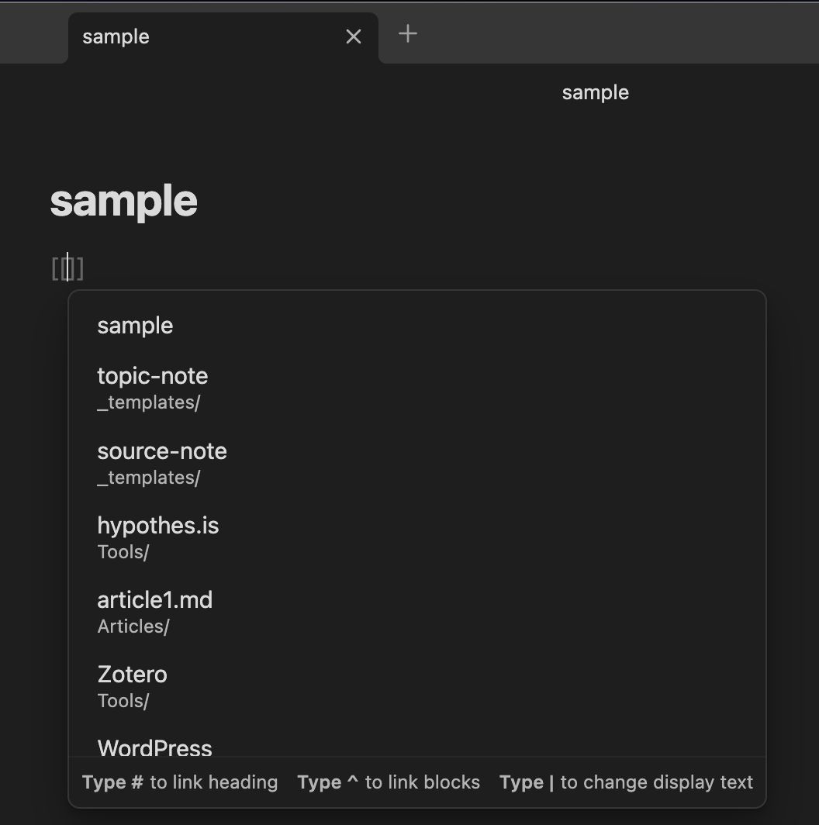
<End dec-image>
<End figure>
Once you choose a page (in this case, article1.md), Obsidian will do the rest, and you will end up with this view:
<Begin figure>
Figure ID: #fig-wikilink2
Caption: Screenshot, Wikilink Created in Obsidian
Columns:
<Begin dec-image>
Alt Text:
Has Lightbox: no
Source Text:
Source URL:
Author:
Author URL:
Copyright:
License Text:
License URL:
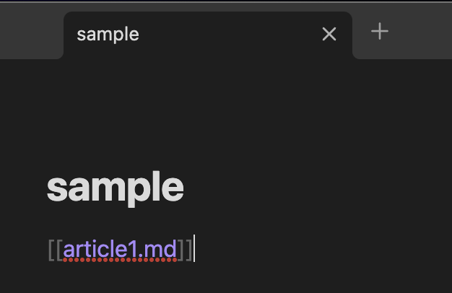{fig-alt=“Screenshot showing Wikilink”article1.md” created in Obsidian” .lightbox fig-align=“left” width=“300”}
<End dec-image>
<End figure>
Wikilinks are the simplest way to link files that are inside your vault. By pressing and holding the “Command” (macOS) or “CTRL” (Windows) button on the keyboard and then hovering over the link you’ve created, you will get a preview of the linked page. If you press and hold the “Command” (macOS) or “CTRL” (Windows) button on the keyboard and then click the link, you will be taken to the page. Once on the linked page, you can scroll to the bottom of the page and see “Backlinks” (a link back to the original page). If you don’t see backlinks, click the three dots in the top right corner of the page and choose “Backlinks in document.”

Markdown Links
While Wikilinks are the default in Obsidian and are the easiest way to link within your vault, sometimes you might want to link to a site on the web. The syntax for a markdown link is a bit different but is still very simple. There are two parts you need to remember:
- the link text (this is what you want your reader to see on your page)
- the link URL (this is the web address of the site you want them to visit)
Here is the syntax: [Link text between single square brackets](URL inside parentheses){target="_blank"} So if you want someone to see the word “YouTube” on the page and for them to be taken to the YouTube website when they click the link, the syntax would be [YouTube](https://youtube.com){target="_blank"} which will display like this: YouTube. Notice that there are no spaces between the closing square bracket and the opening parenthesis.

Why Link?
Creating links to other related topics in your notes is a way that you can start to build connections in your mind about how different ideas are related. For example, if you are studying “trees,” you might want to link over to the previous notes that you created on “plants,” “forests,” or “climate change.” During your study on trees, you might want to create notes on “deciduous” and “coniferous” trees, or “xylem” and “phloem” and link those articles to “trees.” By continually linking notes that are related you are creating a web of your knowledge as well as reminders of how ideas are related. Linking is a way for you to make sense of the information that is coming into your consciousness.
Once you have created links between different files in your vault you can visualize these links using the “Graph View” in Obsidian. Here is part of the graph view for a major paper. Each of the white dots represents a file in the vault, and their size is relative to the number of pages linked to that article. You can see that there are three really big pages that have many links. Those are clearly very important pages.
<Begin figure>
Figure ID: #fig-graph2
Caption: Screenshot, Graph View for Linked Documents in Obsidian
Columns:
<Begin dec-image>
Alt Text: Screenshot, graph view of linked documents in Obsidian
Has Lightbox: yes
Source Text:
Source URL:
Author:
Author URL:
Copyright:
License Text:
License URL:
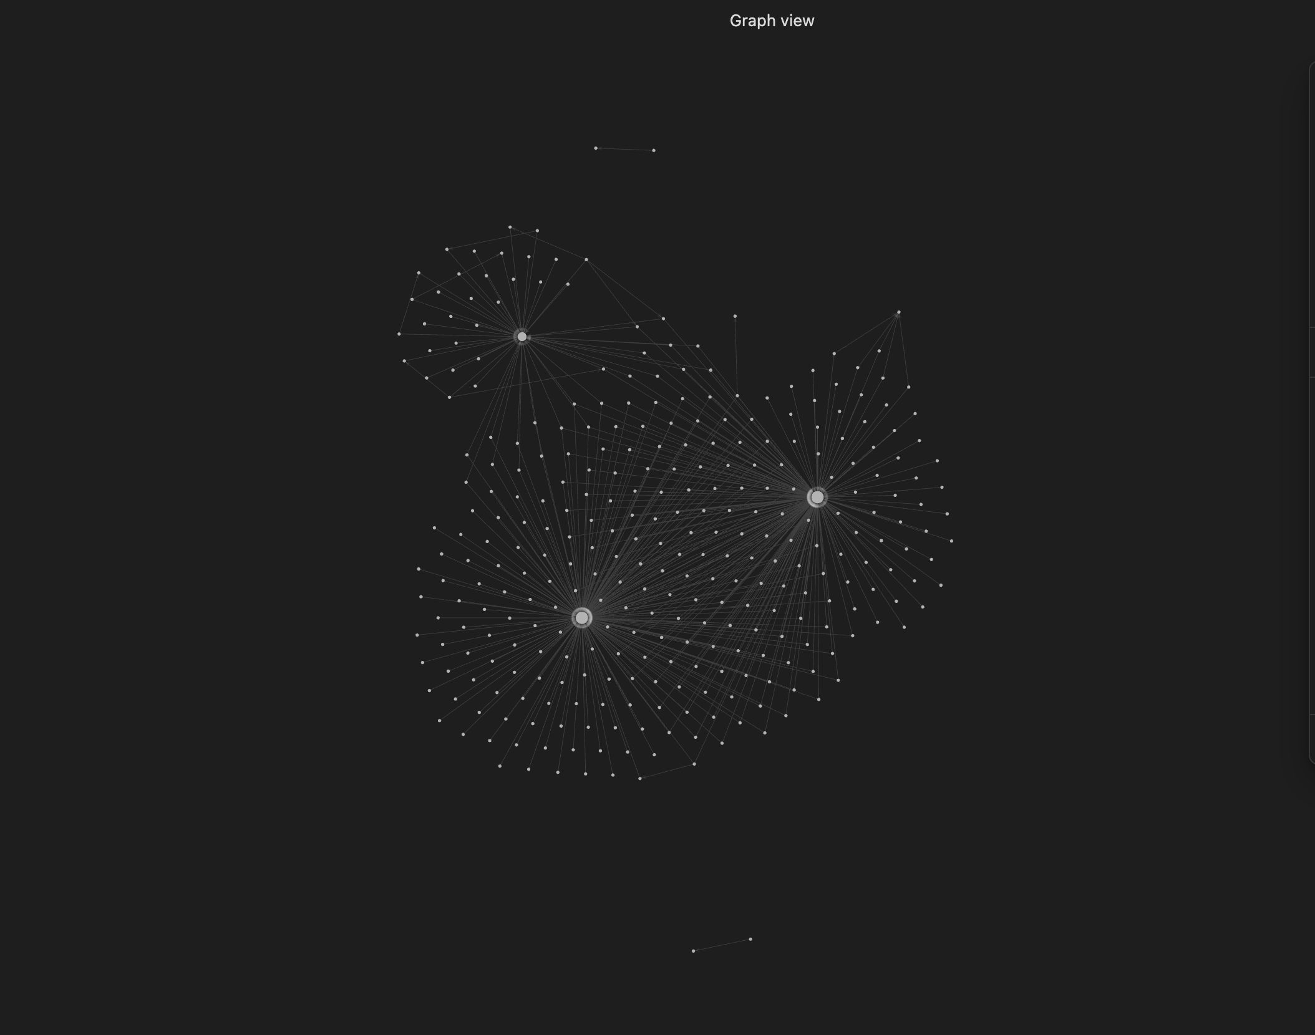
<End dec-image>
<End figure>

1.1.1 Activity: Link, Connect, and Reflect
<Begin learning-activity>
Estimated Time: 30 minutes
- Follow the directions above to add notes to Obsidian on a topic of interest. Search online for interesting articles and videos you want to add to your notes and practice adding them using Wikilinks and markdown links. Locate the graph view in Obsidian to see the connections between the ideas you’ve added.
- After spending some time practicing this new skill, write a reflective journal entry on the process you followed and what your experience was like. What did you struggle with? How did you troubleshoot? What are the advantages of organizing your notes using this method?
Feel free to discuss your experience on the Learning Community in Learning Community. You can also post any questions you have about this process and get technical support from your instructors and facilitators.
<End learning-activity>

1.2 Sense-making Through Tags
A tag is a very short, descriptive word or phrase you can apply to an idea. You are likely familiar with the idea of a hashtag (#) from various social media apps as a way to quickly find information on a specific topic. A tag in Obsidian works just like a hashtag in social media. If you type #trees on a file about trees, and then do the same on your pages about xylem, phloem, climate change, plants, forests, deciduous, and coniferous, you could click that tag on any one of those pages, and Obsidian will find every page that contains that tag.
This acts like a super-fast search of your notes for a particular topic or ideas related to a topic.
We recommend that you put your tags in the same spot on each page so you know where to find them. You can also put those tags at any place in your notes and Obsidian will show you the specific spot in your notes where the tag lives.
You can also show tags in your graph view, as below. Green dots are tags and white dots are files (as before). You can see in this image that there are many more connections.
<Begin figure>
Figure ID: #fig-graph1
Caption: Screenshot, Graph View in Obsidian Including Files (White Dots) and Tags (Green Dots)
Columns:
<Begin dec-image>
Alt Text: Screenshot, Graph view including files (white dots) and tags (green dots) in Obsidian
Has Lightbox: yes
Source Text:
Source URL:
Author:
Author URL:
Copyright:
License Text:
License URL:
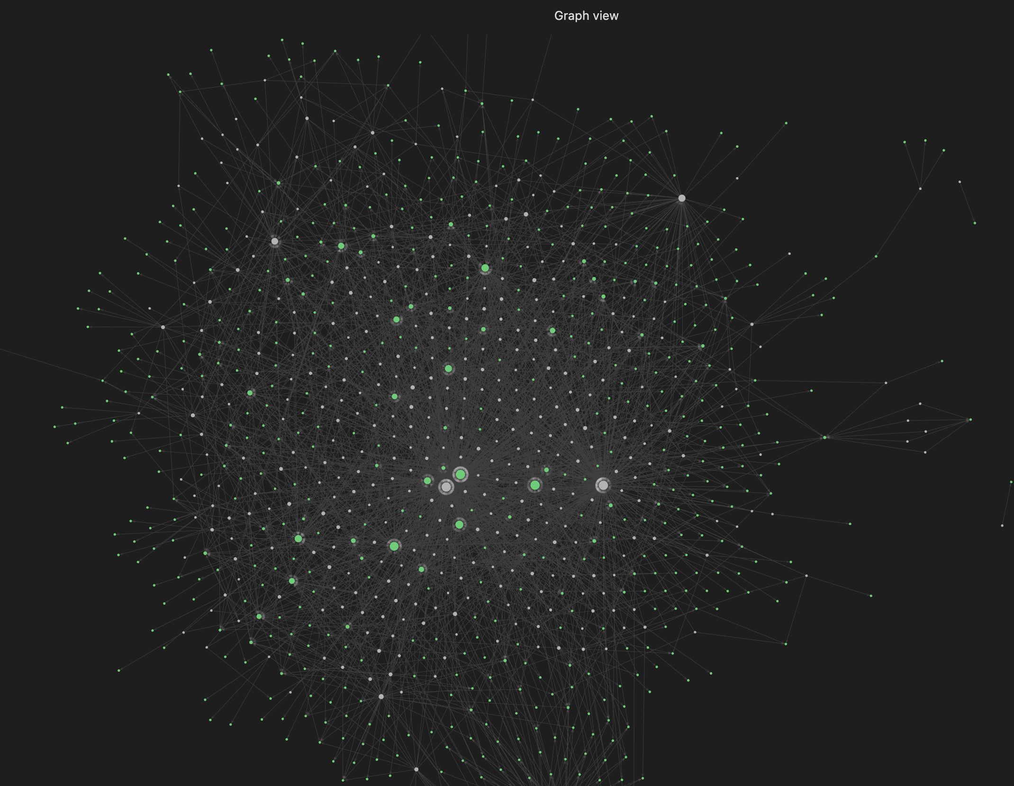
<End dec-image>
<End figure>
You can click any of the tags in Obsidian to see highlighted connections and search results for that tag, allowing you to go directly to notes of interest.
<Begin figure>
Figure ID: #fig-graph3
Caption: Screenshot, Graph View in Obsidian With Tag Expanded to Show Additional Information
Columns:
<Begin dec-image>
Alt Text: screenshot, graph view with tag expanded in Obsidian
Has Lightbox: yes
Source Text:
Source URL:
Author:
Author URL:
Copyright:
License Text:
License URL:
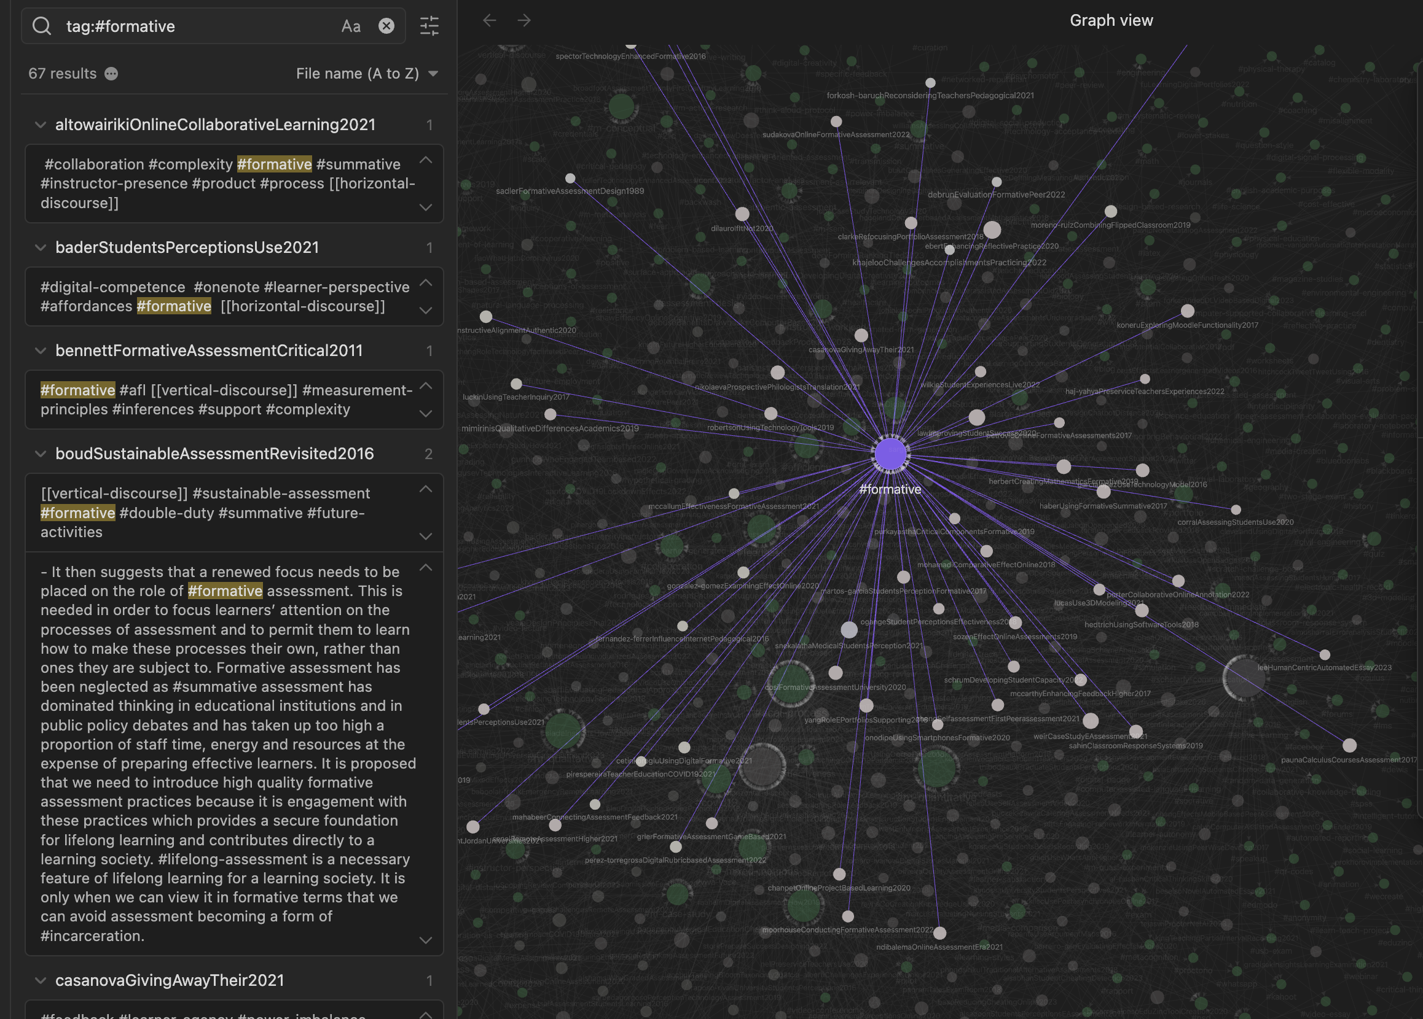
<End dec-image>
<End figure>
Using links and tags together you can build a very powerful and easily searchable vault of all the ideas in your courses. This can be incredibly valuable when it is time to write a paper or prepare for an exam—you can have all your notes easily accessible rather than having to search through pages and pages of handwritten notes.

1.2.1 Activity: Tag, Link, Connect, and Reflect
<Begin learning-activity>
Estimated Time: 30 minutes
- Follow the directions above to add tags to your notes in Obsidian. Again, spend some time on this. The more you practice, the easier the process will be. More than that, as you continue to use tags and links, you will be able to experience the advantages of connecting your ideas using this method.
- Add to your Reflective Journal your thoughts and experience on using tags. What were your struggles or “ah-ha” moments? What questions do you have?
Remember to reach out for support on the Learning Community in Learning Community.
<End learning-activity>

1.3 Sense-making Through Concept Maps
As you saw at the beginning of this unit, sense-making is the work of learning. There is no way around the work of learning because learning is work. It takes time and cognitive effort. As much as we wish to be able to “learn” like Neo in The Matrix, we can’t (see a favourite scene in a movie, below; and it’s not just because Keanu Reeves is the GOAT 🐐).
- Watch The Matrix - ‘I Know Kung Fu’ (2019, February 8)
https://www.youtube-nocookie.com/embed/0YhJxJZOWBw
Tags and links in Obsidian can be visualized using graph view, but as this is an algorithmically generated map of the connections between ideas and files in your vault, there is little you can do to customize it. Fortunately, Obsidian also features a tool called the Canvas, which is a blank space that you can use to manually connect ideas in a visual format, allowing you to see connections and relationships that make sense to you. The following video is a brief explanation of how to use the Canvas in Obsidian.

1.3.1 Activity: Obsidian Concept Map
<Begin learning-activity>
Estimated Time: 30 minutes
- Watch Mind Mapping in Obsidian Canvas (2023, January 7). As you watch, follow the directions and to create a concept map in Obsidian. At the end of this unit, you will create a concept map for Units 1-3. Practice using notes, media, cards, and grouping features in a mind map.
https://www.youtube-nocookie.com/embed/eHI-Szjpafk
<End learning-activity>

1.4 Reading and Note Taking
Next, let’s focus on reading and note taking. In this section, you will demonstrate your note taking skills based on reading an academic publication. You will also have the opportunity to practice using the Markdown markup language. Semantic markup is an important digital skill that separates formatting (e.g., headings, bold, italics, lists) from content, using designated characters without the use of rich text editors. This provides the capability to use plain text files that can be converted to formatted text online. Markdown is one of many such markup protocols and is used here to demonstrate the principles of semantic markup.

1.4.1 Activity: Reading and Note Taking
<Begin learning-activity>
Estimated Time: 30 minutes
- Read the following articles and take notes in Obsidian. Try using Markdown to format your text.
  - Effective Reading and Note-Taking (n.d.)
  - Reading for Understanding: The SQW3R Method (2024)
  - Using Markdown in Obsidian (n.d.)
<End learning-activity>

1.4.2 Activity: Writing a Summary of Your Readings
<Begin learning-activity>
Estimated Time: 30 minutes
In this activity you will read an academic article and write a summary using Obsidian and Zotero.
- First, search for a peer reviewed journal article in support of a research topic of interest.
  - Remember to add the source to your citation management tool, Zotero.
- Next, prepare a summary of the journal article based on this example.
  - Use the Markdown formatting in Obsidian. Your summary must at a minimum demonstrate the following text formats:
    - headings and subheadings
    - bold and italics
    - numbered or unordered list
    - labelled link
    - horizontal rule
    - block quote for one or more citations from the article
  - Copy your summary prepared in Obsidian and paste this text summary into Zotero using the notes feature so that you have a copy for your personal library as backup.
Reflect on your progress in practicing these digital skills. Share your thoughts in your journal and/or in Learning Community.
<End learning-activity>

1.5 Digital Tools To Support Learning
So far in this course you have had opportunities to explore a number of learning tools, including Obsidian, Zotero, and LitMaps.
We anticipate these tools will help you think critically, collaborate, and ultimately succeed in your studies.
There is a plethora of other learning tools out there. We encourage you to explore various apps and evaluate them based on criteria you value (effectiveness, privacy, cost, data ownership, accessibility, and so on).
Note that in the next unit, we will have a more in-depth discussion on how to evaluate digital tools.

1.5.1 Activity: Tools for Learning in University
<Begin learning-activity>
Estimated Time: 60 minutes
- Search for the following apps or websites using the key words listed below. Try adding “top,” “best,” “free,” “university,” or “students” and see how that changes your search results.
  - note taking apps
  - annotate web resources
  - collaborative tools
  - project management tools
  - graphic organizers
  - study tools
  - focus tools
  - research tools
  - writing tools
- In Learning Community, share some tools that you’ve used or that you plan to use to help in your studies.
<End learning-activity>

1.5.2 Activity: Mapping Out Your Learning
<Begin learning-activity>
Estimated Time: 90 minutes
As a final reflective activity, take some time to map out the concepts in Units 1-3. Use the mind mapping tool in Obsidian, including the features of grouping to make connections between concepts.
Here are a couple of resources to guide you as you create your mind map
- Mind Mapping (2024)
- Getting Started with Obsidian Canvas (2024)
<Begin note>
Note: This is a key activity you will use in Assignments 1 and 3 to demonstrate your understanding of the course learning outcomes.
<End note>
<End learning-activity>

Summary
As we conclude our unit, reflect on your learning. Throughout this unit, you’ve acquired a multifaceted skill set that empowers you to harness the potential of technology in synthesizing and organizing knowledge. From understanding the intricate dance of hyperlinks and tags, to mastering the art of digital note taking, you’ve explored tools and strategies that redefine how we connect ideas in the digital age.
Concept maps have become your canvas, allowing you to visually articulate complex relationships and hierarchies with precision and clarity. The curated digital tools we’ve explored are now at your disposal, enhancing your learning experience and catering to your unique preferences. Remember, this unit isn’t just about understanding concepts; it’s about applying these newfound skills in real world scenarios.
As you move forward, carry this digital toolkit with you, leveraging technology as a powerful ally in your ongoing pursuit of knowledge. Your ability to connect ideas seamlessly through hyperlinks, tags, note taking, and concept maps positions you as a dynamic learner in an ever evolving educational landscape. The skills you’ve honed here are not just for this course but are lifelong assets that will continue to enrich your learning journey.
<Begin note>
Note: Your Obsidian vault includes a template to help you track your progress in each unit. Use it to self-assess your understanding of the unit learning outcomes and ensure you’re on track to achieve your learning goals.
<End note>
<Begin checking-your-learning>
Before you move on to the next unit check that you are able to:
- Build and customize technology integrated workflows to enhance and enrich your learning journey
- Practice evaluative judgment to document your process of learning in complex domains of knowledge
- Evaluate digital tools, platforms, and interactions based on ethical principles
<End checking-your-learning>

References
Clipsblu. (2019, February 8). The matrix - I know "kung fu" [Video]. YouTube.
Hyperlink. (2025). Wikipedia.
Obsidian Help. (n.d.). Basic formatting syntax. https://help.obsidian.md/Editing+and+formatting/Basic+formatting+syntax.
Tim Miller. (2024). Getting started with obsidian canvas. In Obsidian Rocks. https://obsidian.rocks/getting-started-with-canvas-in-obsidian/.
University of New South Wales Sydney. (n.d.). Effective reading and note-taking. In Students: UNSW. https://www.student.unsw.edu.au/effective-reading-and-note-taking.
University of New South Wales Sydney. (2024). Reading for understanding: The SQW3R method. In Students: UNSW. https:/www.student.unsw.edu.au/reading-understanding.
University of York. (2024). Mind mapping. In Note-taking: a Practical Guide. https://subjectguides.york.ac.uk/note-taking/mind-map.
Zhao, V. (2023, January 7). Mind mapping in Obsidian canvas [Video]. YouTube.

