Unit 1: Introduction to Digital Literacies for Online Learning

Overview
Welcome to Unit 1 of Learning with Technology! This course will introduce you to some ideas related to living, learning, and working in our digitally saturated society. It is our intent to equip you with an emerging set of skills and literacies related to digital tools for learning. Within your academic pursuits, you will encounter a vast amount of information—integrating digital tools into your learning journey, though challenging, is essential for harnessing the ample learning possibilities offered by your chosen discipline. This course will give you a head start on using digital tools to build a workflow, enabling you to stay organized and to make your learning process visible to both you and your instructors. We will also lead you through readings and discussions on topics such as digital identity, privacy, security, and ethical ways of sharing newfound knowledge.
There will be two primary branches of the course, each focusing on specific tools that we will introduce to you. The first branch will be a workflow that is private to you because it takes place primarily on your own computer, and the second branch is shared as publicly as you are comfortable sharing. You will have control over how public your work is, but we will think about the importance of sharing knowledge and how to do that easily and in ways that preserve your “ownership” over your work.
In this first unit, there will be both theoretical and practical work for you to do. We start with some basic instructions and advice on technology and learning online. Then, in order to build a theoretical understanding of digital tools for learning we will explore the idea of “the digital” in the context of contemporary society. At the same time, there are some important practicalities to manage in order to get set up for the course, so we will lead you through installing some apps on your computer that you will use extensively in this course, and which hopefully will become the backbone of your digital workflow throughout your time in higher education and beyond.

Topics
This unit is divided into the following topics:
- Learning online
- Understanding the digital
- Starting your workflow
- Digital literacies
- Digital privacy and safety

Learning Outcomes
When you have completed this unit you will be able to:
- Explore common digital tools used at Trinity Western University
- Describe your engagement with digital technology
- Apply digital tools to support learning in an academic environment
- Explain what digital literacy means to you
- Examine privacy concerns related to various platforms and tools
- Describe how to protect yourself and others in the digital environment
- Identify the literacies you plan to improve and the steps you will take to achieve your goals

Activity Checklist
Here is a checklist of learning activities that will benefit you in completing this unit. You may find it useful for planning your work.
Learning Activities
- Reflect on why you chose TWU and share your expectations with your peers.
- Write an introduction post on the Learning Hub in Discourse.
- Search online for learning tools to help with note taking, project management, writing, and so on. Share your findings on Discourse.
- Download and install Obsidian.
- Download and open the course vault in Obsidian. Activate the plugins that came with the Obsidian vault.
- View the resources provided on the 21st century learner.
- Create a Visitors and Residents diagram.
- Get a password manager.
- Use the Terms of Service: Didn’t Read (n.d.) website to look up each of the apps we will learn in this course.
- Write a reflection on digital literacies in your journal.
Notes:
- You will be directed to complete these activities as they come up in the unit.
- The learning activities in this course are designed to prepare you for the graded assignments in this course. You are strongly encouraged to complete them.
- If you plan to complete this course in 12 weeks, this unit should take 9-12 hours to complete.

Working through course activities will help you to meet the learning outcomes and successfully complete your assessments.

Assessment
Please see the Assessment section in Moodle for assignment details.

Resources
- All resources will be provided online in the unit.

1.0.1 Activity: Why TWU?
Before we dive into some digital tools you may use in your academic studies at Trinity, let’s pause and think about what TWU means to you. Why did you choose TWU? What do you hope to achieve during your time here?
- Watch: To give you some idea of what life is like at TWU, and why people choose TWU, watch the following video: Discover Undergraduate Studies at Trinity Western University (2021).
https://www.youtube-nocookie.com/embed/Xlqpgb_3cR4
- Questions to Consider
What do you think? Consider the following prompts:
- I’m excited to join the TWU community because …
- I have questions about TWU: …
- I am confident that …
- I am concerned about …

1.0.2 Activity: Join the Hub!
Head over to the Learning Hub, which is an app called Discourse that we use to build community among learners in online courses. Find the Leadership 101 category and respond to the Welcome forum. As you introduce yourself, share your thoughts and questions you have about TWU.

1.1 Learning Online
In face-to-face teaching environments the requirement to physically attend class, coupled with community accountability, makes a learner’s individual learning skills less relevant for academic success. However, when learning online there is less instructor oversight, motivation, and accountability, requiring the student to have the skills required to learn effectively. While a face-to-face instructor might notice that their student is absent, confused, or falling behind, and will check in on their well-being and offer support for their success, an online instructor often has less opportunity to do this. The learner is therefore required to have strong learning skills, recognize their responsibility as a self-directed learner, and practice these skills accordingly.
Online learning requires additional skills differing from face-to-face learning, and since online learning is often self-paced, an absence of these skills will make a student’s learning experience difficult. According to Crozier and Lake (2020) these skills include:
- Time management (i.e., effectively managing deadlines, schedules)
- Organization (i.e., creating a dedicated study space, ability to easily access material)
- Self-motivation (i.e., scheduling set times for coursework, peer study accountability)
- Self-regulation (i.e., strategies can include breaks, physical activity, meditation)
- Strong written and oral communication (i.e. technical writing skills, ability to communicate with others and ask for assistance if needed.
Here are a couple more ways you can hone your online learning skills:
- Active participation: Actively engage in online discussions, forums, and virtual class sessions to enhance your understanding and connect with peers.
- Regular communication with instructors: Establish clear lines of communication with instructors, seeking clarification when needed and participating in office hours or virtual meetings.
- Utilize online resources: Take advantage of digital resources provided by the university, including online libraries, research databases, and academic support services.
- Tech preparedness: Ensure your computer and internet connection are reliable, and familiarize yourself with the required software tools for the course.
- Active reading and note taking: Develop effective reading strategies and take concise notes to enhance comprehension and retain key information.
- Collaborate with peers: Foster virtual collaboration with classmates through group projects, study groups, and peer discussions to enrich your learning experience.
- Regular self-assessment: Reflect on your progress regularly, assess your understanding of the material, and adjust your study strategies accordingly.
Remember, flexibility and adaptability are key in the online learning environment. Tailor these tips to your individual needs and the specific requirements of your courses. Note also that you will have opportunities to practice these skills throughout the course.
Here is some additional advice from TWU students.
- Watch: Learning Online: Student Tips for Success (2020)
https://vimeo.com/493206161

1.1.1 Activity: Learning Online Effectively
There are thousands of websites that offer advice such as “tips for online learning” or “how to succeed in your online class,” and some of those sites are good (see here, here, here, and here ). Some of them are also connected to shady people who want less than your best interests. One of the shining examples of a great resource is the Liberated Learner project, which was created primarily by university and college students like you. There are four main sections in the Liberated Learner resource—we will explore “The Learner” in this activity.
- Read: Take some time to work through The Learner (2022). It begins with a short video and includes activities that you can complete. These are for your reflection.
- Write: Questions to Consider
- Having worked through The Learner, consider the ideas you think would be most beneficial for your online studies. To record your thoughts, you could create a list of your top ten study tips for online learning, or maybe write a message to a friend or sibling who is considering attending TWU next year.
- Following this, reflect on how you can work to ensure your own success in your online courses. What are your goals, and what specific steps will you take to achieve them?

1.1.2 Activity: Online Discussions
Participating in discussions with your peers (what higher education folks like to call discourse—a verb), is an essential aspect of effective online courses, facilitated through platforms such as Moodle discussion forums, WordPress blogs, Discourse posts (in this case, a noun—referring to the app called Discourse), and others. We all know that discussion forums can sometimes be tedious, especially when they are assessed in the same way a formal paper is assessed. However, the benefits of using asynchronous technologies (where your interactions with others are time-delayed) in well-designed activities can be significant.
- Read: Here is an article that will introduce you to some key ideas about discussion forums:
- Students’ Engagement in Asynchronous Online Discussion: The Relationship Between Cognitive Presence, Learner Prominence, and Academic Performance (2019)
Note: You may need to sign in to the TWU library to access this article. You can find help here.
- Write: Make notes, while you read, and create a summary.
- First of all, don’t get too bogged down in the “Method” section of this article, but carefully read sections 1, 2, 4, 5, 6, and the Appendix.
- While you read, jot down some notes, either in a notebook on paper, or in a file on your computer.
- Once you are done, write a two to three sentence summary in your own words of the article and how it relates to you and your experience.
- Do not hesitate to look up words that you don’t understand, and include the definitions in your notes.
Include at least one question that you have about the article in your notes.

Discussion Guidelines for LDRS 101
In this course, we will ask you to discuss ideas with your peers via Discourse, WordPress, and other social media platforms. These discussions are ungraded, as your instructor will not give you marks per discussion. However, they are an important part of this course and you will not be able to complete your assignments without discussing with your peers. Consider for example, two course learning outcomes that relate to online discussions:
- Develop personal and professional learning networks to discover and share knowledge, collaborate with others, and become engaged digital global citizens
- Create inclusive digital communities which embody a sense of belonging, connection, and Christian hospitality
Your discussion posts may be used as learning artifacts to demonstrate your understanding of the course learning outcomes (see Assignment details in Moodle).
In LDRS 101, you should write your posts in a way that shows you are communicating in an academic setting. While you don’t need to adhere to all of the conventions of APA formatting, you should practice the principles of proper citation. For example, to cite an idea from the article in the previous activity, it would look like the following (Galikyan & Admiraal, 2019), and the bottom of the post would include a “References” heading, followed by the full reference (this part may be considered optional since we have included a link to the article in the in-text citation, but it is nice to have). Please consult the APA Style website for details.
It is highly recommended that you begin using a reference manager—we recommend Zotero as it is a free and open source app with all you will ever need to cite properly in any style. We will lead you through some specifics of using Zotero in the next unit of LDRS 101, but if you want to get started, you can download Zotero for free.
In short, similar to a live classroom discussion you need to be polite and professional, and you need to provide evidence for your views, but, as in a normal conversation, you won’t have all of the formalities of academic writing. In LDRS 101, you should consider your forum posts as a time to practice and test your ideas. The stakes are very low, so it is fine to make mistakes.
In online discussion forums, learners are encouraged to respond substantively. What does this mean?
Substantive responses may include:
- Providing a new thought, idea, or perspective
- Citing an experience or example of what we are learning
- Adding a new twist on a perspective
- Critically thinking about an idea or concept
- Questioning or challenging a principle or perspective
- Asking a question or making a comment that shows you are interested in what another person says or encourages another person to elaborate on something they have already said
- Sharing a resource (a reading, web link, video) not covered in the syllabus that adds new information or perspectives to our learning
- Making a comment that underscores the link between two people’s contributions and making this link explicit in your comment, or making a summary observation that takes into account several people’s contributions and that touches on a recurring theme in the discussion
What substantive participation is NOT:
- Very basic comments such as “I agree” or “I disagree”
- Restating what has been said (unless there is a direct purpose in doing so)
- Disrespectfully disagreeing
- Pat answers that are not thought-provoking or do not move the dialogue forward
Here are some examples of how to stimulate your own and others’ thinking:
- What would happen if …
- Other times it may be helpful to …
- It is my understanding … what is your experience with this?
- You might approach this from …
- Is it possible that …
- Would you consider …
- Maybe …
- Possibly …
- Sometimes …
- I’m wondering if …
- Do you think …
For more on substantive participation, read Writing a Substantive Discussion Post for an Online Class Forum (2016).

1.1.3 Activity: Start a Conversation!
- Discuss: Head over to the Learning Hub on Discourse and find the Leadership 101 category. Start a conversation about one of the following (or something else relevant):
- Something that has interested you about learning online
- Your goals for your academic studies
- How will you stay motivated in this course?
- What digital literacy skills do you hope to gain, and how will those benefit you in your academic and professional career?
- A “Wow” and a “Wonder” about online learning

1.2 Understanding the Digital
Our next topic is an introduction to the idea of “the digital.” You may recognize that digital tools are deeply embedded in modern society. It is not uncommon for people of all ages to interact with apps and tools that claim to connect people in conversations or networks, or to perform complex tasks for work, or to control various systems in our vehicles. Digital technology is really everywhere we look. Thinking about these tools is one way to conceptualize how we interact with digital tools but we can also recognize that our social practices and norms have been impacted by digital tools. An example of this, at least in North America, is that the names of companies have become verbs. If people want to learn something about a topic, they Google it. Mobile phones are often essential tools for communication, social media, internet browsing, messaging, entertainment, photography, navigation, online shopping, mobile banking, productivity, two-factor authentication for some websites, and health and fitness management. In some cases, such as in social media, it is almost impossible to participate in public discourse without access to technology.
Modern universities are also deeply impacted by the digital. Every system involved in higher education has been digitized in some manner, including recruitment, accounting, and fundraising. As you begin your university career, here are some digital systems you will likely encounter:
- Courses are designed and often delivered digitally.
- Course logistics (discussion forums, assignment submissions, quizzes, gradebooks) happen in large digital tools called learning management systems (LMS) or virtual learning environments (VLE) such as Moodle.
- Assignments must often be created digitally (using word processors, presentation software, video editors, website builders).
- Research data is gathered, stored, analyzed, and shared digitally.
There are many other processes and procedures that rely on the digital in higher education, but the important thing for you to realize is that there are many tools that you will be required to learn and use. Some are obvious, such as word processors, presentation software, email, the library website, and the LMS, but others are less obvious and won’t necessarily be taught specifically, other than in this course.
Some of the digital tools we will introduce to you will help you build a workflow for you to manage the huge amount of information and resources that you will have to sort through to complete many of your assignments. You will learn to use AI to find relevant resources on whatever your topic might be. As you know from searching Google, a simple search of the web can turn up thousands or millions of hits, but there are tools that can help you highlight the most relevant resources in just a few clicks. Once you find resources, we will show you tools that will allow you to track all your references, create citations in your writing quickly and easily, and then create a perfectly formatted reference list. Do not waste your time creating your own bibliographies! This one tool will save you days and likely weeks of work during your degree (quite literally). We will show you another tool that will allow you to make connections between ideas and notes so that you build a network of connected ideas. Curating this network of ideas is possibly one of the most useful things you can do. You will end up with a searchable network of everything you’ve learned and be able to visualize it at the click of a button. We will help you think through the implications of how you present yourself on the web so that you can make wise decisions about what you share and how you share it. We will also help you make connections on the web that could become a key resource for your learning and working in your career.

1.3 Digital Literacies
Digital literacy is a person’s knowledge, skills, and abilities for using digital tools ethically, effectively, and within a variety of contexts in order to access, interpret, and evaluate information, as well as to create, construct new knowledge, and communicate with others. (Government of British Columbia, n.d., p. 23)
Literacy, as we commonly understand it, is the ability to understand the meaning of texts. It is more than just being able to read. In the same way, digital literacy is the ability to make meaning using digital tools. It is more than simply being able to post to Instagram or TikTok, or whatever app you might use. As the definition above indicates, digital literacy involves using tools ethically, to access, interpret, evaluate, create, construct, and communicate information and knowledge.
“In today’s world, being literate requires much, much more than the traditional literacy of yesterday.” (Alber, 2013)
What digital tools do you use to help you make meaning? What is your “go-to” app for note taking, organizing files, tracking references, and connecting ideas? One valuable tool we are going to show you is called Obsidian, a free note taking and mind mapping app. Before you go through the instructions in the activity below, watch the video This is Obsidian. (2021).
https://www.youtube-nocookie.com/embed/d2FNqEDGc8g

1.3.1 Activity: Getting Started With Obsidian
Follow the steps below to install Obsidian on your computer.
- Go to obsidian.md and follow these instructions to install Obsidian on your computer.
- It is recommended that you use a computer rather than a mobile phone to install Obsidian, but please let your instructor or facilitator know if you are on mobile.
- You do NOT need to purchase any upgrades such as Obsidian Sync or Obsidian Publish.
- Work through the Getting Started section of the Obsidian help pages starting with Create a vault.
- When you create the vault in this step, we recommend that you name it TWU or something similar. Later, you can create as many vaults as you would like.
- It is recommended that you use one of the sync services listed here so that your files are backed up.
If you are having any difficulty in installing Obsidian, feel free to reach out for support on the Learning Hub. There are also several tutorials and videos online; you are encouraged to seek out these resources. One example is Obsidian for Beginners: Start HERE — How to Use the Obsidian App for Notes (2020). The first minute shows how to set up Obsidian … and if you’d like a sneak peek at the amazing features this tool has to offer, watch on! We’ll get to these additional uses of Obsidian later in the course.
Obsidian will become a backbone of this course as we will use it to learn how the web works and give you a workflow that will help you stay organized. One of the advantages of Obsidian is that everything you do in the app happens on your own computer, rather than the cloud, which is just another way of saying someone else’s computer. However, the drawback to that is that you need to ensure that you have a backup of your vaults in a secure location, either one of the sync services mentioned in Step 3, above, or another backup system. Please check the Learning Hub or talk to your instructor or facilitator for help with this.

1.3.2 Activity: Download the Starter Vault
To give you a head start, we have created a starter vault for you to download and use. Follow the instructions below to access the starter vault.
- Click this link to download the vault
- This will download a file called ldrs101-vault-main.zip to your computer
- The .zip extension means that this is a compressed file and it contains multiple other files inside
- Move the compressed file to your Documents folder
- Unzip or extract the contents of the file; you should see a list of files similar to the image below
Figure 1.1
Screenshot of Extracted Files List on Obsidian
[Alt text: Screenshot, Obsidian extracted files listed]
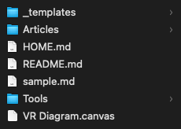

- Rename the folder to ldrs101-[firstname-lastname] (use all lowercase letters and a dash instead of spaces)
- Open Obsidian and click the “Open another vault” icon in the bottom left corner
Figure 1.2
Screenshot of the Open Another Vault Button in Obsidian
[Alt text: Screenshot, Obsidian, with three icons on far left]
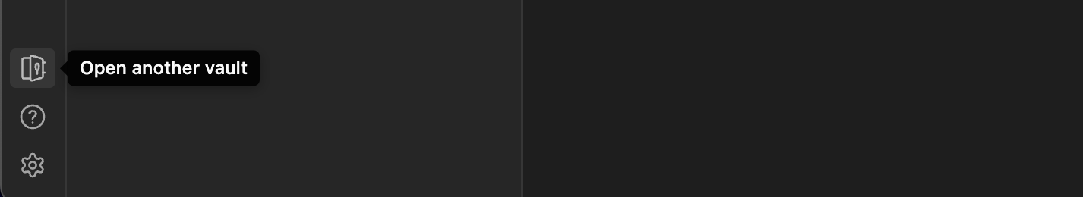

- Choose the ldrs101-[firstame-lastname] folder, and then Obsidian will ask you to trust this vault
- Click “Trust author and enable plugins”
- Once you are in the vault, feel free to take a look around—you will notice a Home page, a Tools folder with some files in it, and a VR Diagram Canvas
Now that you have a place to record your course notes, let’s jump back into the discussion about digital literacy. Traditionally, literacy was about speaking, listening, reading and writing. Literacy has taken on a much broader and complex meaning. Today there’s also digital literacy, media literacy, new literacy, and so on. In the activity below you are invited to reflect on how your literacies have changed when compared to your parents, and to speculate on new literacies the next generation of learners may need for the future.

1.3.3 Activity: Reflection on the 21st Century Learner
- Watch: The following video by the MacArthur Foundation questions how digital media are changing the way young people learn, play, socialize, and participate in civic life. In it, John Seely Brown, a researcher with particular interests in radical innovation and digital culture, suggests that today’s gaming oriented children want to be measured and feel that if they are not learning, it is not fun. How does this relate to how you feel about learning?
- Rethinking Learning: The 21st Century Learner (2010)
While you watch the video think about:
- What “literacy” skills have you acquired when compared to your parents?
- What “literacy” skills will be important for future learners in higher education?
https://www.youtube-nocookie.com/embed/c0xa98cy-Rw
- Reflect on the following writing prompts:
- My parents did not need to …
- A new literacy I acquired is the ability to …
- Higher education students of the future will need to …
- … is an important 21st century skill for future employment
- Write: To complete this activity, click “Open Today’s Daily Note” in your Obsidian vault and write your reflections.
Figure 1.3
Screenshot, Obsidian, Where to Find Today’s Daily Note (Icon Circled)
[Alt text: Screenshot, Obsidian, today’s daily note icon circled]
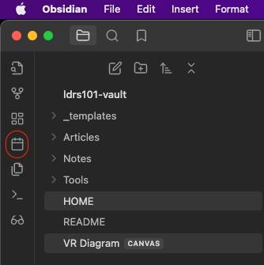

- Style your text using Markdown codes. Click here for the basic Markdown syntax (n.d.).
- Feel free to add images and other media!

Please make sure you add tags to your note. Suggested tags might be #digital-literacy #ldrs101 #macarthur-foundation #john-seely-brown.
Notice that tags start with a hashtag and contain no spaces. Separate words with a hyphen.
Let’s dive a little deeper into this topic of digital literacy. What is it? How would you define digital literacy?
In the next activity, you will start to unpack this term and prepare your own initial definition of digital literacy.

1.3.4 Activity: Defining Digital Literacy
Let’s take a look at the definitions of digital literacy and digital skills on the web and identify the difference. Follow the steps below and feel free to jot down some notes in your Obsidian journal. If you are completing this activity on a new day, create a new daily note.
- Read:
- Read Wikipedia’s definition (2024) of digital literacy—is this a good description?
- Scan the #diglit hashtag on X (Twitter)—did you find any valuable links to defining digital literacy?
- Conduct a Google search for “digital literacy.” Select a few definitions you like and record their URLs, for example by adding these to your browser bookmarks.
- Conduct a Google search for “digital skills.” Select one or two definitions you like and record the URLs.
- Conduct a Google search for “digital fluency.” Select one or two definitions.
- What are the differences between digital literacies, digital fluency, and digital skills? How are these concepts related?
- Read What is Digital Literacy? (2014) by POMO—is this a reliable source?
- How would you rate the academic quality of the definitions you found (e.g., low or high quality)?
- What did you discover?
- Write: Share your thoughts and experiences by posting on the LDRS 101 Discourse chat. For example:
- The major difference between digital skills and literacies is …
- I didn’t realize that …
- For me, digital literacy means …”

1.3.5 Digital Literacies and Skills
Digital literacies for academic learning involves more than Facebook, Snapchat, or X (Twitter) and the associated technical skills in using these technologies.
As you explore the concept, you will find online resources which confuse digital skills with digital literacies. The activities which follow aim to provide an initial introduction to the wide range of digital literacies associated with academic learning. We will explore the concept of digital literacies in greater depth as we progress with the course. When exploring these online resources we encourage you to differentiate between skills and literacies, and to develop a critical disposition. Digital literacies involve issues, norms, and habits of mind surrounding technologies used for a particular purpose. However, these literacies are closely related to technical proficiency in using a range of digital applications.

1.3.6 Activity: What are Digital Literacies?
Watch educator and researcher Doug Belshaw as he discusses his digital literacies framework:
- Watch:
- The Essential Elements of Digital Literacies (2012)
https://www.youtube-nocookie.com/embed/A8yQPoTcZ78
- Read: Next, read the Quick Guide - Developing Students’ Digital Literacy (n.d.).
This guide defines digital literacies as “the capabilities which fit an individual for living, learning and working in a digital society (n.d., Introduction).” Furthermore, this report distinguishes between seven elements of digital literacies:
Figure 1.4
Career Ready Framework
[Alt text: Schematic of seven elements of digital literacies]
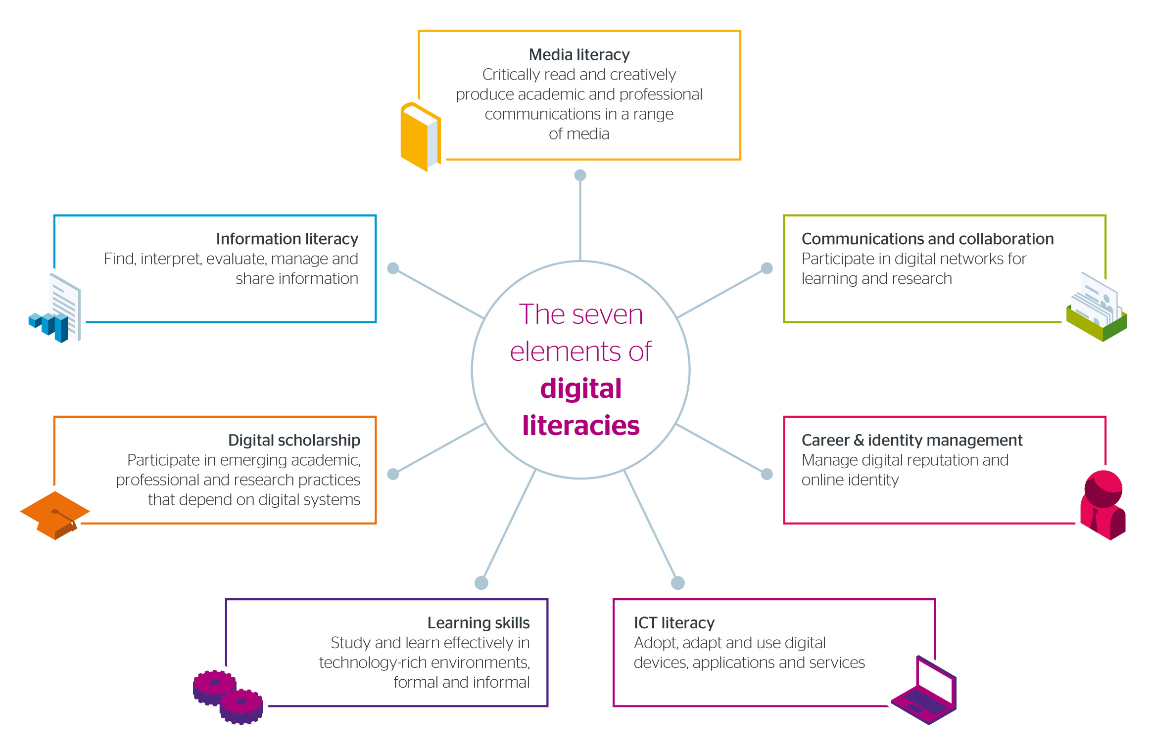

Note. From “Quick Guide - Developing Students’ Digital Literacy,” by Jisc Digital Experience Insights, n.d., p. 2, (https://digitalcapability.jiscinvolve.org/wp/files/2014/09/JISC_REPORT_Digital_Literacies_280714_PRINT.pdf). CC BY-NC-ND 2.0 UK.
Do you agree that these are the key literacies you need to live, learn, and work in today’s society? What would you add?
Conduct a quick Google search for “digital literacies” and add in terms such as “essential,” “top,” “21st century.” What other literacies or skills are emphasized? What would your list be for digital literacies that are important for you?

1.3.7 Activity: Why Digital Literacy Matters
A key component of digital literacy and networked learning relates to the ability to engage meaningfully in online learning communities.
This learning activity will provide you with another opportunity to connect with your peers in Discourse and contribute to online learning discussions.
Watch the following video and jot down the reasons why digital literacy matters to you, then complete the steps which follow.
- Watch:
- Digital Literacy and Why it Matters (2014)
https://www.youtube-nocookie.com/embed/p2k3C-iB88w
- Write:
- Go to the LDRS 101 section in Discourse
- Post a contribution to the discussion on digital literacies and why they are important for you
- Post one or two replies to interesting contributions (you should also “like” good contributions, use the person’s username when replying, and if appropriate, quote a reply when responding.)

1.3.8 Activity: Am I Digitally Literate?
Digital literacy encompasses a wide range of capabilities which extend beyond the digital skills associated with different technologies. Consider the digital literacies you identified from the previous activity.
- Write: Jot down one or more technologies or tools you would recommend for each of the skills and assess your competence in using each particular technology or tool (e.g., below average, average, above average, or excellent).
- Search: Next, use your searching skills to discover online tests for assessing your digital literacies (don’t spend more than 15 to 20 minutes on the self-assessment activity).
- Conduct a Google search using “digital literacy self-assessment”
- Choose a link to conduct a self-assessment of your digital literacy
Alternatively, you can choose from these resources:
- Take the Digital Literacy Self-Assessment (n.d.) from the Canadian Association for Supported Employment or
- Use the Digital Literacy Self-Assessment Tool (2020) from the Digital Citizenship Guide or
- Explore the What is Digital Literacy? page of the Digital Literacies Toolkit (n.d.) developed by the University of Southampton.
- Questions to Consider:
- Did the self-assessment you chose focus on digital skills or digital literacies?
- What did you learn from this exercise?
Share your thoughts by posting on Discourse.

1.3.9 Visitors and Residents
One way to start thinking about digital literacy is to create a map of the apps and tools that you use, how you use them, and what traces of your presence you leave behind on the web. We call this a Visitors and Residents Diagram. To complete this activity, we’ll first discuss some key concepts.
Have you encountered the terms “digital natives” and “digital immigrants?” What are your initial thoughts on their definitions?
Note: Marc Prensky coined the terms “digital natives” and “digital immigrants.” We recognize that the term “native” should not be used to talk about people.
The essential argument is that certain generations have changed, in that they have an innate ability to use and learn technology because they have grown up using technology, and those generations whose formative years pre-date the advent of the internet are forever at a disadvantage compared to kids. You can read a bit more about the idea on Wikipedia, linked below. There is also a link in that article to Prensky’s original article.

Digital Natives
Aside from the problematic framing of learners as kids, there are some distinct challenges with the idea of digital literacy being a fixed trait rather than a matter of comfort, familiarity, and a skill that can be practiced and learned. It is no secret that young people are comfortable using social media apps such as TikTok, Instagram, SnapChat, Weibo, WeChat, and the like, but this doesn’t imply a superior aptitude for learning technology compared to older generations, or an inherent proficiency in doing so. For example, are most first-year university students proficient in using a spreadsheet to create a budget? If they have created a budget, it’s more likely they use an app than a spreadsheet.
We’d like to introduce you to a different way to conceptualize your relationship with digital media, and that is that you may be a visitor in some web spaces and a resident in others. Places on the web where you might be a visitor are those places where you quite literally visit, but importantly, don’t leave a public trace of your time there. You don’t spend any time interacting with people, but rather, you take a rather utilitarian approach by visiting a site, doing a thing, and leaving.
Alternately, there are places and spaces on the web where you reside as a persona, where you interact, socialize, and leave traces of yourself online. For some, that may be Facebook or Instagram, where you keep in touch with friends and family, or X (formerly Twitter), or maybe it’s a blog, or social site. The important distinction is that these are places where you connect with other people, where you are socially present.
At the same time, if we can imagine the visitor $↔$ resident continuum on a horizontal axis, there is also a personal $↕$ professional (or educational) continuum on a vertical axis, leading to four quadrants where you might situate your technology use.

1.3.10 Activity: Where am I Online?
The video below explains a process to help you think about where you reside on the web.
- Watch:
- Visitors and Residents (2014)
https://www.youtube-nocookie.com/embed/sPOG3iThmRI
- Questions to Consider:
- What surprised you as you watched the video?
- How can you apply the concepts presented to your experience in learning with technology?
Feel free to jot down your notes in Obsidian.
Now to the task of creating your own Visitors and Residents Diagram.
See the diagram below … keep in mind that this diagram represents a set of tools that its creator has been using for a decade or more, and that they have invested their career in educational technology. There is a lot here; yours might look significantly different with only a few tools here and there. Or perhaps your diagram has a plethora of tools you use regularly. The key idea of visitors and residents is for you to think about which technologies you use as a resident, and then to think about which tools you may have tried or are interested in pursuing. From there, we can begin to plan for tools we can use that afford us the opportunity to reside there.
Figure 1.5
Visitor–Resident Diagram
[Alt text: Example of a Visitor–Resident diagram including many online tools]

It is certainly notable that this diagram’s creator is very much a visitor in Moodle! This does not mean that they don’t spend much time there, they spend a significant portion of every day working in Moodle, rather, the work that they do there leaves very little trace of their personality. You will (hopefully) see Moodle as much more of a place where you reside. But this foregrounds the question of whether Moodle is actually designed to promote residencies. Certainly the forums allow for users to project their persona into the system, as do a few of the other features, but the system itself is very heavily templated. There are profiles that can be edited, but users are limited to one very tiny image, and virtually no opportunity to determine for themselves what they want to share. There is little room for customization, and every time a course ends every single user must recreate their persona in a new course site (or five).
For many university students, a Learning Management System (LMS) like Moodle is a perfectly reasonable place to reside and they feel comfortable accessing course materials, finding their grades, communicating with classmates, and so on. And just like our physical homes, the quality of the community that lives there isn’t determined by the features of the house itself, but by the people who share the space and how they structure their time and interactions.

1.3.11 Activity: Visitor and Resident Diagram
This activity will help you think about how the tools we use shape and sometimes determine the nature of our interactions with each other. Do the tools you use fall on the visitor or the resident end of your continuum? How do these tools impact your learning?
- Read:
- Visitors and Residents: A New Typology for Online Engagement (2011)
- Create a new canvas in your Obsidian vault and create your own Visitor–Resident Diagram. We have created a sample diagram in the vault.
Note: This diagram can be used to demonstrate your understanding of the course learning outcomes. See the Assessment tab in Moodle for how this activity relates to the assessments in this course.

1.4 Digital Privacy and Safety
Now that you have assessed some of your digital skills or literacies, let’s focus our attention on privacy and safety. In this section we summarize important practices as a reminder to remain vigilant in protecting your privacy and security online. If you are unsure about good security practices, there are a wealth of online resources you can (and should) consult.

Privacy
Your privacy is fragile, easy to lose instantaneously, and difficult to retrieve in an environment that requires so much online interaction.
- Identity theft happens, frequently.
- Never put your social insurance number, your birthday, your mother’s maiden name, or any other personal facts anywhere online. Everyone on the internet will be able to access this information.
- Always assume that anything you write online (including email) can, and probably will, eventually leak. Keep your email address private—to avoid receiving spam. If your email is published in a plain form anywhere online, even if it is part of an archived email list, spammers will “harvest” it for their databases.
- Spam email (at least half of all email being sent) is an unfortunate fact of our modern lives.
- If you must publish your email address online, consider creating a “sacrificial” email address, or one you only use to publish online. You can create an email “alias” which you can set to automatically forward to your primary email, and easily disable if your spam volumes increases. Many email services will automatically generate random email addresses that you can use to hide your true address.
- Another approach is to avoid publishing the email address as something like mailto:myname@somewebdomain.net. Instead, you might use more confusing text, such as myname-at-somewebdomain-net. Some websites support using these types of obfuscation methods, but the spammers who “scrape” email addresses from websites to populate their spam databases use increasingly sophisticated methods to defeat these methods.
- Basically, avoid publishing the email addresses you value online to decrease the amount of spam you receive.

Passwords
What about passwords? Many people have just one, or maybe a few. Given the number of websites and web services which require password-based authentication, this is not good enough to avoid an identity disaster.
The problem with having only a few passwords is that even resource-rich and security-critical organizations have suffered massive leaks. If even one of them suffers a data leak, identity thieves will obtain your password and try to use it on other websites. It is easy for them to do this using computer technologies.
Other ways someone can get your password include:
- Sniffing traffic when you log in to a nonsecure website that uses http:// rather than https:// (the “s” stands for secure because your data transmission’s encrypted). Look for the Lock icon.png in your address bar.
- Sniffing emails—your email, unless encrypted, is not secure. Never send a login and password along with the web address of a service (similarly, don’t send credit card numbers).
- Phishing attacks—where someone sends you an email that looks like it is from a trusted sender, such as from a friend, your bank, an online store you frequent, or a government agency, and asks you to enter your password to confirm it. No one should ever ask you to enter your password via email.
- Always check the web address (hover over the link) to make sure it corresponds to the right place or call the sender to confirm the request over the phone.
- Brute force—hackers often use computers to guess your password, beginning with a list of common passwords, and try different combinations until they get it right, or until the system locks them out for trying too many times.
- “How secure is my password” sites—you should avoid these sites and never type your password into a website or email response that is not appropriate, especially when you know the sender also knows your email.
- Once your email and any password combination are known, identity thieves will try to use them at various websites, because they know most people only use a few passwords. A thief who discovers a password you created for a website you rarely use will try to compromise the security of a website that is important to you such as your email system, your workplace, social media accounts, or bank account.
Here is a table that shows how quickly passwords can be cracked using brute force methods. Note that the best passwords are both long and include a mix of numbers, lowercase and uppercase letters, and symbols.
Figure 1.6
Time Needed to Crack Passwords of Varying Complexity in a Brute Force Attack.
[Alt text: Table showing time it takes hackers to brute force a password]
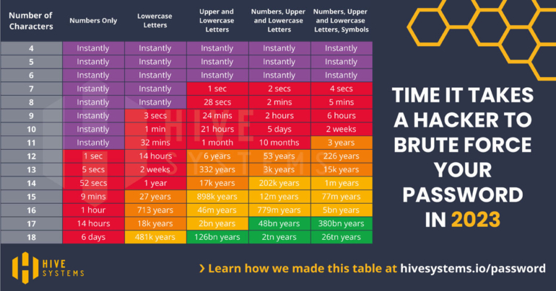
Note. From “Are Your Passwords in the Green in 2023?,” by C. Nesky, 2023, Hive Systems (https://www.hivesystems.com/blog/are-your-passwords-in-the-green-2023). Copyright 2024 Hive Systems. Reprinted with permission.
There are services you can use to check if your email is part of a leaked password data set. So, what can you do to protect yourself?

Password Managers
Get a password manager. They are incredibly helpful and convenient now that many of us use several computers and mobile devices. Password managers help you manage your passwords.
- When you choose a password manager make sure you create one strong password, such as a full sentence with some numbers and special characters. This is all you need to remember—the password manager remembers the others. The ensures you generate a different, fully random password for each website you use that requires a password.
- Good password managers only ever store your details in an encrypted form, where even the company that stores it cannot see your passwords. To access your passwords, you log into the password manager service using your single, strong password (via a secure web link—usually the default, but always check!).
- There are many password manager options. Some widely used proprietary options include Lastpass and 1password. Open source options also exist, such as Bitwarden. Sadly, some of the most popular password managers have suffered from software bugs that have exposed user passwords.

1.4.1 Activity: Get a Password Manager
If you don’t already use a password manager, set up an account with Lastpass, 1password, or the free password manager, Bitwarden to familiarize yourself with how password managers work.
- Read: How to Start Using a Password Manager (2021).
- Create an account on the password manager site and establish a master password (conduct an online search for advice on choosing a secure master password).
- Install the browser extension for your local browser.
- Choose one of the TWU course websites and set up a new secure password using your password manager.
- Log out of the TWU course website and log in again using the password manager.
- Install the mobile phone app for your operating system, and desktop application for your computer (if this applies). Synchronize the local app with your online vault.
- Consider using the password manager for your online accounts so you can easily set up and maintain a unique password for each online account you use.

Good Messaging Hygiene
Always assume that anyone can and will read anything you write in an email. Email is not a secure form of communication. Few people encrypt their email because it is an extra step that even the most technically inclined users are reluctant to take. Both sender and recipient have to be technically proficient.
Text messages and instant messaging programs such as Facebook Messenger are also insecure. Anyone, including government officials and the organization that runs the service, such as Facebook employees, can read it.

Secure Your Own Privacy
Never send any sensitive data such as your social insurance number, credit card number, password, or other personal information via email or text. Call the person to provide this information over the phone.
You can use a secure, encrypted text message service such as Signal if necessary. It is available at no cost, works on most platforms, and encrypts text messages on your phone. If you text someone else with Signal installed, the entire transaction is encrypted.

Secure the Privacy of Others
Another element of good digital hygiene is to protect the identity of others. For example, never send group emails using To: or CC: (carbon copy) for each email address. You will reveal the email addresses for everyone on your list. This is especially problematic if you or another person saves the email message and displays it on the web, such as in a mailing list archive. This makes it easy for spammers and hackers to access and download all of those email addresses.
Use BCC: (blind carbon copy), to hide the email addresses from your recipients to protect everyone’s privacy. Use your own email address, and BCC the rest of the recipients, if your email software requires you to insert an email address into the To: box.
When using an email mailing list where you send messages to a single email address to a list of people, never CC: someone else in the same message. This will compromise the privacy of every CC’d recipient and the privacy of the list. Always check with the people on the list to ensure you are not taking unacceptable liberties.
If someone asks you to share an email address of a friend or colleague you should ask permission to share their email address, and state why the third party is requesting their email.

Be a Thoughtful Sceptic
So how can we protect ourselves if new threats are emerging all the time?
- Be conscious of where you put information that is “private” to you.
- Beware of the terms of service (ToS) of social media providers such as Facebook. Use a service such as Terms of Service: Didn’t Read (TOSDR) to help identify risky, overreaching services. You may be able to use certain privacy settings to protect your information.
- Always check the identity of a website before you enter any passwords or personal information. Secure certificates are generally trustworthy but be sure to check the names and details.
- Always ask whether you should trust a provider or a government agency. Always ask “who benefits when I do this?” What are their incentives?
- Protect your own data and be even more protective of others’ private information. For example, be cautious before posting information about yourself or someone else. Be especially cautious when posting pictures or videos of their children.
- Remember, complacency and unwarranted trust are your biggest enemies. A healthy paranoia is good for your digital health. Think about the great amount of time and effort it will take to regain your identity (and credit rating) if your information is compromised.

1.4.2 Activity: ToS Analysis
- Identify: Use the Terms of Service: Didn’t Read (n.d.) site to look up each of the apps we will learn in this course. Each tool currently has its own file in your Obsidian vault with a template ready to go for you. Fill out the template for each tool based on what is available on tosdr.org and your own examination of the ToS for each tool.
Feel free to add components to the template.

1.4.3 Activity: Introduction to Reflective Journaling
For the final activity of Unit 1 you will be asked to write a reflective journal entry in Obsidian on the topic of digital literacy. This entry can be used as part of Assignment 1: Reflective Journal.
Prior to completing this activity, let’s discuss the practice of writing in a Reflective Journal.
A reflective journal is simply a record of your thoughts. It is a reflection of the way you think and the manner in which you respond to your learning. Journals can consist of traditional note taking, mind maps, pictures, stream-of-consciousness writing, recordings, quotes, sketches, or drawings—whatever you choose to include. Experiment and have fun. The purpose of journaling is to make you an active participant in your learning experiences as you engage in the various activities throughout the course’s readings, activities, and discussions. Reflecting upon these learning events will help you gain a deeper understanding of the course materials and help integrate your learning into applied practice in your everyday life and work. Throughout the course, we will remind you to write in your journal, as we want to be sure you are actively learning the material. To assist you, we have provided you with questions you can ask yourself in order to get your creative energies flowing. Reflective journaling is an activity you can and should complete on a regular or daily basis, even beyond the prompting in course activities.
- Watch:
- Reflective Writing (2014)
https://www.youtube-nocookie.com/embed/QoI67VeE3ds
Here are some common questions used for reflective journaling. As you read them, consider what you have learned in this first unit.
- In your view, what were the most important points in the readings or activities?
- What information did you already know? What skills did you already have?
- What new knowledge, skills, or perspectives have you gained?
- What information was easy to remember or learn? Why?
- What concepts or skills did you find more difficult? Why?
- How can you apply this knowledge to your studies or future career?
- How has this knowledge helped you to make sense of your current or previous experience?
- Has your understanding of a personal or work-related situation changed after studying these concepts?
- Did you agree or disagree with any of the material? If yes, how did you react and why?
- If you could have the opportunity to engage in further learning, what would it be?
- What further questions would like to ask about the concepts presented in this unit?
- What other concepts, resources or discussions would be of interest?

1.4.4 Activity: Digital Literacies for Online Learning
- Write: In this activity you are asked to write a reflective journal entry on the topic of digital literacy.
First, let’s get you set up in Obsidian. Click the little calendar icon in the sidebar of Obsidian to open today’s daily note.
Figure 1.7
Screenshot of the Daily Note Icon in Obsidian (Circled)
[Alt text: Screenshot showing where to find daily note icon in Obsidian]

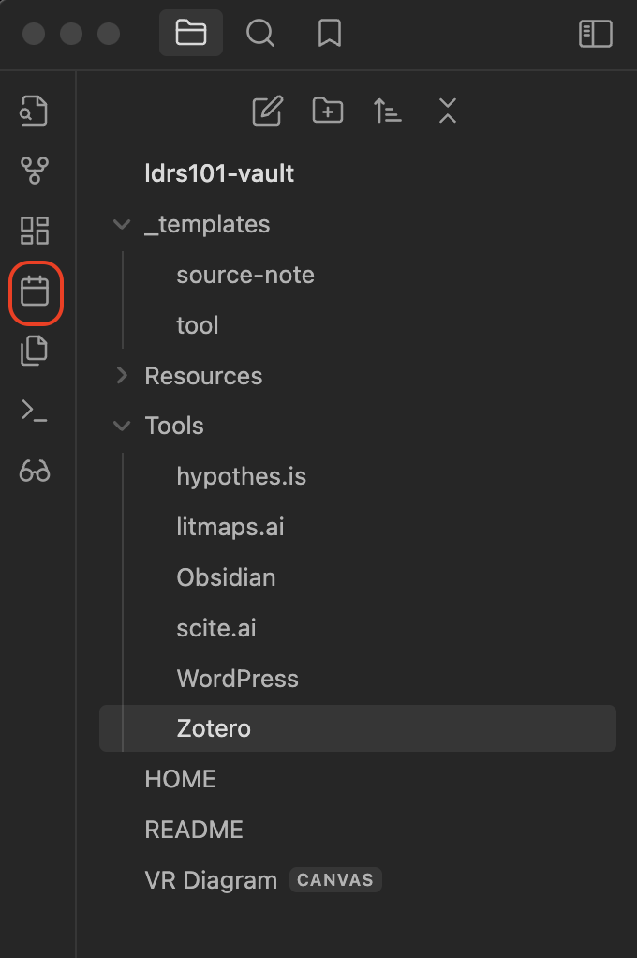
Next, respond to the following prompts:
- Write your personal definition of digital literacies justified from your reading of the literature (about 100 to 150 words).
- Describe what digital literacies mean for you in a sentence.
- Create a link to your VR diagram map in your entry.
- Summarize an action plan for improving your digital literacies—identify the literacies you plan to improve including the reasons why and how you aim to achieve this.
- Ensure that your references are cited appropriately.
Note: This journal entry can be used to demonstrate your understanding of the course learning outcomes. See the Assessment tab in Moodle for how this activity relates to the assessments in this course.

Summary
In this first unit, you have had the opportunity to learn about some of the impacts of “the digital” on your life. You have started to build an academic knowledge management workflow, a pivotal skill essential for efficiently organizing, accessing, and leveraging information. Throughout the unit, you’ve actively engaged with digital tools, shared insights into your personal interactions with digital technology, and begun applying these tools to enhance your academic learning experience. Furthermore, you’ve developed a personalized understanding of digital literacy and explored how to protect yourself and others in digital and online contexts. As you progress through the course, take a moment to identify the specific literacies you aspire to refine and articulate the concrete steps you intend to take in pursuit of these goals.

Checking Your Learning
Before you move on to the next unit you may want to check that you are able to:
- Explore common digital tools used at Trinity Western University
- Describe your engagement with digital technology
- Apply digital tools to support learning in an academic environment
- Explain what digital literacy means to you
- Examine privacy concerns related to various platforms and tools
- Describe how to protect yourself and others in the digital environment
- Identify the literacies you plan to improve and what steps you will take to achieve your goals

Bibliography

For real … using Zotero will literally save you days of tedious work during your university career!

