# Assessment

| Assessment Task | Due Date |
| --- | --- |
| Learning Reflection Blogs | Ongoing |
| Concept Map and Lit Review | September 22 |
| Small Group Facilitation | September 29 |
| Peer Coaching Session | October 6 |
| Analysis | October 27 |
| Synthesis | November 1 |

## Learning Reflection Blogs

Throughout this course, you will be invited to write four reflections about what you are learning in this course. You should consider your posts as a place for you to try out new ideas, to test your assumptions, and to share what you are learning with your community. You will use these posts as data in your analysis and synthesis tasks, so it is in your best interest to be thorough in your reflections (use the W3 process if you’d like a structure, but focus on the ’WHAT?’), and make sure that you demonstrate **evaluative judgement**, or your ability to judge the quality of your own work, in relation to the relevant learning outcomes. Ensure that your post is a reflection of your coaching or facilitation experiences through the lens of the literature you reviewed and your personal coaching and facilitation context. Aim for 300-500 words.

Compose each post in Obsidian using the ‘Daily Note’ template, then copy and paste the text into the relevant topic in [Discourse](https://twu.discourse.group/c/leadership-463-663/21). Make sure you use tags in Obsidian and in Discourse to allow you to curate your thoughts.

### Post 1

#### Due at the end of Unit 1

#### Topic

**Read** [Getting the mix right again: An updated and theoretical rationale for interaction](https://www.irrodl.org/index.php/irrodl/article/view/149/230) by Terry Anderson.  
**Read** [Interaction and the online distance classroom: Do instructional methods effect the quality of interaction?](https://link-springer-com.ezproxy.student.twu.ca/article/10.1007/s12528-011-9049-4) by Heather Kanuka.

Then, post a reponse on your blog defending or criticizing Anderson’s Interaction Equivalency Theorem. Ensure that you defend or criticize the idea, not the person, and include something that you have learned about interaction from somewhere other than the assigned readings.

If your birthday is between January 1 and June 30, **defend** Anderson’s Interaction Equivalency Theorem.

If your birthday is between July 1 and December 31, **criticize** Anderson’s Interaction Equivalency Theorem

Feel free to respond to arguments presented by your colleagues for or against the theorem.

To submit all of your posts for the course, create a new journal entry in your Obsidian vault.

### Post 2

#### Due at the end of Unit 3

Scan through the [feed of posts from previous cohorts of this course](https://ma-lead.github.io/ldrs663/feeds.html) and read through a few posts about Anderson’s *Interaction Equivalency Theorem*. Then revisit your own post from Unit 1 in this cohort and, in a new post, provide a review of your Unit 1 post. Evaluate your post using the SOLO Taxonomy found on the bottom of this page. In your review, make sure you link to more than one post from a previous cohort.

Once you have completed this task using one of your own posts, repeat the process for one of your colleagues’ posts, preferrably, someone who took the opposite view from you (if you defended Anderson’s theorem, then evaluate the post of someone who criticised it).

To create all of your posts for the course, create a new journal entry in your Obsidian vault, then paste your completed post into the appropriate topic in Discourse.

### Post 3

#### Due at the end of Unit 4

#### Topic

In your Discussion Post for this unit, you are being asked to select one core coaching competencies identified in this unit and reflect on how you might apply it in an educational setting. You can use the following questions to guide your writing:

* How would you define the coaching competency?
* Why is the competency important?
* What set of integrated knowledge, skills, aptitudes and attributes help define, in more detail, how to successfully perform the job to be done?

To submit all of your posts for the course, create a new journal entry in your Obsidian vault.

### Post 4

#### Based on Unit 4-5

Throughout this unit we have explore the idea of the educational experience. Your task for this post, is to reflect on recent trends in higher, and other forms, of adult education in terms of the multitude of new ways institutions are offering access educational experiences and how technology and assessment practices influence those experiences. You can use some or all of the following questions to guide your writing:

* How does technology impact the educational experience? Be specific with examples from your own experience.
* In what ways does assessment need to change to meet the challenges of modern higher education?
* How can educational institutions give learners more control over their learning experiences?
* What benefits and challenges does learner-centred access to education introduce?
* Is the recent move towards multi-access education shifting the site of education back to an emphasis on study and away from the focus on instruction that dominated the modern era?
* How might this shift change the educator’s role and responsibilities?
* How might this shift change the learner’s role and responsibilities change?
* How can institutions ensure quality and transformational learning outcomes?

## Concept Map and Literature Review

Working individually and in cooperation with your learning pod, use Google Scholar, the TWU library, and AI-powered tools such as LitMaps to find 8-10 peer-reviewed articles on a topic of your choosing, but related to coaching and/or facilitation. Focus on finding at least one systematic or scoping review and several other topical papers. Import the citations and papers into Zotero and then Obsidian. On each file, summarize the associated article, and annotate the PDF. Export the references from Zotero as an .RIS file and include the file in your vault. Create a new Canvas in Obsidian and create a concept map of the relationships between the ideas in the papers. Include on your canvas a new file in which you summarize your concept map (300-500 words).

## Small Group Facilitation

Working in small groups you will facilitate a short 10-15 min learning activity. In your learning pods, each of you should select a topic from LDRS 463/663 and guide your group through a review discussion of that topic. It is recommended that you use an activity modified from one of the [Liberating Structures activities](https://liberatingstructures.com). Following our meeting, you will have access to the recording of the session and you should re-watch your setion and create a detailed reflection on the experience. Describe as much as you can in response to what happened in your session.

I hope you will push your comfort level in this activity, take some risks, and hopefully mess up. That will be a good thing because it will give you much to reflect on later.

Your reflection should be submitted as a 300-500 word ‘Daily Note’ in your Obsidian vault, named ‘facilitation-reflection’.

In your facilitation session, demonstrate and reflect on the following:

* preparing for the session (as evidenced by your composed materials to support learning in your session).
* creating a supportive environment (referring to participants by name, clarifying expectations, responding in an affirming way to others, and acting in and communicating in a respectful and supportive manner).
* managing the learning process (beginning and ending the session on time, fostering participation by all learners in the group, keeping the learning group on track, facilitating interaction within the learning group, and summarizing learning, calmly and creatively adapting to unexpected events).
* fostering learning (showing interest and enthusiasm, spending more time asking than telling, posing open-ended questions, waiting for learners to respond, seeking clarification, activating learners’ prior knowledge effectively, using appropriate forms of engagement to stimulate learner involvement).

## Peer Coaching Session

Working with another student (in your pod), you will each coach each other through the process of writing your final “showcase” post as part of your learning reflection blog assignment or another challenge you have encountered in the course. You will record a video of your session and write critical reflection on your actions as the learning coach.

* Working with another student, use the G.R.O.W. model to coach each other through the process of planning for a particular learning activity within this course (such as, your facilitation resource project).
* There are two outcomes to assessment:
  + you will produce a Zoom recording of your coaching session, and
  + you will write a 1-2 page reflection on your actions coaching your peer’s learning.

## Data Analysis

Using your learning reflections, your experiences as coaches and facilitators in this course or outside of it, your concept map and literature review as your foundation, answer the ‘SO WHAT?’ portion of the W3 process. You might want to use a general qualitative coding procedure to help understand your data. I also encourage you to assist your peers by coding their posts. This phase of your project should result in a clear and rich picture of your coaching and facilitation experiences. Quote liberally from your learning reflections. It is critical in this phase to be clear about what sense you make from your data. You are answering the question ‘What does this all mean for me?’

## Synthesis and Conclusions

In this final phase, you will work closely with your learning pod to answer the ‘NOW WHAT?’ question. Looking forward to your life and career or vocation, how will your new knowledge impact your way of being in the world? How could your new knowledge impact others’ ways of being in the world in relation to coaching and facilitation? What are the implications of your analysis. Be sure to express that your conclusions are not generalizable. The result of this phase will be a cohesive paper following the tradition of Collaborative Autoethnography.

## Grading Standards and the SOLO Taxonomy

An important reality of higher education is that we need to provide a single number between 0 and 100 to the university that encapsulates the effort, successes, failures, struggles, discoveries and messiness of your work during this course. If we are going to be fair about it, we need to consider where you are starting relative to where you end up, we need to understand your individual context, and we need to be able to determine that number by researching your work.

***Assessment is research.*** You need to show us evidence that you have met the outcomes of the course in alignment with the parameters of the assignment, and you need to do so in a way that shows you can think clearly, write persuasively, and extend your learning beyond the boundaries of the course.

This is a very tall order.

One thing that you should consider is that our assessment of your work is not an assessment of you as a person. It is an assessment of what you have shown in relation to the outcomes of the course. One way that you can ensure that you are providing reflections and creating work that is of high academic quality is to use the SOLO Taxonomy.

### SOLO Taxonomy

SOLO stands for *Structure of the Observed Learning Outcome* and is a gauge to help you (and me) ensure that you are writing at an appropriate level.

**<Begin dec-image>**

**Alt Text:** SOLO Taxonomy (adapted from Biggs & Collis, 1982)  
**Has Lightbox:** no  
**Source Text:**   
**Source URL:**   
**Author:**   
**Author URL:**   
**Copyright:**   
**License Text:**   
**License URL:**

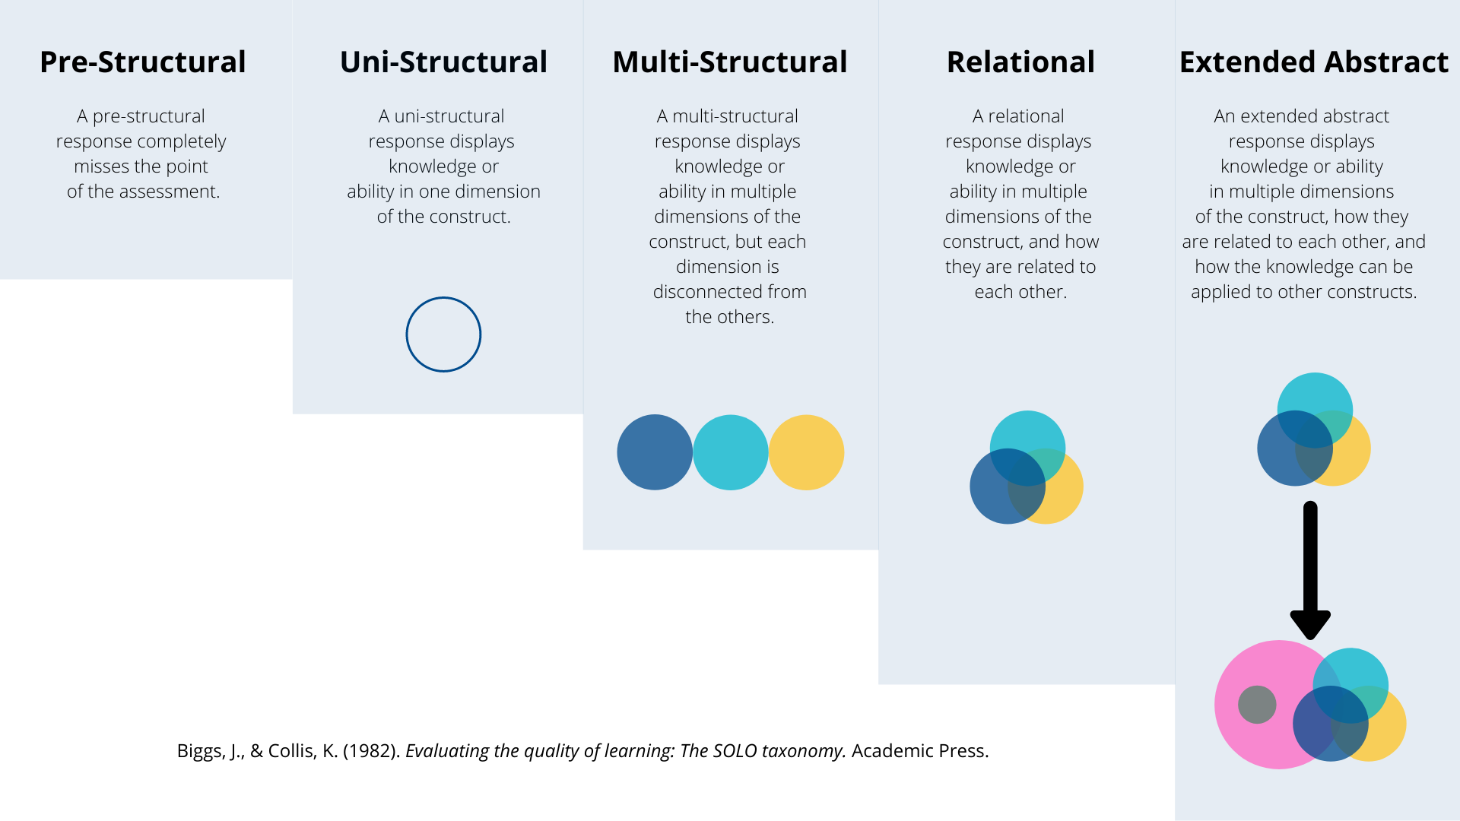

**<End dec-image>**

#### Pre-Structural

A pre-structural response completely ***misses the point*** of the assessment.

#### Uni-Structural

A uni-strucutral response displays knowledge or ability in ***one dimension of the construct***.

#### Multi-Structural

A multi-structural response displays knowledge or ability in ***multiple dimensions of the construct***, but each dimension is ***disconnected*** from the others.

#### Relational

A relational response displays knowledge or ability in ***multiple dimensions of the construct, and how they are related to each other***.

#### Extended Abstract

An extended abstract response displays knowledge or ability in ***multiple dimensions of the construct, how thy are related to each other, and how that construct can be applied to help us understand different constructs***.

If you are providing responses at a pre- or uni-structural level in a graduate course, you are going to have a bad time. Multi-structural responses will lead to grades in the ‘C’ range. At minimum, your responses should be unambiguously relational for a grade in the ‘B’ range and extended abstract for a grade in the ‘A’ range.

The [TWU Grading Scale](https://www.twu.ca/about/policies-guidelines/university-standard-grading-system), available on the syllabus for this course, describes A-, A, or A+ work as

**Outstanding, excellent work**; exceptional performance with strong evidence of original thinking, good organization, meticulous concern for documented evidence, and obvious capacity to analyze, synthesize, evaluate, discern, justify, and elaborate; frequent evidence of both verbal eloquence and perceptive insight in written expression; excellent problem-solving ability in scientific or mathematical contexts with virtually no computational errors; demonstrated masterful grasp of subject matter and its implications. Gives evidence of an extensive and detailed knowledge base. (Note: The A+ grade is reserved for very rare students of exceptional intellectual prowess and accomplishment, especially in lower level courses.)

For a grade in the B-, B, or B+ range, here is what you need to do:

**Good, competent work**; laudable performance with evidence of some original thinking, careful organization; satisfactory critical and analytical capacity; reasonably error-free expository written expression, with clear, focused thesis and well-supported, documented, relevant arguments; good problem-solving ability, with few computational or conceptual errors in scientific subjects; reasonably good grasp of subject matter but an occasional lack of depth of discernment; evidence of reasonable familiarity with course subject matter, both concepts and key issues. Exhibits a serious, responsible engagement with the course content.

We are happy to have a conversation with you if you feel your work has been unfairly assessed and you can provide a justifiable rationale based on the product of your work in relation to the requirements of the assignment and the standards outlined above and in the University Calendar.