Learning Communities

Overview
In this unit, we will review several models of “learning communities” that provide visual representations of the important components of effective learning communities.
Before we consider the models, we first consider the wide variety of learning communities that exist in both educational and professional settings:
A learning community can be created within a specific course, academic program, or professional context.

Learning Communities in Higher Education
Learning communities can be found across university campuses in various formats. One popular format, used at larger universities include a set of interdisciplinary, paired-courses that students take as a cohort. Some graduate programs admit students in a cohort, so students take courses together throughout their program. Residential learning communities are also common for those who live on campus, grounded in residence halls with an integration of living and learning.

Professional Learning Communities
Professional learning communities have also emerged as an important force in education and other fields, as colleagues gather around a shared interest, a focus on continuous quality improvement, and a shared discipline. These professional learning communities can be organized in a professional association, in which professionals within a specific field gather at specified intervals in in-person, virtual, or hybrid formats to share best practices and engage in professional development. Professional and personal learning communities have also emerged within social media and online environments, often lead by a thought leader who writes about a specific topic, and engages people in ongoing conversation about that topic.
In this course, we are focusing on creating learning communities (whether face-to-face or online) that are authentic, emotionally safe and inclusive, in which learners and teachers/facilitators come together to engage in deep learning.
By definition, a learning community includes both “learning” and “community.”

Learning Community © 2025 by Ran Kang and Trinity Western University is licensed under CC BY-SA 4.0
Unit 4 focuses on the following guiding questions:
- What is a learning community?
- What key elements are essential to learning communities?

Topics
This unit is divided into the following topics:
- Learning Community Pyramid
- Community of Truth
- Community of Inquiry
- Trinity Western University Community of Transformational Learning

Unit Learning Outcomes
When you have completed this unit, you will be able to:
- describe elements of an authentic learning community.
- compare learning community models.

Learning Activities
Here is a list of learning activities that will benefit you in completing this unit. You may find it useful for planning your work.
- Read “What IS a Learning Community?” (Brower & Dettinger, 1998) and respond in your reflective journal.
- Read and reflect on the Community of Truth Model (Palmer, 2017).
- Read and reflect on the Community of Inquiry (Garrison et al., 2000).
- Read and reflect on the Community of Transformational Learning (Madland, 2017).
- Respond to the final reflection prompts and share your thoughts with your learning community.
Note: Working through learning activities will help you to meet the learning outcomes and successfully complete your assessments.

Assessment
See the Assessment section in Moodle for assignment details.

Resources
Here are the resources you will need to complete this unit.
- Palmer, P. J. (2017). The courage to teach: Exploring the inner landscape of a teacher's life. Jossey-Bass.
- Other online resources will be provided in the unit.

Learning Community Pyramid
The Learning Community Pyramid, developed by Brower and Dettinger (1998), includes academic, social, and physical components. They describe academic components as those that focus on the curriculum and learning that takes place. The social components are the elements of trust and inclusivity that create space for community. The physical component is the “place or facility where the community meets or resides” (Brower & Dettinger, 1998, p. 17). Since Brower and Dettinger’s (1998) writing, of course, many of the learning communities we engage in now take place online, thus the “place of facility” may now be a virtual space. As an example, in this class, that “place” is the Moodle course.
Building on the foundation of social, physical, and academic elements, Brower and Dettinger (1998) contend that learning communities also include three areas of responsibility: ethical responsibility, civic responsibility, and professional responsibility (p. 17).
According to Brower and Dettinger (1998):
Learning communities, to be considered as such, must integrate academic subject matter and social interactions while providing the physical space or facility for an intellectually stimulating environment to emerge. Furthermore, learning communities must be designed to develop a triad of responsibilities within students—professional, ethical, and civic. (p. 16)
As you consider the learning community you will facilitate, consider how you might develop or model professional, ethical, and civic responsibility within that community. Do you think leaders should develop these same areas of responsibility within the organizations or companies they lead?

Activity: What is a Learning Community?
Estimated Time: 60 minutes
Read “What IS a Learning Community?” (Brower & Dettinger, 1998).
In your reflective journal, respond to the following questions:
- Write down three strengths of this learning community model.
- Write two to three (2-3) questions you have about this learning community model.
- Do you think this model accurately reflects the type of learning community you want to create? Why or why not?
As we compare the other two models, feel free to organize your thoughts into a chart, such as the following:
Model | Strengths of Model | Aspects Unique to this Model | Questions
Learning Community Pyramid (Brower & Dettinger, 1998)
Community of Truth (Palmer, 2017)
Community of Inquiry (Garrison et al., 2000)
Trinity Community of Inquiry (Madland, 2017)

The Community of Truth
Palmer’s (2017) learning community model incorporates learning and community with a “subject” at the center, surrounded by “knowers” who are in a relationship with each other and with the subject. Palmer (2017) asserts that “the community of truth, far from being linear and static and hierarchical, is circular, interactive, and dynamic” (p. 106). Palmer (2017) argues that when we learn together, we learn in a dynamic process, learning more together than we would if we studied alone.
Figure The Objectivist My of Knowing (left) and The Community of Truth (right) (Palmer, 2017, pp. 103, 105)
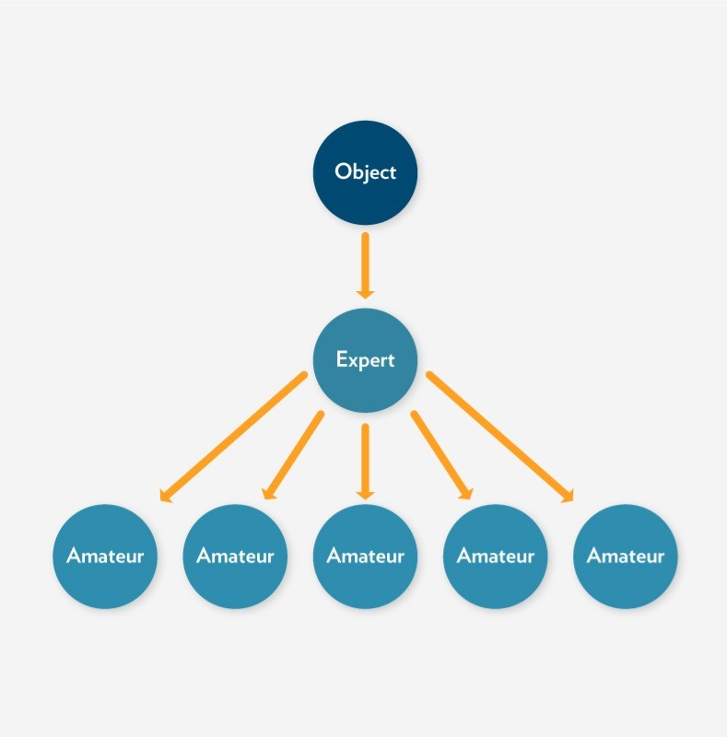 | 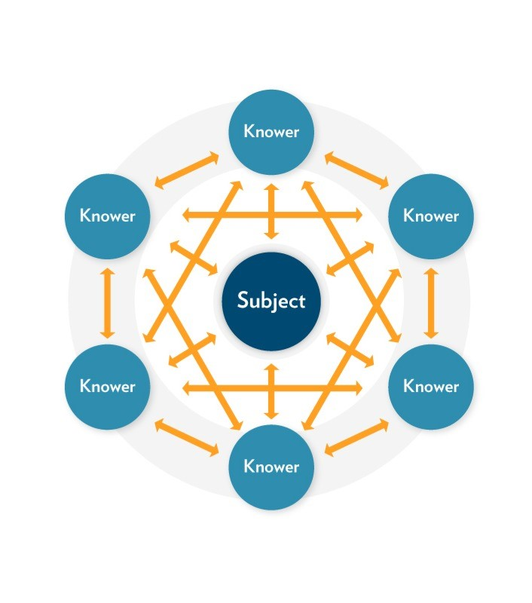
From The courage to teach: Exploring the inner landscape of a teacher's life (Palmer, 2017)

The learning community model, proposed by Palmer (2017), focuses on the process of learning, in which dialogue and ongoing discussion deepen and enhance the learning we experience through disciplined and focused study. “I understand truth as the passionate and disciplined process of inquiry and dialogue itself, as the dynamic conversation of a community that keeps testing old conclusions and coming into new ones” (Palmer, 2017, p. 106). Together, Palmer (2017) argues, we can learn more, learn more deeply, and learn in community.
As teachers, we approach teaching with some sense that we have something specific (some subject) to teach students. We often focus on transferring content or knowledge from us (as teachers) to them (the students). Palmer (2017) challenges us to think differently about teaching/learning experience. (Palmer, 2017, pp. 103, 105).
Instead of solely focusing on what we must teach (and what students must learn), Palmer (2017) challenges us to consider how we all might learn something more together—more than is already known—through the teaching and learning experience. In this way, we must consider that we are not just engaged in transferring information or knowledge, but that, in addition, together we might create new knowledge.
To this effect, Palmer (2017) stated:
I know of no field, from science to religion, where what we regard as objective knowledge did not emerge from long and complex communal discourse that continues to this day, no field where the facts of the matter were delivered fully formed from on high (Palmer, 2017, p. 107).
Palmer’s (2017) model highlights the relational knowledge of learning communities, underscoring the relationship of the people involved and the relationships between people and subject. As you consider facilitating learning communities, give some thought to your own relationship to the subject to be taught and learned. Consider whether you “know” this subject objectively or subjectively. Reflect on what you might learn through further dialogue about the subject you are teaching.

Activity: Community of Truth
Estimated Time: 75 minutes
Read Chapter 4, “Knowing in Community,” in The Courage to Teach: Exploring the Inner Landscape of a Teacher's Life (Palmer, 2017).
In your reflective journal, respond to the following questions:
- Write down three strengths of this learning community model.
- Write two to three (2-3) questions you have about this learning community.
- Do you think this model accurately reflects the type of learning community you want to create? Why or why not? Add your thoughts to the table you created earlier.

The Community of Inquiry
One of the learning community models that is commonly studied regarding online learning communities is the community of inquiry model developed by Garrison et al. (2000). This framework includes three important components of an authentic and meaningful online learning community: social presence, cognitive presence, and teaching presence.

Community of Inquiry
Figure Community of Inquiry Framework
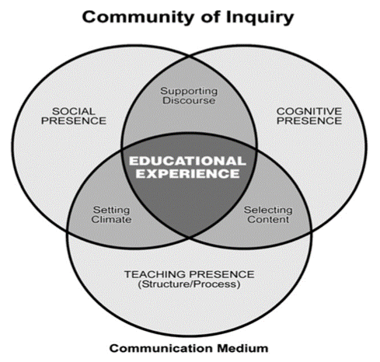
From Communities of inquiry in online learning (Garrison et al., 2000, p. 158)
Importantly, the three areas of presence—social, cognitive, and teaching—are not isolated. Instead, they are interconnected, as demonstrated in the overlapping areas in the Venn diagram.

Social Presence
Social presence is an important element of online learning, as students seek to make connections with each other and the teacher/facilitator, as well as feel a sense of belonging or connection within the course. Garrison (2009) defines social presence as “the ability of participants to identify with the community (e.g., course of study), communicate purposefully in a trusting environment, and develop inter-personal relationships by way of projecting their individual personalities” (p. 353). The focus in this component of the community of inquiry is not on building strong relationships between people, but on forming a group identity. Group cohesion thus is an important component, as this will provide “greater capacity to communicate and collaborate” (Garrison, 2009, p. 353) which in turn leads to more productive learning. “Social presence develops incrementally that begins by focusing first on open communication and cohesion (group identity) and, over time, personal and affective affiliations (personal identity)” (Garrison, 2009, p. 353).

Cognitive Presence
Because our focus in learning communities is learning, we can understand the importance of cognitive presence in our learning communities. But communities of inquiry have a particular approach to learning—inquiry. This inquiry process is one in which “learners are tasked with a problem or issue and, through iteration between discourse and reflection (public and private worlds), construct meaning and confirm understanding” (Garrison, 2009, p. 353). (You may notice elements of this inquiry process in this course. We begin each unit with questions to focus your inquiry. We then encourage you to reflect [private world], before engaging in discussion or written assignments in which you share your learning with others, including your instructor).
Garrison (2009) explains the practical inquiry model (Garrison & Anderson, 2003), including four phases:
The first phase is the recognition and definition of the problem or issue. The second phase is the exploration of the problem or issue through the gathering of relevant information and perspectives through individual searches and discourse. The third phase is making sense of the existing information with the goal to reach resolution through reflection, sharing and critically analyzing the best ideas. The fourth phase is to test the best solution through application either vicariously or directly. Inevitably, the application phase is a catalyst to restart the inquiry process again to rethink, refine or construct a better solution (Garrison, 2009, pp. 353-354).

Teaching Presence
Teaching presence captures the teacher or facilitator’s role and responsibilities within an online learning community. This presence includes three elements: “design, facilitation, and direct instruction” (Anderson et al., 2001). While we are likely familiar with direct instruction, it is important to note that this presence is not just about telling students what they need to know. Instead, elements of course and curriculum design are important components of learning communities, as teachers and facilitators must also create engaging and authentic learning experiences, as well as facilitating that learning experience. According to Garrison (2009), “Design sets the stage and the potential of the learning experience,” (p. 354) and includes the curriculum and the organizational elements of the course, such as timeline, course schedule, assignment due dates, etc.
Direct instruction may take the form of a lecture (long or short) within a face-to-face or video classroom, through pre-recorded videos from your instructor, or through online course content developed by an instructor or subject matter expert.
Like the other elements of “presence,” teaching presence must also consider the social and cognitive elements of the Community of Inquiry, including a focus on creating group cohesion that supports collaborative learning, and engaging students in the learning experiences.

Activity: Community of Inquiry
Estimated Time: 60 minutes
Watch Community of Inquiry Framework (KPU Learning Centre, 2020).
Read the following articles:
- Communities of Inquiry in Online Learning (Garrison, 2009)
- Researching the Community of Inquiry Framework: Review, Issues, and Future Directions (Garrison, 2007)
In your reflective journal, respond to the following questions:
- Write down three strengths of this learning community model.
- Write two to three (2-3) questions you have about this learning community.
- Do you think this model accurately reflects the type of learning community you want to create? Why or why not? Add your thoughts to the table you created earlier.

The TWU Community of Transformational Learning
In our online courses, Trinity Western University seeks to create learning communities that engage student learning on a cognitive, social, and spiritual level. The TWU Community of Transformational Learning model is a visual representation of these three aspects of learning—social, cognitive, and spiritual—and how they interact with each other.
At the intersections of these elements, you find:
- Community of inquiry
- Community of faith
- Integration of faith and reason
Combined, these three elements can lead to transformational learning—an aspiration we hold in this course and program—and a fundamental goal of education in a broader sense.

Figure Community of Transformational Learning
Adapted from TWU Community of Transformational Learning (Madland, 2017). Licensed under CC BY 4.0.

Activity: Trinity Community of Inquiry
Estimated Time: 45 minutes
Review the Transformational Learning at TWU (Madland, 2017).
In your reflective journal, respond to the following questions:
- Write down three strengths of this learning community model.
- Write two to three (2-3) questions you have about this learning community.
- Do you think this model accurately reflects the type of learning community you want to create? Why or why not? Add your thoughts to the table you created earlier.

Activity: Reflection & Discussion
Estimated Time: 60 minutes
After completing this unit, including the learning activities, you are asked to write a 250-word reflective notes on the following:
- Provide a brief description of each of the three models (with citations as appropriate).
- Select the learning community model that most closely aligns with your identity and values as a teacher/facilitator. Describe the strengths you see in this model, explaining why it resonates with your concepts of teaching and learning.
Note: This activity serves as the discussion prompt for this unit. Share your response and connect with others in the Learning Community to deepen your understanding.

Unit Summary
The learning community models we have considered in this unit share some similarities. In each model, there is an awareness that learners and learning is multidimensional. As we engage in teaching and learning, we must always be aware that the learning process is, fundamentally, transformative. It engages people on an intellectual, spiritual, and social level. By designing curriculum, pedagogy, and learning around all aspects of learning—social, cognitive, and spiritual— we provide the foundation for transformational learning.
Palmer (2017) puts it this way:
The reality we belong to, the reality we long to know, extends far beyond human beings interacting with one another… This is a community held together not only by our personal powers of thought and feeling but also by the power of ‘the grace of great things.’ (p. 109)
As Palmer (2017) points out, learning includes both thought (cognitive) and feeling (social), but also something beyond those—the overarching spiritual nature of life and learning.

Checking your Learning
Before you move on to the next unit, you may want to check to make sure that you are able to:
- describe elements of an authentic learning community.
- compare learning community models.

References
Anderson, T., Rourke, L., Garrison, D. R., & Archer, W. (2001). Assessing teaching presence in a computer conferencing context. Journal of Asynchronous Learning Networks, 5(2). http://www.aln.org/publications/jaln/v5n2/v5n2_anderson.asp
Garrison, D.R., Anderson, T., & Archer, W. (2000). Critical inquiry in a text-based environment: Computer conferencing in higher education. The Internet and Higher Education, 2(2-3), 87-105.

