COURSE NAME

TWU Online

Feb 26, 2025

# Welcome

This is the course book for **COURSE NUMBER**. This book is divided into thematic units of study to help you engage with the materials. The course resources and learning activities are designed not only to help prepare you for the course assessments, but also to give you opportunities to practice various skills.

**<Begin note-with-icon>**

Please read the full course syllabus located on the Course Home page in Moodle. It includes key information about the course schedule, assignments, and policies.

**<End note-with-icon>**

## Course Activities

Below is some key information on features you may see throughout the course.

**<Begin learning-activity>**

**Estimated Time:**

This box will prompt you to engage in course concepts by:

* Viewing resources and reflecting on your experience and/or learning.
* Checking your understanding to make sure you are ready for what follows. Ways to check your learning might include self-check quizzes or questions for discussion.

**<Begin note-with-icon>**

Working through course activities will help you to meet the learning outcomes and successfully complete your assessments.

**<End note-with-icon>**

**<End learning-activity>**

Below is an accordion.

**<Begin accordion>**

**Title:** This is an accordion. Click/tap this banner to show/hide the content.

An accordion may contain extra content such as worked examples or sample answers.

**<End accordion>**

# 1. The Heart of a Teacher

**<Begin dec-image>**

**Alt Text:** Guiding Questions  
**Has Lightbox:** no  
**Source Text:**   
**Source URL:**   
**Author:**   
**Author URL:**   
**Copyright:**   
**License Text:**   
**License URL:**

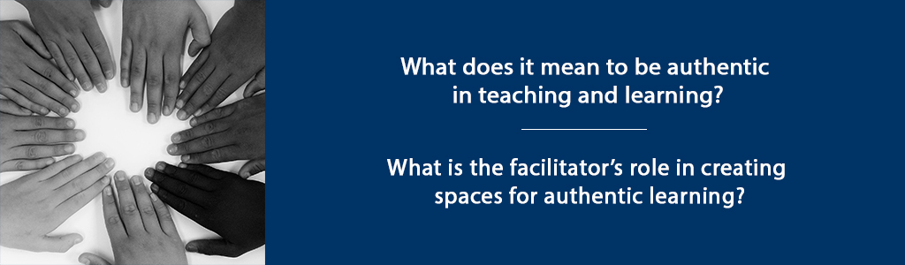

**<End dec-image>**

## Overview

As humans, we long for authenticity in our relationships. We want to feel “at home” in the organizations that are part of our lives – our families, schools, communities, places of worship. We seek connection. We search for a place where we are known.

This sense of being “at home” is essential to our experience as learners. Deep, authentic learning happens in spaces where we feel connected with others – places and spaces where we are known. Palmer (1998) refers to this as the “spiritual quest for connectedness” (p. 5).

In this course, we will explore together the theoretical foundations of learning communities, evaluating key elements essential to creating authentic learning communities, where learners are known and learning is authentic. In this unit, we will engage with the writings of Parker Palmer, a teacher and writer who has written several important works regarding the essential role of authenticity in teaching and learning.

In addition to reading, throughout this course, we will also listen to music and view several short films that will allow us to more deeply engage with the concepts of belonging and authenticity within the teaching/learning experience.

**Unit 1 focuses on two guiding questions:**

* What does it mean to be authentic in teaching and learning?
* What is the facilitator’s role in creating spaces for authentic learning?

### Topics

1. Authenticity in Teaching and Learning
2. Identity and Integrity as a Coach/Facilitator

### Learning Outcomes

When you have completed this unit you should be able to:

1. Describe your own personal identity as a facilitator/teacher.
2. Identify your personal beliefs about your role as a facilitator/teacher.
3. Discuss key elements of an authentic learning community.

### Activity Checklist

These learning activities will engage you in considering the guiding questions for this unit. As you plan your week, be sure to include time for these important learning activities. *Note that not all activities are required. Your instructor will provide guidance on key activities to complete.*

**<Begin learning-activity>**

**Estimated Time:**

**Learning Activities**

* ReadPalmer, P. (2017): Introduction, Chapter 1: The Heart of a Teacher: Identity and Integrity in Teaching; Chapter 3: The Hidden Wholeness: Paradox in Teaching and Learning. Alternatively read Goode, Joanna: [If you Build Teachers, will students come?](https://journals-sagepub-com.twu.idm.oclc.org/doi/pdf/10.2190/2102-5G77-QL77-5506)
* Reflect on your values and respond in your Reflective Learning Journal.
* Rank the strategies listed to create an authentic learning space that is hospitable and open. Then, read: Herrington, J. & Oliver, R. (2000). [An instructional design framework for authentic learning environments.](https://ro.uow.edu.au/edupapers/31/) Educational Technology Research and Development. 48(3), pp 23-48.

**<End learning-activity>**

**<Begin note>**

**Assessment**

* Unit 1 Discussion: Incorporating the readings in this unit, you will write a 150-250 word discussion post that addresses your values related to teaching and learning and the key elements of authentic learning spaces. See the Assessment sections for full details.

**<End note>**

## 1.1 Authenticity in Teaching and Learning

Teaching and learning are deeply personal experiences. Learning is, by definition, a transformative experience; we change as a result of learning. Teaching is also a transformative experience; we change as a result of teaching.

**<Begin dec-image>**

**Alt Text:** Authentic Teachers  
**Has Lightbox:** no  
**Source Text:**   
**Source URL:**   
**Author:**   
**Author URL:**   
**Copyright:**   
**License Text:**   
**License URL:**

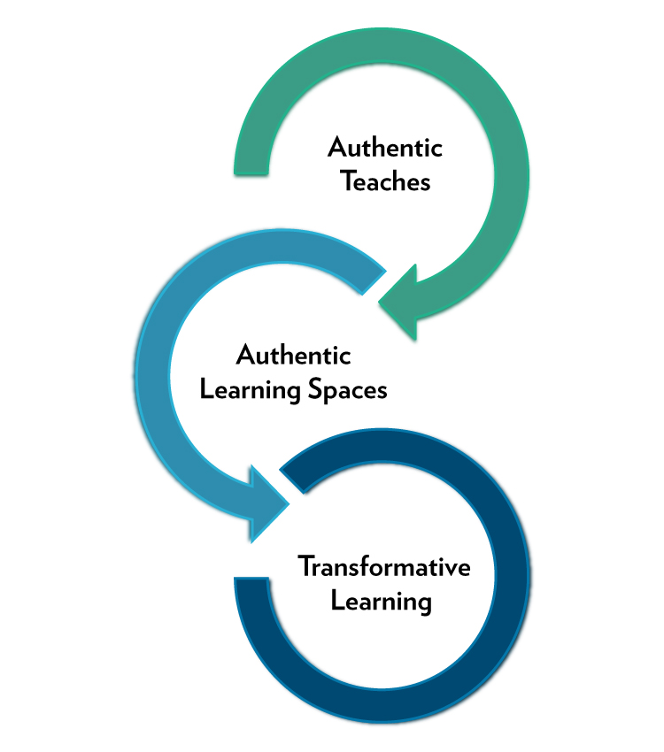

**<End dec-image>**

In his book, *The Courage to Teach: Exploring the Inner Landscape of a Teacher’s Life*, Parker Palmer (2017) argues that the “inner landscape of teaching” is an essential foundation out of which authentic learning experiences emerge.

*Teachers possess the power to create conditions that can help students learn a great deal – or keep them from learning much at all. Teaching is the intentional act of creating those conditions, and good teaching requires that we understand the inner sources of both the intent and the act.* – Palmer (2017, p. 7)

### 1.1.1 Activity: Reading

**<Begin learning-activity>**

**Estimated Time:**

As we explore the importance of the “inner life of the teacher” as a foundation for authentic learning, read Chapter 1: The Heart of a Teacher: Identity and Integrity in Teaching in The Courage to Teach (Palmer, 2017). Alternatively, read [If you Build Teachers, will students come?](https://journals-sagepub-com.twu.idm.oclc.org/doi/pdf/10.2190/2102-5G77-QL77-5506) (Goode, 2007).

For this course, you will keep a Reflective Learning Journal, which will provide the basis for many of your blog posts. Writing can be a powerful learning experience, as we engage in reflection and critical analysis of the new concepts we discover. Through regular writing, we are challenged to think critically, organize, and integrate these new concepts with our prior understanding, as you prepare for your future teaching/coaching.

**Questions to Consider**

* In your Reflective Learning Journal, write a summary sentence for each major idea/concept that relates to your understanding of what it means to be a teacher/facilitator/coach.
* Choose the concept that most resonates with you and write a short paragraph summary of this concept, applied to your professional/personal context.
* Formulate one question that emerged from this reading that you will explore and consider in future course readings and discussions.
* As you prepare your discussions, refer to these notes.

**<End learning-activity>**

## 1.2 Identity and Integrity as a Coach/Facilitator

Identity and integrity are foundational to good teaching. This means we must endeavour to know ourselves and to create learning spaces that foster integrity in our students, allowing them to authentically engage with each other, with us, and with the discipline we are studying.

In order to have integrity, we must know our own values and strengths, our own beliefs about teaching and learning, and our own perspective on the work we are doing.

If the work we do lacks integrity for us, then we, the work, and the people we do it with will suffer. – Palmer (2017, p. 16)

### 1.2.1 Activity: Reflect and Respond

**<Begin learning-activity>**

**Estimated Time:**

As teachers, it’s important to identify and reflect on your own values. Take some time to answer the questions below in your Reflective Learning journal.

* Consider why you are taking this course. Why do you want to coach/facilitate learning?
* What are your beliefs about learning? What are your values about learning?
* What are your strengths? Where do you need help?

**<End learning-activity>**

## 1.3 Creating Authentic Learning Spaces

*For now we see in a mirror dimly, but then face to face; now I know in part, but then I will know fully just as* ***I also have been fully known***. – 1 Corinthians 13:12 (ESV)

As we begin thinking about creating authentic learning spaces, consider a time when you have felt “at home” within a learning community, whether in formal education, your faith community, or your employment. What elements made that learning space feel like “home?”

In the song, *Home**, Phillip Phillips sings about the universal need we share as humans to “belong.” Take a moment now to listen to this song, considering what the lyrics say about what it means to belong.

Just know you’re not alone ’Cause I’m going to make this place your home. – Phillip Phillips,

[Watch: Phillip Phillips - Home](https://www.youtube.com/watch?v=HoRkntoHkIE)

<https://www.youtube-nocookie.com/embed/HoRkntoHkIE>

|  |  |
| --- | --- |
|  | **Note from Production**  Bleep bloop: The above video was auto embedded. If it was just a link, I added a title. If you don’t like the title, change it, and I’ll leave it alone if I come across it again. |

In order for students to authentically learn, we must create learning spaces that are safe, where students know and feel that they belong. Palmer (1998) refers to this need for belonging as the “spiritual quest for connectedness” (p.5).

If a sense of belonging provides a foundation for learning, then in our role as teachers, facilitators, or coaches, we must endeavour to create spaces where students know and feel that they belong.

*Good teachers possess a capacity for connectedness. They are able to eave a complex web of connections among themselves, their subjects, and their students so that students can learn to weave a world for themselves.* – Palmer (2017, p. 11)

But how is this done?

In “*To Know As We Are Known,*” Palmer (1993) suggests that learning spaces must include openness, boundaries, and an air of hospitality. These learning spaces, according to Palmer (1993) can be spaces “both to be and to become” (p. 71).

### 1.3.1 Activity: Ranking

**<Begin learning-activity>**

**Estimated Time:**

Rank the following strategies according to your comfort level. For each strategy, list one practical action you can take in an online learning environment (as facilitator or learner) to create an authentic learning space that is hospitable and open.*

“To study with a teacher who not only **speaks** but l**istens**, who not **only gives answers** but **asks questions** and **welcomes our insights**, who **provides information and theories** that **do not close doors** but **open new ones**, who **encourages students** to help each other learn – to study with such a teacher is to know the power of a learning space” (Palmer, 1997, pp. 70-71)

1. Speaking
2. Listening
3. Giving answers
4. Asking questions
5. Providing information/theories that open doors
6. Encouraging students to help each other learn

Next, read the discussion of authentic learning environments in Herrington and Oliver (2000), consider how the elements they discuss align with or differ from Palmer’s (2017) description of learning communities.

Herrington, J. and Oliver, R. (2000). [An instructional design framework for authentic learning environments](https://ro.uow.edu.au/edupapers/31/).

**Questions to Consider**

* What are the important values that will guide my teaching/facilitation?
* What elements matter most to me in a learning community?
* What can I do to create hospitable learning spaces?

**<End learning-activity>**

## Summary

In this first unit, you have had the opportunity to think and learn about your identify and beliefs about your role as a facilitator/teacher, and consider key elements of authentic learning communities. The hunger for authentic human relationships and authentic learning can and should compel us to consider our own identity and integrity, both as teachers and learners. In our next unit, we will explore ideas related to vulnerability in leadership, and learning to be “at home” with ourselves so we can, in turn, lead and teach others.

## Assessment

**<Begin note>**

**Unit 1 Discussion**

After completing this unit, including the learning activities, you are asked to write a discussion post on the following:

**Part 1**

Incorporating the readings in this unit, write a 150-250 word discussion post that addresses the following:

* List and describe three values you hold related to teaching and learning.
* Write a personal statement about your identity as a coach/facilitator.

**Part 2**

For the second part of your discussion, write a 150-250 response to the following:

* Consider the key elements of authentic learning spaces, outlined by Palmer (2017) in Chapter 3. Select two of these elements that you consider to be important.
* Introduce the element and discuss some practical steps you could take to create an authentic learning space.
* Respond to at least two other learners, providing additional suggestions regarding the elements they have chosen.
* Be sure to cite Palmer (2017) and other authors in both your initial posting and your responses to other learner to demonstrate ways in which your thinking aligns with, contrasts with, or builds on the writing of the authors.

**<End note>**

**<Begin note-with-icon>**

*Please submit your assignments in the appropriate dropbox in Moodle. See the Assessment section for the Grading Criteria that explains how your assignments will be evaluated.*

**<End note-with-icon>**

## Checking Your Learning

**<Begin checking-your-learning>**

**Use the learning outcomes for this unit as a checklist of understanding before you move to the next unit. Can you:**

* describe your own personal identity as a facilitator/teacher?
* identify your personal beliefs about your role as a facilitator/teacher?
* discuss key elements of an authentic learning community?

**<End checking-your-learning>**

# 2. Belonging to One’s Self

**<Begin dec-image>**

**Alt Text:** Guiding Questions  
**Has Lightbox:** no  
**Source Text:**   
**Source URL:**   
**Author:**   
**Author URL:**   
**Copyright:**   
**License Text:**   
**License URL:**

Guiding Questions

**<End dec-image>**

## Overview

As we began to explore in Unit 1, creating authentic learning communities begins with personal authenticity – with knowing one’s self. Palmer (2017) argues that “good teaching comes from the *identity* and *integrity* of the teacher” (p. 13, italics added).

In this unit, we will explore the importance of identity and integrity as teachers/coaches, considering our own sense of identity as teachers, and what it means to belong to one’s self.

**Unit 2 focuses on two guiding questions:**

* What is my identity as a teacher/facilitator?
* What does it mean for me to be authentic as a teacher/facilitator?

### Topics

1. Belonging to Myself
2. Vulnerability in Learning Communities
3. Creating Connections with Learners

### Learning Outcomes

When you have completed this unit you should be able to:

* Articulate a sense of identity as a teacher/facilitator.
* Analyze the influence of teacher authenticity on student learning.

### Activity Checklist

These learning activities will engage you in considering the guiding questions for this unit. As you plan your week, be sure to include time for these important learning activities. *Note that not all activities are required. Your instructor will provide guidance on key activities to complete.*

**<Begin learning-activity>**

**Estimated Time:**

**Learning Activities**

* In a non-graded discussion post, share a little more about yourself with your peers.
* Read Brown, B. (2017). Chapter 1: Everywhere and Nowhere, Then, watch: Maya Angelou: [Interview with Bill Moyers](http://billmoyers.com/content/conversation-maya-angelou/) (7 minutes).
* Watch Brene Brown: [The Power of Vulnerability](https://www.ted.com/talks/brene_brown_on_vulnerability) (20 minutes)
* Read Brown, B. (2017). Chapter 2: The Quest for True Belonging.
* In your Reflective Learning Journal, consider a time when you were your “true self” in a professional or personal setting in which you wondered if you really “belonged.” What part of yourself did you share? How did this make you feel vulnerable? What were the results?
* Listen to [Brave](https://www.youtube.com/watch?v=QUQsqBqxoR4) by Sara Bareilles.
* Take the [“Clance Imposter Phenomenon”](https://paulineroseclance.com/pdf/IPscoringtest.pdf) assessment from *The impostor phenomenon: When success makes you feel like a fake* (pp. 20-22), by P.R. Clance, 1985, Toronto: Bantam Books, ABPP.
* Read Gardner, B., Avolio, B., Luthans, F., May, D. & Walumbwa, F. (2005) Can you see the real me? A self-based model of authentic leader and follower development. *The Leadership Quarterly 16*, pp. 343–372. Optional Read: Cuddy, A. (2016). [I don’t deserve to be here: Presence and the imposter syndrome.](https://leanin.org/news-inspiration/overcoming-imposter-syndrome-to-reveal-your-presence)
* Participate in the exercise, “Nine Why’s”

**<End learning-activity>**

**<Begin note>**

**Assessment**

* Unit 2 Discussion: Write a discussion post on belonging and the “Nine Why’s” activity. See the Assessments section for more details.

**<End note>**

## 2.1 Belonging to Myself

In order to create authentic, safe learning spaces for others, we must first be comfortable with who we are.

**Identity:** Knowing ourselves as teachers means that we must explore what Palmer (2017) calls the “inner landscape.” We must be aware of the character traits, personal experiences, values, beliefs, and cultural environment in which we were raised and now live. These elements are part of our identity – and we bring our identity with us into the classroom and learning spaces in which we coach and teach others (Palmer, 2017).

**Integrity:** So, too, our integrity comes with us into the learning spaces in which we teach. Integrity, from Palmer’s (2017) discussion, is not about ethics, but about an integrated sense of self – a self that is whole, integrating life experiences and values and beliefs in a meaningful, authentic way.

Whether we are aware of it or not, our integrity and identity are part of who we are as teachers. It is on this foundation that we build connections with students, and are able to invite them into spaces where personal transformation and authentic learning will take place.

Authenticity is also an essential ingredient for effective leadership. Authentic leadership includes elements of both self-knowledge and identity, as well as collaboration with others within the context of relationship (Northhouse, 2019). Avolio, Walumbwa and Weber (2009) provide a model of authentic leadership that includes “self-awareness, internalized moral perspective, balanced processing, and relational transparency” (as cited in Northhouse, 2019, p. 198).

However, even when we long to be vulnerable and authentic within our roles as teachers or leaders, we are often challenged by our own desire to project competence and strength, thinking that vulnerability and strength are mutually exclusive. Despite our need for authentic leaders and teachers, many of us remain reluctant to share any level of vulnerability – perhaps even more so when we are in positions of influence, as teachers, coaches, or leaders.

In her book, *Imposter Phenomenon: When Success Makes You Feel Like a Fake*, Clance (1985) argues that many of us enter the arena of public engagement and career with concerns about whether we really belong. This fear often means we are afraid that being vulnerable or authentic will reveal to others that we do not truly “belong” in our roles.

The first step to belonging, as seen in the work of Brown (2017) and Palmer (2017) is a sense of our own identity – including both our strengths and our areas of disconnection or discontent. Both these scholars urge us to understand our own humanity – to “learn to trust ourselves and trust others” (Brown, 2017, p. 37).

As poet [Maya Angelou](http://billmoyers.com/content/conversation-maya-angelou/) discusses, belonging to one’s self is an ongoing journey – a journey that is not always easy.

I belong to myself. – Maya Angelou, 1973

### 2.1.1 Activity: Who are you?

**<Begin learning-activity>**

**Estimated Time:**

For this activity, you are asked to share a little more about yourself with your peers. First, find a quote about either identity or integrity. For example, you may want to perform a Google image search for “identity quote.” Find one that resonates with you, and then include a picture of something that tells us something about you. Post the quote and your image to the Unit 2 Discussion forum with a 1-2 sentence explanation. This is a non-graded activity, but may help you reflect on this topic and to prepare for the assignment in this unit.

**<End learning-activity>**

### 2.1.2 Activity: View and Reflect

**<Begin learning-activity>**

**Estimated Time:**

View the following resources and reflect on your learning:

* Read. Brown, B. (2017). Chapter 1: Everywhere and Nowhere.
* Watch: Maya Angelou: [Interview with Bill Moyers](http://billmoyers.com/content/conversation-maya-angelou/) (7 minutes).

**<End learning-activity>**

## 2.2 Vulnerability in Learning Communities

Learning to be vulnerable enough to share our authentic selves can be challenging – and knowing how much to be vulnerable (and when!) also poses a challenge, both in teaching and leadership. Students also wrestle with similar questions – How much of myself should I share in this class? This paper? This blog? Is this a safe space to express my own feelings of vulnerability?

**Authenticity is built on trust** – spaces in which you are comfortable enough to share your true self – your identity. Brown (2017) argues that “self-trust” provides a foundation for belonging.

Authenticity involves both owning one’s personal experiences (values, thoughts, emotions and beliefs) and acting in accordance with one’s true self (expressing what you really think and believe and behaving accordingly) (Harter, 2002, as cited in Gardner, Avolio, Luthans, May, and Walumbwa, 2005, pp. 344-5).

Gardner et al. (2005) describe authentic leadership is demonstrated when “relationships are characterized by: a) transparency, openness, and trust, b) guidance toward worthy objectives, and c) an emphasis on follower development” (p. 345).

If effective relationships include these characteristics, then authentic teachers and leaders must consider what it means to be transparent and open, as well as what it means to extend trust.

### 2.2.1 Activity: Vulnerability Video

**<Begin learning-activity>**

**Estimated Time:**

Watch the TedTalk by Brene Brown: (20 minutes)

[Watch:The power of vulnerability | Brené Brown (20 minutes)](https://www.youtube.com/watch?v=iCvmsMzlF7o)

<https://www.youtube-nocookie.com/embed/iCvmsMzlF7o>

|  |  |
| --- | --- |
|  | **Note from Production**  Bleep bloop: The above video was auto embedded. If it was just a link, I added a title. If you don’t like the title, change it, and I’ll leave it alone if I come across it again. |

**Questions to Consider**

1. What elements of a learning community would create conditions for learners to be vulnerable about their fears about the course, their concerns about learning, and their questions regarding whether they are capable of achieving success in their course?
2. In what ways do you feel vulnerable as a teacher/facilitator? Are there people with whom you can share this vulnerability?

You may want to answer these questions in your Reflective Learning Journal, and refer back to them as you complete the assessment for this unit.

**<End learning-activity>**

### 2.2.2 Activity: Brown Reading & Reflection

**<Begin learning-activity>**

**Estimated Time:**

Brown (2017) argues that authenticity is essential to belonging.

You will always belong anywhere you show up as yourself and talk about yourself and your work in a real way. – Brene Brown (2017, p. 26)

**As you read Brown (2017) Chapter 2, answer the following questions in your Reflective Learning Journal:**

* Write a summary sentence for each major idea/concept that relates to belonging.
* Choose the concept that you would like to apply in your own learning communities, both as a student and teacher/facilitator.
* Formulate one question that emerged from this reading that you will explore and consider in future course readings and discussions.
* As you prepare your discussion post, refer to these notes.

**<End learning-activity>**

### 2.2.3 Activity: Sharing your Identity

**<Begin learning-activity>**

**Estimated Time:**

Being vulnerable involves sharing something of our true selves, which we might not always be comfortable doing in certain environments.

In your Reflective Learning Journal, consider a time when you were your “true self” in a professional or personal setting in which you wondered if you really “belonged.” Perhaps this is a time when shared your spoke up about an issue that was important to you, lead a team in a new direction, or created a process that felt more authentic to you. - What part of yourself did you share? - How did this make you feel vulnerable? What were the results?

**<End learning-activity>**

## 2.3 Creating Connections with Learners

In our role as teachers, we are asked to connect students with new ways of thinking and knowing, as well as new knowledge. But the first (and perhaps most important) connections we make (and the connections on which all learning is built) are connections between students, and between students and teachers.

Good teachers join self and subject and students in the fabric of life. – Parker Palmer (1998, p. 11)

Leadership, like teaching, relies not just on the relationships that teachers form with learners, but also on the identity of the teacher. “Authentic leaders understand their own *values* and *behave* toward others based on these values” (Northouse, 2019, p. 201).

These relationships will form the basis for learning in the classroom. Learning is, at its heart, a personal activity. Learners often experience vulnerability as they enter into (and continue through) the learning experience, wondering if they belong, if they are up to the challenge, and if they will succeed.

### 2.3.1 Activity: Listen and Reflect

**<Begin learning-activity>**

**Estimated Time:**

Listen to “Brave” sung by Sara Bareilles.

[Watch: Sara Bareilles - Brave](https://www.youtube.com/watch?v=QUQsqBqxoR4)

<https://www.youtube-nocookie.com/embed/QUQsqBqxoR4>

|  |  |
| --- | --- |
|  | **Note from Production**  Bleep bloop: The above video was auto embedded. If it was just a link, I added a title. If you don’t like the title, change it, and I’ll leave it alone if I come across it again. |

**Questions to Consider**

1. Is there an area in my current professional work where I need to be brave and speak up?
2. What fears would keep me from sharing my thoughts or experience?
3. How will I create a learning community that allows learners to share their thoughts authentically?

**<End learning-activity>**

### 2.3.2 Activity: Self-Test (non-graded)

**<Begin learning-activity>**

**Estimated Time:**

Take the [Clance Imposter Phenomenon test](http://paulineroseclance.com/pdf/IPscoringtest.pdf). As you take the test, consider the areas in which you feel vulnerable in your work as a learner. How would you address these concerns for learners in courses you facilitate?

**<End learning-activity>**

### 2.3.3 Activity: Readings

**<Begin learning-activity>**

**Estimated Time:**

Read: Gardner, B., Avolio, B., Luthans, F., May, D. & Walumbwa, F. (2005) Can you see the real me? A self-based model of authentic leader and follower development. The Leadership Quarterly 16, pp. 343–372.

Optional Read: Cuddy, A. (2016). [I don’t deserve to be here: Presence and the imposter syndrome](https://leanin.org/news-inspiration/overcoming-imposter-syndrome-to-reveal-your-presence).

**<End learning-activity>**

### 2.3.4 Activity: Connection Activities & Discussion

**<Begin learning-activity>**

**Estimated Time:**

“[Liberating Structures](https://www.liberatingstructures.com/ls-menu)” (Lipmanowicz & McCandless, 2013) are used in collaborative learning and work environments to create space for all participants to engage in collaborative inquiry and unleash innovation. One of these “Liberating Structures” is the strategy of the “Nine Whys,” which allows participants to clarify what is important in their work. You may choose to use a strategy like this in your role as a facilitator and teacher. For this learning activity, however, you will use the strategy of the “Nine Whys” to consider your own identity as a teacher/facilitator.

**Identify someone in your life who knows you well, with whom you have a history of talking about your goals or dreams. Ask them to participate in this exercise with you.**

1. Begin by telling them why you are taking this course, as well as why you want to engage in teaching/coaching/facilitation.
2. When you have finished talking, your “Nine Whys” partner will ask you: Why is that important to you?
3. Your partner should continue asking that question up to nine times, or until you cannot go any deeper.
4. At this point, you will have uncovered something fundamental about your identity as a teacher/facilitator. As you complete this exercise, take detailed notes in your Reflective Learning Journal. You will be asked to create a discussion post about this experience in the Unit 2 Assessment.

**<End learning-activity>**

## Summary

In this unit, we have explored the importance of identity, authenticity, and vulnerability in creating authentic learning communities. Our own identity as a teacher will go with us into the classroom, and we will be able to build on our own abilities to create connections as we share our authentic selves with students. In the next unit, we will focus on strategies to create a sense of belonging among students, building on our own understanding of vulnerability to create spaces where students, too, can bring their authentic selves to the learning experience.

## Assessment

**<Begin note>**

**Unit 2 Discussion**

**Part 1: Belonging**

After completing this unit, including the learning activities, you are asked to write a discussion post on the following:

Referring to Brown (2017) Chapter 2, answer the following questions:

* Write a summary sentence for each major idea/concept that relates to belonging.
* Choose the concept that you would like to apply in your own learning communities, both as a student and teacher/facilitator.
* Formulate one question that emerged from this reading that you will explore and consider in future course readings and discussions.

**Part 2: Liberating Structure Activity**

In this unit, you were asked to use the strategy of the “Nine Whys” to consider your own identity as a teacher/facilitator. You asked a friend/family member to help you with this activity, asking questions about your engagement with this course and teaching/coaching/facilitation.

Write 250 word discussion post on this process, including your “why” for teaching/facilitating.

**<End note>**

**<Begin note-with-icon>**

*Please submit your assignments in the appropriate dropbox in Moodle. See the Assessment section for the Grading Criteria that explains how your assignments will be evaluated.*

**<End note-with-icon>**

## Checking Your Learning

**<Begin checking-your-learning>**

**Use the learning outcomes for this unit as a checklist of understanding before you move to the next unit. Can you:**

* articulate a sense of identity as a teacher/facilitator?
* analyze the influence of teacher authenticity on student learning?

**<End checking-your-learning>**

## 2.4 References:

* Gardner, W.L., Avolio, B.J., Luthans, F., May, D.R., & Walumbwa, F. (2005). *“Can you see the real me?” A self-based model of authentic leader and follower development.* The Leadership Quarterly, (16), pp. 343-372.
* Lipmanowicz, H. & McCandless, K. (2013). *The surprising power of liberating structures: Simple rules to unleash a culture of innovation.* Liberating Structures Press.

# 3. Belonging to Others

**<Begin dec-image>**

**Alt Text:** Guiding Questions  
**Has Lightbox:** no  
**Source Text:**   
**Source URL:**   
**Author:**   
**Author URL:**   
**Copyright:**   
**License Text:**   
**License URL:**

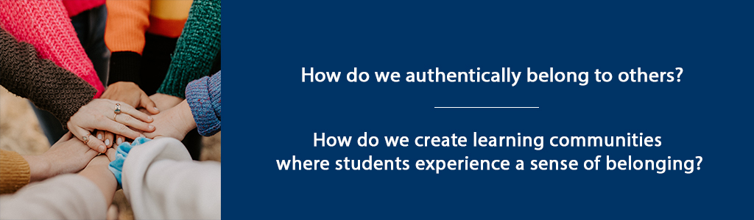

**<End dec-image>**

## Overview

Building on our discussion of “belonging to ourselves” in the previous unit, in this unit we will explore the concept of “belonging to others.” This key concept is foundational to the creation of authentic learning communities – spaces where students experience genuine connection with other learners, with the facilitator, and with the discipline they are studying.

**Unit 3 focuses on two guiding questions:**

* How do we authentically belong to others?
* How do we create learning communities where students experience a sense of belonging?

### Topics

1. Belonging to Others
2. Creating Learning Spaces Where Students Belong

### Learning Outcomes

When you have completed this unit you should be able to:

* Discuss how we can authentically belong to others.
* Describe elements of a learning community that create a sense of belonging.
* Identify problems that affect learning communities.
* Plan a learning activity that builds community.

### Activity Checklist

These learning activities will engage you in considering the guiding questions for this unit. As you plan your week, be sure to include time for these important learning activities. *Note that not all activities are required. Your instructor will provide guidance on key activities to complete.*

**<Begin learning-activity>**

**Estimated Time:**

**Learning Activities**

* Reflect on Rilke, R.M. [*Ah, Not to be Cut Off*](https://gladdestthing.com/poems/ah-not-to-be-cut-off).
* Select from the three reading options (Brown, Palmer, Westheimer) to help you reflect on inclusive learning communities.
* Listen and respond to Taylor Swift’s *A Place in this World*.

**<End learning-activity>**

**<Begin note>**

**Assessment**

* Unit 3 Discussion: Write a post in response to your readings, including the BRAVING checklist (Brown, 2017, p. 114). Then, create a learning activity you would use in a course that incorporates elements of belonging.
* Assignment 1: Identity as a Teacher Paper (20%)**: Write a 3-4 page paper in which you describe your identity as a teacher/facilitator.

**<End note>**

## 3.1 Belonging to Others

In *Braving the Wilderness: The Quest for True Belonging and the Courage to Stand Alone,* Brene Brown (2017) discusses the universal human need for belonging – and the importance of belonging authentically. She contrasts a true sense of “belonging” to “fitting in” which she describes as a sense of being accepted, but not as one’s true self.

We want to be part of something, but we need it to be real – not conditional or fake or constantly up for negotiation. We need true belonging. – Brene Brown (2017, p. 31)

According to Brown (2017), belonging involves a certain level of vulnerability, because it means we are must show up as our true selves – and those selves often include some level of doubt or weakness or insecurity.

She defines “belonging” this way:

Belonging is the innate human desire to be part of something larger than us. Because this yearning is so primal, we often try to acquire it by fitting in and by seeking approval, which are not only hollow substitutes for belonging, but often barriers to it. Because **true belonging** only happens when we present our authentic, imperfect selves to the world, our sense of belonging can never be greater than our level of self-acceptance – (Brown, 2017, p. 32).

Part of our role as teachers and facilitates or to foster learning communities where students can truly belong.

## 3.2 Creating Learning Spaces Where Students Belong

Learning, by its nature, requires us to wrestle with ideas and facts and theoretical perspectives that are new or contradict our current knowledge or beliefs. Therefore, learning spaces must serve as spaces where we can be challenged by new ideas and challenge our current thinking, while at the same time feel confident that our thoughts and perspective are valued. These learning spaces must simultaneously allow us to be our authentic selves – and allow others to be authentic as well.

Brene Brown (2017) discusses key concepts of creating spaces that facilitate a sense of belonging – including civility, inclusive language, truth, and respect. Often, the balance between truth and civility can be challenging – as we seek to authentically discuss new ideas – but in a manner that is both civil and respectful of others.

Trust is at the heart of authentic learning communities. Brown (2017) uses the acronym “BRAVING” to describe key elements of trust. These elements include Boundaries, Reliability, Accountability, Vault, Integrity, Non-Judgement, and Generosity (p. 114).

Palmer (2017) also argues that spaces free of fear are necessary for authentic learning. He describes a “shutdown” that occurs as we seek to protect ourselves – both teachers and students – and as we think about learning and knowing in from an either-or perspective, failing to acknowledge the great vastness of truth. Learning communities, then, must be places of trust, with a focus on learning that incorporates both “profound truth” and “paradox” (Palmer, 2017, p. 65).

Brower and Dettinger (1998) contend that diversity of thought and perspective is an essential element of a learning community. “When we define a community as a group of individuals committed to shared values and goals, who purposefully come together and work together to reach these goals, then diversity is encouraged not just for ideological reasons but also because different perspectives, experiences, and backgrounds contribute to the collaborative efforts to achieve the community’s goals” (Brower & Dettinger, 1998, p. 16).

### 3.2.1 Activity: Reflection

**<Begin learning-activity>**

**Estimated Time:**

Find a quiet space in your home or outdoors. Make your favourite beverage. With your iced coffee or hot tea with honey next to you, settle into a comfortable position.

Read the poem by Rainer Maria Rilke [“Ah, not to be cut off”](https://gladdestthing.com/poems/ah-not-to-be-cut-off). Sit for a moment with this poem. Re-read it. Consider the words and ideas expressed by Rilke.

In your Reflective Journal, jot down your thoughts. Consider how you have, in your own learning experiences, experienced “the winds of homecoming” or the desire “not to be cut off.”

**<Begin dec-image>**

**Alt Text:**   
**Has Lightbox:** no  
**Source Text:**   
**Source URL:**   
**Author:**   
**Author URL:**   
**Copyright:**   
**License Text:**   
**License URL:**



**<End dec-image>**

*Image by* [*Engin Akyurt*](https://pixabay.com/users/engin_akyurt-3656355/?utm_source=link-attribution&utm_medium=referral&utm_campaign=image&utm_content=2242212) *from* [*Pixabay*](https://pixabay.com/?utm_source=link-attribution&utm_medium=referral&utm_campaign=image&utm_content=2242212)

**<End learning-activity>**

### 3.2.2 Activity: Read and Reflect

**<Begin learning-activity>**

**Estimated Time:**

**There are three reading options to help you reflect on inclusive learning communities.**

1. Read: Brown (2017). Chapters 3-6.

* In preparation for the discussion in this unit, reflect on the BRAVING checklist (p. 114).
* How would you apply this concept in a course to create an inclusive, authentic learning community?

1. Read Palmer (2017) Chapter 2. As you read, consider these questions:

* How am I “at home in a universe that embraces both the smallness of ‘I’ and the vastness of all that is ‘not I,’”? (Palmer, 2017, p. 59).
* What fears do I need to overcome as a teacher so I can create space for students to express their fears?

1. Read Westheimer et. al (2004) [Education Leading to Good Citizens](assets/unit3/Westheimer.pdf).

* How would you apply what the authors are saying in a course to create an inclusive, authentic learning community?

**<End learning-activity>**

### 3.2.3 Activity: Listen and Reflect

**<Begin learning-activity>**

**Estimated Time:**

Listen to [*A Place in this World*](https://music.youtube.com/watch?v=_FNQ5qLuLjA&list=RDAMVM_FNQ5qLuLjA), sung by Taylor Swift.

**Consider the following scenario:**

Imagine a student in a course you are facilitating. A young student submits a poorly written assignment and then does not complete the next week’s assignment. When you ask the student to meet with you, she shares this song with you and shares that she feels all alone, she doesn’t feel confident writing at an academic level, and she didn’t do this week’s assignment because she’s afraid she will fail. She thinks she probably shouldn’t have been admitted to this program.

In your Reflective Journal, compose an email or talking points for a conversation with the student, specifically describing why she belongs in this course.

**<End learning-activity>**

## Summary

In this unit, you have had the opportunity to consider concepts related to our own sense of “belonging to others” and what it means to create safe learning spaces, built on trust and an awareness that learning is both vast and paradoxical. Bringing our selves to the educational experience – both as teachers/facilitators and as students/learners, we must seek to authentically engage in the learning experience – and to form connections with other learners. In the next unit, we will move from the philosophical and self-reflective to explore practical strategies for creating authentic learning communities.

## Assessment

**<Begin note>**

**Unit 3 Discussion**

**Part A: Braving**

Using the readings from this unit, including the BRAVING checklist (Brown, 2017, p. 114), write a 250-word discussion post that includes a description of each element of the checklist, as well as a 2-3 sentence description of how you would apply this concept in a course to create an inclusive, authentic learning community.

**Part B: Belonging Learning Activity**

Based on the learning activities in this unit, create a learning activity you would use in a course that incorporates elements of belonging, discussed in the course readings and your blog posts. Include the learning outcome for the activity, the learning activity, and a discussion of how the different elements of the learning activity would serve to support a sense of belonging for students.

**<End note>**

**<Begin note>**

**Assignment 1: Identity as a Teacher Paper (20%)**

Building on your learning in the first three weeks of class, write a 3-4 page paper in which you describe your identity as a teacher/facilitator. Incorporate references to the Brown (2017) and Palmer (2017) texts, as well as other resources from your graduate coursework. The paper should include an introduction, a statement of your identity as a teacher/facilitator, and a discussion of three important aspects of that identity. Your conclusion should include a discussion of how you will use your identity to create authentic spaces for learning in the courses you facilitate/teach.

**<End note>**

**<Begin note-with-icon>**

*Please submit your assignments in the appropriate dropbox in Moodle. See the Assessment section for the Grading Criteria that explains how your assignments will be evaluated.*

**<End note-with-icon>**

## Checking Your Learning

**<Begin checking-your-learning>**

**Use the learning outcomes for this unit as a checklist of understanding before you move to the next unit. Can you:**

* discuss how we can authentically belong to others?
* describe elements of a learning community that create a sense of belonging?
* identify problems that affect learning communities?
* plan a learning activity that builds community?

**<End checking-your-learning>**

# 4. Learning Communities

**<Begin dec-image>**

**Alt Text:** Guiding Questions  
**Has Lightbox:** no  
**Source Text:**   
**Source URL:**   
**Author:**   
**Author URL:**   
**Copyright:**   
**License Text:**   
**License URL:**



**<End dec-image>**

## Overview

In this unit, we will review several models of “learning communities” that provide visual representations of educational learning environments. A learning community can be created within a specific course, academic program, or professional context. Learning communities can be found across university campuses and often include a set of interdisciplinary, paired-courses that students take as a cohort. They can be grounded in residence halls with an integration of living and learning. Or, they can be developed in formal educational environments with a focus on students learning together as a cohort. Professional learning communities have also emerged as an important force in education and other fields, as colleagues gather around a shared interest, a focus on continuous quality improvement, and a shared discipline.

Learning communities are authentic, emotionally-safe and inclusive spaces (whether physical or virtual) where learners and teachers come together to engage in deep learning. By definition, a learning community includes both LEARNING and COMMUNITY.

**Unit 4 focuses on 2 guiding questions:**

* What is a learning community?
* What key elements are essential to learning communities?

### Topics

In this unit, our topics explore three different models of learning communities.

1. Pyramid Model of Learning Communities (Brower & Dettinger, 1998)
2. The Community of Truth (Palmer, 2017)
3. Trinity Community of Inquiry (Madland, 2017)

### Learning Outcomes

When you have completed this unit you should be able to:

* Describe elements of an authentic learning community.
* Compare learning community models.

### Activity Checklist

These learning activities will engage you in considering the guiding questions for this unit. As you plan your week, be sure to include time for these important learning activities. *Note that not all activities are required. Your instructor will provide guidance on key activities to complete.*

**<Begin learning-activity>**

**Estimated Time:**

**Learning Activities**

* Read “What IS a Learning Community?” (Brower & Dettinger, 1998) and respond in your Reflective Journal. Alternatively, read and reflect on Defining and Measuring Academic Success (York et. Al).
* Read and reflect on *The Courage to Teach,* Chapter 4 Knowing in Community (Palmer, P. (2017).
* Read and reflect on Trinity Community of Inquiry (Madland, 2017).

**<End learning-activity>**

**<Begin note>**

**Assessment**

* Complete your Discussion post and respond to two other peers.

**<End note>**

## 4.1 Learning Community Pyramid

The Learning Community Pyramid, developed by Brower & Dettinger (1998) includes academic, social, and physical components. They describe academic components as those that focus on the curriculum and learning that takes place. The social components are the elements of trust and inclusivity that create space for community. The physical component is the “place or facility where the community meets or resides” (Brower & Dettinger, 1998, p. 17). In the case of this course, that “place” is the course hub.

Building on the foundation of social, physical, and academic elements, Brower and Dettinger (1998) contend that learning communities also include three areas of responsibility: ethical responsibility, civic responsibility, and professional responsibility (p. 17).

According to Brower & Dettinger (1998), “Learning communities, to be considered as such, must integrate academic subject matter and social interactions while providing the physical space or facility for an intellectually stimulating environment to emerge. Furthermore, learning communities must be designed to develop a triad of responsibilities within students—professional, ethical, and civic” (p. 16).

As you consider the learning community you will facilitate, consider how you might develop or model professional, ethical, and civic responsibility within that community. Do you think leaders should develop these same areas of responsibility with the organizations or companies they lead?

### 4.1.1 Activity: Compare Community Models

**<Begin learning-activity>**

**Estimated Time:**

Read [“What IS a Learning Community?” (Brower & Dettinger, 1998)](assets/unit4/Learning_community.pdf).

**In your Reflective Journal:** - Write down three strengths of this learning community model. - Write 2-3 questions you have about this learning community. - Do you think this model accurately reflects the type of learning community you want to create? - Why or Why not?

**As we compare the other two models, feel free to organize your thoughts into a chart such as the following:**

| Strengths of model | Aspects Unique to this Model | Questions |
| --- | --- | --- |
| Learning Community Pyramid (Brower & Dettinger, 1998) |  |  |
| Community of Truth model (Palmer, 2017) |  |  |
| Trinity Community of Inquiry (Madland, 2017) |  |  |

**<End learning-activity>**

### 4.1.2 Activity: York Reading and Reflection

**<Begin learning-activity>**

**Estimated Time:**

Read York et.al - [Defining and Measuring Academic Success](https://eric.ed.gov/?q=EJ1059739) (2015). Also available through the TWU library.

In your Reflective Journal, write down three strengths of the way York et.al defines and measures academic success. How do these measure “fit” into an authentic learning community?

**<End learning-activity>**

## 4.2 The Community of Truth (Palmer, 2017)

Palmer’s learning community model (2017) incorporates both learning and community with a “subject” as the center, surrounded by “knowers” who are in relationship to both each other and the subject. Palmer (2017) assets that “the community of truth, far from being linear and static and hierarchical, is circular, interactive, and dynamic” (p. 106).

**<Begin dec-image>**

**Alt Text:**   
**Has Lightbox:** no  
**Source Text:**   
**Source URL:**   
**Author:**   
**Author URL:**   
**Copyright:**   
**License Text:**   
**License URL:**

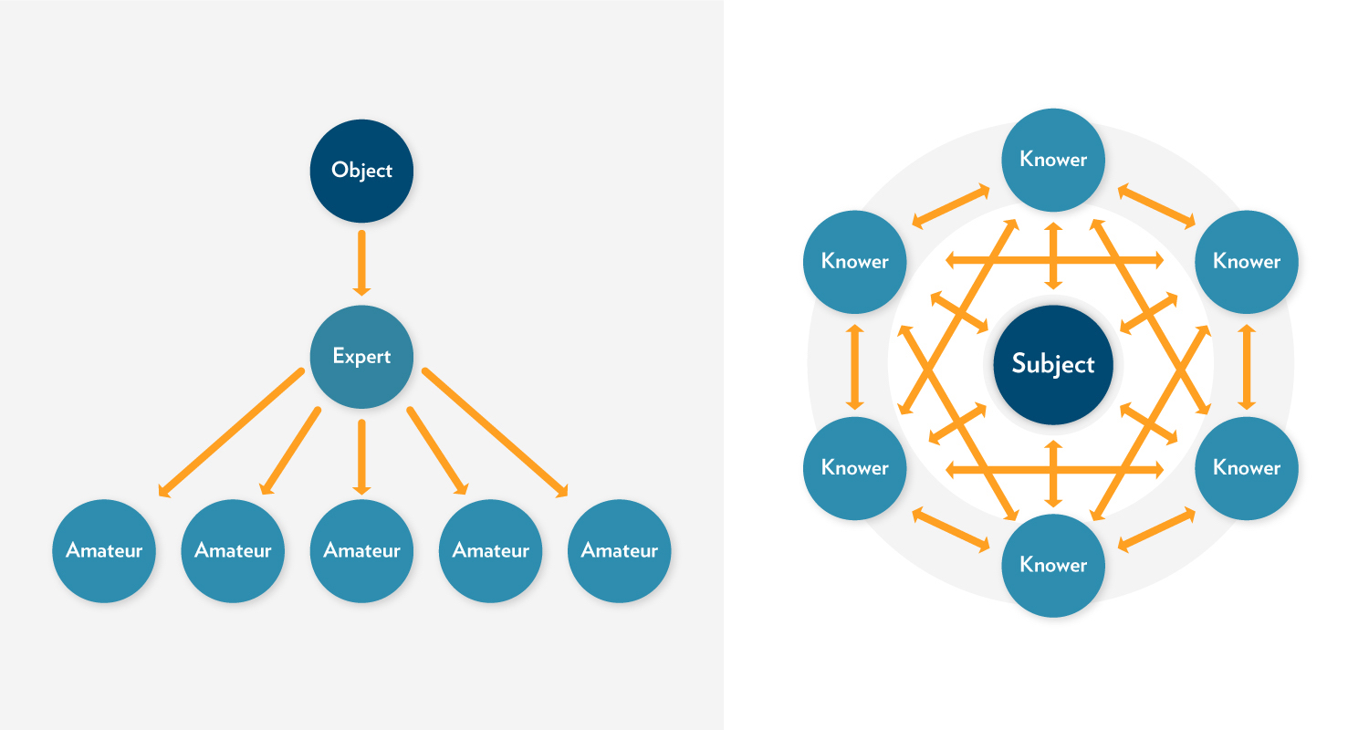

**<End dec-image>**

The learning that takes place in this model is captured in this statement: “I understand truth as the passionate and disciplined process of inquiry and dialogue itself, as the dynamic conversation of a community that keeps testing old conclusions and coming into new ones” (p. 106).

As teachers, we approach teaching with some sense that we have some thing (some subject) to teach students. Palmer (2017) challenges us to think differently about the teaching/learning experience. (See “The Objectivist Myth of Knowing,” p. 103 and “The Community of Truth,” p. 105).

Instead of solely focusing on what we must teach (and what students must learn), Palmer challenges us to consider how we all might learn something more together – more than is already known – through the teaching/learning experience. In this way, we must consider that we are not just engaged in transferring information or knowledge, but that (in addition to that), together we might create new knowledge.

I know of no field, from science to religion, where what we regard as objective knowledge did not emerge from long and complex communal discourse that continues to this day, no field where the facts of the matter were delivered fully formed from on high (Palmer, 2017, p. 107).

Palmer’s (2017) model highlights the relational knowledge of learning communities, underscoring not just the relationship of the people involved, but also the relationships between people and subject. As you consider facilitating learning communities, give some thought to your own relationship to the subject to be taught and learned. Consider whether you “know” this subject objectively or subjectively.

### 4.2.1 Activity: Palmer Reading and Reflection

**<Begin learning-activity>**

**Estimated Time:**

Read *The Courage to Teach,* Chapter 4 “Knowing in Community” (Palmer, 2017).

**In your Reflective Journal:** - Write down three strengths of this learning community model. - Write 2-3 questions you have about this learning community. - Do you think this model accurately reflects the type of learning community you want to create? - Why or Why not?

**<End learning-activity>**

## 4.3 The TWU Community of Inquiry (Madland, 2017)

In our online courses, Trinity Western University seeks to create learning communities that engage student learning on a cognitive, social, and spiritual level. The TWU Community of Inquiry model is a visual representation of these three aspects of learning (Social, Cognitive, and Spiritual), and how they interact with each other. At the intersections of these elements, you find:

1. Community of Inquiry
2. Community of Faith
3. Integration of Faith and Reason

Combined, these three elements can lead to transformational learning – an aspiration we hold in this course and program – and a fundamental goal of higher education in a broader sense.

**<Begin dec-image>**

**Alt Text:**   
**Has Lightbox:** no  
**Source Text:**   
**Source URL:**   
**Author:**   
**Author URL:**   
**Copyright:**   
**License Text:**   
**License URL:**

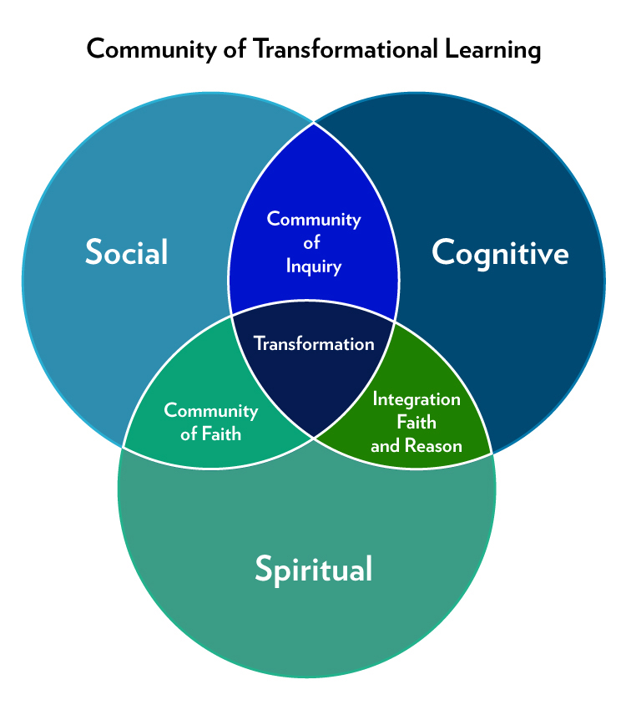

**<End dec-image>**

**<Begin dec-image>**

**Alt Text:**   
**Has Lightbox:** no  
**Source Text:**   
**Source URL:**   
**Author:**   
**Author URL:**   
**Copyright:**   
**License Text:**   
**License URL:**

Community of Transformational Learning by Colin Madland is licensed under a Creative Commons Attribution-ShareAlike 4.0 International License.

**<End dec-image>**

### 4.3.1 Activity: Madland Reading and Reflection

**<Begin learning-activity>**

**Estimated Time:**

Review the [The Trinity Community of Inquiry](assets/unit4/Madland-transformational-learning.pdf) (Madland, 2017).

**In your Reflective Journal:** - Write down three strengths of this learning community model. - Write 2-3 questions you have about this learning community. - Do you think this model accurately reflects the type of learning community you want to create? - Why or Why not?

**<End learning-activity>**

## Summary

The learning community models we have considered in this unit share some similarities. In each model, there is an awareness that learners and learning is multidimensional. As we engage in teaching and learning, we must always be aware that the learning process is, fundamentally, transformative. It engages people, not only on an intellectual level, but also on a spiritual and social level. By designing curriculum, pedagogy, and learning around all aspects of learning – social, cognitive, and spiritual – we provide the foundation for transformational learning.

Palmer (2017) puts it this way:

The reality we belong to, the reality we long to know, extends far beyond human beings interacting with one another… This is a community held together not only by our personal powers of thought and feeling but also by the power of ‘the grace of great things’” (p. 109).

As Palmer (2017) points out, learning includes both thought (cognitive) and feeling (social), but also something beyond those – the overarching spiritual nature of life and learning.

## Assessment

**<Begin note>**

**Unit 4 Discussion**

After completing this unit, including the learning activities, you are asked to write a 250-word discussion post on the following:

Provide a brief description of each of the three models (with citations as appropriate). Select the learning community model that most closely aligns with your identity and values as a teacher/facilitator. In your post, tell your readers the strengths you see in this model, explaining why it resonates with your concepts of teaching and learning.

**<End note>**

**<Begin note-with-icon>**

*Please submit your assignments in the appropriate dropbox in Moodle. See the Assessment section for the Grading Criteria that explains how your assignments will be evaluated.*

**<End note-with-icon>**

### Checking your Learning

**<Begin checking-your-learning>**

**Use the learning outcomes for this unit as a checklist of understanding before you move to the next unit. Can you:**

* describe elements of an authentic learning community?
* compare learning community models?

**<End checking-your-learning>**

## References

* Athabasca University. (n.d.) Community of Inquiry Model. Retrieved from: <https://coi.athabascau.ca/coi-model>
* Brower, A., Carlson-Dakes, C.G., Barger, S.S. (2007). A learning community model of graduate student professional teaching excellence. *Wisconsin Center for the Advancement of Postsecondary Education*. Retrieved from: <https://minds.wisconsin.edu/bitstream/handle/1793/43615/WP010.pdf?sequence=1&isAllowed=y>
* Brower, A. & Dettinger, K. (1998). What is a learning community?: Toward a comprehensive model. *About Campus: Enriching the Student Experience. 3*(5), 15-21*.
* Madland, C. (2017). The Trinity Community of Inquiry. Creative Commons License.
* Palmer, P. (2017). *The courage to teach: Exploring the inner landscape of a teacher’s life.* San Francisco: Wiley.

# 5. Creating Space for All Learners

**<Begin dec-image>**

**Alt Text:** Guiding Questions  
**Has Lightbox:** no  
**Source Text:**   
**Source URL:**   
**Author:**   
**Author URL:**   
**Copyright:**   
**License Text:**   
**License URL:**

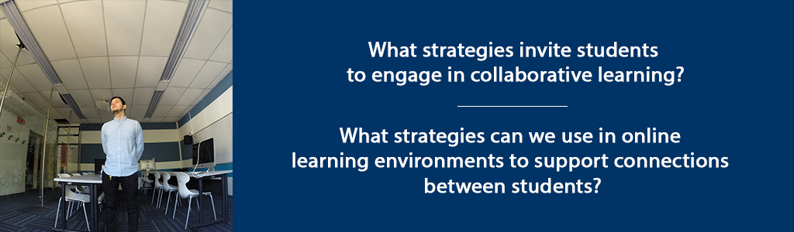

**<End dec-image>**

## Overview

Building on our discussion of learning community models, in this unit we will explore specific strategies to engage students in collaborative learning, and support connections between learners.

**Unit 5 focuses on two guiding questions:**

* What strategies invite students to engage in collaborative learning?
* What strategies can we use in online learning environments to support connections between students?

### Topics

1. Creating Collaborative Learning in an Online Environment
2. Supporting Connections Between Learners

### Learning Outcomes

When you have completed this unit you should be able to:

1. Identify facilitator strategies that invite students to engage in collaborative learning.
2. Identify strategies in online learning environments that support connections between students.

### Activity Checklist

These learning activities will engage you in considering the guiding questions for this unit. As you plan your week, be sure to include time for these important learning activities. *Note that not all activities are required. Your instructor will provide guidance on key activities to complete.*

**<Begin learning-activity>**

**Estimated Time:**

**Learning Activities**

* Read: Palmer, P. (2017) *The Courage to Teach,* Chapter 5 Teaching in Community; Chapter 6 Learning in Community, Chapter 7 Divided No More.
* Review the [“Principles of Appreciative Inquiry”](https://appreciativeinquiry.champlain.edu/learn/appreciative-inquiry-introduction/5-classic-principles-ai)
* Listen: Sarah Bareilles [Brave](https://www.youtube.com/watch?v=QUQsqBqxoR4). Watch: Kalhil KJ Adames [Identity Short Film](https://www.youtube.com/watch?v=ikGVWEvUzNM). Read: Brown, B. (2017) *Braving the Wilderness,* Chapter 7 Strong Back. Soft Front. Wild Heart.
* Read Burwell & Huyser (2013). Practicing hospitality in the classroom. Respond in your Reflective Learning Journal.

**<End learning-activity>**

**<Begin note>**

**Assessment**

* Unit 5 Discussion - Part 1: Appreciative Inquiry & Part 2: **Peer Interview**

**<End note>**

## 5.1 Creating Collaborative Learning in an Online Environment

In our role as a teacher or facilitator, we are engaged in leading learners through a transformational educational process. “Collaborative Inquiry” is a process through which we, as educators, engage in learning about the practice of teaching through collaborative inquiry and reflection (Donohoo & Velasco, 2016).

Athabasca University defines a *Community of Inquiry* as “a group of individuals who collaboratively engage in purposeful critical discourse and reflection to construct personal meaning and confirm mutual understanding” (Athabasca University, n.d.).

While *Collaborative Inquiry* is often used to describe a process used by professional learning communities to guide organizational change – or to describe *Communities of Practice* among educators – collaborative inquiry is also a practice that can be implemented within classrooms.

The fields of Collaborative Inquiry (Donohoo & Velasco, 2016) and Appreciative Inquiry (Whitney & Trosten-Bloom, 2010) are built on the premise that we must all collaborate together in a community of learners, and that by doing so, we can generate learning that goes beyond what we might learn on our own. It is a strengths-based approach to learning and change that has been described as “unifying moments when joy touches joy, strength touches strength, health touches health, inspiration combines with inspiration – and how to make the combinations happen more rapidly and frequently” (Cooperrider, D., as cited in Whitney & Trosten-Bloom, 2010, p. xiii).

Palmer’s (2017) “Community of Truth” that we explored in the last unit, incorporates the essence of collaborative learning, underscoring the importance of relationship within education. He writes, “What seems right for me, after many years of searching, is to sit in a circle with my students (or try to relate to the crowd in a lecture hall as if we were in a circle) and lead an inquiry into the great thing in our midst, But there are other ways to create community in the classroom, and some of them look nothing like the interactive encounter we normally associate with that word” (p. 139).

Whitney & Trosten-Bloom cast a compelling vision for collaborative environments where the act of engaging in appreciative inquiry can transform communities. They write: “Appreciative Inquiry transforms organizations into places that are free and alive, where people are eager and filled with positive power, and where the creativity of the whole never ceases to amaze, surprise, and innovate” (Whitney & Trosten-Bloom, 2010, p. xi). Learning communities, too, can become places that are free and alive, where all members of the community engage in challenging, authentic learning.

**Appreciative Inquiry (Whitney & Trosten-Bloom, 2010) is built on eight principles, which can inform the way we support learners in an online learning context. These include:**

1. The Constructionist Principle
2. The Simultaneity Principle
3. The Poetic Principle
4. The Anticipatory Principle
5. The Positive Principle
6. The Wholeness Principle
7. The Enactment Principle
8. The Free-Choice Principle

*(Whitney & Trosten-Bloom, 2010, p. 52).*

**<Begin dec-image>**

**Alt Text:** Principles of Appreciative Inquiry  
**Has Lightbox:** no  
**Source Text:**   
**Source URL:**   
**Author:**   
**Author URL:**   
**Copyright:**   
**License Text:**   
**License URL:**

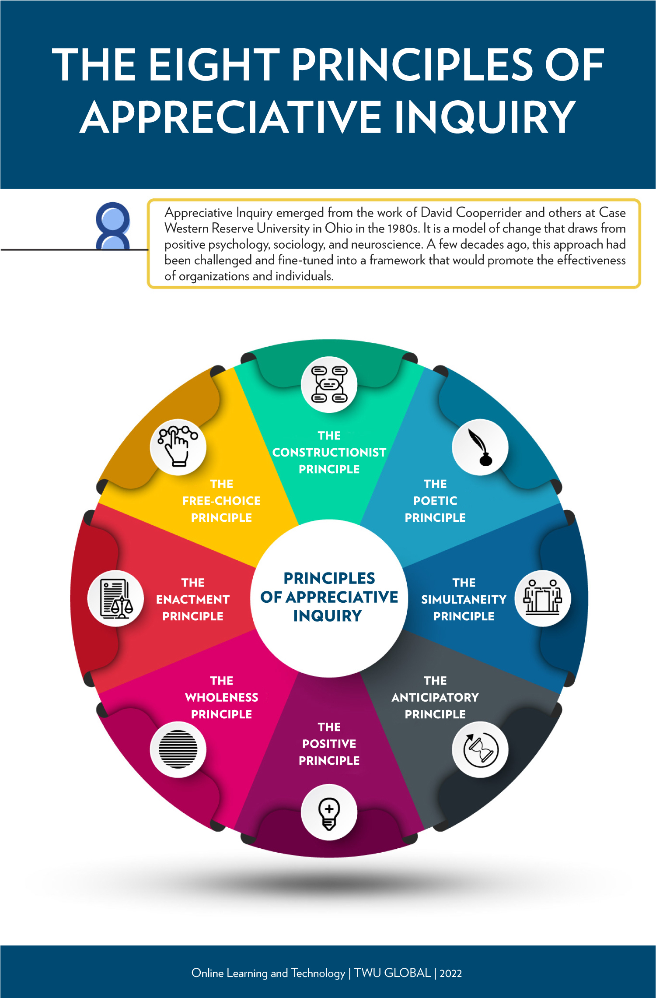

**<End dec-image>**

These principles can serve as a guide for facilitating online discussions, designing lessons, and providing formative feedback to learners. For example, the “Simultaneity Principle” is based on the premise that by its nature, asking questions not only leads to change, but the very act of engaging in inquiry is, in fact, the first step in change. According to this principle, “the moment we ask a question, we begin to create a change” (Whitney & Trosten-Bloom, 2010, p. 52).

Likewise, the “Free-Choice Principle” contends that “people perform better and are more committed when they have freedom to choose how and what they contribute” (Whitney & Trosten-Bloom, 2010, p. 52). Facilitating discussions that allow learners to engage in conversation (whether face-to-face or online), determine some aspects of their assignments, select topics, etc., can have a powerful influence on student engagement with learning.

### 5.1.1 Activity: Palmer Reading and Reflection

**<Begin learning-activity>**

**Estimated Time:**

Read: Palmer, P. (2017) *The Courage to Teach,* Chapter 5 Teaching in Community; Chapter 6 Learning in Community, Chapter 7 Divided No More.

**In your Reflective Journal, make notes on the following questions:**

1. What specific actions could you take to invite students in to the “community of truth”?
2. What questions can I ask to invite students to engage in collaborative, inquiry-based learning?

**<End learning-activity>**

### 5.1.2 Activity: AI Read and Discussion

**<Begin learning-activity>**

**Estimated Time:**

Review the [“Principles of Appreciative Inquiry”](https://appreciativeinquiry.champlain.edu/learn/appreciative-inquiry-introduction/5-classic-principles-ai/) from the Appreciative Inquiry Commons at Champlain University. (Also in Whitney & Trosten-Bloom. (2010). *The power of appreciative inquiry: A practical guide to positive change.*)

* Select two of the Principles of Appreciative Inquiry. In a 250-word discussion post, describe a learning activity you would conduct with your class that integrates both of these principles. For example, how would you design a writing assignment that included “Positive Principle”?
* **Or**, describe an assignment through which you ask students to create a short video that incorporates the “Poetic Principle.”

**<End learning-activity>**

## 5.2 Supporting Connections Between Learners

Creating a positive, open, learning environment is a critical component for fostering authentic learning – a place where we can both belong to ourselves and to others.

Brown (2017) poses these questions:

Are we willing to show up and be seen when we can’t control the outcome? Are we willing to create courageous spaces so we can be fully seen? (p. 154)

Palmer (2017), offers five suggestions for ways in which we can prepare students for engagement in authentic communities – both in education, our places of work, and our communities.

1. We must help our students debunk the myth that institutions process autonomous, even ultimate, power over our lives.
2. We must validate the importance of our students’ emotions as well as their intellect.
3. We must teach our students how to “mine” their emotions for knowledge.
4. We must teach them how to cultivate community or the sake of both knowing and doing.
5. We must teach – and model for – our students what is meant to be on the journey toward “an undivided life.” (p. 205).

In this course, we are exploring concepts of education that include our emotional experiences with learning, the importance of community, the nature of knowledge, and the foundational importance of the teacher’s authenticity. For some academics, the acknowledgement of the emotional experience of education can be challenging, according to Palmer, who argues that the feelings we have influence our learning.

Donohoo and Velasco (2016), in their work on Collaborative Inquiry, also underscore the importance of acknowledging the emotional experiences of student. “There is no doubt that learning is interrupted when negative emotions and attitudes surface, as such feelings hinder our ability to make sense of things” (Donohoo and Velasco, 2016, p. 36).

### 5.2.1 Activity: View and Reflect

**<Begin learning-activity>**

**Estimated Time:**

For this activity, you will spend some time reflecting on your own experience as a learner, in order to consider the needs of the students you lead in online and face-to-face learning environments. So pick up your Reflective Learning Journal, grab your laptop, and settle down into a comfy chair (or sit among some trees).

1. [Watch: *Identity* by Kalhil KJ Adames (5 minutes)](https://www.youtube.com/watch?v=ikGVWEvUzNM)

<https://www.youtube-nocookie.com/embed/ikGVWEvUzNM>

|  |  |
| --- | --- |
|  | **Note from Production**  Bleep bloop: The above video was auto embedded. If it was just a link, I added a title. If you don’t like the title, change it, and I’ll leave it alone if I come across it again. |

1. [Listen: Sara Bareilles - Brave](https://www.youtube.com/watch?v=QUQsqBqxoR4)

<https://www.youtube-nocookie.com/embed/QUQsqBqxoR4>

|  |  |
| --- | --- |
|  | **Note from Production**  Bleep bloop: The above video was auto embedded. If it was just a link, I added a title. If you don’t like the title, change it, and I’ll leave it alone if I come across it again. |

1. Read: Brown (2017) *Braving the Wilderness,* Chapter 7 Strong Back. Soft Front. Wild Heart.

**Jot down some of your notes describing your own identity as a student.**

* List 2-3 times in your educational experience where you have been “brave” by sharing your thoughts or concerns in a learning environment – whether with other learners or teachers.
* List 2-3 times when you wanted to speak up, but chose instead to remain silent.
* Reflect on how these actions impacted your experience as a learner. Consider what you might do, as a course facilitator, to encourage learners to speak up.

**<End learning-activity>**

### 5.2.2 Activity: Read and Strategize

**<Begin learning-activity>**

**Estimated Time:**

Read Burwell & Huyser (2013). Practicing hospitality in the classroom (available through the [TWU Library](https://www.twu.ca/library).

In your Reflective Learning Journal, make a note of the “stances” described by the authors. For each Stance, list one strategy you can employ to practice hospitality in your classes. Be as specific as possible.

**<End learning-activity>**

## Summary

In this unit, we have considered how we can create learning environments where students belong, the essential nature of creating connections between learnings, and specific strategies we can use to support collaborative learning.

## Assessment

**<Begin note>**

**Unit 5 Discussion**

After completing this unit, including the learning activities, you are asked to write a discussion post on the following:

**Part 1: Principles of Appreciative Inquiry**

Select two of the Principles of Appreciative Inquiry. In a 250-word post, describe a learning activity you would conduct with your class that integrates both of these principles. For example, how would you design a writing assignment that included “Positive Principle”? Or, describe an assignment through which you ask students to create a short video that incorporates the “Poetic Principle.”

**Part 2: Peer Interview**

In this discussion, you will interview another student in this class to explore strategies for creating inclusive, collaborative learning communities.

First, develop a minimum of five questions to guide the interview process. The questions should be developed based on your course learning to date, and should integrate the articles, Ted talks, short films, and other resources we have reviewed together. Building on your learning, develop at least five questions that you will ask another learner, in order to answer the guiding questions of this unit:

1. What strategies invite students to engage in collaborative learning?
2. What strategies can we use in online learning environments to support connections between students?

Then, contact the student assigned to you for this assignment and schedule a time to meet, preferably in real-time, through zoom, skype, some other form of video conferencing, or by phone.

After you have completed the interview, prepare a 250-word discussion post, identifying at least three strategies you can use to engage students in collaborative learning as well as strategies you can use to support connections between students in online learning environments. Be sure to reference the other learner for her/his original ideas.

**<End note>**

**<Begin note-with-icon>**

*Please submit your assignments in the appropriate dropbox in Moodle. See the Assessment section for the Grading Criteria that explains how your assignments will be evaluated.*

**<End note-with-icon>**

## Checking Your Learning

**<Begin checking-your-learning>**

**Use the learning outcomes for this unit as a checklist of understanding before you move to the next unit. Can you:**

* identify facilitator strategies that invite students to engage in collaborative learning?
* identify strategies in online learning environments that support connections between students?

**<End checking-your-learning>**

## References

* Bell, T., Urhahne, D., Schanze, S., & Ploetzner, R. (2009). Collaborative inquiry learning: models, tools, and challenges. *International Journal of Science Education. (32)*3, 349-377.
* Brown, B. (2017). *Braving the wilderness: The quest for true belonging and the courage to stand alone.* New York: Penguin Random House.
* Burwell, R. & Huyser, M. (2013). Practicing hospitality in the classroom. *International Journal of Christianity and Education. 17*(1), 9-24.
* Donohoo, J. & Velasco, M. (2016). *The Transformative Power of Collaborative Inquiry.* Corwin (SAGE): Thousand Oaks, CA.
* Palmer, P. (2017). *The courage to teach: Exploring the inner landscape of a teacher’s life.* San Francisco: Wiley.
* Whitney, D., Trosten-Bloom, Amanda. *The Power of Appreciative Inquiry: A Practical Guide to Positive Change, 2nd Edition*. Berrett-Koehler Publishers, 03/2010.

# 6. Authentic Learning and Identity

**<Begin dec-image>**

**Alt Text:** Guiding Questions  
**Has Lightbox:** no  
**Source Text:**   
**Source URL:**   
**Author:**   
**Author URL:**   
**Copyright:**   
**License Text:**   
**License URL:**



**<End dec-image>**

## Overview

As you have explored in units 1-5, personal authenticity refers to genuineness, vulnerability and connectedness. In units 5-10 we will broaden the lens to consider the adult educator as authentic leader and facilitator in the learning environment. We will engage with the writings of [Margaret Wheatley](http://margaretwheatley.com/home/), a peace activist, philosopher, world traveler and management consultant. Before you begin the second half of the course, I invite you to take a few minutes to explore her website and get a sense of her work as it relates to creating authentic learning communities. Her book contains powerful concepts that will challenge you to see leadership with a new lens. She suggests that her book not be read but savoured because the concepts need to be dwelt upon. I agree that you will get more out the book if you take your time, pause frequently and note ideas in your reflective journal.

In this unit we will consider the impact of identity in a learning environment and the adult educator as creator and leader of a learner centered environment. Given the prominence of technology in contemporary society, we will consider Wheatley’s comments about the use of technology and how this influences leadership and communication.

**Unit 6 focuses on two guiding questions:**

* How does my identity impact the learning environment?
* What actions can support learners and focus on people and relationships?

### Topics

1. The Impact of Identity in a Learning Environment
2. The Adult Educator as Creator and Leader of a Learner Centered Learning Environment

### Learning Outcomes

When you have completed this unit you should be able to:

1. Evaluate personal and professional attitudes towards technology in light of authentic learning and identity.
2. Develop a personal philosophy of the role of facilitator in creating authentic learning communities
3. Evaluate and choose strategies to adapt to the identity and learning needs of participants.

### Activity Checklist

These learning activities will engage you in considering the guiding questions for this unit. As you plan your week, be sure to include time for these important learning activities. *Note that not all activities are required. Your instructor will provide guidance on key activities to complete.*

**<Begin learning-activity>**

**Estimated Time:**

**Learning Activities**

* Read Wheatley: Opening and chapters 1 and 2, and take notes in your Reflective Journal.
* Browse the Brookfield, Silberman texts and the [*Liberating Structures* website](http://www.liberatingstructures.com/ls-menu/). Take notes in your journal about the impact of technology.

**<End learning-activity>**

**<Begin note>**

**Assessment**

* Choose one of the two topics listed and write your discussion post

**<End note>**

## 6.1 The Impact of Identity in a Learning Environment

An essential question for adult educators to reflect on is: *What matters to me and how can my work advance this in some way?* Discovering and acting upon a purpose beyond oneself brings meaning to work and can motivate learners to find meaning also. This leads to a deeper commitment and sense of fulfillment. Having a greater purpose creates unity and fights fragmentation in the activities of life. The words of Jean Vanier are a call to action for all adult educators:

It is always good for individuals, communities and indeed nations, to remember that their present situation is a result of the thousands of gestures of love or hate that came before. This obliges us to remember that the community of tomorrow is being born of our fidelity to the present. We discover that we are at the same time very insignificant and very important because each of our actions is preparing the humanity of tomorrow; it is a tiny contribution to the huge and glorious final humanity. (Vanier, 1989, p.152)

What we value, we prioritize, and this directs our work and lives, shaping not just what we do but who we become. We need to start practicing now who we want to be in the future (Bregman, P., 2016).

Adult educators have a privileged position in the lives of their students that can be leveraged to help them develop the skills, attitudes and dispositions they need to improve their lives and those of others. In this sense, an adult educator is a leader of self and a leader in the classroom. *Who* we are matters.

Figuring out how our identity impacts the learning environment involves discerning our personal values through self-reflection. What makes us act and react the way we do? Through what screens do we view and respond to life? On what basis do we make decisions? Questions, like those in the following list (Atha et al., 2018, p. 26), can assist with the values and identity discernment process:

1. What is important to me?
2. What makes me feel fulfilled?
3. What make me feel angry or indignant?
4. What makes my life meaningful?
5. What makes me feel fulfilled and gets my adrenalin flowing?
6. What influences my decision-making process?
7. How do I like to be treated?
8. How do I treat others?

### 6.1.1 Activity: Wheatley Reading and Reflection

**<Begin learning-activity>**

**Estimated Time:**

Read Wheatley, M. (2017). *Who Do We Choose to Be? : Facing Reality, Claiming Leadership, Restoring Sanity.* Oakland, CA: Berrett-Koehler Publishers. Opening pages 2-25; Chapters 1 (pages 28-61 and 2 (pages 63-97). As you read these pages think about a teacher, instructor or professor who is/was a leader in your eyes - someone you’ve most admired. What were their behaviours? How did you feel in their classroom? What kind of student were you, including the quality of what you produced? How do you feel about them now?

**As you read Wheatley (2017) answer the following questions in your Reflective Learning Journal:**

* Write a summary sentence for each major idea/concept that relates to belonging.
* Choose the concept that you would like to apply in your own learning communities, both as a student and teacher/facilitator.
* Formulate one question that emerged from this reading that you will explore and consider in future course readings and discussions.

**As you prepare your discussion post, refer to these notes.**

**<End learning-activity>**

## 6.2 The Adult Educator as Creator and Leader of a Learner Centered Learning Environment

Being ‘learner centered’ means teaching people not subjects. It means thinking about who is in your class, their prior knowledge about the topic, any fears or resistance they may bring to the topic and only then planning for facilitation of content. The person of the learner - not the curriculum - is the primary focus. A skillful educator however, will use the content to impact the learner and attain learning objectives. For adult educators who strive to be servant leaders, the undergirding value is human dignity, as philosopher Immanuel Kant admonishes:

Act so that you treat humanity, whether in your own person or in that of another, always as an end and never as a means only. (Rachels, 1986, p. 1)

Servant leadership is an appropriate model for adult educators who strive to:

serve others by investing in their development and well-being for the benefit of the common good. … aspire to be great only in their service to others… with integrity, humility, sincere concern, a generous, forgiving and giving heart, and self-discipline… by investing, empowering, caring for, and consulting others. (Atha et al, 2018, p. 1)

The resources you have in Brookfield, Silberman and Lipmanowiz and McCandess are learner centered in that their goal is learner engagement. Skillful adult educators try to avoid what Lipmanowicz and McCandless (2013) assert:

Unwittingly, the conventional structures used to organize how people routinely work together stifle inclusion and engagement. Conventional structures are either too inhibiting (presentations, status reports and managed discussions) or too loose and disorganized (open discussions and brainstorms) to creatively engage people in shaping their own future. They frequently generate feelings of frustration and/or exclusion and fail to provide space for good ideas to emerge and germinate. (from <http://www.liberatingstructures.com/home/>)

By incorporating liberating structures or those suggested by Brookfield and Silberman, you will indeed avoid methods and processes that stifle. Instead, you will liberate learners to express themselves and be transformed into agents of transformation. Strategies for engagement build confidence and can have a strong, positive impact on self-efficacy and identity in the sense of empowering learners to take action. As an adult educator you have a role of equipping leaders – whether for self-leadership or leadership with others. This broader view of the role can also be purpose-filled and motivating so embrace and enjoy it!

### 6.2.1 Activity: Strategies for Supporting Learners

**<Begin learning-activity>**

**Estimated Time:**

The belief in technology to fix the messes we’ve made and to save us from decline has been labeled by Ronald Wright, ‘The Progress Trap’ (Wheatley, p. 41).

**Wheatley’s point is that an over-reliance on technology is not helpful in the creation of an adult learning environment. What is then?**

Browse through the Brookfield, Silberman texts and the [*Liberating Structures* website](http://www.liberatingstructures.com/ls-menu/). Jot down in your journal what actions and strategies (whether technology-oriented or not) an adult educator can choose, to support and focus on people and relationships in a technologically-driven world.

**<End learning-activity>**

## Summary

In this unit, you have had the opportunity to learn about the adult educator as authentic leader and facilitator in the learning environment. You have considered the impact of identity in a learning environment and the adult educator as creator and leader of a learner centered environment.

## Assessment

**<Begin note>**

**Unit 6 Discussion**

**After completing this unit, including the learning activities, you are asked to choose one of the two themes to write on:**

**Option A**

Do some research about a marginalized group related to your current or future working context. What will be important for you to understand about this group in order to teach authentically in that space? What indigenous perspectives need to be considered? Consider how your own identity impacts your ability to interact in this space.

**Option B**

Explore the concept of Assimilation.

Have you ever tried to hide your home language, religion or any other aspect of your family’s culture from your friends or classmates? If so, why? Describe the experience, how it felt, and what, if anything, about the situation you would change if you could.

**<End note>**

**<Begin note-with-icon>**

*Please submit your assignments in the appropriate dropbox in Moodle. See the Assessment section for the Grading Criteria that explains how your assignments will be evaluated.*

**<End note-with-icon>**

## Checking Your Learning

**<Begin checking-your-learning>**

**Use the learning outcomes for this unit as a checklist of understanding before you move to the next unit. Can you:**

* evaluate personal and professional attitudes towards technology in light of authentic learning and identity?
* develop a personal philosophy of the role of facilitator in creating authentic learning communities?
* evaluate and choose strategies to adapt to the identity and learning needs of participants?

**<End checking-your-learning>**

### Resources

* Atha, D.L., Castellon, A.R., Strong, H., & Wu, T. (2017). MA Leadership and MA in Educational Leadership Monograph 2018. *Unpublished Manuscript Trinity Western University, Langley BC*, (70), 22–32.
* Brookfield, Stephen and Preskill, S. (2016). *The Discussion Book: 50 Great Ways to Get People Talking*. San Francisco: Jossey Bass. Various; as needed
* Lipmanowicz, H., McCandless, K. (2013) *Liberating Structures.* Creative Commons License. Liberating Structures Press. Retrieved from: <https://www.liberatingstructures.com/>
* Rachels, J. (1986). *The Elements of Moral Philosophy*, pp. 114-17,122-23. NY: Random House, Inc.
* Silberman, M. L., & Biech, E. (2015). *Active training: A handbook of techniques, designs, case examples, and tips* (4th ed.). Wiley. Various; as needed.
* Wheatley, M. (2017). *Who Do We Choose to Be? : Facing Reality, Claiming Leadership, Restoring Sanity.* Oakland, CA: Berrett-Koehler Publishers.