Landing, Login, and Enrollment Pages Development

Taylor Walston

The University of Arizona Global Campus

CST499: Capstone for Computer Software Technology

Joseph Rangitsch

March 28, 2025

Landing, Login, and Enrollment Pages Development

For this assignment, the LAMPP stack was installed on a Windows laptop to C:\XAMPP. This provides an XAMPP Control Panel, allowing for Apache and MySQL to be administered and launched. I used the most recent LAMPP stack and Bootstrap versions for this project.A screenshot of a computer

HTML content written to the htdocs subdirectory is served through Apache. For simplicity, I created a CST499 subdirectory to contain the contents of this project. The PHP files created in this directory are run by invoking localhost/CST499/index.php.

Data access is conducted using the MySQL database, and the web server is provided through a local installation of Apache as part of the XAMPP product grouping. A standard database.php class is created to provide a cross-cutting feature allowing for database access through methods tailored according to need. Fetches are provided through query methods, while updates and selects containing user input are made through “safe” methods. These “safe” methods provide user input sanitation to prevent SQL injection attacks using prepared queries and the mssqi database access library.

**Insert Registration Code**

The handler for the form uses the generic database class to capture the form fields from the post and create an insert statement for the User table.

Registration Page layout:

I have used a freeware registration image to capture a pleasing registration form. I used the Bootstrap 5 columnar layout to place the form on the left and the responsive image on the right. All fields are validated as required, and the Bootstrap 5 types are indicated to capture appropriate numeric and text inputs.

Table Structure

Data after insert:

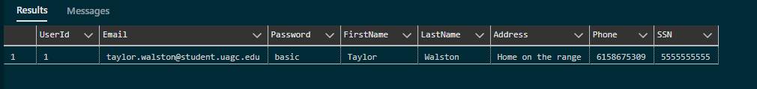

Registration Source Code

The form is identified as “registrationForm,” and the post action type is set. This will be captured with a DOM-rendered event below to post to an insert_registration PHP script. Again, bootstrap form groups and row/column layouts are utilized. Bootstrap 5 utilizes a Row and column layout strategy. I got a tight registration page by placing labels and inputs in the same row. Each row is separated with a bottom margin of 3 to provide simple spacing. Data is named and captured using input tags that specify the data type and require each field. This will constrain the data in each field and require all fields to be provided before the form is submitted for insertion.

The image is provided as the img_fluid class to fit into the div size in the right-hand column. Additionally, a script is registered on the form to provide a success message and clear the form after data is sent. Using preventDefault(), I bypass the form’s defined submit action, allowing me to capture the operation's success, display the success alert, and reset the form. .

Session logic captures the signed-in user as a super global state. This state controls navigation menu options, fetches the logged-in user profile for editing, and is cleared when the user signs out of the site. User information is stored in a user table in MySQL. Connection information is encapsulated in a config.php file stored in a production site in a non-accessible file location on the server. Web and responsive layouts are provided using Twitter Bootstrap version 5. Freeware images were used to provide a pleasant user experience.

**References**

Connolly, R., & Hoar (2022), R.*Fundamentals of Web Development, 3/e* Pearson.

Kasia Mikoluk.XAMPP Tutorial: How to Use XAMPP to Run Your Own Web Server. <https://blog.udemy.com/xampp-tutorial/>