Tyler Wathey

MISY Homework

1.

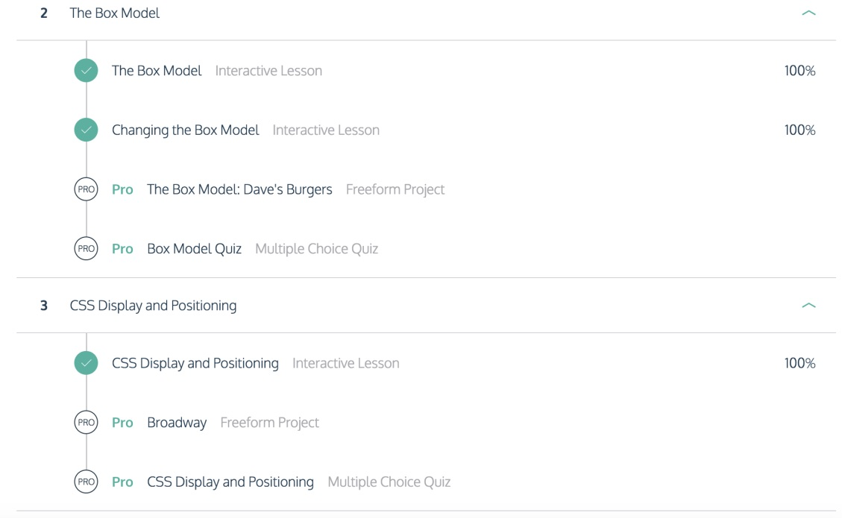

2. a. what's the difference between Margin and Padding?

**Padding is the space that’s inside the element between the element and the border. It goes around all sides. Margin is whats between the border and next element.**

b. what property can used to hide or show elements?

**The display property can be used to hide or show elements.**

c. given the following CSS code snippet, what's the bottom margin and padding:

margin: 10px 15px 20px 25px;

padding: 10px 15px;

**30px**.

3.

1. Why “Top Vacation Spots” in blue?

The .title selector is applied and the heading has the title class applied to it.

.title {

color : blue;

}

1. Does the order of the classes matter? <h1 class="title cursive capitalize">Top

Vacation Spots</h1>

Yes, the last word in the sentence takes precedent in how the phrase will be styled. It is most specific from left to right.

1. Does the “capitalize” class work?

The capitalize class does not work.

1. What does the following do? .description h5 { color: green;}

It takes any h5 within the description class and turns it green. It does not apply because there are 2 classes applied, and the outside class takes power over the inner and overrides it.

1. Why “Top Attractions” in purple?

The h5 tag which includes important takes precedent over the other css styles.

1. Are there any unused css styles?

.uppercase