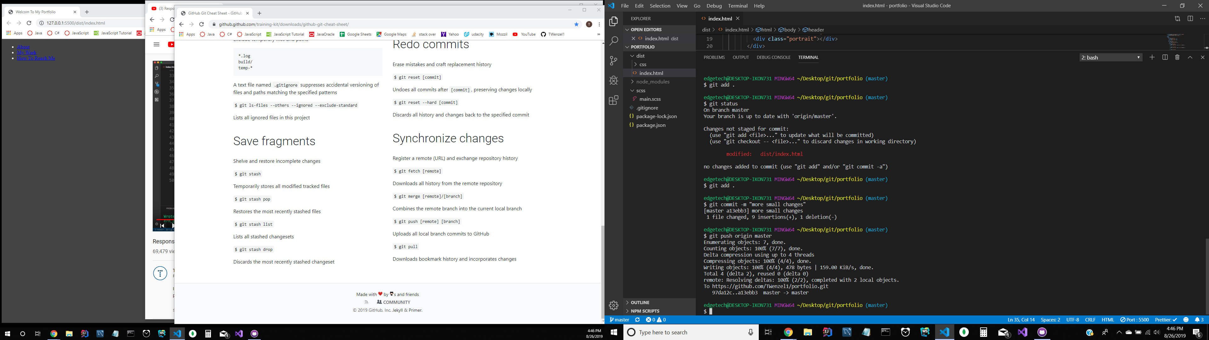

**Create a new Repository**

echo "# JSPracticeFiles" >> README.md

git init

git add README.md

git commit -m "first commit"

git remote add origin https://github.com/TWenzel1/JSPracticeFiles.git

git push -u origin master

**…or push an existing repository from the command line**

git remote add origin https://github.com/TWenzel1/JSPracticeFiles.git

git push -u origin master

npm install -g

npm start

code .

express folderName

npm install -g

npm start

code .