TRANSIENT STABILITY LIMIT
PREDICTION GUI
USER GUIDE
A practical, step-by-step guide for operators and data scientists
using the DSC-580 prototype data product.

Application | Audience | Project | Document Purpose
Transient Stability Limit Prediction GUI | Operator and Data Scientist users | DSC-580 Milestone 3 | Explain how to install, launch, navigate, use, interpret, and troubleshoot the application.

SAFETY NOTICE
This application is a research and educational prototype. Its machine-learning predictions have not been established as validated for actual bulk electric system operations and must not be used as the sole basis for real-world electric-system operating decisions. Independently verify analytical results before applying them to engineering or operational decisions.

Title Page
Transient Stability Limit Prediction GUI
User Guide
DSC-580 Prototype Data Product
Version: Milestone 3
Prepared for academic evaluation and prototype demonstration.

Copyright and Legal Notice
Copyright © 2026. All rights reserved by the project author except for third-party software, libraries, datasets, models, or other materials that remain subject to their respective licenses and terms.
This guide describes an educational prototype. Users are responsible for complying with applicable software licenses, dataset terms, organizational policies, cybersecurity requirements, and electric-system operating procedures. The guide does not replace approved engineering studies, operating procedures, protection schemes, or operator judgment.
No warranty is made that the prototype is suitable for production, safety-critical, or real-time grid operation.

Preface
This guide is written for both nontechnical operational users and data scientists. It separates operational tasks from model-development details so that users can find the information appropriate to their role. Procedures are presented as numbered steps, while conceptual sections explain what the application does and how to interpret its output.
Accessibility is considered throughout the guide. Users should not rely on color alone when interpreting a display; read labels, values, table entries, and legends. Users with low vision can use operating-system or application zoom and display-scaling features. Keyboard navigation should be used where supported by the application and operating system.

Table of Contents
1. General Information
2. System Summary
3. Getting Started
4. Using the System
5. Understanding Model Metrics
6. Safety, Accessibility, Security, and Data Handling
7. Troubleshooting
8. Frequently Asked Questions (FAQ)
9. Help and Contact Details
10. Glossary
11. Quick Reference
12. Project Resources
13. Disclaimer
Search tip: In Microsoft Word, press Ctrl+F and enter a section name, feature, error message, or glossary term.

1. General Information

1.1 Purpose
The Transient Stability Limit Prediction GUI is a Python-based prototype that presents power-system data and machine-learning results through role-specific views. It demonstrates how machine-learning models can support exploration and prediction of transient stability limits.

1.2 Intended Users
User | Primary Need | Recommended View
Operator | Interpret system and transient-stability results without unnecessary model-development detail. | Operator
Data Scientist | Compare machine-learning models using predictive-accuracy and computational-performance metrics. | Data Scientist

1.3 Scope and Limitations
- The application is a prototype for research and educational use.
- Input data must follow the feature structure expected by the trained models.
- Model performance measured on evaluation data does not guarantee performance for every future operating condition.
- The application does not replace approved operational tools, engineering analysis, or required reliability procedures.

2. System Summary
The GUI provides a common entry point to two role-specific workflows. The Operator view emphasizes the predicted condition or stability information. The Data Scientist view emphasizes model benchmarking and comparison.
Component | Purpose
GUI Rev 1.2.py | Main application entry point and user interface.
Operator.py | Operator-oriented functions and displays.
Data_Scientist.py | Model benchmarking and data-scientist functions.
saved_models/ | Stores trained model files used by the application.
long_df_head.csv | Sample dataset included with the project.
requirements.txt | Lists Python dependencies required by the project.

2.1 Conceptual Workflow
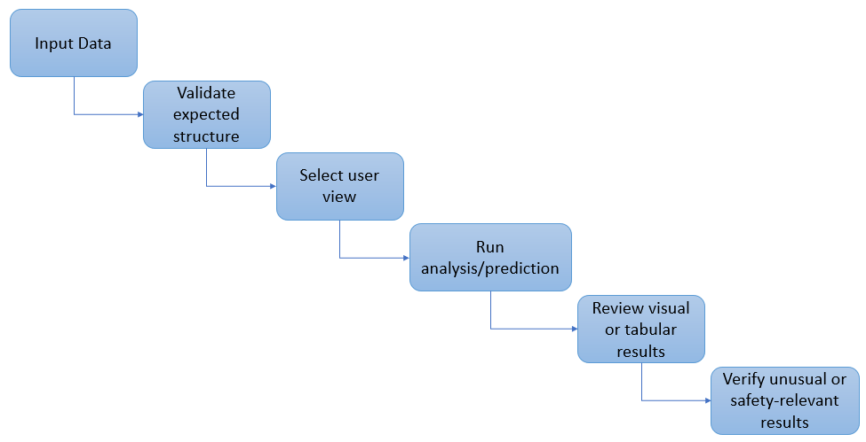 Figure 1. Conceptual application workflow

3. Getting Started

3.1 Before You Start
- Python is installed.
- Packages listed in requirements.txt are installed in the environment used to run the GUI.
- The saved_models folder is present with the trained model files.
- GUI Rev 1.2.py, Operator.py, and Data_Scientist.py remain in the expected project structure.
- A compatible CSV dataset is available when data input is required.

3.2 Installation
- Obtain the complete project folder from the project repository or approved project location.
- Open a terminal in the project directory.
- Create or activate the Python environment you intend to use.
- Install the dependencies listed in requirements.txt using the Python package-management process used by your environment.
- Confirm that the saved_models directory and required .joblib model files are present.
- Confirm that the sample CSV and Python source files are present before starting the application.
Note: Exact installation commands can vary by Python environment and operating system. If your organization manages Python installations, follow its approved software-installation procedure.

3.3 Start the GUI
- Open a terminal in the project directory.
- If using Visual Studio Code, confirm that the selected Python interpreter is the same environment in which the project requirements were installed.
- Run: python "GUI Rev 1.2.py"
- Wait for the application window to open.
- Select the user view appropriate to your task.

3.4 First-Run Check
- The GUI opens without a Python traceback or missing-module message.
- The required view can be selected.
- A compatible dataset can be opened when required.
- Expected model files are found.
- Displayed results contain plausible values before the output is interpreted.

4. Using the System

4.1 Choosing the Appropriate View
If you need to... | Use...
Review operational transient-stability information | Operator view
Compare predictive accuracy across models | Data Scientist view
Compare prediction speed across models | Data Scientist view
Investigate model-development metrics | Data Scientist view

4.2 Working With Data
- Select a dataset that follows the structure expected by the trained models.
- Do not rename or remove required feature columns.
- Load or open the dataset using the control provided by the application.
- Review displayed system information for completeness.
- If an error identifies a missing feature or column, stop and verify the source file before continuing.
The repository includes long_df_head.csv as a sample dataset. Other datasets must use column names and feature formats compatible with the saved models.

4.3 Operator View: Step-by-Step
- Open the Operator view.
- Open or load the required power-system data.
- Review the displayed system information for completeness and plausibility.
- Run or view the available transient-stability prediction.
- Read the displayed numeric values, labels, tables, and legends; do not rely on color alone.
- Use the visual or tabular output to interpret the result.
- If the result is unusual, missing, implausible, or outside known model limits, verify the source data and analytical output before relying on it.
- Independently validate safety-relevant results using the appropriate approved engineering or operational process.

4.4 Data Scientist View: Step-by-Step
- Open the Data Scientist view.
- Confirm that the evaluation dataset is appropriate for the saved models.
- Run the model benchmark.
- Compare the available models using R², RMSE, MAE, total prediction time, and single-prediction time.
- Use the same evaluation context when comparing models.
- Do not select a model from one metric alone; consider both predictive error and computational performance.
- Investigate unexpected model results before recommending deployment.
The current benchmarking functionality compares saved HistGradientBoosting, KNN, and SVR-RBF regression models using the same randomly selected sample of data. The benchmark uses P_diff_target0_est as the default target, selects the exact input features expected by each saved model, uses a default sample of up to 1,000 rows, and uses a fixed random state to support consistent comparison.

5. Understanding Model Metrics
Metric | Plain-Language Meaning | General Interpretation
R² | How much variation in the target is explained by the model. | Higher is generally better; values closer to 1 indicate stronger fit.
RMSE | Prediction error that gives larger errors more weight. | Lower is generally better.
MAE | Average absolute difference between actual and predicted values. | Lower is generally better.
Total Time (sec) | Time required to predict the evaluation sample. | Lower indicates faster batch prediction for the tested sample.
Single Prediction Time (ms) | Average time for one prediction, measured repeatedly. | Lower may be preferable when rapid individual predictions are important.

Example: A model with slightly lower R² may still be useful if it is substantially faster, while a slower model may be preferable when prediction accuracy is the dominant requirement. The acceptable tradeoff should be tied to the intended use and stakeholder requirements.

6. Safety, Accessibility, Security, and Data Handling

6.1 Safe Interpretation
- Confirm that input data represent the intended system condition.
- Compare multiple performance metrics instead of relying only on R².
- Investigate unexpected predictions or abrupt changes in displayed results.
- Treat predictions outside the model's known or validated operating domain as uncertain.
- Independently validate results before using them for engineering or operational decisions.
- Do not use this prototype as the sole basis for a real-world switching, dispatch, transfer-limit, or other safety-critical operating decision.

6.2 Accessibility
- Do not rely on color alone. Use labels, numeric values, legends, symbols, and table entries to interpret results.
- For low vision, increase operating-system display scaling or application/window zoom where supported.
- Maintain high-contrast display settings when needed and avoid interpreting faint visual differences without checking the associated values.
- Use keyboard navigation where supported; if a control cannot be reached or understood, use an accessible alternative or request assistance.

6.3 Security and Data Handling
- Load data only from trusted and authorized sources.
- Do not assume a shared or public-facing data file is accurate merely because the application can open it.
- Protect sensitive or restricted power-system information according to applicable organizational requirements.
- If the prototype is deployed beyond a local environment, evaluate access control, input validation, dependency management, logging, monitoring, backups, and incident response.
- Keep third-party Python packages and model files under controlled change-management practices appropriate to the deployment environment.

6.4 Legal and Licensing Considerations
Use the project only in accordance with applicable software licenses, dataset licenses, organizational policies, and legal requirements. Third-party libraries and datasets retain their own copyright and licensing terms. Production deployment would require a separate review of applicable security, reliability, accessibility, data, and operational requirements.

7. Troubleshooting
Problem | What to Check | Recommended Action
GUI does not start | Python environment and requirements.txt | Activate the correct environment and install the listed dependencies.
ModuleNotFoundError | Missing Python package | Install the missing package in the same environment used to launch the GUI.
Saved model cannot be found | saved_models directory and .joblib files | Restore the expected project structure and model files.
Missing feature/column error | CSV column names and required fields | Use a compatible file; do not rename or remove required features.
Model results look unusual | Data types, missing values, source quality, training-domain match | Stop interpretation, verify the data, and rerun only after the issue is understood.
Prediction timing changes between runs | Computer load, hardware, background processes, runtime behavior | Repeat timing tests under comparable conditions before drawing conclusions.
Results are difficult to distinguish visually | Display scaling, contrast, reliance on color | Use labels/tables, increase scaling or contrast, and do not rely on color alone.

8. Frequently Asked Questions (FAQ)
Can this application determine an operational limit for the real electric grid?
Not by itself. It is an educational/research prototype, and its predictions have not been established in this guide as validated for actual bulk electric system operations.
Which view should an operator use?
Use the Operator view when the goal is to interpret system and transient-stability results without model-development detail.
Which view should a model developer use?
Use the Data Scientist view to compare model accuracy and computational performance.
Can I load any CSV file?
No. The input must contain the features and formats expected by the trained models.
Which model is best?
There is no universal answer. Compare R², RMSE, MAE, timing, intended use, and stakeholder requirements rather than choosing from one metric.
What should I do with an implausible prediction?
Do not rely on it. Verify the source data, confirm that the case is within the model's intended domain, and independently validate the analytical result.
Why did prediction time change?
Small changes can result from hardware, computer load, background processes, and Python/runtime behavior.
What if I cannot distinguish colors in a visualization?
Use the associated labels, numeric values, legend, or table. The result should not be interpreted from color alone.
How can I search this guide?
Use Ctrl+F in Microsoft Word and search for a task, error message, metric, or glossary term.

9. Help and Contact Details
For application help, first review the Troubleshooting and FAQ sections and confirm that the project structure, Python environment, model files, and input data are correct.
Support Need | Resource
Source code / project files | Project repository: TXBern/Milestone-3-GUI on GitHub
Course or assignment questions | Contact the DSC-580 instructor through the course's approved communication channel.
Technical environment issues | Use the support process for the computer, Python environment, or development environment being used.
Safety-critical operational question | Use approved organizational engineering and operating procedures; do not rely on this prototype as the authoritative source.

Note: Personal contact information is intentionally not invented in this guide. Add the project author's approved email or support channel here before external distribution if one is required.

10. Glossary
Term | Plain-Language Definition
CSV | Comma-separated values file used to store tabular data.
GUI | Graphical user interface: the windows, controls, tables, and visual displays through which a user interacts with the application.
Machine-learning model | A trained mathematical model used to estimate or predict an output from input features.
Transient stability | The ability of a power system to remain in synchronism after a large disturbance.
Transient stability limit (TSL) | In this project, the boundary or transfer-related limit the machine-learning application is intended to help predict.
Feature | An input variable supplied to a machine-learning model.
Target | The value the model is trained to predict; the benchmark uses P_diff_target0_est as the default target.
R² | A goodness-of-fit measure describing how much variation in the target is explained by the model.
RMSE | Root mean squared error; an error measure that gives larger prediction errors more weight.
MAE | Mean absolute error; the average absolute difference between predicted and actual values.
Inference / prediction time | The amount of time required for a trained model to produce a prediction.
Training domain | The kinds and ranges of data represented when the model was developed; cases outside this domain may be less reliable.
Saved model | A previously trained model stored in a file so it can be loaded by the application without retraining.

11. Quick Reference
Need | Action
Operational results | Use the Operator view.
Compare ML models | Use the Data Scientist view.
Best R² | Generally compare the highest value together with error metrics.
Best RMSE/MAE | Generally compare the lowest values.
Fast inference | Compare Single Prediction Time (ms).
Error after loading new data | Check required columns, data types, and feature names.
Unusual or safety-relevant result | Stop, verify the source data and analytical output, and independently validate the result.

12. Project Resources
Repository: TXBern/Milestone-3-GUI on GitHub
Primary project files include GUI Rev 1.2.py, Operator.py, Data_Scientist.py, long_df_head.csv, requirements.txt, and the saved_models directory.

13. Disclaimer
This software is provided for educational and research purposes. The machine-learning predictions generated by the application have not been established in this guide as validated for actual bulk electric system operations. Users should independently verify analytical results before applying them to engineering or operational decisions.

