NoSQL-HandsOn1

Part 1:

- Create three more users of your choosing, using the insertOne() query, and add them to the appusers collection.
  - Include at least the firstName, lastName, and age fields. Feel free to also include any other fields you think would be useful data for an app user.
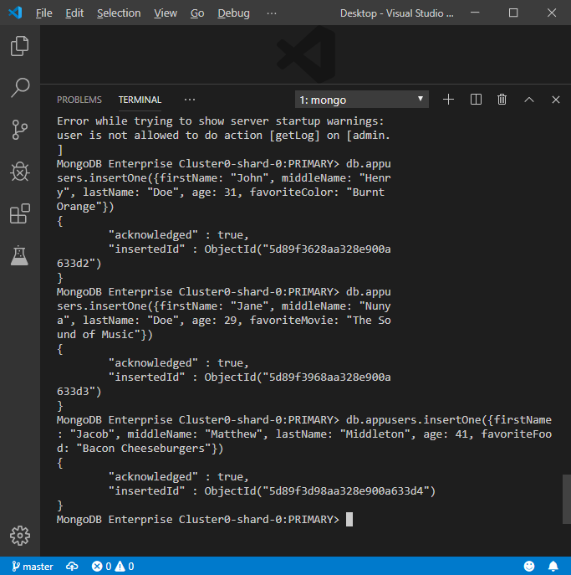
- Next, run a basic find() query to see all of your documents within your database through the Mongo Shell.
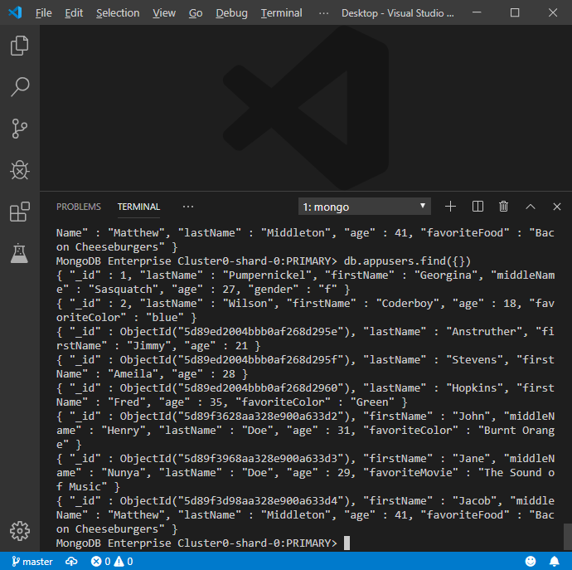
Part 2:

- Create a new collection within your database through Atlas.
  - This new collection should be named cars.

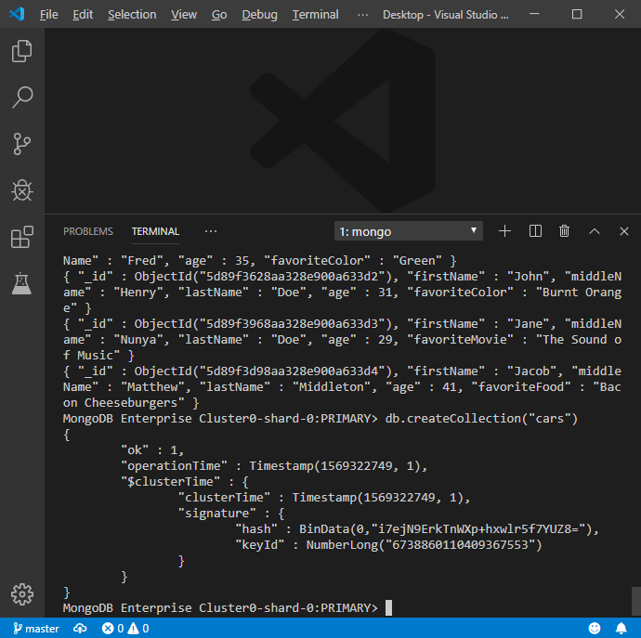

- Insert five cars into this collection using the insertMany() query.
  - Include the following fields: make, model, color, year, fourDoor, and fourWheelDrive.
    - The last two fields, fourDoor and fourWheelDrive, should be of type Boolean (i.e. true or false).
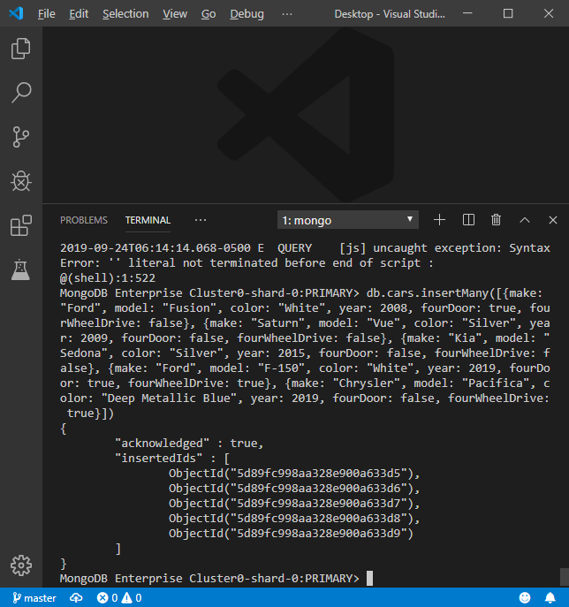

- Once that is done, run a find() query to see your newly created documents.
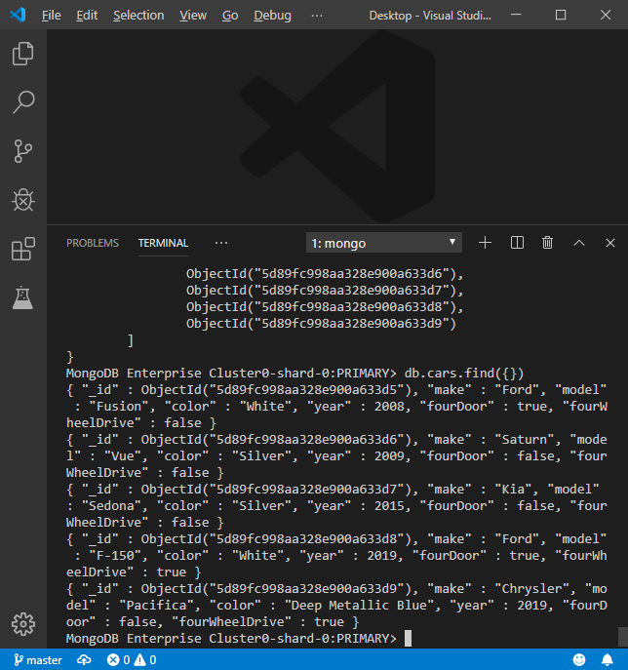
- Lastly, return to Atlas and view your collection and documents there.
