NoSQL – Lesson 2 HandsOn

Part 1:

Run the following queries:
- Find all movies that are longer than 2 hours
db.movies.find({“lengthInMin”: {$gt: 120}})
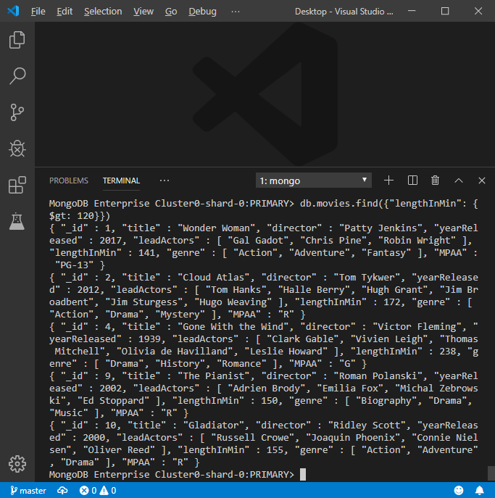
- Find all movies that do not have Tom Hanks as a lead actor
db.movies.find({"leadActors": {$not: {$eq: "Tom Hanks"}}})

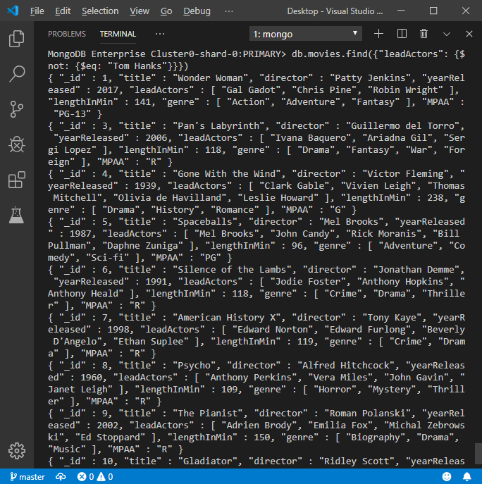
- Find all movies that were directed by Mel Brooks
db.movies.find({“director”: {$eq: “Mel Brooks”}})
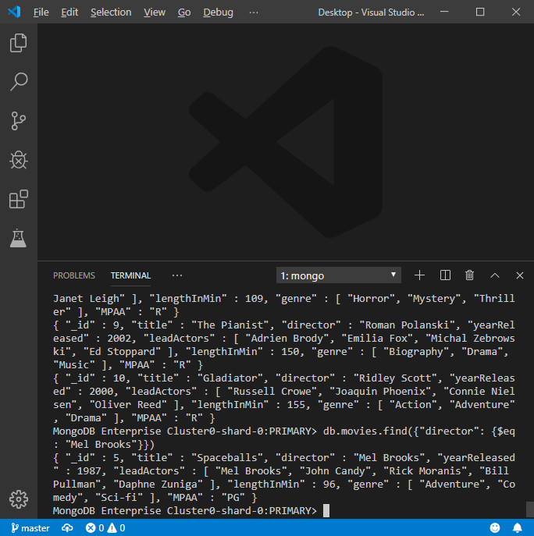
- Find all movies that are not considered Drama
db.movies.find({"genre": {$not: {$eq: "Drama"}}})
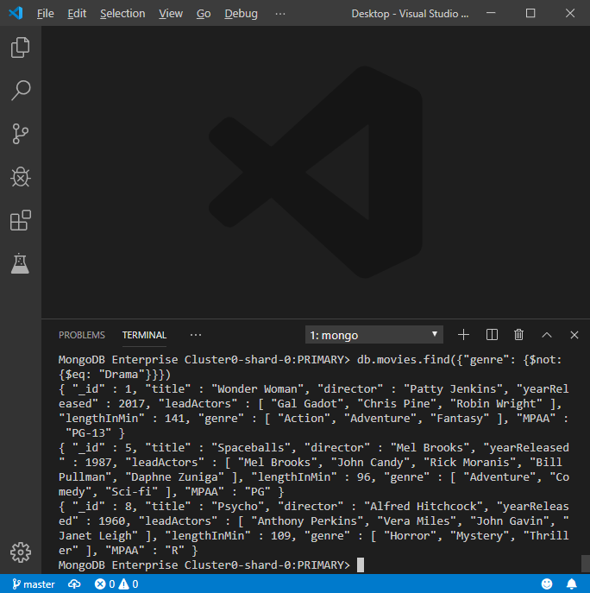
- Find all movies that are longer than 90 minutes but less than 2 hours
db.movies.find({$and: [{"lengthInMin": {$gt: 90}}, {"lengthInMin": {$lt: 120}}]})
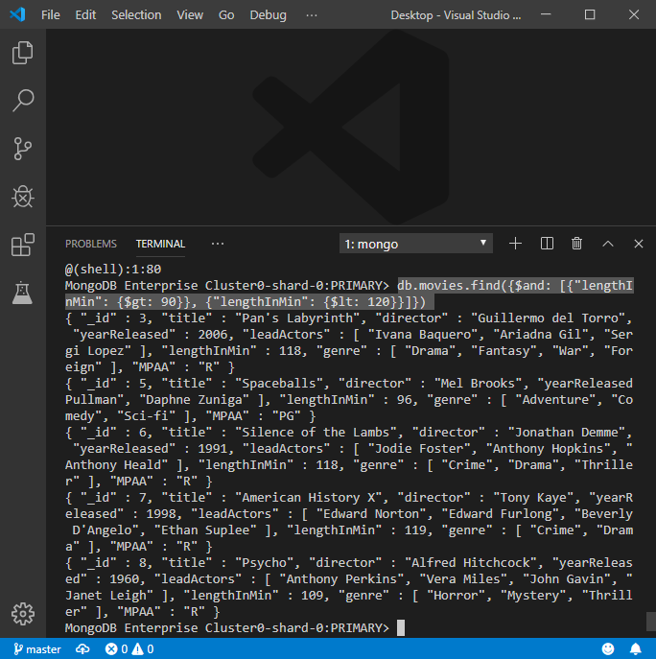
- Find all movies that are considered Action or Adventure and return only the title of the movie
db.movies.find({"genre": {$in: ["Action", "Adventure"]}}, {“title”: 1})
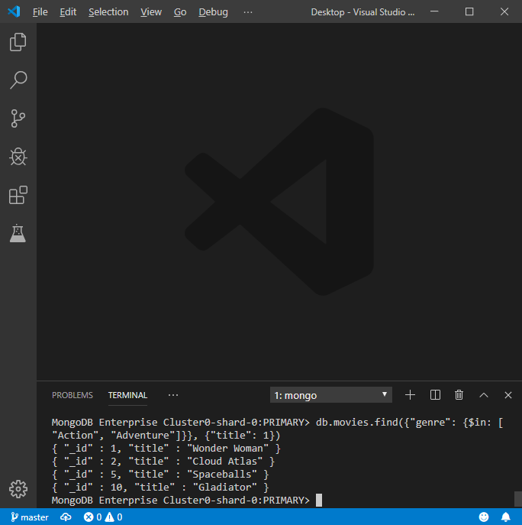

Part 2:

Below is a real-life scenario. Please read this scenario and run the appropriate queries needed.

The company you work for is having a movie night for all employees, and they are trying to find the perfect movie for movie night. The problem is, so many people have different opinions, and they want to make everyone happy. Sally has very poor eyesight so cannot watch any foreign films but likes comedies and dramas. Robert hates Jodie Foster and refuses to watch any movies with her in it, but likes comedies and horror films. Stewart has somewhere to be after movie night, so he can't watch a movie longer than 2 hours; he prefers thrillers and comedies.

After running your query(ies), what movie is going to be played at movie night?
db.movies.find({$and: [{"genre":{$eq: "Comedy"}}, {"leadActors": {$not: {$eq: "Jodie Foster"}}}, {"lengthInMin": {$lte: 120}}]}, {"title": 1})
