NoSQL – HandsOn3

Part1:

Within your inventory collection, run queries to accomplish the following:
- Update the item of journal to have a height of 16.
db.inventory.update({item:'journal'}, {$set: {size: {"h": 16, "w": 21, "uom": "cm"}}})
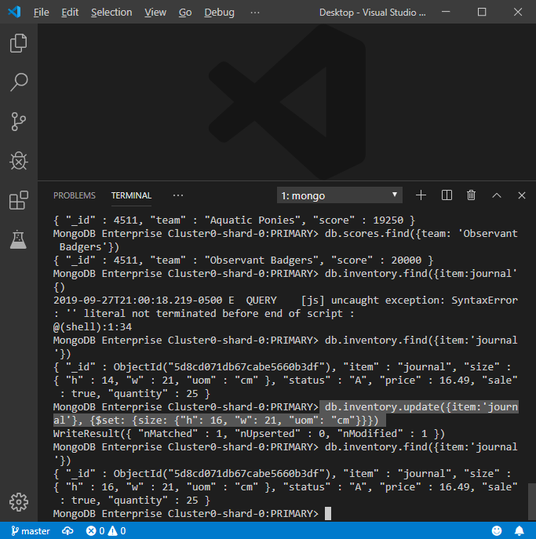
- Update all items with a status of D to have a quantity of 50.
db.inventory.update({status:"D"}, {$set: {quantity: 50}}, {multi: true})

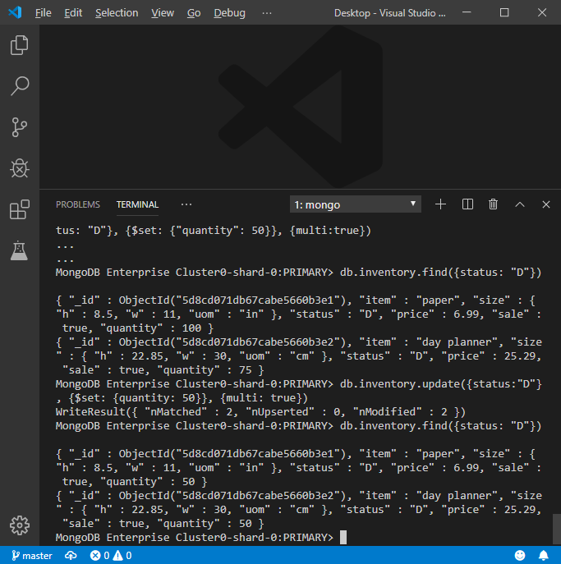
- Update the item paper to include a field rating that has the value of 4 stars and change its status to A.
db.inventory.updateOne({"item": "paper"}, {$set: {"rating": "4 stars", "status": "A"}}, {upsert: true})
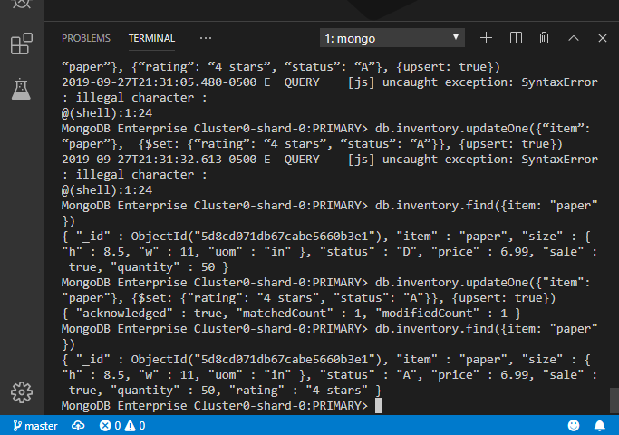
- Update all items to change the h and w fields to be height and width.
db.inventory.updateMany({}, {$rename: {'size.h': "size.height", 'size.w': "size.width"}})
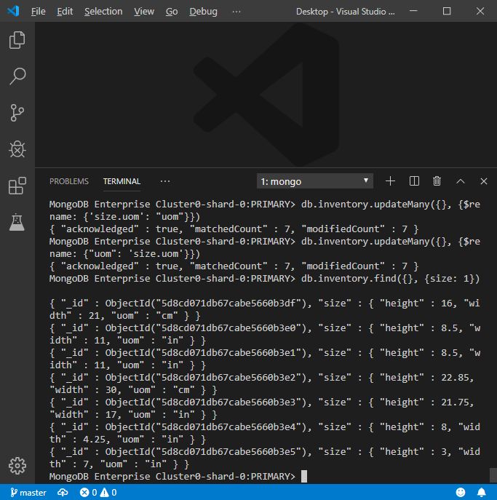
- Update the item spiral notebook so that the height and width is incremented by 2.
db.inventory.update({item: "spiral notebook"}, {$inc: {'size.height': 2, 'size.width': 2}})
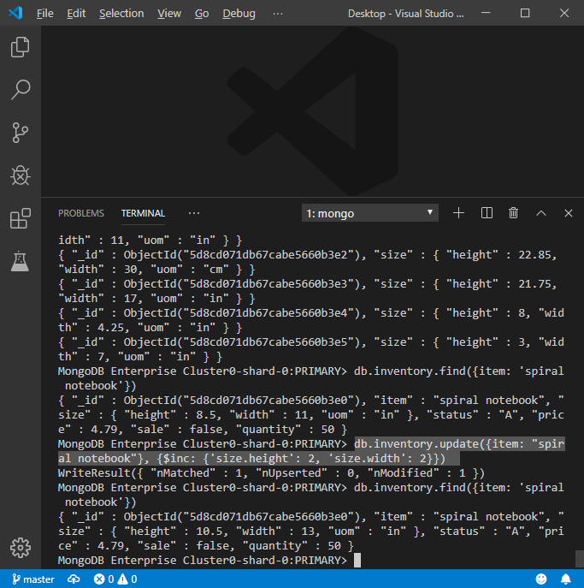
- Update the items paper and day planner to multiply the height by 3.
db.inventory.updateOne({item: "paper"}, {$mul: {'size.height': 3}})
db.inventory.updateOne({item: "day planner"}, {$mul: {'size.height': 3}})
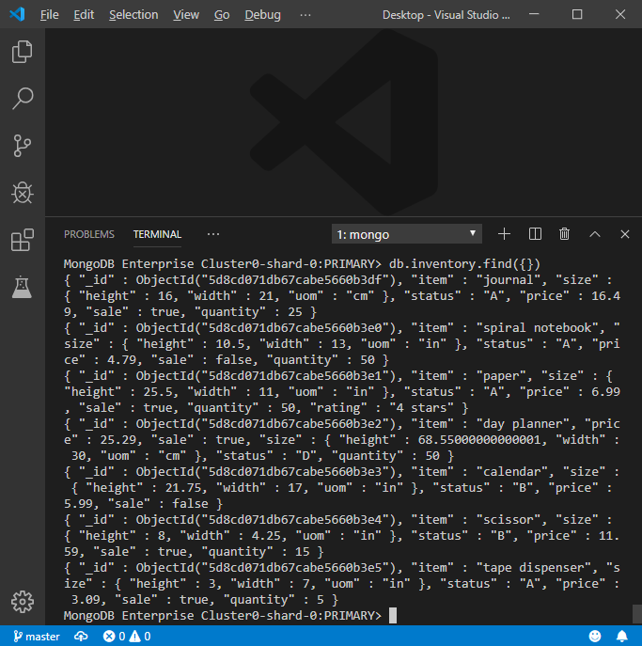
Part2:

The company you are working for wants to update their inventory database. Currently, there are ten pieces of inventory in the database. They want to give each product a rating of 4 stars to start, as well as a field that shows if it has been rated yet using a boolean. They would like this to be reflected in the database as rating with two fields: numberOfStars, and hasBeenRated. Also, they want to double the quantity of every product since the company is rapidly growing. Lastly, they would like you to find all products that are sized using centimeters and give them a status of "B".

db.inventory.updateMany({}, {$set: {"rating": {"numberOfStars": "4 stars", "hasBeenRated": true}}}, {upsert:
true})
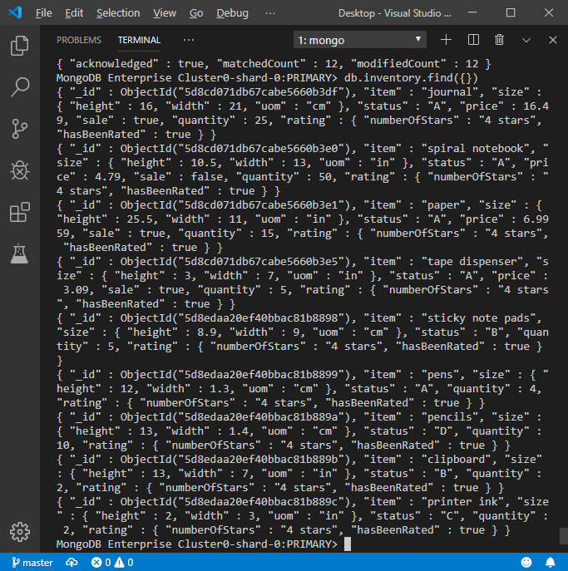
db.inventory.updateMany({}, {$mul: {"quantity": 2}})

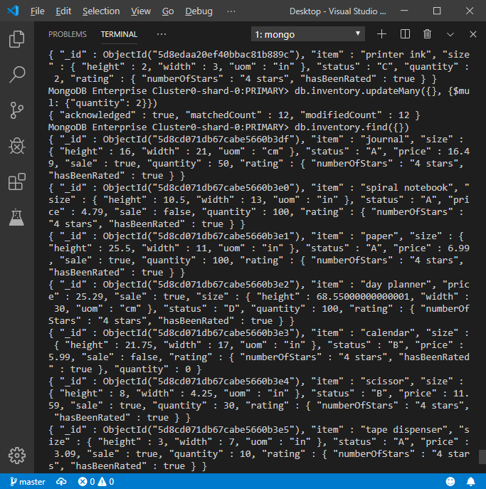

db.inventory.updateMany({'size.uom': "cm"}, {$set: {status: "B"}})

