NoSQL-Lesson5HandsOn

Part1:

db.employees.insertMany([{
name:”Alison Davidson”, birthday: “1975-05-04”, address: “874 W. Oak Place”, city: “Gary”, state: “Indiana”, position: {positionName: “Customer Support”, remote: true, fullTime: true}},

{name: “Henry Chapelton”, birthday: “1980-29-09”, address: “9324 E. Vista Way”, city: “Tempe”, state: “Arizona”, position: {positionName: “Customer Support”, remote: false, fullTime: true}},

{name: “Alex Miller”, birthday: “1983-22-11”, address: “244 Price Road”, city: “Mesa”, state: “Arizona”, position: {positionName: “Customer Support”, remote: false, fullTime: false}},

{name: “Carly Nielson”, birthday: “1987-04-08”, address: “678 W. Westward Road”, city: “Phoenix”, state: “Arizona”, position: {positionName: “Office Manager”, remote: false, fullTime: true}},

{name: “Tom Talbot”, birthday: “1989-30-12”, address: “12 Oakland Way”, city: “Chandler”, state: “Arizona”, position: {positionName: “Inventory Manager”, remote: false, fullTime: true}},

{name: “Mary Crawley”, birthday: “1980-06-07”, address: “1010 Granite Way”, city: “Charlotte”, state: “North Carolina”, position: {positionName: “Human Resources”, remote: true, fullTime: true}}])

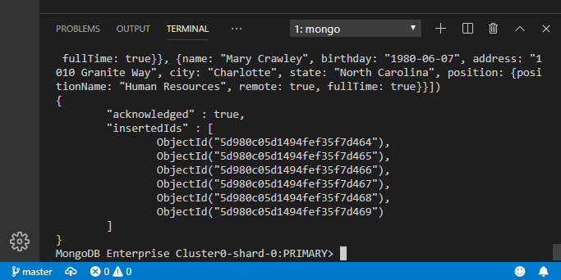
db.employees.insertMany([
{name: “Daisy Baxter”, birthday: “1987-09-09”, address: “990 E. 84th St.”, city: “Tempe”, state: “Arizona”, position: {positionName: “CEO”, remote: false, fullTime: true}},

{name: “William Coyle”, birthday: “1991-11-10”, address: “944 W. 16th St.”, city: “Phoenix”, state: “Arizona”, position: {positionName: “Intern”, remote: false, fullTime: false}},

{name: “Edith Bates”, birthday: “1990-28-07”, address: “7 E. 20th Pl.”, city: “Chandler”, state: “Arizona”, position: {positionName: “Customer Support”, remote: false, fullTime: true}},

{name: “Gwen Harding”, birthday: “1986-11-10”, address: “234 W. 48th. St.”, city: “Phoenix”, state: “Arizona”, position: {positionName: “Office Assistant”, remote: false, fullTime: true}}])

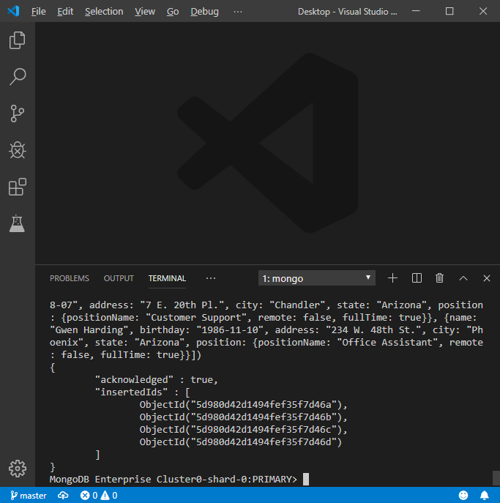

db.employees.updateOne({name: "Alison Davidson"}, {$set: {address: "777 E. 1st ST. #120", city: "Tempe", state: "Arizona"}})

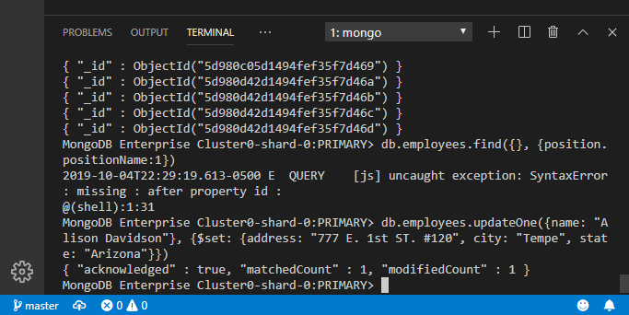

db.employees.findOneAndUpdate({name:"Mary Crawley"}, {$set: {address: "8322 W. Vista Pl.", city: "Scottsdale", state: "Arizona"}})
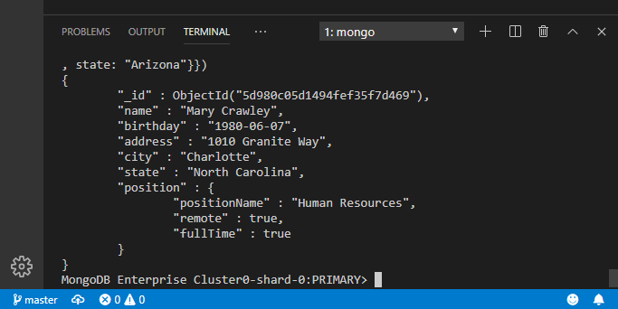

db.employees.updateMany({state: “Arizona”}, {$unset: {state: “”}})

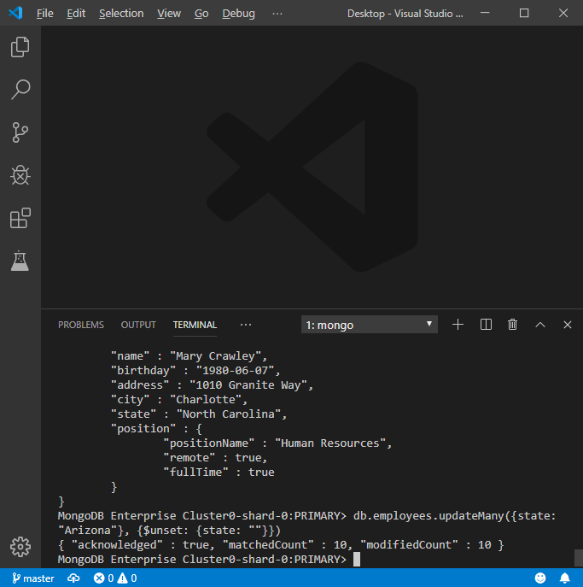
db.employees.createIndex({position:1})

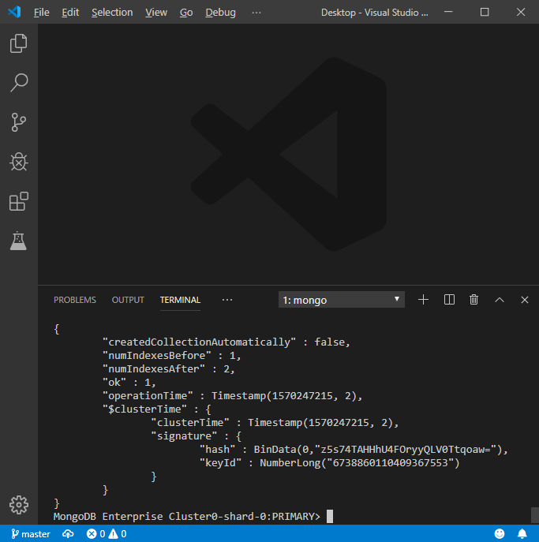
Part2:
db.songs.insertMany([
{songId: 1, title: “Girls Just Want To Have Fun”, details: {artist: “Cyndi Lauper”, album: “She's so Unusual”, releaseYear; 1983}},

{songId: 2, title: “Hips Don't Lie”, details: {artist: “Shakira feat. Wyclef Jean”, album: “Oral Fixation Vol. 2”, releaseYear: 2006}},

{songId: 3, title: “Poker Face”, details: {artist: “Lady Gaga”, album: “The Fame”, releaseYear: 2008}},

{songId: 4, title: “Wannabe”, details: {artist: “Spice Girls”, album: “Spice”, releaseYear: 1996}},

{songId: 5, title: “California Gurls”, details: {artist: “Katy Perry feat. Snoop Dogg”, album: “Teenage Dream”, releaseYear: 2010}},

{songId: 6, title: “Bye, Bye, Bye”, details: {artist: “Nsync”, album: “No Strings Attached”, releaseYear: 2000}},

{songId: 7, title: “I Will Always Love You”, details: {artist: “Whitney Houston”, album: “I Will Always Love You: The Best of Whitney Houston”, releaseYear: 2012}},

{songId: 8, title: “Baby One More Time”, details: {artist: “Britney Spears”, album: “Baby One More Time”, releaseYear: 1999}},

{songId: 9, title: “Vogue”, details: {artist: “Madonna”, album: “I'm Breathless”, releaseYear: 1990}}])

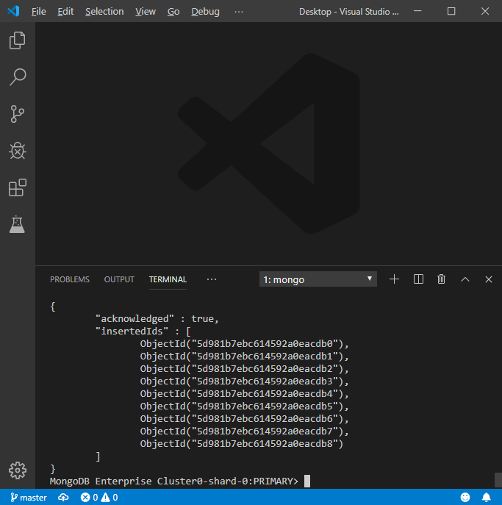
db.songs.insertMany([
{songId: 10, title: “Rolling in the Deep”, details: {artist: “Adele”, album: “21”, releaseYear: 2011}},

{songId: 11, title: “1234”, details: {artist: “Feist”, album: “The Reminder”, releaseYear: 2007}},

{songId: 12, title: “Elastic Heart”, details: {artist: “Sia”, album: “The Hunger Games: Catching Fire Soundtrack”, releaseYear: 2015}},

{songId: 13, title: “Oops! I Did It Again”, details: {artist: “Britney Spears”, album: “Oops! I Did It Again”, releaseYear: 2000}},

{songId: 14, title: “Bad Romance”, details: {artist: “Lady Gaga”, album: “The Fame Monster”, releaseYear: 2009}},

{songId: 15, title: “Lose Control”, details: {artist: “Missy Elliot”, album: “The Cookbook”, releaseYear: 2005}},

{songId: 16, title: “U Can't Touch This”, details: {artist: “MC Hammer”, album: “Please Hammer, Don't Hurt 'Em”, releaseYear: 1990}},

{songId: 17, title: “Thriller”, details: {artist: “Michael Jackson”, album: “Thriller”, releaseYear: 1982}},

{songId: 18, title: “Single Ladies”, details: {artist: 'Beyonce”, album: “I am... Sasha Fierce”, releaseYear: 2008}}])

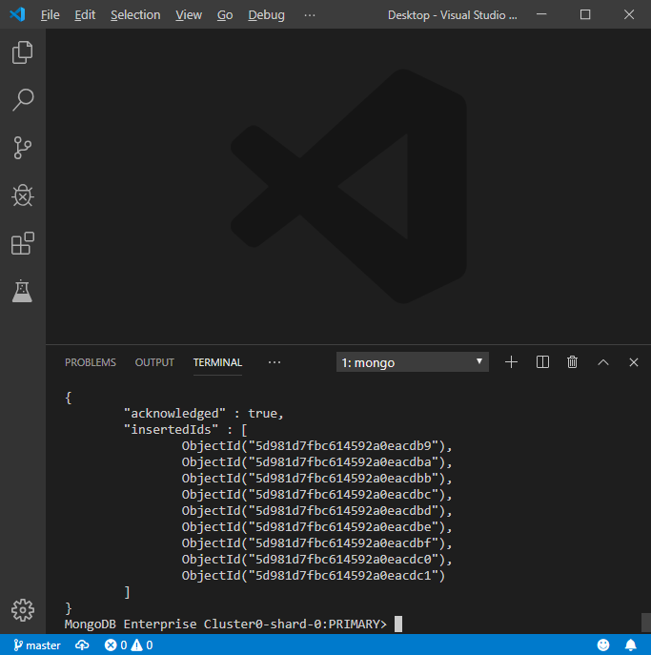
db.songs.insertOne({songId: 19, title: “Rhythm Nation”, details: {artist: “Janet Jackson”, album: “Janet Jackson's Rhythm Nation 1814”, releaseYear: 1989}})

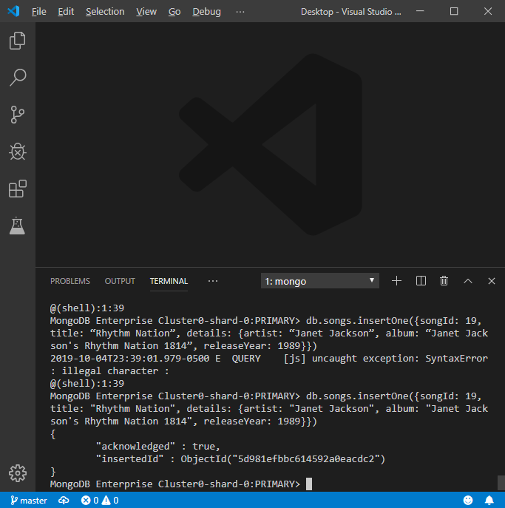

db.songs.update({}, {$rename: {'title': 'songTitle'}})

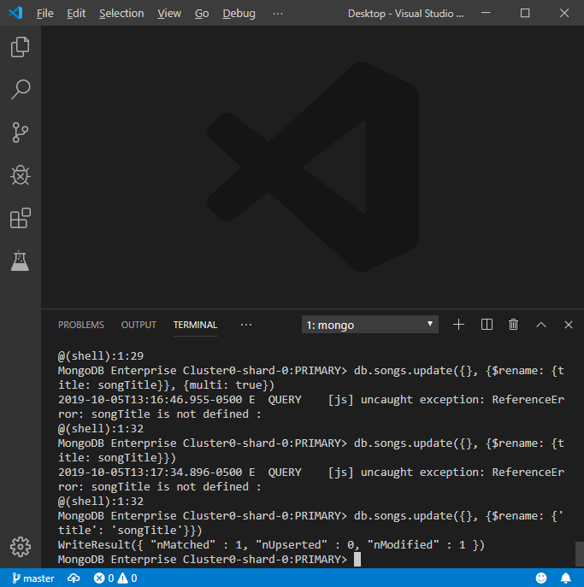

db.songs.update({}, $rename: {'title': 'songTitle'}}, {multi: true})

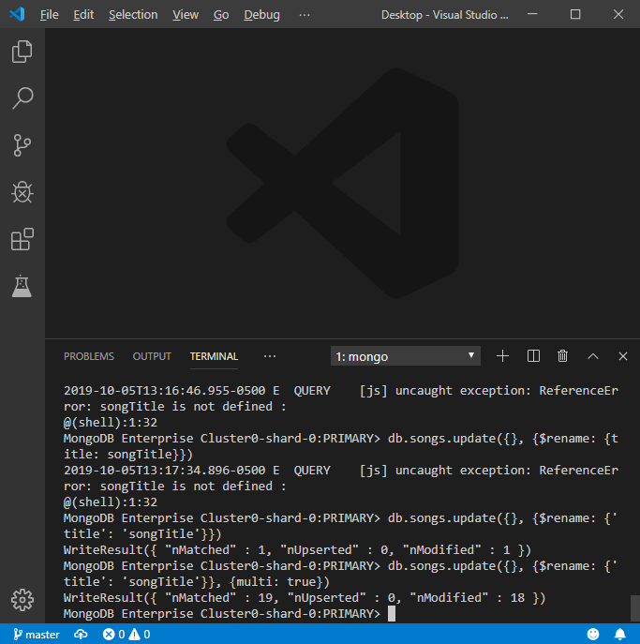
db.songs.update({}, $rename: {'details.artist': 'artist'}}, {multi: true})

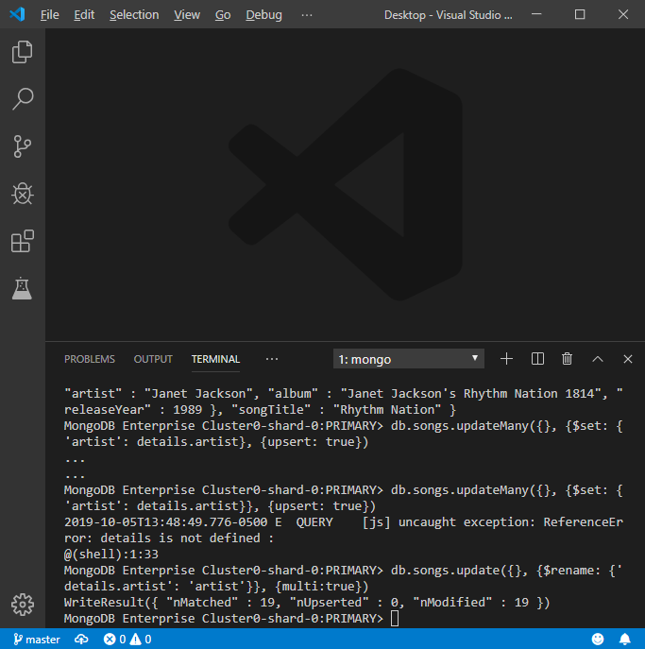
db.songs.find({})

