SQL – Final Project

Part 1:

- Run a query to view the information within the Customers table.

SELECT * FROM customers;
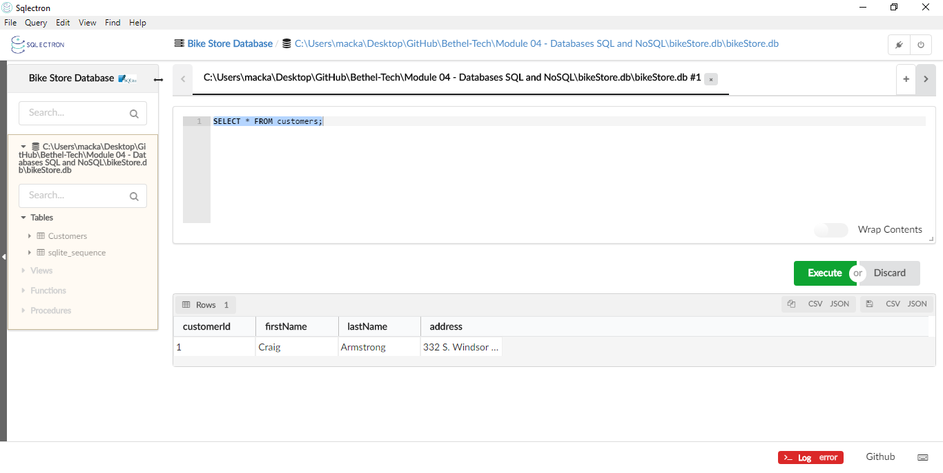
- Write out the query that would have been used to create the Customers table

CREATE TABLE customers (
customerId INTEGER PRIMARY KEY AUTOINCREMENT,
firstName VARCHAR(50) NOT NULL,
lastName VARCHAR(50) NOT NULL,
address VARCHAR(70) NOT NULL
);

- Currently, there is only one customer within the Customers table. Add the following customers:

Name | Address
Kenneth Davis | 84 E. Heathcoat Rd. Avon, CT. 06001
David Shirley | 3493 N. Star Way Eagle, ID. 83669
Donna Bumbleton | 255 E. Main St. P.O. Box 38 Louisville, KY 40018

INSERT INTO customers (firstName, lastName, address)
VALUES('Kenneth', 'Davis', '84 E. Heathcoat Rd. Avon, CT. 06001');
INSERT INTO customers (firstName, lastName, address)
VALUES('David', 'Shirley', '3493 N. Star Way Eagle, ID. 83669');
INSERT INTO customers (firstName, lastName, address)
VALUES('Donna', 'Bumbleton', '255 E. Main St. P.O. Box 38 Louisville, KY 40018');
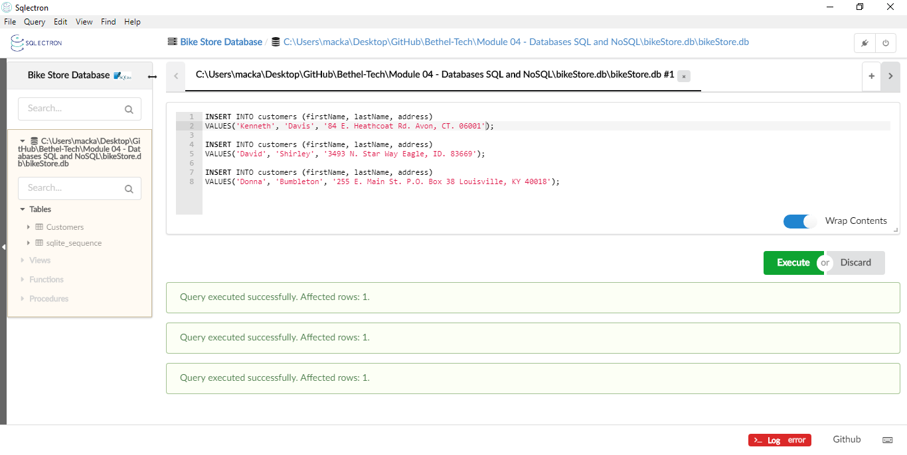
- Run a query to see all of the new customers within the database.

SELECT * FROM customers;

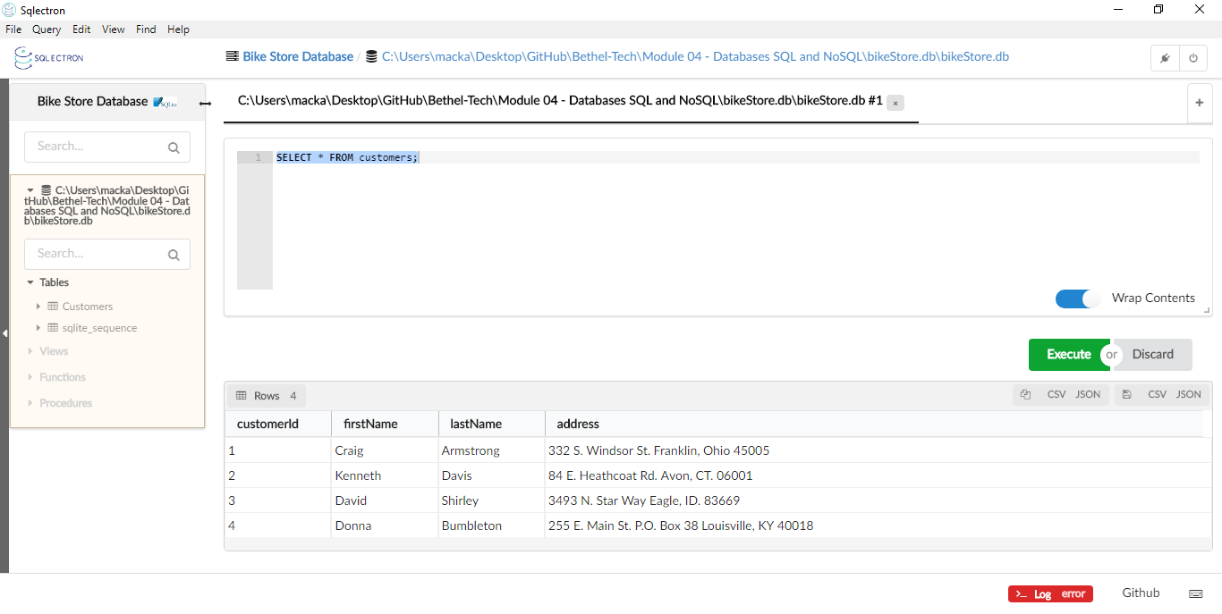

Part 2:

- Run the following SQL query to add a new table into the database:

CREATE TABLE Products(
productId INTEGER PRIMARY KEY AUTOINCREMENT,
brand NVARCHAR(50) NOT NULL,
type NVARCHAR(50) NOT NULL,
model NVARCHAR(50) NOT NULL,
yearProduced INTEGER,
instock INTEGER CHECK(instock IN (0, 1))
);

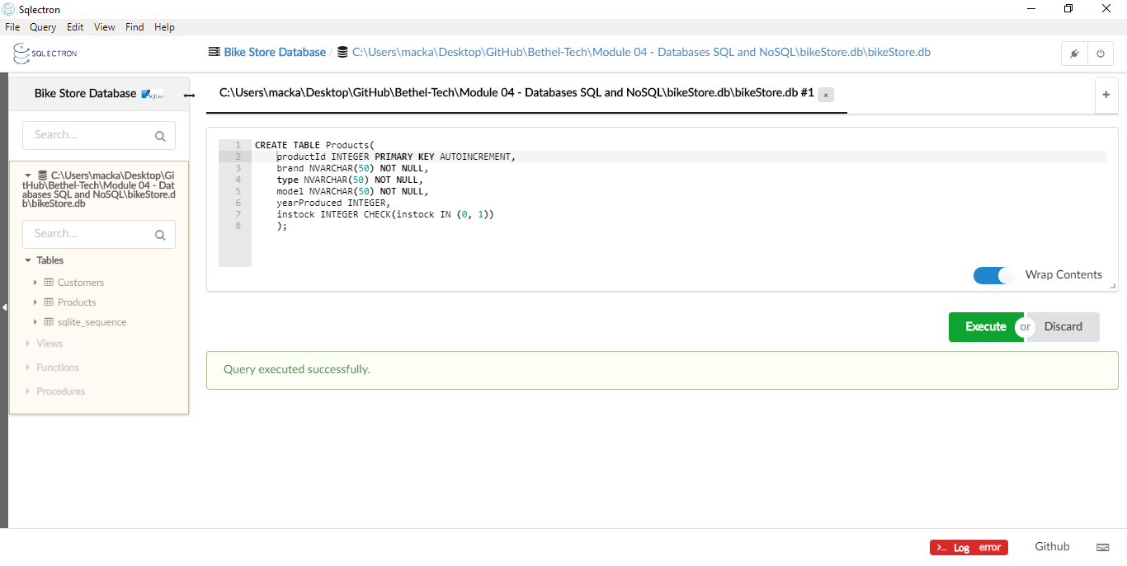
- Next, run the following insert statements to add some data to the Products table:
-- query 1
INSERT INTO Products (brand, type, model, yearProduced, instock)
VALUES ("Specialized", "Road", "Langster Street", 2018, 1)

-- query 2
INSERT INTO Products (brand, type, model, yearProduced, instock)
VALUES ("Trek", "Mountain", "820 WSD", 2019, 1)

-- query 3
INSERT INTO Products (brand, type, model, yearProduced, instock)
VALUES ("Specialized", "Triathlon", "Alias Comp Tri", 2015, 0)

-- query 4
INSERT INTO Products (brand, type, model, yearProduced, instock)
VALUES ("Electra", "Single Speed", "Loft 1", 2015, 1)

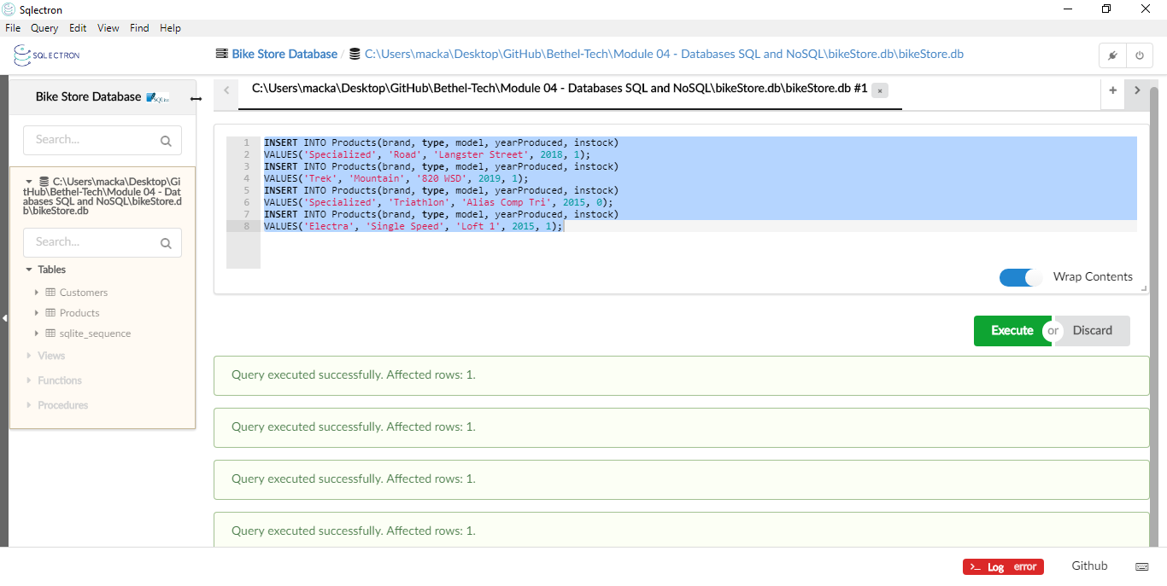

- Run a query to see all of your products.
SELECT * FROM Products;

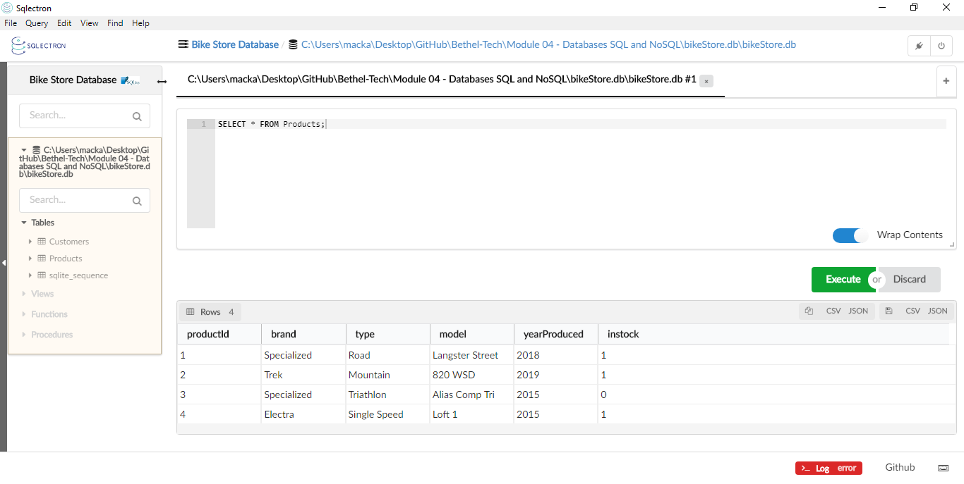

Part 3:

- Run the following SQL query to add a new table into the database:

CREATE TABLE Orders(
orderId INTEGER PRIMARY KEY AUTOINCREMENT,
customerId INTEGER NOT NULL,
productId INTEGER NOT NULL,
FOREIGN KEY(customerId) REFERENCES Customers(customerId),
FOREIGN KEY(productId) REFERENCES Products(productId)
);

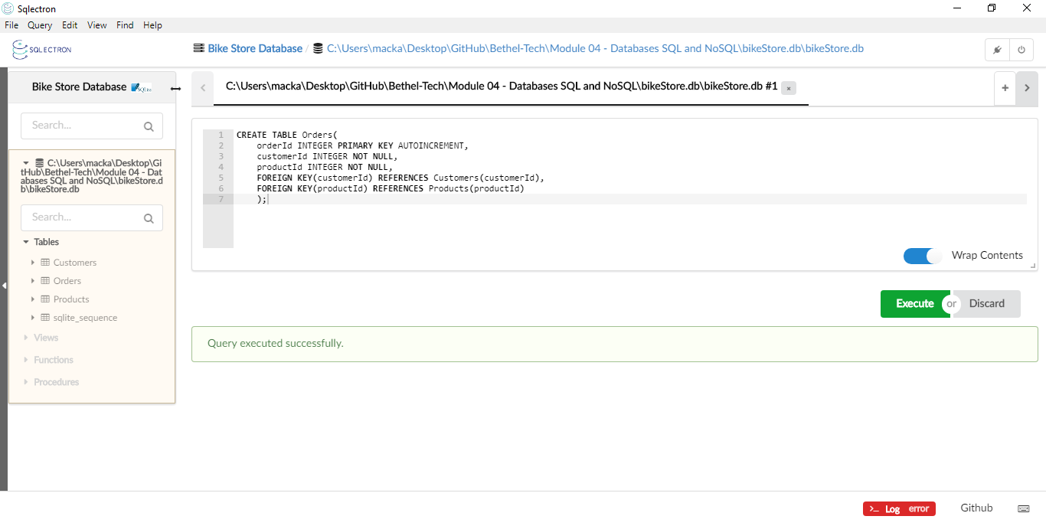

- Next, run the following insert statements to add some data to the Orders table:
-- query 1
INSERT INTO Orders (customerId, productId)
VALUES (1, 2)

-- query 2
INSERT INTO Orders (customerId, productId)
VALUES (2, 1)

-- query 3
INSERT INTO Orders (customerId, productId)
VALUES (3, 2)

-- query 4
INSERT INTO Orders (customerId, productId)
VALUES (4, 1)

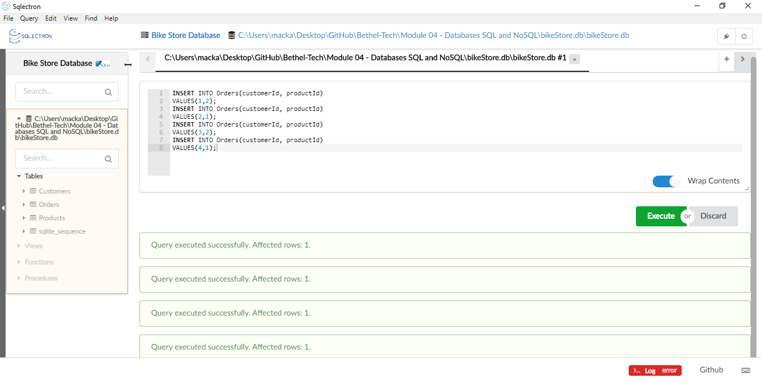
- Lastly, run a query to see the customer's full name, their address, and their orderId as well as the brand, type, model, and yearProduced of the bicycle they ordered. The list of customers should be ordered in alphabetical order by their last name.

Your final output should look like the following:
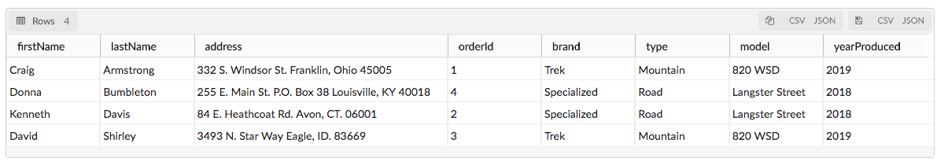
SELECT firstName, lastName, address, orderId, brand, type, model, yearProduced FROM customers
JOIN orders USING(customerId)
JOIN Products USING(productId)
ORDER BY lastName;

