SQL-HandsOn2

Part 1:

- Write a query to find the first and last name, customer ID and invoice ID for customers who have purchased an item.

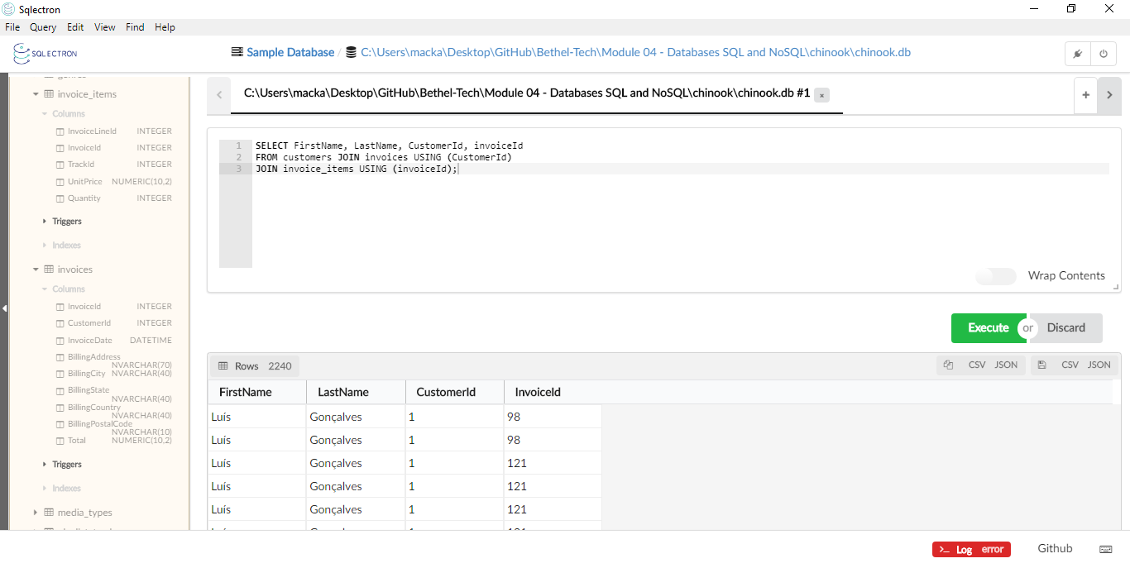
- Write a query that finds all playlists with tracks that have a trackId less than 5 and Bytes less than 6,000,000.
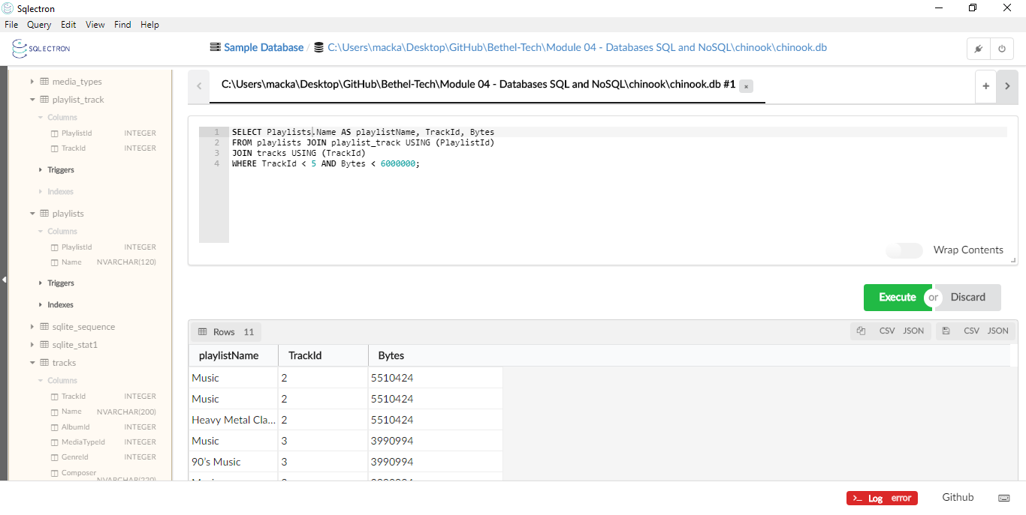

- Write a query that lists out all information of every track along with the Name of the Genre for each track, even if a genre doesn't exist for that track.
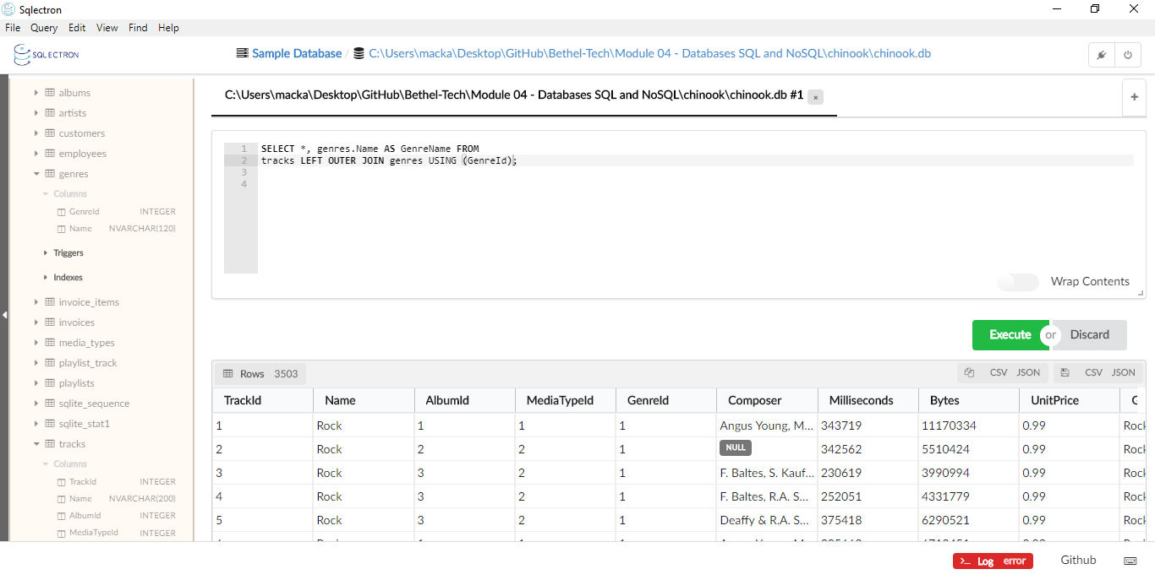
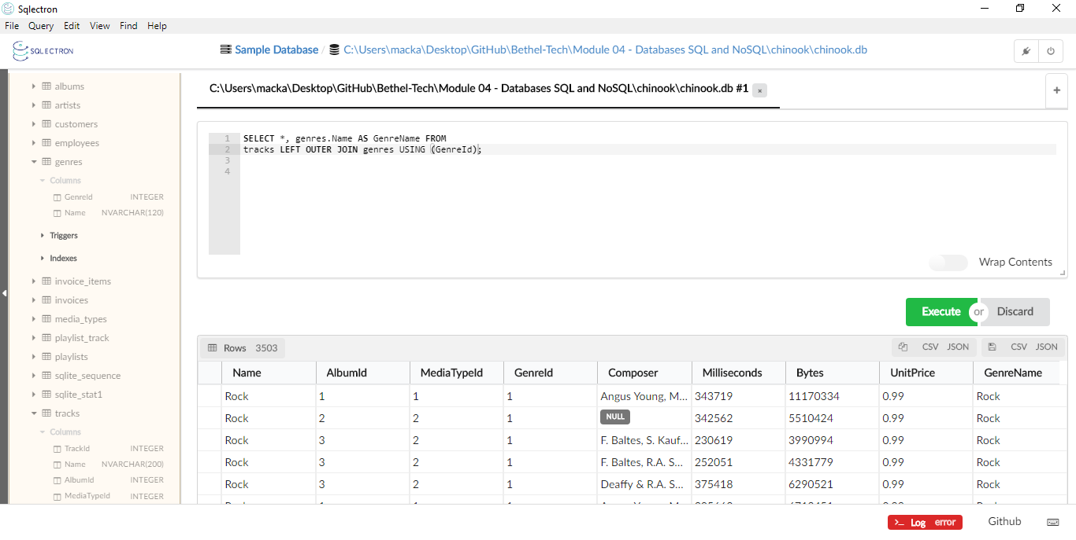

- Write a query that lists out the title of albums and the name of the artists who wrote those albums. Additionally, only list albums that were written by artists that start with a vowel.
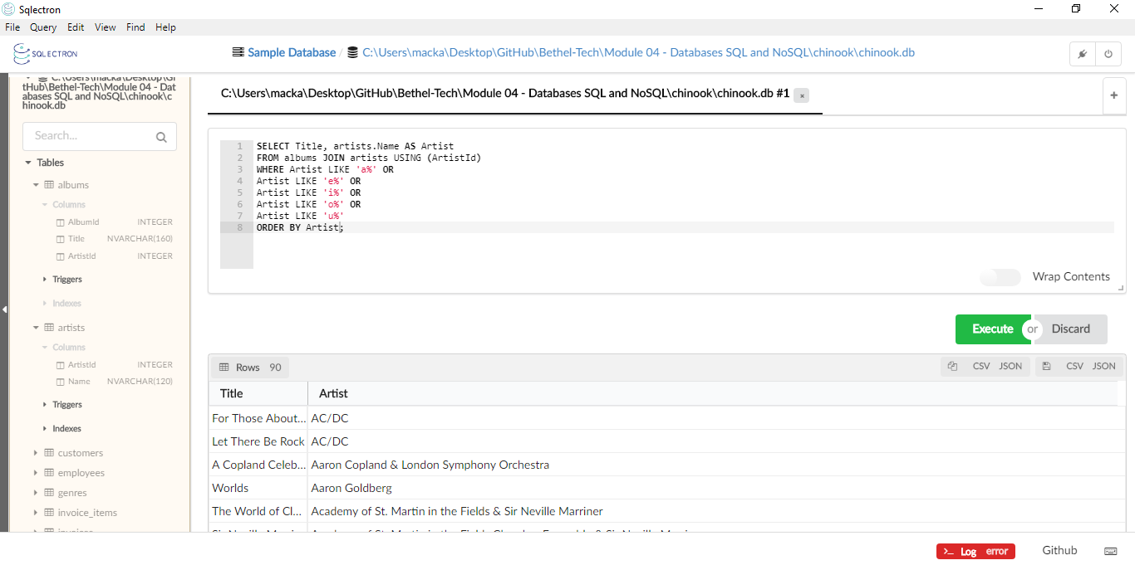
Part 2:

You have just been hired as a Data Analyst for a company that sells music to customers. They would like a list of playlists and the tracks that exist inside each playlist. They want to see the Name of the playlist, the Title of the tracks in the playlist, the Composer for each track, and the UnitPrice for each track. They would like to see all of the data, even if it is Null. Lastly, they would like to see the data in reverse alphabetical order of the Composers.

SELECT playlists.Name AS PlaylistName, tracks.Name AS TrackTitle,
tracks.Composer AS Composer, UnitPrice FROM playlists
JOIN playlist_track USING (PlaylistId)
JOIN tracks USING (TrackId)
ORDER BY UPPER(Composer) DESC;

