SQL-HandsOn3

Part 1:

- Write a query that Inserts a new employee into the database. However, you only have the following information on the new employee: First and Last Name, Birthday, Hire Date, City, State, Country, Phone Number, and Email. Once you have completed the insert, write a query to view all information for that specific employee.
INSERT INTO employees (FirstName, LastName, BirthDate, HireDate, City, State, Country, Phone, Email)
VALUES ('Anthony', 'Mack', '01-13-1983', '09-18-2019', 'Jefferson', 'Wisconsin', 'USA', '262- 719-6936', 'mackattack713@gmail.com');
SELECT * FROM employees
WHERE EmployeeId = 9;
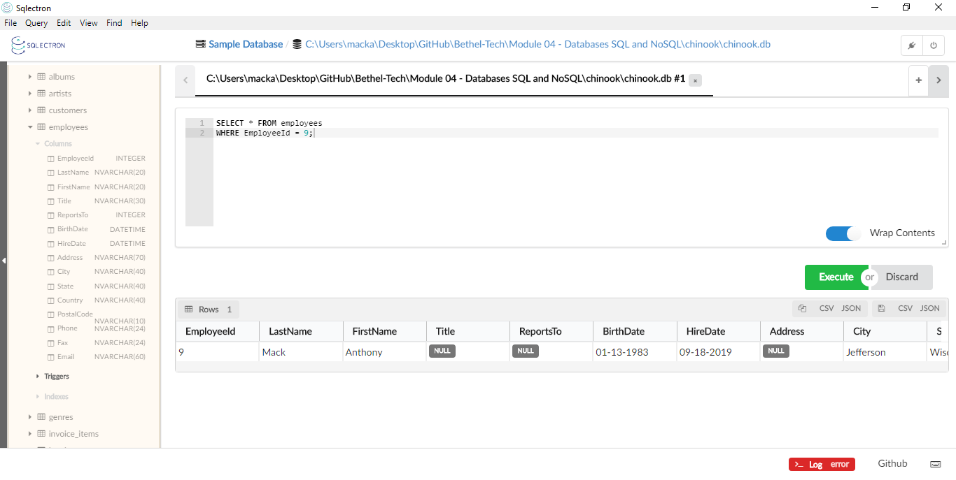
- Write a query to Update the employee that you just inserted. Give your new employee a Title of "Floor Manager". Also, your employee now reports to an employee with an id of 2. When you have completed that query, run another query to see your updated employee.
Tip! Make sure only to update your specific employee. Don't update all employees!

UPDATE employees
SET Title = 'Floor Manager', ReportsTo = 2
WHERE EmployeeId = 9;
SELECT * FROM employees
WHERE EmployeeId = 9;
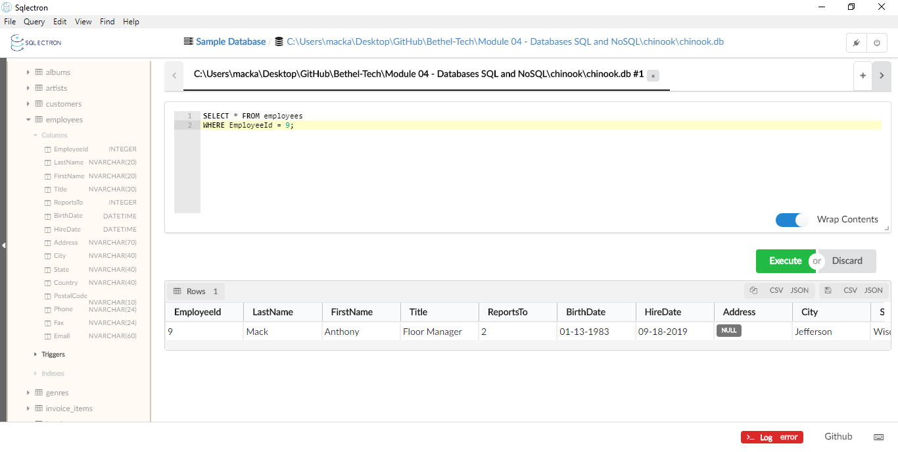
- Write a query that finds all tracks that do not have a value specified for Composers.
SELECT * FROM tracks
WHERE Composer IS Null;
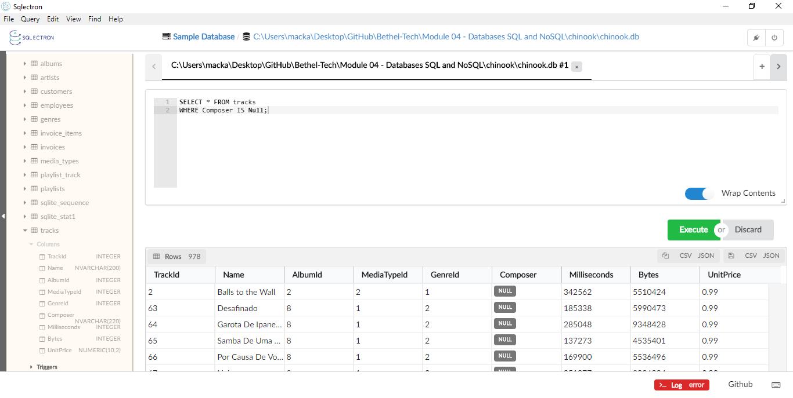
- Write a query that finds all customer's information that has a value for the State they live in and the Company for whom they work.
SELECT * FROM customers
WHERE State IS NOT NULL
AND Company IS NOT NULL;
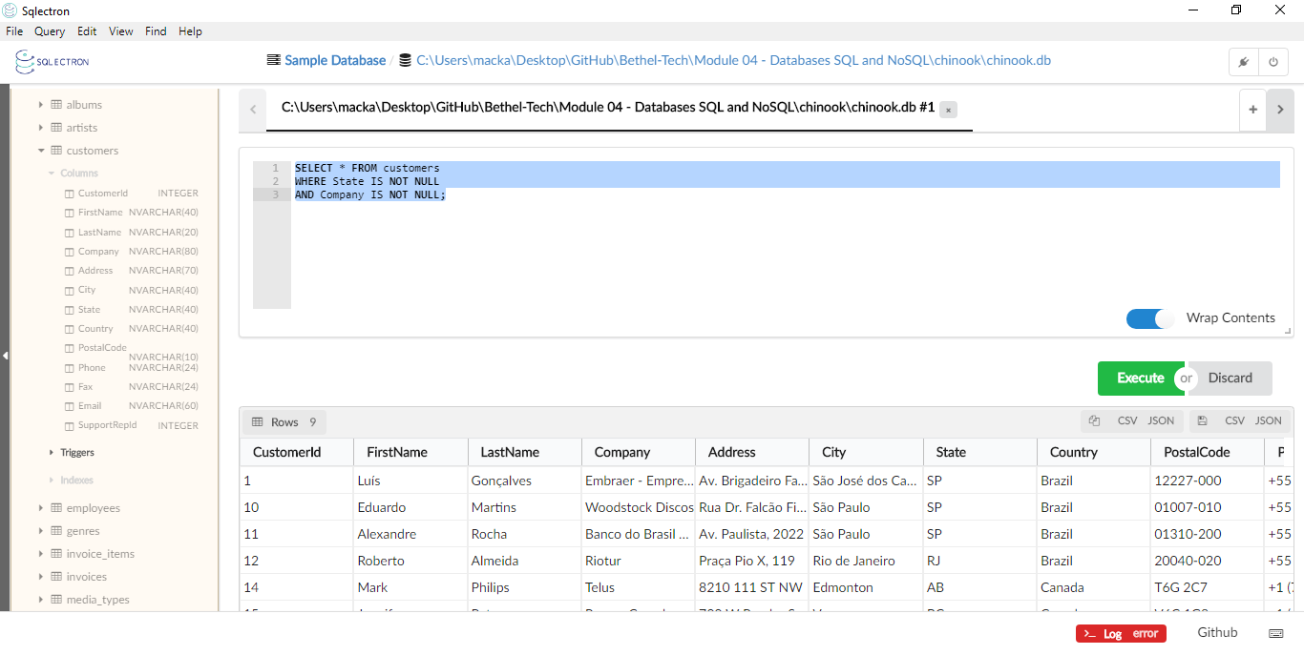
- Write a query that finds all customer's information that has a Null value for the State they live in and the Company for whom they work. If you notice, all customers with a Null value in the State column are from either Europe, Asia or South America. Update their State to be either "Europe," "Asia," or "South America" depending on where their country is. Lastly, write a query that will allow you to view all information of the updated customers with a state of "Europe," "Asia," or "South America."
SELECT * FROM customers
WHERE State IS NULL
AND Company IS NULL;
UPDATE customers
SET State = 'Europe'
WHERE Country = 'Germany'
OR Country = 'Norway'
OR Country = 'France'
OR Country = 'Austria'
OR Country = 'Czech Republic'
OR Country = 'Belgium'
OR Country = 'Denmark'
OR Country = 'Portugal'
OR Country = 'Finland'
OR Country = 'Hungary'
OR Country = 'Poland'
OR Country = 'Spain'
OR Country = 'Sweden'
OR Country = 'United Kingdom';
UPDATE customers
SET State = 'South America'
WHERE Country = 'Chile'
OR Country = 'Argentina';
UPDATE customers
SET State = 'Asia'
WHERE Country = 'India';
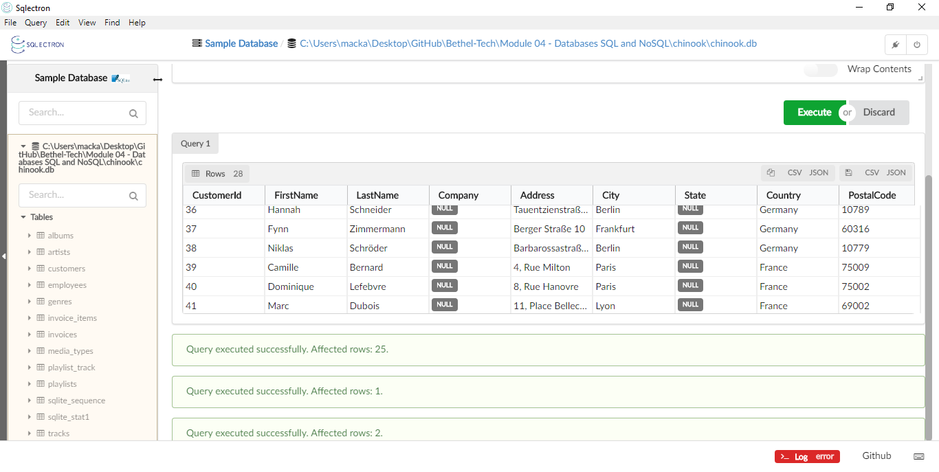
SELECT * FROM customers
WHERE State IN ('Europe', 'Asia', 'South America');
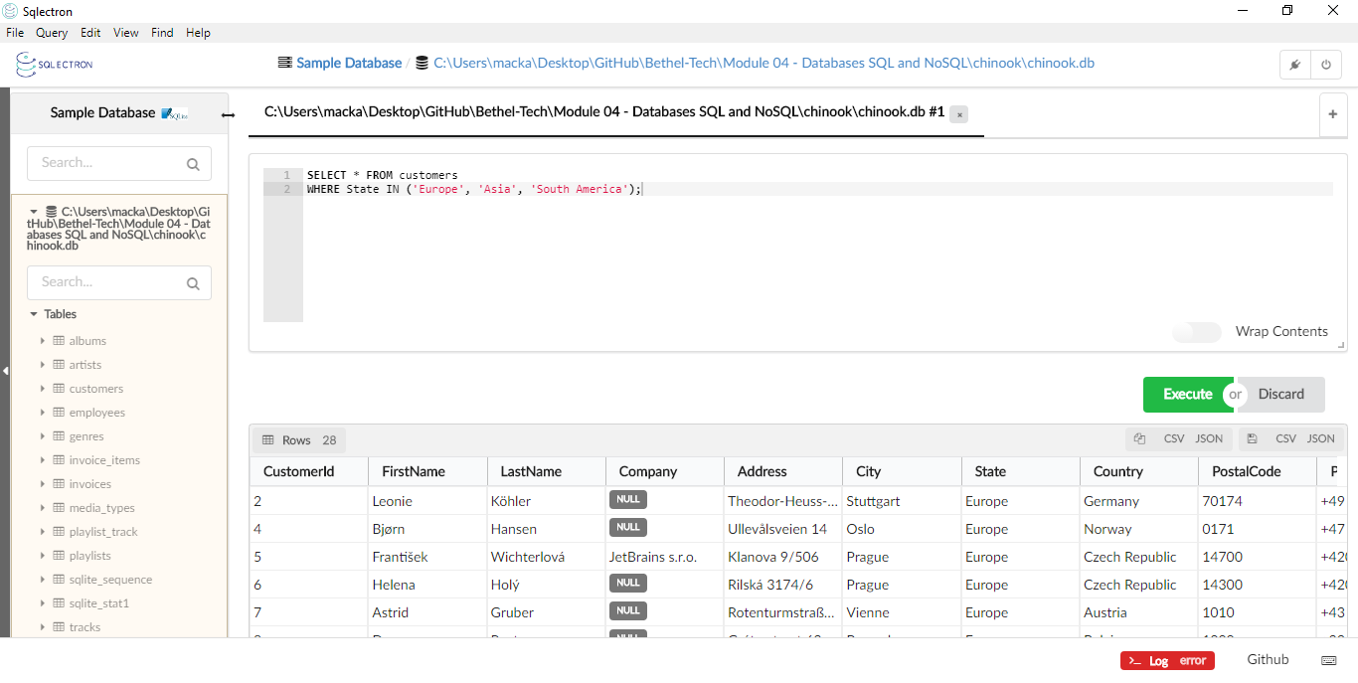
Part 2:

Below is a real-life scenario. Please read this scenario and run the appropriate queries needed.
You have been working at a company as a data analyst. This particular company can no longer operate in the United Kingdom, so customers from the UK must be deleted from the database. However, they want to keep the same number of customers. Replace the deleted customers with the same amount of new customers. These new customers are from Russia, and you only have the following information for each person: first and last name, city, country, phone, and email. Great job, everything looks great! Oh, wait.. your boss just walked in and informed you that everyone from Russia should have a SupportRepId of 6. Update your new customers to reflect this new information and then run a query to view the customers from Russia.
SELECT * FROM customers
WHERE Country = 'United Kingdom';
DELETE FROM customers
WHERE Country = 'United Kingdom';
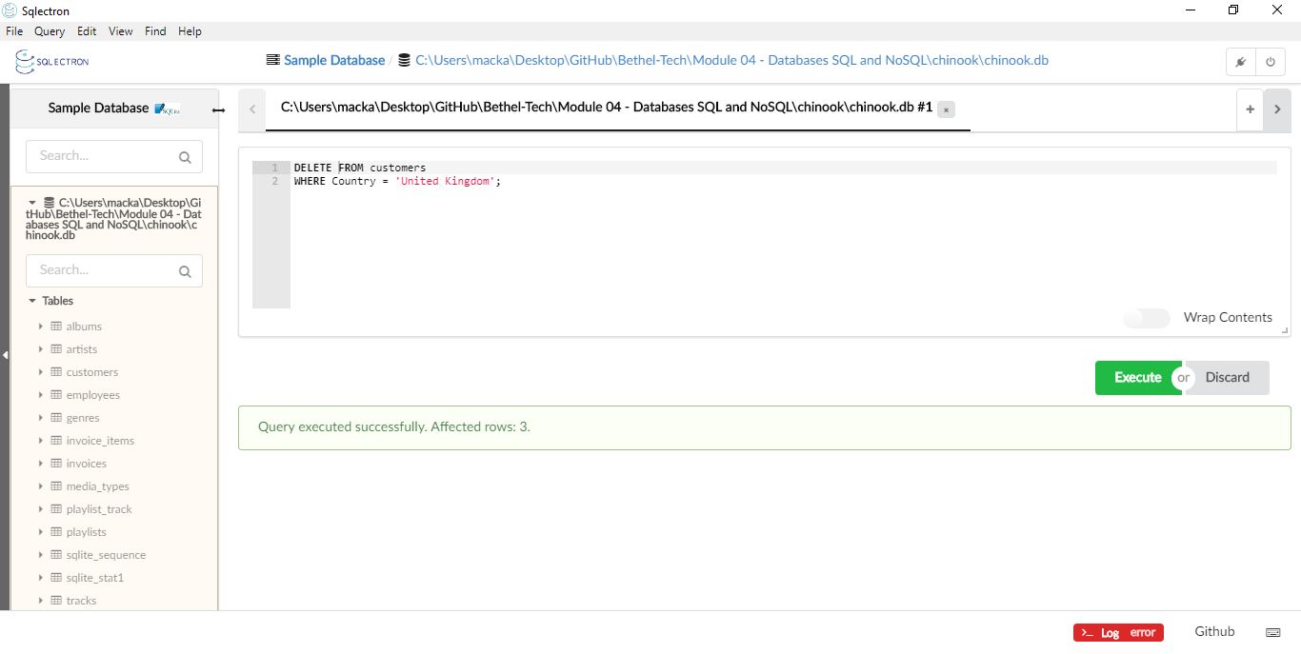
SELECT * FROM customers
WHERE Country = 'United Kingdom';
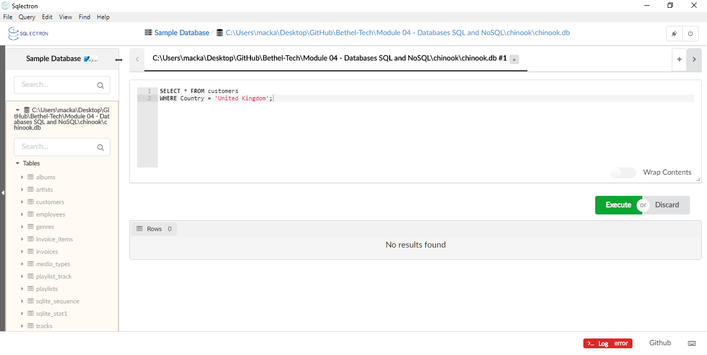
INSERT INTO customers (FirstName, LastName, City, Country, Phone, Email)
VALUES ('Vladimir', 'Putin', 'Moscow', 'Russia', '7-111-11-11', 'vlad@spymail.rus');
INSERT INTO customers (FirstName, LastName, City, Country, Phone, Email)
VALUES('Boris', 'Yeltsin', 'Moscow', 'Russia', '7-222-22-22', 'boris@spymail.rus');
INSERT INTO customers (FirstName, LastName, City, Country, Phone, Email)
VALUES('Dmitri', 'Medvedev', 'Moscow', 'Russia', '7-111-11-11', 'dmitri@spymail.rus');
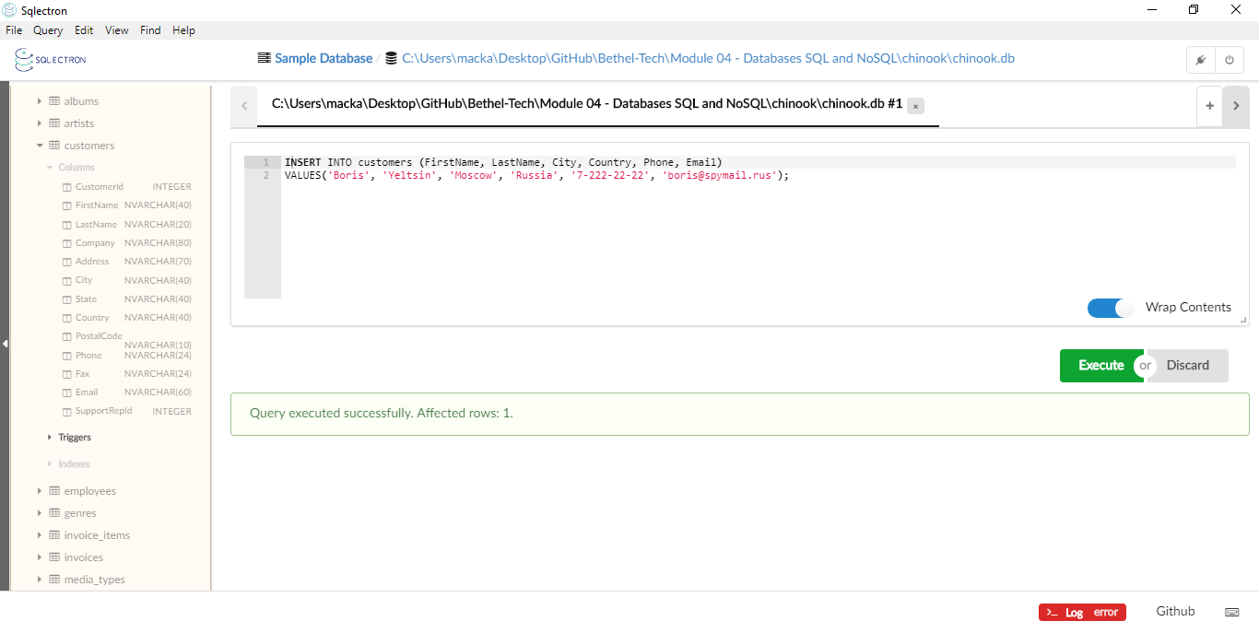
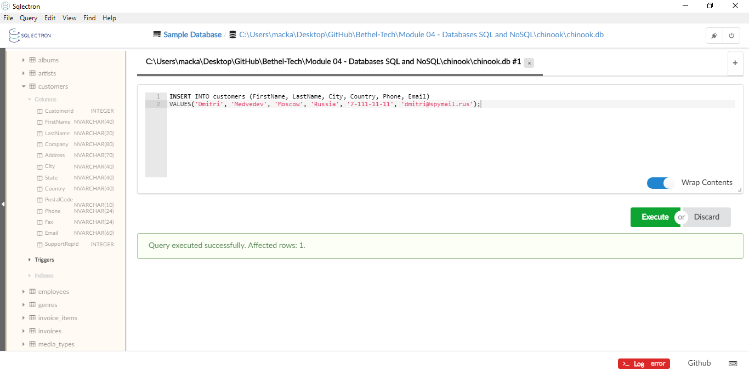
SELECT * FROM customers
WHERE Country = 'Russia';

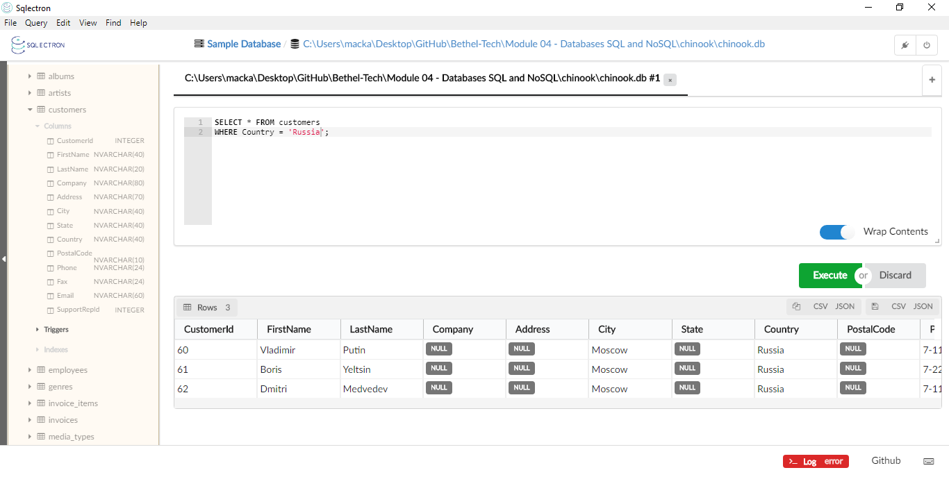
UPDATE customers
SET SupportRepId = 6
WHERE Country = 'Russia';
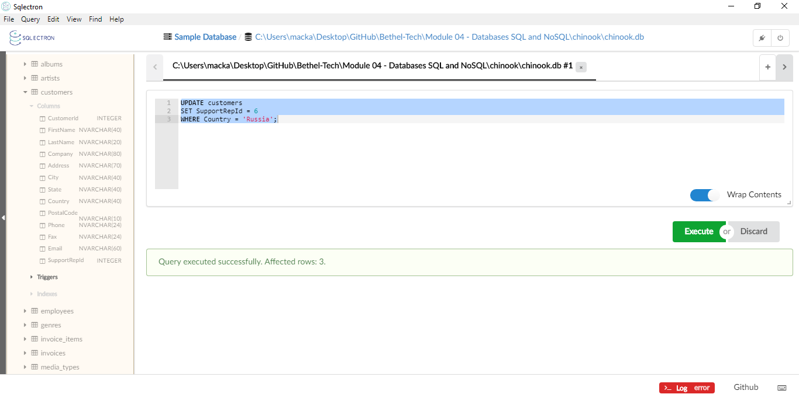
SELECT SupportRepId, * FROM customers
WHERE Country = 'Russia';

