SQL – HandsOn4

Part 1:
Run the following queries:
- Create a view named "ArtistsAlbums" that shows all artists Name, Album Title, and ArtistId, even if the value is Null. Only run this query for artists that have an id less than 100. Once that is complete, select and view your newly created view.
CREATE VIEW ArtistsAlbums AS
SELECT Name, Title, ArtistId
FROM artists
LEFT OUTER JOIN albums USING (ArtistId)
WHERE ArtistId < 100;

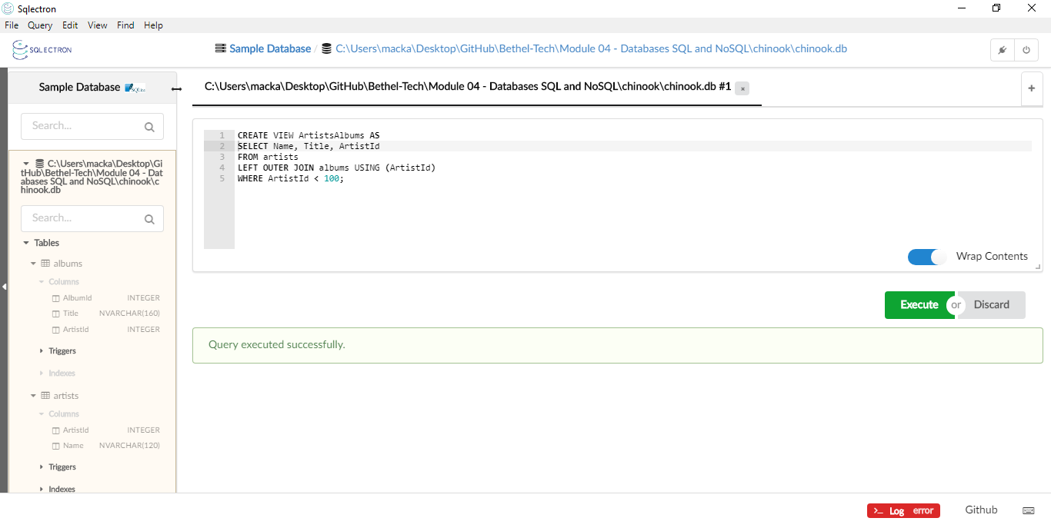
SELECT * FROM ArtistsAlbums;

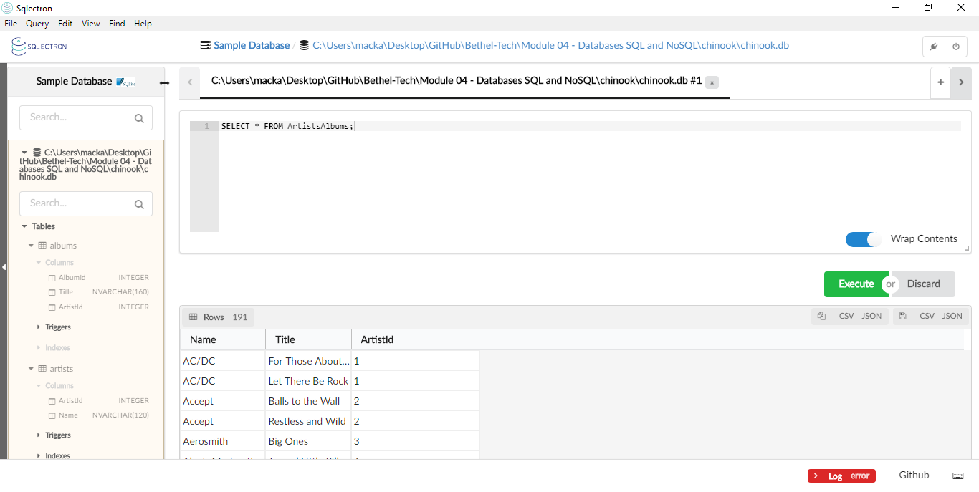

- Update the view you created to also include the AlbumId column. Once you have done that, run a query to see your updated view.

DROP VIEW ArtistsAlbums;

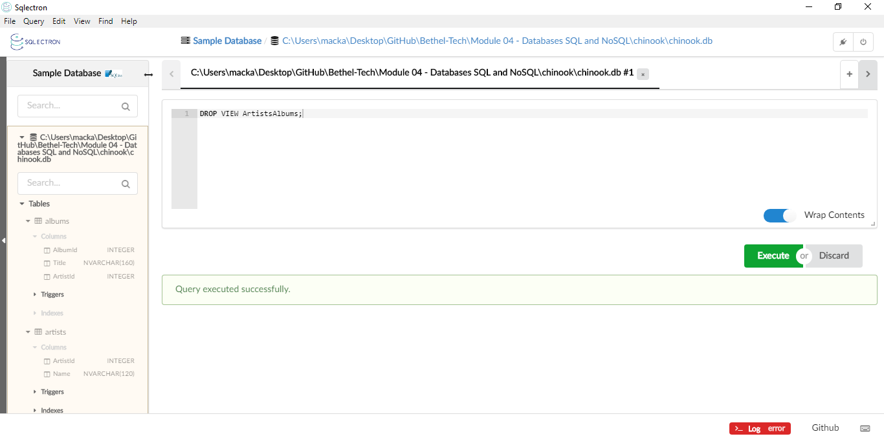
CREATE VIEW ArtistsAlbums AS
SELECT Name, Title, ArtistId, AlbumId
FROM artists
LEFT OUTER JOIN albums USING (ArtistId)
WHERE ArtistId < 100;

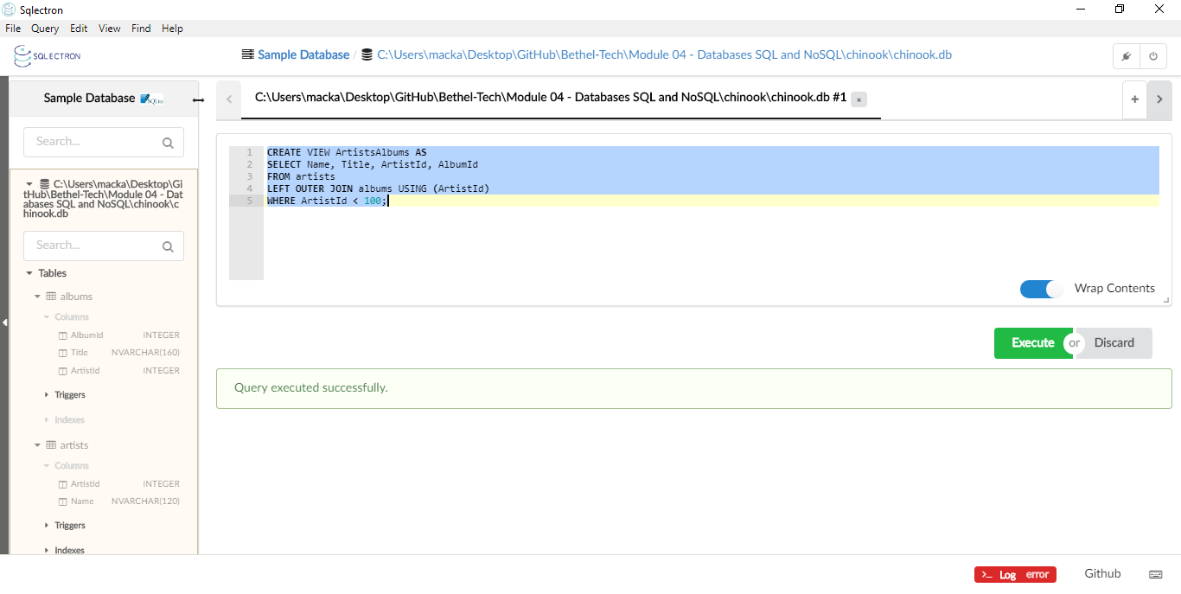
SELECT * FROM ArtistsAlbums;

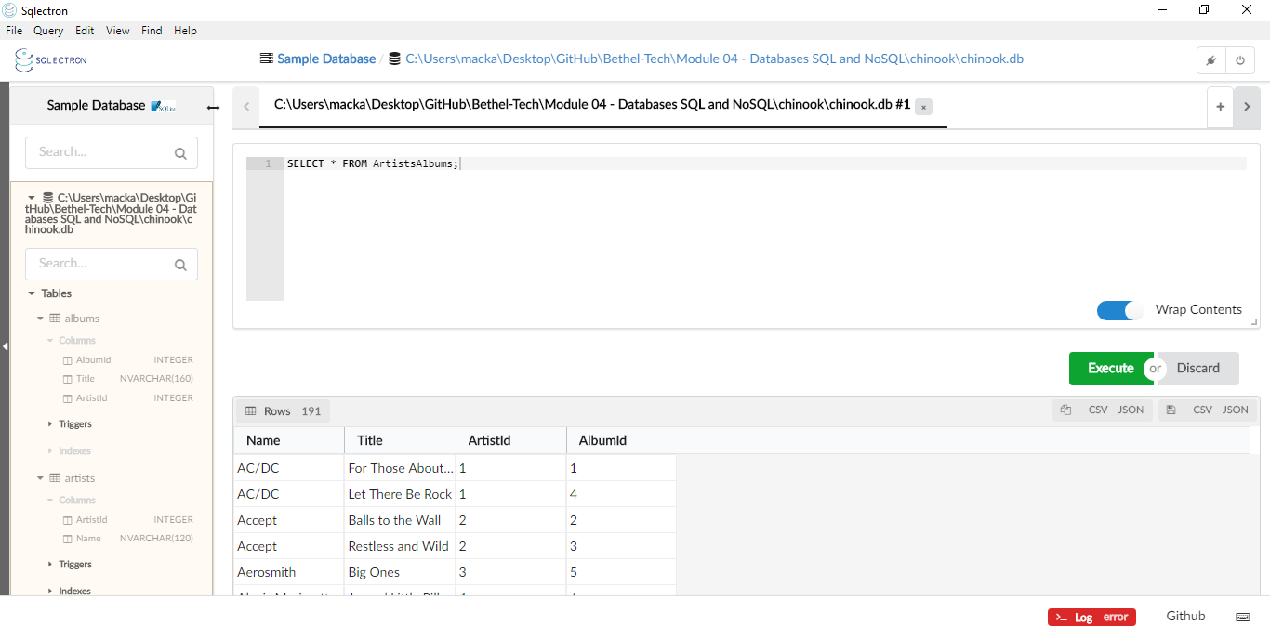
Part 2:
Complete the following:
Create a table named "ProductList". Include the following columns:
- ProductId
- ProductName
- Price
- DateAdded
- EmployeeSupportId

Include the following requirements:
- Every product should have an automatically generated id number that should be unique for each product.
- Give each column a data type that would apply
- Give the DateAdded column a default value for the current local time.
- All columns CANNOT be null.

CREATE TABLE ProductList (
ProductId INTEGER PRIMARY KEY AUTOINCREMENT,
ProductName VARCHAR(50) NOT NULL,
Price NUMERIC(10,2) NOT NULL,
DateAdded date DEFAULT (datetime('now', 'localtime')),
EmployeeSupportId INTEGER NOT NULL
);

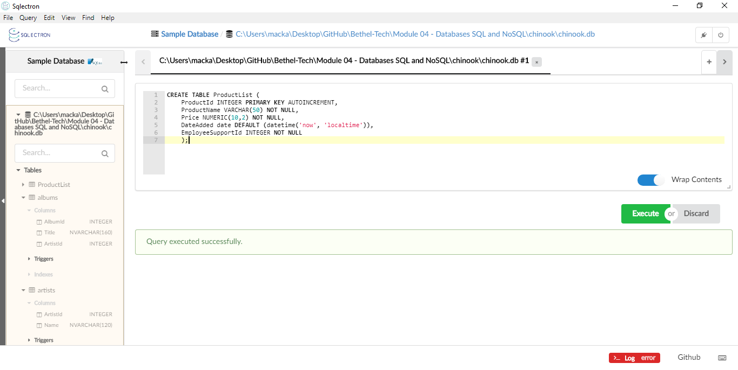
Next, insert one product into the table following the given guidelines when the table was created. When inserting the data, don't include the ProductId or the DateAdded. Finally, run a query to see the single product in your table.

INSERT INTO ProductList (ProductName, Price, EmployeeSupportId)
VALUES ('Blueberries', 3.99, 3);
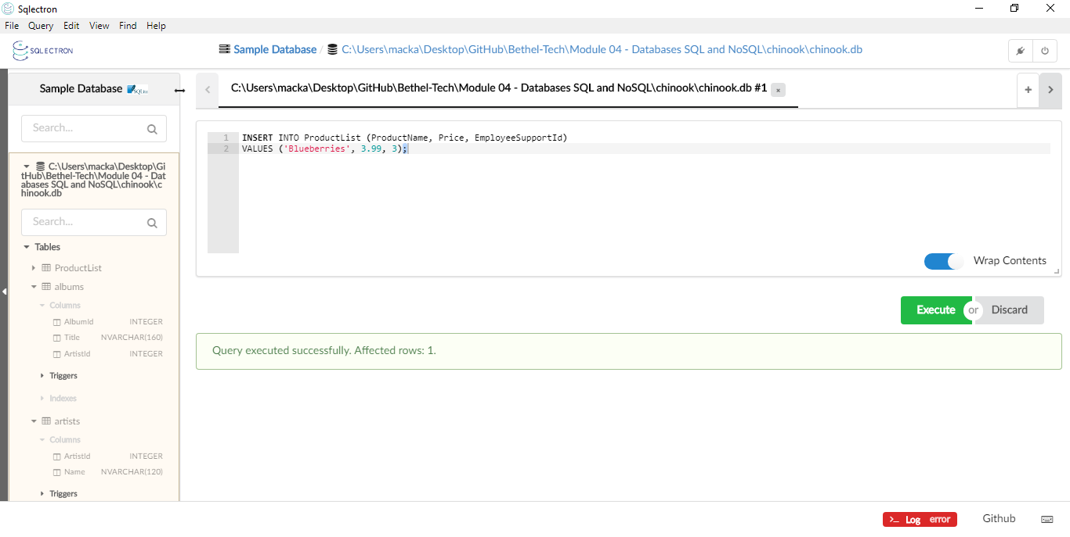
SELECT * FROM ProductList;
