Borislav S. Sabotinov

bss64@txstate.edu | TXST Student ID: A04626934

Abstract

This report examines the design, implementation, and execution of an expert system, which diagnoses vehicle issues and recommends repairs to the user. Report covers how the program employs course concepts and how it makes use of data structures and algorithms.

Vehicle diagnosis and repair recommendations

Project 1 – CS4346: Advanced Artificial Intelligence

Table of Contents

1 Introduction 2

1.1 Purpose 2

1.2 System Scope 2

1.3 Terms and Definitions 2

1.4 Overview 2

2 System Description 2

2.1 System Perspective 2

2.2 System Features 2

2.3 Design and Implementation Constraints 2

2.4 Assumptions and dependencies 2

3 System Design and Specification 2

3.1 Decision Tree Diagram 2

3.1.1 Failure to Start Diagnosis 2

3.1.2 Vehicle Noise Diagnosis 2

3.1.3 Vehicle Overheating Diagnosis 2

3.1.4 Vehicle Overheating Diagnosis 2

3.1.5 Electrical Issues Diagnosis 2

3.1.6 Power Steering Issues Diagnosis 3

3.1.7 Tire Issues Diagnosis 3

3.1.8 General Diagnostics 3

3.2 Variables List for Decision Tree 3

3.3 UML Class Diagram 3

4 Classes Deep-Dive 3

4.1 ClauseItem 3

4.1.1 Data Structures Used 3

4.2 Statement 3

4.2.1 Data Structures Used 3

4.3 VariableListItem 3

4.3.1 Data Structures Used 3

4.4 KnowledgeBase 3

4.4.1 Data Structures Used 3

4.5 Back Chain 3

4.4.1 Data Structures Used 3

4.5 ForwardChain 3

4.5.1 Data Structures Used 3

5 Back Chaining Deep-Dive 3

6 Forward Chaining Deep-Dive 3

7 Building and Running the Program 3

8 Sample Runs 3

8.2 Sample Run #2: Diagnosing a Start-up Issue 4

8.3 Sample Run #3: Repair Recommendation, Air Filter Replacement due to Noise 4

8.4 Sample Run #4: Repair Recommendation, Replacing a Defective Water Pump 4

8.5 Sample Run #5: Printing out the Knowledge Base when prompted 4

8.6 Sample Run #6: Printing the Help Menu 4

8.7 Sample Run #7: Intentionally Running with Faulty Knowledge Base File to Examine Error Handling 4

References 4

Appendix A: Decision Tree Diagram 0

Appendix B: Variables for Decision Tree 11

Appendix C: Source Code 13

# 1 Introduction

## 1.1 Purpose

d

## 1.2 System Scope

d

## 1.3 Terms and Definitions

dd

## 1.4 Overview

d

# 2 System Description

## 2.1 System Perspective

d

## 2.2 System Features

D

## 2.3 Design and Implementation Constraints

D

## 2.4 Assumptions and dependencies

D

# 3 System Design and Specification

D

## 3.1 Decision Tree Diagram

D

### 3.1.1 Failure to Start Diagnosis

D

### 3.1.2 Vehicle Noise Diagnosis

D

### 3.1.3 Vehicle Overheating Diagnosis

D

### 3.1.4 Vehicle Overheating Diagnosis

D

### 3.1.5 Electrical Issues Diagnosis

D

### 3.1.6 Power Steering Issues Diagnosis

D

### 3.1.7 Tire Issues Diagnosis

D

### 3.1.8 General Diagnostics

D

## 3.2 Variables List for Decision Tree

D

## 3.3 UML Class Diagram

D

# 4 Classes Deep-Dive

## 4.1 ClauseItem

D

### 4.1.1 Data Structures Used

D

## 4.2 Statement

D

### 4.2.1 Data Structures Used

D

## 4.3 VariableListItem

D

### 4.3.1 Data Structures Used

D

## 4.4 KnowledgeBase

D

### 4.4.1 Data Structures Used

D

## 4.5 Back Chain

D

### 4.4.1 Data Structures Used

D

## 4.5 ForwardChain

D

### 4.5.1 Data Structures Used

D

# 5 Back Chaining Deep-Dive

D

# 6 Forward Chaining Deep-Dive

D

# 7 Building and Running the Program

D

8 Sample Runs  
  
8.1 Sample Run #1: Diagnosing a Tire Issue

D

## 8.2 Sample Run #2: Diagnosing a Start-up Issue

D

## 8.3 Sample Run #3: Repair Recommendation, Air Filter Replacement due to Noise

D

## 8.4 Sample Run #4: Repair Recommendation, Replacing a Defective Water Pump

D

## 8.5 Sample Run #5: Printing out the Knowledge Base when prompted

D

## 8.6 Sample Run #6: Printing the Help Menu

D

## 8.7 Sample Run #7: Intentionally Running with Faulty Knowledge Base File to Examine Error Handling

D

8.8 Sample Run #8: Exhausting the Options – Inconclusive

# References

D

# Appendix A: Decision Tree Diagram

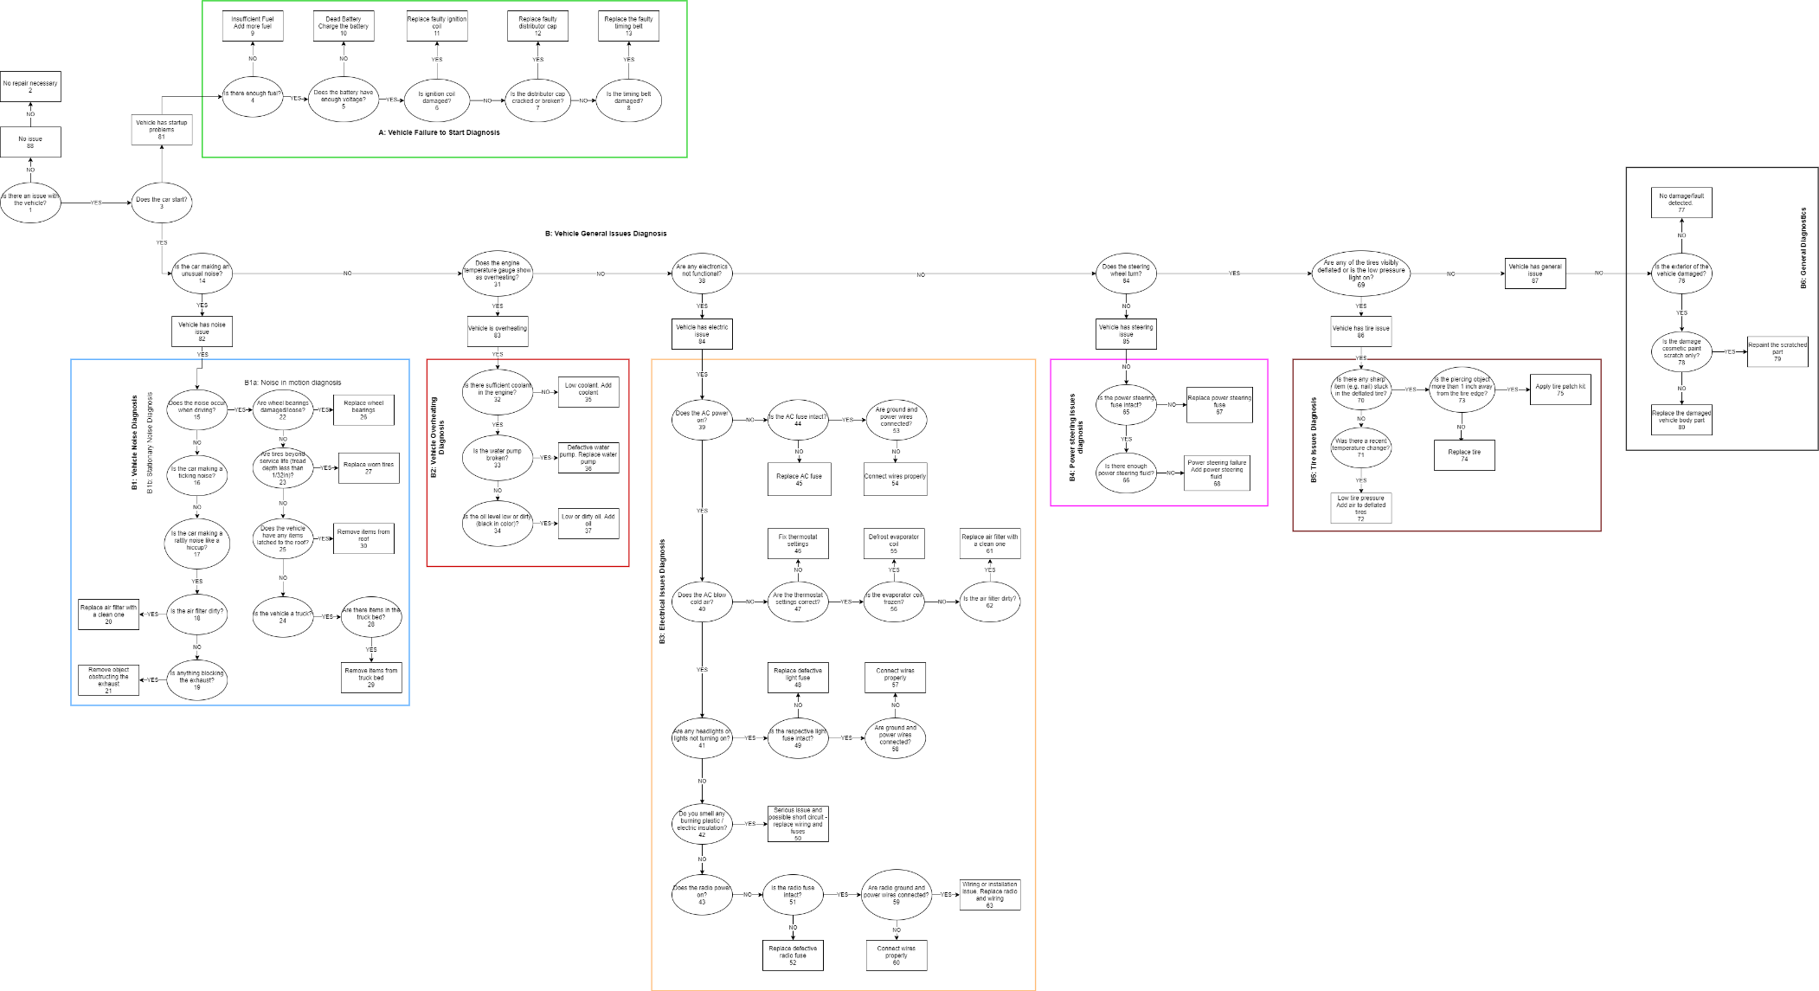

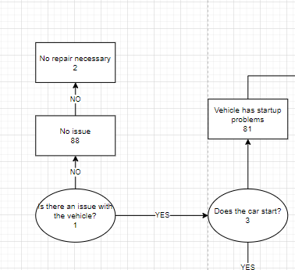

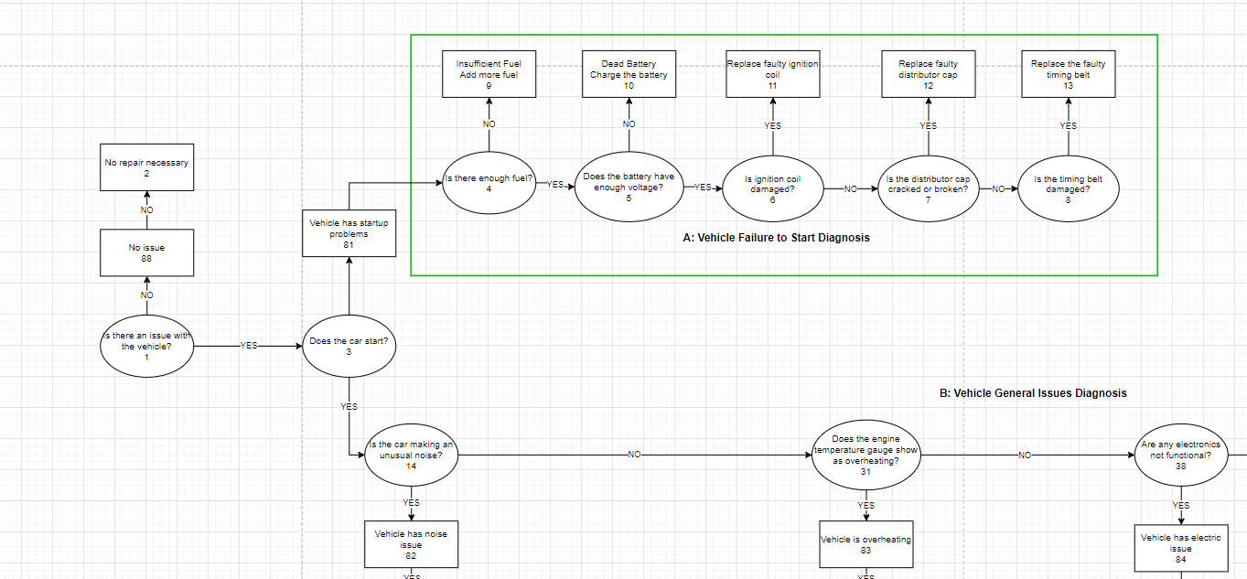

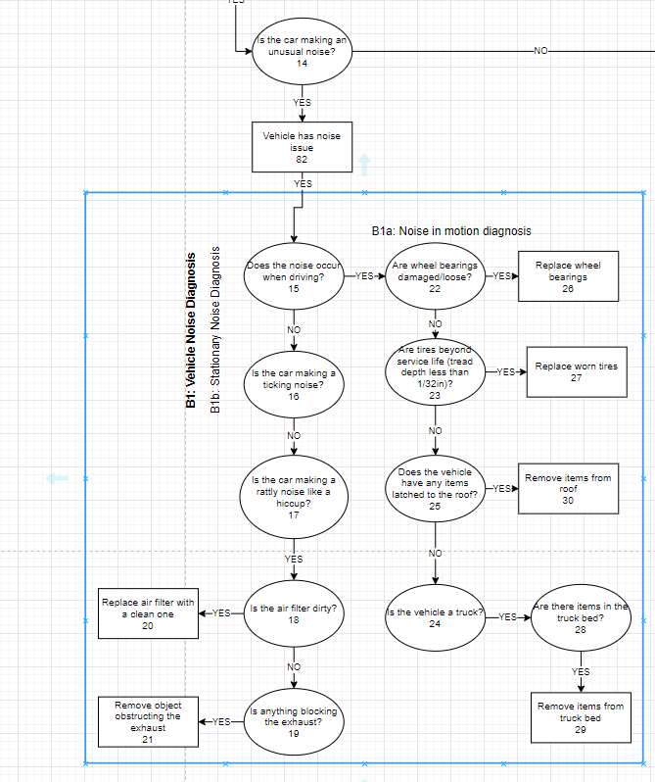

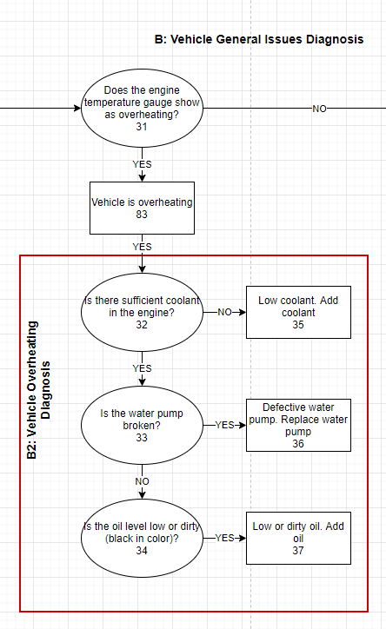

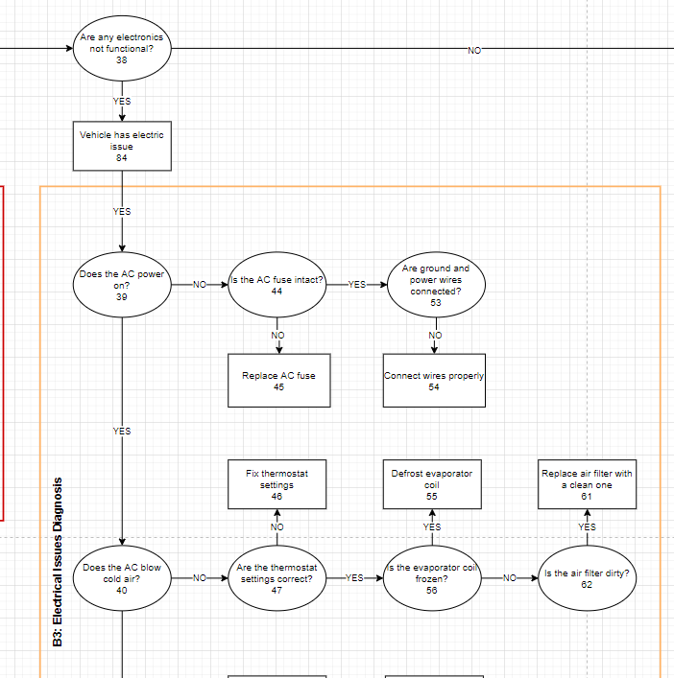

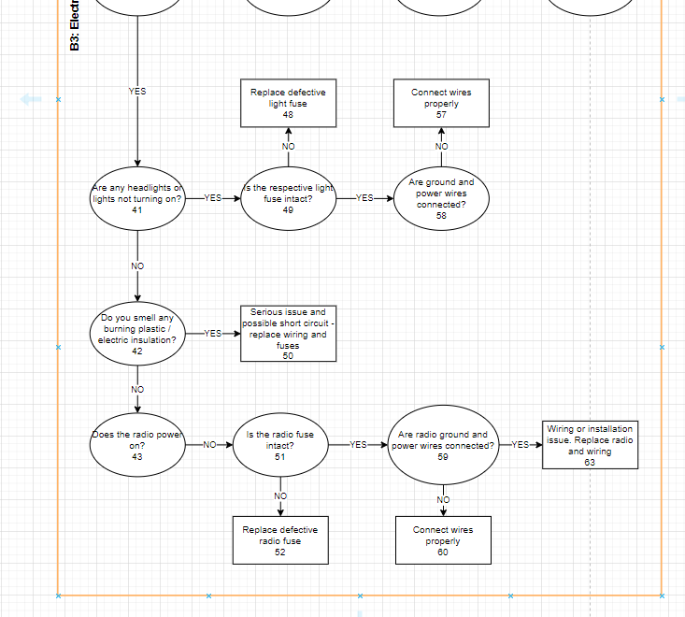

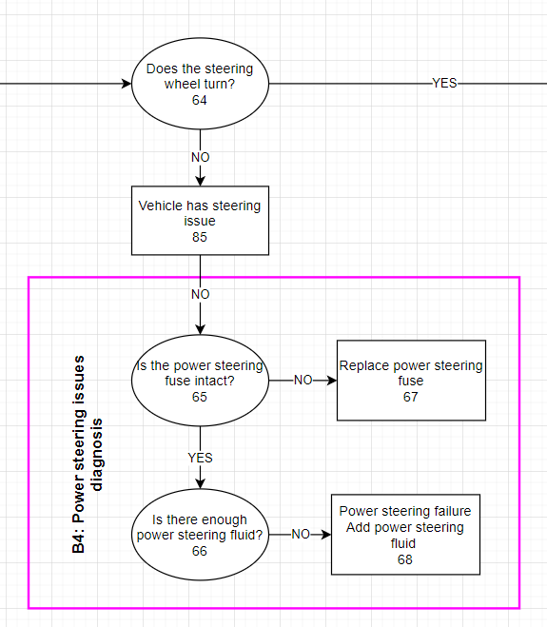

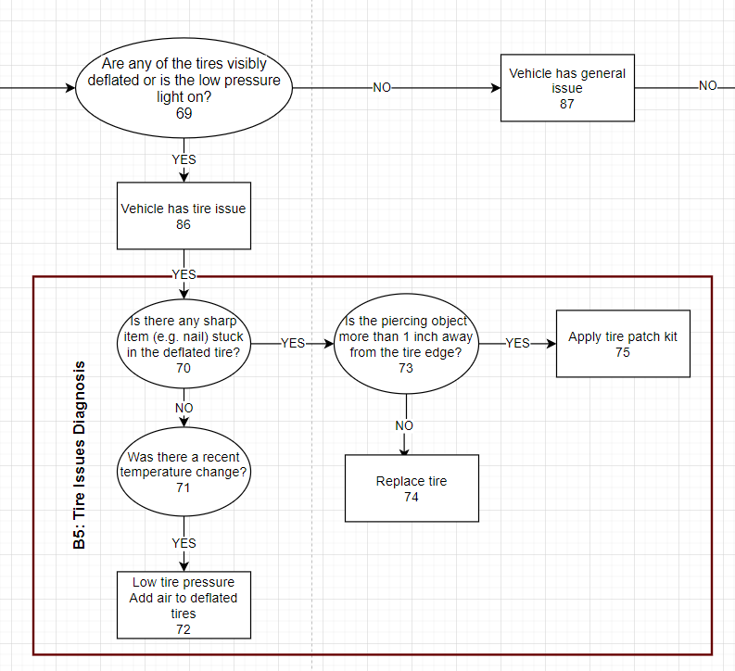

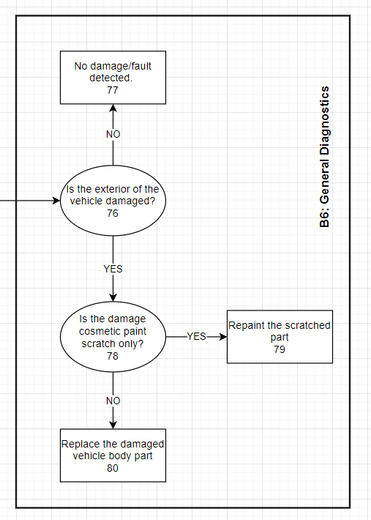

# Appendix B: Variables for Decision Tree

|  |  |  |  |  |
| --- | --- | --- | --- | --- |
| **Variable Name** | **Type** | **Description / Meaning** | **Node(s)** | **Subsystem** |
| has_issue | bool | Is there an issue with the vehicle? (y/n) | 1 | Initial Position |
| is_starting | bool | Does the car start? (y/n) | 3 | Vehicle Failure to Start Diagnosis |
| has_fuel | bool | Is there enough fuel? (y/n) | 4 | Vehicle Failure to Start Diagnosis |
| has_voltage | bool | Does teh battery have enough voltage? (y/n) | 5 | Vehicle Failure to Start Diagnosis |
| is_ignition_coil_damaged | bool | Is the ignition coil in good condition? (y/n) | 6 | Vehicle Failure to Start Diagnosis |
| is_distributor_cap_damaged | bool | Is the distributor cap cracked or broken? (y/n) | 7 | Vehicle Failure to Start Diagnosis |
| is_timing_belt_damaged | bool | Is the timing belt damaged? (y/n) | 8 | Vehicle Failure to Start Diagnosis |
| is_making_noise | bool | Is the car making an unusual noise? (y/n) | 14 | General - Vehicle Noise Diagnosis |
| is_noisy_while_driving | bool | Does the noise occur when driving? (y/n) | 15 | General - Vehicle Noise Diagnosis |
| is_ticking_noise | bool | Is the car making a ticking noise? (y/n) | 16 | General - Vehicle Noise Diagnosis |
| is_hiccup_noise | bool | Is the car making a rattly noise like a hiccup? (y/n) | 17 | General - Vehicle Noise Diagnosis |
| is_air_filter_dirty | bool | Is the air filter dirty? (y/n) | 18 | General - Vehicle Noise Diagnosis |
| is_exhaust_blocked | bool | Is anything blocking the exhaust? (y/n) | 19 | General - Vehicle Noise Diagnosis |
| are_wheel_bearings_damaged | bool | Are wheel bearings damaged/loose? (y/n) | 22 | General - Vehicle Noise Diagnosis |
| are_tires_bald | bool | Are tires beyond service life (tread depth less than 1/32in)? (y/n) | 23 | General - Vehicle Noise Diagnosis |
| is_truck | bool | Is the vehicle a truck? (y/n) | 24 | General - Vehicle Noise Diagnosis |
| has_items_in_truck_bed | bool | Are there items in the truck bed? (y/n) | 28 | General - Vehicle Noise Diagnosis |
| has_items_on_roof | bool | Does the vehicle have any items latched to the roof? (y/n) | 25 | General - Vehicle Noise Diagnosis |
| is_overheating | bool | Does the temperature gauge show as overheating? (y/n) | 31 | General - Vehicle Overheating Diagnosis |
| has_coolant | bool | Is there sufficient coolant in the engine? (y/n) | 32 | General - Vehicle Overheating Diagnosis |
| is_water_pump_broken | bool | Is the water pump broken? (y/n) | 33 | General - Vehicle Overheating Diagnosis |
| is_oil_low_or_dirty | bool | Is the oil level low or dirty (black in color)? (y/n) | 34 | General - Vehicle Overheating Diagnosis |
| has_nonfunctional_electronics | bool | Are any electronics not functional? (y/n) | 38 | General - Electrical Issues Diagnosis |
| does_ac_power_on | bool | Does the AC power on? (y/n) | 39 | General - Electrical Issues Diagnosis |
| does_ac_blow_cold | bool | Does the AC blow cold? (y/n) | 40 | General - Electrical Issues Diagnosis |
| has_nonfunctional_headlights | bool | Are any headlights or lights not turning on? (y/n) | 41 | General - Electrical Issues Diagnosis |
| is_ac_fuse_intact | bool | Is the AC fuse intact? (y/n) | 44 | General - Electrical Issues Diagnosis |
| are_ac_wires_connected | bool | Are AC ground and power wires connected? (y/n) | 53 | General - Electrical Issues Diagnosis |
| are_therm_settings_correct | bool | Are the thermostat settings correct? (y/n) | 47 | General - Electrical Issues Diagnosis |
| is_evaporator_coil_frozen | bool | Is the evaporator coil frozen? (y/n) | 56 | General - Electrical Issues Diagnosis |
| is_air_filter_dirty | bool | Is the air filter dirty? (y/n) | 62 | General - Electrical Issues Diagnosis |
| is_nonfunct_light_fuse_intact | bool | Is the respective non-working light fuse intact? (y/n) | 49 | General - Electrical Issues Diagnosis |
| are_nonfunct_light_wires_conn | bool | Are ground and power wires connected? (y/n) | 58 | General - Electrical Issues Diagnosis |
| has_burning_plastic_smell | bool | Do you smell any burning plastic / electric insulation? (y/n) | 42 | General - Electrical Issues Diagnosis |
| is_radio_working | bool | Does the radio power on? (y/n) | 43 | General - Electrical Issues Diagnosis |
| is_radio_fuse_intact | bool | Is the radio fuse intact? (y/n) | 51 | General - Electrical Issues Diagnosis |
| are_radio_wires_connected | bool | Are radio ground and power wires connected? (y/n) | 59 | General - Electrical Issues Diagnosis |
| does_wheel_turn | bool | Does the wheel turn stiffly or fail to turn? (y/n) | 64 | General - Power Steering Issues Diagnosis |
| is_power_steering_fuse_intact | bool | Is the power steering fuse intact? (y/n) | 65 | General - Power Steering Issues Diagnosis |
| has_power_steering_fluid | bool | Is there enough power steering fluid? (y/n) | 66 | General - Power Steering Issues Diagnosis |
| are_tires_deflated | bool | Are any of the tires visibly deflated or is the low pressure light on? (y/n) | 69 | General - Tire Issues Diagnosis |
| has_piercing_object | bool | Is there a sharp item (e.g., nail) stuck in the deflated tire? (y/n) | 70 | General - Tire Issues Diagnosis |
| is_obj_inch_away_from_edge | bool | Is the piercing object more than 1in away from the tire edge? (y/n) | 73 | General - Tire Issues Diagnosis |
| is_recent_temp_change | bool | Was there a recent temperature change? (y/n) | 71 | General - Tire Issues Diagnosis |
| is_exterior_damaged | bool | Is the exterior of the vehicle damaged? (y/n) | 76 | General Issue Diagnosis |
| is_damage_cosmetic | bool | Is the damage cosmetic paint scratch only? (y/n) | 78 | General Issue Diagnosis |
| repair | string | What repair should be recommended to the user? These are the decision nodes. | 2, 9, 10, 11, 12, 13, 26, 27, 30, 20, 21, 29, 35, 36, 37, 45, 54, 46, 55, 61, 48, 57, 50, 52, 60, 63, 67, 68, 75, 74, 72, 77, 79, 80 | Conclusion variable |
| issue | string | What is the general vehicle issue detected based on user's response? | 81,82,83,84,85,86,87,88 | Conclusion variable, also used as intermediate variable in premise list |

# Appendix C: UML Class Diagram

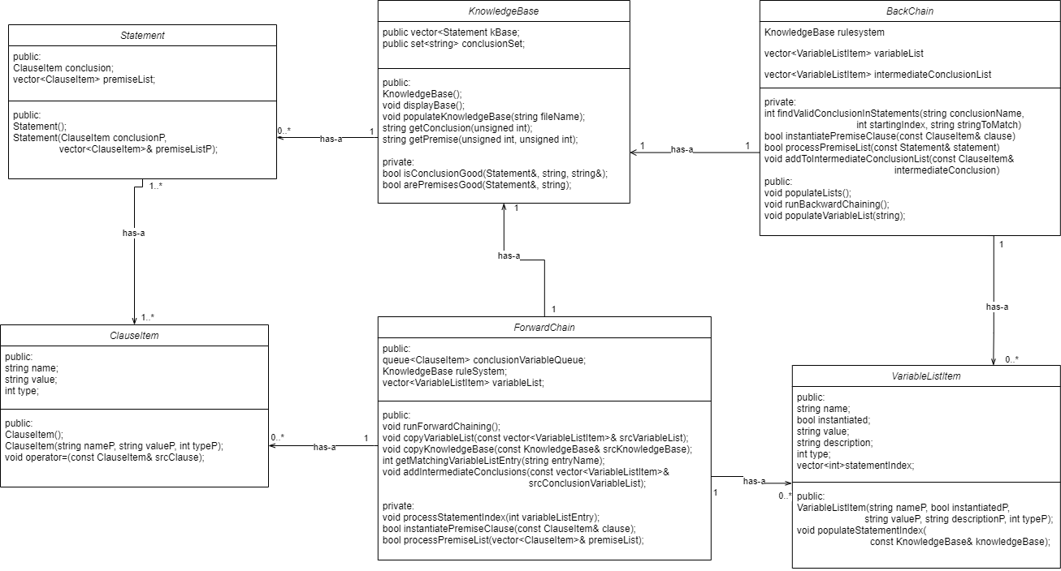

# Appendix C: Source Code

D