System Design Specification (SDS)

[simplyatx.com](https://www.simplyatx.com/)

|  |  |
| --- | --- |
| ***Current Version:*** | 0.5 Pre-release |
| ***Author(s):*** | Borislav Sabotinov, Justin Franz, Lanlan Liu |
| ***Date Created:*** | 3/5/2020 |

**Revision History**

|  |  |  |  |
| --- | --- | --- | --- |
| **Version Number** | **Date Updated** | **Revision Author** | **Brief Description of Changes** |
| 0.1 | 3/5/2020 | Boris | Created document |
| 0.2 | 4/10/2020 | Lanlan | Updated outline for sections 2-5 |
| 0.3 | 4/15/2020 | Boris | Added class and architecture diagrams |
| 0.4 | 4/16/2020 | lanlan | Updated user diagrams |
| 0.5 | 4/17/2020 | Justin | Added use case tables and their details |
| 0.6 | 4/17/2020 | Boris | Added table describing class diagram at the feature level, description of architecture diagram, and updated use case diagrams |
| 0.7 | 4/17/2020 | lanlan | Edited use case tables |

**Table of Contents**

1 Introduction

Purpose of the SDS

1.2 System Scope

1.3 Definitions and Acronyms

1.4 References

1.5 Overview

2 Use Cases

2.1 Actors

2.1.1 Administrative user

2.1.2 General User

2.2 Use Cases

3 Design Overview

3.1 Introduction

3.2 System Architecture

4 System Object Model

4.1 Introduction

4.2 Subsystems

5 Object Descriptions

5.1 Class diagram

5.2 Description of Attributes and Methods

5.2.1 User Login

5.2.2 Perform Search

5.2.3 Leave a Review

5.2.4 Subscribe to notification

5.2.5 Leave Feedback

5.2.6 Activity Milestone

# 1 Introduction

## Purpose of the SDD

The purpose of the Software Design Document is to provide a description of the design of a system fully enough to allow for software development to proceed with an understanding of what is to be built and how it is expected to be built. The Software Design Document provides information necessary to provide description of the details for the software and system to be built. It also provides a list of requirements against which to test the final project and determine whether the system is successfully implemented according to the design. This SDD outlines the design for the SimplyATX website.

## 1.2 System Scope

The software product that will be produced is a website called SimplyATX. The URL is <https://simplyatx.com/>.

SimplyATX will:

* Help users find information about movies and TV listings.
* Provide an interface for users to find a movie or TV listing of their choice.
* Provide an interface for users to rate a movie or TV listing, using a unique and fun emoji scheme.
* Provide an interface for users to buy a movie ticket from an external vendor.
* Provide an interface for users to create and manage a personal user account with limited options.
* Aggregate reviews and showtime information from public API’s that can be leveraged, as well as get relevant showtime information and display it.
* Provide an interface for users to subscribe and receive notifications about predefined categories and special offerings, if possible.
* Provide an interface for users to get contribution milestones.
* Provide an optional interface for users to leave feedback about the website.

The ultimate goal of this website is to give users the ability to find movie information, view and leave reviews, buy tickets for movies, and subscribe to be notified of special offerings.

## 1.3 Definitions and Acronyms

Table 1: Terms and Definitions

|  |  |
| --- | --- |
| **Term** | **Definition** |
| **SRS** | System Requirement Specification, this document will outline all the requirements that the software must fulfil. |
| **UI / GUI** | User interface / Graphical User Interface |
| **Backend** | The part of a computer system or application that is not directly accessed by the user, typically responsible for storing and manipulating data. |
| **Frontend** | Relating or denoting the part of a computer system or application with which the user interacts directly |
| **Interface** | a device or program enabling a user to communicate with a computer. |
| **API** | Application programming interface |
| **IMDB** | International Movie Database, a website which provides movie and TV show related information |
| **IE** | Internet Explorer, a web browser developed by Microsoft. |
| **WAN** | Wide area network. A telecommunications network that extends over a large geographical area for the primary purpose of computer networking. |
| **LAN** | Local area network. The SimplyATX application is not accessible via LAN only networks. |
| **SMTP** | Simple Mail Transfer Protocol |
| **Session** | A user’s time in the system measured from login to logout |

## 1.4 References

[1] IEEE Software Engineering Standards Committee, “IEEE Std 1016-2009, IEEE Recommended Practice for Software Design Description”

<http://cengproject.cankaya.edu.tr/wp-content/uploads/sites/10/2017/12/SDD-ieee-1016-2009.pdf>

[2] Use Case Diagrams Reference. 2009-2020 uml-diagrams.org  
 <https://www.uml-diagrams.org/use-case-reference.html>

## 1.5 Overview

The Software Design Document is divided into 5 sections with various subsections.

The sections of the Software Design Document are:

1) Introduction,

2) Use Cases,

3) Design Overview,

4) System Object Model, and

5) Object Descriptions

# 2 Use Cases

## 2.1 Actors

### 2.1.1 Administrative user

The Administrative User is a user who administers the system by overseeing accounts creation and system management. They also respond to user feedback if

necessary.

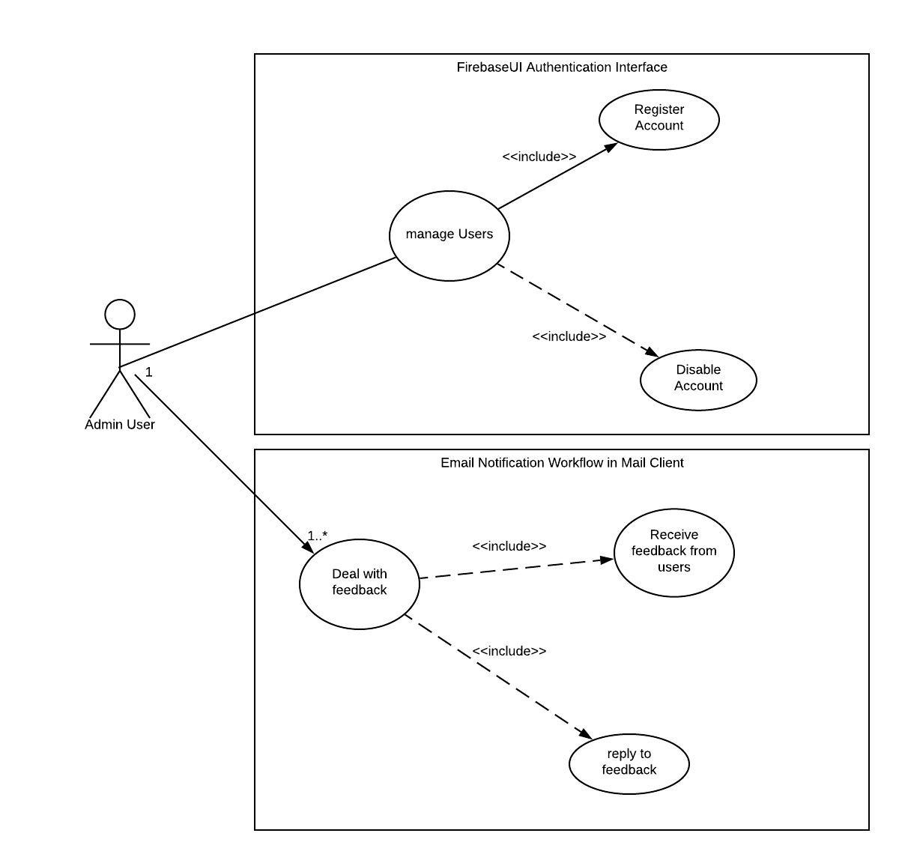

### 2.1.2 General User with Admin for User Feedback

The general user can perform unauthenticated searches and be linked to external ticket providers. To leave a review for a title, sign up for notifications, or receive

an activity milestone, the user must be authenticated.

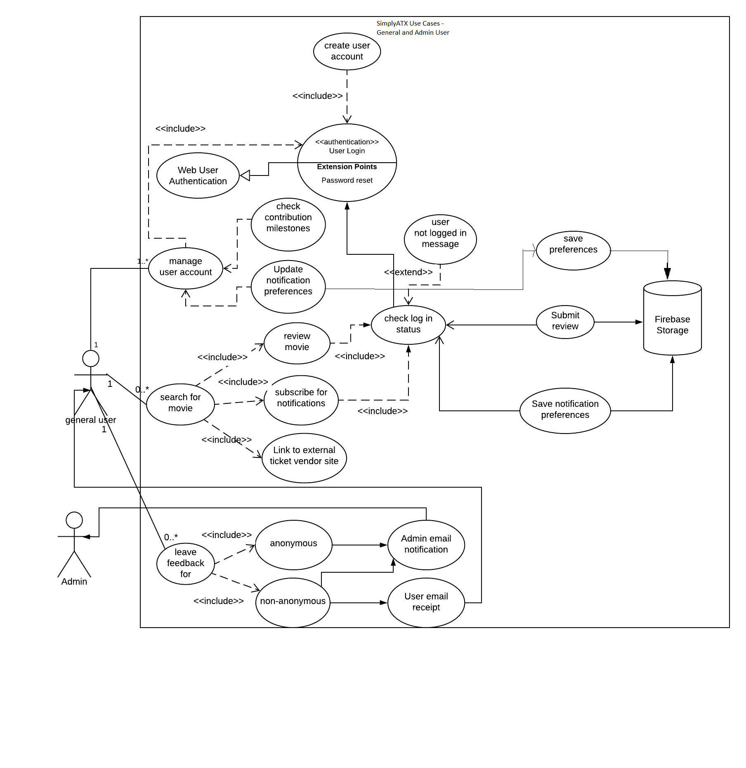

## 2.2 Use Cases

2.2.1 Document Use Case - Login

|  |  |  |  |  |  |
| --- | --- | --- | --- | --- | --- |
| **Use case name:** Web User Authentication | | **ID:** 1 | | **Priority:** High | |
| **Primary actor:**  SimplyATX.com | **Source:** Admin, General User | **Use case type:** Business | | **Level:** Detail | |
| **Interested Stakeholders:** | Admin, General User | | | | |
| **Brief description:** | This use case describes the account login process for a user. In this use case, the actor's goal is to provide a certifiable user name, and an email and password that the authentication system can verify. | | | | |
| **Goal:** | * A successful account verification process. | | | | |
| **Success Measurement:** | * Users are allowed access to their account on SimplyATX.com or denied access if invalid credentials are provided for an existing account. | | | | |
| **Precondition:** | * User has an account already created and archived within the SimplyATX.com account management sub-system. | | | | |
| **Trigger:** | * Users have accessed the SimplyATX.com website through a web browser tab in a new session. | | | | |
| **Relationships:** | Include:  GoogleAuthenticationProvider  Email based Firebase-Authentication  Extend:  Depends on:  Pre-existing email or Google Account | | | | |
| **Typical flow of events:** | 1. Users attempt to access SimplyATX.com website on a web browser. 2. Google DNS redirects user requests to the main screen. 3. Users can perform basic search functionality but must authenticate to leave reviews. 4. Site directs request to FirebaseUI Authentication system. 5. Authentication channels are queried: Google Auth or Email-Based Firebase Auth. 6. If passed, access it granted and site redirects to the User profile portal on the main site, SimplyATX.com. 7. If failed, the login page is updated with failure notification allowing a retry. | | | | |
| **Assumptions:** | The user has an existing email or a Google account. The user has a working network and internet connection. | | | | |
| **Implementation Constraints and Specifications:**  If a user does not have an existing account, they are not prompted to create one. Simply attempting to log in and providing an email and password or signing in via an existing Google account will create a new account for the user. Firebase does this intentionally to make account creation simpler and drive increased conversion rates. | | | | | |

2.2.2 Document Use Case - Leave Feedback

|  |  |  |  |  |  |
| --- | --- | --- | --- | --- | --- |
| **Use case name:** Leave Feedback about the website | | **ID:** 2 | | **Priority:** Low | |
| **Primary actor:**  SimplyATX.com | **Source:** General User | **Use case type:** Business | | **Level:** Detail | |
| **Interested Stakeholders:** | Admin, General User | | | | |
| **Brief description:** | This use case describes how a general user may leave feedback, anonymously or not, from the site’s main UI and receive a receipt email. | | | | |
| **Goal:** | * Allow a general user to access the feedback interface to submit any information to the site’s owners. | | | | |
| **Success Measurement:** | * Users can access the feedback system and receive an acknowledgement email from SimplyATX.com upon submission. | | | | |
| **Precondition:** | * Users need to know how to open the website | | | | |
| **Trigger:** | * Users have accessed the SimplyATX.com website through a web browser tab in a new session. | | | | |
| **Relationships:** | Include:  Non- anonymous feedback  Anonymous feedback  Extend:  Depends on:  ZoHo Mail service API | | | | |
| **Typical flow of events:** | 1. Users attempt to access SimplyATX.com website on a web browser. 2. Google DNS redirects user requests to the main UI Login screen. 3. User clicks on Feedback link. 4. UI redirects User to Feedback form page. 5. User enters feedback into form fields and submits. 6. Data is sent to data storage and mail service is triggered. 7. Receipt email is sent to the user as confirmation. | | | | |
| **Assumptions:** | The user has a working network.  The user has explored the features on the website. | | | | |
| **Implementation Constraints and Specifications:** Feedback form may require the addition of a security CAPTCHA to prevent bots or other malicious forms of behaviour from breaking the systems or site. | | | | | |

2.2.3 Document Use Case - Search

|  |  |  |  |  |  |
| --- | --- | --- | --- | --- | --- |
| **Use case name:** Search for a Title | | **ID:** 3 | | **Priority:** High | |
| **Primary actor:**  SimplyATX.com | **Source:** General User | **Use case type:** Business | | **Level:** Detail | |
| **Interested Stakeholders:** | General User | | | | |
| **Brief description:** | This use case describes how a general user may search for title information by a keyword. | | | | |
| **Goal:** | * Allow a general user to operate a search interface to exploit the search API available through the website. | | | | |
| **Success Measurement:** | * The search API returns a collection of results, either full or empty, in no particular order. | | | | |
| **Precondition:** | * Users know how to open the website and enters a search | | | | |
| **Trigger:** | * The main interface preloads with the search bar after a user navigates to the site. | | | | |
| **Relationships:** | Include:  IMDB.com  AFI.com  Extend:  Depends on:  IMDB.com - open catalog access  AFI.com - open catalog access | | | | |
| **Typical flow of events:** | 1. From the main page, a user enters a search term and clicks the search button. 2. The request is sent to the WebService API of SimplyATX.com. 3. That service calls the AFI and IMDB search APIs and waits for a result set. 4. That result set is then processed by the service and returns the conditioned set to the main interface. 5. The main page builds a wrapper set around the results and displays these as a list of links, one per title. 6. The user then selects a desired title by clicking on the displayed result. 7. This event triggers a service call to the SimplyATX.com API. 8. The service makes an internal request to IMDB for specific movie information. 9. The resultant catalog information is then processed by the service which conditions it and returns it to the main site. 10. The main site parses the information and displays it for the user. | | | | |
| **Assumptions:** | The user has a working network. | | | | |
| **Implementation Constraints and Specifications:** All information is based on external sites and resources, no movie or TV listing is sourced by SimplyATX.com. Some title information may not be available via the AFI or IMDB external datasets. | | | | | |

2.2.4 Document Use Case - Leave Review

|  |  |  |  |  |  |
| --- | --- | --- | --- | --- | --- |
| **Use case name:** Leave Review for a movie | | **ID:** 4 | | **Priority:** High | |
| **Primary actor:**  SimplyATX.com | **Source:** General User | **Use case type:** Business | | **Level:** Detail | |
| **Interested Stakeholders:** | General User | | | | |
| **Brief description:** | This use case describes how an existing user may leave a review for a movie or tv show. | | | | |
| **Goal:** | * Allow an existing user to click on an emoji to leave a simple but unique and intuitive title review. | | | | |
| **Success Measurement:** | * Users are able to leave review for movies after they log into the website | | | | |
| **Precondition:** | * Users must log into their account. * Users must query a specific Movie listing. | | | | |
| **Trigger:** | * After a successful query through the SimplyATX.com Search API, a selected title will present an option for leaving a review. | | | | |
| **Relationships:** | Include:  IMDB.com  AFI.com  Extend:  SimplyATX.com user resources  Depends on:  IMDB.com - open catalog access  AFI.com - open catalog access | | | | |
| **Typical flow of events:** | 1. Users must log into their account. 2. In the successful search results a user must select a listing of Movies by title. 3. The main interface makes a call to the SImplyATX.com search service API. 4. The service makes a specific request to IMDB for the title's detailed information. 5. The service conditions the dataset and returns it to the main interface. 6. The webpage receives the data and parses it for display, adding a link for a review option on SimplyATX.com. 7. The user clicks the link for reviewing and is presented with a modal window view interface. 8. The interface contains a template for name, email, subject and message. | | | | |
| **Assumptions:** | The user has a working network.  The user is logged into SimplyATX.com.  The user has searched for a TV show or Movie listing. | | | | |
| **Implementation Constraints and Specifications:** All review information is non-verbal and uses proprietary review feedback content for ease of tracking and reuse management. | | | | | |

2.2.5 Document Use Case - Subscribe to Notifications

|  |  |  |  |  |  |
| --- | --- | --- | --- | --- | --- |
| **Use case name:** Subscribe to notifications | | **ID:** 5 | | **Priority:** High | |
| **Primary actor:**  SimplyATX.com | **Source:** General User | **Use case type:**  Business | | **Level:** Overview | |
| **Interested Stakeholders:** | General User | | | | |
| **Brief description:** | This use case describes how a general user may subscribe to notifications concerning a specific predefined category of specialty showings. | | | | |
| **Goal:** | * Allow a general user to subscribe to notification messages from SimplyATX.com concerning a specific category of TV show or Movie. | | | | |
| **Success Measurement:** | * Users have access to the notification system through the main interface on SimplyATX.com. | | | | |
| **Precondition:** | * Users are logged in to SimplyATX.com. | | | | |
| **Trigger:** |  | | | | |
| **Relationships:** | Include:  ZoHo mail  Extend:  SimplyATX.com, user account settings  Depends on:  ZoHo mail service API | | | | |
| **Typical flow of events:** | 1. From the main interface a user selects a link to access their personal account information. 2. The main interface displays, from the main site, a UI that contains the users account info, including a notification option. 3. The user selects this option to display a modal interface view that presents a categorical selection list and an update button. 4. This makes a request of the SimplyATX.com service API to update the users account in Firebase cloud storage. 5. Upon SimplyATX.com receiving updates in the selected category for upcoming films or reviews, the user accounts which signed up for the request notification are sent messages via the ZoHo mail SMTP server. | | | | |
| **Assumptions:** | ZOHO mail is operational and users email address is correct  The user has a working network.  The user is logged into SimplyATX.com. | | | | |
| **Implementation Constraints and Specifications:** Any and all categorical notification assignments are limited to any generic genre available from external media sources. | | | | | |

2.2.6 Document Use Case - Activity Milestone

|  |  |  |  |  |  |
| --- | --- | --- | --- | --- | --- |
| **Use case name:** Activity Milestone | | **ID:** 6 | | **Priority:** High | |
| **Primary actor:**  SimplyATX.com | **Source:** General User | **Use case type:** Business | | **Level:** Overview | |
| **Interested Stakeholders:** | General User | | | | |
| **Brief description:** | This use case describes how a general user achieves and receives Activity Milestone awards within SimplyATX.com award system. | | | | |
| **Goal:** | * Allow a user to earn and add a badge icon to their account profile through the SimplyATX.com award system. | | | | |
| **Success Measurement:** | * Users may complete pre-specified metrics tracked through SimplyATX.com that fulfill the criteria programmed into the award system. Upon meeting the requirement, the user is awarded with the specific milestone achievement. | | | | |
| **Precondition:** | * User has an account with SimplyATX.com and has completed the required activities on SimplyATX.com. | | | | |
| **Trigger:** | * The User satisfies the programmed metric. | | | | |
| **Relationships:** | Include:  SimplyATX.com - features and subsystems  Extend:  SimplyATX.com user account management  Depends on:  SimplyATX.com - award subsystem | | | | |
| **Typical flow of events:** | 1. **Pioneer**: Leave 1st custom review 2. **Well-informed**: Subscribe to notifications 3. **Grrr!**: Leave 5 “angry” reviews 4. **I’m not crying, you’re crying**: Leave 5 “sad” reviews 5. **Heh…**: Leave 5 “funny” reviews 6. **Is the paint dry?**: Leave 5 “boring” reviews 7. **Much ado about nothin’**: Leave 5 “meh” reviews 8. **Huh?**: Leave 5 “hmm” reviews 9. **WTF?!**: Leave 10 “huh” reviews 10. **Bruh**: Leave 5 “expressionless” reviews | | | | |
| **Assumptions:** | The user has a working network.  The user is logged into SimplyATX.com.  The user has been leaving reviews for movies | | | | |
| **Implementation Constraints and Specifications:** Content and badges does not violate any trademark, logo nor copyrighted media. All media used in this system was obtained from open license media providers. | | | | | |

# 3 Design Overview

## 3.1 Introduction

The Design Overview is a section to introduce and give a brief overview of the design. The System Architecture is a way to give the overall view of a system and to place it into context with external systems. This allows for the reader and user of the document to orient themselves to the design and see a summary before proceeding into the details of the design.

## 3.2 System Architecture

Refer to attached architecture diagram; zoom in and scroll as needed for vizibility.   
Diagram is included as an attachment to preserve readability for connectors between components.

**<<<ATTACH DIAGRAM FILE>>>**

Observe the numbered gray triangle, normally on the bottom right of a component when possible: 

This represents the component’s number and is used to describe the sequence of execution.

**Example**: Let us examine the “Leave a review” use case sequence:   
(perform search sequence mandatory) + 10, 15, 10, 9

What this tells us is that we have to first perform the sequence of execution for performing a search - it is a mandatory prerequisite for leaving a review for any given title. Next, we start from the last number of the search sequence, which is 9, the UI. We go to 10, the back-end API. **Important note**: we procure user data directly via client-side code but we make a back-end call to the API for any processing and to invoke business logic as needed. Then we visit Firebase Storage at 15, to save the new review. We get a return status in our API and get back to the UI, informing the user that their actions have been accepted and saved.

The diagram consists of seven tiers, with flow of execution between the tiers and components therein clearly outlined. Refer to the bottom left chart for the line color legend. All ports and types of traffic are annotated where possible. The seven tiers are: client, access, web, application, managed services, data, and storage. The dashed yellow line around components 9 and 10 indicates that they both reside as Google Cloud Platform projects. Memory, storage size, and CPU count or speed are also annotated where possible. For component 10, the 1000m CPU speed is due to the application residing in a shared tenant environment at the free tier of service. This means it receives only a share of a single CPU’s time.

# 4 System Object Model

## 4.1 Introduction

The System Object Model Section allows for a description of the subsystems in use. This allows for describing the system in an overall manner to show the different groupings of parts into respective systems.

## 4.2 Subsystems

|  |  |  |  |  |  |  |
| --- | --- | --- | --- | --- | --- | --- |
| **Name** | **Interface** | **Description** | | | | |
| **AFI** | *catalog.afi.com* | Used the Search API to accrue all intermediate search results for movies over the last 100 years. | | | | |
| **IMDB** | *V2.sg.media-imdb.com* | Used to locate proprietary movieid information based on title. | | | | |
| *m.imdb.com* | Used to obtain specific details covering numerous characteristics of a title’s relevant media and metadata. | | | | |
| **ZoHo Mail** | [*https://www.zoho.com/mail/*](https://www.zoho.com/mail/) | Using the online email provider for all messaging between SimplyATX.com and its visitors or users. | | | | |
| **Firebase** | [*https://firebase.google.com/*](https://firebase.google.com/) | Used for user authentication and persistent storage of user data (e.g., reviews, milestones) | | | | |

### 

# 5 Object Descriptions

## 5.1 Class diagram

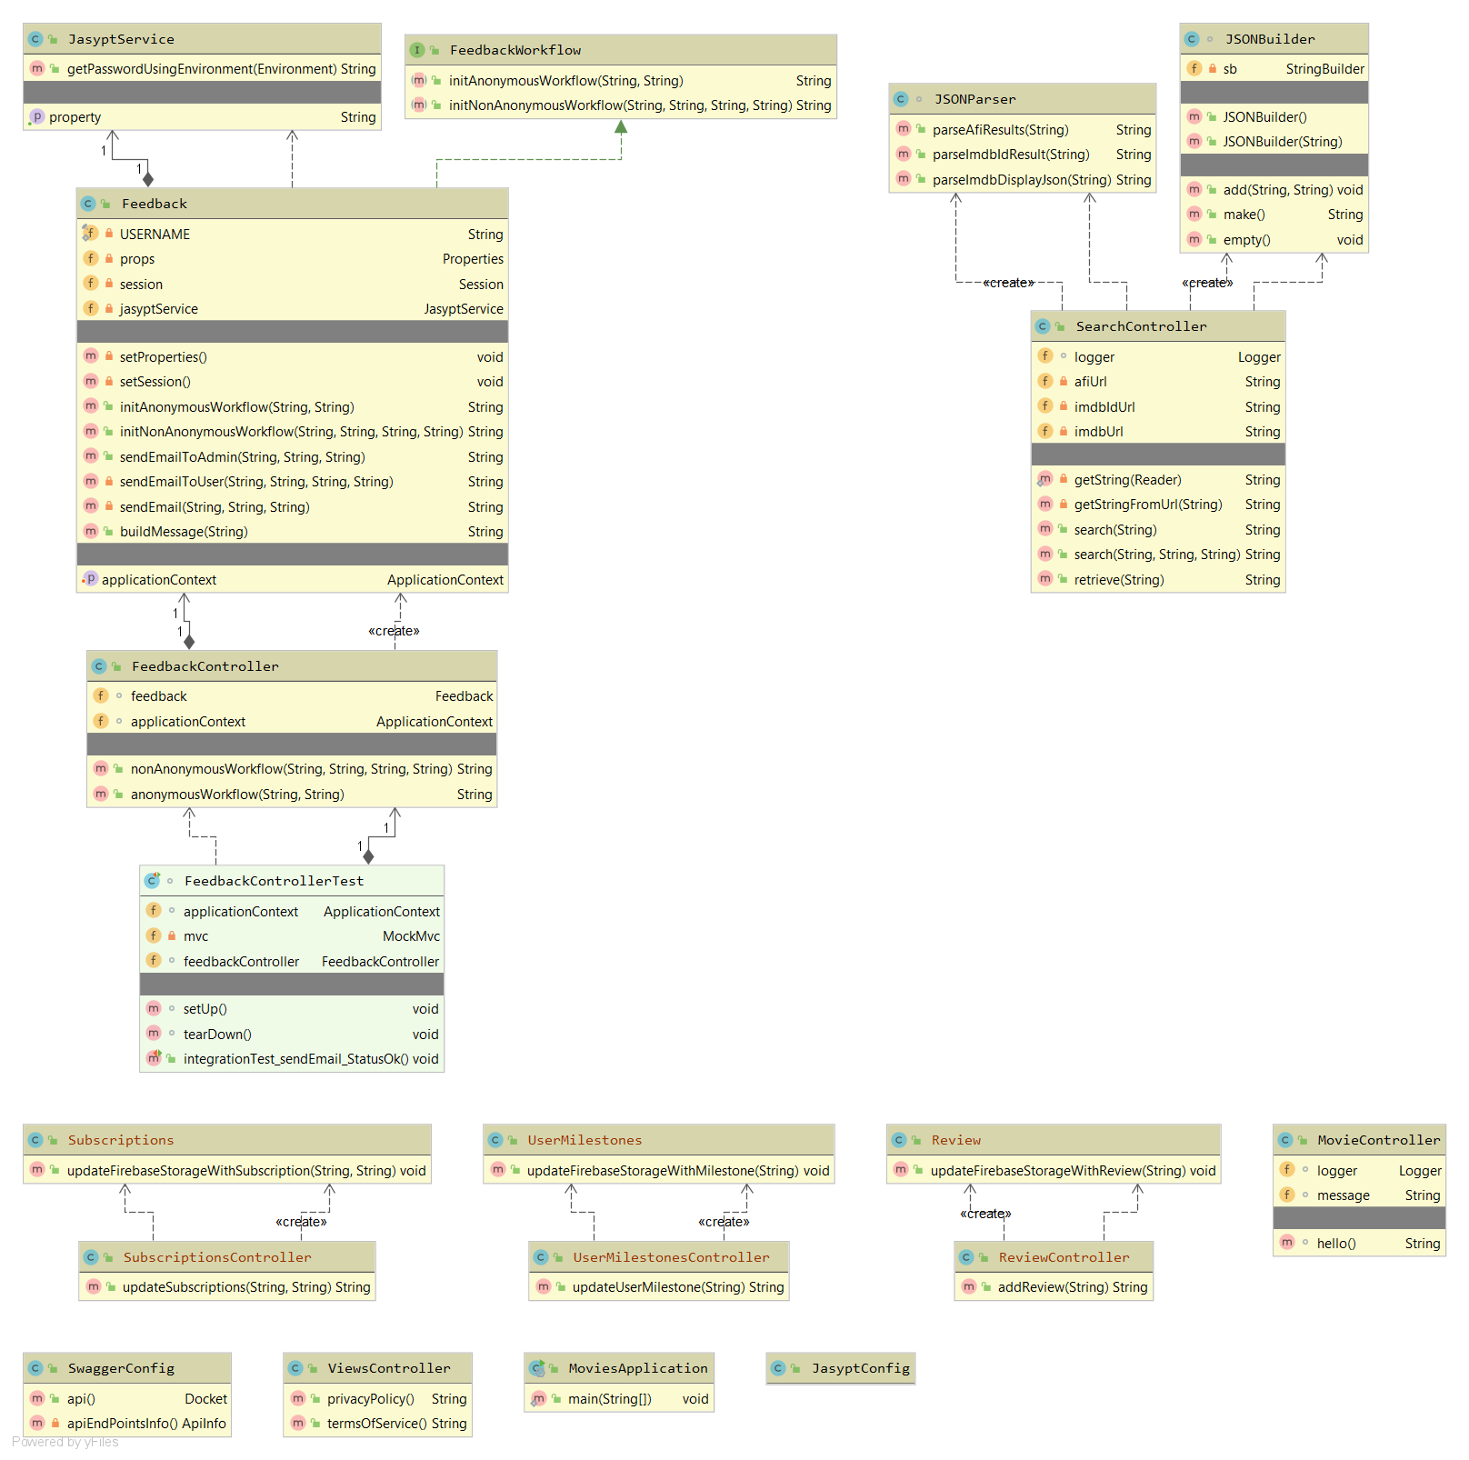



The @RequestMapping annotation maps controllers to all requests starting with "/{url_path}". Methods in a controller need only declare paths relative to that. The @Controller annotation indicates that a particular class serves the role of a *controller*.

Table 2: Class description at the feature level

|  |  |
| --- | --- |
| **Class / Classes** | **Description** |
| MoviesApplication | This class is annotated as @SpringBootApplication. It serves as the entry point into the application and |
| FeedbackController, Feedback | The FeedbackController class is responsible for processing feedback requests issued through the UI by visitors to SimplyATX.com.  Feedback is instantiated by FeedbackController and performs the business logic. For example, the buildMessage(String name) method will consume a user’s name as a string and return a pre-defined email message body containing a custom greeting using the user’s name. |
| SearchController | The SearchController class is responsible for processing search requests issued by users through the UI on SimplyATX.com. |
| SearchController.JSONBuilder | The JSONBuilder is a wrapper for the internal Java.String.stringbuilder class with added methods to encapsulate java strings as json strings for packet transmission via service request replies of the SearchController exposed methods. |
| SearchController.JSONParser | The JSONParser is a custom class designed for parsing the received data packets from both IMDB and AFI API calls. |
| ReviewController | The ReviewController class is responsible for processing and managing the review system within SimplyATX.com for users that create review objects through the main UI at the site level. |
| MovieController | The MovieController class is responsible for processing movie and or TV show title analysis requests by users. It is a planned class that will direct the flow of logic for more detailed title information and possible analytics. It is also responsible for providing a basic REST endpoint for application keep-alive monitoring, to ensure the availability of the API. |
| UserMilestoneController | The UserMilestoneController class is responsible for managing the milestone system within SimplyATX.com and tracking users actions through the main UI at the site level. |
| SubscriptionsController | The SubscriptionsController class is responsible for managing the subscription system within SimplyATX.com and tracking user subscriptions based on ongoing activity outside of the main site. |
| JasyptConfig, JasyptService | These classes are used to procure sensitive application data, such as passwords. The passwords are encrypted and stored in the application properties file and are decrypted at runtime when needed. |
| SwaggerConfig | This is a helper class that provides a detailed description of the entire API - all available HTTP requests are evaluated by this library and is accessible via swagger-ui.html, a dynamically created UI for documenting the API endpoints. |
| ViewsController | This controller returns views, which are maintained as static HTML in the back-end. Currently it returns the site’s privacy and terms of service statements. |

## 5.2 Description of Attributes and Methods (Client-side code)

This section will cover what is not easily described by a class diagram. The SimplyATX website contains much of its logic as client-side JavaScript code.

**app.js:**

* firebaseConfig:JSON object which registers our application with Firebase
* uiConfig: this object configures how we use the drop-in FirebaseUI authentication and defines which authentication methods we make available to the user - email and Google provider sign-in.
* initApp(): function to initialize the application with the defined Firebase services and get the initial user authentication state.
* logout(): allows the user to log out if they are signed in.

**feedbackRestUtility.js:** contains logic to perform HTTP GET requests to the API for handling user feedback.

* anonymousFeedback(subject, message): makes an HTTP GET request to the API without a username or email.
* nonAnonymousFeedback(name, email, message): makes an HTTP GET request with username and email. User will receive a receipt at the end of this workflow.

**searchRestUtility.js:** contains logic to perform HTTP GET requests to the API for obtaining JSON data from AFI and IMDB regarding the user’s search criteria.

* searchImdb(origin, searchCriteria): Will obtain IMDB JSON payload for parsing and displaying to the user.
* searchAfi(origin, searchCriteria): Will obtain AFI JSON payload for parsing and displaying to the user.

**show.js:** defines what comprises a “show” and it’s associated attributes, such as title, year of release, description, and a URL for the poster. It will consume these as parameters passed to it and return back an HTML element with the title’s provided details.

### 5.2.1 User Login

Sequence(1, 6, 7, 8, 9, 3, 4 OR 5, 3, 9 )

A User connects through local DNS with Google DNS->Google GTM->GoogleLTM->SimplyATX.com

At the login screen the user inputs their login credentials which are validated by FirebaseUI Auth->Google/Firebase Authentication-> then returns to SimplyATX.com with the login confirmation or failure result.

### 5.2.2 Perform Search

Sequence((login sequence optional) + 1, 6, 7, 8, 9, 10, 13 AND 14, 10, 9)

From the main UI of SimplyATX.com a user/visitor may activate the 'Search' feature directly this makes a service request on SimplyATX.com Web Service API->AFI/Search API which returns a list of possible results, and then upon a users selection of a title for more information a request is issued to the IMDB.com API, all requests return payloads to the main UI on SimplyATX.com

### 5.2.3 Leave a Review

Sequence(perform search sequence mandatory) + 10, 15, 10, 9)

After a search request has been successfully issued and received by the user, when the review feature is selected a review form is opened in the main site allowing a user to make a review submission this makes a request on the SimplyATX.com Web Service API->Firebase Cloud Storage to add a record for the given user on the requested title->an acknowledgement is then posted on the main UI of SimplyATX.com returning to the search results screen from where the review request was originated.

### 5.2.4 Subscribe to notification

Sequence((login sequence mandatory) + 10, 15, 10, 11, 12, 1 )

A User connects through local DNS with Google DNS->Google GTM->GoogleLTM->SimplyATX.com

At the login screen the user inputs their login credentials which are validated by FirebaseUI Auth->Google/Firebase Authentication-> then returns to SimplyATX.com with the login confirmation or failure result.

After users have successfully logged in, users can click on which content to subscribe to, those settings will be saved to Firebase Cloud Storage through SimpleATX Web Service API. Important note: we procure user data directly via client-side code but we make a back-end call to the API for any processing and to invoke business logic as needed. Then we visit Firebase Storage at 15, to save the new settings. We get a return status in our API and get back to the UI, if there is an update on the content of subscription, users will be informed.

### 5.2.5 Leave Feedback

Sequence (1, 6, 7, 8, 9, 10 , 11, 12, 1, AND 2 )

User connects thru local DNS with Google DNS->Google GTM->GoogleLTM->SimplyATX.com

A feedback form will pop up for users to provide feedback. Users have two choices: either leave anonymous feedback without entering an email address, or leave non-anonymous feedback by entering an email address.

After the user hits the submit button, SimpleATX Web Service API will connect to ZOHO Mail Server. From here, emails will be sent to the admin email account. If this is non-anonymous feedback, another email will be sent to the user to confirm the admin has received the feedback.

5.2.6 Activity Milestone

Upon successful login, search and review procedures are completed the MilestoneActivity system will actively monitor all transactions and in the event of a completed milestone metric the SimplyATX.com Web Service API will make an update on the users account through the Firebase Cloud Storage and then a call to the Zoho mail service API to notify the user of a completed milestone.