**Practical Related Questions**

1. **Draw the activity life cycle diagram.**

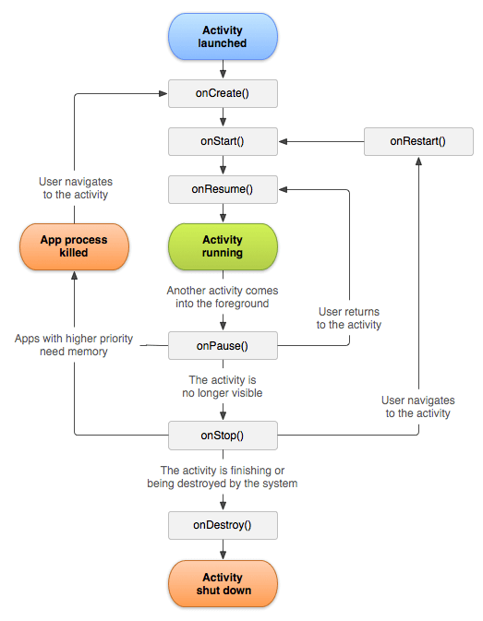

1. **Give the hierarchy of directory structure where you store activity file.**

**res/layout/activity_foo.xml** - This file describes the layout of the activity's UI. This means the placement of every view object on one app screen.

**src/.../FooActivity.java** - The Activity "controller" that constructs the activity using the view, and handles all event handling and view logic for one app screen.

1. **Write difference between onStop() and onDestroy() methods, also between onPause() and onResume()methods.**

onDestroy() is called whenever:

* The user takes out the activity from the "recent apps" screen.
* The user takes out the activity from the "recent apps" screen.

onStop() is called whenever:

* The user leaves the current activity.

So in your example, when the user launches Activity B, Activity A called onStop().

**Exercise**

**1.**

a) MainActivity.java

package com.example.activitylife;  
  
import androidx.appcompat.app.AppCompatActivity;  
  
import android.os.Bundle;  
import android.util.Log;  
  
public class MainActivity extends AppCompatActivity {  
  
 @Override  
 protected void onCreate(Bundle savedInstanceState) {  
 super.onCreate(savedInstanceState);  
 setContentView(R.layout.*activity_main*);  
 Log.*d*("lifecycle","onCreate invoked");  
 }  
 @Override  
 protected void onStart() {  
 super.onStart();  
 Log.*d*("lifecycle","onStart invoked");  
 }  
  
 @Override  
 protected void onResume(){  
 super.onResume();  
 Log.*d*("lifecycle", "OnResume Invoked");  
 }  
  
 @Override  
 protected void onPause(){  
 super.onPause();  
 Log.*d*("lifecycle", "OnPause Executed");  
 }  
  
 @Override  
 protected void onStop(){  
 super.onStop();  
 Log.*d*("lifecycle", "OnStop Lifecycle Executed");  
 }  
  
 @Override  
 protected void onRestart(){  
 super.onRestart();  
 Log.*d*("lifecycle", "OnRestart Executed");  
 }  
  
 @Override  
 protected void onDestroy(){  
 super.onDestroy();  
 Log.*d*("lifecycle", "OnDestroy Executed");  
 }  
}

b) activity_main.xml

<?xml version="1.0" encoding="utf-8"?>  
<androidx.constraintlayout.widget.ConstraintLayout xmlns:android="http://schemas.android.com/apk/res/android"  
 xmlns:app="http://schemas.android.com/apk/res-auto"  
 xmlns:tools="http://schemas.android.com/tools"  
 android:layout_width="match_parent"  
 android:layout_height="match_parent"  
 tools:context=".MainActivity">  
  
 <TextView  
 android:layout_width="wrap_content"  
 android:layout_height="wrap_content"  
 android:text="Hello World!"  
 app:layout_constraintBottom_toBottomOf="parent"  
 app:layout_constraintLeft_toLeftOf="parent"  
 app:layout_constraintRight_toRightOf="parent"  
 app:layout_constraintTop_toTopOf="parent" />  
  
</androidx.constraintlayout.widget.ConstraintLayout>