Practical related question:-

1. Draw the lifecycle of service.

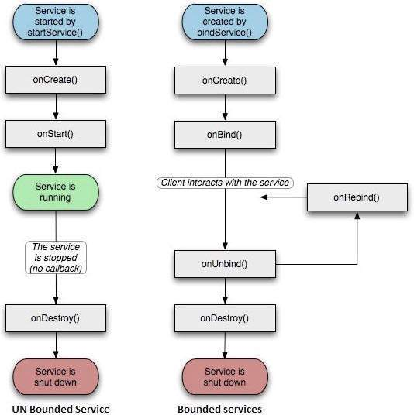

1. Differentiate between bounded services and unbounded service.

|  |  |
| --- | --- |
| unbounded | bounded |
| Unbounded Service is used to perform long repetitive task | Bounded Service is used to perform background task in bound with another component |
| Unbound Service gets starts by calling **startService()**. | bounded Service gets starts by calling **bindService()**. |
| Unbound Service is stopped or destroyed explicitly  by calling **stopService().** | bounded Service is unbind or destroyed by calling **unbindService()**. |
| Unbound Service is independent of the component in which it is started. | bound Service dependents on the component in which it is started. |

1. Describe startService() and bindService() method.

**Startservice**:- Creating a **started service**. A **started service** is one that another component **starts** by calling startService() , which results in a call to the **service's** onStartCommand() method. When a **service** is **started**, it has a lifecycle that's independent of the component that **started** it.

**bindService**():-t allows components (such as activities) to **bind** to the **service**, send requests, receive responses, and perform interprocess communication (IPC). A bound **service** typically lives only while it serves another application component and does not run in the background indefinitely

**Exercise:-**