**Practical Related Questions**

1. **Differentiated between Activity Intent and Broadcasting Intent.**

**Broadcasting Intents**: If you want your application itself should generate and send custom intents then you will have to create and send those intents by using the sendBroadcast() method inside your activity class. If you use the sendStickyBroadcast(Intent) method, the Intent is sticky, meaning the Intent you are sending stays around after the broadcast is complete.

**Activity Intent:** Android Intent is the message that is passed between components such as activities, content providers, broadcast receivers, services etc.

It is generally used with startActivity() method to invoke activity, broadcast receivers etc.

The dictionary meaning of intent is intention or purpose. So, it can be described as the intention to do action.

1. **Draw Broadcast Receivers Lifecycle.**

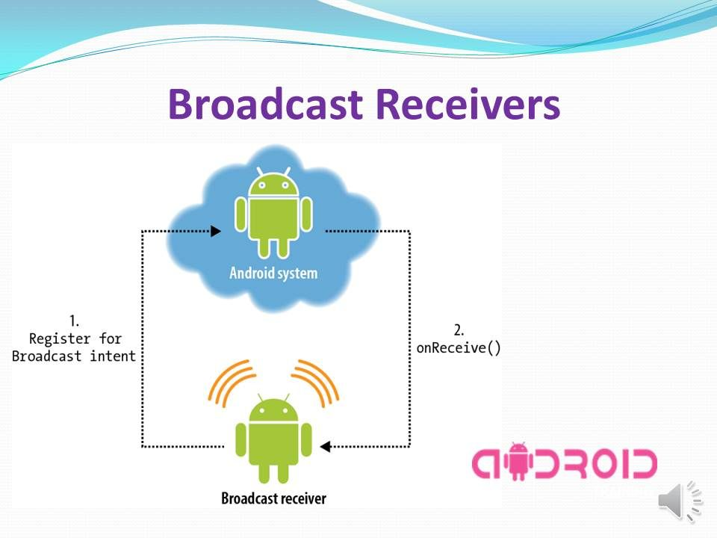

1. **List the System Events related to Broadcast Receivers**

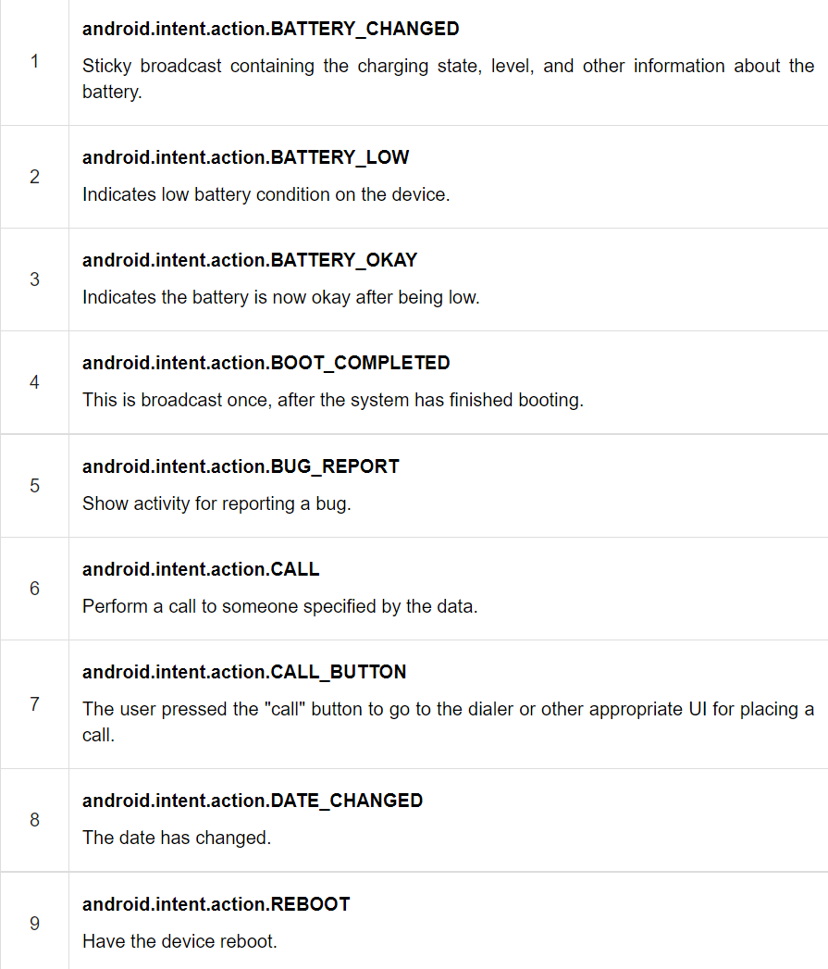

**Exercise**

**MainActivity.java**

package com.example.broadcastreceg;  
import androidx.appcompat.app.AppCompatActivity;  
import android.content.Intent;  
import android.os.Bundle;  
import android.view.View;  
import android.widget.Button;  
public class MainActivity extends AppCompatActivity {  
 @Override  
 protected void onCreate(Bundle savedInstanceState) {  
 super.onCreate(savedInstanceState);  
 setContentView(R.layout.*activity_main*);  
 Button b = (Button) findViewById(R.id.*button*);  
 b.setOnClickListener(new View.OnClickListener(){  
 @Override  
 public void onClick(View view){  
 Intent i = new Intent();  
 i.setAction("com.broadcastreceg.CUSTOM_INTENT");  
 sendBroadcast(i);  
 }  
 });  
 }  
}

**MyReceiver.java**

package com.example.broadcastreceg;  
import android.content.BroadcastReceiver;  
import android.content.Context;  
import android.content.Intent;  
import android.widget.Toast;  
public class MyReceiver extends BroadcastReceiver {  
 @Override  
 public void onReceive(Context context, Intent intent) {  
 Toast.*makeText*(context, " Received", Toast.*LENGTH_LONG*).show();  
 }  
}

**AndroidManifest.xml**

<?xml version="1.0" encoding="utf-8"?>  
<manifest xmlns:android="http://schemas.android.com/apk/res/android"  
 package="com.example.broadcastreceg">  
 <application  
 android:allowBackup="true"  
 android:icon="@mipmap/ic_launcher"  
 android:label="@string/app_name"  
 android:roundIcon="@mipmap/ic_launcher_round"  
 android:supportsRtl="true"  
 android:theme="@style/Theme.BroadcastRecEG">  
 <receiver  
 android:name=".MyReceiver"  
 android:enabled="true"  
 android:exported="true">  
 <intent-filter>  
 <action android:name="com.broadcastreceg.CUSTOM_INTENT">  
 </action>  
 <action android:name="android.intent.action.ACTION_POWER_CONNECTED"></action>  
 <action android:name="android.intent.action.ACTION_POWER_DISCONNECTED"></action>  
 <action android:name="android.intent.action.BATTERY_CHANGED"></action>  
 </intent-filter>  
 </receiver>  
 <activity android:name=".MainActivity">  
 <intent-filter>  
 <action android:name="android.intent.action.MAIN" />  
 <category android:name="android.intent.category.LAUNCHER" />  
 </intent-filter>  
 </activity>  
 </application>  
</manifest>

**Activity_main.xml**

<?xml version="1.0" encoding="utf-8"?>  
<androidx.constraintlayout.widget.ConstraintLayout xmlns:android="http://schemas.android.com/apk/res/android"  
 xmlns:app="http://schemas.android.com/apk/res-auto"  
 xmlns:tools="http://schemas.android.com/tools"  
 android:layout_width="match_parent"  
 android:layout_height="match_parent"  
 tools:context=".MainActivity">  
 <TextView  
 android:id="@+id/textView"  
 android:layout_width="wrap_content"  
 android:layout_height="wrap_content"  
 android:text="Broadcast Receiver"  
 app:layout_constraintBottom_toBottomOf="parent"  
 app:layout_constraintLeft_toLeftOf="parent"  
 app:layout_constraintRight_toRightOf="parent"  
 app:layout_constraintTop_toTopOf="parent" />  
 <Button  
 android:id="@+id/button"  
 android:layout_width="wrap_content"  
 android:layout_height="wrap_content"  
 android:text="Send Broadcast"  
 app:layout_constraintBottom_toBottomOf="parent"  
 app:layout_constraintEnd_toEndOf="parent"  
 app:layout_constraintStart_toStartOf="parent"  
 app:layout_constraintTop_toBottomOf="@+id/textView" />  
  
</androidx.constraintlayout.widget.ConstraintLayout>