**Practical Related Questions**

1. **Explain the use of equals() function.**

The **equals()** method compares two strings, and returns true if the strings are **equal**, and false if not.

1. 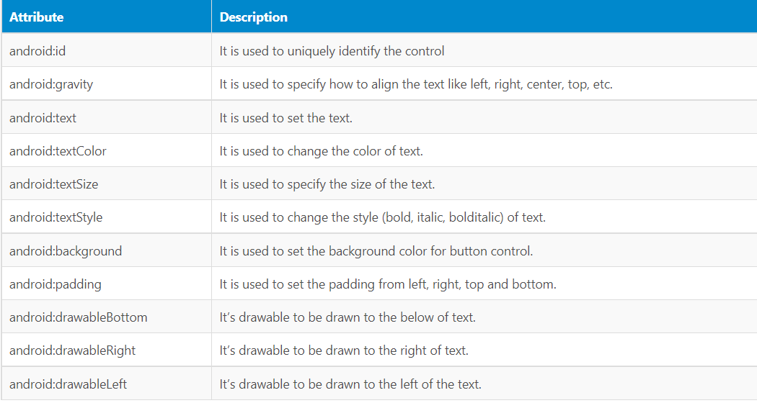**List the important functions which are related to GUI component “Button”.**
2. **State the uses of Toast message.**

Toasts display brief, temporary notifications. They are meant to be noticed without disrupting a user's experience or requiring an action to be taken.

**Exercise**

**MainActivity.java**

package com.example.logineg;  
  
import androidx.appcompat.app.AppCompatActivity;  
  
import android.os.Bundle;  
import android.view.View;  
import android.widget.Button;  
import android.widget.EditText;  
import android.widget.Toast;  
  
public class MainActivity extends AppCompatActivity {  
  
 EditText unm, pw;  
 Button b;  
  
 @Override  
 protected void onCreate(Bundle savedInstanceState) {  
 super.onCreate(savedInstanceState);  
 setContentView(R.layout.*activity_main*);  
 b = (Button) findViewById(R.id.*button*);  
 unm = (EditText) findViewById(R.id.*editTextTextPersonName*);  
 pw = (EditText) findViewById(R.id.*editTextTextPassword*);  
  
 b.setOnClickListener(new View.OnClickListener(){  
 @Override  
 public void onClick(View view){  
 String user = (String) unm.getText().toString();  
 String pass = (String) pw.getText().toString();  
 Toast.*makeText*(MainActivity.this, user + " " + pass, Toast.*LENGTH_LONG*).show();  
  
 if(user.equals("abcd") && pass.equals("abc123")){  
 Toast.*makeText*(MainActivity.this, "Login Successful", Toast.*LENGTH_LONG*).show();  
 }  
 else{  
 Toast.*makeText*(MainActivity.this, "Username and password does not match", Toast.*LENGTH_LONG*).show();  
 }  
 }  
 });  
 }  
}

**activity_main.xml**

<?xml version="1.0" encoding="utf-8"?>  
<androidx.constraintlayout.widget.ConstraintLayout xmlns:android="http://schemas.android.com/apk/res/android"  
 xmlns:app="http://schemas.android.com/apk/res-auto"  
 xmlns:tools="http://schemas.android.com/tools"  
 android:layout_width="match_parent"  
 android:layout_height="match_parent"  
 tools:context=".MainActivity">  
  
 <Button  
 android:id="@+id/button"  
 android:layout_width="273dp"  
 android:layout_height="56dp"  
 android:layout_marginBottom="204dp"  
 android:text="Log In"  
 app:layout_constraintBottom_toBottomOf="parent"  
 app:layout_constraintEnd_toEndOf="parent"  
 app:layout_constraintStart_toStartOf="parent" />  
  
 <EditText  
 android:id="@+id/editTextTextPersonName"  
 android:layout_width="266dp"  
 android:layout_height="40dp"  
 android:ems="10"  
 android:hint="Username/Email"  
 android:inputType="textPersonName"  
 app:layout_constraintBottom_toTopOf="@+id/editTextTextPassword"  
 app:layout_constraintEnd_toEndOf="parent"  
 app:layout_constraintHorizontal_bias="0.475"  
 app:layout_constraintStart_toStartOf="parent"  
 app:layout_constraintTop_toTopOf="parent"  
 app:layout_constraintVertical_bias="0.685" />  
  
 <EditText  
 android:id="@+id/editTextTextPassword"  
 android:layout_width="273dp"  
 android:layout_height="46dp"  
 android:layout_marginBottom="96dp"  
 android:ems="10"  
 android:hint="Password"  
 android:inputType="textPassword"  
 app:layout_constraintBottom_toTopOf="@+id/button"  
 app:layout_constraintEnd_toEndOf="parent"  
 app:layout_constraintStart_toStartOf="parent" />  
</androidx.constraintlayout.widget.ConstraintLayout>