**Practical Related Questions**

1. **List the names of map type and write the syntax to change it.**

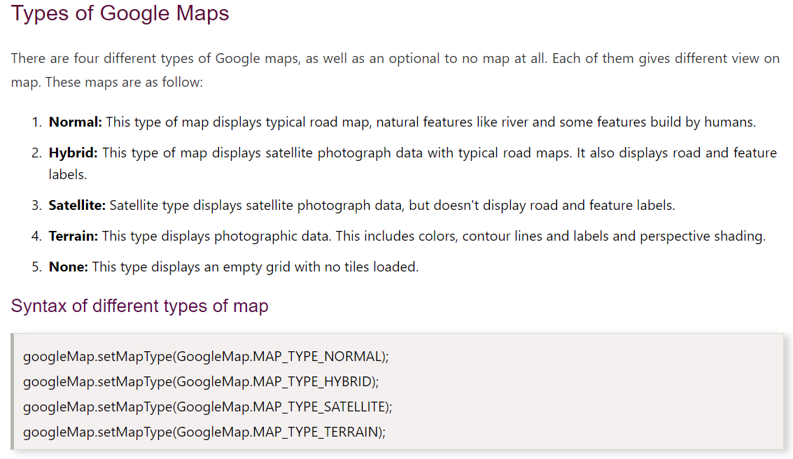

1. **Name the methods used to enable and disable zoom feature.**

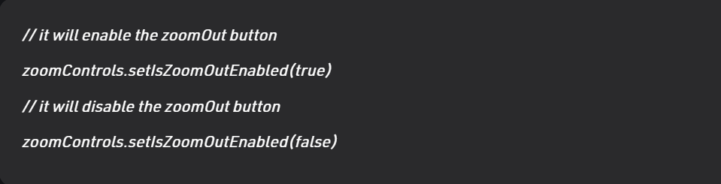

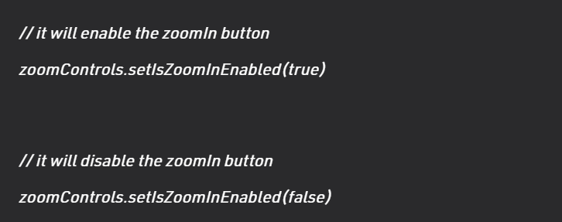

**Exercise**

**MapsActivity.java**

package com.example.mylocation;  
  
import androidx.fragment.app.FragmentActivity;  
  
import android.location.Criteria;  
import android.location.Location;  
import android.location.LocationListener;  
import android.location.LocationManager;  
import android.os.Bundle;  
import android.widget.TextView;  
  
import com.google.android.gms.common.ConnectionResult;  
import com.google.android.gms.common.GooglePlayServicesUtil;  
import com.google.android.gms.maps.CameraUpdateFactory;  
import com.google.android.gms.maps.GoogleMap;  
import com.google.android.gms.maps.OnMapReadyCallback;  
import com.google.android.gms.maps.SupportMapFragment;  
import com.google.android.gms.maps.model.LatLng;  
import com.google.android.gms.maps.model.MarkerOptions;  
  
public class MapsActivity extends FragmentActivity implements OnMapReadyCallback, LocationListener {  
  
 private GoogleMap mMap;  
  
 @Override  
 protected void onCreate(Bundle savedInstanceState) {  
 super.onCreate(savedInstanceState);  
 setContentView(R.layout.*activity_maps*);  
 // Obtain the SupportMapFragment and get notified when the map is ready to be used.  
 SupportMapFragment mapFragment = (SupportMapFragment) getSupportFragmentManager()  
 .findFragmentById(R.id.*map*);  
 mapFragment.getMapAsync((OnMapReadyCallback) this);  
  
 }  
 @Override  
 public void onLocationChanged(Location location) {  
 TextView locationTv = (TextView) findViewById(R.id.*latlongLocation*);  
 double latitude = location.getLatitude();  
 double longitude = location.getLongitude();  
 LatLng latLng = new LatLng(latitude, longitude);  
 mMap.addMarker(new MarkerOptions().position(latLng));  
 mMap.moveCamera(CameraUpdateFactory.*newLatLng*(latLng));  
 mMap.animateCamera(CameraUpdateFactory.*zoomTo*(15));  
 locationTv.setText("Latitude:" + latitude + ", Longitude:" + longitude);  
 }  
  
 @Override  
 public void onProviderDisabled(String provider) {  
 // *TODO Auto-generated method stub* }  
  
 @Override  
 public void onProviderEnabled(String provider) {  
 // *TODO Auto-generated method stub* }  
  
 @Override  
 public void onStatusChanged(String provider, int status, Bundle extras) {  
 // *TODO Auto-generated method stub* }  
  
 */**  
 * Manipulates the map once available.  
 * This callback is triggered when the map is ready to be used.  
 * This is where we can add markers or lines, add listeners or move the camera. In this case,  
 * we just add a marker near Sydney, Australia.  
 * If Google Play services is not installed on the device, the user will be prompted to install  
 * it inside the SupportMapFragment. This method will only be triggered once the user has  
 * installed Google Play services and returned to the app.  
 */* @Override  
 public void onMapReady(GoogleMap googleMap) {  
 mMap = googleMap;  
  
 mMap.setMyLocationEnabled(true);  
 LocationManager locationManager = (LocationManager) getSystemService(*LOCATION_SERVICE*);  
 Criteria criteria = new Criteria();  
 String bestProvider = locationManager.getBestProvider(criteria, true);  
 Location location = locationManager.getLastKnownLocation(bestProvider);  
 if (location != null) {  
 onLocationChanged(location);  
 }  
 locationManager.requestLocationUpdates(bestProvider, 20000, 0, this);  
 }  
  
 private boolean isGooglePlayServicesAvailable() {  
 int status = GooglePlayServicesUtil.*isGooglePlayServicesAvailable*(this);  
 if (ConnectionResult.*SUCCESS* == status) {  
 return true;  
 } else {  
 GooglePlayServicesUtil.*getErrorDialog*(status, this, 0).show();  
 return false;  
 }  
 }  
}

**activity_maps.xml**

<?xml version="1.0" encoding="utf-8"?>  
<RelativeLayout xmlns:android="http://schemas.android.com/apk/res/android"  
 xmlns:tools="http://schemas.android.com/tools"  
 android:layout_width="match_parent"  
 android:layout_height="match_parent"  
 tools:context=".MapsActivity">  
<fragment xmlns:android="http://schemas.android.com/apk/res/android"  
 xmlns:map="http://schemas.android.com/apk/res-auto"  
 xmlns:tools="http://schemas.android.com/tools"  
 android:id="@+id/map"  
 android:name="com.google.android.gms.maps.SupportMapFragment"  
 android:layout_width="match_parent"  
 android:layout_height="match_parent"  
 tools:context=".MapsActivity" ></fragment>  
  
 <TextView  
 android:id="@+id/latlongLocation"  
 android:layout_width="fill_parent"  
 android:layout_height="wrap_content"  
 android:gravity="bottom"  
 android:layout_alignParentBottom="true"  
 android:background="#ff058fff"  
 android:paddingTop="5dp"  
 android:paddingBottom="5dp"  
 android:textColor="#ffffffff"  
 android:paddingLeft="5dp"  
 android:paddingRight="5dp" />  
</RelativeLayout>

**AndroidManifest.xml**

<?xml version="1.0" encoding="utf-8"?>  
<manifest xmlns:android="http://schemas.android.com/apk/res/android"  
 package="com.example.mylocation">  
  
 <!--  
 The ACCESS_COARSE/FINE_LOCATION permissions are not required to use  
 Google Maps Android API v2, but you must specify either coarse or fine  
 location permissions for the "MyLocation" functionality.  
 -->  
 <permission  
 android:name="com.javapapers.currentlocationinmap.permission.MAPS_RECEIVE"  
 android:protectionLevel="signature" />  
  
 <uses-permission android:name="com.javapapers.currentlocationinmap.permission.MAPS_RECEIVE" />  
 <uses-permission android:name="android.permission.INTERNET" />  
 <uses-permission android:name="android.permission.WRITE_EXTERNAL_STORAGE" />  
 <uses-permission android:name="com.google.android.providers.gsf.permission.READ_GSERVICES" />  
 <uses-permission android:name="android.permission.ACCESS_COARSE_LOCATION" />  
 <uses-permission android:name="android.permission.ACCESS_FINE_LOCATION" />  
 <uses-permission android:name="android.permission.ACCESS_NETWORK_STATE" />  
  
 <application  
 android:allowBackup="true"  
 android:icon="@mipmap/ic_launcher"  
 android:label="@string/app_name"  
 android:roundIcon="@mipmap/ic_launcher_round"  
 android:supportsRtl="true"  
 android:theme="@style/Theme.MyLocation">  
  
 <!--  
 The API key for Google Maps-based APIs is defined as a string resource.  
 (See the file "res/values/google_maps_api.xml").  
 Note that the API key is linked to the encryption key used to sign the APK.  
 You need a different API key for each encryption key, including the release key that is used to  
 sign the APK for publishing.  
 You can define the keys for the debug and release targets in src/debug/ and src/release/.  
 -->  
 <meta-data  
 android:name="com.google.android.geo.API_KEY"  
 android:value="@string/google_maps_key" />  
  
 <activity  
 android:name=".MapsActivity"  
 android:label="@string/title_activity_maps">  
 <intent-filter>  
 <action android:name="android.intent.action.MAIN" />  
  
 <category android:name="android.intent.category.LAUNCHER" />  
 </intent-filter>  
 </activity>  
 </application>  
  
</manifest>