Problem Statement-1: How It Works

TellMyStory

|  |  |
| --- | --- |
| **1** | **PREREQUISIITES** |
| 1.1 | Client Framework |
| 1.2 | API |
| 1.3 | Database |
|  |  |
| **2** | **PROJECT STRUCTURE** |
| 2.1 | UI |
| 2.2 | API |
|  |  |
| **3** | **PROJECT EXECUTION STEPS** |
| 3.1 | UI |
| 3.2 | API |
| 3.3 | Database |
|  |  |
| **4** | **PROJECT EXECUTION SCREENS** |
| 4.1 | UI |
| 4.2 | Database |
|  |  |
| **5** | **Thank You** |

Table of Content



# **Prerequisites**

**Client Frame Work**

1. Node latest stable version should be installed.
2. Visual Studio code latest stable version should be installed.
3. Angular “@angular/cli”: “~13.3.9”

**API**

1. JDK, Stable version of Spring Tool Suite, MySQL Workbench, MySQL server and Lombok should be installed
2. Refer below link to install JDK

<https://www.guru99.com/install-java.html>

1. Refer below link to install Spring Tool Suite

<https://www.codejava.net/frameworks/spring/install-spring-tool-suite-windows>

1. Refer below link to install Lombok

<https://www.digitalocean.com/community/tutorials/java-project-lombok>

**Database**

1. Refer below link to install MySQL Workbench and MySQL Server

<https://www.simplilearn.com/tutorials/mysql-tutorial/mysql-workbench-installation>

# **Folder Structure**

**UI**

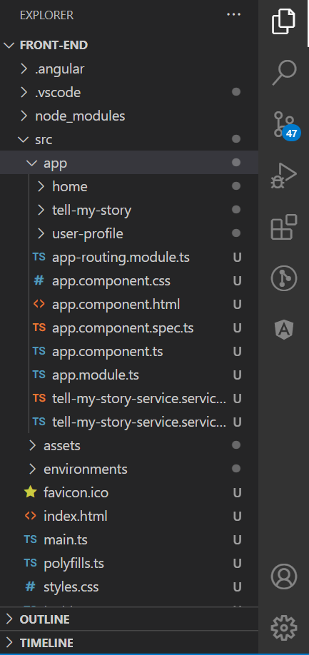

**API**

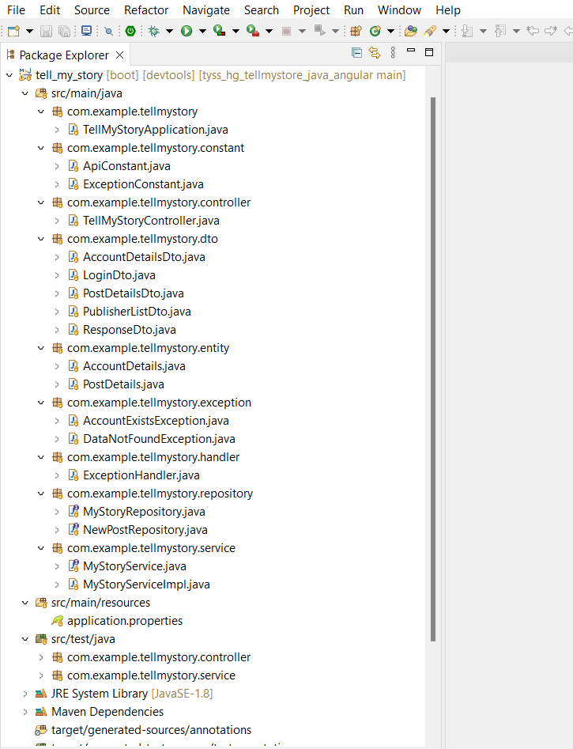

**Database**

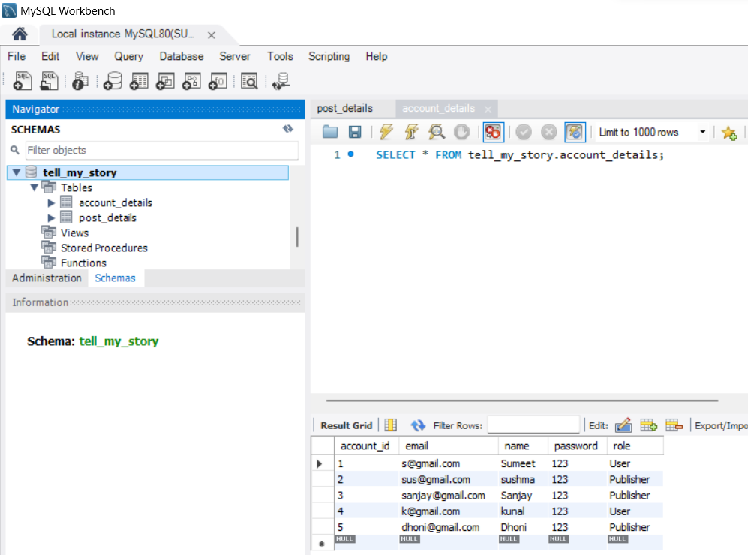

# **Project Execution Steps**

**Database**

1. Import the dump into MySQL work bench

**API**

1.Open/Import the project in STS (Spring Tool Suite).

2.Change directory to BE, execute the command below

a.cd BE

3.Update the maven project

4. Run the application

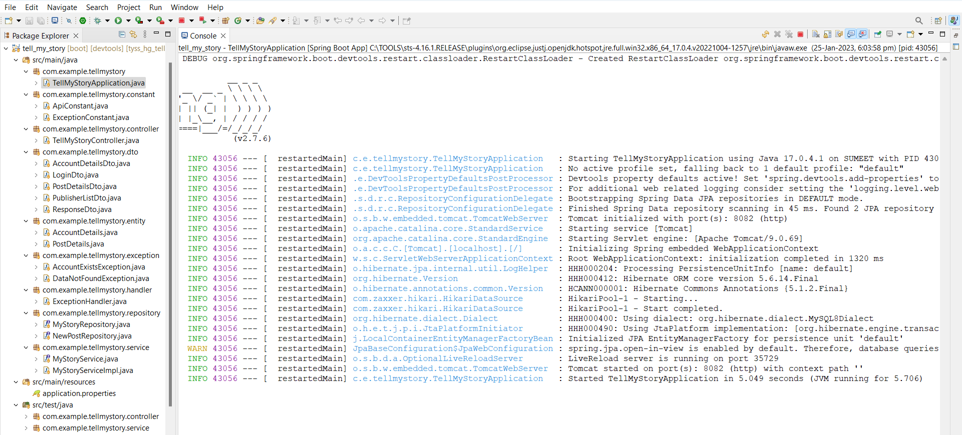

**UI**

1.Change directory to front-end folder, execute the command below

* ng serve -o to run UI project

3.The above command will open the chrome tab automatically. In case if it fails to open browser with Project URL: **http://localhost:4200**

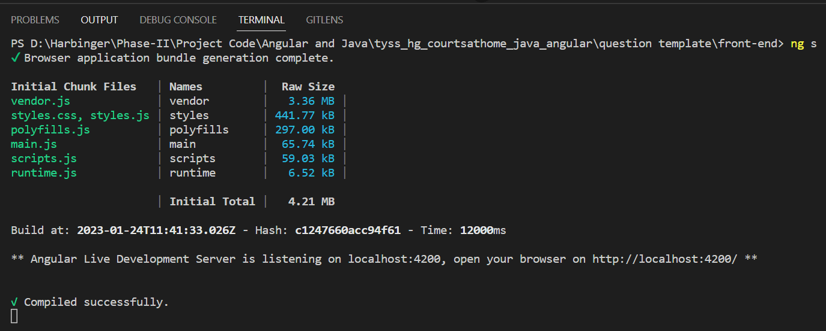

# **Project Execution Screens**

**UI**

1. Register Screen

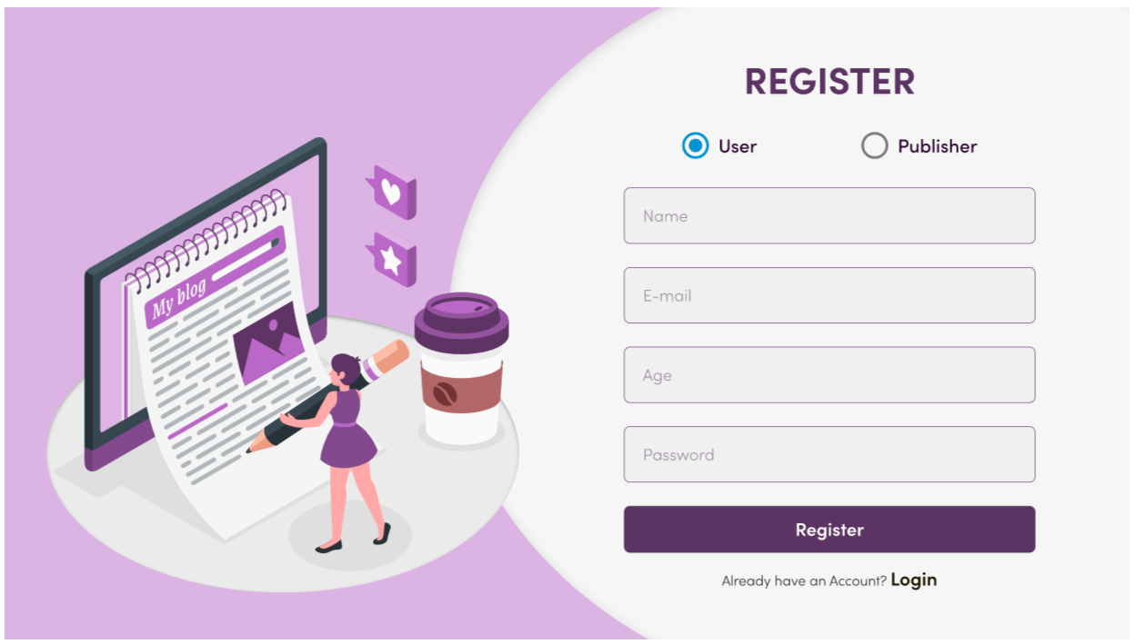

2. Login Screen.

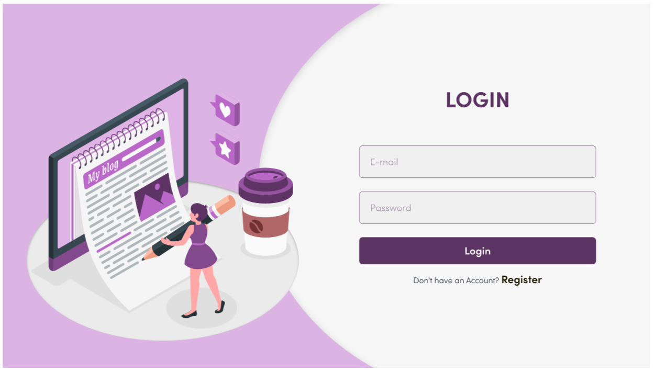

* Home Page

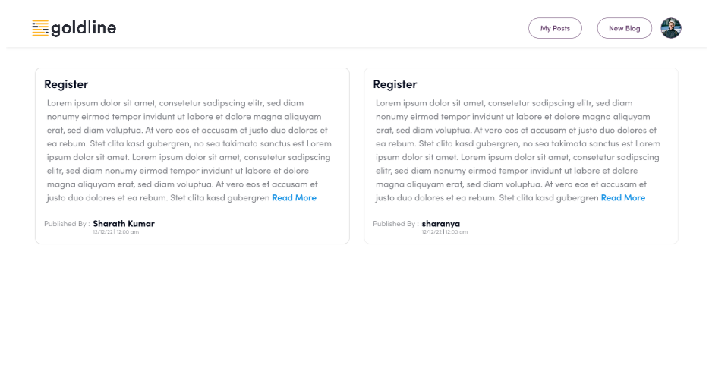

* Read More Tab

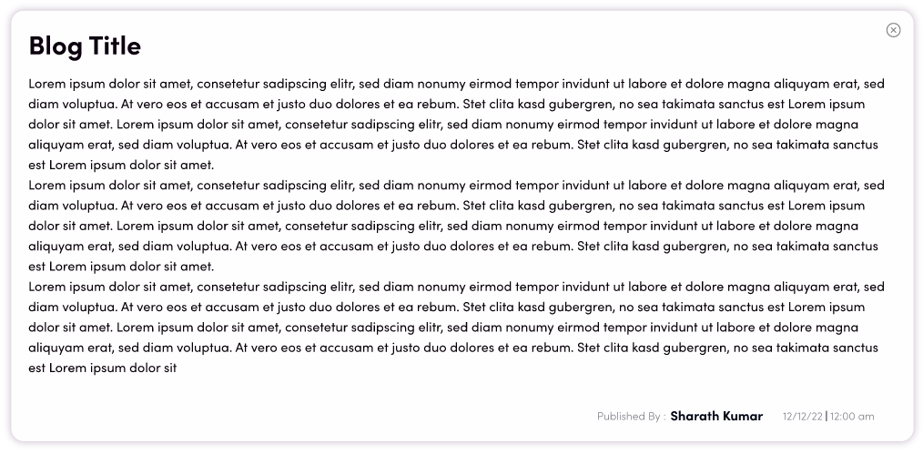

* Post new Story modal

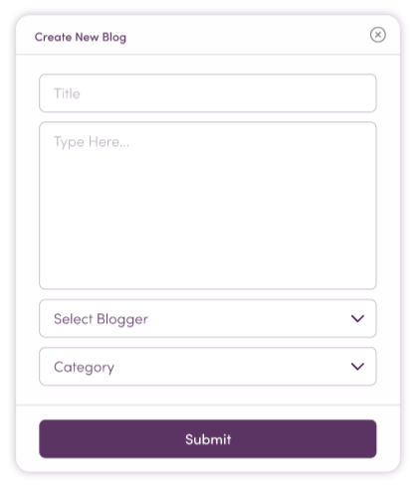

4. My Profile Page.

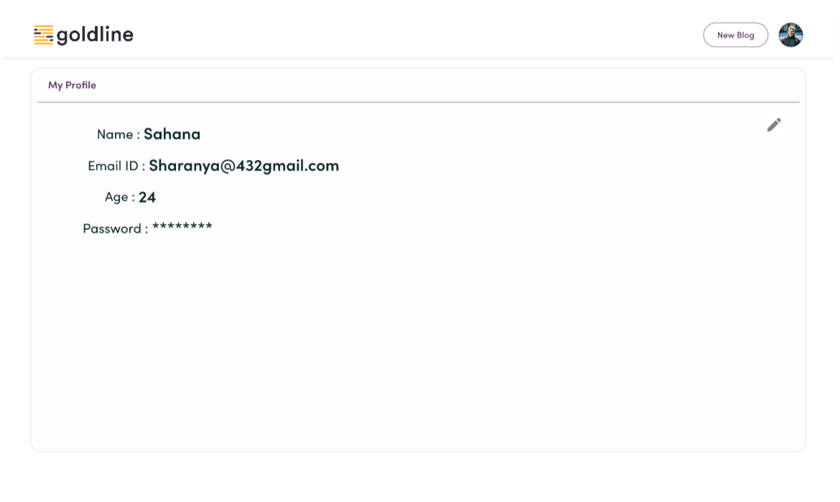

* Approved, Pending, Requests and Rejected tabs

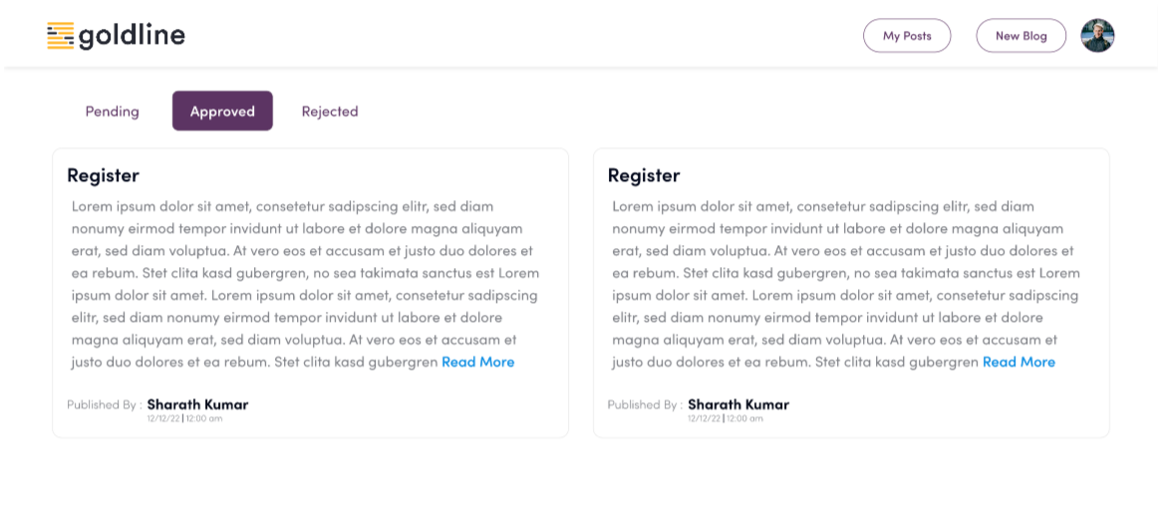

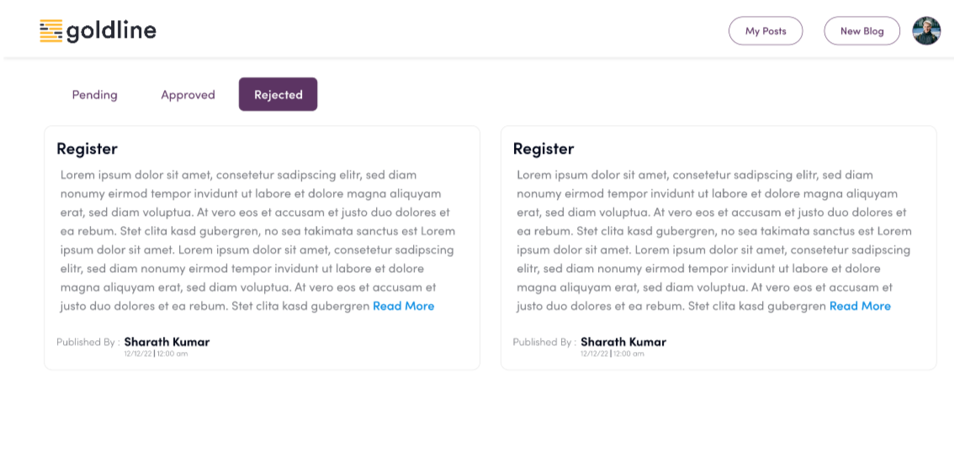

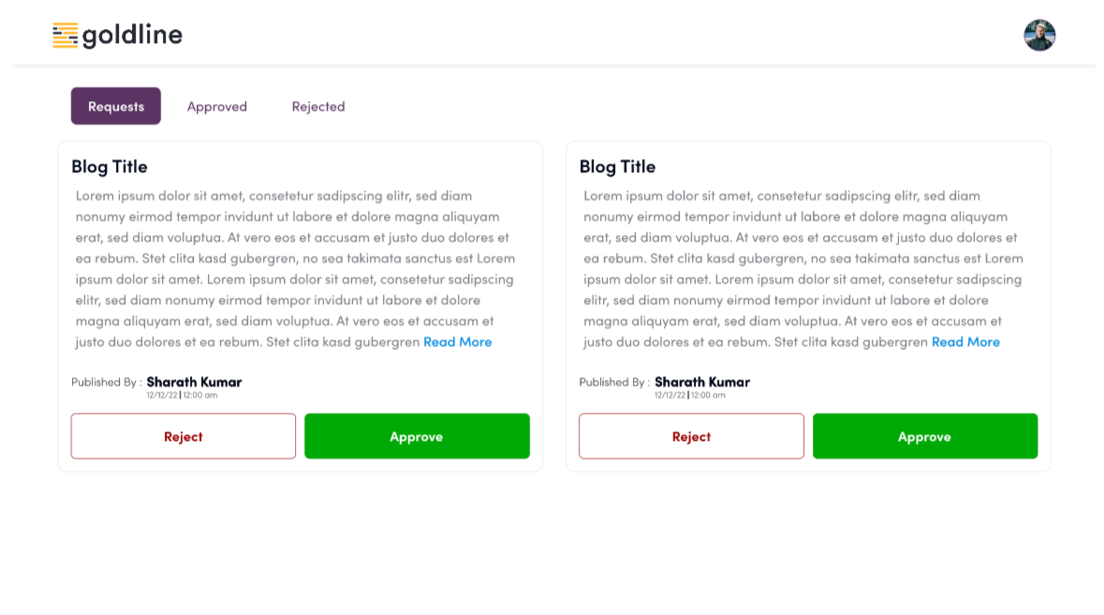

**Database**

1. AccountDetails Collection

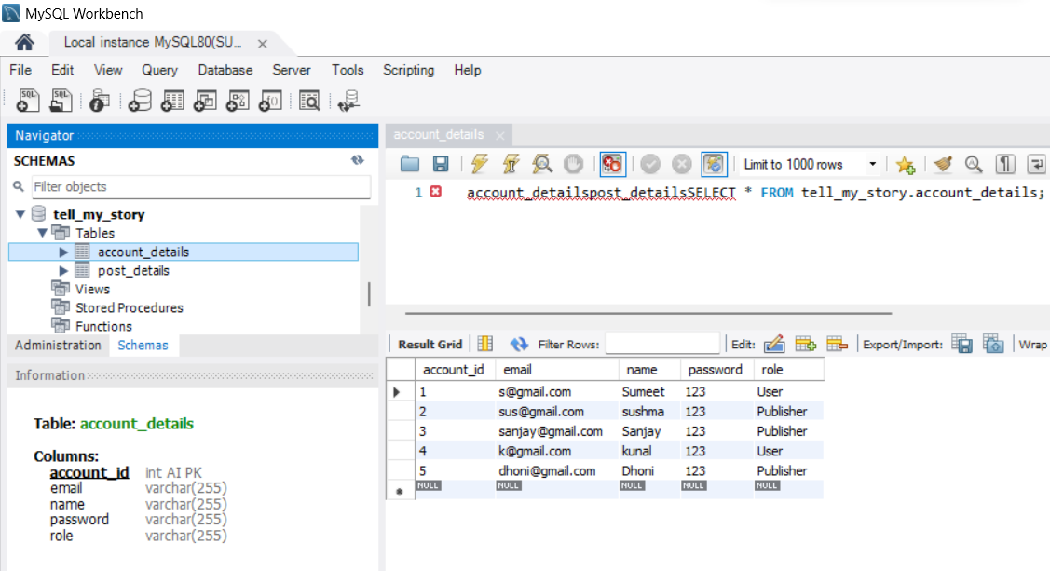

2. PostDetails Collection

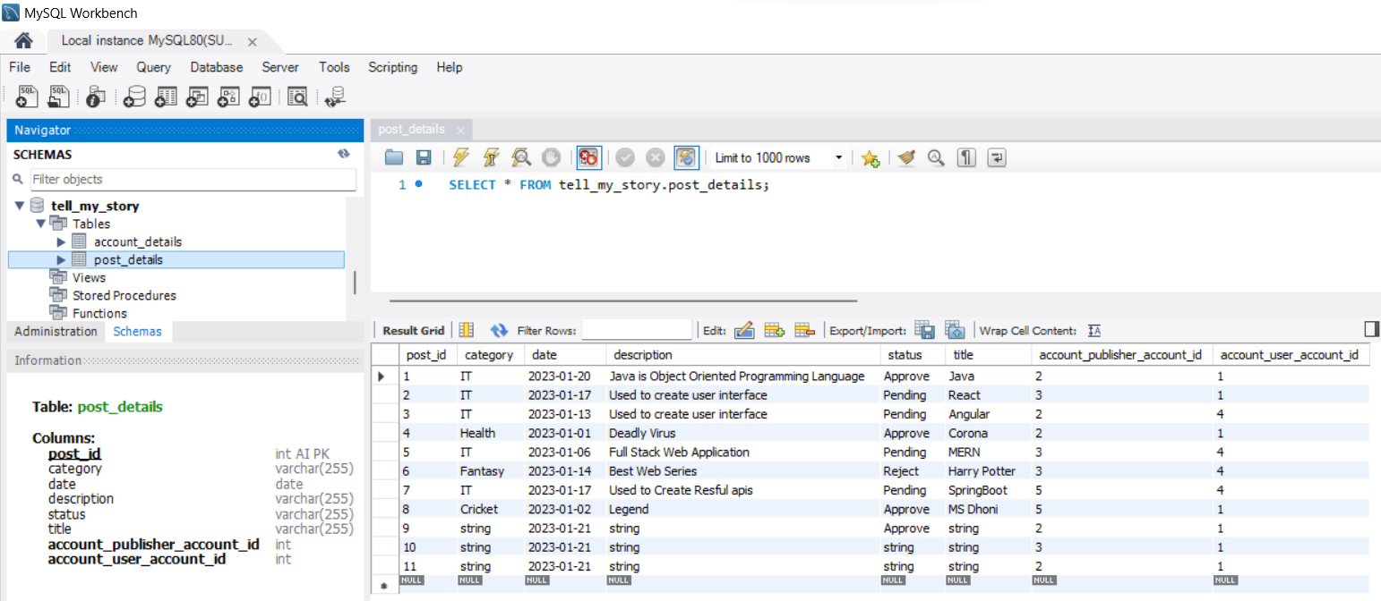

# **Thank You**