Canonical Landscape SaaS
First-Time User Experience & Customer Success Response Strategy

FIRST-TIME USER EXPERIENCE & CUSTOMER SUCCESS RESPONSE STRATEGY
An Exploratory Evaluation Based on a Hands-On Ubuntu Virtual Machine Deployment
Test date: October 17, 2026 | Report language: English
Evaluation scope: One Ubuntu 24.04.4 LTS instance, Landscape SaaS, and an Ubuntu Pro free personal subscription
Report status: Independent hands-on evaluation and simulated CSM response plans; not an official Canonical report or a record of customer support delivered to actual clients.

01 Executive Summary
This project evaluates the full journey from initial onboarding to the first successful remote management action from the perspective of a first-time Landscape SaaS administrator. It examines friction that can affect Time to First Value (TTFV). The exercise validated device registration, remote scripting, package installation and removal, remote reboot, and the visibility of Ubuntu Pro service status. It also recorded the administrator’s first-hand difficulties and translated them into proposed Customer Success Manager (CSM) responses.
Key assessment: The main remote administration operations worked and could be traced through Activities. However, a first-time administrator needed to understand additional script-execution plugin and user-permission settings, and had to navigate to Activities to confirm package-management submissions. An empty process view and a security-upgrade label that appeared difficult to reconcile with local APT information remain unresolved; the available evidence does not establish their root causes.

Evaluation Highlights
- Remote scripting succeeded after two failures: unavailable plugin → root execution restriction → successful run under an authorized user.
- The cbonsai 1.3.1-1 package was installed and removed remotely; both results were checked again on Ubuntu.
- The reboot request succeeded and the instance returned Online; Ubuntu Pro service status matched local pro status output.
- Three practical CSM response playbooks were developed for asynchronous-task feedback, script prerequisites, and unavailable process information.

Evidence Standards and Conclusion Categories
Category | Meaning in This Report
Validated | Outcome supported by a Landscape task record and/or Ubuntu-local evidence
UX observation | Friction experienced during actual use; not necessarily a widespread product defect
Requires investigation | The behavior was observed, but the root cause in collection, synchronization, server logic, or UI remains unverified

02 Test Environment and Scope
Item | Actual Test Environment
Operating system | Ubuntu 24.04.4 LTS
Virtualization | One VMware virtual machine
Managed instance | felixtong-VMware-Virtual-Platform (redact when sharing externally)
Landscape | Landscape SaaS / landscape-client 24.02-0ubuntu5.7
Subscription | Ubuntu Pro — free personal subscription
Evidence and methods | SaaS Activities, Ubuntu CLI, client.conf, manager/monitor/broker logs, and plugin source

Limitations: The exercise did not involve an enterprise subscription, concurrent management of multiple devices, production SLAs, real customer interviews, or representative usability testing. Results must not be extrapolated to enterprise performance or the prevalence of defects.

03 First-Time User Journey: From Onboarding to First Value
Stage | Actual Activity | Outcome / Friction
Preparation | VMware Ubuntu; Ubuntu Pro attach | ESM Apps, ESM Infra, and Landscape enabled
Onboarding | Configure Landscape Client and register with SaaS | Instance Online; account naming and registration required learning
First script | Submit a diagnostic script through the UI | Unavailable-plugin error; additional investigation required
Diagnosis / fix | Enable ScriptExecution and configure script_users | Root execution blocked; switch to authorized non-root user
First success | Run landscape-system-check | Succeeded at 18:16; first validated remote-action outcome
Further adoption | cbonsai install/remove; reboot; Pro/Security views | Core capabilities validated; task-submission feedback friction observed

Journey milestone: An instance being Online does not necessarily mean the customer has realized value. The more meaningful milestone is a verified, successful remote action on the first managed device.

04 Remote Management Validation
Capability | Evidence | Assessment
Instance registration | Overview / Instances / Info; Online | Passed
Diagnostic script | E06–E08: two Failed, then Succeeded | Passed after remediation
Package installation | E09: cbonsai 1.3.1-1; local dpkg-query | Passed
Package removal | E10: Remove cbonsai; absent locally | Passed
Reboot and recovery | E11: reboot requested; later Online | Passed
Ubuntu Pro | E12 compared against local pro status | Service status matched
Security issues | “No security issues found” page | Page accessible; remediation not tested
Processes | E13: “No processes running” | Requires investigation
dpkg status | E14: “Security upgrade” vs local APT query | Requires investigation

4.1 Remote Script Execution: Failures, Configuration, and Verification
The first attempt at 17:46 failed. Activities reported “plugin which should handle it isn’t available.” The interface suggested several possible causes, including a disabled plugin, a malfunctioning client, or an outdated client version. However, it did not directly identify the configuration steps relevant to this environment.
The client configuration (/etc/landscape/client.conf), manager.log, and plugin modules were then inspected. ScriptExecution was enabled and script_users was set to felixtong; the log confirmed the plugin registration. A second attempt at 18:06 failed with “Scripts cannot be run as user root.” The task was resubmitted under the authorized non-root user and succeeded at 18:16, returning the hostname, uptime, and dpkg version 1.22.6ubuntu6.6.
Technical conclusion: This was a resolved configuration-prerequisite and execution-identity issue, not a confirmed defect in the remote scripting engine.
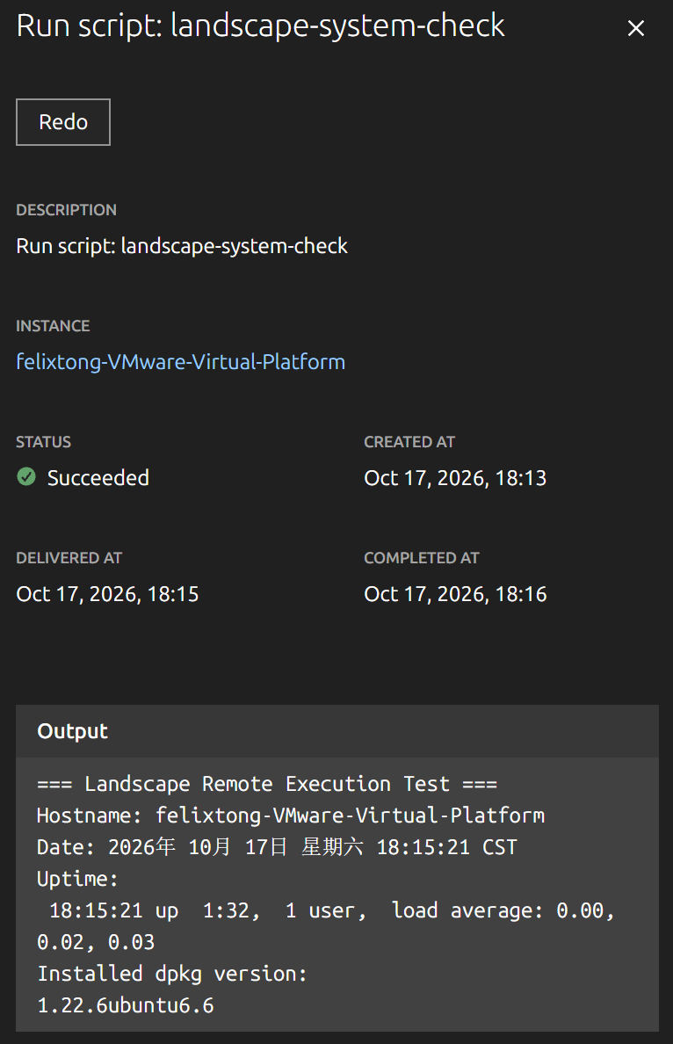
Figure 1 | Successful diagnostic script: Succeeded status and output (E08)

4.2 Package Installation and Removal: End-to-End Validation
The cbonsai installation task was created at 21:47 and completed at 21:50. Logs confirmed download, unpacking, and configuration of version 1.3.1-1 from an Ubuntu package mirror. Local verification returned “install ok installed 1.3.1-1.” The removal task was created at 21:56 and completed at 21:59; a subsequent local query confirmed that cbonsai was no longer installed.
In both operations, the tester did not perceive a clear submission confirmation and had to open Activities to verify the task. The activity details, however, provided creation, delivery, and completion timestamps as well as execution output, supporting reliable retrospective traceability.

4.3 Remote Reboot and Return to Service
A reboot activity was created at 22:09 and completed at 22:12 with “Reboot requested of the system.” Ubuntu subsequently rebooted, the Landscape instance returned Online, and a new heartbeat was recorded at 22:19. The acceptance of a reboot request and the device’s later return online are two separate verification points.

4.4 Ubuntu Pro Integration and Security Visibility
The Ubuntu Pro page reported esm-apps, esm-infra, and landscape as enabled and livepatch as disabled, consistent with local pro status. The Security issues page showed “No security issues found,” which only establishes that the page displayed no issues at the time of inspection; it does not verify that all vulnerabilities were absent or that remediation workflows had been tested.

05 First-Time User Experience Findings and Evidence Levels
ID / Priority | Observed Behavior | Evidence and Interpretation
UX-01 / High | No perceived submission feedback after Install / Uninstall | Observed twice; both Activities succeeded; UX observation
UX-02 / High | First script attempts encountered plugin and root restrictions | E06–E08 and logs; configuration issue resolved
UX-03 / Medium | Processes empty on an Online instance | E13; ActiveProcessInfo registered; root cause unknown
UX-04 / Medium | dpkg: “Security upgrade”; available version --- | E14; local installed and candidate versions matched; cause unknown
UX-05 / Low | Exact tree package could not be located smoothly | Single observation; insufficient evidence of a search defect

UX-01 Task Submission Visibility: High Priority
User perception: After clicking Install or Uninstall, the administrator could not tell whether a task had been submitted. Both tasks ultimately succeeded, confirming that the execution path worked. The observation concerns the visibility of feedback at submission, not the quality of the Activities audit trail. A prominent “Task created” confirmation should link directly to the relevant activity and show the target device count and status.

UX-02 Script Execution Prerequisites: High Priority
The initial error already listed possible causes, but the user still had to identify the relevant ScriptExecution setting and permitted execution identity. A prerequisite checklist, version-appropriate documentation, and actionable next steps in the error view could reduce first-use troubleshooting. Security constraints should remain intact; permitting root execution should not be presented as a shortcut.

UX-03/04 Data Visibility and Status Meaning: Further Investigation Required
Several causes might explain the empty Processes page. The client’s ActiveProcessInfo plugin was confirmed to be registered, but end-to-end SaaS ingestion and presentation were not verified. Meanwhile, the dpkg entry displayed “Security upgrade” with no available version, although local APT showed the installed version matching the candidate version. These may reflect update classification or synchronization semantics. Both should remain open support questions, not confirmed bugs.
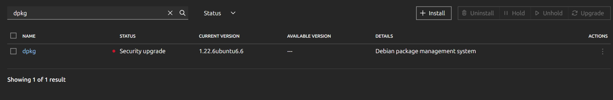
Figure 2 | dpkg marked “Security upgrade” with “Available Version” shown as --- (E14)

06 Simulated CSM Response Strategy
Scenario: A hypothetical mid-sized company managing approximately 200 Ubuntu devices is evaluating Landscape. This fleet size is an illustrative customer persona only; the actual test used one virtual machine. The CSM’s role is to understand business outcomes, drive issue resolution, and validate adoption—not independently perform all product engineering or incident response.

Case A | Customer Cannot Confirm Whether Installation Was Submitted
- Assess business impact: identify affected devices, target package, production criticality, submission time, and whether repeated clicks occurred.
- Navigate to Activities: locate the relevant task and explain Created, Delivered, Completed, and Succeeded/Failed.
- Verify the end state: where appropriate, compare the console result with package-manager output on the managed device.
- Prevent recurrence: provide a one-page guide to asynchronous task tracking and collect a screen recording or reproducible steps for product feedback.
Success criterion: The customer can independently submit, track, and verify an installation without unintentionally repeating the action.

Case B | Customer Cannot Execute Remote Scripts
- Clarify the intended script outcome, scope of affected devices, permissions, and error messages.
- Confirm that the instance is Online, Landscape Client is running, ScriptExecution is enabled, and the execution user is authorized.
- Support a fix within security policy. If the issue falls outside documented configuration guidance, escalate sanitized logs, version information, and reproduction steps to Technical Support.
- Rerun a read-only diagnostic script; close the issue only after Activities shows Succeeded and the output matches expectations.
Success criterion: The customer can reliably execute scripts under an authorized identity and understands the prerequisites and security limitations.

Case C | Online Instance Shows No Process Information
- Clarify whether the customer needs a process inventory, performance diagnosis, or process-termination capability; assess the actual business impact.
- Collect screenshots, instance state, client version, timestamps, and collection logs without presuming a root cause.
- When necessary, coordinate with Technical Support to review collection, transport, server-side state, and front-end presentation while providing status updates to the customer.
- Offer an authorized alternative way to inspect processes while the issue remains open, making its limitations explicit.
Success criterion: Process information becomes available as expected, or the customer understands the limitation and has an acceptable interim method.

07 Customer Success Metrics and Business Value
Metric | Calculation / Proposed Use
Time to First Value | Elapsed time from the start of onboarding to completion and local verification of the first remote task
Onboarding completion | Share of customers who finish registration, Online verification, authorization setup, and first task
Task completion & visibility | Execution success rate plus qualitative confirmation that administrators can locate task status
Self-service resolution | Share of common issues resolved without Technical Support engineering intervention
Support ticket trend | Volume of issues associated with first-time onboarding, script configuration, and package tasks
Feature adoption | Coverage of scripts, upgrades, and reboots across the customer’s intended device fleet
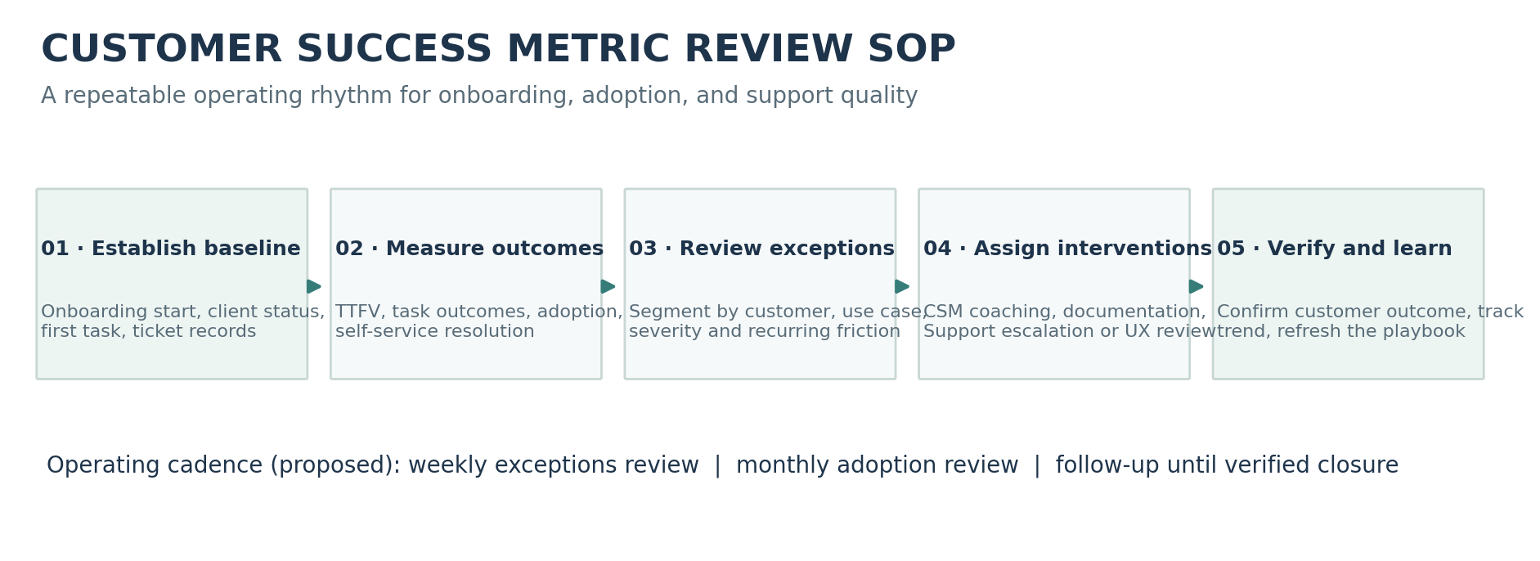
Figure 3 | Proposed customer success metrics review and intervention SOP
Operational rule (proposed): Establish a baseline at onboarding, inspect exceptions weekly, review adoption trends monthly, assign owners to negative trends, and confirm corrective outcomes before marking follow-up complete.

These are recommended CSM metrics and monitoring practices. A one-device exploratory test does not establish measured improvements in operational productivity, cost savings, or actual ticket-volume reduction.

08 Improvement Recommendations and Cross-Functional Collaboration
Priority | Recommendation | Partner Functions
P1 | Clear confirmation after async task submission and direct link to Activity | Product Design / Front End / CSM
P1 | Onboarding guidance for script prerequisites and authorization restrictions | Technical Documentation / Support / CSM
P2 | Show last collection time and diagnostic entry point for empty data states (subject to validation) | Support / Product / Engineering
P2 | Clarify the source and meaning of the Security upgrade label | Documentation / Package Management Engineering
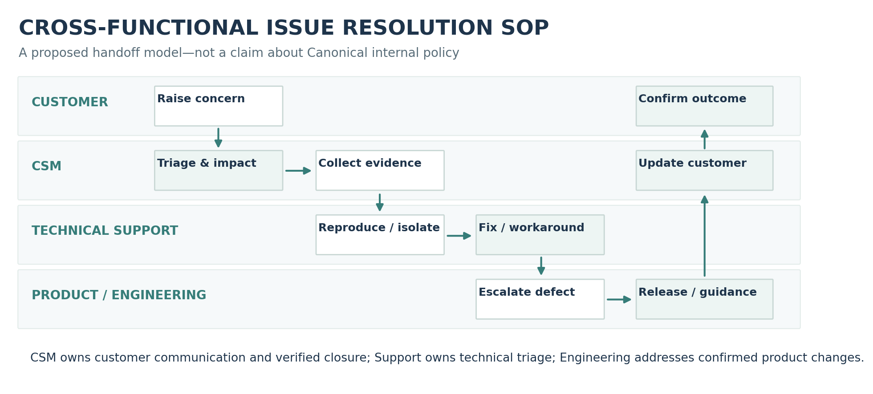
Figure 4 | Proposed cross-functional resolution and customer communication SOP
Operational rule (proposed): CSM assesses impact and maintains communication; Support validates technical evidence and offers a workaround; confirmed product issues are routed to Product/Engineering; the CSM verifies the customer outcome and updates reusable guidance.

09 Conclusions and Scope Boundaries
In this experiment, Landscape SaaS successfully supported centralized device onboarding, remote scripts, package installation and removal, reboot management, and Ubuntu Pro service-state visibility. Product value depends not only on whether a remote action can be completed, but also on whether new administrators understand the prerequisites, receive clear task feedback, and know the next step when exceptions occur.
From a simulated CSM perspective, the essential method is: clarify the customer goal → assess impact and priority → diagnose or escalate → verify the customer outcome → capture reusable guidance and product feedback. This exercise demonstrates selected hands-on capabilities; it is not a substitute for actual enterprise implementation or customer-facing CSM experience.

10 Further Validation and Information-Handling Checklist
- Record the full UX-01 submission interaction to determine whether a toast, navigation cue, or other confirmation was present but not noticeable.
- Further investigate UX-03 and UX-04 under controlled conditions to verify collection and status-classification behavior. Keep both findings in the “further investigation” category until supported by evidence.
- If the enterprise scenario is expanded, register a second Ubuntu test instance and assess tags, grouping, bulk operations, and access permissions.
- Before sharing externally, redact account email, device ID, hostname, serial number, and private IP address from screenshots; never include tokens, credentials, or registration secrets.

Appendix A Screenshot Evidence and Activity Records
Evidence IDs follow the order in which the screenshots were collected. Images reflect genuine activity from this test and may support several sections. The screenshots retain their original interface and log language, including Chinese text where present.

E01 Overview: Online Status, Regular Upgrades, and Available Packages
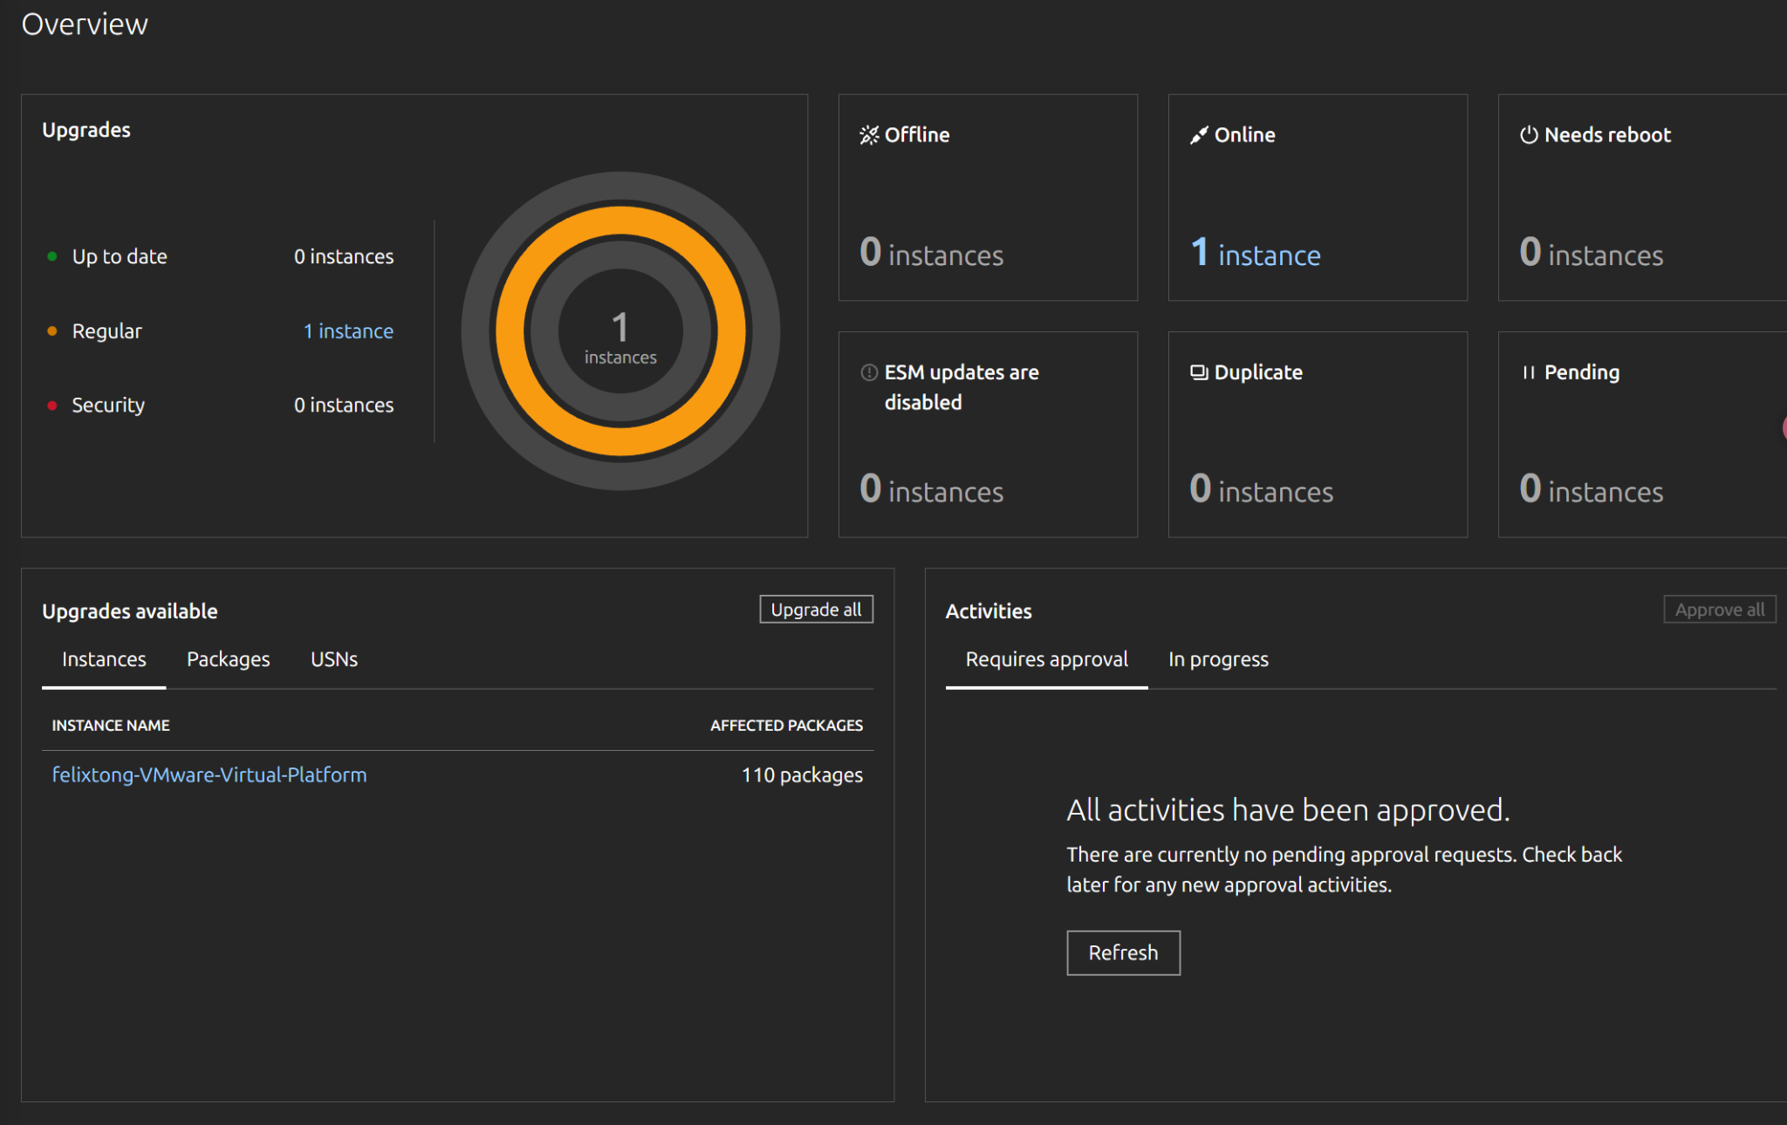
E01 | Overview: Online Status, Regular Upgrades, and Available Packages

E02 Instances: Registered Device, Online Status, and OS Version
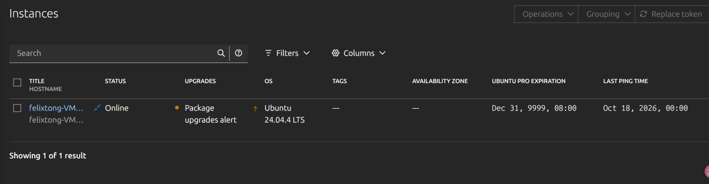
E02 | Instances: Registered Device, Online Status, and OS Version

E03 Activities: Four Successful and Two Failed Task Attempts
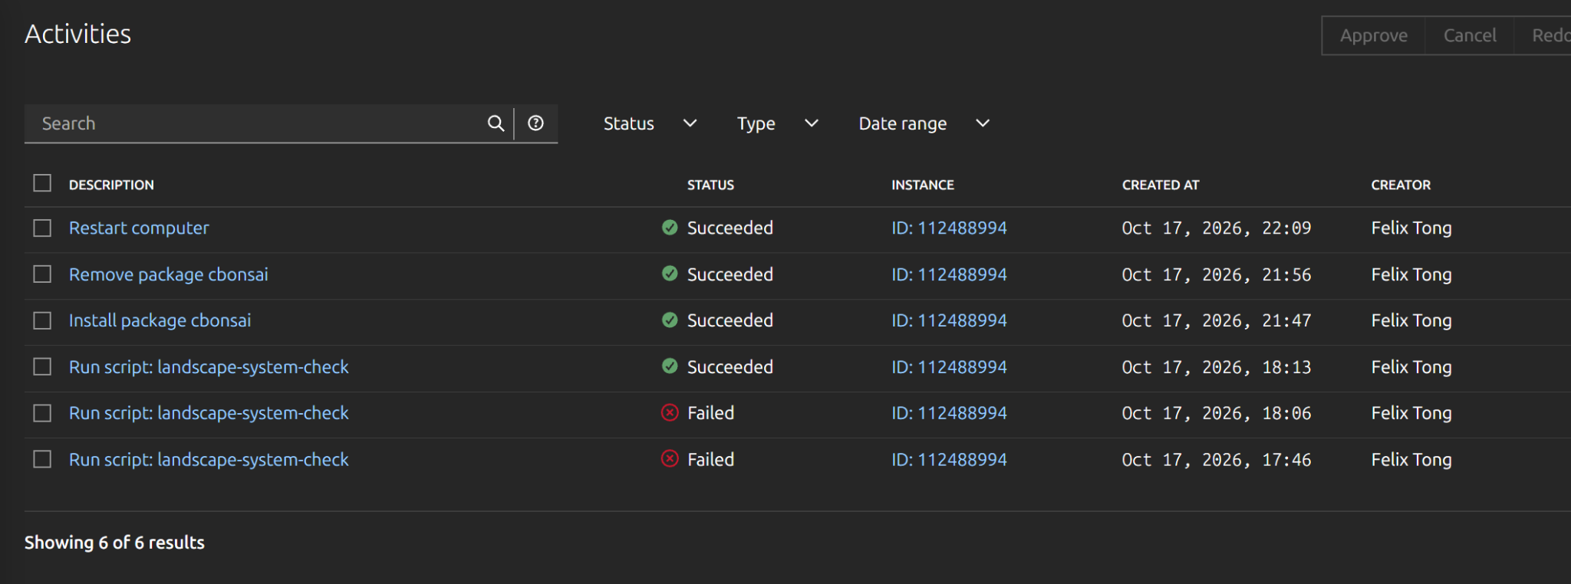
E03 | Activities: Four Successful and Two Failed Task Attempts

E04 landscape-system-check: Diagnostic Script Source
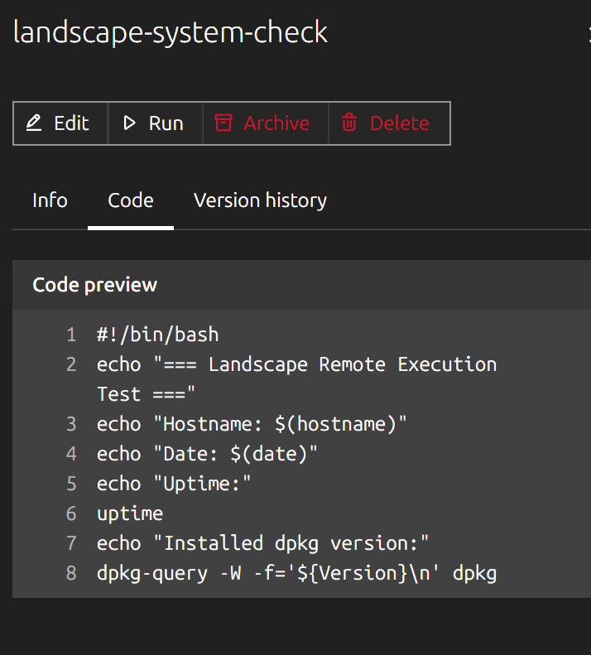
E04 | landscape-system-check: Diagnostic Script Source

E05 Device Info: Registration and Last Heartbeat
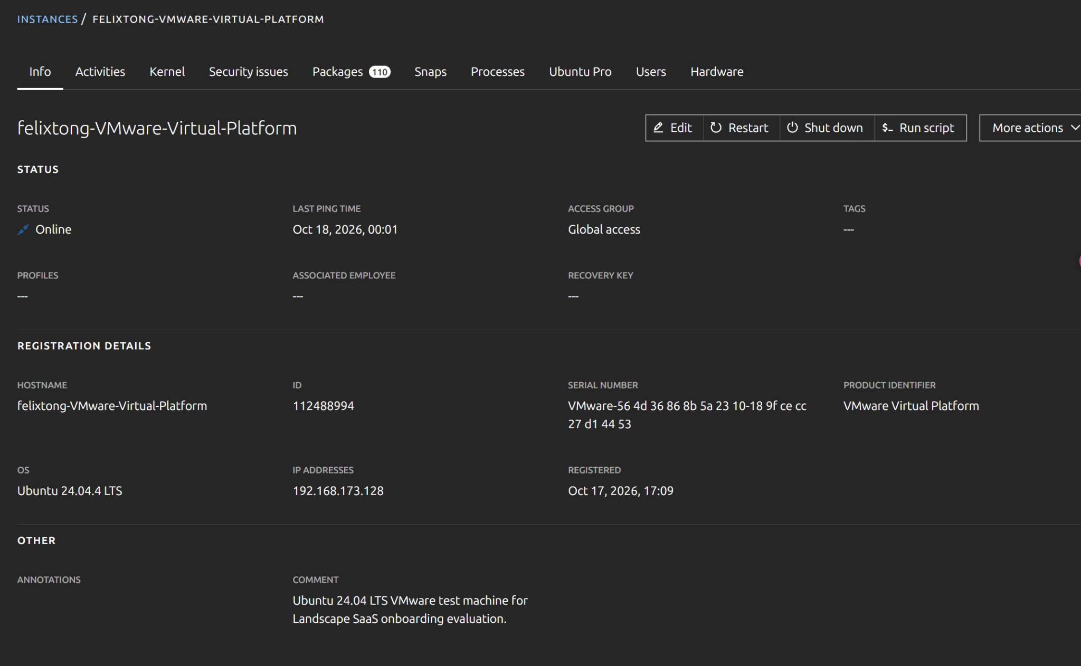
E05 | Device Info: Registration and Last Heartbeat

E06 Initial Script Failure: Unavailable Plugin and Suggested Causes
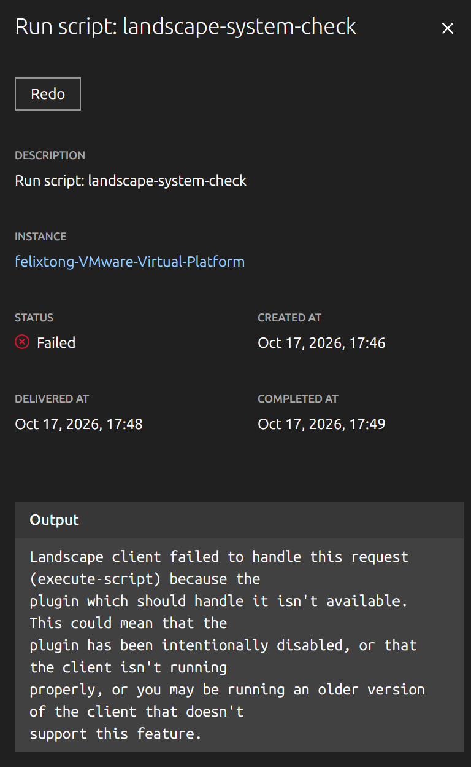
E06 | Initial Script Failure: Unavailable Plugin and Suggested Causes

E07 Second Script Failure: Root Execution Is Not Allowed
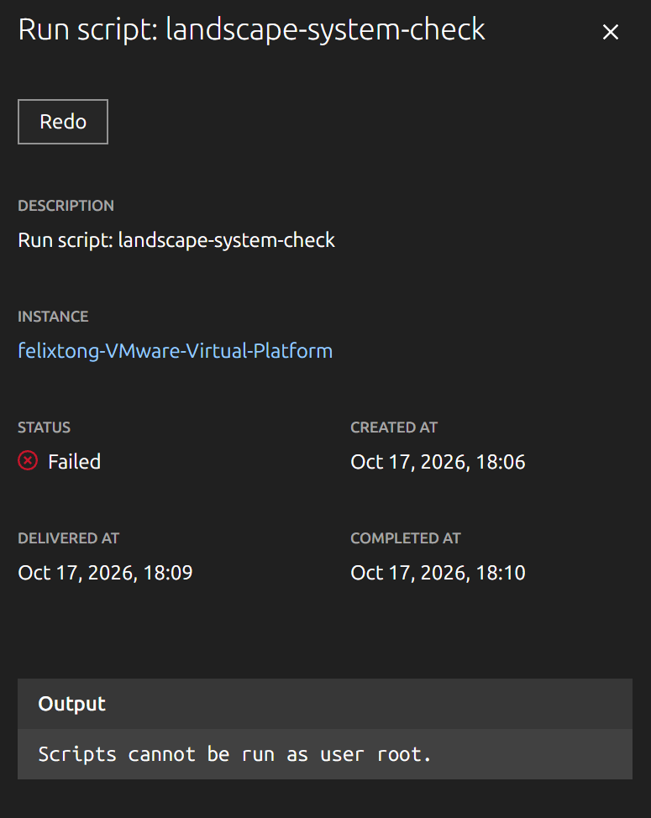
E07 | Second Script Failure: Root Execution Is Not Allowed

E08 Script Success: Hostname, Uptime, and dpkg Version
E08 | Script Success: Hostname, Uptime, and dpkg Version

E09 Remote Installation of cbonsai: Download and Configuration Output
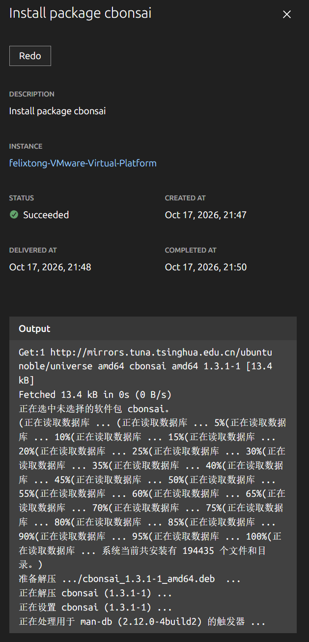
E09 | Remote Installation of cbonsai: Download and Configuration Output

E10 Successful Remote Removal of cbonsai: Package-Removal Output
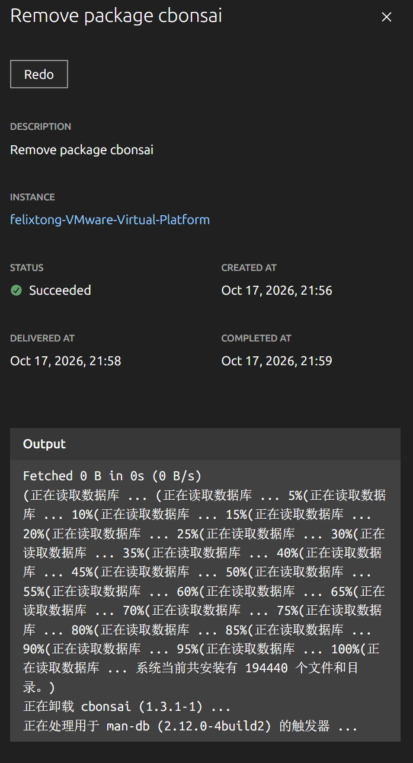
E10 | Remote Removal of cbonsai: Package-Removal Output

E11 Successful Remote Reboot: Reboot Requested of the System
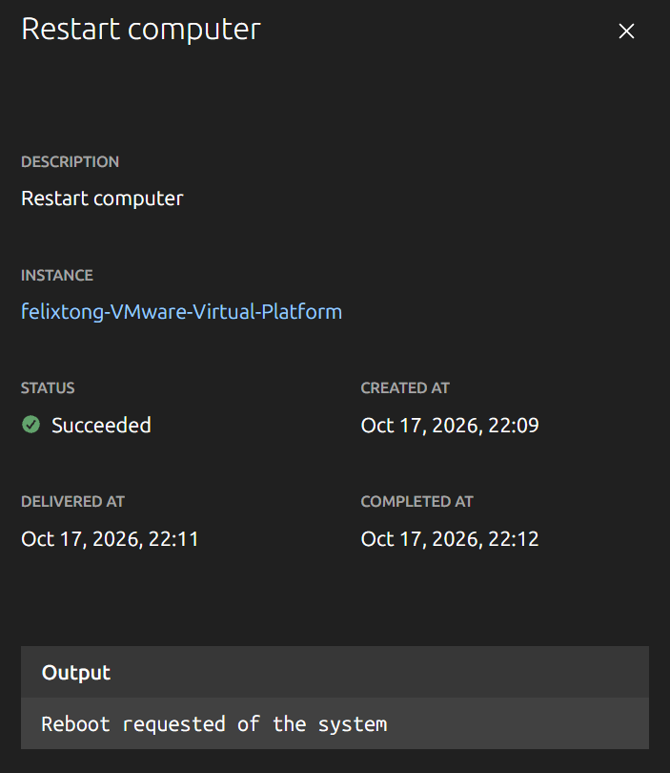
E11 | Remote Reboot: “Reboot requested of the system”

E12 | Ubuntu Pro: ESM and Landscape Service Status
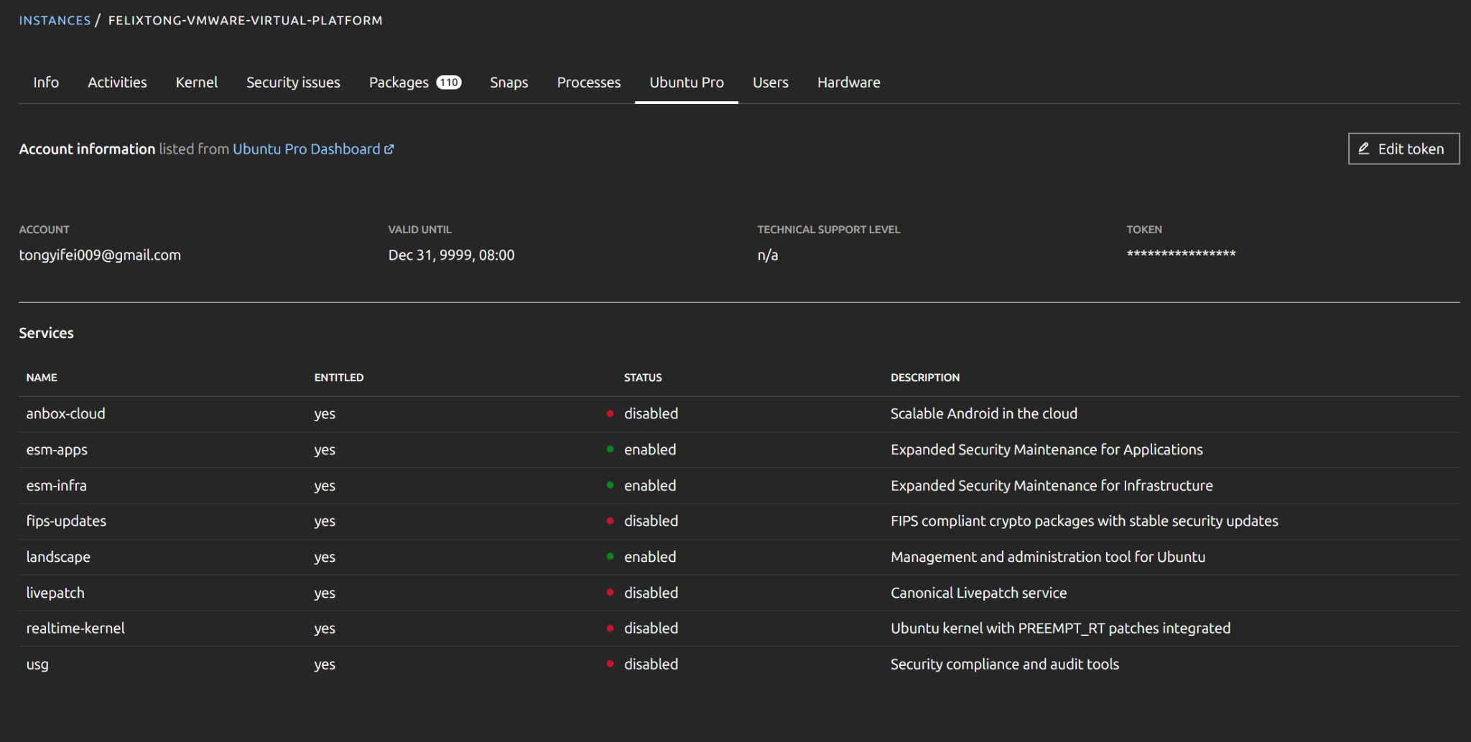
E12 | Ubuntu Pro: ESM and Landscape Service Status

E13 | Processes: “No processes running”
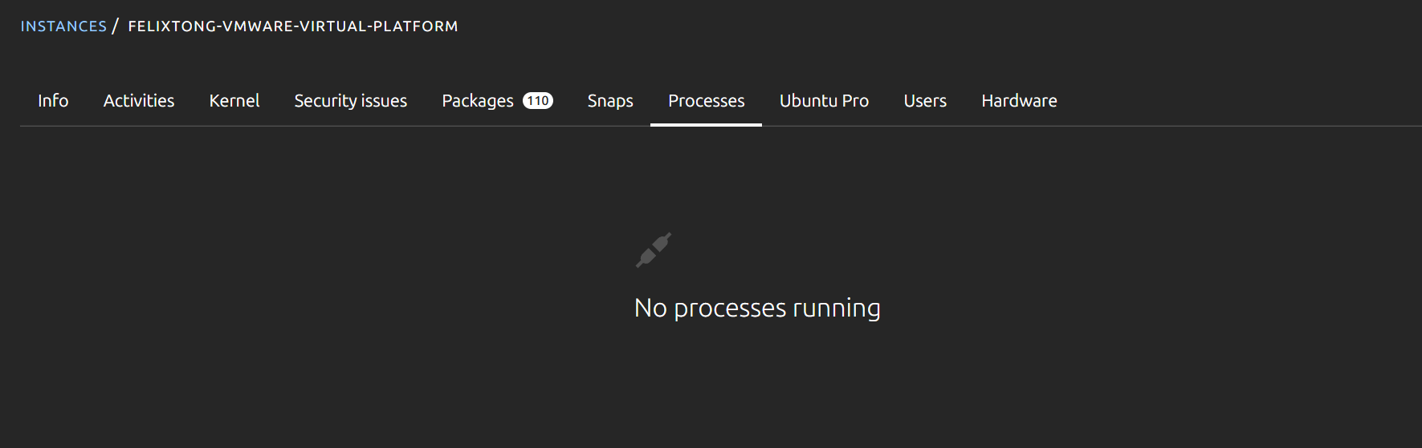
E13｜Processes：No processes running

E14 Packages: dpkg Security Upgrade Status
E14 | Packages: dpkg Security Upgrade Status

