# Class Explication

## Demo

Demo address is /BuildGame/Test_TianyuanJIA.exe

## Simple UML class schema

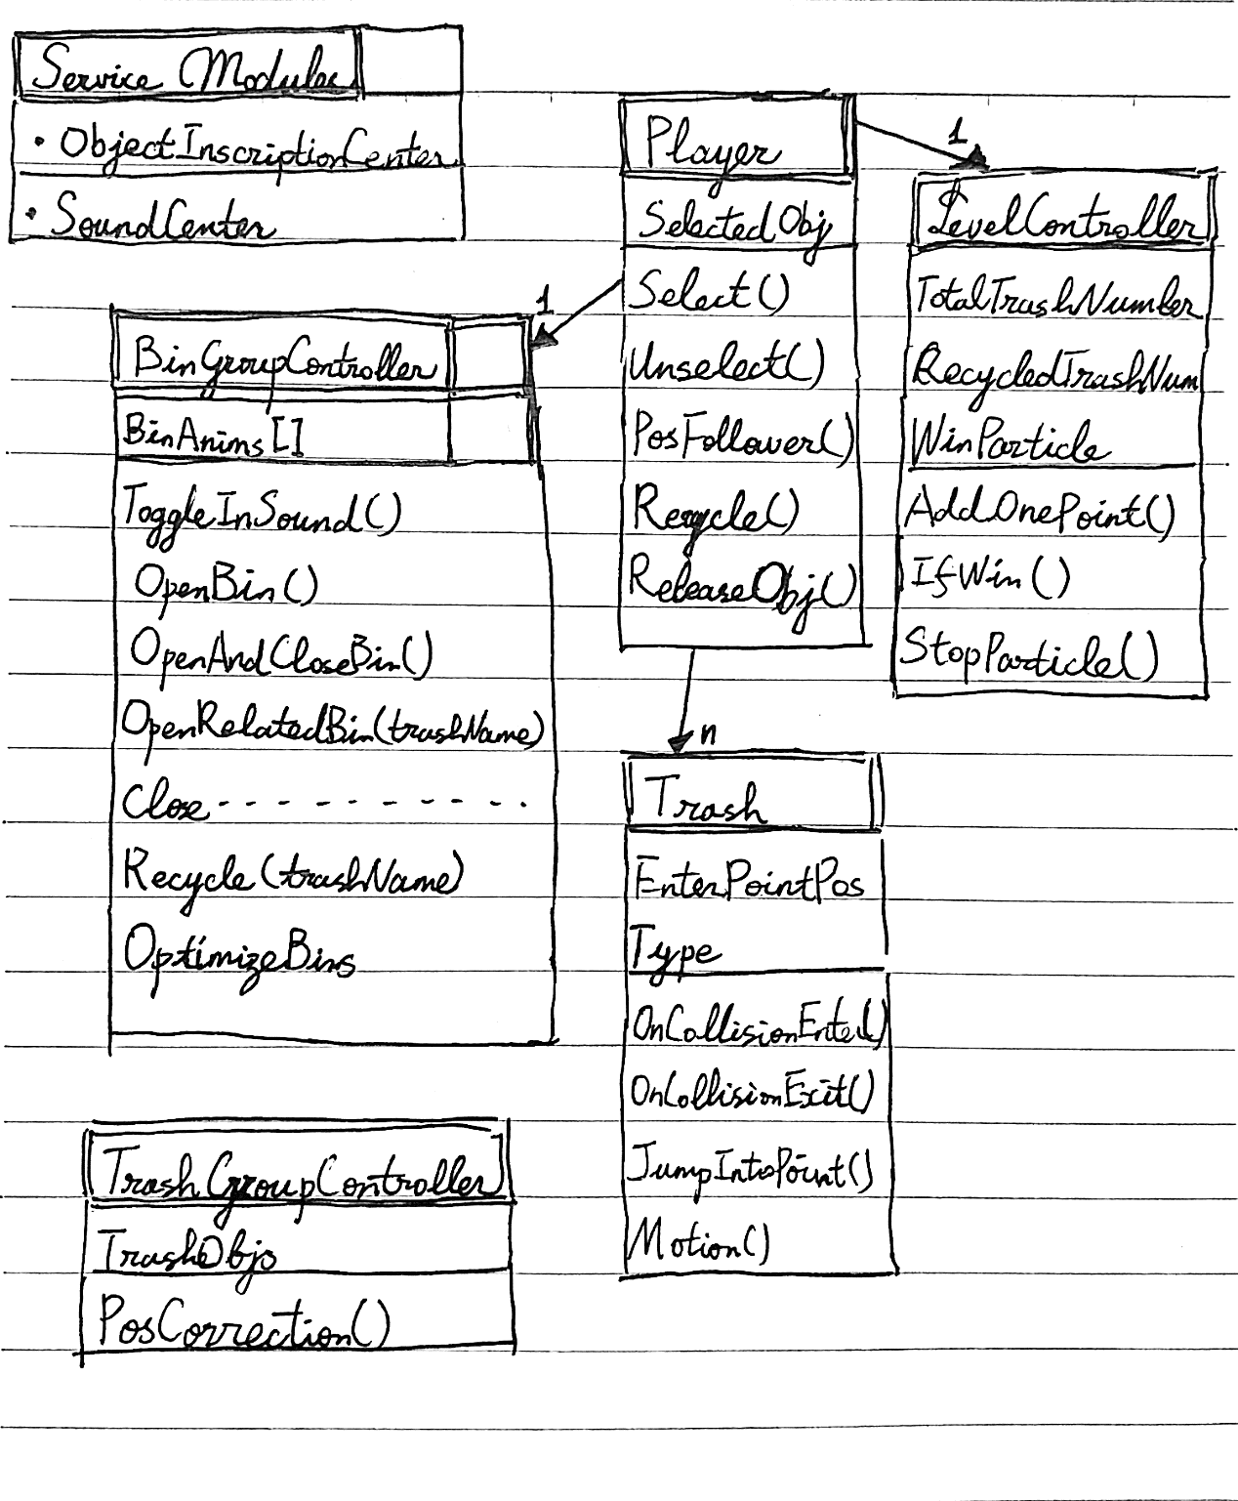

## ObjectInscriptionCenter (OIC)

1/ Optimize sources on Awake() / Start() on game mode. A common object used by several scripts is searched just one time by OIC in edit mode, then other scripts could find them directly in the OIC.

2/ Easy to add new objects in lists, easy to extend.

3/ Prevent “missing object”.

## SoundCenter

1/ Two pools of AudioSource to dynamically manage all sounds and to optimize AudioSource number with correct sound logic. (open/close sounds of one same bin could not play in the same time, but several pickup/recycle sounds could simultaneously play)

2/ Common pool : check if any AudioSource is free, if yes use one, otherwise add a new one in the pool.

3/ Reserved pool : one object could use one certain AudioSource to play sounds.

## BinGroupController

1/ To realize logics of Animation Events like ToggleRollInSound().

2/ Optimize static parts (bin bodies), hide them and replace the background sprite.

When bins are moving:

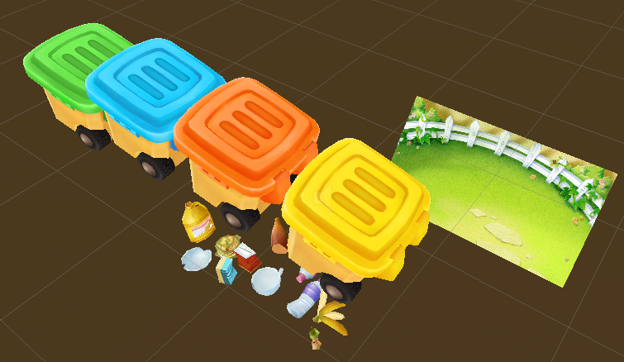

When bins are stopped:

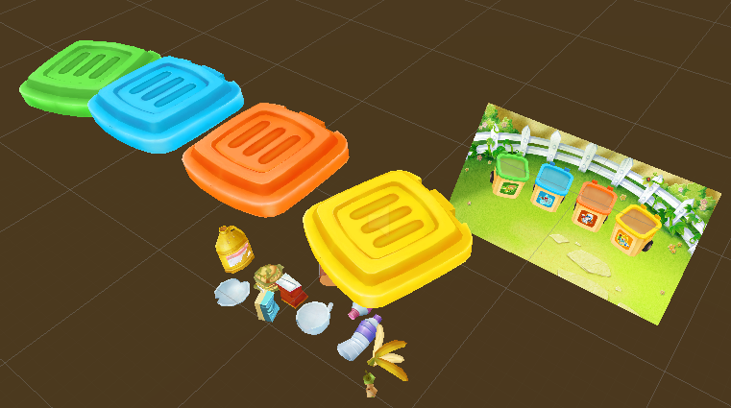

In main camera:

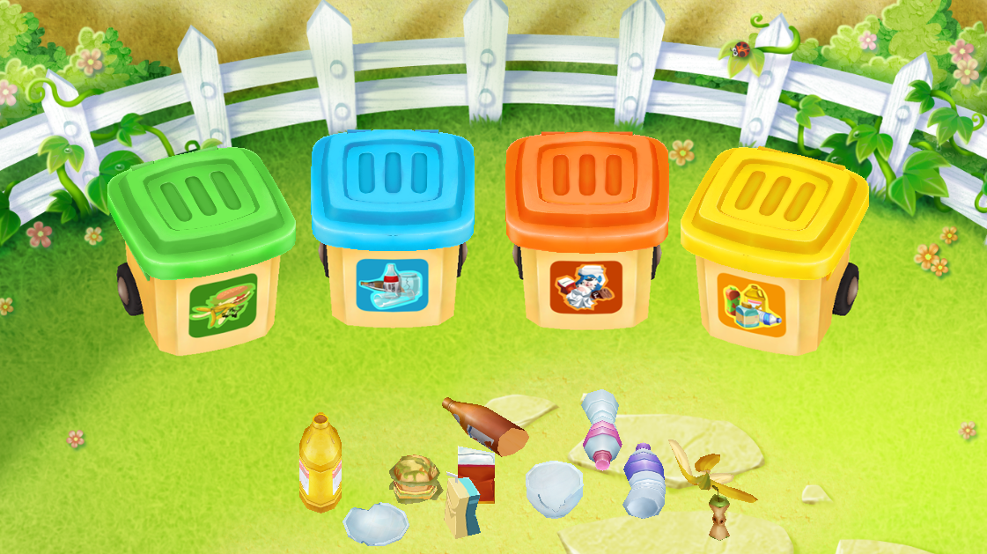

3/ Play Bin Animations with sound.

## Player

1/ For selecting, unselecting and dragging trashes.

2/ Tell BinGroupController witch Animation should be played.

## LevelController

To count points and verify if the player is win.

## Trash

1/ To verify if the selected trash is on the correct bin.

2/ realize a tiny animation for jumping in.

## TrashGroupController

Limit positions of trashes.

## Other Optimization

1/ Texture resolution & compression changed