Data extraction

1. Source files
The pack contains five document types:
Folder | What it contains | Example files
RAMS | Risk assessment (HIRA) | HIRA Front Page 1, pages 2–3
Permit To Work | Work permit | Front and back of permit 098001
Rescue Plan | Confined space rescue plan | Front page and back page
Confined Space Check List | IMSF job checklist | Checklist pages 1–3
Contractor Approval | Clearance to work | Authorisation and clearance pages

Pages used
RAMS
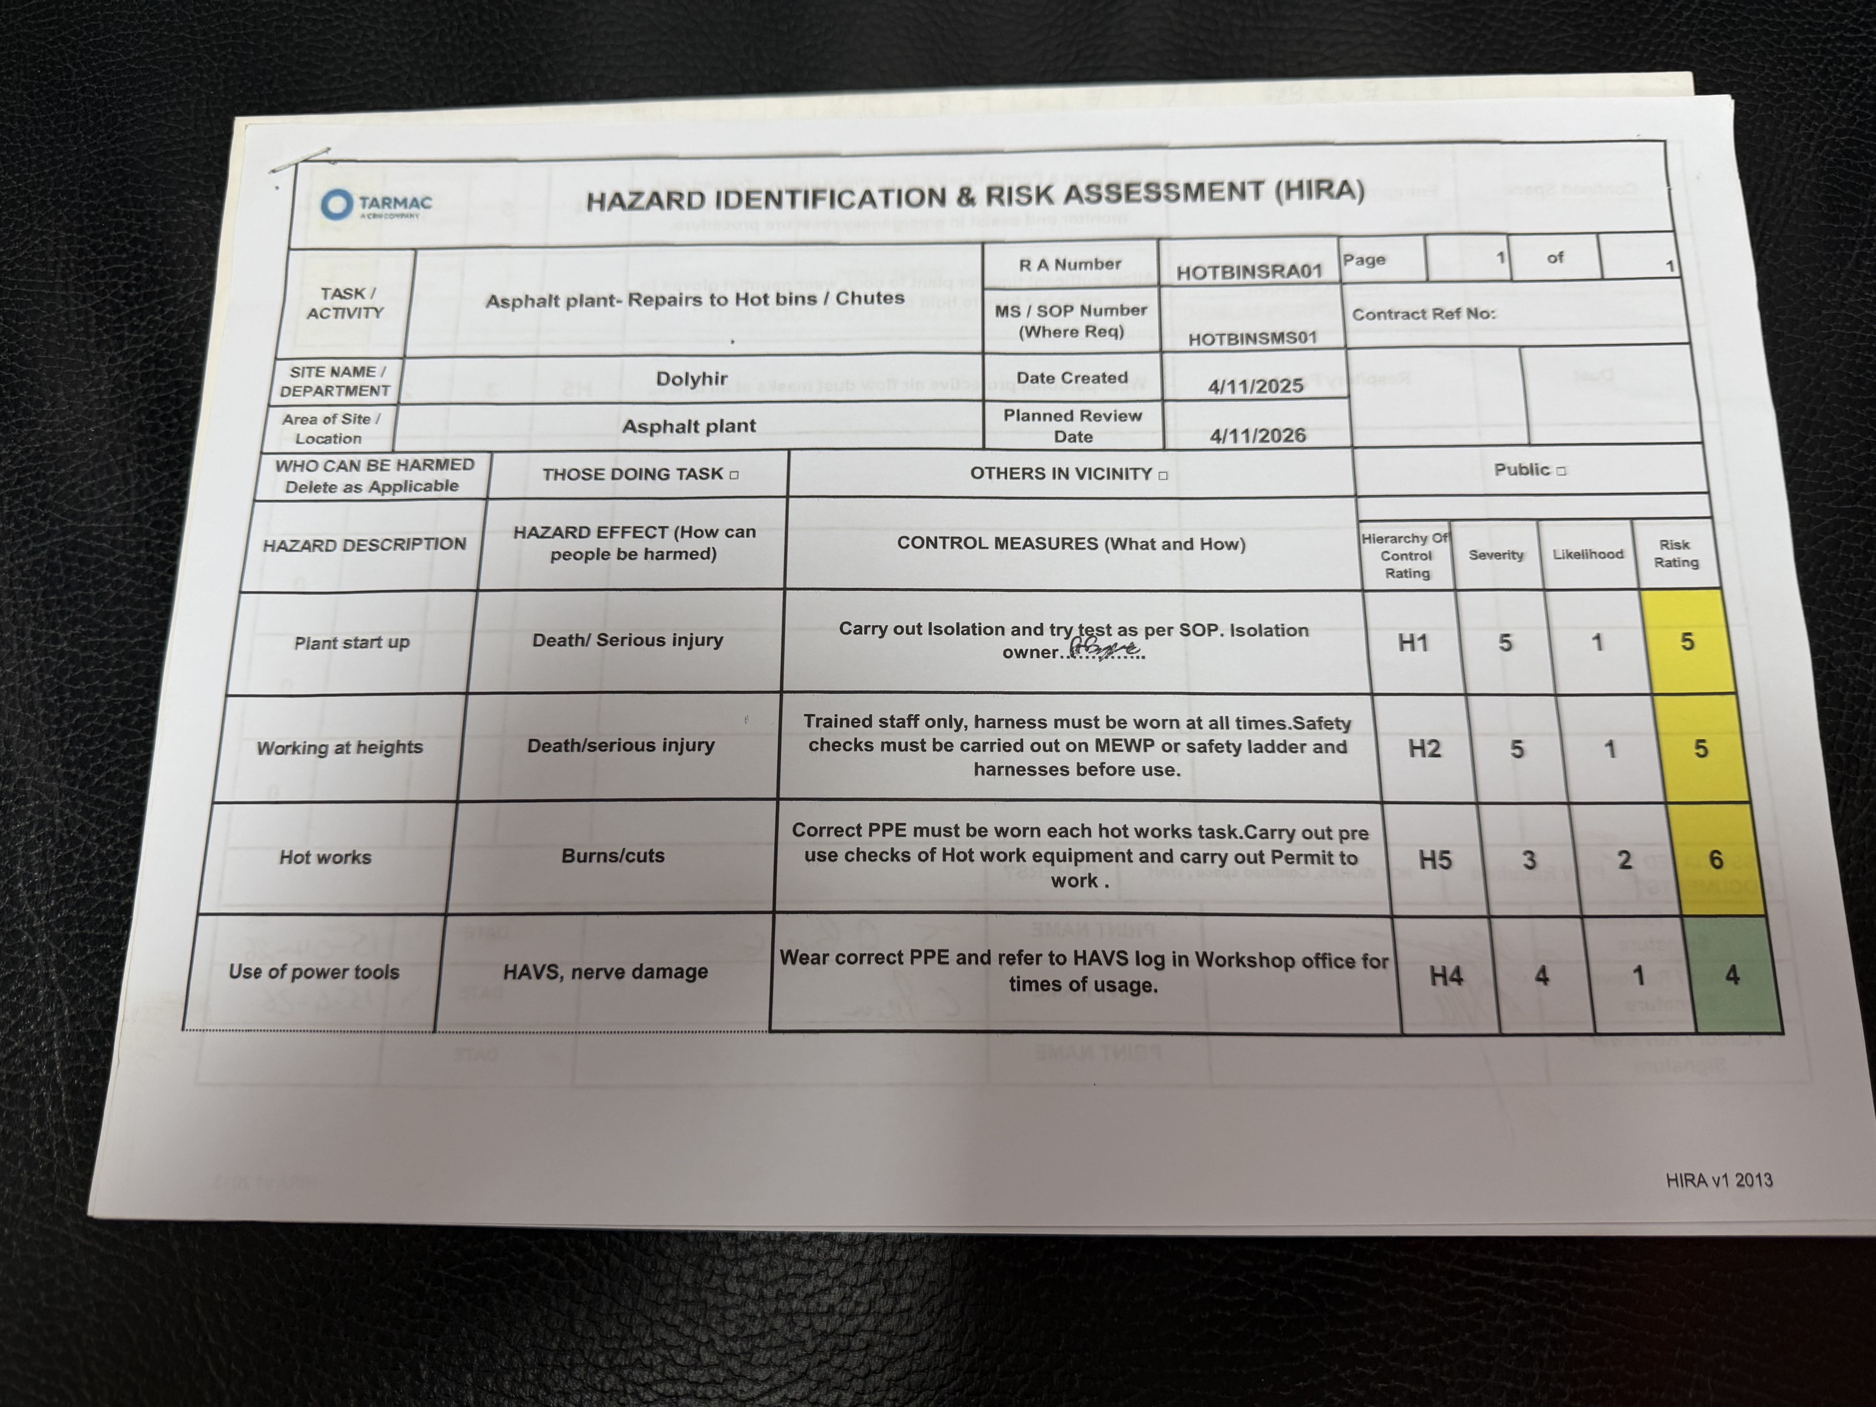
Permit To Work
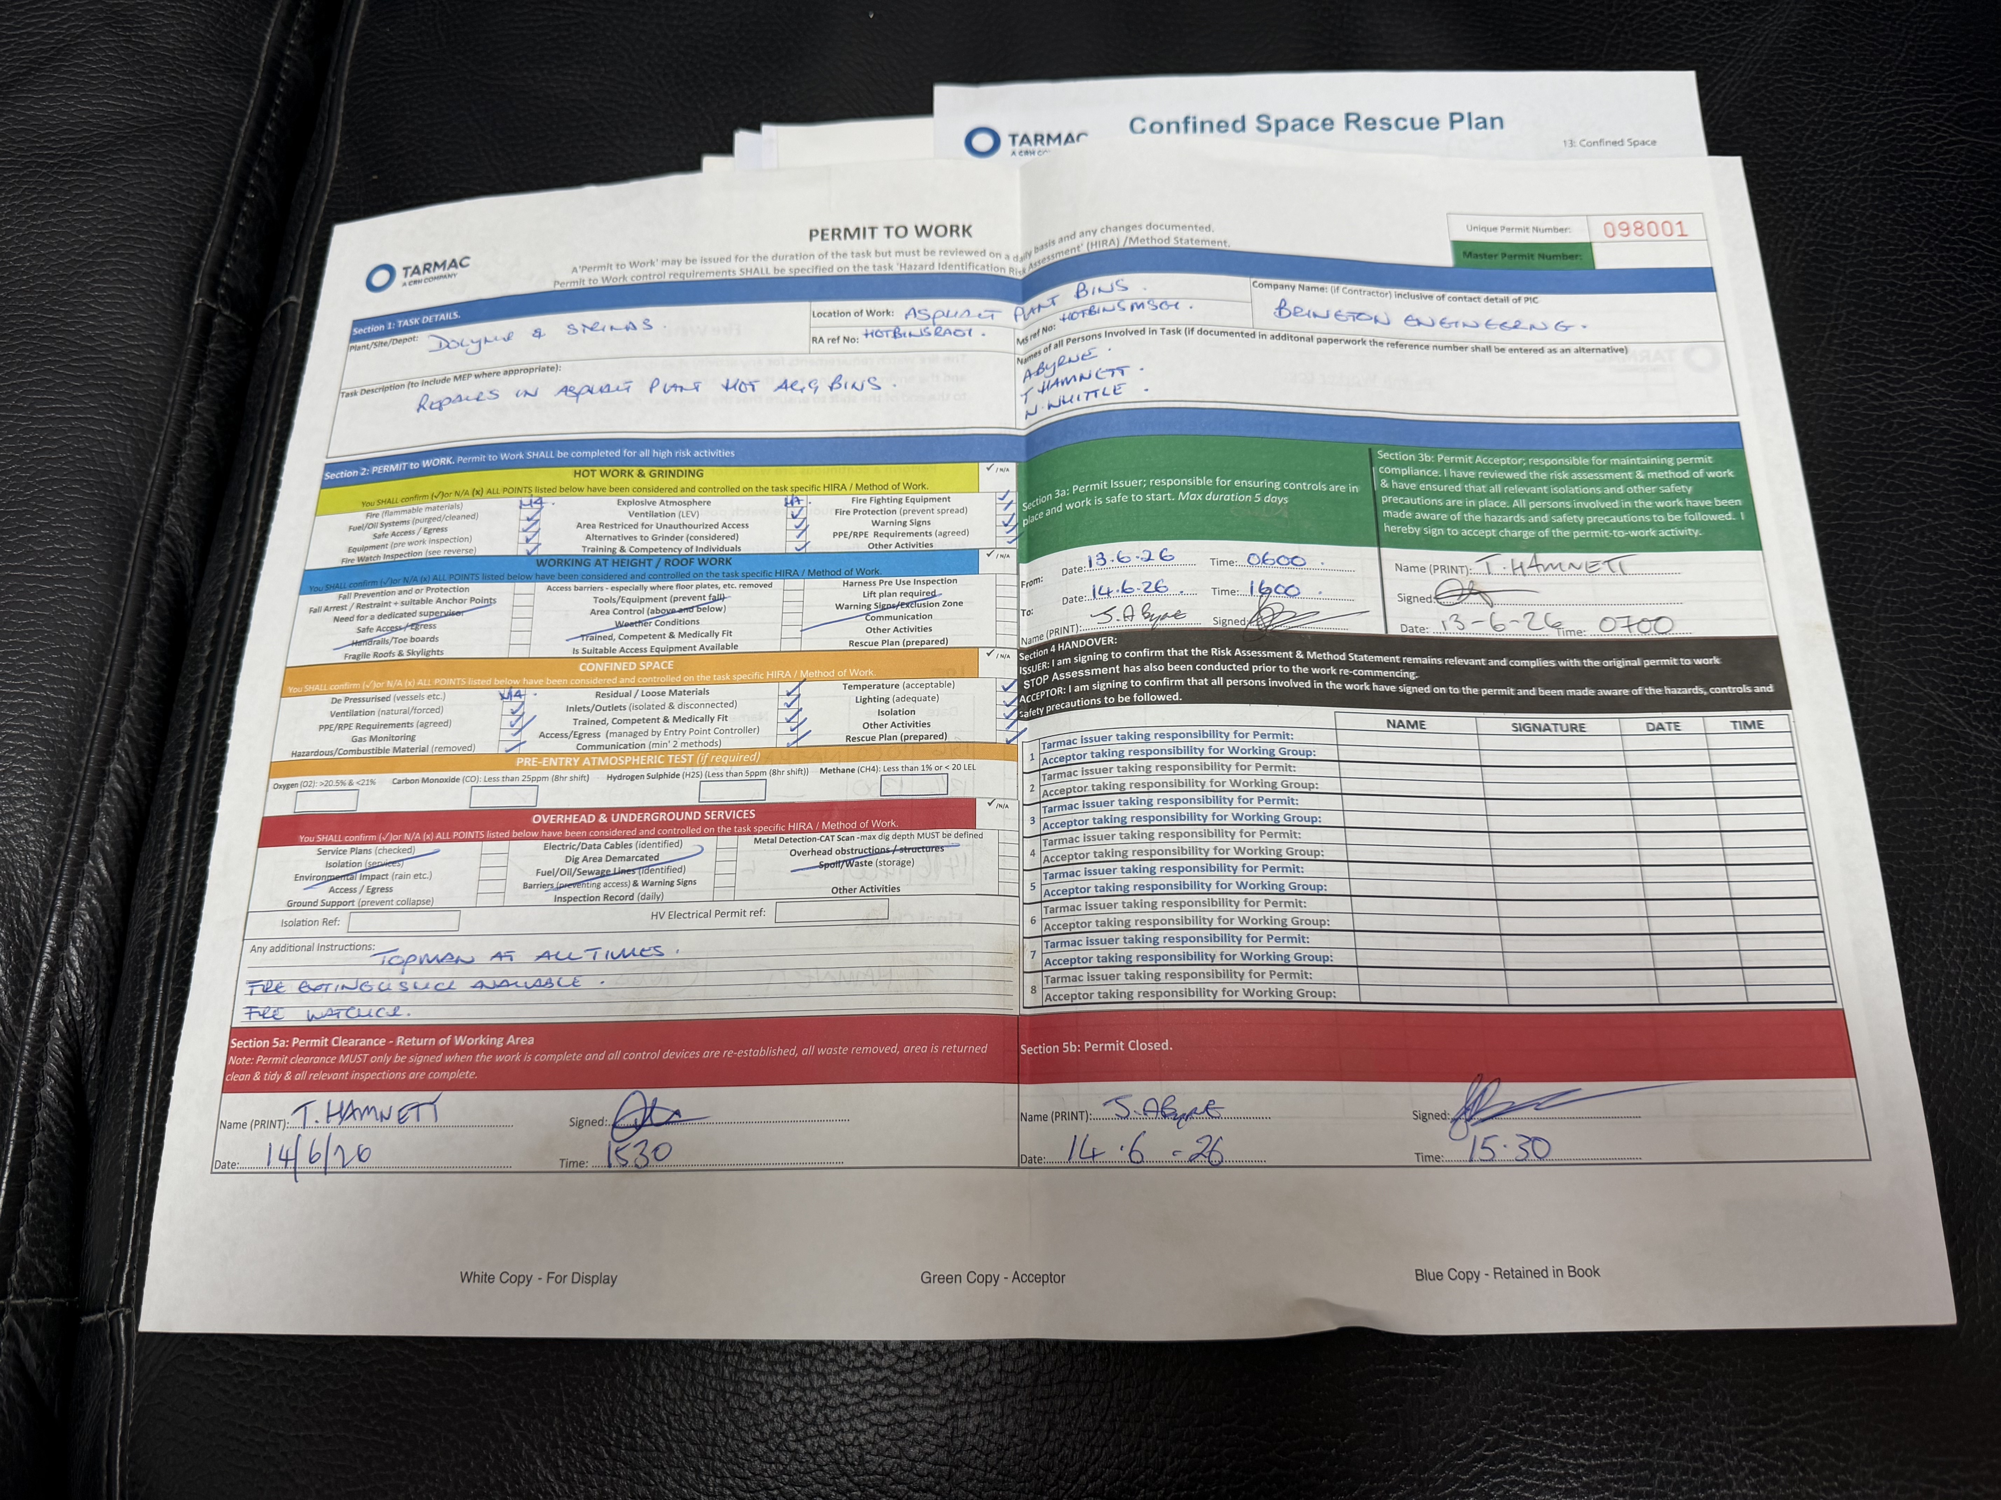
Rescue Plan
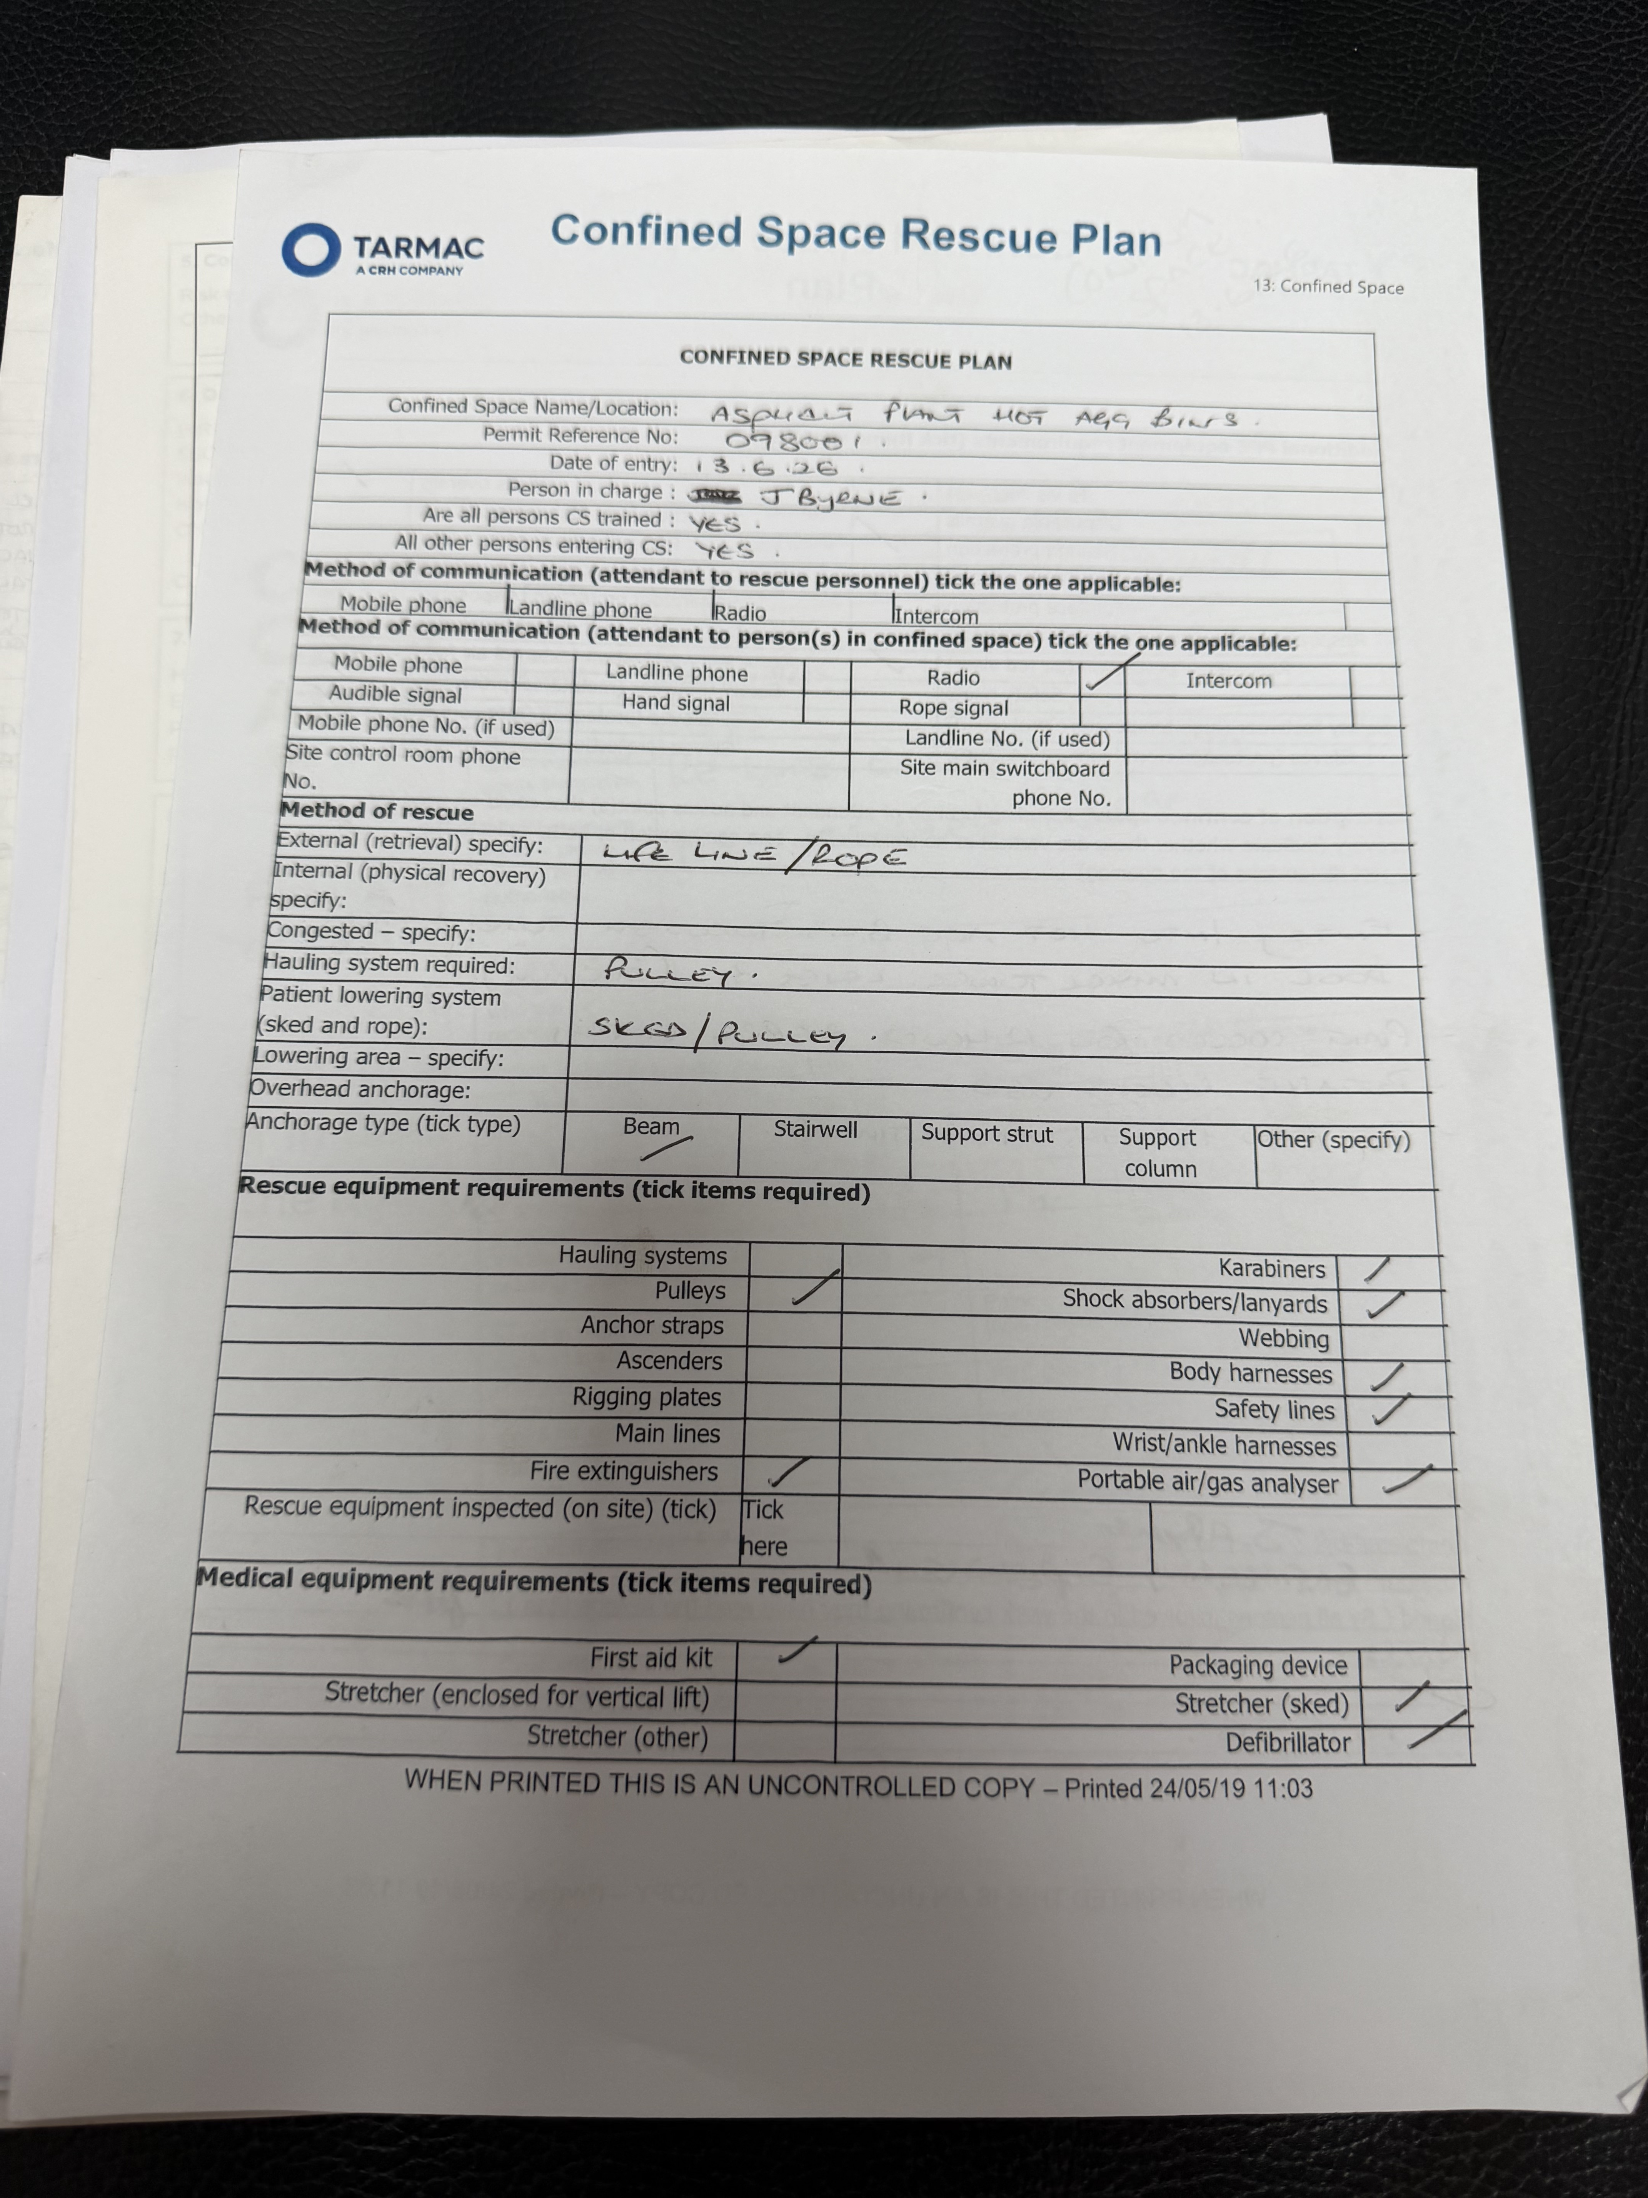
Confined Space Check List
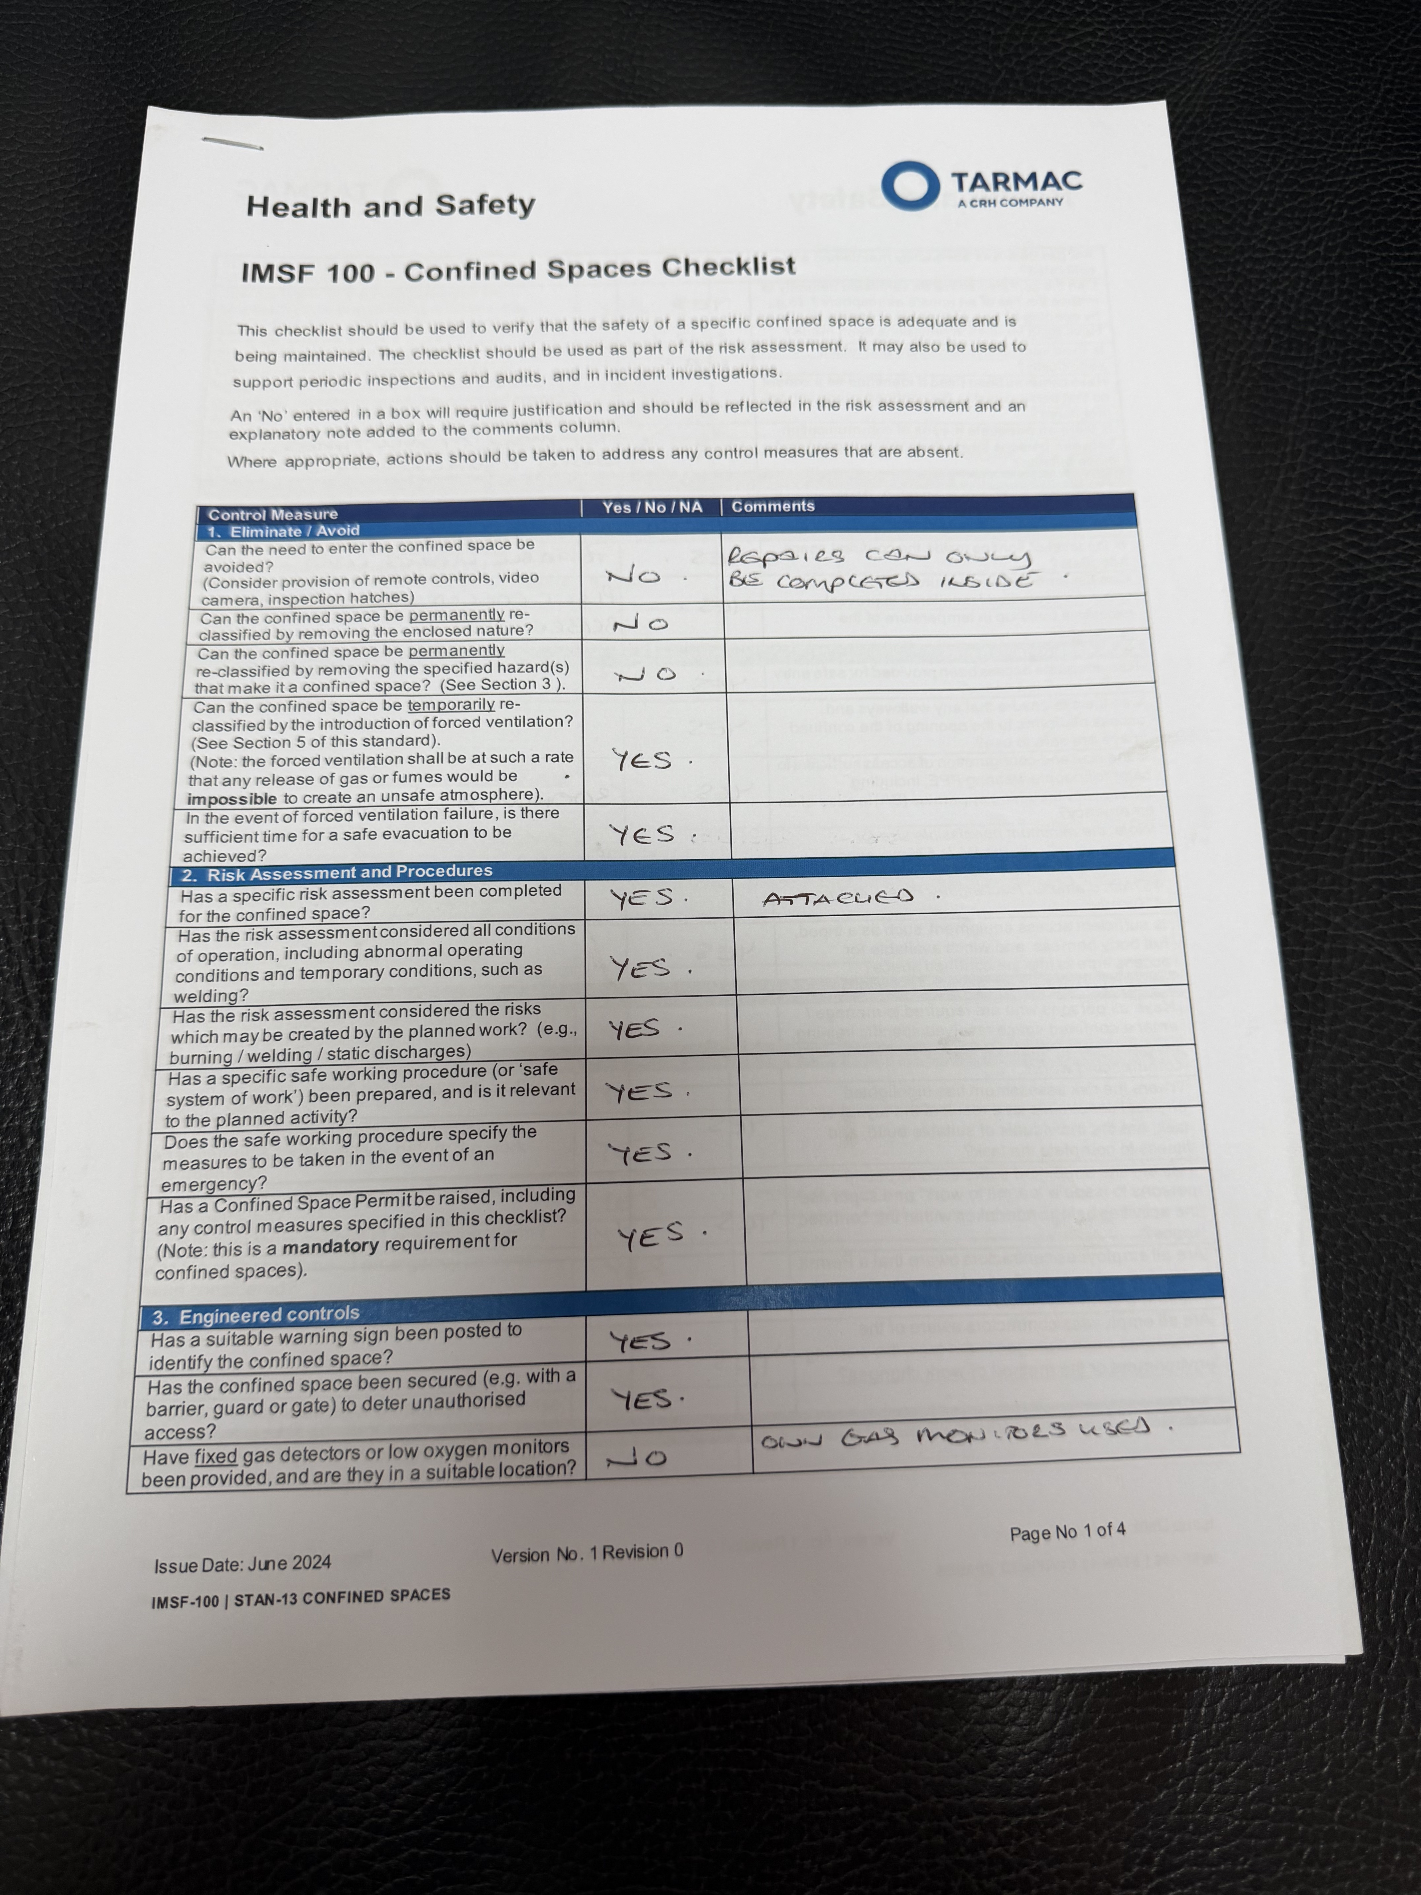
Contractor Approval
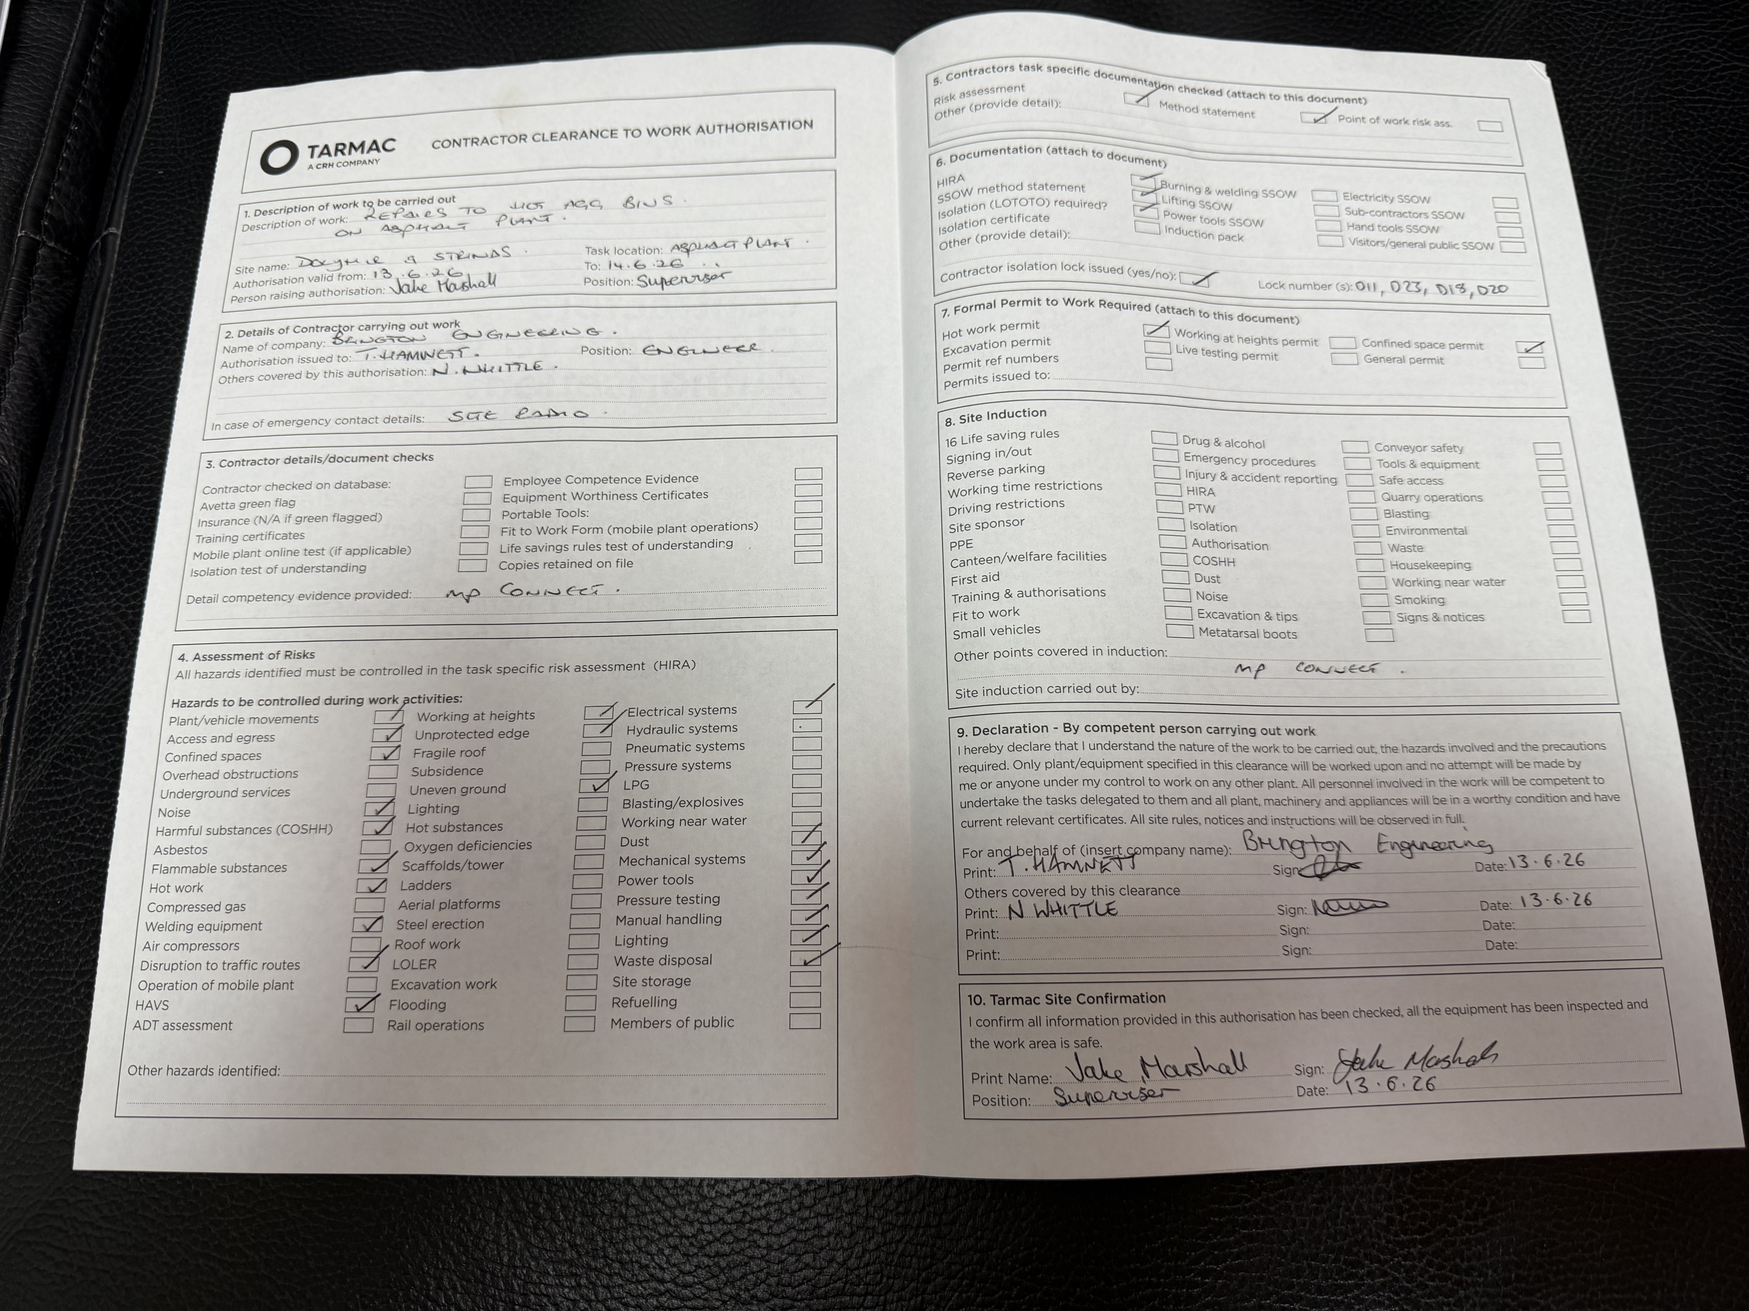

2. How we created the Excel file
The process is the same for this sample pack and for any future job pack
- Step 1 — Collect the scanned job pack (RAMS, permit, rescue plan, checklist, contractor clearance).
- Step 2 — Extract names, references, dates, locations, and checklist questions directly from each page using AI
- Step 3 — Match each fact to the field a user would fill in on the SafeIn5 back-office screens.
- Step 4 — Write those values into the correct worksheet

3. Screen wise detail
This is where the client organisation is set up in SafeIn5. We copied the client name from the paperwork headers and logos.

Client

SafeIn5 screen
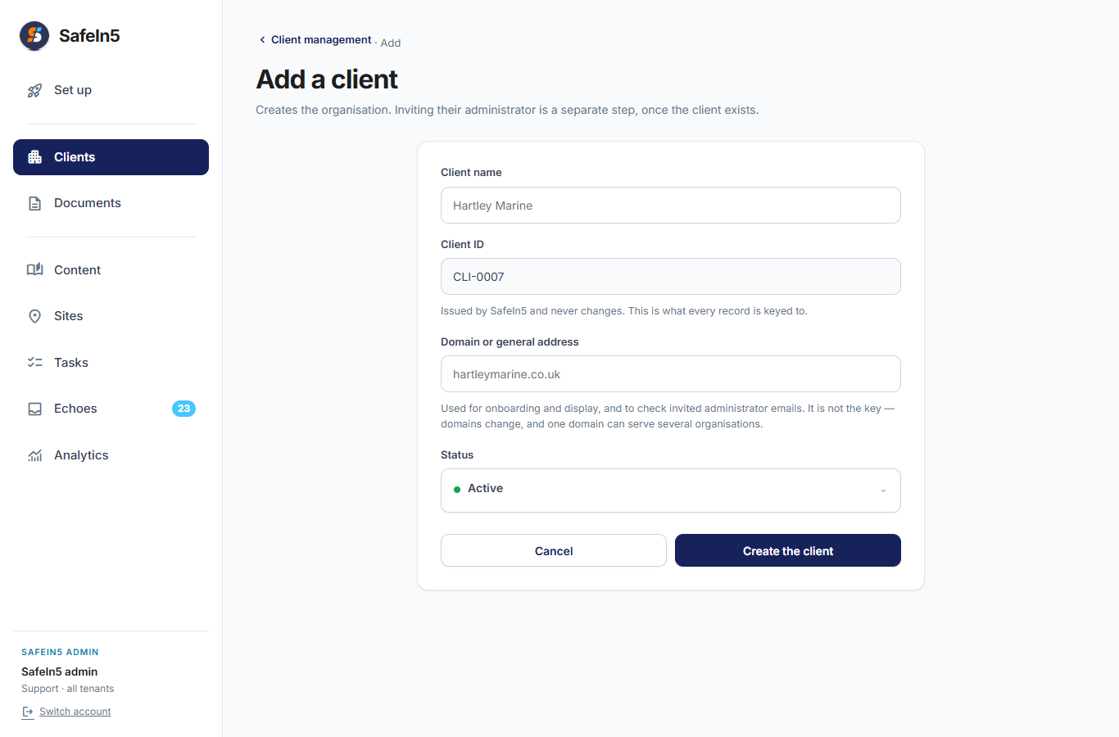

What we read from job pack
Field on screen | Value in Excel | Found on papers?
Client name | Tarmac | Yes — Tarmac logo on all scans
Domain or general address | (blank) | No
Status | (blank) | No
Echo records retention | (blank) | No
Media retention | (blank) | No

2. Site
Names were taken from the permit and rescue plan.

SafeIn5 screen
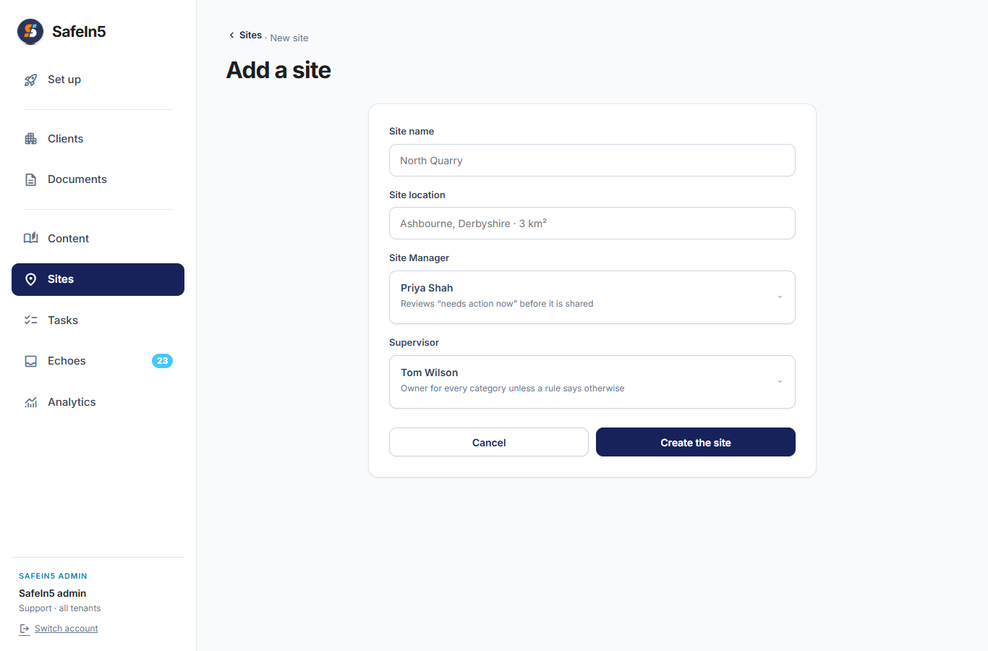

What we read from job pack
Field on screen | Value in Excel | Found on papers?
Site name | Dolyhir | Yes — HIRA and permit
Site location | (blank) | No — not clearly on these scans
Site Manager | JA Byrne | Yes — permit issuer
Supervisor | J Abrahams | Yes — rescue plan supervisor

3 Space

SafeIn5 screen
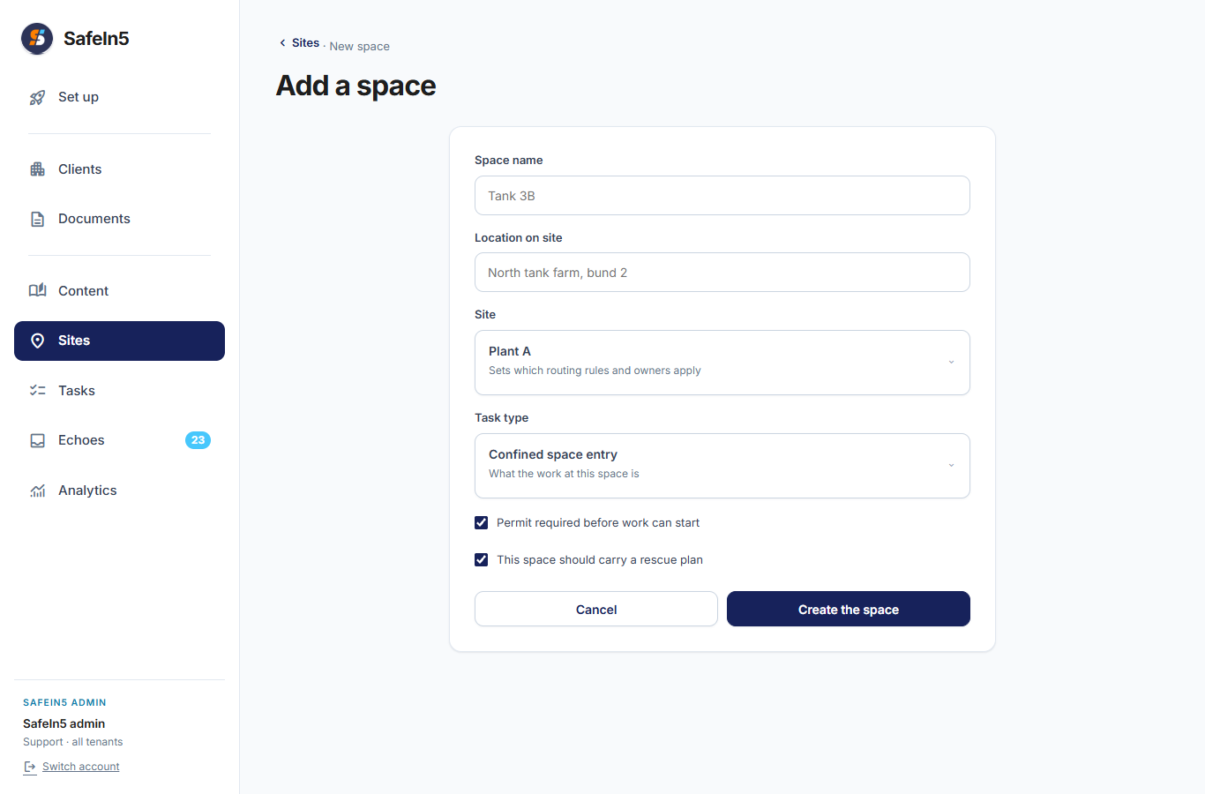

What we read from job pack
Field on screen | Value in Excel | Found on papers?
Space name | Hot Aggregate Bins | Yes — rescue plan title
Location on site | Asphalt Plant, mixer house level 3 | Yes — rescue plan back page
Site | Dolyhir | Yes — links to site above
Task type | Confined space entry | Yes — permit type
Permit required before work can start | Yes | Yes — permit raised
This space should carry a rescue plan | Yes | Yes — rescue plan supplied

4 People

SafeIn5 screen
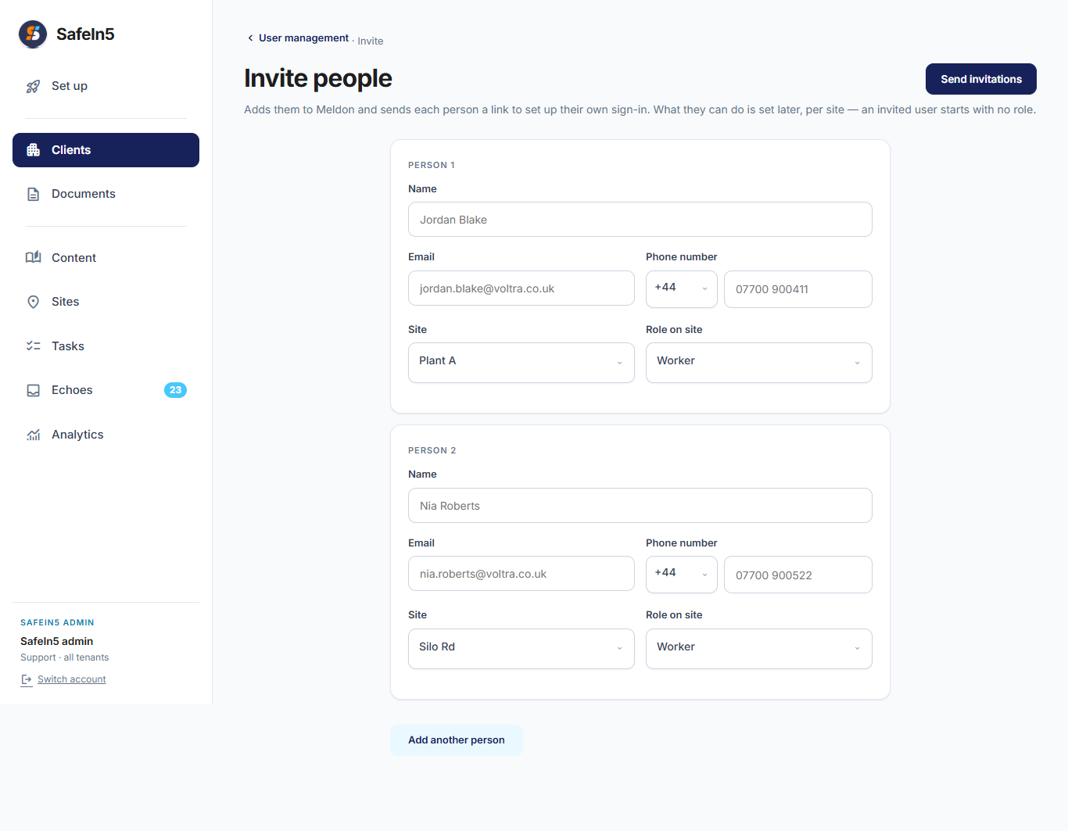

What we read from job pack
Name | Role on site | Email in Excel | Where we found the name
JA Byrne | Site Manager | (blank) | Permit issuer; HIRA reviewer J. A Byrne
Jake Marshall | Supervisor | (blank) | Contractor clearance: person raising authorisation
J Abrahams | Supervisor | (blank) | Rescue plan completed by: Engineering Supervisor
T Hamnett | Worker | (blank) | Permit acceptor; contractor engineer, Brington Engineering
Nathan Whittle | Worker | (blank) | Permit crew / worker log

5 Task

SafeIn5 screen
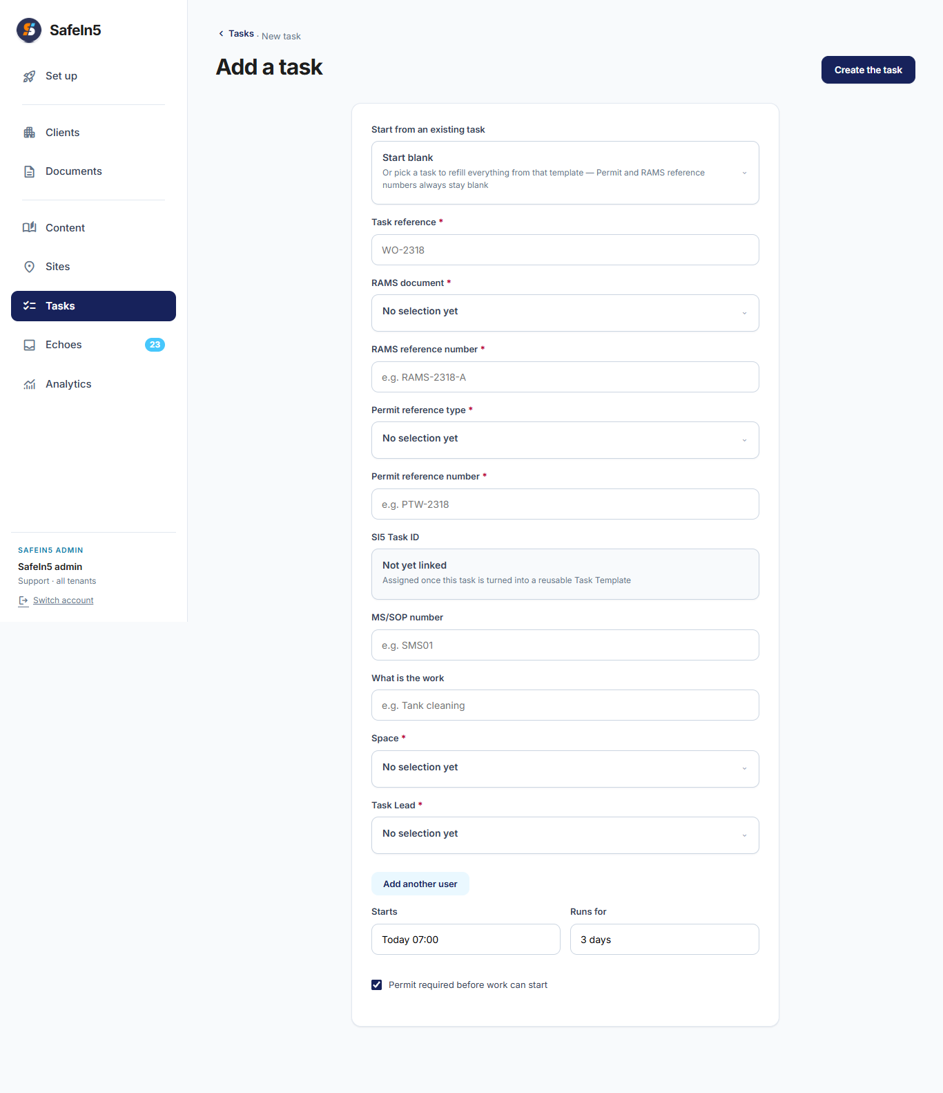

What we read from job pack
Field on screen | Value in Excel | Found on papers?
Task reference | 098001 | Yes — permit number
RAMS document | Hazard Identification & Risk Assessment — Hot Bins / Chutes | Yes — HIRA title
RAMS reference number | HOTBINSRA01 | Yes — HIRA
Permit reference type | Confined Space; Hot Work | Yes — permit front
Permit reference number | 098001 | Yes — permit
MS/SOP number | HOTBINSMS01 | Yes — permit
What is the work | Repairs in Asphalt Plant Hot Agg Bins | Yes — permit
Space | Hot Aggregate Bins | Yes — links to space above
Task Lead | Jake Marshall | Yes — contractor clearance
Starts | 13 Jun 2026 06:00 | Yes — permit
Runs for | 2 days | Yes — permit
Permit required before work can start | Yes | Yes — permit

6 Documents
Each scanned document is listed once with its file name, document kind, and paper reference number.

SafeIn5 screen
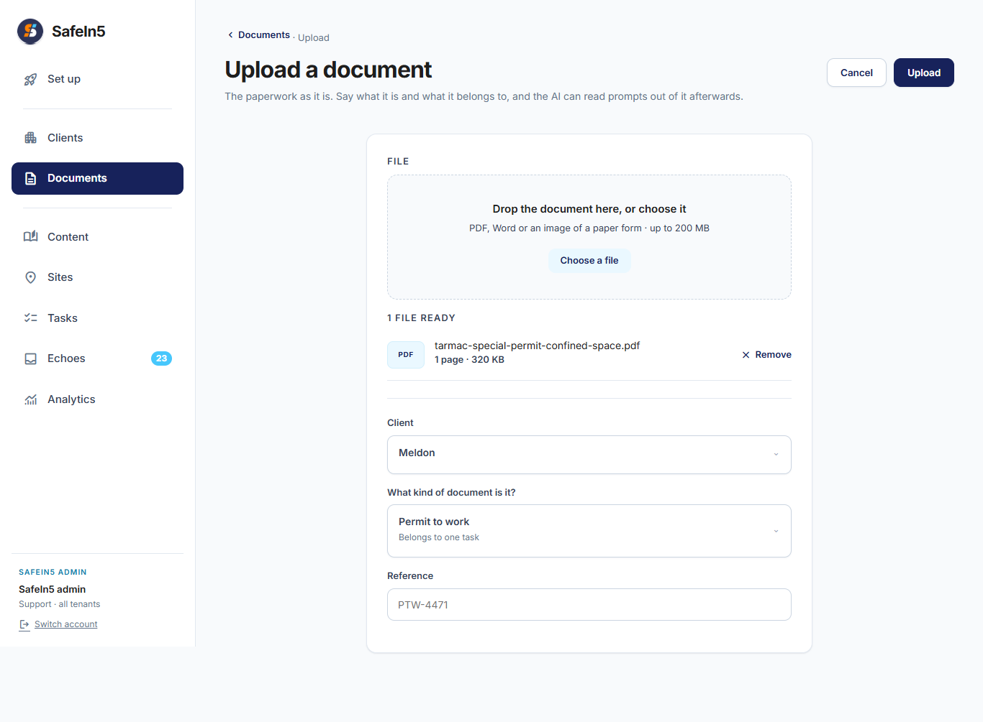

What we read from job pack
File from job pack | Document kind | Reference
RAMS/HIRA Front Page 1 .jpeg | Risk assessment (HIRA / RAMS) | HOTBINSRA01
Permit To Work/Permit to Work Front Page .jpeg | Permit to work | 098001
Rescue Plan/Rescue Plan Front Page.jpeg | Rescue plan | r1 · uncontrolled copy printed 24/05/19
Confiend Space Check List/CS Check List Page 1.jpeg | Checklist | Version 1 Revision 0 · June 2024
Contractor Approval/Contractor Clearence to work main page.jpeg | Other (contractor clearance) | 13.6.26–14.6.26

7 Checklist content
The confined-space checklist was transcribed line by line. The Excel workbook contains all 56 checklist prompts; a sample is shown below.

SafeIn5 screen
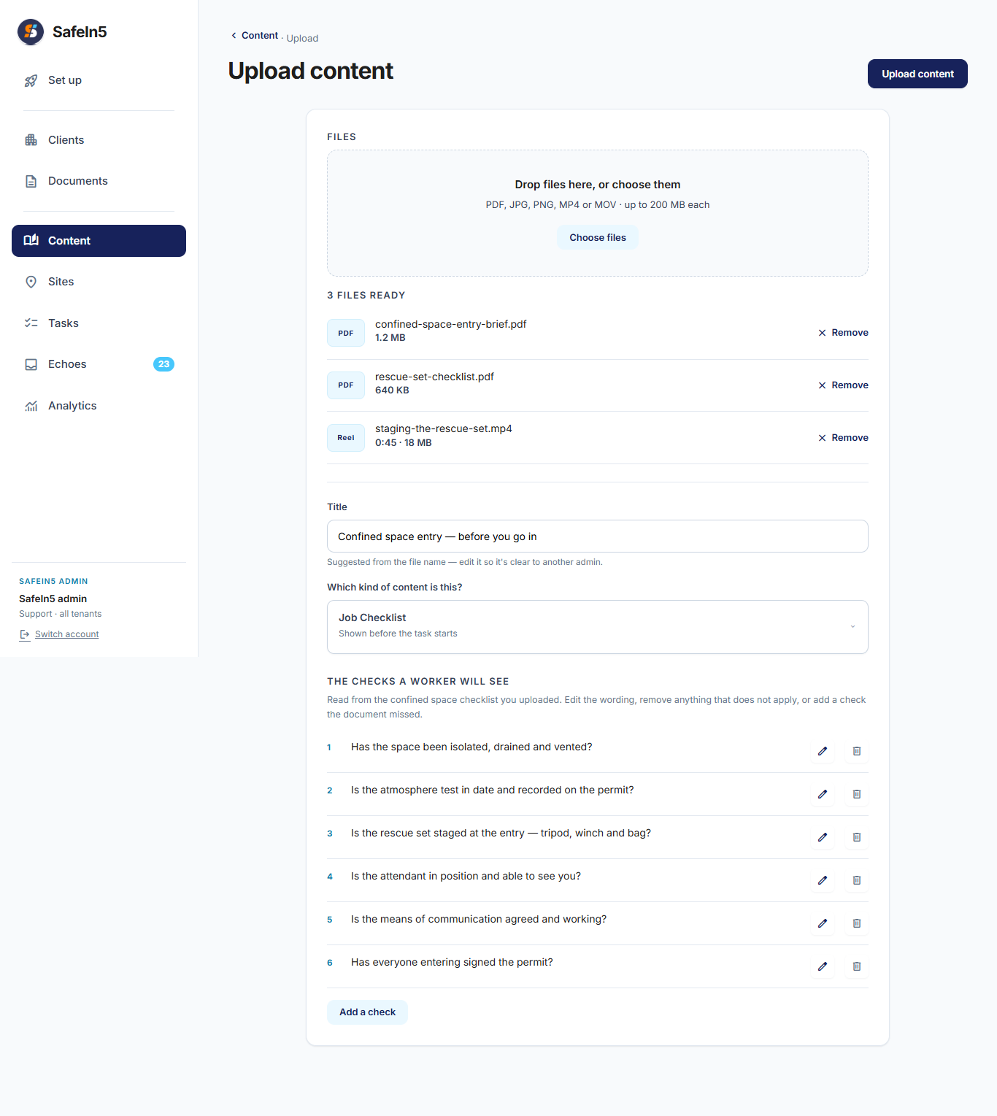

What we read from your job pack
Checklist title | Content kind | Example prompt
IMSF 100 — Confined Spaces Checklist | Job Checklist | Can the need to enter the confined space be avoided?
 |  | Can the confined space be permanently re-classified by removing the enclosed nature?
 |  | Can the confined space be permanently re-classified by removing the specified hazard(s)?
 |  | Can the confined space be temporarily re-classified by forced ventilation?
 |  | If forced ventilation fails, is there sufficient time for a safe evacuation?
 |  | Has a specific risk assessment been completed for the confined space?
 |  | … plus 50 more rows in the Excel file

