SafeIn5
AI extraction from job pack scans
What we read from each page and where it appears in SafeIn5

1. What this document is for
We used AI to read the scanned pages from your sample job pack. This report covers only those scans — the same pages used to pre-fill documents and checklist content in SafeIn5.
For each page you will see: the original scan, what we read from it, and the SafeIn5 upload screen where that information appears.
- 8 document scans (RAMS, permit, rescue plan, contractor clearance)
- 3 checklist pages (IMSF 100 confined space checklist)

2. Where extracted data goes in SafeIn5

A. Document scans → Upload a document
Permits, risk assessments, rescue plans, and clearance forms are uploaded to the document library. AI pre-fills the document kind, title, and reference.
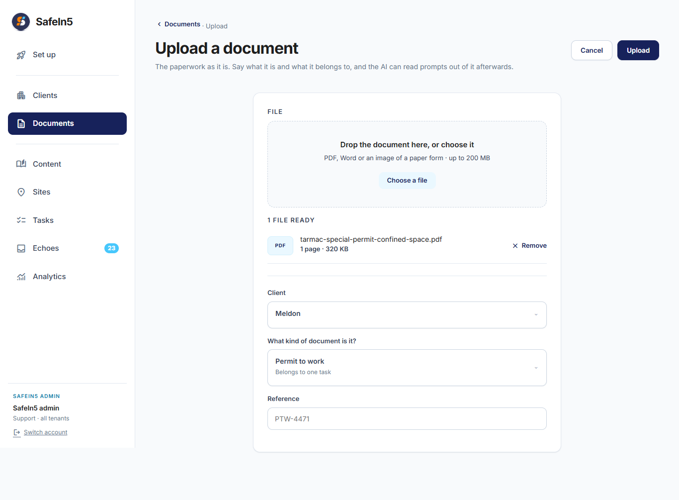

B. Checklist pages → Upload content (Job Checklist)
Each yes/no question on the IMSF checklist becomes one prompt in a Job Checklist content pack.
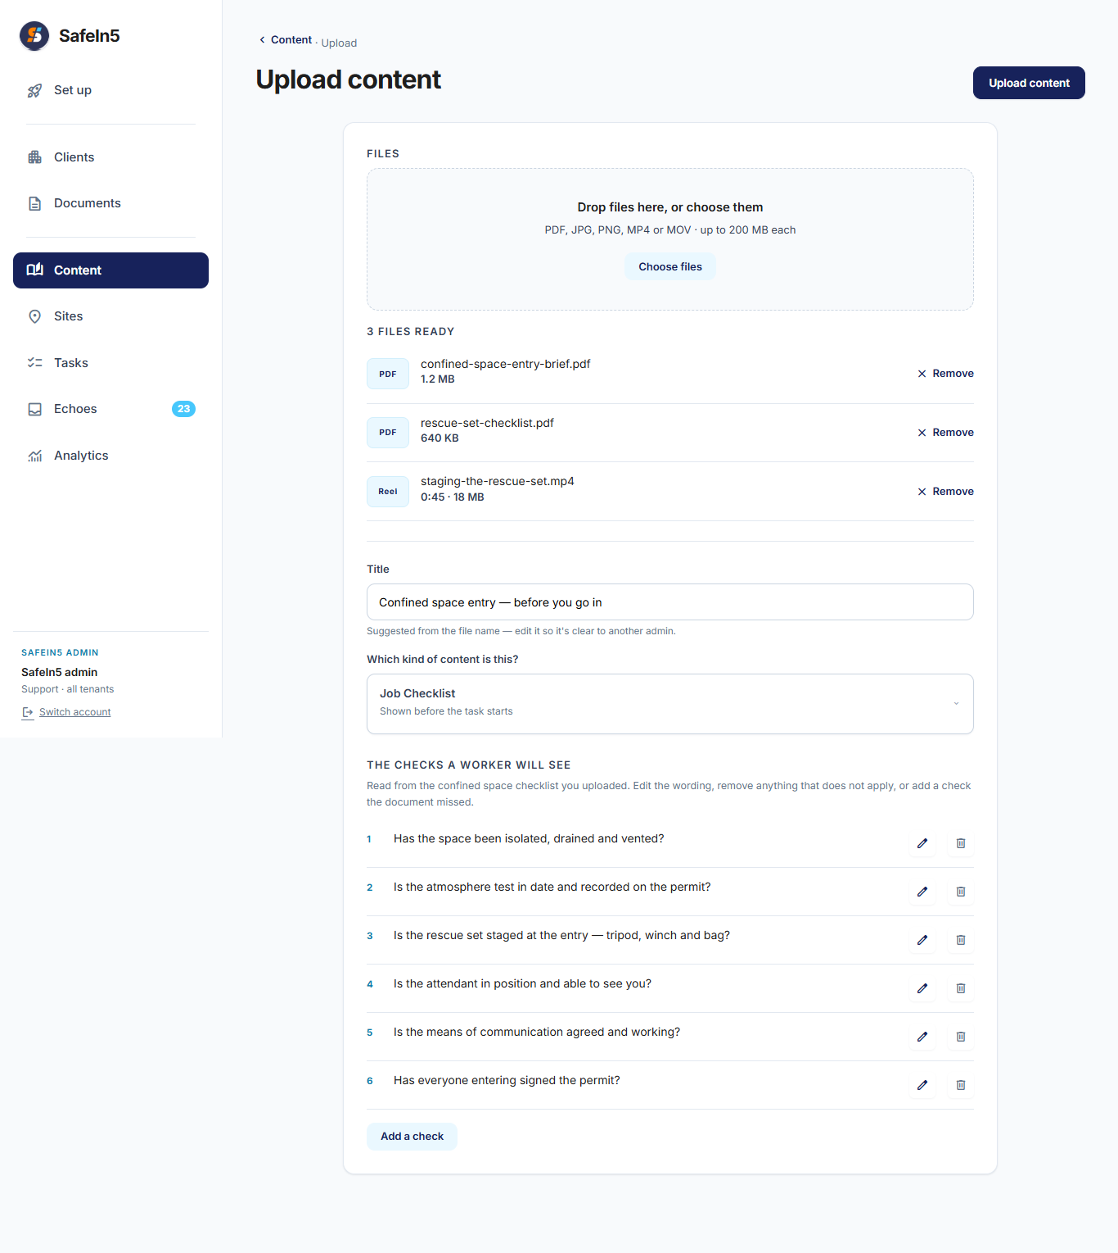

Part A — Document scans
Each scan below is uploaded as a document with kind, title, and reference pre-filled.

Risk assessment (HIRA) — cover page
File: RAMS/HIRA Front Page 1 .jpeg
This risk assessment scan is stored in the document library with its kind, title, and reference number pre-filled from the page.

Your document
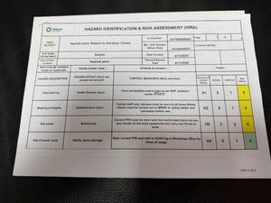

What we read from this page
On your paper | What we captured
Document type | Risk assessment (HIRA / RAMS)
Document reference | HOTBINSRA01
Document title / work description | Asphalt plant- Repairs to Hot bins / Chutes
Work area named on page | Asphalt plant

Where this appears in SafeIn5
Upload a document
Document kind, title, and reference are pre-filled when this scan is uploaded.
Attach a document
The document is attached to the task or work area.
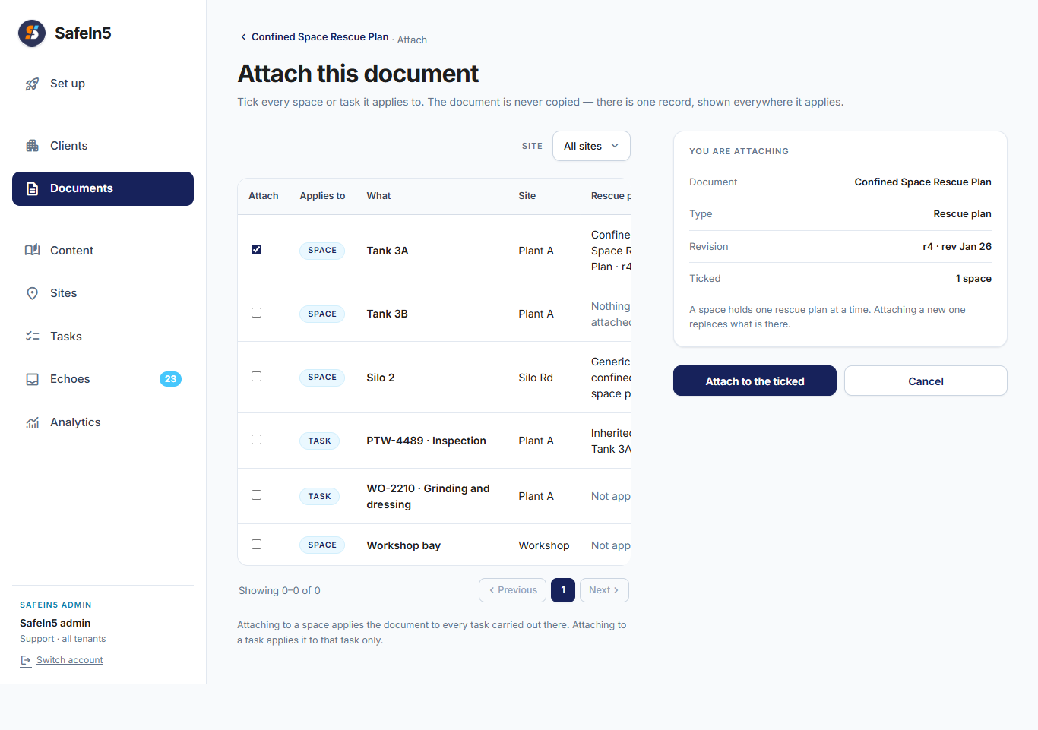

Risk assessment (HIRA) — hazard details
File: RAMS/HIRA Page 2.jpeg
This risk assessment scan is stored in the document library with its kind, title, and reference number pre-filled from the page.

Your document
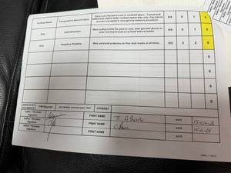

What we read from this page
On your paper | What we captured
Document type | Risk assessment (HIRA / RAMS)
Document reference | HIRA v1 2013

Where this appears in SafeIn5
Upload a document
Document kind, title, and reference are pre-filled when this scan is uploaded.
Attach a document
The document is attached to the task or work area.

Risk assessment (HIRA) — sign-off page
File: RAMS/HIRA Page 3.jpeg
This risk assessment scan is stored in the document library with its kind, title, and reference number pre-filled from the page.

Your document
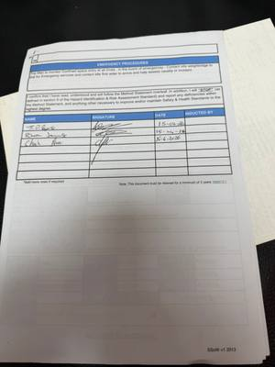

What we read from this page
On your paper | What we captured
Document type | Risk assessment (HIRA / RAMS)
Document reference | 7690413.1
Document title / work description | Confined space entry; Top Man to monitor confined space entry at all times. In emergency, contact site weighbridge to dial for emergency services and contact site first aider to assess casualty or incident.

Where this appears in SafeIn5
Upload a document
Document kind, title, and reference are pre-filled when this scan is uploaded.
Attach a document
The document is attached to the task or work area.

Permit to work — front page
File: Permit To Work/Permit to Work Front Page .jpeg
This permit scan is stored as a permit-to-work document. The permit number and work description are taken from the page.

Your document
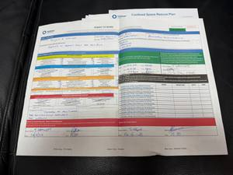

What we read from this page
On your paper | What we captured
Document type | Permit to work
Document reference | HOTBINSRA01
Document title / work description | REPAIRS IN ASPHALT PLANT HOT AGG BINS
Work area named on page | ASPHALT PLANT BINS
Dates on page | 13-6-26 0600 to 14-6-26 1900

Where this appears in SafeIn5
Upload a document
Document kind, title, and reference are pre-filled when this scan is uploaded.
Attach a document
The document is attached to the task or work area.

Permit to work — back page (gas tests)
File: Permit To Work/Permit to Work Back Page.jpeg
This permit scan is stored as a permit-to-work document. The permit number and work description are taken from the page.

Your document
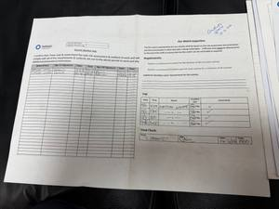

What we read from this page
On your paper | What we captured
Document type | Permit to work
Work area named on page | CONFINED SPACE
Dates on page | 13-6-26 to 14/6/26

Where this appears in SafeIn5
Upload a document
Document kind, title, and reference are pre-filled when this scan is uploaded.
Attach a document
The document is attached to the task or work area.

Rescue plan — location sketch
File: Rescue Plan/Confined Space Rescue Plan Back page.jpeg
This rescue plan scan is stored as a rescue-plan document and linked to the confined space on the task.

Your document
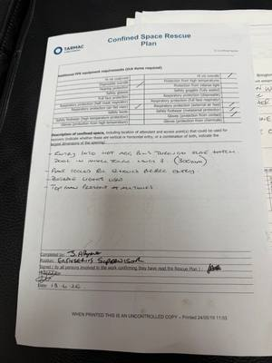

What we read from this page
On your paper | What we captured
Document type | Rescue plan
Document title / work description | ENTRY INTO HOT AGG BINS THROUGH SLIDE HATCH. DOOR IN MIXER HOUSE LEVEL 3. (300mm). PLANT COOLED FOR 12 HOURS BEFORE ENTRY. PORTABLE LIGHTS USED. TOP MAN PRESENT AT ALL TIMES.
Work area named on page | ENTRY INTO HOT AGG BINS THROUGH SLIDE HATCH. DOOR IN MIXER HOUSE LEVEL 3. (300mm)
Dates on page | 13.6.26

Where this appears in SafeIn5
Upload a document
Document kind, title, and reference are pre-filled when this scan is uploaded.
Attach a document
The document is attached to the task or work area.

Contractor clearance — main form
File: Contractor Approval/Contractor Clearence to work main page.jpeg
This contractor clearance scan is stored as a supporting document in the document library.

Your document
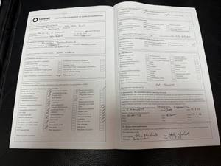

What we read from this page
On your paper | What we captured
Document type | Contractor clearance
Document title / work description | REPAIRS TO HOT AGG BINS ON ASPHALT PLANT.
Work area named on page | ASPHALT PLANT
Dates on page | 13.6.26 to 14.6.26

Where this appears in SafeIn5
Upload a document
Document kind, title, and reference are pre-filled when this scan is uploaded.
Attach a document
The document is attached to the task or work area.

Contractor clearance — cover page
File: Contractor Approval/Contract Authorisation Front Page.jpeg
This contractor clearance scan is stored as a supporting document in the document library.

Your document
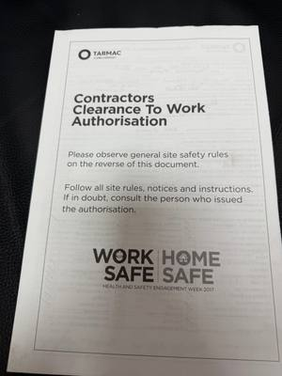

What we read from this page
On your paper | What we captured
Document type | Contractor clearance

Where this appears in SafeIn5
Upload a document
Document kind, title, and reference are pre-filled when this scan is uploaded.
Attach a document
The document is attached to the task or work area.

Part B — Checklist pages
The IMSF 100 confined space checklist was read across three scanned pages. Below are the top 10 highest-priority questions for the Job Checklist in SafeIn5.

Top 10 priority questions
Priority | Question
1 | Can the need to enter the confined space be avoided? (Consider remote controls, video camera, or inspection hatches.)
2 | Can the confined space be permanently re-classified by removing the enclosed nature?
3 | Can the confined space be ventilated naturally to reduce unsafe atmosphere risk (e.g. by opening or removing doors or hatches)?
4 | Can the confined space be permanently re-classified by removing the specified hazard(s) that make it a confined space?
5 | Have fixed ventilation provisions been made?
6 | Can the confined space be temporarily re-classified by forced ventilation at a rate that would make an unsafe atmosphere impossible?
7 | Is sufficient ventilation available? (Do not force oxygen into the space—it can create an explosive atmosphere.)
8 | Has the atmosphere in the confined space been verified as safe prior to entry?
9 | If forced ventilation fails, is there sufficient time for a safe evacuation?
10 | Is fixed ventilation maintained and tested periodically?
AI ranked 56 questions across all checklist pages; only the 10 most safety-critical are shown here.

Confined space checklist — page 1
File: Confiend Space Check List/CS Check List Page 1.jpeg

Your document
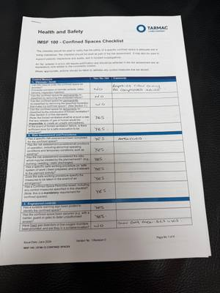

Summary for this page
On your paper | What we captured
Checklist title | IMSF 100 - Confined Spaces Checklist
Form reference | Confiend Space Check List/CS Check List Page 1.jpeg
Page | Page No 1 of 4
Number of questions on this page | 14
Handwritten answers on this page (for your review) | Q1: no — REPAIRS CAN ONLY BE COMPLETED INSIDE; Q2: no; Q3: no; Q4: yes; Q5: yes

Confined space checklist — page 2
File: Confiend Space Check List/CS Check List Page 2 .jpeg

Your document
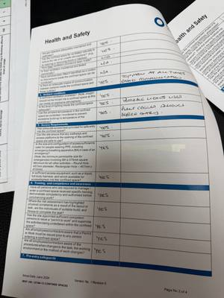

Summary for this page
On your paper | What we captured
Checklist title | Health and Safety — Confined Spaces
Form reference | IMSF-100 | STAN-13
Page | Page 2 of 4
Number of questions on this page | 18
Handwritten answers on this page (for your review) | Q1: yes; Q2: yes; Q3: no; Q4: na; Q5: na

Confined space checklist — page 3
File: Confiend Space Check List/CS Check List Page 3 .jpeg

Your document
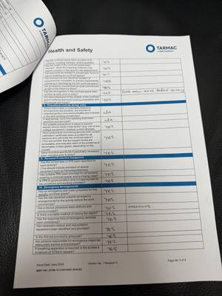

Summary for this page
On your paper | What we captured
Checklist title | Health and Safety — Confined Spaces
Form reference | Confiend Space Check List/CS Check List Page 3 .jpeg
Page | Page No 3 of 4
Number of questions on this page | 24
Handwritten answers on this page (for your review) | Q1: yes; Q2: yes; Q3: yes; Q4: yes; Q5: yes

Where this appears in SafeIn5
Upload content — Job Checklist
Checklist title and each question appear on the Job Checklist upload screen.
Attach content to a task
The completed checklist pack is attached to the task.
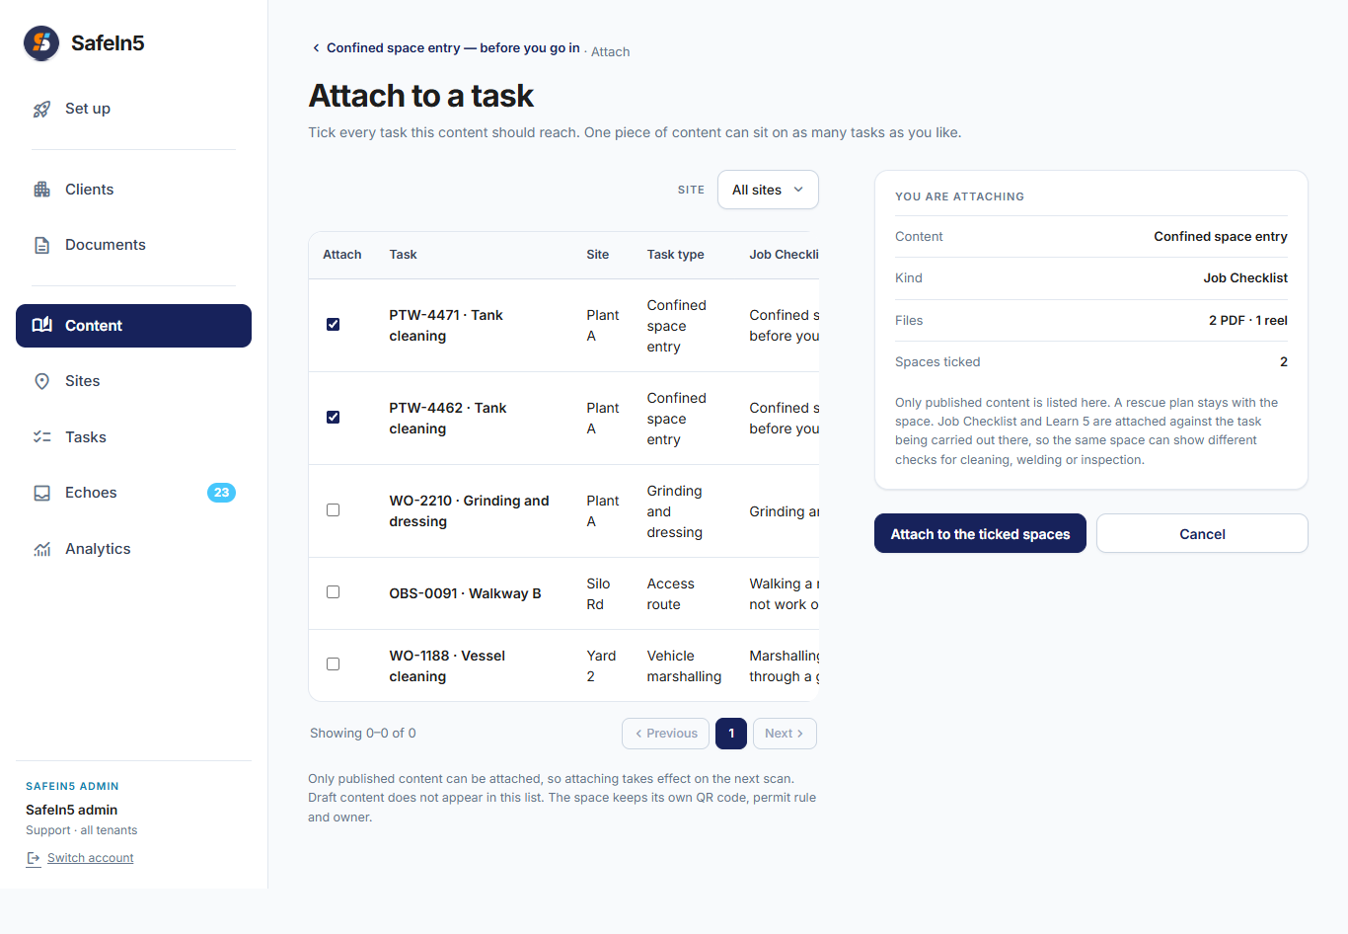

Summary
We processed 11 scanned pages from your job pack. Please check the values in the tables — especially handwritten permit numbers, dates, and reference numbers — and tell us if anything needs correcting.

