Output: -
ML Model training with 2000 dataset
Service_Fluid | Cavitation_or_Noise_Requirement | NPS_inch | NDT_Level
Operating_Pressure_bar | AntiCavitation_Trim | DN_mm | PMI
Operating_Temperature_C | LowNoise_Trim | Pressure_Class_ASME | Heat_Treatment
DeltaP_bar | LowNoise_Trim | Bore | ThirdParty_Inspection
Cv | Flashing_Risk | End_Connection | Documentation_Pack
Leakage_Class | Valve_Type | FaceToFace_Standard | Manufacturing_Route
Body_Material_Grade | Seat_Type | Cr_pct | Machining_Complexity_1to5
Body_Material_Group | NACE_MR0175 | Ni_pct | Tolerance_Class
Trim_Material | Chloride_Resistance_Required | Mo_pct | LeadTime_Weeks
Hardfacing_or_Coating | Erosion_Resistance_Required | C_pct | Capacity_Load_Fraction
Actuator_Type | Limit_Switch | Volume_Tank | Routing_Operations_Count
Fail_Action | Proximity_Sensor | ASME_B16_34 | Vendor_Brand_Tier
Spring_Return | Partial_Stroke_Test | API_598_Testing | Foundry_Route
Positioner | Air_Set | API_607_FireSafe | Localization_Fraction
Solenoid | Booster | Fugitive_Emissions_Packing | Price_INR

Model training
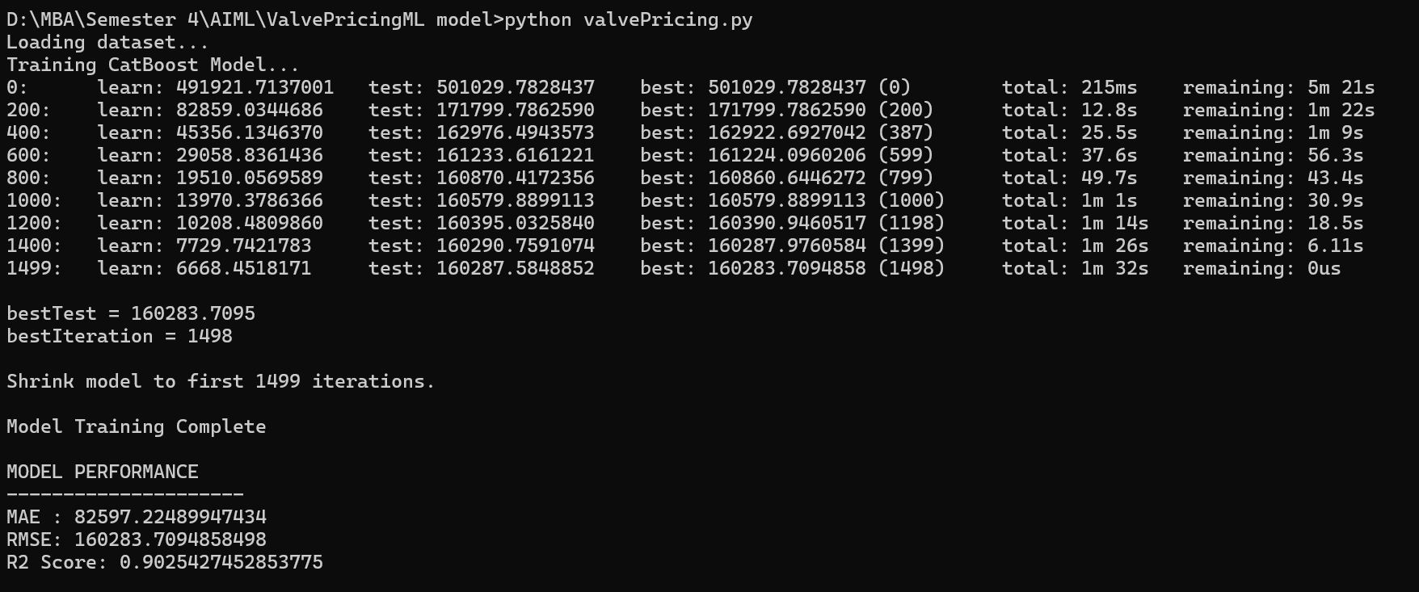

User Input:
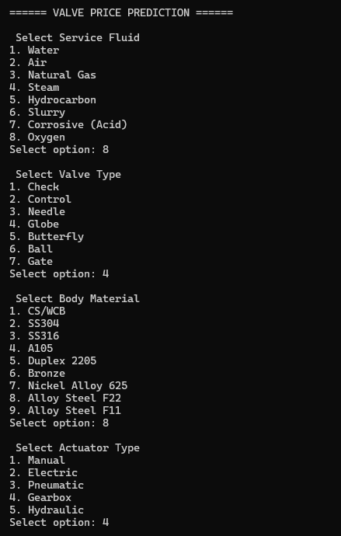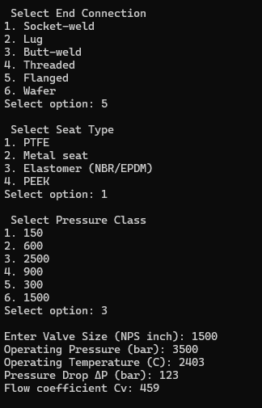

Model Output:
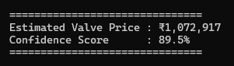

1. Dataset used
Dataset what it is used is a historical quotation database.
So the model learns:
If valve has these specifications → price should be around this value
This is called Supervised Learning.
Because we give the model:
- Input (features) → valve details
- Output (label) → price

2. How the model learns (training stage)
In code:
df = pd.read_csv("valve_pricing_dataset_2000.csv") – The excel has 2k data for training the model.
This loads your 2000 valve records into memory.
It will load an Excel sheet into Python.
Split features and price
X = df.drop(columns=[TARGET])
y = df[TARGET]
Here we separate:
X → valve specifications
Ex: Valve Type, Material, Size, Pressure, Actuator
y → price
Ex: ₹85,000, ₹1,20,000, ₹34,000
So the model learns:
X → y
Valve specs → price

3. Train-test split
train_test_split(X, y, test_size=0.2)
This splits data:
Usage | Data
Training | 80%
Testing | 20%
Example:
Purpose | Records
Train | 1600 valves
Test | 400 valves

4. CatBoost model training
model = CatBoostRegressor(...)
model.fit(train_pool)
This is the learning stage.
CatBoost builds hundreds of decision trees.

5. What a Decision Tree looks like
Imagine a valve engineer thinking like this:
IF Valve Type = Control
IF Material = SS316
IF Size > 4
Price = High
Another rule:
IF Valve Type = Butterfly
IF Size < 6
Price = Medium

Example:
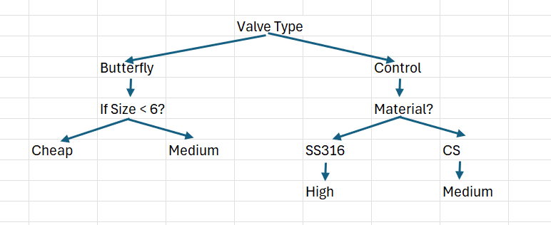
6. Why CatBoost uses many trees
One tree is too simple.
So CatBoost builds hundreds of trees.
Each tree learns small corrections.
Example:
Tree 1 predicts: ₹80,000
Tree 2 corrects: + ₹5,000
Tree 3 corrects: - ₹2,000
Final prediction:
₹83,000
This technique is called Gradient Boosting
It improves predictions step-by-step.

7. Why CatBoost is good for CPQ
Your data has many categories.
Example: Valve_Type, Material, Actuator_Type, End_Connection, Vendor_Brand
Most ML algorithms cannot understand text.
Example:
Valve_Type = Ball
But CatBoost automatically converts these categories into numbers internally.
So we don't need complex preprocessing.

8. After training
The model now understands patterns like:
Condition | Price Trend
Large valve size | Higher price
High pressure class | Higher price
Nickel alloy material | Very expensive
Electric actuator | Higher price
More testing (NDT, API) | Higher price
So the model learns industrial pricing behavior.

9. User input stage
After training, the code asks the user questions.
Example:
Select Valve Type
1 Gate
2 Ball
3 Butterfly
4 Control
User selects:
4
Then:
Enter Valve Size: 6
Operating Pressure: 45
Temperature: 200
The program creates a row like this:
Feature | Value
Valve_Type | Control
Size | 6
Pressure | 45
Material | SS316
Actuator | Pneumatic

10. Prediction stage
Then the model runs:
model.predict(user_data)
The trained trees evaluate the input.
Example:
Tree 1 → ₹320000
Tree 2 → + ₹12000
Tree 3 → - ₹6000
Tree 4 → + ₹8000
Final result:
₹334000

11. Confidence score
The code calculates confidence using price variability.
If dataset prices vary a lot → confidence slightly lower.
Example output:
Estimated Valve Price : ₹334,200
Confidence Score : 88%
Meaning:
Based on past data, model is 88% confident the valve price is near this value.

12. Regression Model Evaluation:
These are three standard metrics used to evaluate regression models (models that predict numbers, like your valve price).
They help you understand how accurate your predictions are.
Think of it like this:
Your model predicts valve price:
Valve | Actual Price | Predicted Price
V1 | ₹100000 | ₹105000
V2 | ₹200000 | ₹190000
V3 | ₹300000 | ₹280000
Each prediction has an error.
Error = Actual Price − Predicted Price
1. MAE (Mean Absolute Error)
MAE is the average of absolute errors.
Formula
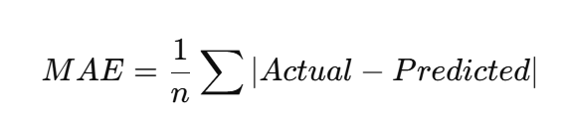
Example
Actual | Predicted | Error
100000 | 105000 | 5000
200000 | 190000 | 10000
300000 | 280000 | 20000
MAE = (5000 + 10000 + 20000) / 3 = 11666
Meaning
MAE = ₹11,666
Model is on average ₹11,666 wrong per valve.
Why MAE is good
- Easy to understand
- Error measured in same units as price (INR)

2. RMSE (Root Mean Square Error)
RMSE gives more penalty to large errors.
Formula
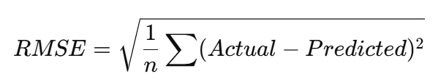
Example
Errors
5000
10000
20000
Square errors
25,000,000
100,000,000
400,000,000
Average
525,000,000 / 3
Square root
RMSE ≈ 13,228
Meaning
RMSE = ₹13,228
Large mistakes increase RMSE strongly.
Why RMSE is useful
In valve pricing:
A ₹2 lakh mistake is much worse than ₹5k mistake, so RMSE penalizes big errors more.

3. R² Score (R-Squared)
R² measures how well the model explains the data.
Range:
R² = 1 → Perfect prediction
R² = 0 → Model is useless
R² < 0 → Worse than guessing average
Example
R² = 0.92
means
Model explains 92% of price variation
Example interpretation for valve pricing:
Price depends on:
- Valve size
- Pressure class
- Material
- Actuator
- Testing requirements
If R² = 0.92
Your model successfully learned 92% of pricing logic.
Simple comparison
Metric | Meaning | Unit
MAE | Average prediction error | INR
RMSE | Error penalizing large mistakes | INR
R² | Model explanatory power | %

Example Output from Your Model
Your model may print something like:
MAE : ₹18,500
RMSE : ₹28,200
R2 : 0.91
Meaning:
- Average mistake ≈ ₹18.5k
- Large mistakes exist but limited
- Model explains 91% of pricing logic
This is very good for industrial pricing models.

