Installation and Upgrade of TYPO3
Extension Key: doc_guide_install
Language: en
Version: 1.0.0
Keywords: forAdmins, forBeginners
Copyright 2000-2011, Documentation Team, <documentation@typo3.org>

This document is published under the Open Content License
available from http://www.opencontent.org/opl.shtml

The content of this document is related to TYPO3
- a GNU/GPL CMS/Framework available from www.typo3.org

Official documentation
This document is included as part of the official TYPO3 documentation. It has been approved by the TYPO3 Documentation Team following a peer-review process. The reader should expect the information in this document to be accurate - please report discrepancies to the Documentation Team (documentation@typo3.org). Official documents are kept up-to-date to the best of the Documentation Team's abilities.
Guide
This document is a Guide. Guides are designed to familiarize a reader with a specific topic in order to provide a working knowledge of that particular process. Readers should peruse the guide from cover to cover in order to gain a practical overview of the process. Once completed, the Guide becomes a practical reference tool that a reader will refer to as needed. Guides offer advice on how best to achieve a given task.

Table of Contents
Installation and Upgrade of TYPO3 1
Introduction 3
About this document 3
What's new 3
Credits 3
Feedback 3
Installing TYPO3 – Quick Install 4
1-2-3 4
The Install Tool 4
In-Depth Installation 11
Which Package and which File Format? 11
The Distributions in Detail 11
Using the Source Distribution effectively 13
The upgrade advantage 13
The Install Tool 13
Upgrade 16
1: Backup 16
2: Install the new Source 16
3: Compare and Update the Database 16
4: Install the new static Tables and Description Tables 18
5: Clear Caches, temp Files and User Settings 19
6: Remove “temp_CACHED_” files 19
7: Check the Changelog and NEWS.txt 20
Trouble Shooting 21
Cached Files in typo3temp/ 21
Possible Problems with the cached Files 21
PHP Caches, Extension Classes etc. 21
Changing Image processing Settings 22

Introduction

About this document
This manual should give you an introduction on how to install or upgrade your TYPO3 installation. It's meant for beginners with TYPO3 who will work as administrators for their projects.
Hopefully this manual will help you. If you find errors, typos or just think there are things missing please file a bug report at bugs.typo3.org category Documentation. Thx!

What's new
Updated the manual to the new template and adapted the screenshots for TYPO3 version 4.5

Credits
This manual was originally written by Kasper Skårhøj and is now kept up to date by the documentation team.

Feedback
For general questions about the documentation get in touch by writing to documentation@typo3.org.
If you find a bug in this manual, please file an issue in this manual's bug tracker: http://forge.typo3.org/projects/typo3v4-doc_guide_install/issues
Maintaining quality documentation is hard work and the Documentation Team is always looking for volunteers. If you feel like helping please join the documentation mailing list (typo3.projects.documentation on lists.typo3.org).

Installing TYPO3 – Quick Install

1-2-3
- Download the matching package for your requirements from http://typo3.org/download/packages/ (If you are not sure which package you should choose read the section “Which package and which file format” in the in-depth part of the manual).
- Upload the contents of this package to your webserver.

Tip
The package contains thousands of files, so if you're able to unzip or untar the file on the server, better do that!
- Hit the site with your browser and follow the Install Tool (http://www.example.com/typo3/install/index.php?mode=123&step=1).
The Install Tool will help you to
  - setup MySQL username/password/database,
  - dump any default database content and
  - check the configuration of your PHP installation for compatibility. This is outlined below.
- After the Install Tool, you should seriously consider to protect the folder typo3/install/ with a password or simply delete the ENABLE_INSTALL_TOOL file. The file gets deleted automatically after 1h.

The Install Tool
The Install Tool is located in 'typo3/install/' and should automatically start in “1-2-3”-mode with password 'joh316' if you have not set up any database for the site.
In other words, this is what you should see:
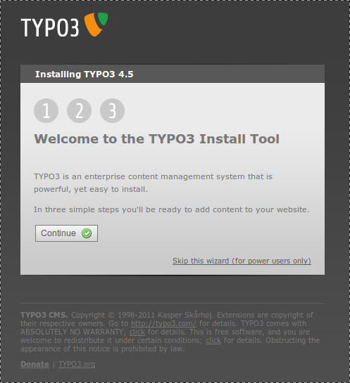Click “Continue”.

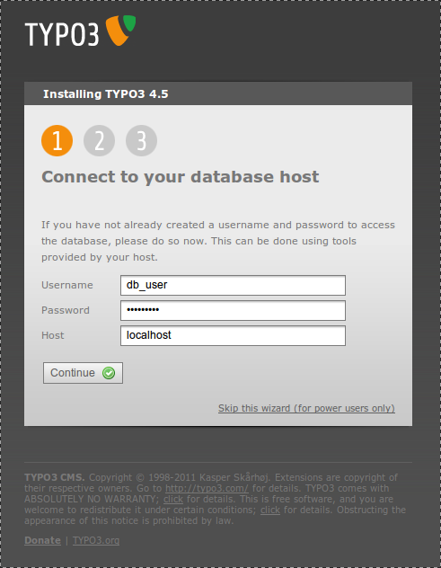Enter your database credentials.

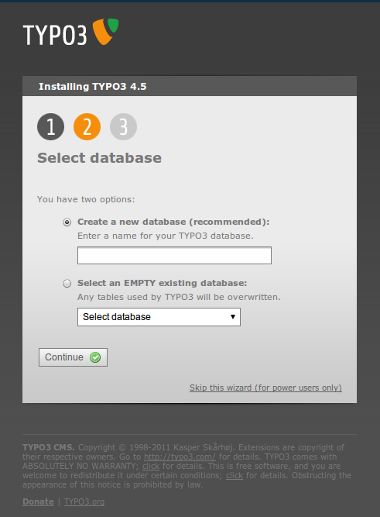Create a new database for TYPO3 or use an existing empty database.

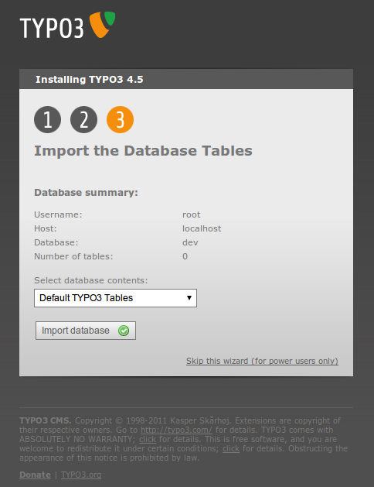Import the default database tables.

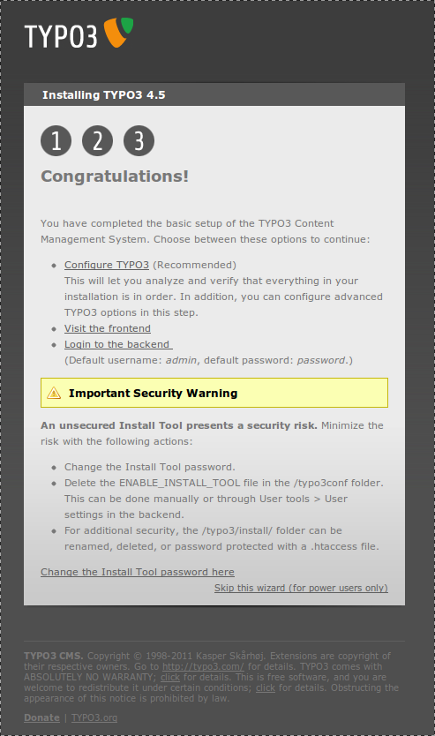The basic installation is now complete.
After you finished the basic installation procedure we recommend to go to the install tool in normal mode to change the install tool password and verify the details of your configuration. Click the “Configure TYPO3” link to do so.
Starting from version 4.1 TYPO3 uses InnoDB as database engine for several tables. This helps to prevent locks and increases performance. Also InnoDB is more crash-resistant compared to MyISAM. We recommend to review your MySQL configuration and to ensure that your table space has the "autoexpand" option enabled. See MySQL manual for more information about configuring InnoDB. If you do not have InnoDB enabled, MySQL will use MyISAM automatically and you don't need to take any actions.

In-Depth Installation

Which Package and which File Format?
TYPO3 is available in various “packages” and within each package normally a .zip or .tar.gz distribution (targeted at Windows- and Unix-server users respectively).
For testing and learning we recommend you to use the introduction package. For building your own website from scratch use the dummy and source package.
An overview of all available packages and versions can be found at http://typo3.org/download/packages/

Introduction package
The introduction package is a complete demo website with a lot of default content for testing and learning. This is how the filenames might be:
introductionpackage-4.5.0.zip
(This is both the source and site-specific files and is ready to run out-of-the-box! Please try this if you are a newbee! Can be used on both Unix and Windows servers)
introductionpackage-4.5.0.tar.gz
(This does not contain the source files but only symlinks to the source following the generally recommended practice of symlinks. Use this if only if you know about symlinks.)

TYPO3 Source
This is the source files of the TYPO3 CMS which is mandatory in all TYPO3 systems.

TYPO3 Dummy
This is a skeleton for a new TYPO3 website. For every website made with TYPO3 you will need both the Dummy and the Source package.

The Distributions in Detail

The .zip distribution
These are the contents of the introduction package .zip-file:
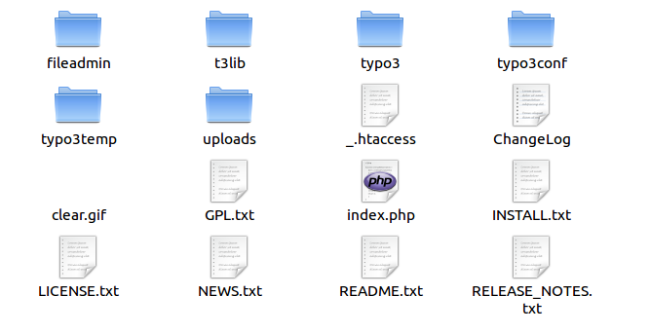

The .tar.gz distribution
The .tar.gz distribution is mainly targeted at Unix users as it contains relative symlinks. If you untar both the dummy and the source at the same level and leave the file names intact, you will automatically have correct symlinks.
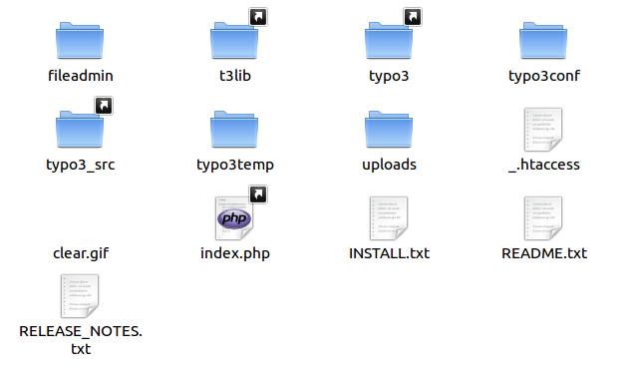
The main point is - compared to the .zip distribution - that the source directory is stored once in the file-structure (possibly writeprotected) on the Unix server and every website using the same TYPO3 version symlinks the proper folders to the source. Thus you save space because you avoid redundant files and get easy maintenance if you do it right.

TYPO3 Folders and Documents
t3lib/ and typo3/ contain the TYPO3 source code, files, images and scripts distributed by TYPO3.
index.php is the main script for the website frontend (same as typo3/sysext/cms/tslib/index_ts.php).
showpic.php is a document used to display images on request (same as typo3/sysext/cms/tslib/showpic.php).
clear.gif is a 1x1 clear-pixel gif-file. Used in many places.
NEWS.txt describes what has changed in a TYPO3 installation since the last version. Read this carefully if you are going to update your system
INSTALL.txt contains a short installation how-to
All these files are a part of TYPO3s core, you should never change them and you can write protect them if you like! They are the ones you must upgrade when you install a new version of TYPO3.
Don't change any of these!

Site specific Folders and Documents
fileadmin/ contains files of your choice, local to the website. You can put templates, user uploads, external scripts, external html and images here. Also used to store uploaded files by default.
typo3temp/ should be empty from the beginning. But gradually temporary files will appear here. The directory must be writeable.
uploads/ contains folders used to store documents attached to database records - hence they should be writeable!
typo3conf/ contains configuration for the local site
typo3conf/localconf.php is the main configuration file of your installation and the one all the install tool options get written to. It therefore has to be writeable.

Custom folders?
Yes, just add whatever you like. Why not?

Using the Source Distribution effectively
The source distribution provides a minimum of space usage and maintenance if used intelligently. This is our suggestion:
- Extract the .tar.gz file somewhere on your server
- From the directory holding the root-directory of your site, create a symlink to the source folder. Call it 'typo3_src':
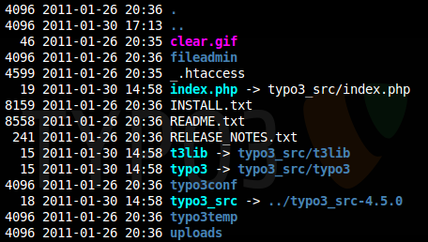
- Afterwards create links to the index.php file and the t3lib and typo3 folder as shown. Note that those just link to the first created typo3_src link. (In most current available packages these symlinks are included by default so you just have to create / change the typo3_src link to your source directory)

The upgrade advantage
The advantages of this approach is apparently that when you wish to upgrade to a new TYPO3 version, you simply change one symlink and every distributed TYPO3 file is upgraded instantly - on as many sites as you like!

Remember the Install Tool!
After switching the sources around you have to enter the Install Tool of every single site that is sharing the upgraded source and update any changes that are required in the database and clear the cache tables.

The Install Tool
To install your new TYPO3 site you can either use the 1-2-3 wizard as described in the “Quick Install” section or you can do it in more detail via the advanced mode of the install tool. This advanced installation is described here.
First go to your site and enter the install tool (http://www.example.com/typo3/install).

Basic Configuration
The section basic configuration checks some prerequisites for installing TYPO3. There is a check for necessary folders and their rights. If anything is wrong in this section you have to add the folders and adjust the file permissions before you continue.
The next checks concern php.ini settings such as safe_mode, max_execution_time and so on. Again if something is wrong, fix it before going any further.
One of the major features of TYPO3 is the ability to work with images (transform them, use layers, masks etc.). For that to work you need to have freetype, gdlib and imageMagick or graphicsMagick. The next section checks for these.

Note
If the text in the freetype text image exceeds the image borders you are using Freetype 2 and need to set TYPO3_CONF_VARS[GFX][TTFdpi]=96.
Now in the next part you have to enter your database settings. Note that you have to save after entering your username and host and reload the page, then you'll get the database select box.
Choose a site name for your new website. This will be displayed later in various places in the backend.

Database Analyser
In this section you can get an overview of your currently selected database compared to the needed tables and fields of a correctly installed TYPO3 version. You can also import sql data directly into the database or upgrade tables from earlier versions of TYPO3.
If you came here while installing your new web site you have to click “COMPARE” and then check all changes. After that click “Write to database”. This may take a little while.
Afterwards choose “IMPORT” to import static data. Static data are predefined data sets that can be used by TYPO3, for example languages, currencies or TYPO3 repository locations. If you don't know what you'll need just import all of them.
If you did not use the 1-2-3 mode you have to create an admin user via “Create admin user”.

Upgrade Wizard
You don't need the upgrade wizard while installing TYPO3. It will be explained in a later chapter about upgrading TYPO3.

Image Processing
The section image processing contains an explanation of TYPO3s image manipulation capabilities and at the bottom a test menu. Try each test to see if you configured your image generation settings correct. If you have problems check the explanation of the test for a hint how to solve them. Additionally have a look at the image processing settings in the section “All configuration”.

All Configuration
Here you can configure all options concerning your TYPO3. We suggest you go at least once through the whole list and read the description of the settings carefully, so you get an impression of what you can configure. Normally you don't have to change anything here while installing as the steps before already took care of the most important settings.

Clean Up
You don't need this section while installing TYPO3. This section is meant to provide methods to clean up your TYPO3 installation after it is running for a while.

phpinfo()
Here are some infos about your installation, the full phpinfo() and some constants used by TYPO3 which can help a lot when finding and solving problems with your configuration.

Edit files in typo3conf/
Here you can edit the files in typo3conf/ directly if you want to make some quick changes. You normally don't need this section either.

About
The “About” section describes each of the install tool sections and – more important – provides a possibility to change the install tool password which you should always do when installing TYPO3.

Change the install tool password
You should consider changing the install tool password as the very first thing you do when installing TYPO3. The default password is widely known and should never ever be in use on a live web server.

Upgrade
When new versions of TYPO3 arrive, you should always follow any additional upgrade information carefully. You might also need to skim the included changelog to see if any features affects the way your site works (look for lines prepended with “!!!” - those are the really important!)
Basically these steps are involved in updating your TYPO3 site:

1: Backup
Make a backup of both uploads/ folder and database. Also you may prefer to upgrade a copy of your site first if there has been a lot of changes and some of them seems to interfere with your site. See the changelog.

2: Install the new Source
Upgrade the distributed source files to the new version.
.tar.gz:
If you're using the source-distribution in the .tar.gz file, just extract the package on your web server and adjust the typo3_src symlink
.zip:
If you're using the .zip distribution, then download the zip source package and copy (and overwrite) it into your TYPO3 folder.

3: Compare and Update the Database
Enter the Install Tool at '.../typo3/install/' on your TYPO3 site.
(If you have password/access problems, please see the section about the Install Tool in this document).
Go to the “Database Analyser” section, check that the database configuration is correct.
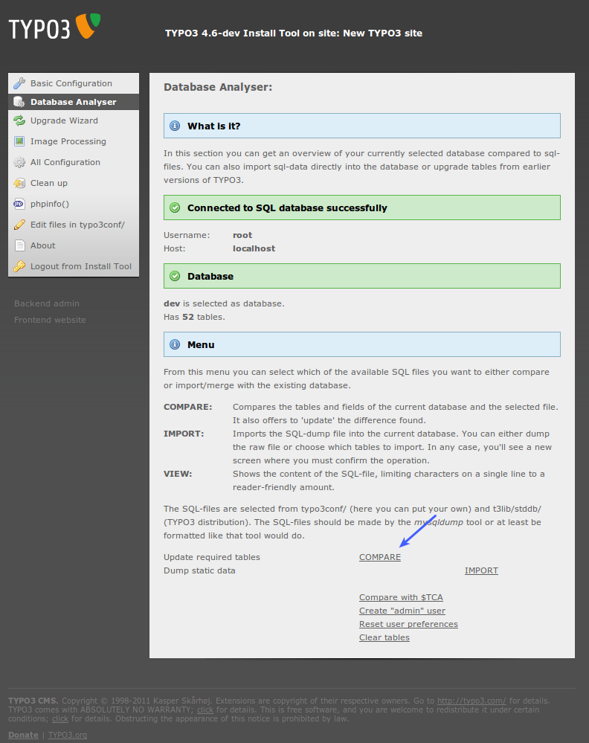
Click “Compare”. Now all ext_tables.sql files from core and extensions are read and compared to your current database tables and fields. Any discrepancies will be shown and you'll be able to execute queries sufficient to upgrade your database so it corresponds to the structure required for the new TYPO3 version.
Caution
Be aware if you have deliberately added fields and/or tables to your TYPO3 database for your own purposes! Those tables and fields are removed only if you mark them to be deleted of course, but please be alert that you don't overlook them!
In the next step you should see that all added and changed fields are done properly since they don't show up again. If you chose to delete some fields or tables you will see that they have been only renamed for now. Now you can consider to let them be and delete them later when you're sure you're not going to need them. Or you can just go on and drop them finally.
After clicking “Write to database” you should at the end see this:
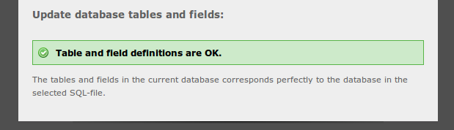

4: Install the new static Tables and Description Tables
The table 'static_template' (and some other “static_” tables) contains information that you should never alter yourself. This tables contains static information distributed with TYPO3 releases. Follow these steps to upgrade the tables with the newest information.
Go to the “Database Analyser” section.
Then click “IMPORT” at “Dump static data” :
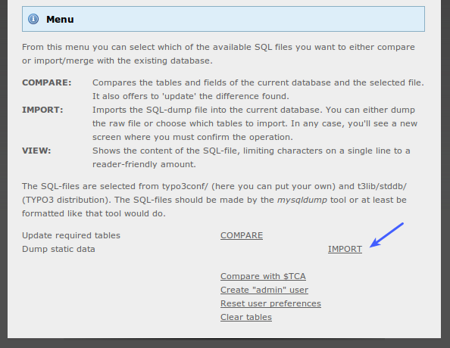
Then tick the check box “Import the whole file...” and click “Write to database”:
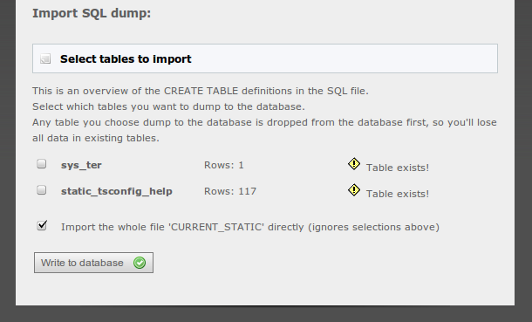

... and you should see this:
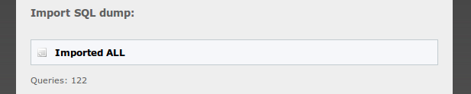

5: Clear Caches, temp Files and User Settings
You should always clear the cache-tables. (Go to “Database Analyser” → Clear tables)
You might also consider clearing the backend user preferences if something in the upgrade requires this. (Go to “Database Analyser” → Reset User Preferences)

6: Remove “temp_CACHED_” files
In typo3conf/ you will most likely find cached files for ext_localconf.php and ext_tables.php files from extensions. These must be removed as well.
So all files in typo3conf/ directory which are named “temp_CACHED_*_ext_localconf.php” or “temp_CACHED_*_ext_tables.php” must be removed!
An easy way to clear these files are pressing the link on the top right side in the backend when logged in as admin user:
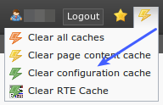
However, if you see more than two of these “temp_CACHED_” files in typo3conf/ only two of them will be removed by this method and you have to remove the rest with either the superadmin.php script, the “extdeveval” extension or manually!

7: Check the Changelog and NEWS.txt
Look through the changelog and the NEWS.txt file in your TYPO3 root folder. It's a good place to get an idea about new functions you might need or be interested in.
Especially pay attention to the lines starting with “!!!”. They are important because they are about changes that may affect some websites.

Trouble Shooting

Cached Files in typo3temp/
Generally you should know that TYPO3 generates temporary “cached” scripts in typo3conf/. Those would look like these:
-rw-r--r-- 1 www-data www-data 61555 2011-01-11 16:28 temp_CACHED_ps3f58_ext_localconf.php
-rw-r--r-- 1 www-data www-data 81995 2011-01-11 16:28 temp_CACHED_ps3f58_ext_tables.php
-rw-r--r-- 1 www-data www-data 47098 2011-01-11 16:28 temp_CACHED_FE_ps3f58_ext_localconf.php
-rw-r--r-- 1 www-data www-data 45517 2011-01-11 16:28 temp_CACHED_FE_ps3f58_ext_tables.php

The temp_CACHED_FE* files have been introduced in TYPO3 v4.3.
You can experience more than these files. In that case it will be because of multiple paths, symlinks or just old files.
You can at any time remove these files and on the next hit to the system they will be re-written. These files simply contains all ext_tables.php and ext_localconf.php files from the installed extensions concatenated in the order they are loaded. Therefore including one of these files would be the same as including potentially hundred PHP-files and that saves some milliseconds for the system.
The "temp_CACHED_FE" files contain only the ext_tables.php and ext_localconf.php files from those extensions which are needed to render frontend output. Since these files are smaller than the temp_CACHED files with all extensions configuration this should save some additional milliseconds.
But it also means that a) you can never make any local changes to these files since they can at anytime be removed and recreated from the “originals” and b) if you make changes to the original “ext_tables.php”/”ext_localconf.php” files you will have to clear these files away!

Possible Problems with the cached Files

Changing absolute paths to TYPO3
If you change the path of the TYPO3 installation you might get a lot of errors like “Failed opening …” or “Unable to access ...”. The problem is that absolute file paths are hard coded inside the files.
Fix: Manually remove the temp_CACHED_*.php files via FTP or the file system. Then hit the page again.

Changing the TYPO3 admin dir, “typo3/”
Same problem as above. Solve it the same way.

PHP Caches, Extension Classes etc.
There are some situations known which can cause what looks like totally illogical problems after an upgrade:
- If extensions override classes where functions have changed.
Solution; try to disable extensions and enable them one by one again till it fails.
- If a PHP-cache somehow fails to re-cache scripts, in particular if a change happened to a parent class overridden by a child class which was not updated.
Solution; remove ALL cached PHP files (for PHP-Accelerator, remove "/tmp/phpa_*") and restart Apache.

Changing Image processing Settings
When you change the settings for Image Processing (in normal mode) you must take into account that old images may still be in typo3temp/ folder and prevent new files from being generated! This is especially important to know, if you're trying to set up image processing for the very first time.
The problem is solved by clearing the typo3temp/ folder. Also make sure to clear the cache_pages table.

