Basic Reference Information

Drop Down Menu Options

Clicking on the yellow folder opens up this drop down menu.
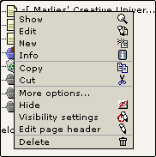
Here is a list of all the drop down menu options. Below that are the explanations of the options in the drop down menu:
Show displays the page in the Internet Browser.
Edit opens up the page's content information in the work area to the right.
Clicking on the folder name will do the same thing.
New opens up all the options for new page content in the work area to the right.
Info opens the page to the right and a popup window with all the page info at a glance.
Copies that file into memory, but leaves the original file in place.
No visible reminder that something was done.
However, clicking on the file folder again shows that 2 new options have been added to the menu: Paste into and Paste after.
Cut copies that file into memory. The removal does not show up immediately. There is no visible reminder that something was done.
However, clicking on the file folder again shows that 2 new options have been added to the menu: Paste into and Paste after.
Paste Into opens a pop up menu that asks if you want to copy the selected file into that particular folder and then copies the file into the selected file folder with the original name plus (copy 1) after it. The file name can be changed later.
Paste after opens a pop up menu that asks if you want to copy the selected file after a particular file and then copies the file below that file with the original name plus (copy 1) after it. If you copy the file more than once each copy will be consecutively numbered. The file name can be changed later.
Clicking on 'More options' opens another drop down menu with the following options: Import/Export to .t3d, Move Page, 'Create New' Wizard, History/Undo, Access and Web>List Mode.
'Create New' Wizard opens in the work area to the right with choices of where to place the new page.
Move Page (available under the more options ... tab) opens up a directory tree in the work area with grey arrows pointing to new possible positions for the page. This option is available under more options ...
Just mentioned here because it shows up. Do not touch.
Access (available under the more options ... tab) opens up in the work area information about who has access/permission to make changes to the page/s.
The Web>List Module gives an overview of the content of the current folder
Hide places a red X next to the file in the directory tree and hides the file so that it does not show up in the menu.
Unhide removes the red X next to the file in the directory tree and make the file visible again in the menu.
Edit page header opens a long page in the work area (the column to the right) with various options for information of the page.
The same information is also accessible by clicking on the file name and then on Edit page header.
Delete opens a pop up menu that asks if you want to delete the file.

Show - Edit - New - Info

Show
Show displays the page in the Internet Browser.

Edit
The Edit Work Area can be accessed by clicking on the yellow folder and then edit from the drop down menu or by clicking on the folder's name.

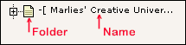

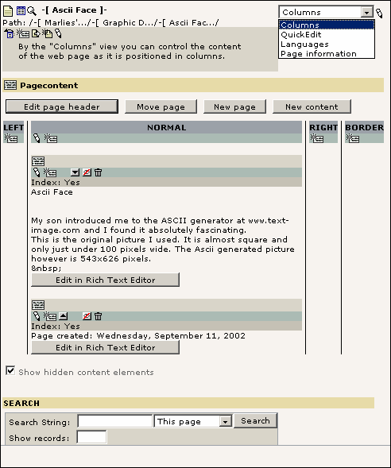
This is a screen shot of the Edit Page. For detailed instructions go to the Edit Page information page.

New
New opens up all the available options for new page content in the work area to the right. Here is a screen shot of it:

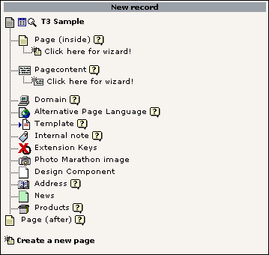

Info
Clicking on 'Info' opens the page in the work area to the right and a popup window that gives page information at a glance like this:

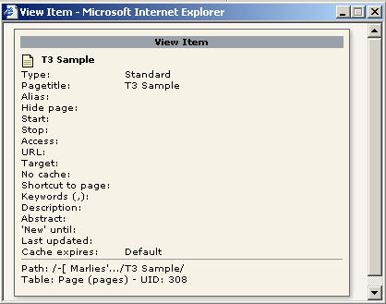

Copy - Cut - Paste Into - Paste After

Copy
This copies the file into memory, but leaves the original file in place.
No visible reminder that something was done.
However, clicking on the file folder again shows that now 2 new options have been added to the menu: Paste into and Paste after.

Cut
This cuts the file and copies it into memory. The removal does not show up immediately. There is no visible reminder that something was done.
However, clicking on the file folder again shows now that 2 new options have been added to the menu: Paste into and Paste after.

Paste Into
See detailed instructions later on in the tutorial.

Paste After
See detailed instructions later on in the tutorial.

More Options
Clicking on 'More options' opens another drop down menu with the following options: Import/Export to .t3d, Move Page, 'Create New' Wizard, History/Undo, Access and Web>List Mode.
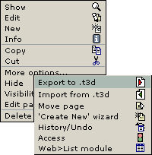

Move Page
Move Page (available under the more options ... tab) opens up a directory tree in the work area with grey arrows pointing to new possible positions for the page. Screen shot of Move Page:
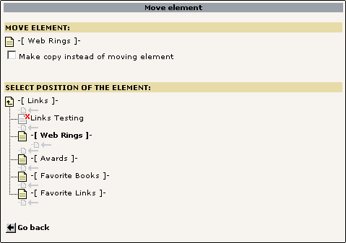
The page you want to move will be bold.
If you want to move the file outside of the current folder click on this icon
to go up to the next level.
Once you have found the new place for your page click on the little grey arrow pointing to a file
and your page will be moved there

'Create New' Wizard
Clicking on 'Create New' Wizard opens up the screen on the next page in the work area to the right.
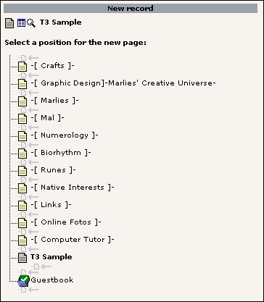
Chose where you want to put your new page by clicking on the grey arrow pointing to a file and your page will be created there.

Note
The page where you are currently at will be shown in bold
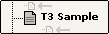

History/Undo
Clicking on 'History/Undo' opens up this screen to the right in the work area:
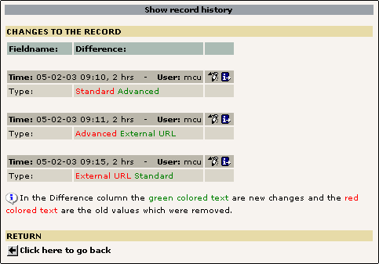
I don't recommend touching anything here. I am just giving the information to satisfy your curiosity.

Access
Clicking on 'Access' opens up this screen to the right in the work area:
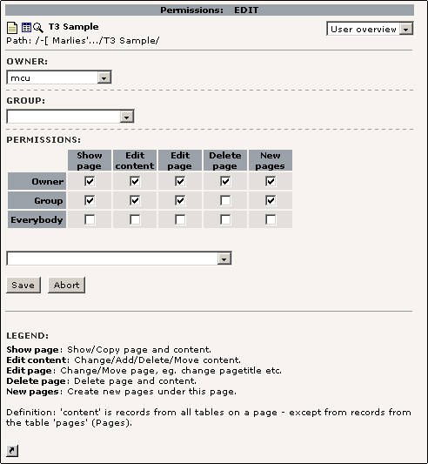
This shows information about who has access/permission to make changes to the page/s. I don't recommend touching anything here. I am just giving the information to satisfy your curiosity.

Web>List Module
Clicking on 'Web>List Module' opens up this screen to the right in the work area:
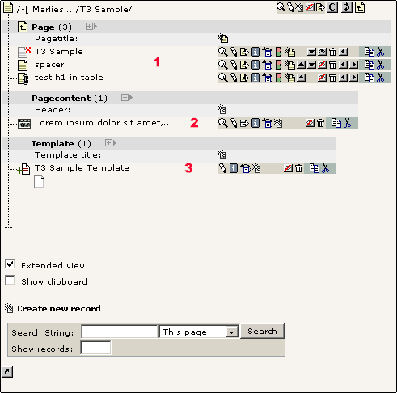

This basically is an overview of the folder with your current webpage.
[1] Page
This shows all the other pages that are in that folder. In the current example there are 3 pages
[2] Pagecontent
This shows the page content sections of the current webpage. The sample page has only one content section.
[3] Template
This shows the Typo3 template that is associated with this file. This will only show up for the root file of that particular folder. For page editing purposes this is totally irrelevant.

Export & Import to .t3d
This information is totally irrelevant for editing purposes.

Hide - Unhide - Edit Page Header - Delete

Hide
Clicking on 'Hide' hides that file/page.
Your screen will refresh and you will see that a red X
has been placed next to the file in the directory tree. Your file will now not show up in the menu if the template has been setup this way.
Hiding a page comes in handy when you are preparing a page in advance or want to keep a copy of a page ready as a template for the future.
When you click on the yellow file folder again you will now notice that there is a new option 'Unhide'.

Unhide
Clicking 'Unhide' reverses what 'Hide' did and removes the red X
next to the file in the directory tree and make the file visible again in the menu. Your screen will refresh and you will see that the red X is gone and your file folder will look like this again

Edit Page Header
Selecting 'Edit page header' opens a long page in the work area (the column to the right) with various options for information of the page.
The same information is also accessible by clicking on the file name and then on the Edit page header tab.

Delete
Delete opens a pop up menu like the one below that asks if you want to delete the file.

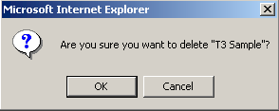

Rich Text Editor
These are the options available in the Rich Text Editor.
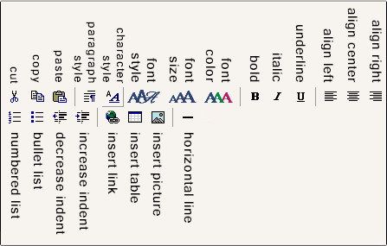
I am only giving an explanation for icons that are important for web publishing. Basic word processing functions are self-explanatory.

Paragraph Style

Use this option to control the look of your text. Clicking on the icons opens up this drop down menu:

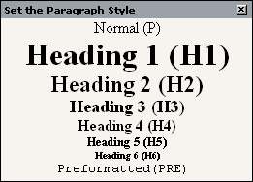
For normal text select the Normal (P) setting. The definition will already be set for your in the style sheet for your website.

Headings are used for titles with each number the size of the font is successively smaller. Again there will already be a definition in the style sheet and all you have to do is select the size you want.

To see how it is going to look on the web click on 'save document and view page icon'
at the top or bottom of the work area. If you don't like the way it looks, make changes.

Character Style

You can use this option to remove HTML formatting from your text.

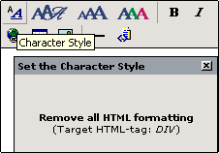

Font Style & Font Size

Font Styles and Font Sizes are already defined in the stylesheet for your website, so don't use this or it will totally change the look of your pages.

Color Text

Color Text lets you change the color of individual words or characters. Use this option very sparingly if at all as your text color is already defined in the stylesheet for your website.

Insert Link & Remove Link

Clicking on this icon either lets you add a hyperlink or remove a hyperlink. Click on the insert link icon and you will get the screen below.

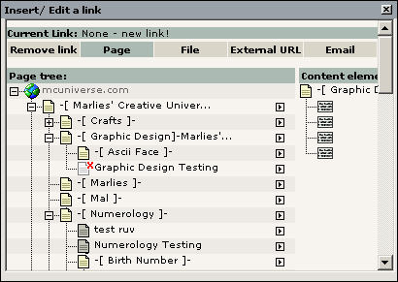
You will end up by default in Page option tab view (green background)

Page
This tab lets you link to a page or page's content on your website.

To create a link to a page: select that page by moving your cursor over the name and your link will be automatically added.
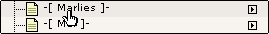
Linking to a page's content section comes in handy when you have a piece of information that appears on several web pages. You only have to create that content once and then link to it by clicking on the arrow to the right of the file's name and then select the content from 'Content elements' and your link will be automatically added.
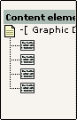

File
By selecting the 'File Tab' you can create a link to a file on your website. The file can be a picture or a document that you want to share.

This is how your screen will now look. I clicked on a name of a folder in the pic folder and a second column opened with the title 'Files:' with all the names of the files in that folder.

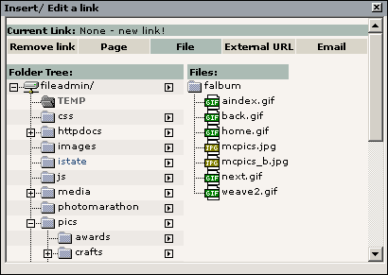
Clicking on the name of the file automatically creates the link to it.

External URL
By selecting the 'External URL Tab' you can insert a hyperlink to a page on the web. Just copy the URL from your browser's address bar and paste it into the box.
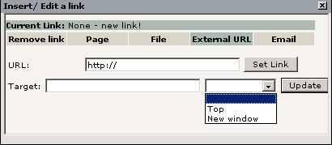
Target gives you a choice of opening the link in the current window or if you want it to open in a new window. By default links to pages outside the current website open in a new window.
Now press the [Set Link] button to save the link.
Also when you are creating or editing your text by just writing the web address will create a hyperlink automatically.

Email
By Selecting the 'Email Tab' you can link to an email address
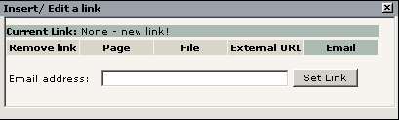
Write the address in the 'Email address:' box and press the [Set Link] button.
Also when you are editing your text by just writing the email address will create a hyperlink automatically.

Remove Link
Clicking on the 'Remove link tab' will automatically remove any hyperlink from your document. The tab will not be colored green to show it is active, you just press it and will be back in the Rich Text Editor.

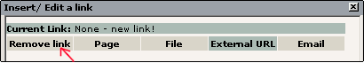

Insert Table
Clicking on the 'Insert Table' icon will open up this screen.

Rows and Columns
This option helps you define how your table is going to look. You decide how many row and columns it is going to have. By default it is set to 2 rows and 2 columns.

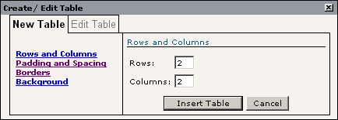

Padding and Spacing
Padding defines how close to the cell edges the text/content of the cell comes. A good size setting is 5.

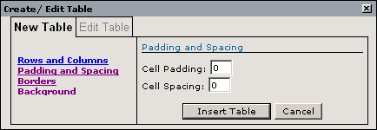
Spacing defines how close together the individual cells are in a table. If you use padding you don't really need to space your cells apart. The exception is when you are using a border to define individual cells and want them to show that they are spread apart a bit like this:

In the example to the right the spacing is set at 5 and a border of 1 is set in the border option.
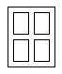

Borders
Borders defines if you see lines between individual cells. If you don't want any to show set the 'Border Width' box to 0. In the 'Border Color' box you can write the hexadecimal color value if you know it or move your cursor over the individual color squares to select your color this way.
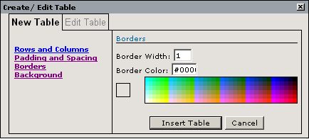

Background
Background defines the color/pattern behind the text in the table. You can use a picture by writing the URL where the picture is in the 'Background Image URL' box or you can write the hexadecimal color value into the 'Background Color' box or move your cursor over the individual color squares to select your color this way.
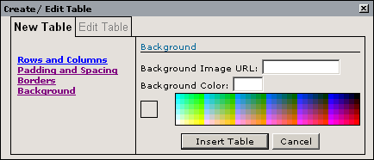

Table Example
The table to the right was created with the following settings:
Rows: 5
Columns: 5
Cell Padding: 5
Cell Spacing: 5
Border Width: 5
Border Color: #000000 (black)
Background Color: #FFCCFF (pink)
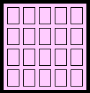

Edit Table
You will have noticed that when you were in the insert popup screen that it said at the top 'Create / Edit Table'. The 'Edit Table' option, however, was greyed out.
To activate the 'Edit Table' option you place your cursor over your table until the cursor changes to 4 arrows going into 4 different directions [1] and click. Your table now has handles around it.

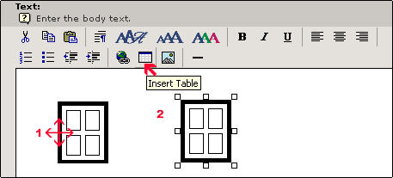
[2] Then click again at the 'Insert Table' icon and make the changes. You popup menu will look the same as for creating the table in the first place.

Your screen will look now like the picture to the left with the 'Create / Edit Table' pop up window. This time, however, the 'Edit Table' tab is not greyed out. Click on it and you will see this:

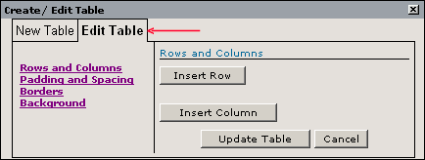
The 'Edit Table' tab is now black and you can click it and then make changes to your table.

Aligning Table
By default the new table is left aligned on the page. To change the alignment, select your table and then chose the alignment option you want (center or right) from the toolbar.

Insert Picture
To insert a picture into your webpage you click on the 'Insert Picture' icon . You will now see this screen:

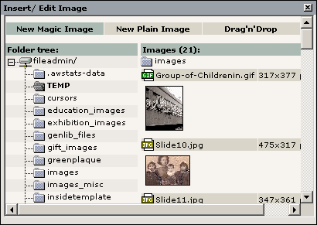
- In the left column under the heading Folder tree: is the directory structure of the website.
- In the right column under the heading 'Images:' are thumbnails (small versions of the pictures) in the folder you have selected. The number in brackets next to the heading 'Images' tells you at a glance how many pictures are in that folder.
- Above each thumbnail is the information about the picture.
First the icon states the type of format the picture is in, either GIF
or JPG
Next to it is the name of the picture and then at the end the size of the picture in pixels.

If you move your cursor over the icon your cursor will turn into a hand and below the hand it will show the name of the picture inside a yellow box.
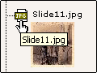
If you click on the icon you will see this drop down up menu. Rename, Copy, Cut and Delete are standard functions.
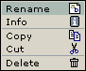
Clicking on info or clicking on the thumbnail picture will open the pop up screen on the next page with a larger thumbnail of the picture, the file name, file size and the pictures dimensions.

You select the picture to insert it into you page by clicking on the picture's name.

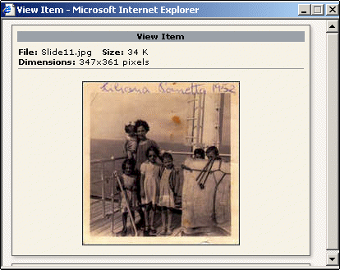
If your picture is still on your computer there are 2 ways to upload it. The 1st way you can only upload one picture at a time. The 2nd way you can upload up to 9 pictures at the same time.

Uploading New Picture Version 1
If the picture is not yet uploaded to the website, you can do this right from here. However, you can only upload one picture at a time this way.

To get to the upload options move the slider in the 2nd column all the way to the bottom and you will see this on your screen
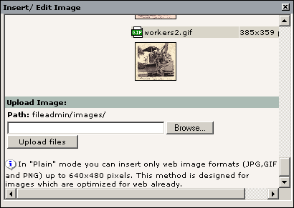
Use the [Browse] button to get to the picture on your computer and select and the click on the [Upload files] button.

Now you can insert the picture following the instructions on the previous page.

Uploading New Picture Version 2
In this version you can upload several pictures or even files at once (up to 9).

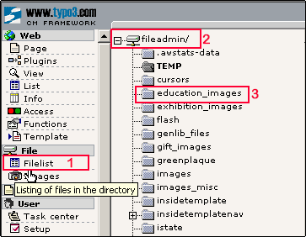
[1] Click on ‘Filelist’ in the Typo3 column
[2] In the middle column you will now see at the top of the screen ‘fileadmin/’. This is the directory structure of website on the server.
[3] Select the folder where you want to upload your pictures/file(s) to and you will see this popup menu

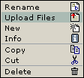
Select ‘Upload Files and you will see this screen below. By default it will only give you 1 file to upload, but by clicking on the down arrow you can select as many as 9 files to upload at once.
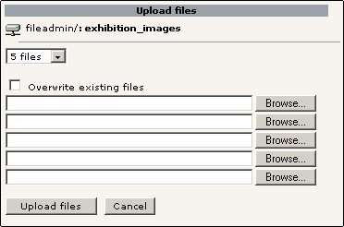
- Browse to your pictures/files on your hard drive and select them.
- Once you have them all selected click on the [Upload files] button.
- Then you can insert the picture as explained in insert picture.

You probably noticed this at the top of the pop up menu. Below is an explanation of the options.

In the examples below I have used the Slide10.jpg picture as both a New Magic Image and a New Plain Image selection.

New Magic Image
Using this selection will place your picture at a reduced size on your page with the following dimensions: 300 pixels wide and 312 pixels in height. The original picture size was 475 pixels wide and 317 pixels high.

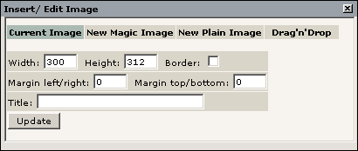

New Plain Image
Using this selection will place your picture on your page at the original picture size of 475 pixels wide and 317 pixels high.
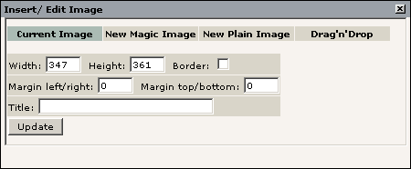
Note
Once the picture is on your page by selecting the picture (moving your cursor over the picture until the handles around the picture appear) and selecting the 'Insert Picture' icon again you will get the above screens where you can see the size/dimensions of your picture. Changing the dimensions of the width or height of the picture will not automatically adjust the other proportionally. Selecting the picture and holding down the Shift key and then moving the mouse will let you resize the picture proportionally.

Fine-tuning Your Picture
To place your picture where you want it on your page, select your picture and click on the alignment buttons to have it centered, left aligned or right aligned.

The following options are available by selecting the picture and clicking the [Insert picture] button again and from the pop up menu make your selections.

To place a border (a line) placed around your picture click on the empty box and place a check mark into it.

Margin left/right and Margin top/bottom lets you decide how close you want the text of the page to come to the picture.

Filling in the 'Title' box will show the name of the picture when you move your mouse over the picture when it its displayed in the browser. It is a good idea to always place a name in there.

This is how the pop up window you are working in looks with all the fields filled in.
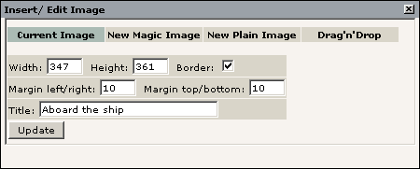
When you are done click the 'Update' button to save your changes and you will be back in the Rich Text Editor.

Horizontal Line
Use this to place a horizontal line between sections of text on your page.

