Browser - TYPO3 without PHP
This is an abstract only. The manual is an own extension.
See: browser_manual_en

Publish the data of your extension with the Browser – TYPO3 without PHP! You don't need neither any own PHP code nor any own plugin. You can save up to 85 percent of your operating expense. The Browser – TYPO3 without PHP – provides responsive templates, an index browser (a-z), a page browser, a record browser, a search form, filters, category menus, AJAX, GoogleMaps and OpenStreetMap by default. SEO – Search Engine Optimization – is optional.



Version: 7.4.2 – 2016-01-19
Extension Key: browser
Language: en
Keywords: browser, frontend-framework, frontend-engine, frontend, engine, framework, sql, index browser, page browser, sql browser, templating, responsive, TYPO3 without PHP
Copyright 2008-2016, Dirk Wildt, Die Netzmacher, <http://wildt.at.die-netzmacher.de>

This document is published under the Open Content License available from http://www.opencontent.org/opl.shtml
The content of this document is related to TYPO3 - a GNU/GPL CMS/Framework available from www.typo3.org
Table of Contents
Browser - TYPO3 without PHP 1
Screen Shots 3
Key Image 3
Filter 3
Responsive 4
Ready-to-use Extensions 4
Introduction 5
What does it do? 5
What do you need? 5
Audience 5
Non possible features 6
Installation 7
Extension Manager 7
Ready-to-use Sample 8
Upgrade 9
From 4.x to 7.x 9
What's new? 10
7.3 10
7.2 11
6.x/7.0 11
4.9 15
4.8 15
Manual 17
Change Log 18

Screen Shots

Key Image
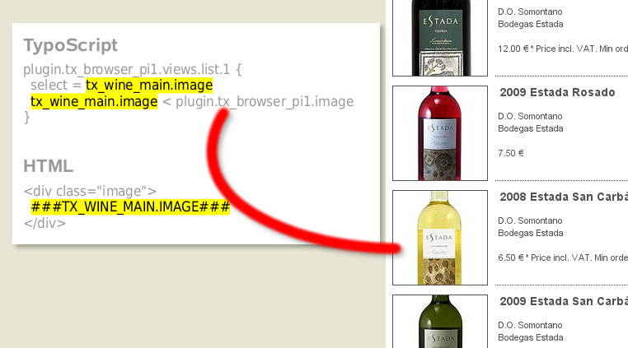Illustration 1: Amazing - you need two lines TypoScript to render an image.
Publish the data of your extension with the Browser – TYPO3 without PHP! You don't need neither any own PHP code nor any own plugin. You can save up to 85 percent of your operating expense.
Screenshot from http://typo3-wine.de

Filter
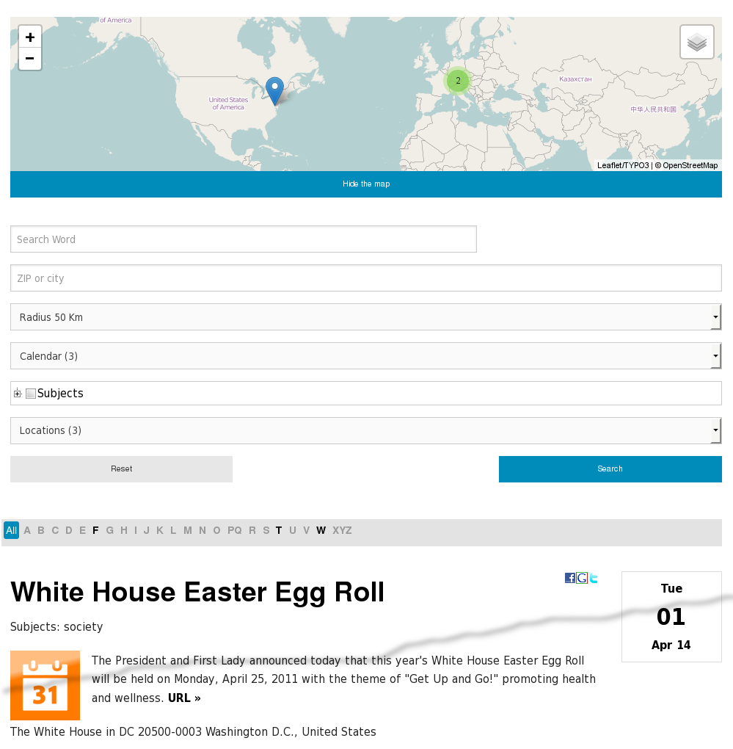Illustration 2: The Browser – TYPO3 without PHP – supports a lot of filters
The Browser – TYPO3 without PHP – simplifies to filter data by categories, by a radial search or by displaying it in a map.
Example at http://typo3-organiser.de > Calendar

Responsive
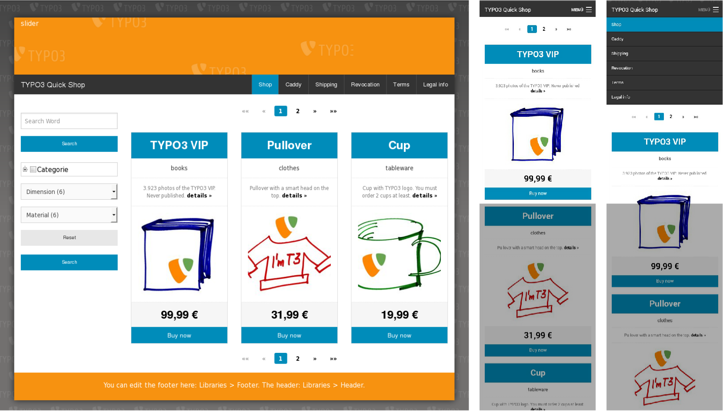Illustration 3: List view on a desktop (left) and on a smartphone (right)
The Browser – TYPO3 without PHP – is responsive. Templates are optimised for desktops, tablets and smartphones.
Example at http://typo3-quick-shop.de/

Ready-to-use Extensions
If you like to test the Browser – TYPO3 without PHP –, you can install ready-to-use extensions with one mouse click.
See the illustration below for the extension Organiser – TYPO3 for Lobbies and Organisers.
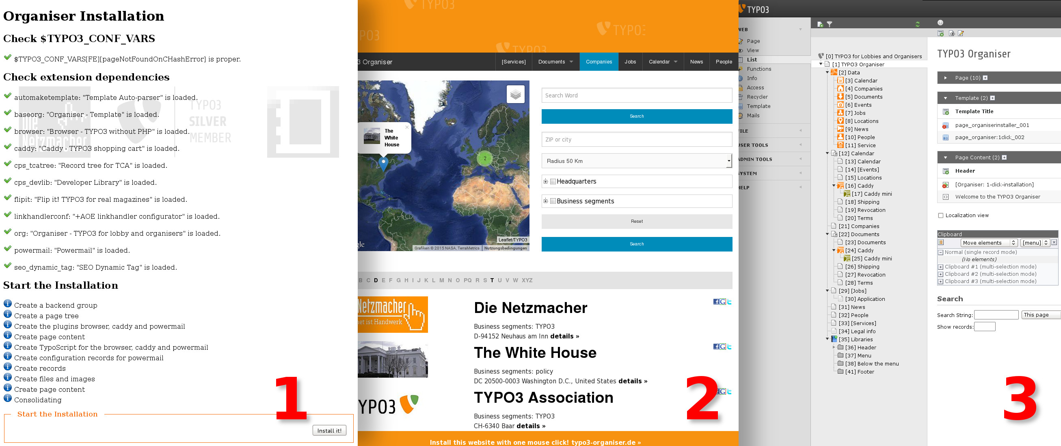Illustration 4: Install the Organiser with one click! Installer button (1). Result in the frontend (2) and in the backend (3).

Introduction
The Browser – TYPO3 without PHP – enables TYPO3 developers and TYPO3 integrators to develop own extensions without any own plugin and without any own line PHP code. Use the Browser and you will develop TYPO3 eight times faster! The "Fehler: Referenz nicht gefunden" is illustrated on page Fehler: Referenz nicht gefunden Fehler: Referenz nicht gefunden.

What does it do?
- With one line TypoScript you will get a result list with a search form, a page browser and an index browser for your tt_news records or for any other database of any other extension. With one line TypoScript more you will get a single display of your record extended with a record browser.
- The extension simplifies the team play of HTML templates and TypoScript.
Example with tt_news: The TypoScript code "select = tt_news.title" and the HTML marker ###TT_NEWS.TITLE### will display news titles in list and single views in the frontend.
- The Browser discovers relations between tables like tt_news and tt_news_cat automatically. It displays data of related tables in list and single views. The extension builds the SQL relations automatically. If it fails, it is possible to configure the relations manually.
- The Browser has it's own search engine and it offers filters. You can filter for data areas like 2009 to 2011 or 10.000 EUR to 20.000 EUR. Filter can be check boxes, radio buttons, select boxes, lists and tree views.
- BrowserMaps – the Browsers map module – enables you, to publish your data with Google Maps and OpenStreetMap.
  - The Browser offers a radial search. For example: Dislplay all hits within a radius of 50 kilometers with the center of Berlin.
  - BrowserMaps is able to add latitude and longitude to any address data while editing a record and periodically by a cron job.
- The Browser supports the export of data in CSV format and XML format (like RSS feeds).
- The Browser is multiple plugin able: You can use the Browser plugins on a page unlimited.
  - Plugins are able to control other plugins. They can hide or display depending on URL parameters.
- The Browser is supported by the DRS – Development Reporting System. The DRS displays both: errors and work flow. For example: If you like to inspect the performance, you can enable the performance report. The DRS investigates bottlenecks and if it will find some, it try to suggest a solution.
- You can install Browser samples ready-to-use with one mouse-click:
  - Organiser – TYPO3 for the Lobby and the Organisers
  - Quick Shop – Responsive, ready-to-use, one-click-installation
- The Browser can recover extensions, which are running in TYPO3 4.x only.
- The Browser supersedes template engines like Smarty.

What do you need?
- TYPO3 from 4.5 to 6.x
- Experience in TypoScript.
- The extension devlog, if you want to use the DRS – the Development Reporting System.

Audience
- TYPO3 integrators, who have less knowledge about TYPO3 and TypoScript and have little demands.
- TYPO3 developers and TYPO3 agencies, who have a lot of experience with TYPO3 and TypoScript and have high demands.

Non possible features
- The Browser doesn't support
  - neither versioning
  - nor workspaces.

Installation

Extension Manager
Open the extension manager, download the extension Browser (extkey: browser) and install it.

Ready-to-use Sample
See
- Browser Manual
HTML: http://typo3.org/extensions/repository/view/browser_manual_en/
PDF: http://typo3-browser.de/typo3conf/ext/browser_manual_en/doc/manual.pdf
- Extension key: browser_manual_en

Upgrade

From 4.x to 7.x
See
- Browser Manual
HTML: http://typo3.org/extensions/repository/view/browser_manual_en/
PDF: http://typo3-browser.de/typo3conf/ext/browser_manual_en/doc/manual.pdf
- Extension key: browser_manual_en

What's new?

7.3

Backend filter: configurable CSS class
[7.2.8]
If you like to overwrite the default TYPO3 backend CSS, please refer to the hooks:
- PreHeaderRender.php
- RenderPreProcess.php
Thanks to Heinrich Pegelow
See: http://typo3-browser-forum.de/fa/list_post/forum/typo3-browser-wunschliste/thema/css-klasse-statt-inline-css/

Bootstrap
[7.3.0]
The Browser supports Bootstrap
- Grid System
- Pagination
You have to include the static template: Browser [5] + Bootstrap Templates
See "Fehler: Referenz nicht gefunden" on page Fehler: Referenz nicht gefunden Fehler: Referenz nicht gefunden.

Leaflet popup is configurable
[7.2.13]
You can configure the popup in leaflet maps by the Constant Editor.
See: [BROWSERMAPS - DESIGN POPUP – PROPERTIES]
Properties are:
- className
- closeButton
- maxHeight
- maxWidth
- minWidth
- offset
- zoomAnimation

Prompt in list views
[7.2.15]
The flexform tab [list view] has a new property "prompt"
The prompt is placed below the title of a list view.
Value of this proeprty will replace the marker ###MY_PROMPT### while runtime.
###MY_PROMPT### is configured by
plugin.tx_browser_pi1.marker.my_prompt

7.2

Backend filter
[7.2.6]
Improvement: Backend filter are extended for ###CURRENT_PID### and MM_match_fields. It run's proper in TYPO3 6.2.

First Image only for List Views
[7.1.1]
The Browser – TYPO3 without PHP – supports the new feature: display the first image in list views only.
This property is configurable in the record of each news.
The Organiser – TYPO3 for the lobby and the organisers – is extended for this feature.
See http://typo3-organiser.de

Foundation Template
[7.1.2]
Foundation Template 5: content only.

RealURL sample
[7.1.3]
RealURL sample. See: Resources/Private/Extensions/RealURL/realurl_conf.php

vCard
[7.2.0]
You can download staff data as a vCard file.
The vCard is configurable by the Constant Editor.
See
- Browser Tutorial CSV/RSS/vCard/XML (en)
http://typo3.org/extensions/repository/view/browser_tut_rss_en/

6.x/7.0

cHashExcludedParameters
[6.0.2]
Prompt for cHashExcludedParameters configurable by extension manager

Children handling
[5.0.0]
Children are handled before parents. Enables comfortable TypoScript.

CSS
[5.0.17]
CSS for multicolumns menus
<ul> of a menu got the additional class "dropdown-{register:count_menuItems}

[5.0.11]
CSS class browsebox is renamed to pageBrowser
[5.0.0]
Classes are moved:
- item to row
- cell to column
Map form label got the CSS property display:inline-flex

DAM
[7.0.6]
Sample for DAM is deprecated and removed

Foundation
[6.0.7]
Own include static templates for normalize css, jQuery and modernizr JavaScript

Images
[5.0.0]
There is new link management: Links in list view for images and text and in the map for icons and text are managed by the Browser – TYPO3 without PHP. Type of links will respected: to single view, to an internal page, to an external page or no link.
Because of this the Browser lost the capability, to detect and render images automatically. Sorry.
New features at http://typo3-browser.de/typo3conf/ext/browser_tut_images_en/doc/manual.pdf

Leaflet
See "Map" on page 12 below too.
[7.0.0]
Integration of Leaflet - responsive map
Constant Editor Categories
- BrowserMaps - Compatibility
TypoScript properties
- navigation.map.template.leaflet
See: http://leafletjs.com/
Modul Marker-Cluster: https://github.com/Leaflet/Leaflet.markercluster
Modul Plugin-Master (GoogleMaps): https://github.com/shramov/leaflet-plugins

Map
See "Leaflet" on page 12 above too.
[6.0.8]
Toggle the map. See example at:
- http://typo3-organiser.de > Companies
Configuration by TypoScript Constant Editor
- Category [BROWSERMAPS - HTML]
[6.0.7]
Don't display any map, if there isn't any category.
[6.0.0]
Links depending on record type: record, page, noType, url
[5.0.18]
Additional themes for the zoom and the navigation of the map
- res/js/map/themes
  - dark
  - dark red
  - orange
[5.0.12]
Map in mobile mode: OpenLayers Version is moved from 2.12 (buggy) to 2.13 (proper)
[5.0.8]
Map zoom level calculation respects the ratio of the map.

Page browser
[6.0.2]
Static template for pageBrowser Wrap 4.9
[6.0.0]
Page-Browser got foundation wrapping.
[5.0.18, 6.0.0]
Page-Browser should dislayed twice: above the list and below the list
[5.0.15]
Display the pageBrowser even if there isn't any page or one page only. New TypoScript property:
navigation.pageBrowser.forceOutput

[5.0.13]
_LOCAL_LANG.default.pi_list_browseresults_displays is moved from
###FROM### to ###TO### out of ###OUT_OF### records
to
Page ###CURRENT_PAGE### of ###TOTAL_PAGES###

navigation.pageBrowser.showRange is moved from 1 to 0
[5.0.11]
Don't display an 'empty' pageBrowser.

pageNotFoundOnCHashError
[6.0.2]
Prompt for pageNotFoundOnCHashError configurable by extension manager

Radial Search
[6.0.8]
Radial search: Don't display records without epmty lat and empty lon in list views.
Configuration by TypoScript Constant Editor:
- Category [BROWSERMAPS - CONTROLLING]

Relations
[5.0.0]
Support for TCA MM_insert_fields and MM_match_fields. Enables to manage all relations of all tables of an extension in one relation table.

Responsive
[5.0.17]
HTML foundation top bar
[5.0.15]
New founfation templates:
- main_02.html
- table_02.html
[5.0.9]
Foundation framework is integrated.

Search
[5.0.15]
New master template for the search box
displayList.master_templates.subparts.listview.searchform.simpleMapOrderFilter

[5.0.8]
Input field for full text search got a placeholder. Javascript onfocus is removed.
Searchform can be part of the htmlSnippets.

Table
[7.0.2]
Disable order properties in the table head. See:
- plugin.tx_browser_pi1.displayList.tableHead_orderBy

Templates
New features at http://typo3-browser.de/typo3conf/ext/browser_tut_templating_en/doc/manual.pdf
[5.0.1, 5.0.3, 5.0.6, 5.0.7, 6.0.0]
Linked details, header, image, text, typolink, url:
You got a header, image or text with a "details"-part linked to the singleview, an internal page, an external URL or not linked – depending on the record type. See XXX
[5.0.16]
HTML-Template for newsletter

tt_content
Tutorial: "Ready-to-use Sample" on page 8 above.
[7.0.6]
Adapt the tt_content sample to Browser 6.x/7.x and TYPO3 6.x with FAL

tt_news
Tutorial: http://typo3-browser.de/typo3conf/ext/browser_tut_tt_news_en/doc/manual.pdf
[7.0.6]
Adapt the tt_news sample RSS feed to Browser 6.x/7.x and TYPO3 6.x
Adapt the tt_news sample to Browser 6.x/7.x and TYPO3 6.x

TYPO3 6.2
[6.0.0]
Upgrade for TYPO3 6.2

TypoScript Engine 5.x
[5.0.10]
displayList.templateMarker.oddClass is replaced by displayList.templateMarker.cssClass
[5.0.1]
TypoScript file is unitised. Should simplify the maintenance.
[5.0.0]
No support for GROUP_BY, handle as title, text and image. Sorry.
In case of trouble try
plugin.tx_browser_pi1.advanced.downgrade.5_0_0.typoscriptEngine4x = 1

4.9

Filter: AND
[4.8.8]
Filter items can queried by OR and AND.
See
- Browser Tutorial Filter and Search
http://typo3-browser.de/typo3conf/ext/browser_tut_search_en/doc/manual.pdf

Filter: Checkboxes for Selectbox
[4.8.8]
If you are using a selectbox in the backend, you can render the items both ways in the frontend:
- as selectbox or
- as checkboxes.
See
- Browser Tutorial Filter and Search
http://typo3-browser.de/typo3conf/ext/browser_tut_search_en/doc/manual.pdf

TYPO3 6.1
[4.8.10]
The Browser should be fit for TYPO3 6.1. Especially:
- Documents will rendered without any conflict with the FAL.
- Proper form in the extension manager.

4.8

BrowserMaps / Custom Map: controlling of map visibility
[4.8.5]
If you are using a custom map, you can controll the visibility of the wms (Google Maps or OpenStreetMap) with the property: wmsVisibility. wmsVisibility is false by default. See

configuration = {
language : 'de' // default | en | de
, ...
, customMap : {
type: 'Image'
, ...
, wmsVisibility : true
}

BrowserMaps / Routes: controlling the error prompt
[4.7.0]
Configurable error prompt in case of missing categories / marker (POI). See
- TypoScript Constant Editor > Browsermaps – Debugging > Route Relations

BrowserMaps / Routes: evaluation of relations
[4.8.5]
If an editor saves a route record (path, marker (POI) and category), the Browser – TYPO3 without PHP – evaluates the relations. If there is an unproper relation, the editor will get a prompt.

jQuery: live() -> on()
[4.8.4]
The Browser javascript is using the jQuery method on() instead of live(). live() is supported by jQuery to version 1.8 only.

Radial Search (Umkreissuche)
[4.7.0]
You can geocode your address data automatically. See the Tutorial BrowserMaps at
- http://typo3.org/extensions/repository/view/radialsearch/

Recursion Guard – configurable by Constant Editor
[4.8.5]
The recursion guard is configurable by the constant editor. See
- TypoScript Constant Editor > Browser – Advanced > Recursion Guard
The Browser checks fault-prone loops by the recursion guard limit. If a loop cross this limit, the workflow will exit. You will get an error prompt in the frontend. The limit is by default 10.000 runs per one loop.

User function: render_table
[4.8.0]
tt_content.table.20 can used by tt_content records only.
The Browser extends tt_content.table.20 for every database. See
- a TypoScript example
- and further information
at
- HTML http://typo3.org/extensions/repository/view/browser_tut_userfunc_en
- PDF http://typo3-browser.de/typo3conf/ext/browser_tut_userfunc_en/doc/manual.pdf
Quick Shop is using this method for datasheets.

tt_address tutorial (german)
[4.7.0]
Matthias Haack has written and published a tutorial for tt_address and the Browser – TYPO3 without PHP.
The tutorial is in German language. See
- http://blog.matthaa.de/die-typo3-extension-browser-typo3-without-php-anwendungsbeispiel-mit-tt_address-daten/
Matthias Haak is Certified TYPO3 Integrator. See http://www.matthaa.de

TYPO3 6.x
[4.7.4]
The Browser – TYPO3 without PHP – is fit for TYPO3 6.x.

Manual
See
- Browser Manual
HTML: http://typo3.org/extensions/repository/view/browser_manual_en/
PDF: http://typo3-browser.de/typo3conf/ext/browser_manual_en/doc/manual.pdf

Change Log

7.4.2 Improvement
* #i0222: 201 datetime got the time property
* #i0221: %m/%d/%y is moved to %m/%d/%y %H:%M
Bugfix
* #i0220: .0. is moved to .6.
* #i0219: PHP Warning: Invalid argument supplied for foreach() in pi1/class.tx_browser_pi1_viewsingle.php
7.4.1 Improvement
* #i0218: Map: improved DRS
* #i0217: Calendar: DRS error prompt in case of different value_stdWrap and url_stdWrap is improved
Bugfix
* #i0216: Error: Geocoding by Browser - TYPO3 without PHP. Prompt: Unknown column 'filterPrompt' in 'field list'
7.4.0 Feature
* #i0215: Plugin for frontend-editing.
DRS
* New category: Frontend Editing
Limitations: Only some TCA config types are supported
Improvement
* #i0216: Flexforms are moved from pi* to Configuration/FlexForms/pi*
7.3.0 Feature
* #i0206: Bootstrap classes and TypoScript template.
New static template: Browser [5] + Bootstrap Templates
Effected files:
* Configuration/TypoScript/Bootstrap/Templating/* (new)
* Resources
* Public/Images/BackendLayouts/Bootstrap/* (new)
* Private/Templates/HTML/Bootstrap/* (new)
Improvement
* #i0207: Indexbrowser isn't obligated any longer for a valid template
* #i0205: 127.0.0.1 and 127.0.0.2 is removed from plugin/flexform statistic. See:
* Configuration/TypoScript/includes/setup/plugin/tx_browser_pi1/flexform/sDEF.ts
* pi1/flexform_sheet_sDEF.xml
* #i0204: Content of error prompt in case of unproper page id for documents
7.2.15 Improvement
* #i0203: flexform list view got the prompt property
New marker ###MY_PROMPT###
7.2.14 Bugfix
* #i0202: replace code with an return;
pi1/class.tx_browser_pi1_template.php
* hook_template_elements()
* hook_template_elements_transformed
7.2.13 Feature
* #i0199: Configurable leaflet popup
See Constant Editor: [BROWSERMAPS - DESIGN POPUP – PROPERTIES]
Properties:
* className
* closeButton
* maxHeight
* maxWidth
* minWidth
* offset
* zoomAnimation
Improvement
* #i0201: Optimise CSS classes for map pupup in case of notype
* #i0200: tag lists in the constant editor are extended with span
* #i0198: Update leaflet from 0.7.3 to 0.7.7
7.2.12 Bugfix
* #i0197: map_toggle.js used a deprecated toggle() method. See
* Resources/Public/JavaScript/Map/oxMap/toggle/map_toggle.js
7.2.11 Bugfixes
* #i0196: If a geo-record hasn't no category, it won't displayed in the single view
* #i0195: Page browser on the top wasn't centered at
* Resources/Private/Templates/HTML
* default_ul.tmpl
* main.tmpl
* #i0194: Disabled DRS prompts in case of enabled hooks.
7.2.10 Bugfix
* #i0193: Don't display empty values/rows
7.2.9 Improvement
* #i0192: locallang for BE filters
Thanks to Michael Schams for the improved code
7.2.8 Improvement
* #i0191: CSS class for backend-filter.
Thanks to Heinrich Pegelow
See: http://typo3-browser-forum.de/fa/list_post/forum/typo3-browser-wunschliste/thema/css-klasse-statt-inline-css/
If you like to overwrite the default TYPO3 backend CSS, please refer to the hooks:
* PreHeaderRender.php
* RenderPreProcess.php
7.2.7 Improvement
* #i0190: meta tag viewport is removed. It is added only in case of using foundation templates.
Effected file:
* Configuration/TypoScript/includes/setup/PAGE/meta.ts
7.2.6 Improvement
* #i0189: Extend BE-filter for ###CURRENT_PID###
* #i0188: Extend BE-filter for MM_match_fields
* #i0187: Update BE-filter for TYPO3 6.2
7.2.5 Bugfix
* #i0186: PHP Warning: key() expects parameter 1 to be array, null given in
pi1/class.tx_browser_pi1_typoscript.php line 371
7.2.4 Bugfix
* #i0185: Checkbox: enable multiple
7.2.3 Improvement
* #i0184: Conflict mode: dbal is enabled
7.2.2 Feature
* #i0183: vCard. version 2.1 is added.
* Can enabled by Constant Editor
7.2.1 Feature
* #i0181: vCard
* SOURCE: can enabled and disabled by Constant Editor
* URL: page uid by Constant Editor
Improvement
* #i0182: Browser foundation icons
7.2.0 Major Feature
* #i0178: Resources/Public/Css/foundation-icons-3/*
Deprecated, because foundation should added by another extension like start.
* #67208: vCard
Definition http://de.wikipedia.org/wiki/VCard
Improvement
* #i0180: Additional headers for the page objects csv,
map and vCard are configurable by the constant editor.
* #i0179: Update foundation from 5.4.5 to 5.5.1
7.1.4 Improvement
* #i0177: Configuration/TypoScript/includes/setup/PAGE/meta.ts won't included any longer
* meta.viewport will included by a foundation template
7.1.3 Feature
* #i0176: RealURL sample. See: Resources/Private/Extensions/RealURL/realurl_conf.php
7.1.2 Feature
* #i0175: Foundation Template 5: content only
* #i0174: New property constant editor [BROWSER TEMPLATES - LIST - HEADER] > title and title crop
* #i0173: First image for list view only
* #i0171: New templates list view text 2 and 3
Bugfix
* #i0172: Bugfix arrDataQuery
7.1.1 SECURITY BUGFIX
* #i0170: hidden fields
7.1.0 SECURITY BUGFIX
* #i0169: Prevent cross site scripting. See #i0164 too.
Feature
* #i0168: Slick Carousel template. See tab Template in the flexform.
Bugfix
* #i0169: Text with image should wrapped as text only in case of no image.
7.0.16 Improvement
* #i0166: Base class wrap: some classes are removed
Bugfix
* #i0167: Flexform property "Template" > "wrap in base class" wasn't respected
7.0.15 SECURITY BUGFIX
* #i0165: Proper comment in TER upload prompt.
7.0.14 SECURITY BUGFIX
* #i0164: $GLOBALS[ 'TYPO3_DB' ]->escapeStrForLike() is replaced
by $GLOBALS[ 'TYPO3_DB' ]->quoteStr()
7.0.13 Improvement
* #i0163: Additionally TypoScript template: Browser [0] + Foundation Framework + JSS fastclick
7.0.12 Improvement
* #i0162: ATagTitle field for the foundation top bar.
* #i0161: CSS: remove border-right from .category_menu.
7.0.11 Improvement
* #i0160: Autocomplete added to the list of components in
* t3jquery.txt
7.0.10 Feature
* #i0159: Resources/Public/JavaScript/Map/oxMap/toggle/map_slideUp.js
See Browser Tutorial Leaflet
7.0.9 Improvement
* #i0158: Browser Manual:
Remove
* Manual Out-of-the-box
* Icon: Update
7.0.8 Bugfix
* #66391: Radialseach doesn't calculate radial distance
* #66389: SQL Error in context with radial search
7.0.7 Feature
* #i0155: link management: tt_news types 0, 1, and 2 are respected
Bugfix
* #i0156: foundation lightbox
7.0.6 Improvement
* #i0152: state is set from alpha to beta
* #i0150: Adapt the tt_news sample RSS feed to Browser 6.x/7.x and TYPO3 6.x
* #i0148: Sample for DAM is deprecated and removed
* #i0146: Adapt the tt_news sample to Browser 6.x/7.x and TYPO3 6.x
* #i0143: Adapt the tt_content sample to Browser 6.x/7.x and TYPO3 6.x with FAL
Bugfix
* #i0154: distance is added in default templates but without radial search
* #i0153: Images aren't sized in some cases (wine extension for example):
GM (GraphicsMagick missed on the local server)
* #i0151: CSV export: fields aren't wrapped proper
* #i0149: RSS-Feed template: detection error
* #i0147: tt_news sample list view: image isn't rendered
* #i0145: FAL failes in single view
* #i0144: isset() returns false in case of a NULL value > moved to array_key_exists()
7.0.5 ToDo
* #i0142: JOINS doesn't run proper, if field with MM_match_fields isn't called like the foreign table.
7.0.4 Bugfix
* #61797: Unproper results depending on search without zip
7.0.3 Bugfix
* #i0141: Order of list items with translation and language overlay
* #i0140: Order of filter items with language overlay
* #i0139: SQL ressource error in case of an empty result in localisation mode
7.0.2 Features
* #i0138: Disable order properties in the table head. See:
* plugin.tx_browser_pi1.displayList.tableHead_orderBy
Improvement
* #i0136: debugTrail() compatibility TYPO3 4.x / 6.x
* #i0133: Template must contain subpart marker ###SINGLEBODYROW### or ###LISTBODYITEM###
* #i0132: Constants for image and url got default values
Bugfix
* #i0137: Filter aren't respected in localisation mode and in case of no counting
* #i0135: Order of filter items wasn't proper in case of no counting
* #i0134: Proper localisation for the single view
7.0.1 Improvement
* #i0131: Templates row / columns
7.0.0 Major Feature
* #65184: Integration of Leaflet - responsive map
Constant Editor Categories
* BrowserMaps – Compatibility
TypoScript properties
* navigation.map.template.leaflet
See: http://leafletjs.com/
* #65184/#i193: Modul Marker-Cluster
See: https://github.com/Leaflet/Leaflet.markercluster
* #65184/#i194: Modul Plugin-Master (GoogleMaps)
See: https://github.com/shramov/leaflet-plugins
6.0.8 Features
* #i0129: Radio buttons and checkbox: field got label
* #i0127: Radial search: Don't display records without epmty lat and empty lon in list views
Configuration by TypoScript Constant Editor
* Category [BROWSERMAPS – CONTROLLING]
* Empty coordinates?
* #i0126: New property: displayList.templateMarker.cssClass.wrap
* #i0123: Toggle the map
See example at
* http://typo3-organiser.de > Companies
Configuration by TypoScript Constant Editor
* Category [BROWSERMAPS – HTML]
* JavaScript
* Template
* #i0121: 3rd backend layout without HTML snippet for foundation
Improvements
* #i0130: CSS: Checkbox row is moved to checkbox-row, radio button row is moved to radio-row
* #i0124: Map default template: filter are moved from top to bottom
Bugfix
* #i0128: td class in case of an non default template
* #i0125: Map marker pop-up without desription
* #i0122: Missing sword in value of HTML sword input field
6.0.7 Feature
* #i0120: Don't display any map, if there isn't any category
* #i0110: Own include static templates for normalize css, jQuery and modernizr JavaScript
* #i0109: Class for indexBrowser tab by TypoScript
* #i0108: Additional templates head 3 and 4, image 3 and 4, typoscript/url 4
Improvements
* #i0119: CSS for multicolumnsmenu becomes own file
* Resources/Public/Css/Foundation/multicolumnmenu.css
* see: #i0081
* #i0111: Support for supporting t3globals is removed. It isn't needed.
If you need it, please configure TypoScript.
* #i0106: moved: static templates of pi3 and pi4 are moved to Configuration/TypoScript
* #i0105: removed: Configuration/TypoScript/includes/setup/plugin/tx_browser_pi1/displayList/\
master_templates/subparts/searchform/complex.ts
* #i0104: moved: res/sample to Resources/Public/Sample
* #i0103: moved: res/js to Resources/Public/JavaScript
* #i0102: moved: res/images to Resources/Public/Images
* #i0101: moved: res/html/map to Resources/Private/Templates/HTML/Map
* #i0100: removed: Configuration/TypoScript/downgrade/4.5.4
* #i0099: removed: Configuration/TypoScript/downgrade/3.9.0
* #i0098: removed: res/html/until_3.9.6
* #i0097: moved: default.css from res/html to Resources/Public/Css
* #i0096: moved: favicon.ico from res/html to Resources/Public/Images
* #i0095: moved: res/html/*tmpl are moved to Resources/Private/Templates/HTML/
UPGRADE: All Browser Plugins/Flexforms must be updated. See [Templating] > HTML
* #i0094: static to Configuration/TypoScript
UPGRADE: All TypoScript Templates must be included again
Bugfix
* #i0118:
PHP Warning: Invalid argument supplied for foreach() in pi1/class.tx_browser_pi1_map.php line 201
PHP Warning: implode(): pi1/class.tx_browser_pi1_map.php line 262
PHP Warning: array_flip() pi1/class.tx_browser_pi1_map.php line 2089
* #i0117: Bug in case of a table with a tree parent field and more than one used filter
* #i0116: Invalid argument supplied for foreach() in pi1/class.tx_browser_pi1_filter_4x.php line 5243
* #i0115: PHP Warning: implode(): Invalid arguments passed in pi1/class.tx_browser_pi1_typoscript.php
* #i0114: in_array() expects parameter 2 to be array in pi1/class.tx_browser_pi1_flexform.php
* #i0113: PHP Warning: Couldn't fetch mysqli_result in pi1/class.tx_browser_pi1_viewlist.php line 1144
* #i0112: Browser engine 5 is using code of Browser 3
* #i0107: tx_browser_pi1_typoscript::wrapRowTableLocalGetFields cached fields by a static variable.
* #i0106: tx_browser_pi1_sql::get_statements cached get statements by a static variable.
* #64116: No noItemMessage in case of no records
6.0.6 Feature
* #i0092: Plugin: icons for Browser templates
Improvements
* #i0093: Plugin: display the first three jquery ui templates only
* #i0091: PHP Warning: Illegal string offset
* 'file' in pi1/class.tx_browser_pi1_backend.php line 1809
* 'name' in pi1/class.tx_browser_pi1_backend.php line 2118
* 'file' in pi1/class.tx_browser_pi1_backend.php line 2119
* #i0090: Improve recursion guard
6.0.5 Improvements
* #i0089: Responsive HTML ###MAP###
6.0.4 Bugfix
* #i0088: Wrong constant paths twice
6.0.3 Bugfix
* #i0087: Added pagebrowser bottom to main.tmpl
6.0.2 Feature
* #62615: Static template for pageBrowser Wrap 4.9 (see #i0084)
* #62610: Prompt for cHashExcludedParameters configurable by extension manager
* #62607: Prompt for pageNotFoundOnCHashError configurable by extension manager
Bugfix
* #62604: Make sure that jQuery will be loaded at the bottom of the page,
BUT before every other javascript inclusions
6.0.1 Bugfix
* #62546: SQL query with "AND AND"
6.0.0 Major Feature
* #i0086: Foundation is updated from 5.3.0 to 5.4.5
* #i0084: pagebrowser got foundation wrapping
* #i0083: pagebrowser is placed at top and bottom of lists.
* Supbart marker ###PAGEBROWSER### is moved to ###PAGEBROWSERTOP###
* New supbart marker ###PAGEBROWSERBOTTOM###
* #61970: Templates for header, text and images
* #61971: Templates for header
* plugin.tx_browser_pi1.displayList.master_templates.tableFields.header
* #61972: Templates for text
* plugin.tx_browser_pi1.displayList.master_templates.tableFields.text
* #61973: Templates for images
* plugin.tx_browser_pi1.displayList.master_templates.tableFields.image
* #61974: Templates for url
* plugin.tx_browser_pi1.displayList.master_templates.tableFields.details
...* plugin.tx_browser_pi1.displayList.master_templates.tableFields.url
* #61986: Foundation clearing lightbox
* #61520: Update TYPO3 6.2: Compatibility with TYPO3 6.2
* #61594/#61664: TYPO3 6.2: &cHash empty / cHashExcludedParameters / pageNotFoundOnCHashError
* hidden fields are removed from the form
* no_cache
* tx_browser_pi1[plugin]
* hidden fields are rendered by PHP
* #61646: Replace the static method t3lib_div::intInRange
* #i0083: Improvements for Foundation
* wrapInBaseIdClass
Feature
* #61938: BrowserMaps: Links depending on record type: record, page, noType, url
See #61937 at route
Improvement
* #i0083: graded from beta to alpha
Bug
* #61926: ###MAP### marker in main template is removed (error with route. see: route ChangeLog)
* #i0084: Treeview filter displays "Array" instead of a rendered HTML filter after sending a filter value
5.0.18 Improvement
* #i0082: Filter local table: Replace mysql_real_escape_string
* #t0013: Additional themes for the zoom and the navigation of the map
* res/js/map/themes
* dark
* dark red
* orange
* #t0014: Page-Browser should dislayed twice: above the list and below the list
5.0.17 Feature
* #i0081: CSS multicolumns menu
* <ul> of a menu got the additional class "dropdown-{register:count_menuItems}"
Improvement
* #i0080: HTML foundation top bar
5.0.16 Feature
* #60530: HTML-Template for newsletter
Improvement
* #i0079: Improve arrDataQuery
5.0.15 Features
* #i0078: New master template for the search box
* displayList.master_templates.subparts.listview.searchform.simpleMapOrderFilter
* #i0077: New founfation templates:
* main_02.html
* table_02.html
* #60426: Display the pageBrowser even if there isn't any page or one page only
New TypoScript property: navigation.pageBrowser.forceOutput
5.0.14 Improvement
* #i0076: map has an JSS error, if there is a category without any proper record
(a record without lat or lon)
* #i0075: fields with a null value weren't wrapped
* #i0074: Search form should not send the page pointer of the page browser
* #i0073: Sword: Phrases are concatenated with OR and AND
* #i0072: Treeview reset:
* cookies will removed now
5.0.13 Improvement
* #i0071: Pagebrowser:
* _LOCAL_LANG.default.pi_list_browseresults_displays is moved
from "###FROM### to ###TO### out of ###OUT_OF### records"
to "Page ###CURRENT_PAGE### of ###TOTAL_PAGES###"
* navigation.pageBrowser.showRange is moved from 1 to 0
5.0.12 Improvement
* #i0070: Map in mobile mode: OpenLayers Version is moved from 2.12 (buggy) to 2.13 (proper)
* #i0069: Treeview filter: exhausetd filter resets the input fields of the form proper.
* #i0067: Sword: Phrases are concatenated with OR but it must be AND
5.0.11 Improvement
* #i0066: Don't display an 'empty' pageBrowser
* #i0065: CSS class browsebox is renamed to pageBrowser
5.0.10 Feature
* #i0064: displayList.templateMarker.oddClass is replaced by displayList.templateMarker.cssClass
Bugfix
* #i0062: Default icon for record without any category
* #i0061: Map zoomLevel: zoomLevel is set to 1, if there isn't any POI
* #i0060: Map jsonData: if there isn't any data, jsonData doesn't return null any longer but {}
* #i0059: Map zoomlevel doesn't return -INF any longer but 18.
5.0.9 Feature
* #i0058: Foundation
5.0.8 Improvement
* #i0057: map zoom level calculation respects the ratio of the map
* #i0056: Input field for full text search got a placeholder. Javascript onfocus is removed.
* #i0055: htmlSnippets:
* viewlist: will redner earlier in the workflow
* subparts will rendered before the rendering of the marker
* success: searchform can be part of the htmlSnippets.
5.0.7 Feature
* #60142: Templating: new type notype
5.0.6 Feature
* #i0054: A 2nd and 3rd image and url template
5.0.5 Bugfixes
* #i0053: noItemMessage
* #i0052: Children relation in case of opposite field
5.0.4 Feature
* #60107: Consolidate Search
* pi1/class.tx_browser_pi1_zz_sword.php ( new ) [NOT USED!]
* TypoScript
* Searchform elements got the Typoscript property TEXT
* and
* or
* not
* plugin.tx_browser_pi1.displayList.display.searchform.noResult is removed,
because it was deprecated
* CSS
* Wrap of noItemMessage is moved
from <p class="noItemMessage">|</p> to <p style="padding:2em 0;">|</p>
5.0.3 Feature
* #60089: tableField templates 2/2
New template
* plugin.tx_browser_pi1.displayList.master_templates.tableFields.typolink
is used in
* plugin.tx_browser_pi1.navigation.map.marker.variables.system.url
* plugin.tx_browser_pi1.displayList.master_templates.tableFields.header
* plugin.tx_browser_pi1.displayList.master_templates.tableFields.text
* plugin.tx_browser_pi1.displayList.master_templates.tableFields.image
Updated template
* plugin.tx_browser_pi1.navigation.map.marker.variables.system.description
Description was a text oit of a title. It is now a COA with image, header and text.
5.0.2 Feature
* #i0051: Make TypoScript main file clear: map
* static/includes/setup/plugin/tx_browser_pi1/navigation/map/* ( new )
5.0.1 Feature
* #60089: tableField templates 1/2
New templates
* plugin.tx_browser_pi1.displayList.master_templates.tableFields.header
* plugin.tx_browser_pi1.displayList.master_templates.tableFields.text
* plugin.tx_browser_pi1.displayList.master_templates.tableFields.image
* #60076: Make TypoScript main file clear: Different files instead of one file
5.0.0 Feature
* #i0050: map form label got the CSS property display:inline-flex
* #60014: Consolidate table head
* #59953: Consolidate single view
* #59942: Devider for children per table.field (from Typoscript engine 5.x)
* #59669: Consolidate Wrapper
* Typoscript engine is upgraded from 4.x to 5.x
* 5.x doesn't support
* GROUPBY
* handle as title, text, image
* If you need the former behaviour, please configure:
plugin.tx_browser_pi1.advanced.downgrade.5_0_0.typoscriptEngine4x = 1
* CSS
* class 'item' is moved to 'row'
* class 'cell' is moved to 'column'
* #59563: Enhance MM-relations for TCA MM_match_fields
* #59579: Children
* Feature : consolidate wrapAndLinkValue
* Feature : children are rendered before the parent is rendered, parent can use rendered
children (from Typoscript engine 5.x)
* Bugfix : The links of children records are unproper from second record
* #52301: Optimise Search Box
* #12739: Asc/Desc-Marker to CSS-classify header fields in self defined list views
Improvement
* #i0051: MY_TITLE in flexform is set in default language in every case
Bugfix
* #i0050: $this->pObj->objWrapper4x->constant_markers() (from Typoscript engine 5.x)
* #60013: SQL error, if select box for ordering is empty
* #59729: Don't mark up search words within HTML tags
* #54983: cHash comparison failed
* #46200: SQL error when searching with "and"
4.9.1 Bugfix
* #i0046: var_dump in tx_browser_cssstyledcontent::render_uploads_per_language
4.8.10 Feature
* #58348: TYPO3 6.1: replacement of tt_content.uploads.20
* static/includes/typo3_45/tt_content/uploads/setup.ts (new)
4.8.9 Bugfixing
* #i0045: Creating default object from empty value in class.tx_browser_pi1_cObjData.php
4.8.8 Features
* #56339: Filter: "combined" values - not realised
* #56332: Frontend checkboxes for backend selectbox
* #56329: AND option for filter
* New TypoScript property filter.table.field.modeAndOr
* Option isn't tested in localised context
4.8.7 Bugfixing
* #56088: Browser Calendar: Bug for dates over several days
4.8.6 Bugfixing
* #i0044: numberFormat( ) without cObj->data
* #i0043: $$ -> $
* #54901: TYPO3 6.1: Unproper form of extension manager
4.8.5 Features
* #i0042: DRS prompt: Map +Route: no indexBrowser possible.
* #i0041: DRS prompt: Map +Route: no pageBrowser possible.
* #54616: TypoScript constant recursionguard
* #54612: BrowserMaps: custom layer: controll initial visibility
* #54575: Evaluate Backend tables route
* #54548: CSS class for form lables
Improvement
* #i0040: Frontend prompt, if recursion is bigger than ...
* #i0039: BrowserMaps: Limit for children of a path is increased from 99 to 999
* #i0038: OpenStreetMap_0.0.2.js > OpenStreetMap_1.3.10.js
oxMap.Render_1.2.01.js > oxMap.Render_1.3.07.js
Bug
* #54595: Unwanted error message in case of no data for a map
4.8.4 Feature
* #54094: jQuery: replace live() with on()
4.8.3 Improvement
* #i0037: Improved DRS for hooks
4.8.2 Improvement
* #i0036: area with intergers got an andWhere with an unix_timestamp
* #i0035: Conflict radial search and multiple filter
* #i0034: Improved error prompt for filter
4.8.1 Bug
* #53466: BrowserMaps Corporate Design: Zoom-Level properties without effect
4.8.0 Feature
* #53397: CSS styled content: table
4.7.4 Feature
* #53366: Fit it into TYPO3 6.x
4.7.3 Bug
* #i0033: Missing argument 1 for tx_browser_pi1_filterRadialsearch::andWhere( )
4.7.2 Bug
* #53356: Filter loop seems to quit after first select box
4.7.1 Imrovements
* #i0032: Radialsearch
4.7.0 Feature
* #52903: BroserMaps/Routes: configurable error prompt in case of missing categories / marker (POI)
* #52545: Example of use for tt_address
* #52486: Radial Search
4.6.5 Bugfixing
* #52297: Selectbox for ordering is missing
* displayList.selectBox_orderBy.display = 0 (before 1)
4.6.4 Bugfixing
* #i0031: pi1/class.tx_browser_pi1_multisort.php
4.6.3 Bugfixing
* #52166: Fatal error: class.tx_browser_tcemainprocdm.php on line 145
4.6.2 Improvement
* #i0029: Views array will cleaned up proper
Example:
* single.301. ... will removed, if single.301 is not configured
4.6.1 Feature
* #51494: Index-Browser: make SQL command LATIN1 configurable
Bugfixing
* #47602: BrowserMaps: No icons without categories
4.6.0 Improvement
* #i0028: Update the manual
4.5.15 Improvement
* #i0027: Renaming Constant Marker
* map.enabled -> map.controlling.enabled
* map.provider -> map.controlling.provider
* map.openLayers.css -> map.design.css
* map.height -> map.design.height
* map.openLayers.imgPath -> map.design.imgPath
* map.path.categoryIcon -> map.design.path.categoryIcon
* map.width -> map.design.width
* map.controls.debugging -> map.openlayers.controls.debugging
* map.controls.default -> map.openlayers.controls.default
* map.modules.debugging -> map.openlayers.modules.debugging
* map.modules.default -> map.openlayers.modules.default
* map.modules.routes.debugging -> map.openlayers.modules.routes.debugging
* map.modules.routes.default -> map.openlayers.modules.routes.default
* map.popup.behaviour -> map.openlayers.popup.behaviour
* #51477: BrowserMaps: mobile navigation
displayList.master_templates.map.descriptionWiLinkToSingle.30 moved from TEXT to COA
4.5.14 Improvements
* #i0026: Replace 3.x-method global_stdWrap with 4.x-method cObjGetSingle
* #i0025: Flash Messages GPX-Data Upload
4.5.13 Features
* #51477: BrowserMaps: mobile navigation
* #51478: BrowserMaps: automatic rendering of latitude and longitude
Bugfix
* #51464: Whitespace in PHP file breaks XML (RSS) output
4.5.12 Improvements
* #i0024: alias for showUid is controlled by the Constant Editor
NEW constant: plugin.tx_browser_pi1.navigation.showUid
Replaced Constant: plugin.tx_browser_pi1.recordBrowser.uidName > plugin.tx_browser_pi1.navigation.showUid
4.5.11 Improvements
* #i0023: Flexform: All fields: excluded is set from 1 to 0
* #i0022: BrowserMaps: oxMap.Render_1.3.07.js is added
* #i0021: BrowserMaps: CSS .tx-browser-pi1 .mapview-content: padding: 1em; moves to padding: 1em 0;
* #i0020: BrowserMaps: route row to cObj
* #i0019: BrowserMaps: cat devider
* #i0017: BrowserMaps: Constant Editor
plugin.tx_browser_pi1.map.marker.position.* moves to plugin.tx_browser_pi1.map.icon.listNum.*
Bugfix
* #50222: Record Browser is broken
* CSS: #record-browser is moved to .indexBrowser
* HTML: id of ul contains uid of the current plugin
* tx_browser_pi1-0.0.5.js is moved to tx_browser_pi1-0.0.6.js
* #50214: Fix core error prompts
* #50195: mysql_real_escape_string: Bug in case of no MySQL connection
* #i0022: jQuery UI labels in the flexform
* #i0018: htmlentities in BrowserMaps popup
4.5.10 Feature
* #50069: Placement controlling of JSS scripts
4.5.9 Bugfix
* #49495: Unporoper methods for TYPO3 >= 6.x
4.5.8 SECURITY FIX!
* #i0017: if showUid has an alias it will removed from piVars too, if there is a security risk.
Improvements
* #i0014: DRS: Warning in case of several plugins
* #i0013: Different controlling of the URL for a marker or for a path
mapLinkToSingle
* #i0010: oxMap Route Categories
1.3.05 ->1.3.06
Bugfix
* #i0016: andWhere isn't a COA
* #i0015: oxMap Route Marker
1.3.06 ->1.3.07
* #49495: Unporoper methods for TYPO3 >= 6.x
* #i0012: DRS prompt, if Map +Routes is enabled by Constant Editor but a Browser plugin
doesn't have a proper SQL query
* #i0011: Error prompt, if TypoScript is missing
4.5.7 SECURITY FIX!
* #48859: Security fix
Feature
* #47631: Route Interface oxMap
Marker
* ###JSONDATA### -> ###RAWDATA###
* #47630: Backend Routes
* #47628: BrowserMaps Route Integration: Integration GeoJSON
* #46062: BrowserMaps: Localisation of the form labels
* #33336: Export: filter are respected
* #i0007: TypoScript version
Bugfix
* #i0009: Bugfix oxMap Route Categories
1.3.04 ->1.3.05
* #i0008: 3x->get_queryArray .> 3x->get_query_array
4.5.6 Feature
* #47823: Extend cObj->data +++ second step
* #47632: oxMap 1.3 for Routes
* Properties
* Constant Editor
* plugin.tx_browser_pi1.map.field.* -> plugin.tx_browser_pi1.map.marker.field.*
* Setup
* plugin.tx_browser_pi1.navigation.map.configuration.categories.fields.category ->
plugin.tx_browser_pi1.navigation.map.configuration.categories.fields.category
* #43397: filter CSV export
Bugfix
* #48613: Unproper URL for icons in Backend-Module
* #47700: SQL functions 3.x: orderBy evaluation is unproper in case of aliases
* #47680: Engine 4.x query building: doesn't respect SQL manual mode
class.tx_browser_pi1_sql_manual_3x.php -> class.tx_browser_pi1_sql_manual.php
* #47679: tmplRowIsExtraUidField( ) is unporper in SQL manual mode
* #47678: Localisation mode isn't set in manual SQL mode
* #47089: Filter can cause an unproper value in $arrConsolidate['addedTableFields']
4.5.5 Bugfixes
* #i0006: * array_multisort() : invalid arguments passed in line 989
* array_diff() : invalid arguments passed in line 192
4.5.4 Update Sponsors
4.5.3 Improvement
* #i0005: Updating the manual from 4.4.3 to 4.5.3
Publishing 4.5.3 in the TER
4.5.2 Bugfix
* #46776: Handle periods over days: With and without Browser +Calendar
4.5.1 Bugfix
* #i0004: * implode( ): invalid arguments passed in line 592
* end( ): expects parameter 1 to be array line 576
* array_flip( ) expects parameter 1 to be array line 572
* in_array( ) expects parameter 2 to be array, null given in line 863
4.5.0 Feature
* #45846: Controlling JSS alerts
* #43108: TYPO3 6.0 compatibility
* t3lib_div::intInRange -> t3lib_utility_Math::forceIntegerInRange()
* t3lib_div::int_from_ver -> t3lib_utility_VersionNumber::convertVersionNumberToInteger()
* t3lib_div::cHashParams -> t3lib_cacheHash
4.4.8 Improvement
* #i0003: Optimise query string for DRS. Replace ',' with ', '
4.4.7 Feature
* #45422: Calendar: Handle periods over days
4.4.6 Improvement
* #42788: BrowserMaps will extended for Google Maps
* param mapZoomWheel is moved to zoomWheelEnable
* mapMarker and MarkerInfo removed
* New Api
4.4.5 Feature
* #i0002: class.tx_browser_cssstyledcontent.php is integrated in the DRS
Improvement
* #i0001: Optimise cObjcObjGetSingle
* #44858: Extend cObj->data +++ first step
4.4.4 Improvement
* #00000: BrowserMaps Constant Editor
Debug mode for modules
Feature
* #44858: Extend cObj->data +++ first step
Bugfix
* #44849: BrowserMaps: dummy category in single-view
* dummy got a LL-value
* dummy is displayed only if there isn't any category
4.4.3 Improvement
* #44619: BrowserMaps: cHash in links to the single view
mapLinkToSingle: useCasheHash
Bugfix
* #44621: Filter and localisation: localisation is ignored in some cases
4.4.2 Bugfix
* #44584: Download: broken images and archives
4.4.1 Improvement
* #00000: Tree view can enabled and disabled by the constant editor
4.4.0 New Features
* #42788: BrowserMaps will extended for Google Maps
* Moved files
* default_0.0.9.tmpl -> default_1.1.01.tmpl
* OpenLayers_2.10.0 -> OpenLayers_2.12
* oxMapConfig_0.0.10.js -> oxMapConfig_1.1.01.js
* oxRenderMap_0.0.10.js -> oxRenderMap_1.1.02.js
* ID of filter is moved from filter to oxMapFilter
* TypoScript constants are moved from ... to ...
* zoomLevel.fixed -> zoomLevel.start
* TypoScript properties are moved from ... to ...
* MapControls -> oxMapConfigMapControls
* MapMarker -> oxMapConfigMapMarker
* MapMarkerInfo -> oxMapConfigMapMarkerInfo
* MapMarkerEvent -> oxMapConfigMapMarkerEvent
* MapZoomLevels -> oxMapConfigNumZoomLevels
* MapZoomWheel -> oxMapConfigMapZoomWheel
* OSMConfigCenter -> oxMapConfigCenter
* OSMConfigZoom -> oxMapConfigStartLevel
Improvements
* #44318: Workaround bug t3lib_BEfunc::implodeTSParams
* #44316: Improve performance: substitute_marker_recurs( ) is deprecated.
Substitute it with substitute_tablefield_marker( )
* #44306: Improve jquery loading
* #44299: t3jquery: respect dontIntegrateOnUID
* #44300: Update jQuery 1.6.2 -> 1.8.3
Bugfix
* #44313: GPvar is not interpreted in some case: Case is org_npzch
Cause: GPvar is deprecated. Use GP instead
* #44296: Rotation of modes: $(...).effect is not a function
* #44295: Rotation of modes: Content is empty!
4.3.1 New Features
* #44131: Additional HTML templates main and margin
Bugfixes
* #44125: SQL statements: brackets without slash
Thanks to tomcat (Kuschmann) for reporting the fix on typo3-browser-forum.de
4.3.0 New Features
* #43854: Workaround: don't use relation twice
* #43808: Reintegration of groupby feature from 3.x to 4.x
* #43780: New manual: Browser out of the box
See extension browser_manual_ootb_en
* #43746: Preconfigures view
* #43741: Centralised jQuery UI configuration
* #43732: Integration of index browser in jQuery UI themes
* #43627: TypoScript snippets for HTML templates
* #33841: AJAX: optimised JSS code for transparency in IE 8
Improvement
* #43737: Remove button method
tx_browser_pi1_cleanup_4.1.21.js -> tx_browser_pi1_cleanup_4.2.0.js
tx_browser_pi1-0.0.4.js -> tx_browser_pi1-0.0.5.js
Bugfix
* #43889: consolidation module: foreign table is missing, if andWhere contains table.uid
* #43852: CSV-Export: Is ignored, if you are using several plugins
Workaround documented. See
* http://typo3.org/extensions/repository/view/browser_tut_rss_en/
* http://typo3.org/extensions/repository/view/browser_tut_severalplugins_en/
* #43803: Category menu: li-tags are missing
* #43778: Filter aren't handled proper in some cases
* #43692: jQuery isn't loaded in some cases of a treeview
* #41004: SQL table join: NULL safe comparsion
Thanks to Christian Weiske for the bug report
4.1.26 Improvements
* #00000: tx_browser_pi1-0.0.3 -> tx_browser_pi1-0.0.4
* #00000: Qualified prompt in tx_browser_pi1_localisation::zz_promptLLdie()
* #00000: category_menu.treeview.enabled.value = 0
Bugfixes
* #43685: Treeview and localisation: language prefixes are ignored
* #43558: navigation.indexBrowser.defaultTabWrap isn't handled since 4.0
* #43530: BUG at tx_browser_pi1_backend::evaluate_pluginInitRecordBrowser
* #42738: CSV-Export: Supbart isn't processed
* #42736: "Is not an array" in cal, map,
Missing parameters in tmplRowFieldOfSingleViewIsEmpty( )
Thanks to Thomas.Scholze@HS-Lausitz.de for bug report and a patch
* #42302: Invalid database result resource detected
4.1.25 New Features
* #42125: OpenStreetMap: offset for categories
* #42124: OpenStreetMap: improve performance
oxMapConfig_0.0.9.js -> oxMapConfig_0.0.10.js
oxRenderMap_0.0.9.js -> oxRenderMap_0.0.11.js
Bugfixing
* #42566: BrowserMaps: remove the cat devider from categories
* #42565: Unproper result, if first children is 0, empty or null
4.1.24 Update
* #00000: * pi3/locallang.xml
4.1.23 New Features
* #42173: OpenStreetMap: configurable zoomWheel
Effected files:
* static
* constants.txt
* setup.txt
* #42172: OpenStreetMap: configurable event mode
Effected files: see #42173
* #42126: OpenStreetMap: individual design of control panel
Effected files: see #42173
4.1.22 Bugfixing
* #42127: OpenStreetMap: filter aren't proper in Internet Explorer 8
oxMapConfig_0.0.2.js -> oxMapConfig_0.0.9.js
oxRenderMap_0.0.2.js -> oxRenderMap_0.0.9.js
Effected files:
* pi1/class.tx_browser_pi1_map.php
* res/html/map/default_0.0.9.tmpl
* static
* setup.txt
* downgrade/3.9.0/setup.txt
* t3jquery.txt
* #42128: OpenStreetMap: filter aren't proper while using the zoom
Effected files: see #42127
* #42129: OpenStreetMap: tooltips aren't proper
Effected files: see #42127
* #41570: jquery.t3browser-0.0.2.js -> jquery.t3browser-0.0.3.js
marginBottomPx: width -> height
Effected files:
* res/js/jquery/plugins/jquery.t3browser/jquery.t3browser-0.0.3.js
* static
* setup.txt
* downgrade/3.9.0/setup.txt
* t3jquery.txt
* #00000: inc3ludeLibs -> includeLibs
Effected files:
* static/setup.txt
4.1.21 New Feature
* #41753: Treeview as checkbox
* #41753.01: New COA TREEVIEW
Effected files
* pi1
* class.tx_browser_pi1_filter_4x.php
* class.tx_browser_pi1_javascript.php
* res/js/jquery
* tx_browser_pi1_cleanup_x.x.x.js
* tx_browser_pi1_jstree_x.x.x.js
* static
* constants.txt
* setup.txt
Improvement
* #41754: Filter: optimise performance
CHECKBOX is enabled for treeviews
* #41754.01: $arr_andWhereFilter isn't never allocated
* #41754.02: init_aFilterIsSelected (boolean) is moved to get_selectedFilters (array)
* #41754.03: SQL optimisation: new method sql_resAllItemsFilterWoRelation( )
* #41754.04: Improve performance reports
Effected files
* pi1
* class.tx_browser_pi1_template.php
* class.tx_browser_pi1_wrapper.php
BE AWARE: It isn't tested in localised context
* #41776: Make filter 4.x independent of filter 3.x
Effected files:
* pi1
* class.tx_browser_pi1_cal.php
* class.tx_browser_pi1_filter_4x.php
* class.tx_browser_pi1_filter_4x.php
* class.tx_browser_pi1_template.php
Bugfix
* #41814: Filter: local table isn't proper, if hits aren't displayed
* #41811: Filter areas: last item doesn't count hits
4.1.20 Improvement
* #00000: oxRenderMap 0.0.9
4.1.19 Development
* #00000: Treeview Checkboxes
4.1.18 Improvement
* #00000: t3jquery.txt for supporting the configuration of t3jquery
* #00000: jsTree: non used files and folders are removed
jsTree TypoScript Constant Editor: dots and icons
* #00000: jQuery 1.8.x is checked with success
* #00000: res/js/jquery
tx_browser_pi1_jstree-3.9.21.js is moved to tx_browser_pi1_jstree-4.1.18.js
Bugfix
* #00000: res/js/tx_browser_pi1_ajax-0.0.4.js
4.1.17 Bugfix
* #00000: oxRenderMap 0.0.7
4.1.16 Bugfix
* #00000: Filter areas: If any filter is matched in localised context, alls records were displayed
* #00000: Filter weren't displayed in case of any record doesn't matched
4.1.15 Improvement
* #41372: Filter areas: strings aren't supported proper
4.1.14 Improvement
* #00000: oxRenderMap 0.0.6
4.1.13 New Features
* #41057: Open Street Map with custom image layer;
Effected files:
* pi1
* class.tx_browser_pi1_map.php
* static
* constants.txt
* setup.txt
* #41129: Registers for rows and columns, first, last, even and odd
* browser_numColumn
* browser_numColumnFirst
* browser_numColumnLast
* browser_numColumnOdd
* browser_numRow
* browser_numRowFirst
* browser_numRowLast
* browser_numRowOdd
Effected files:
* pi1/class.tx_browser_pi1_template.php
Improvement
* #00000: Update OpenLayers from 1.x to 2.10
Effected files:
* static/setup.txt
* static/downgrade/3.9.0/setup.txt
Bugfix
* #41051: UPPER causes bugs in some SQL engines. Solution UPPER -> upper
* #00000: Invalid argument supplied for foreach() in
* lib
* class.tx_browser_cssstyledcontent.php line 904
* pi1
* class.tx_browser_pi1_cal.php line 2419
* class.tx_browser_pi1_filter_3x.php line 454
* class.tx_browser_pi1_filter_3x.php line 1105
* class.tx_browser_pi1_filter_4x.php line 4948
* class.tx_browser_pi1_localisation_3x.php line 863
* class.tx_browser_pi1_sql_auto.php line 2747
* class.tx_browser_pi1_sql_auto.php line 2748
4.1.12 Bugfix
* #11401: Filter: ###UID### replacement depends on localtable or foreigntable
4.1.11 New Feature
* #40959: Multiple plugins: Flexform [General] got the new property:
Views: If plugin is included by a foreign page, ...
If "add tx_browser_pi1[plugin]", the plugin will ignore piVars of other plugins of the current page.
Effected files:
* pi1
* class.tx_browser_pi1_flexform
* flexform_sheet_sDEF.xml
* locallang_flexform.xml
4.1.10 New Feature
* #00000: Register [General] of the plugin / flexform got the field "my comment"
Bugfix
* #40958: Multiple plugins: if you are using multiple plugins but any filter, piVars are missing in the URL.
* #40960: Multiple Plugins: Record Browser doesn't use piVars[plugin] in links to the single view
Effected files:
* pi1/class.tx_browser_pi1_navi_recordbrowser.php
* static/setup.txt
* #00000: * SearchForm: remove hiddden field for plugin
Effected files:
* res/sample/tt_news/default.tmpl
4.1.9 Bugfixes
* #40937: Empty list at start without any effect
4.1.8 New Feature
* #40495: Record browser links back to the list view depending on the last configuration
Thanks to http://freemedia.ch for sponsorship
Effected files:
* pi1/class.tx_browser_pi1_navi_recordbrowser.php
* pi1/class.tx_browser_pi1_session.php
* static/setup.txt
4.1.7 New Feature
* #41055: Enable OSM (map) to process category icons delivered by the database
Effected files:
* pi1/class.tx_browser_pi1_map.php
* static/contstants.txt
* static/setup.txt
Improvements
* #00000: Plugin check: record storage page and access to root level records
Bugfixes
* #00000: Plugin check: Fatal error, if plugin wasn't never saved
* #40354: Checkbox without input-tag
Effected file: static/setup.txt
* #40354: Checkbox and radiobuttons
* items without proper line breaks
* items without a name
* items without hits
Effected files:
* pi1/class.tx_browser_pi1_filter_4x.php
* static/setup.txt
4.1.6 Update
* #00000: Sponsors
* Drei Gorillas
* r-system
4.1.5 Improvements
* #00000: static/setup.txt
Bugfix
* #00000: static/setup.txt
4.1.4 New Feature
* #00000: Filter for map
Effected files:
* pi1/class.tx_browser_pi1_map.php
* static/contstants.txt
* static/setup.txt
Bugfix
* #00000: Array error in lib/class.tx_browser_befilter_hooks.php::getDBlistQuery
4.1.3 Improvement
* #00000: Code is cleaned up in class.tx_browser_pi1_views.php
* #38612: Record browser is able to overwrite sys_lsysanguage_overlay temporarily
(freemedia case)
Effected file: static/setup.txt
4.1.2 Improvement
* #00000: Record browser got an own class. See class.tx_browser_navi_recordbrowser.php
* #38612: Record browser respects all items of the listview and not only the displayed one
* #00000: Session management of the record browser differs languages
* #00000: navi class moved to navi_3x class
Bugfix
* #38611: Pagebrowser is confused in localisation mode
4.1.1 Improvement
* #00000: Extension Manager. Effected file: ext_conf_template.txt
4.1.0 New Feature
* #32654: OpenStreetMap
4.0.0 Publishing
* #00000: Release 4.0.0
All change logs from 1.0.2 to 3.9.9 see file ChangeLog.
1.0.1 Major Version Release
New Tools like SQL Autorelation Building and Field Autowrapping
Renaming
- Browser (extkey: browser)
- Former: Frontend Database Browser (extkey: fe_db_browser)
All change logs from 0.0.2 to 0.9.9 see file ChangeLog.
0.0.1 Initial release
Frontend Database Browser (extkey: fe_db_browser)

http://typo3-organiser.de/
http://typo3-quick-shop.de/

