Organiser
TYPO3 Organiser, TYPO3 for the lobbies and the organisers. See: http://typo3-organiser.de/ Manual: http://typo3-organiser.de/typo3conf/ext/org/doc/manual.pdf. The Organiser provides a lot of features for handle a simple calendar, companies, contacts, events, jobs, locations, news, people and services. Sell your tickets with the integrated shop. The installer enables you to install the Organiser with one mouse click! Sample data is included.



Version: 7.8.2, 2016-01-19
Extension Key: org
Language: en
Keywords: calendar, events, lobby, locations, news, organiser, people, responsive, shop, staff, tickets, vCard
Copyright 2010-2016, Dirk Wildt - Die Netzmacher, <http://wildt.at.die-netzmacher.de>

This document is published under the Open Content License available from http://www.opencontent.org/opl.shtml
The content of this document is related to TYPO3 a GNU/GPL CMS/Framework available from www.typo3.org
Table of Contents
Organiser 1
Screen Shots 3
Frontend 3
Backend 7
One-Click-Installation 9
Introduction 10
What does it do? 10
What do you need? 11
Audience 11
Non possible TYPO3 core features 11
Further manuals 11
Upgrades 12
Features 13
Tables 13
Caddy 21
E-payment 22
Flip it! 23
Georeferenced data 24
Maps (Google Maps, Open Street Map) 25
Radial Search 26
Responsive 27
SEO – Search Engine Optimisation 27
Others 28
Preconditions 30
TYPO3 6.2 is recommended 30
Latest extensions 30
Installation 31
One click with the Organiser Installer 31
Adapt some constants to your needs 31
Controlling by the extension manager 32
Basic 32
Downgrade 32
Geocoding 32
Hide tables 32
Linkhandler 32
Simplifyer 33
Controlling by plugins 36
Annotation 36
Plugins in the frontend 36
Plugins in the backend 37
Randomised plugins 38
Controlling by TypoScript 39
Constant Editor 39
TypoScript Object Browser 40
Controlling the Caddy 41
Job 41
Plugin 41
TypoScript 41
Communicating with Powermail 42
Page TSconfig 43
Organiser records 43
CSS 46
Remove the default CSS 46
Add your own CSS 46
SEO and RealUrl 47
DRS – Development Reporting System 48
Reference 49
Completely browser reference 49
Upgrades 50
From version < 6.0 50
Update from < 3.x 51
SQL Migration 54
From Organiser 4.x to 6.x 54
From tt_news to Organiser 56
What's new? 60
7.5 60
7.3 60
7.2 60
7.0 61
6.0 61
4.0 63
3.0 63
2.1 64
2.0 65
FAQ 66
Bugs 66
Configuration 66
Status 67
Store record configuration 67
Store fe_groups configuration 68
Helpful suggestions and benefits 69
Forum 69
Packages for Sponsors 70
Fun – 50 EUR 70
Logo – 150 EUR 70
Patron – 500 EUR 70
Further Information 71
Demo website 71
Manual and tutorial in PDF 71
Professional Support 71
Other extensions published by Die Netzmacher 72
Removing deprecated Relations 73
Known Bugs 75
AOE Link Handler 75
Change Log 76
Illustration index 85
Alphabetical Index 86

Screen Shots

Frontend

Current Version

Installed by the Organiser Installer

Desktop
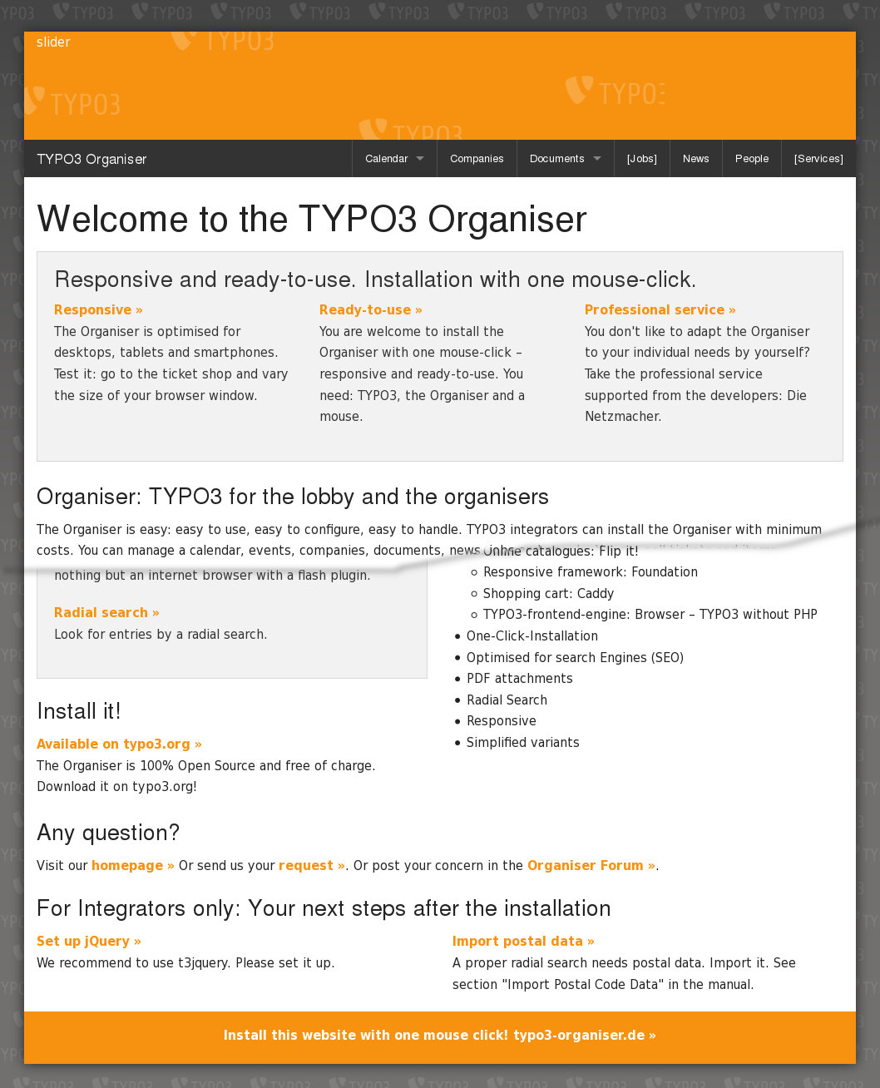Illustration 1: TYPO3 Organiser home page
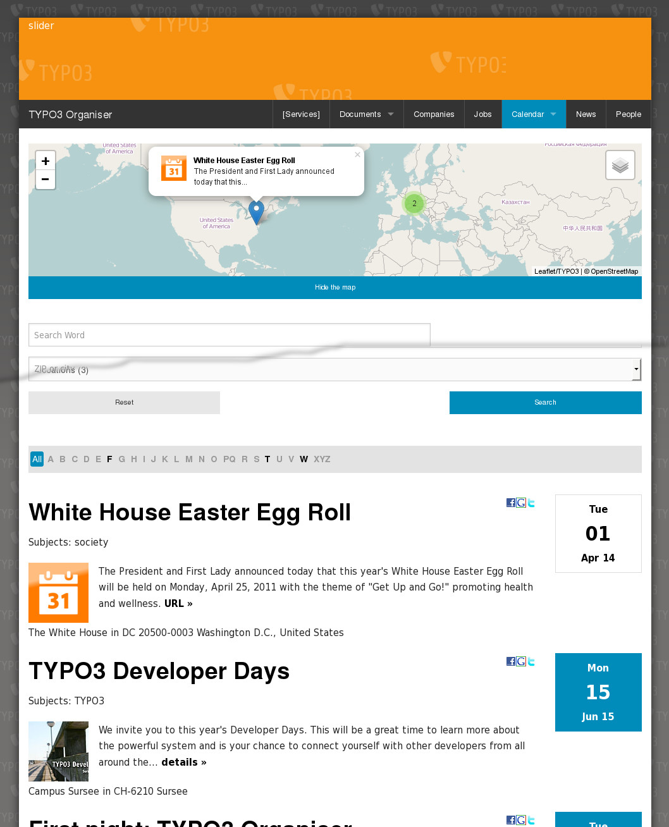Illustration 2: TYPO3 Organiser Calendar
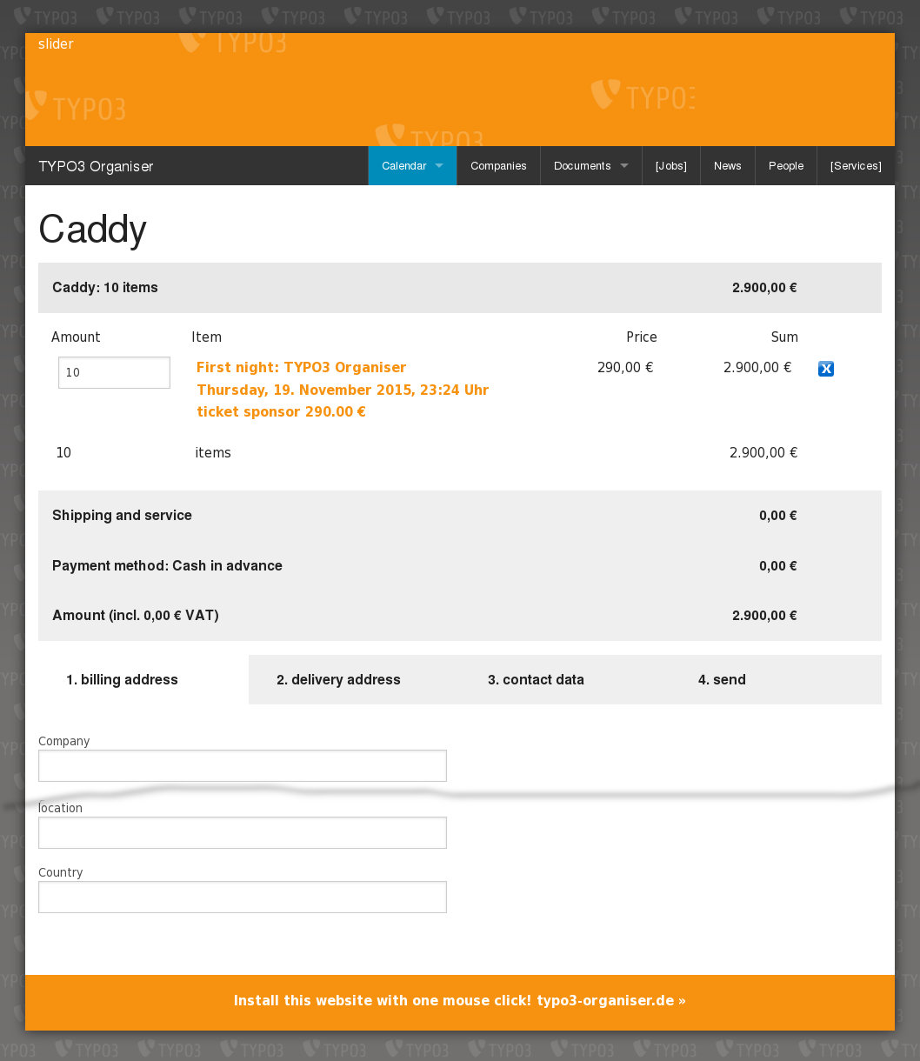Illustration 3: TYPO3 Organiser Caddy with 10 sponsor tickets
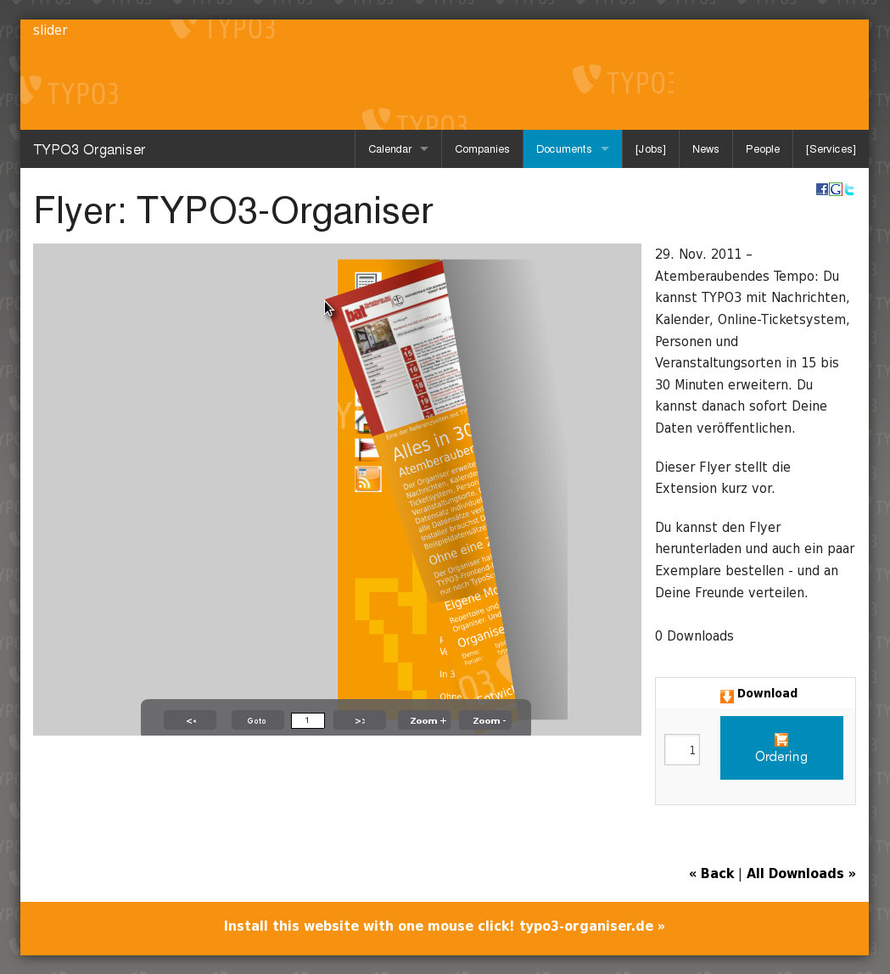Illustration 4: Flip pages of PDF files with the TYPO3 Organiser!

Smartphone
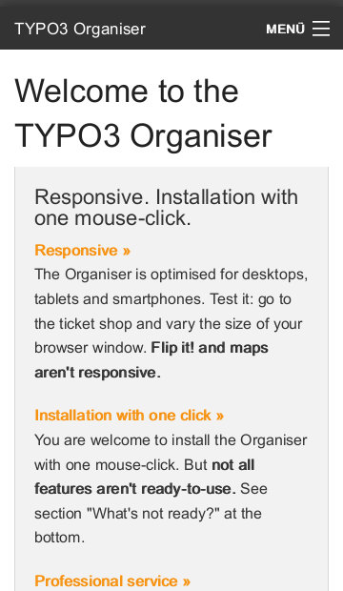Illustration 5: Home
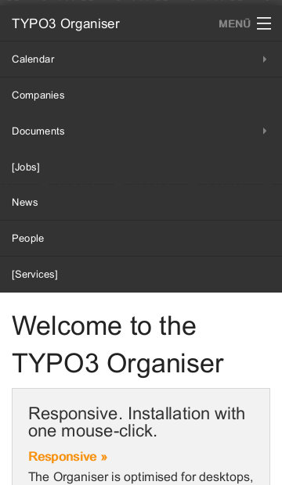Illustration 6: Home with open menu
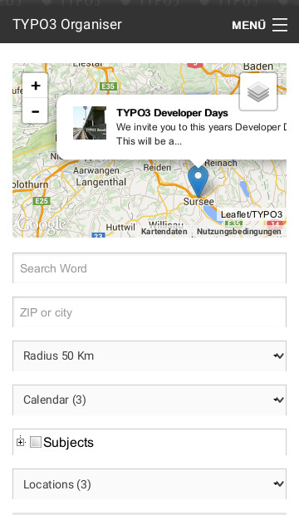Illustration 7: Calendar
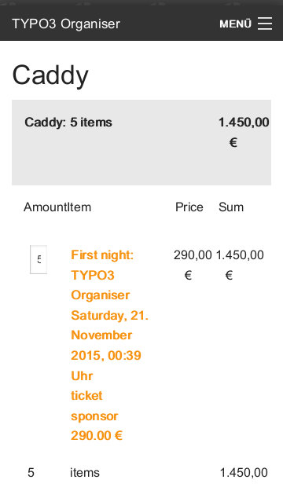Illustration 8: Caddy
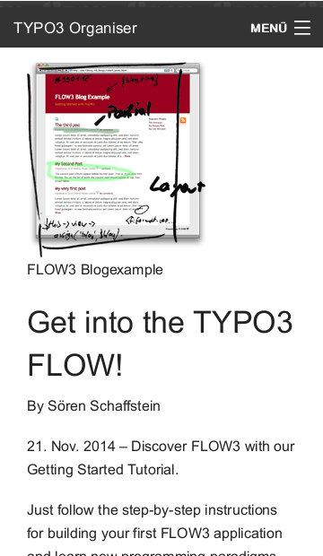Illustration 9: News (single view)
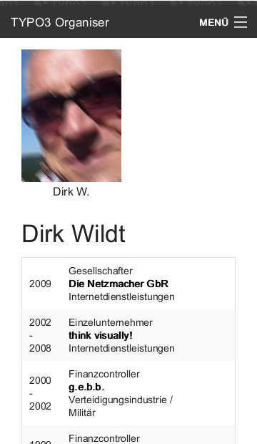Illustration 10: People (single view)

vCard
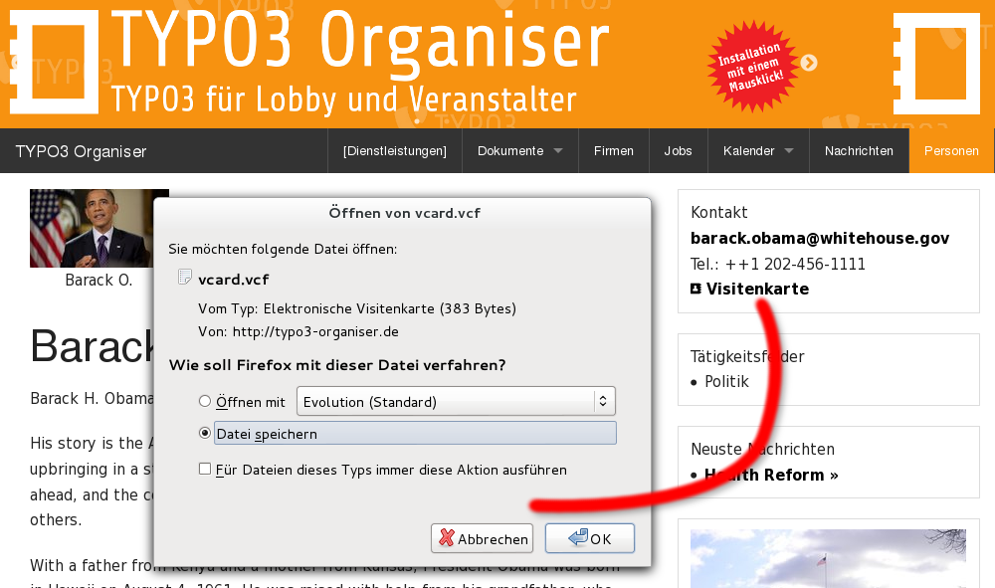Illustration 11: Donwload the vCard of Barack Obama

Version 4.x
[DEPRECATED!]
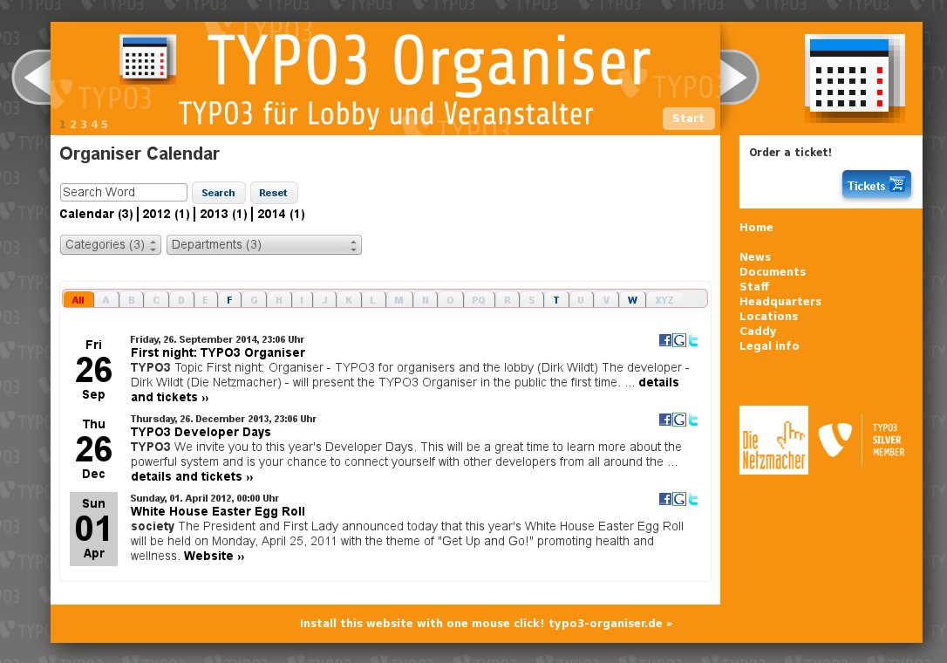Illustration 12: TYPO3 Organiser home page
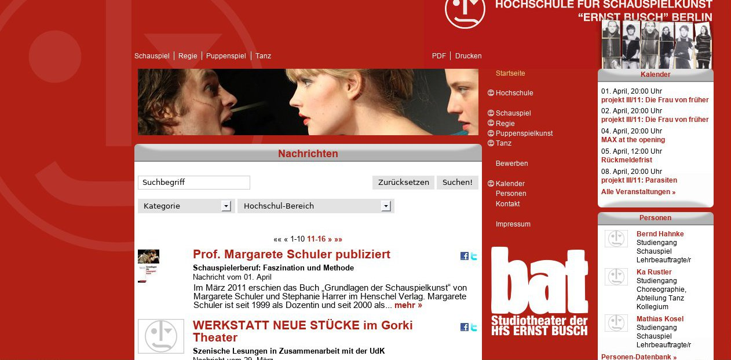Illustration 13: Hochschule für Schauspiel "Ernst Busch" Berlin
Illustration 14: LEG Thüringen
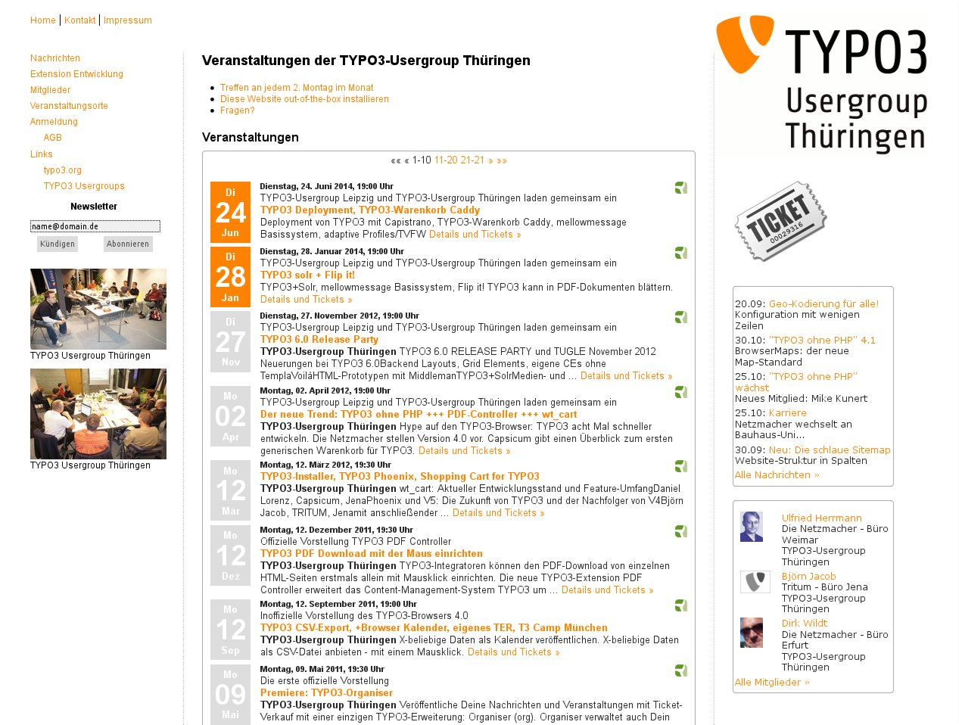Illustration 15: TYPO3 Usergroup Thuringia
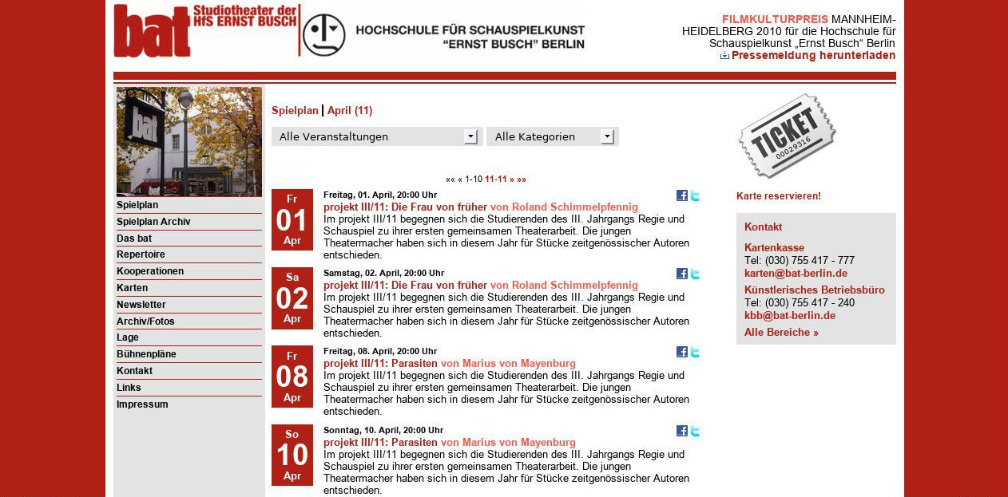Illustration 16: bat Studiotheater
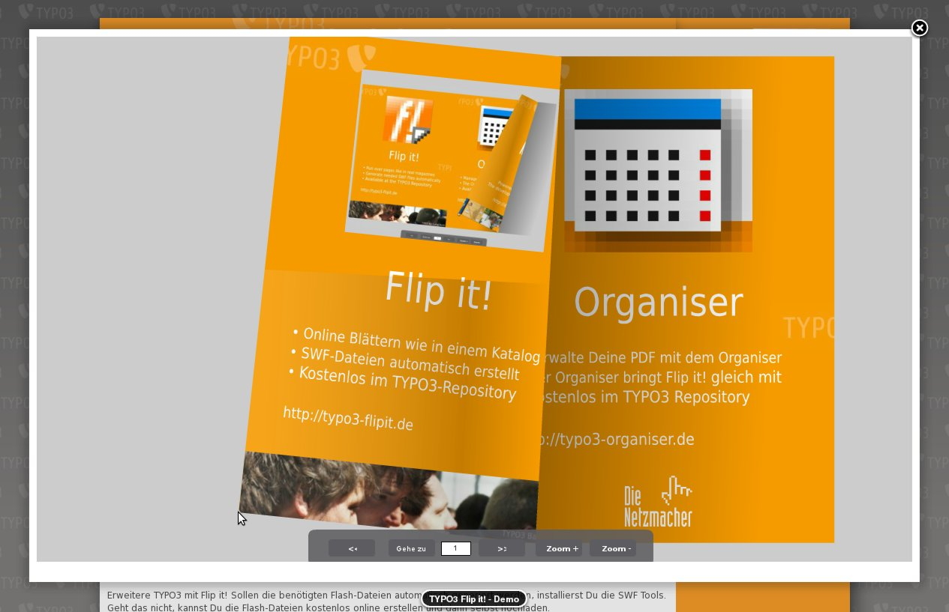Illustration 17: The Organiser has Flip it! integrated.
- bat-Studiotheater der Hochschule für Schauspiel "Ernst Busch" Berlin
http://www.bat-berlin.de/
- Hochschule für Schauspiel "Ernst Busch" Berlin
http://www.hfs-berlin.de/
- Landesentwicklungs-Gesellschaft Thüringen
http://www.leg-thueringen.de/downloads/
- TYPO3 Organiser
http://typo3-organiser.de/
- TYPO3 Usergroup Thuringia
http://typo3-thüringen.de/

Backend

Organiser website
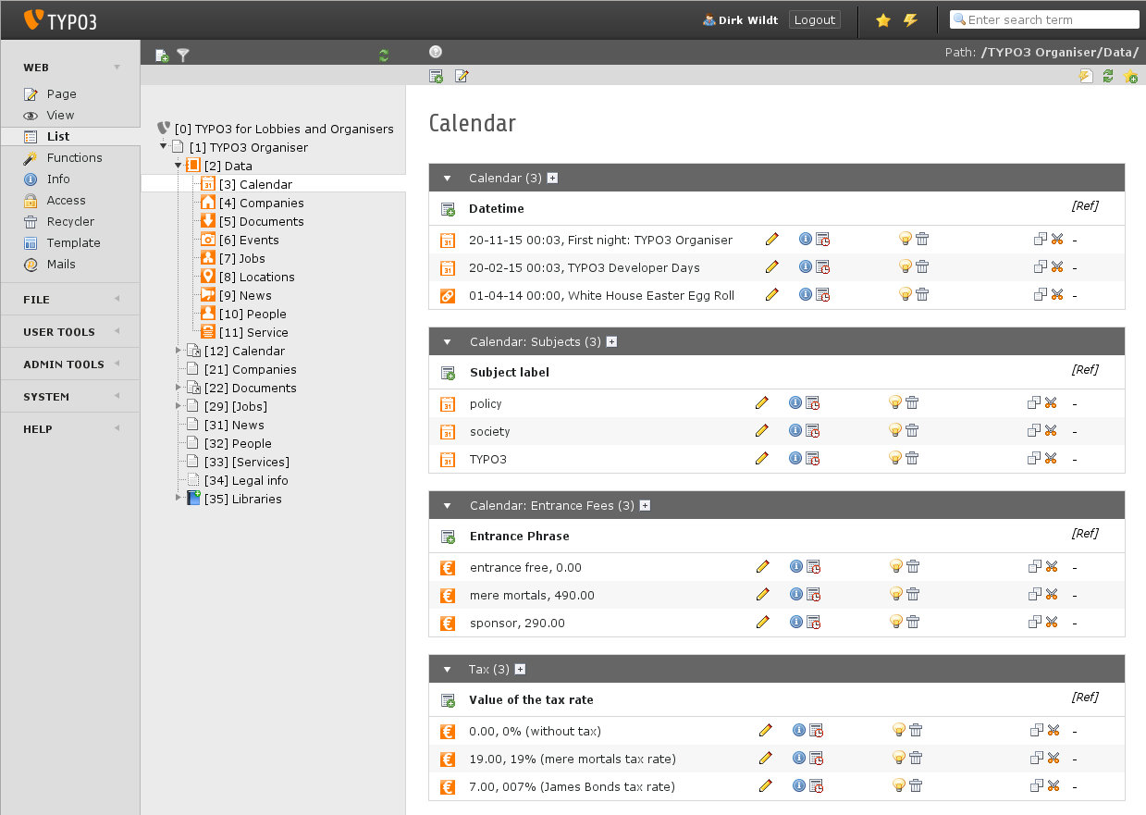Illustration 18: Result after installing with the Organiser Installer. Here: folder with the calendar data.

Backend Filter
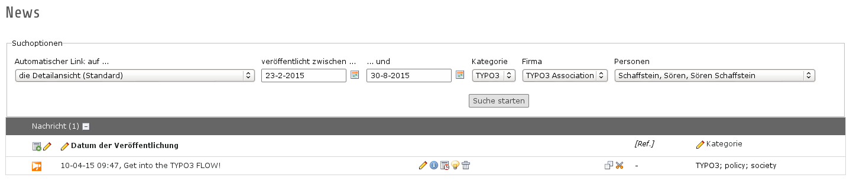Illustration 19: News list with backend filter

Form for a calendar item
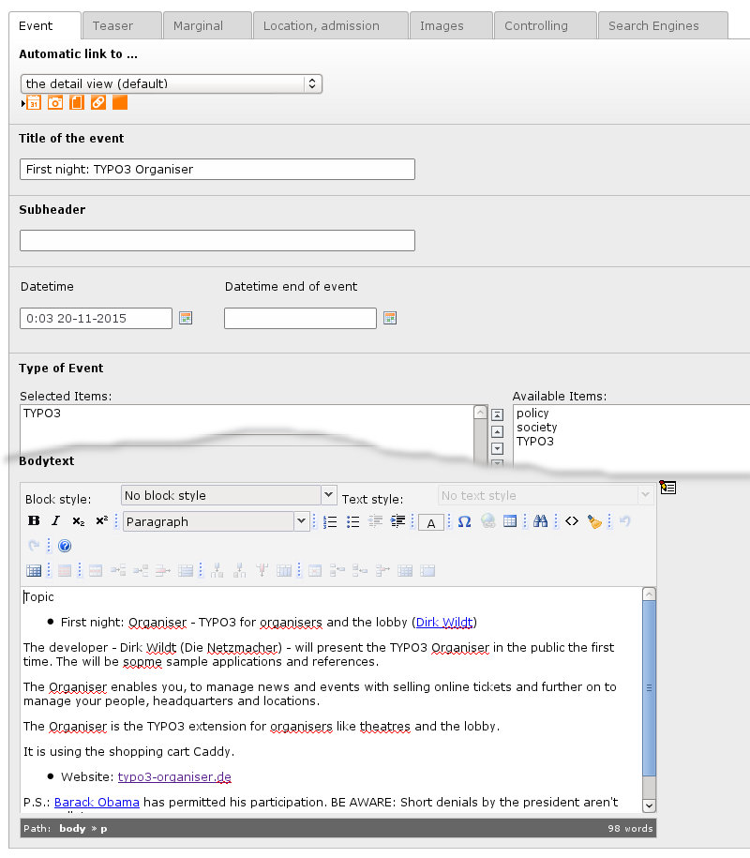Illustration 20: The form for a calendar item

Link Wizard
NOTE: The AOE Link Handler has a bug in TYPO3 6.2 and doesn't work!
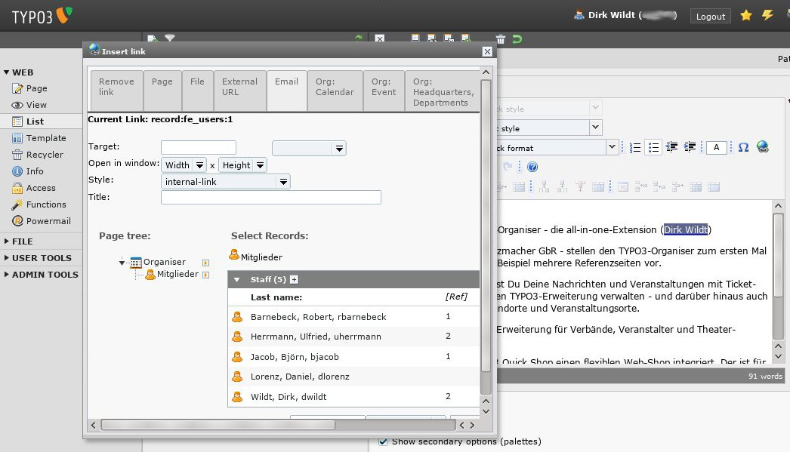Illustration 21: You can link to every Organiser record by the link wizard.

One-Click-Installation
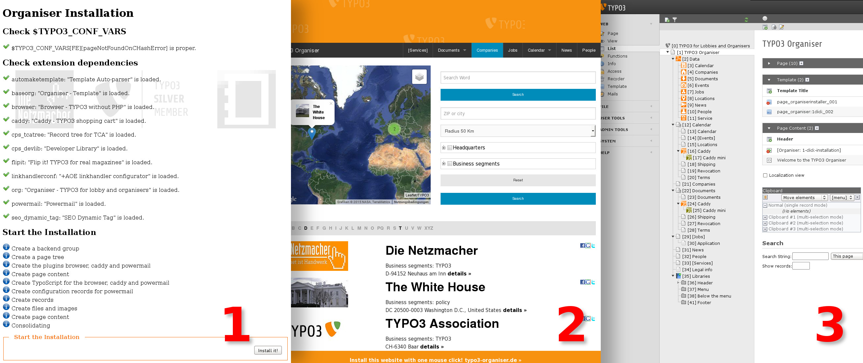Illustration 22: Install the Organiser with one click! Installer button (1). Result in the frontend (2) and the backend (3)

Introduction

What does it do?

Organiser: TYPO3 for the lobbies and the organisers
The Organiser is easy: easy to use, easy to configure, easy to handle. TYPO3 integrators can install the Organiser with minimum costs. You can manage a calendar, events, companies, documents, news, jobs and people. You can sell tickets and items.
The Organiser is the solution for a small budget and for small-scale enterprises, which make low demands on e-commerce.

Responsive.
The Organiser is optimised for desktops, tablets and smartphones. Test it: Visit several pages and vary the size of your browser window.

Installation with one click.
You are welcome to install the Organiser with one mouse-click. A lot of features are ready-to-use like interactive maps or the booking of tickets.

Features
- E-payment
- Georeferenced data
- Image gallery by default
- Localisation
- Maps (Google Maps, Open Street Map)
- Modular
  - Formular management, spam protection: Powermail
  - Interactive map: Leaflet
  - Online catalogues: Flip it! (not responsive)
  - Responsive framework: Foundation
  - Shopping cart: Caddy
  - TYPO3-frontend-engine: Browser – TYPO3 without PHP
- One-Click-Installation
- Optimised for search Engines (SEO)
- PDF attachments
- Radial Search
- Responsive
- vCard

What's not ready?
Events, Jobs and Services hasn't any sample data and hasn't any prepaired TypoScript. Tax rate for tickets can't configured, the rate is 0%. Documents haven't any field for a price.
TYPO3 Editors can't change this behaviour. TYPO3 Integrators can change it, but they must be familiar with TCA, TypoScript and the Browser – TYPO3 without PHP.
We would like to solve the open issues, but we need contracts.

What do you need?
- If you like to use the Organiser ready-to-use, you don't need nothing, but TYPO3, the Organiser Installer and a mouse.
- If you intend to adapt Organiser to your needs, you should be familiar with TypoScript and TCA – the TYPO3 table configuration array.

Audience
- TYPO3 agencies
- TYPO3 integrators
- TYPO3 developers

Non possible TYPO3 core features
The Organiser doesn't support
- versioning
- workspaces

Further manuals
This manual doesn't explain
- the Browser – TYPO3 without PHP
- Caddy – the TYPO3 shopping cart
- Flip it!
- Foundation – the responsive framework
- Leaflet
- Powermail
- Radial Search (Umkreissuche)
- SEO Dybamic Tag
in depth.
If you have any question about these extensions and frameworks, please refer to
- Browser – TYPO3 without PHP (browser)
http://typo3.org/extensions/repository/view/browser/
- Caddy (caddy)
http://typo3.org/extensions/repository/view/caddy/
- Flip it! (flipit)
http://typo3.org/extensions/repository/view/flipit/
- Foundation
http://foundation.zurb.com/
- Leaflet
http://leafletjs.com/
- Powermail (powermail)
http://typo3.org/extensions/repository/view/powermail/
- Radialsearch (Umkreissuche) (radialsearch)
http://typo3.org/extensions/repository/view/radialsearch/
- SEO Dynamic Tag (seo_dynamic_tag)
http://typo3.org/extensions/repository/view/seo_dynamic_tag/

Upgrades
- Bad news: It isn't possible to upgrade from a former version to 6.x. I'm sorry.
- See reasans and possible support in the section "Upgrades > From version < 6.0" on page 50 below.

Features

Tables

Calendar
Illustration 23: Calendar on a desktop ...
Illustration 24: ... and on a smartphone
- Search Form
  - full text search
  - radial search
  - filter for locations, periods and subjects
- Index browser
- Page-browser / record-browser
- Different CSS for current and expired dates
- Social bookmarks in list and single view
- Ticket ordering
- AJAX supported

Map and georeferenced data
The map is based on Google Maps or Open Street Map. You move from the one to the other by a mouse click.
Maps aren't optimised for desktops, tablets and smartphones. They aren't responsive!

Live examples
- http://typo3-organiser.de
- http://www.bat-berlin.de

Companies
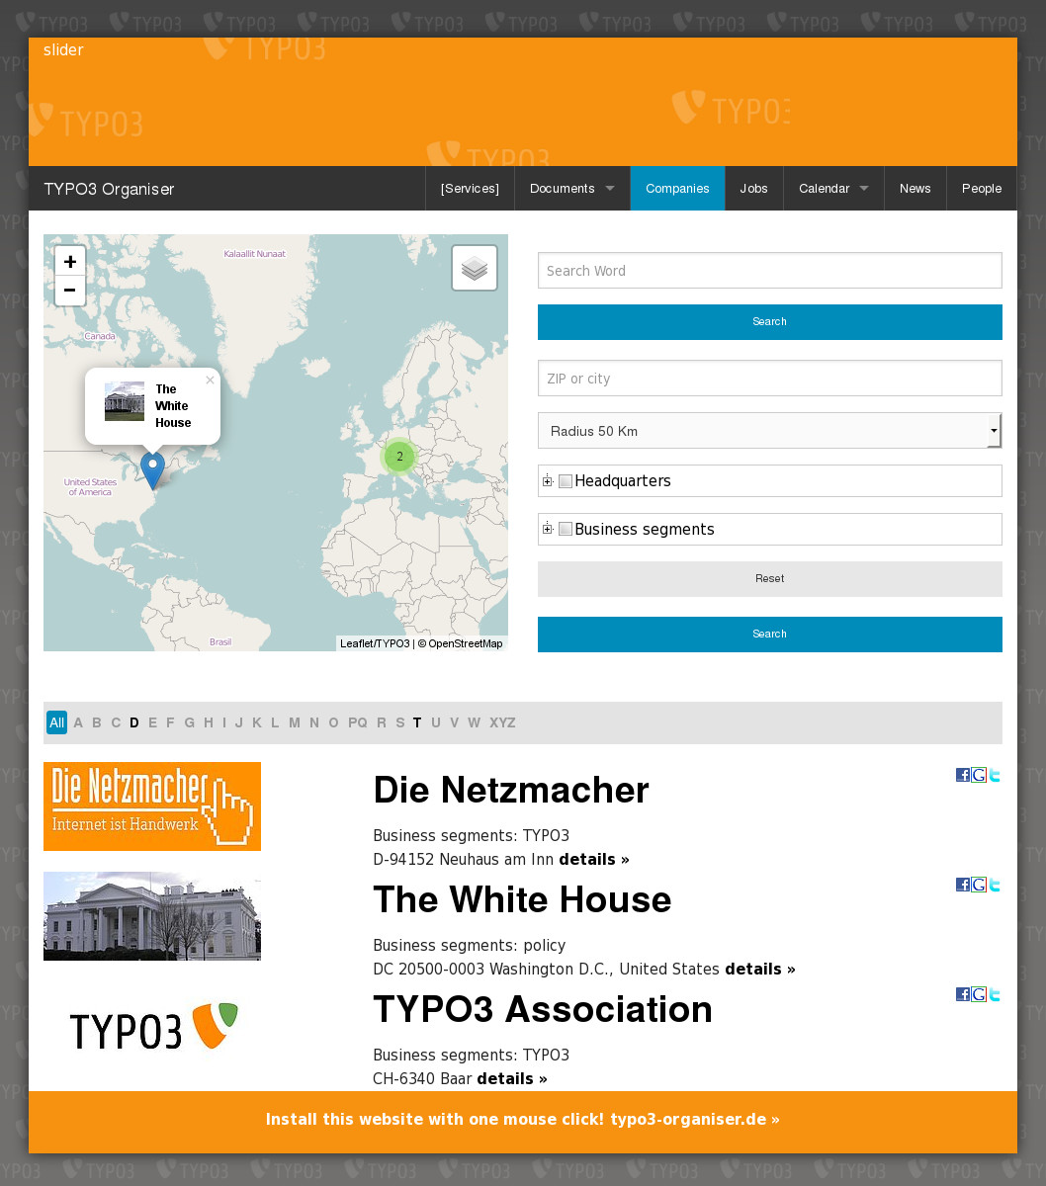Illustration 25: Companies on a desktop ...
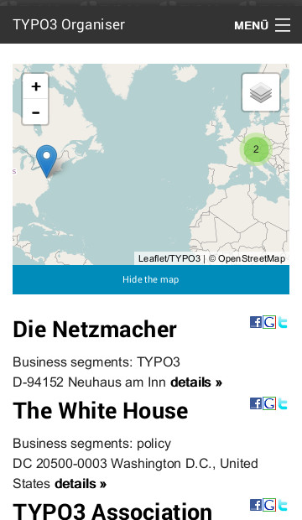Illustration 26: ... and on a smartphone
- Search Form
  - full text search
  - radial search
  - filter for business segments
- Index browser
- Page-browser / record-browser
- Social bookmarks in list and single view
- AJAX supported

Map and georeferenced data
The map is based on Google Maps or Open Street Map. You move from the one to the other by a mouse click.
Maps aren't optimised for desktops, tablets and smartphones. They aren't responsive!

Live examples
- http://typo3-organiser.de

Documents
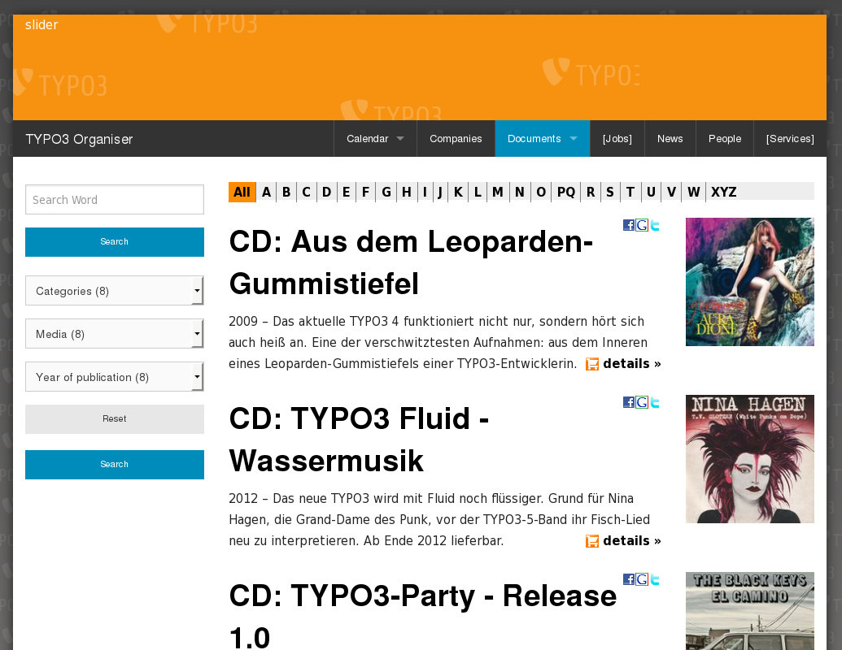Illustration 27: Documents on a desktop ...
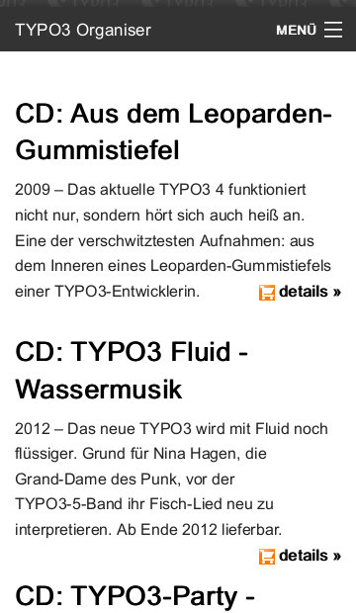Illustration 28: ... and on a smartphone
- Search Form
  - full text search
  - filter for categories, media and periods
- Index browser
- Page-browser / record-browser
- Social bookmarks in list and single view
- AJAX supported
- Document download
- Document ordering

Flip it!
TYPO3 Flip it! enables you, to page flip in PDF files like in real magazines.
The Organiser has Flip it! integrated. Visitors of your website can page flip in your documents online.
The visitor of your website needs a internet browser with a flash plugin only.
See details at
- TYPO3 Flip it!
http://typo3-flipit.de/en/
See screen shot at
- "Screen Shots > Frontend" on page 3 above.
Flip it isn't optimised for desktops, tablets and smartphones. It isn't responsive!

Online examples
- http://typo3-organiser.de/downloads/
- http://www.leg-thueringen.de/en/downloads/ DEPRECATED

Events
Event is a special type of calendar item. It is a benefit, if you have repeating dates.
Sorry, but there isn't any prepaired TypoScript in the current version.

Jobs
Sorry, but there isn't any prepaired TypoScript in the current version.

Locations
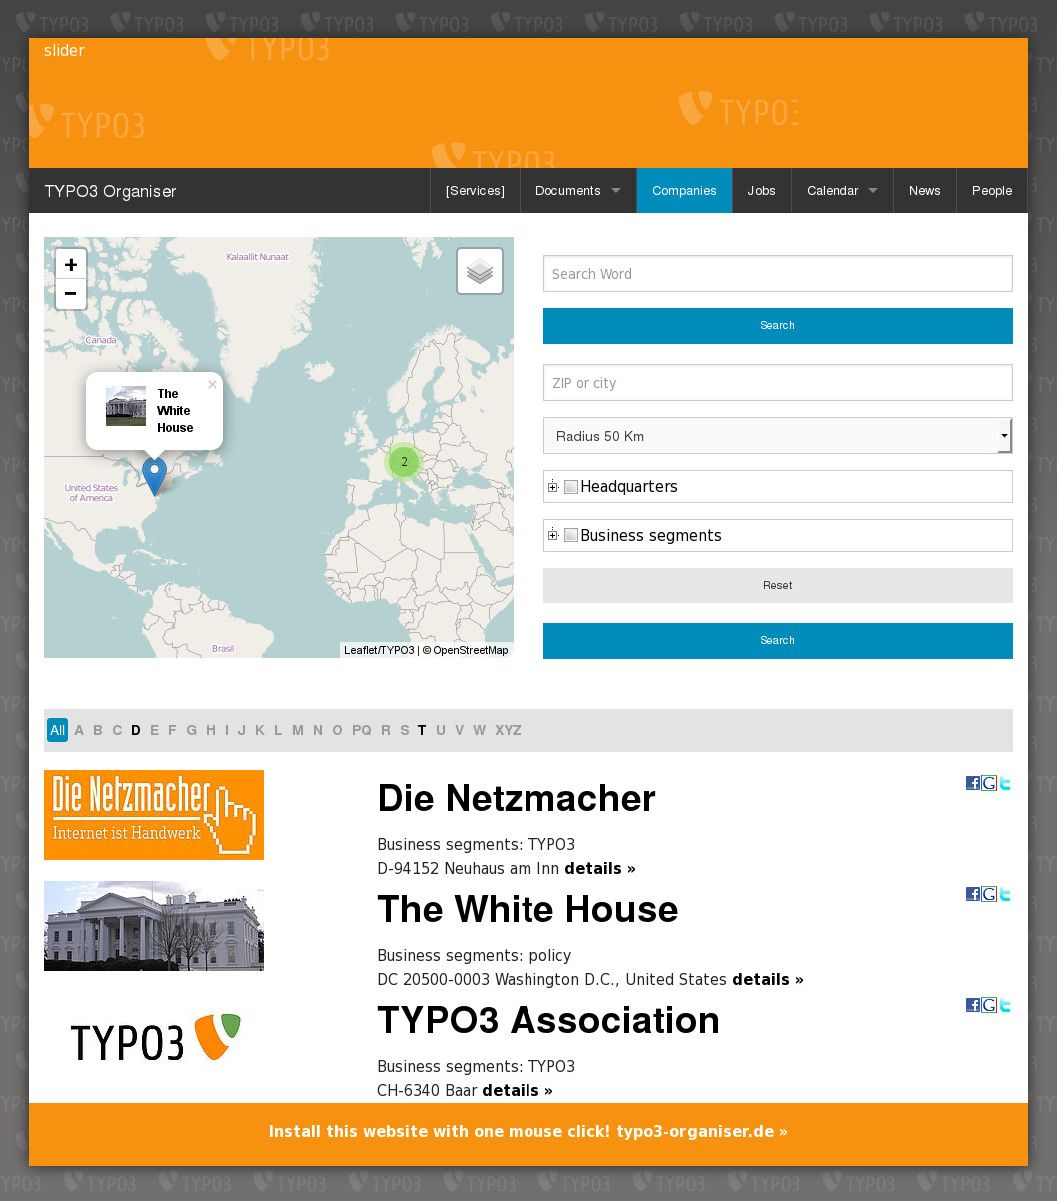Illustration 29: Locations on a desktop ...
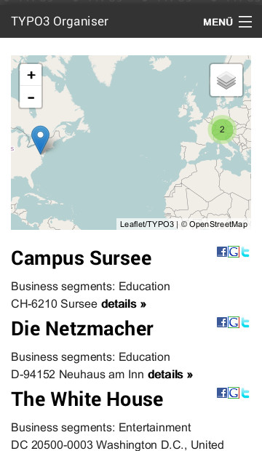Illustration 30: ... and on a smartphone
- Search Form
  - full text search
  - radial search
  - filter for business segments
- Index browser
- Page-browser / record-browser
- Social bookmarks in list and single view
- AJAX supported

Map and georeferenced data
The map is based on Google Maps or Open Street Map. You move from the one to the other by a mouse click.
Maps aren't optimised for desktops, tablets and smartphones. They aren't responsive!

Live examples
- http://typo3-organiser.de

News
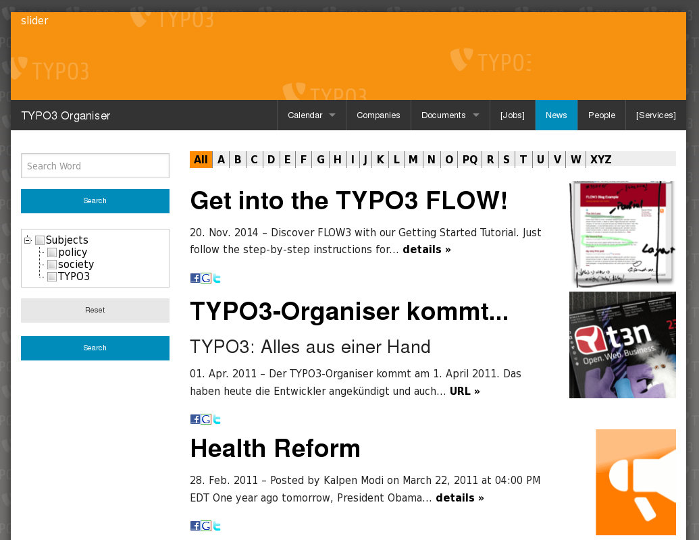Illustration 31: News on a desktop ...
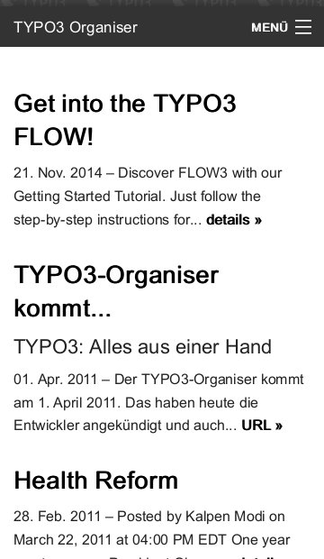Illustration 32: ... and on a smartphone
- Search Form
  - full text search
  - radial search
  - filter for subjects
- Index browser
- Page-browser / record-browser
- Social bookmarks in list and single view
- AJAX supported

Live examples
- http://typo3-organiser.de

People
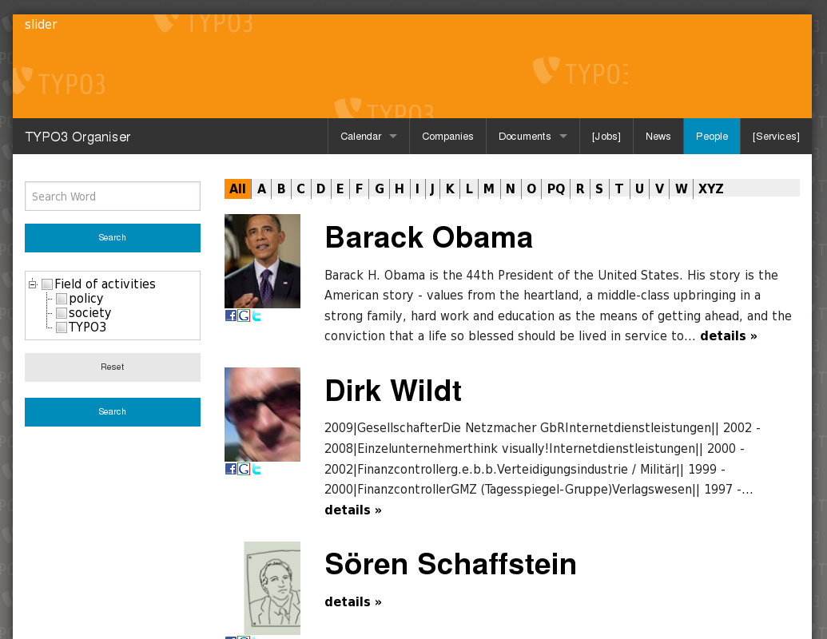Illustration 33: People on a desktop ...
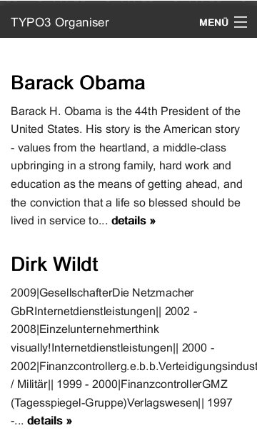Illustration 34: ... and on a smartphone
- Search Form
  - full text search
  - radial search
  - filter for field of activities
- Index browser
- Page-browser / record-browser
- Social bookmarks in list and single view
- vCard in single view
- AJAX supported

vCard
Illustration 35: Donwload the vCard of Barack Obama
Staff data are donwloadable as a vCard file by default.
The vCard is a feature of the Browser – TYPO3 without PHP – and can used by any other extension too.

Live examples
- http://typo3-organiser.de

Caddy
Illustration 36: Caddy on a desktop ...
Illustration 37: ... and on a smartphone
See further information at
- Caddy – responsive Shopping Cart
PDF: http://typo3-caddy.de/typo3conf/ext/caddy/doc/manual.pdf
TER: http://typo3.org/extensions/repository/view/caddy/
If you are using the Organiser Installer, the Installer take care of all properties.

E-payment
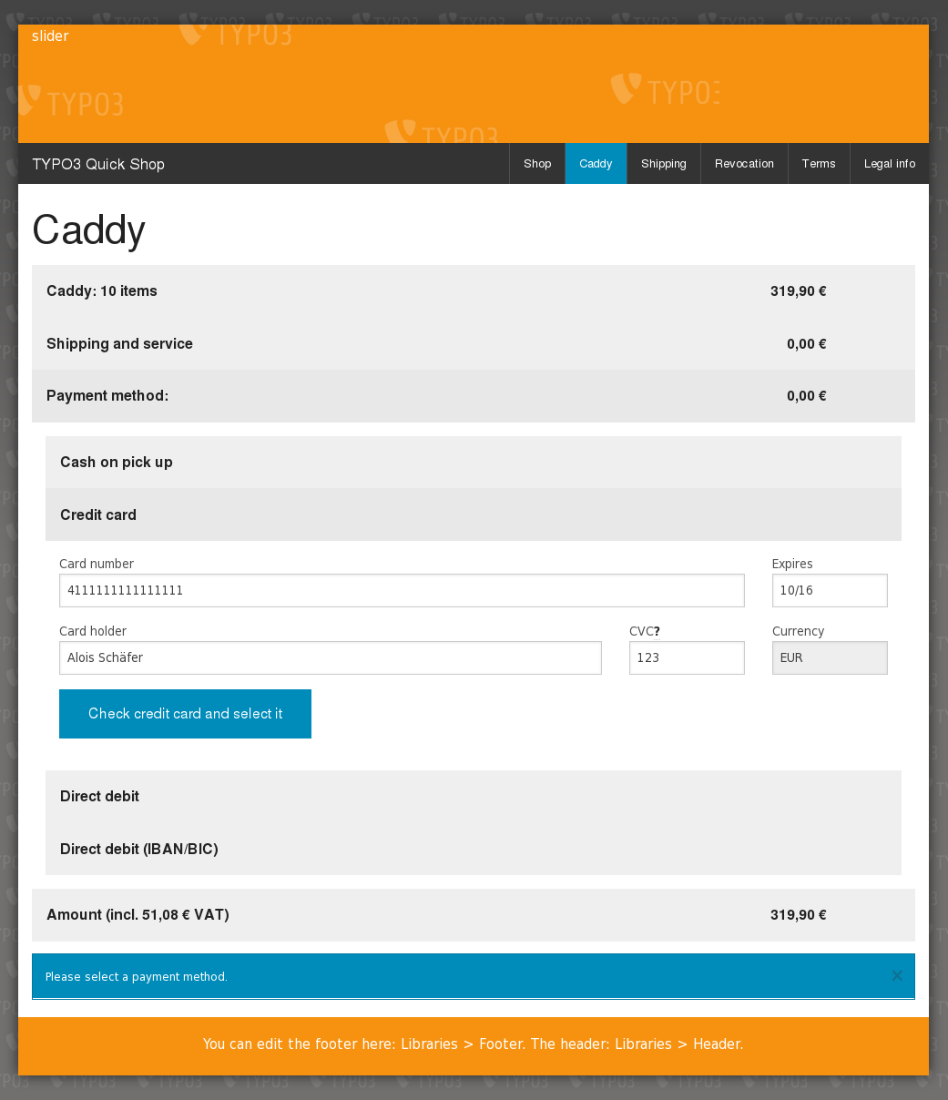Illustration 38: Caddy e-payment (Paymill) in live mode
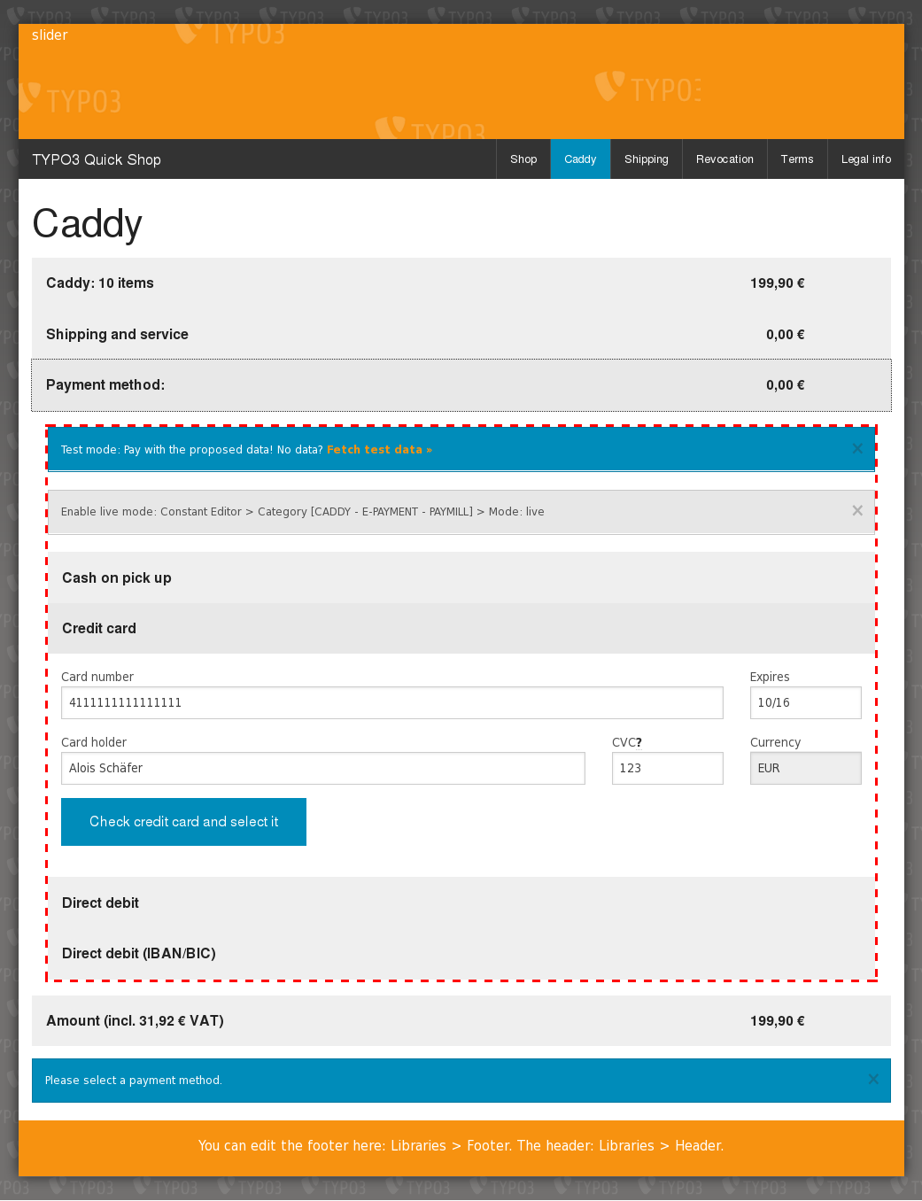Illustration 39: Caddy e-payment (Paymill) in test mode
You can use the Caddy with an e-payment modul. See further information at
- Caddy – responsive Shopping Cart
PDF: http://typo3-caddy.de/typo3conf/ext/caddy/doc/manual.pdf
TER: http://typo3.org/extensions/repository/view/caddy/
Precondition is a contract with an e-payment provider (here: Paymill)

Flip it!
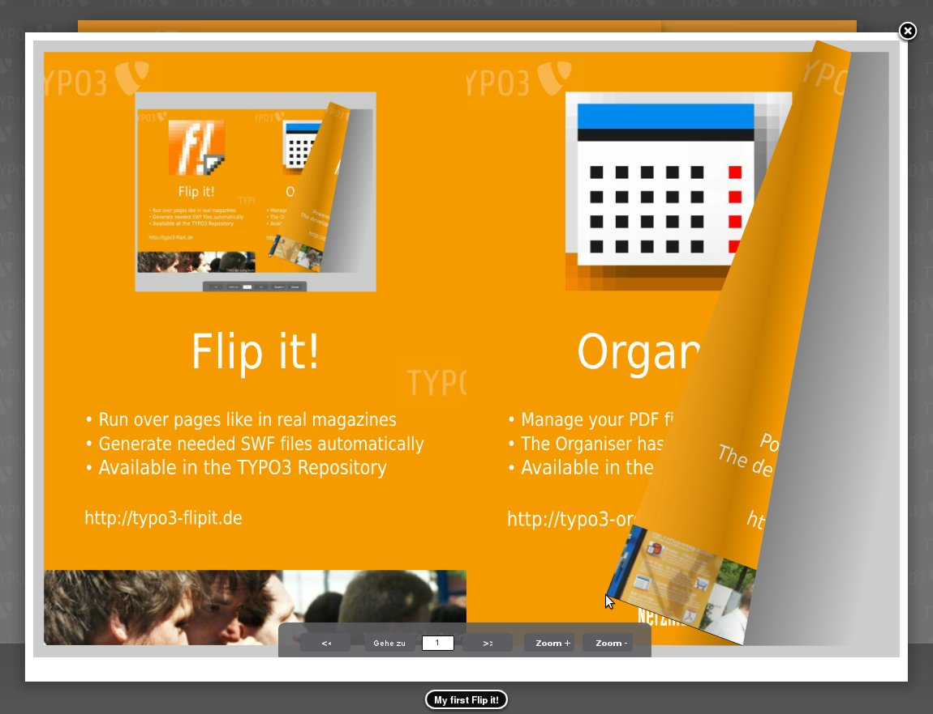Illustration 40: Run over pages like in a real magazine. Flip it! application in the fancybox.
Flip it! enables you to run over pages in PDF documents like in a real magazine. Flip it! offers lovely and smooth page flip transitions. The visitor of your website does not need any PDF plugin but a Flash plugin. Flip it! can convert PDF documents to SWF files automatically.
Further information:
- Flip it!
Website: http://typo3-flipit.de/
PDF: http://typo3-flipit.de/typo3conf/ext/flipit/doc/manual.pdf
TER: http://typo3.org/extensions/repository/view/flipit/
Flip it! isn't responsive. See section "What isn't responsive?" on page 27 below.
If you are using the Organiser Installer, the Installer take care of all properties.

Georeferenced data
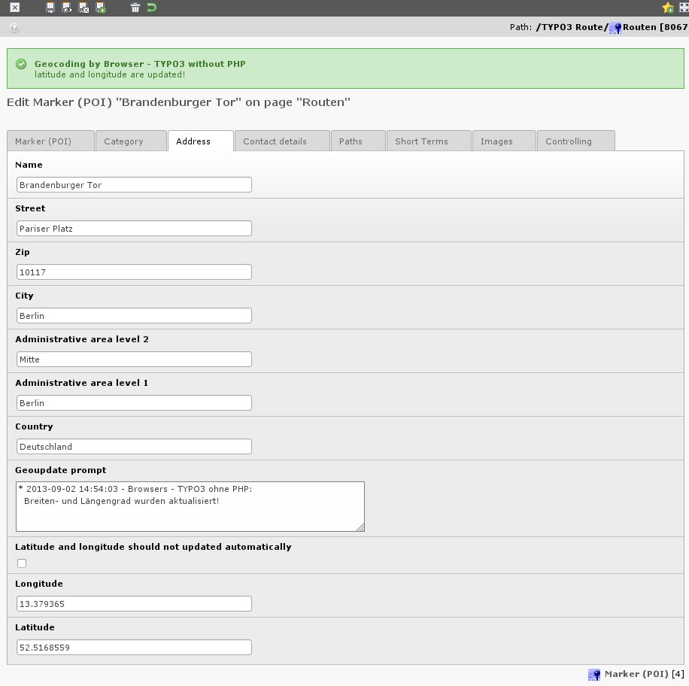Illustration 41: Calculate the geocoding data of your address automatically. Here: example with TYPO3 Route.
BrowserMaps – the modul of the frontend engine Browser – is able to geocode address data.
Geocoding means: your address data get a latitude and a longitude.
BrowserMaps supports automatic geocoding:
- while you are save a record with address data
- by a cronjob for all address data of one table
BrowserMaps is using the Google Geocoding API.
See further information at
- BrowserMaps Tutorial (en)
PDF: http://typo3-browser.de/typo3conf/ext/browser_tut_map_en/doc/manual.pdf
TER: http://typo3.org/extensions/repository/view/browser_tut_map_en/
If you are using the Organiser Installer, the Installer take care of all properties, but the cron job.

Maps (Google Maps, Open Street Map)
See examples at the sections:
- OpenStreetMap: Companies on page 15 above
- Google Maps: Locations on page 18 above
See further information at
- BrowserMaps Tutorial (en)
PDF: http://typo3-browser.de/typo3conf/ext/browser_tut_map_en/doc/manual.pdf
TER: http://typo3.org/extensions/repository/view/browser_tut_map_en/
If you are using the Organiser Installer, the Installer take care of all properties.

Leaflet

Radial Search
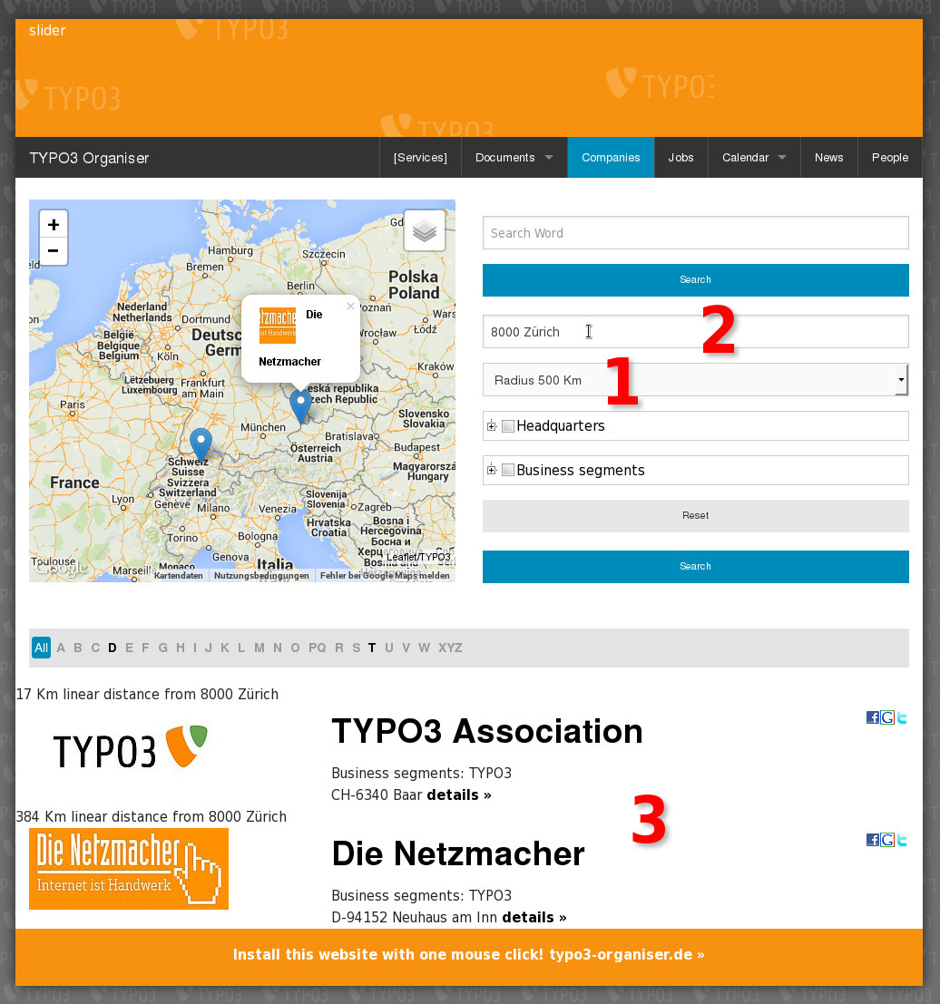Illustration 42: Radial search (1, 2) withihn the given radius (3)
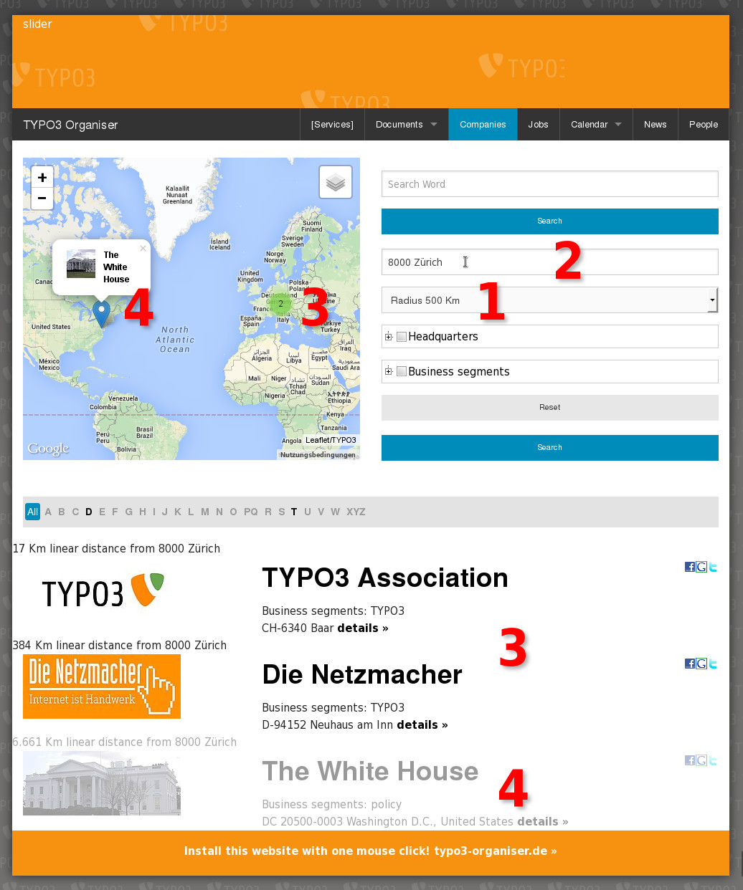Illustration 43: ... and without the given radius (4)
The Radial Search form has both parts:
- An input field for ZIP and city (2) with an auto-complete function.
- A select box with values for a radius (1).
See examples at the sections:
- Companies on page 15 above
- Locations on page 18 above
See further information at
- Radial Search
PDF: http://typo3-organiser.de/typo3conf/ext/radialsearch/doc/manual.pdf
TER: http://typo3.org/extensions/repository/view/radialsearch/
If you are using the Organiser Installer, the Installer take care of all properties.

Responsive

What's responsive?
The Organiser is responsive in principle but Flip it!

What isn't responsive?

Flip it!
Flip it! isn't responsive, because the size of the area is fixed, which contains the PDF document. It won't adapt to the screen size of the device.
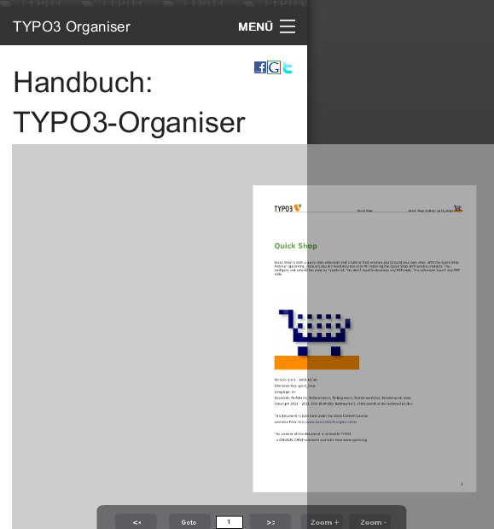Illustration 44: Flip it! on a smartphone
The area outside of the screen is shaded.

SEO – Search Engine Optimisation
Search Engine Optimisation (SEO) is done by SEO Dynamic Tag and can be extended by RealURL.
See
- SEO Dynamic Tag 2 (seo_dynamic_tag)
PDF: http://typo3-organiser.de/typo3conf/ext/seo_dynamic_tag/doc/manual.pdf
TER: http://typo3.org/extensions/repository/view/seo_dynamic_tag/
- Browser Tutorial RealURL (en)
http://typo3.org/extensions/repository/view/browser_tut_realurl_en/
See Constant Editor [SEO DYNAMIC TAG - *].
If you are using the Organiser Installer, the Installer take care of all properties.

Others

+AOE link handler configurator
The AOE link handler enables to link from every content element with an RTE field to certain records in the database.
You are configuring the AOE link handler with the AOE link handler configurator.
And the Organiser has the AOE link handler configurator integrated (since version 3.3). See
- AOE link handler configurator (linkhandlerconf)
http://typo3.org/extensions/repository/view/linkhandlerconf/

Workflow
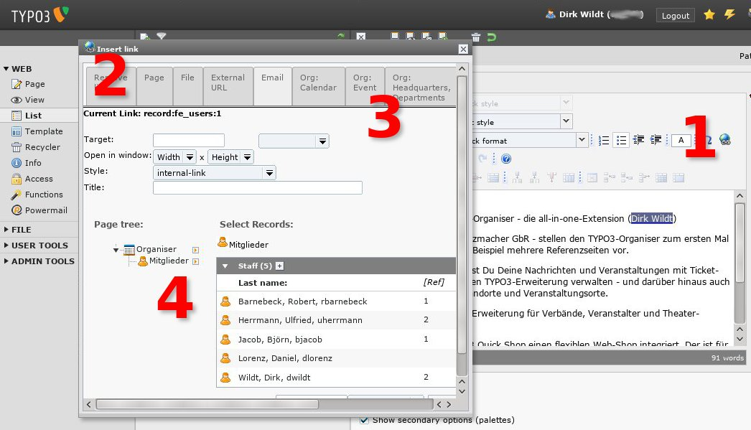Illustration 45: Link from everywhere to everywhere
TYPO3 Organiser enables to link from every RTE-field to every TYPO3 Organiser record.
- RTE field: Click on the link icon
- The link wizard will be opened in a new window.
- The link wizard has tabs for every TYPO3 Organiser record. Select the tab like [Org: Staff]
- The link wizard will display the TYPO3-Organiser page tree. Select the user, you want to link to.

Controlling
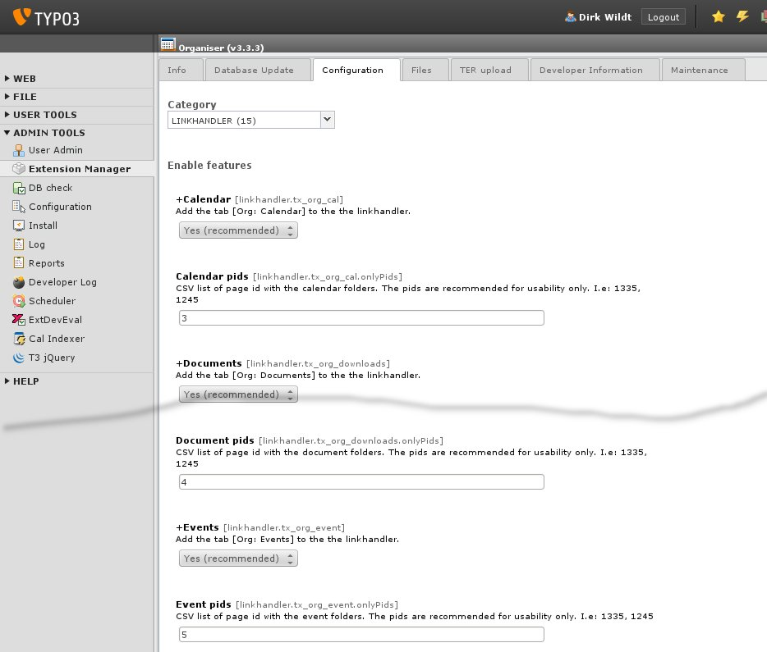Illustration 46: Integrated link handler
You are controlling the AOE link handler by the Extension Manager.
- Modul Admin Tools Extension Manager
- Edit area Organiser (org)
- [Configuration]
- Category [LINKHANDLER]
The user interface should be self-explained.
If you are using the Organiser Installer, the Installer take care of all properties.

Preconditions

TYPO3 6.2 is recommended
TYPO3 6.2 is recommended. Maybe the Organiser runs in smaller versions proper too.

Latest extensions
You are needing the latest extensions! These are
- browser 7.2
- caddy 6.0
- powermail 2.x is recommended, 1.x is proper too

Installation

One click with the Organiser Installer
Illustration 47: Install the Organiser with one click! Installer button (1). Result in the frontend (2) and the backend (3)
Install the Organiser with the Organiser Installer (org_installer):
- http://typo3.org/extensions/repository/view/org_installer/
The one-click-installation is recommended.

Adapt some constants to your needs
See "Constant Editor" on page 39 below.

Controlling by the extension manager

Basic
Check TYPO3 version.
Localise special backend labels.

Downgrade
Some downgrade properties for using deprecated fields from Organiser 4.x.

Geocoding
Enable automatically geocoding.

Hide tables
Hide no needed tables, simplify your backend forms.

Linkhandler
Enable tabs for each Organiser table in the form of the klink wizard.

Simplifyer
Simplify backend forms.

Localise special backend labels
Language for special backend labels like TypoScript static templates and the link handler.

Exclude Organiser fields
Simplify backend forms! Default: The editor has access to most fields. None excluded: The editor has access to all fields like the administrator. All excluded: the editor has access to required fields only like the title. This option has an effect for editors and it hasn't any effect for administrators.
See examples below.

All excluded
All fields should be excluded
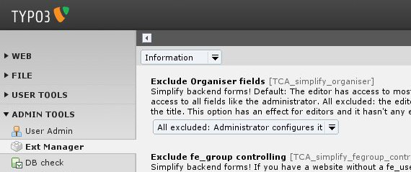Illustration 48: All excluded – the alignment in the extension manager
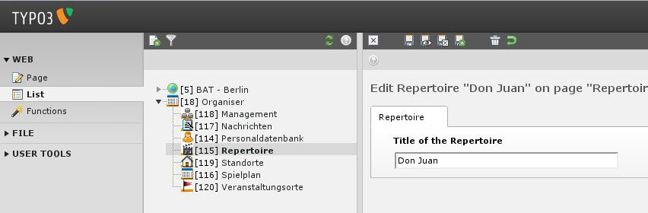Illustration 49: All are excluded: editor has access to required fields only. Here: table repertoire
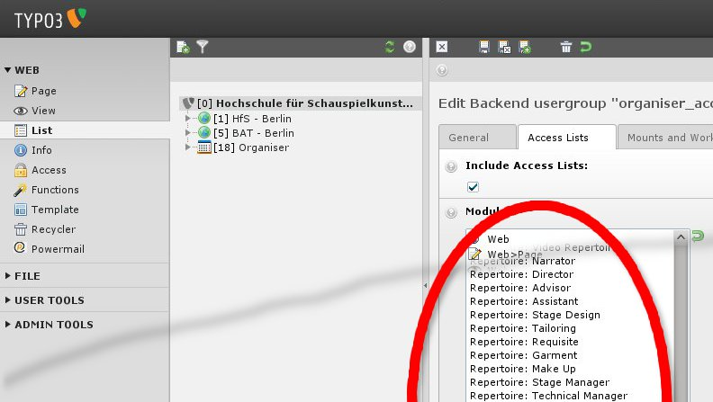Illustration 50: Backend user configuration. The administrator can configure a lot.

The None-Examples
None field should be excluded
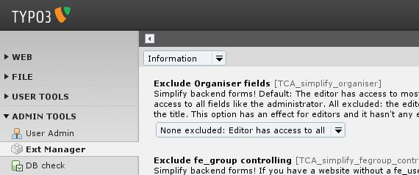Illustration 51: None excluded – the alignment in the extension manager
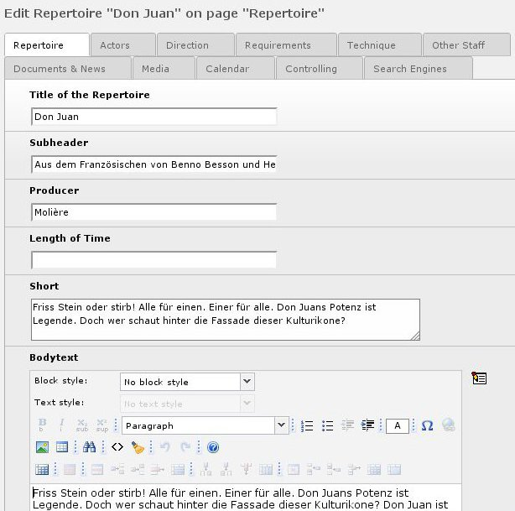Illustration 52: None are excluded: editor has access to all fields. Here: table repertoire
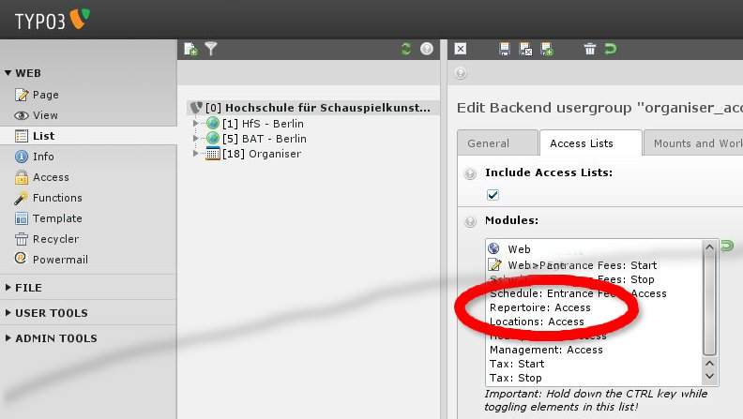Illustration 53: Backend user configuration. The administrator can't configure near by nothing.

Exclude fe_group controlling
Simplify backend forms! If you have a website without a fe_user administration, you don't need the fe_group controlling field in backend forms. This option marks it in organiser tables 'excluded'. This has an effect for editors and it hasn't any effect for administrators.

Exclude time controlling
Simplify backend forms! If you don't want to control records by time, you don't need the time control field in backend forms. This option marks it in organiser tables 'excluded'. This has an effect for editors and it hasn't any effect for administrators.

Don't exclude fe_users fields
The organiser needs some fe_users fields by default. Organiser makes this fields visible by disabling the 'exclude' property. This has an effect for editors only. For administrators all fields are visible anyway.

Store record configuration
[Easy]: less configuration costs. If you want to link from one record to another, both have to be stored in the same directory. It may be confusing in case of a lot of data.
[Clear presented]: each record group has its own directory. I.e. fe_users are in [staff], events are in [calendar]. Disadvantage: you have to configure page TSconfig and you will have some wizards without an add icon and without an list icon.
[Multi grouped]: Same like [clear presented], but record groups can have more than one directory. It enables sophisticated access rules.
See section "FAQ: Store record configuration" in the manual.

Store fe_groups configuration
[Store it everywhere (TYPO3 default)]: You will see fe_groups of the whole website in a flexform fe_groups field. This is the TYPO3 default.
[Managed by general record storage page (not recommended)] If you like to see only fe_groups of a special folder, you can configure it in the page properties with the field "general record storage page".
[Managed by page TSconfig (ID)] If you like to see only fe_groups of a special folder, you can configure it in the page TSconfig with the property PAGE_TSCONFIG_ID.
[Managed by page TSconfig (list)] If you like to see only fe_groups of a special folder, you can configure it in the page TSconfig with the property PAGE_TSCONFIG_IDLIST.
See section "FAQ: Store fe_groups configuration" in the manual.

Full wizard support
If full wizard support is enabled, main records will have all three icons for their category records: edit, add and list. This is best usability. But you have to store category records in the same directory like the main records. You have to rough it, if there are needs to store categories in other directories. This property has only an effect in case of store records [clear presented] or [multi grouped].

Controlling by plugins

Annotation
You are controlling the TYPO3 Organiser with the Browser plugin. The Browser – TYPO3 without PHP – enables the separation of the database (the backend) and the design / work flow (frontend):
Organiser data (database) <> Browser (plugin) <> Organiser output (design)
A Browser plugin is always available.
A plugin enables to configure a lot of things with the mouse:
- Seach form
- A-Z browser
- Page-browser / record browser
- empty page on start
- among others.
The Browser plugin needs a TypoScript template. The TypoScript template controls both:
- the query to the database and the handling of the result
- the connection to an HTML template with so called database markers.
If you like to extend the TYPO3 Organiser or to change queries or templates, it is a good idea to become familiar with the Browser – TYPO3 without PHP. See
- Browser homepage
http://typo3-browser.de
- Browser in the TYPO3 repository
http://typo3.org/extensions/repository/view/browser/
The Organiser has prepared a lot of TypoScript templates, so there isn't any need to configure a TypoScript template, if you are satisfied with the default views and the default work flow.

Plugins in the frontend
This section regards to Organiser 4.x and is deprecated!
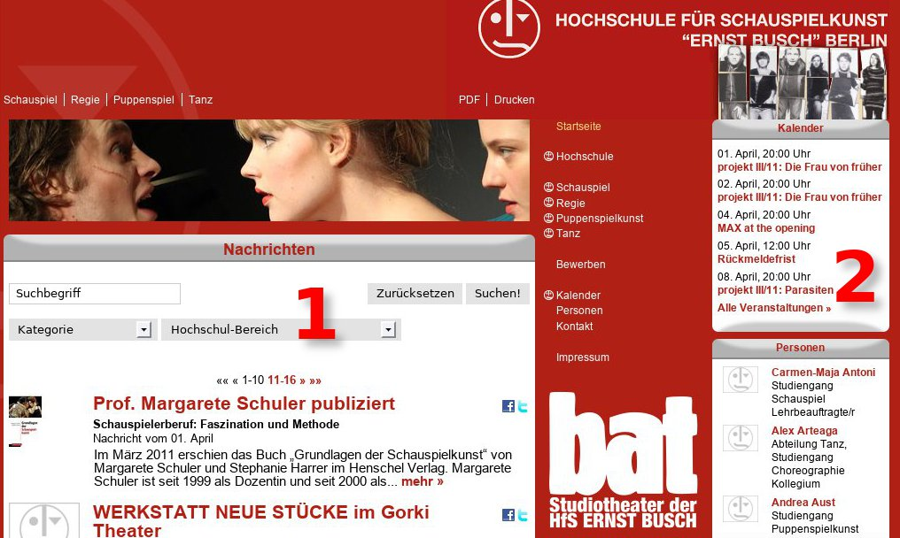
There are two types of plugins:
- main (1) and
- margin (2)
The differences are only, that
- main plugins display the list view and the single view on the same page
- margin plugins display the single view on another page
- usually main plugins are more detailed than margin plugins

Plugins in the backend
The most of this section is applicable, but it regards to Organiser 4.x and is deprecated!
If you are using the Organiser Installer all plugins in the backend are configured.
If you like to change some configurations investigate the illustration below.
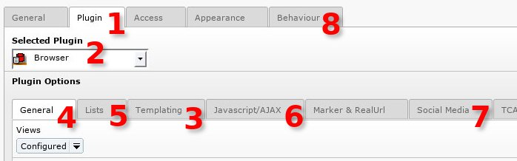Illustration 54: The Browser plugin
- Tab [Plugin]
- Plugin [Browser]
- Tab [Templating]
Select the TypoScript template like calendar or news.
- Tab [General]
Select the available view. The view depends on the selection in the tab [Templating] (3)
- Tab [Lists]
Configure your list view
- Tab [Javascript/AJAX]
Enable AJAX and configure it.
- Tab [Social Media]
Add social bookmarks to your list views and single views.
- Tab [Behaviour]
Don't forget to configure the record storage page. Without it, the Browser hasn't any chance to find the Organiser records.

Main
Prepaired
- +Org: Calendar
- +Org: +Calendar +Caddy
- +Org: +Calendar expired
- +Org: Companies
- +Org: Downloads
- +Org: +Downloads +Caddy
- +Org: +Downloads +Caddy +Flags
- +Org: +Downloads Flip it!
- +Org: Downloads categories
- +Org: Locations
- +Org: News
- +Org: People

Margin
This section regards to Organiser 4.x and is deprecated!
- +Org: Calendar – margin
- +Org: Department – margin
- +Org: Downloads – TOP 5
- +Org: Headquarters – margin
- +Org: Locations – margin
- +Org: News – margin
- +Org: Shopping cart for tickets – margin
- +Org: Staff – margin (don't cache it)

Randomised plugins
It is possible to randomise the content of plugins. There is one plugin prepared:
- +Org: Staff – margin (don't cache it)

Live examples
- "Personen" in the right column of
http://www.hfs-berlin.de/ DEPRECATED
- "TYPO3-Thüringen Mitglieder" in the right column of
http://typo3-thüringen.de/ DEPRECATED

Controlling by TypoScript

Constant Editor
If you have installed the Organiser with the Organiser Installer, all constants should be proper but [ORGANISER STATIC URL] (see below).
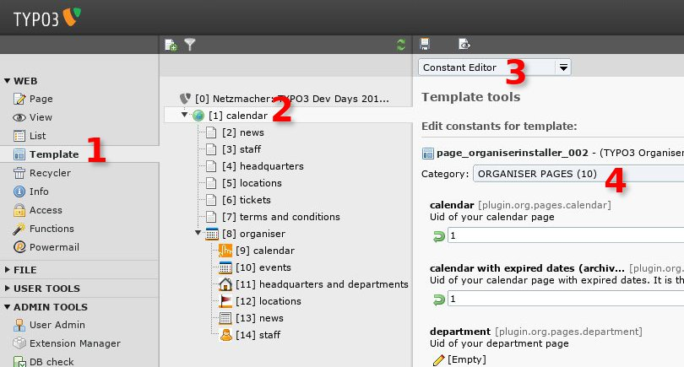Illustration 55: TypoScript Constant Editor
- Modul: Web > Template
- Page tree: root page
- Edit area: [Constant Editor]
- Category [ORGANISER STATIC URL]
The Installer will failed in two cases:
- You aren't using real url
- You haven't installed the organiser on the top-level

TypoScript Object Browser
The most of this section is applicable, but it regards to Organiser 4.x and is deprecated!
The TypoScript Object Browser is your tool, if you like to change TypoScript.
You need it, if you like to change labelling, to wrap fields in a different way or to use other HTML templates.
This manual doesn't repeat the configuring of the Browser – TYPO3 without PHP –, but it explains where to find the TypoScript of the Organiser in principle.
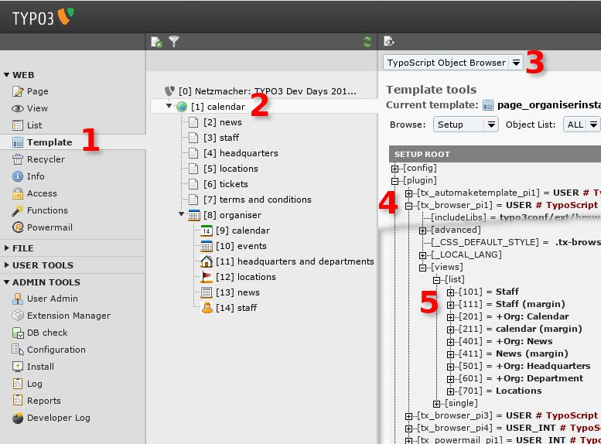Illustration 56: TypoScript Constant Editor
- Modul: Web > Template
- Page tree: root page
- Edit area: [TypoScript Object Browser]
Browse: [Setup]
- Look for plugin.tx_browser_pi1.views.list
- Investigate the array [101] to [701]
If you like to change the configuration for single views, please take a look on plugin.tx_browser_pi1.views.single.
If you like to configure a randomised plugin, you have to configure plugin.tx_browser_pi4.

Controlling the Caddy
Caddy has its own manual. See further information at
- Caddy – responsive Shopping Cart
PDF: http://typo3-caddy.de/typo3conf/ext/caddy/doc/manual.pdf
TER: http://typo3.org/extensions/repository/view/caddy/

Job
The job of Caddy is:
- session management for items
- calculating
- storing orders in the Caddy database (usually on the page with the Caddy plugin)

Plugin
You configure the Caddy with its plugin on the pages "Caddy". See
- Organiser
  - Calendar
    - Caddy
  - ...
  - Documents
    - Caddy
  - ...

TypoScript

Constant Editor
- Modul: Web > Template
- Page tree: root page
calendar > caddy
documents > caddy
- Edit area: [Constant Editor]
- Category [CADDY – ...]

Setup
Please use the Constant Editor in principle.

Caddy
If you like to investigate the TypoScript, please take a look into:

plugin.tx_caddy_pi1 {
...
}

Caddy Mini
If you like to investigate the TypoScript, please take a look into:

plugin.tx_caddy_pi3 {
...
}

Communicating with Powermail
The extension powermail enables the storing of Powermail e-mails.
powermail has its own plugin on the pages "Caddy". The page contains all forms, fieldsets and fields related to the frontend ordering form.
If you are interested in powermail, please refer to:
- Powermail (powermail)
http://typo3.org/extensions/repository/view/powermail/

Page TSconfig

Organiser records
The Organiser Installer configure some page TSconfig in the organiser sysfolders.
The effect is, that a backend user is allowed to add certain Organiser records to certain Organiser sysfolders only. For example:
- People records can added to the people sysfolder only.
You will find the configuration in the page TSconfig of the sysfolder "data" and all subfolders.

Page Tsconfig snippets

Sysfolder Data (here: pid 33)
// Created by ORGANISER INSTALLER at 2014-11-22 10:55:21 -- BEGIN

///////////////////////////
//
// INDEX

// TCEFORM
// organiser tables
// TCEMAIN
// clearCacheCmd
// permissions
// MOD
// web_layout

// PID
// [43] organiser
// [44] calendar
// [46] downloads
// [47] events
// [45] headquarters
// [49] locations
// [50] news
// [51] staff

// organiser tables
TCEFORM {
tx_org_cal_all_tables {
tx_org_cal {
PAGE_TSCONFIG_IDLIST = 43,44
PAGE_TSCONFIG_ID = 44
}
tx_org_calentrance < .tx_org_cal
tx_org_calspecial < .tx_org_cal
tx_org_caltype < .tx_org_cal
tx_org_downloads {
PAGE_TSCONFIG_IDLIST = 43,46
PAGE_TSCONFIG_ID = 46
}
tx_org_downloadscat < .tx_org_downloads
tx_org_downloadsmedia < .tx_org_downloads
tx_org_event {
PAGE_TSCONFIG_IDLIST = 43,47
PAGE_TSCONFIG_ID = 47
}
tx_org_eventcat < .tx_org_event
tx_org_headquarters {
PAGE_TSCONFIG_IDLIST = 43,45
PAGE_TSCONFIG_ID = 45
}
tx_org_headquarterscat < .tx_org_headquarters
tx_org_location {
PAGE_TSCONFIG_IDLIST = 43,49
PAGE_TSCONFIG_ID = 49
}
tx_org_job {
PAGE_TSCONFIG_IDLIST = 43,%pageOrgDataJob_title%
PAGE_TSCONFIG_ID = %pageOrgDataJob_title%
}
tx_org_jobcat < .tx_org_job
tx_org_news {
PAGE_TSCONFIG_IDLIST = 43,50
PAGE_TSCONFIG_ID = 50
}
tx_org_newscat < .tx_org_news
tx_org_service {
PAGE_TSCONFIG_IDLIST = 43,52
PAGE_TSCONFIG_ID = 52
}
tx_org_servicecat < .tx_org_service
tx_org_staff {
PAGE_TSCONFIG_IDLIST = 43,51
PAGE_TSCONFIG_ID = 51
}
tx_org_staffcat < .tx_org_staff
}
tx_org_cal < .tx_org_cal_all_tables
tx_org_calentrance < .tx_org_cal_all_tables
tx_org_calspecial < .tx_org_cal_all_tables
tx_org_caltype < .tx_org_cal_all_tables
tx_org_downloads < .tx_org_cal_all_tables
tx_org_downloadscat < .tx_org_cal_all_tables
tx_org_downloadsmedia < .tx_org_cal_all_tables
tx_org_event < .tx_org_cal_all_tables
tx_org_headquarters < .tx_org_cal_all_tables
tx_org_location < .tx_org_cal_all_tables
tx_org_job < .tx_org_cal_all_tables
tx_org_jobcat < .tx_org_cal_all_tables
tx_org_news < .tx_org_cal_all_tables
tx_org_newscat < .tx_org_cal_all_tables
tx_org_service < .tx_org_cal_all_tables
tx_org_servicecat < .tx_org_cal_all_tables
tx_org_staff < .tx_org_cal_all_tables
tx_org_staffcat < .tx_org_cal_all_tables
}
// organiser tables
// TCEFORM

////////////////////////////////////////////////////////////////////////
//
// TCEMAIN

TCEMAIN {
clearCacheCmd = pages
permissions {
// 1: organiser
groupid = 1
group = show,edit,delete,new,editcontent
}
}
// TCEMAIN

///////////////////////////
//
// MOD

mod {
web_list {
// Deny all tables!
allowedNewTables = xxx
}
}
// MOD

// Created by ORGANISER INSTALLER at 2014-11-22 10:55:21 -- END

Sysfolder Calendar (here: pid 34)
// Created by ORGANISER INSTALLER at 2014-11-22 10:55:21 -- BEGIN

mod {
web_list {
allowedNewTables (
tx_org_cal,
tx_org_calentrance,
tx_org_calspecial,
tx_org_caltype,
tx_org_tax
)
}
}

// Created by ORGANISER INSTALLER at 2014-11-22 10:55:21 -- END

CSS

Remove the default CSS
The Organiser and the other used TYPO3 extensions are adding a default CSS file to your website. If you don't like it, please configure
plugin.tx_browser_pi1._CSS_DEFAULT_STYLE
...
page.includeCSS... <- Look for EXT:browser/..., EXT:caddy/..., EXT:org/...

Add your own CSS
If you like to have an own CSS file, you can upload it in the folder fileadmin for example. You have to add the CSS file like in the snippet below.
page.includeCSS.myCss = fileadmin/...

SEO and RealUrl
Please refer to the section "SEO – Search Engine Optimisation" on page 27 above.

DRS – Development Reporting System
Because the Organiser is based on the Browser – TYPO3 without PHP –, the Organiser is supported by the DRS – the Development Reporting System. You enable the DRS with the extension manager of the Browser. If the DRS is enabled, you will receive a report in the backend. It is supporting you in case of errors or if you like to develop the Organiser.

Reference
It is recommended to use the Constant Editor for managing TypoScript properties!
The Organiser hasn't any own plugin. If you like to configure TypoScript directly please use

plugin.tx_browser_pi1 {
...
}

Completely browser reference
You find an overview with a manual in detail and all tutorials with the Browser – TYPO3 without PHP – here:
- Browser manuals and tutorials
http://typo3-browser.de/en/browser-tutorials/

Upgrades

From version < 6.0

Non possible
Bad news: It isn't possible to upgrade from a former version to 6.x. I'm sorry.

Reasons
The relation management is simplified: All relations need one table only, in the past each relation had needed an own table. See details in the section "One table for all relations" on page 61 below.
The Organiser took some new conventions from TYPO3 6.x. In the follow TypoScript templates got another path.
The Organiser has new CSS classes, because of the movement to a responsive Shop.
The table department is removed. See "Departments (tx_org_department) are removed" on page 62 below.
All Organisers fields in fe_users are removed, all relations to fe_users aer removed. See ""Frontend users" (fe_users) are removed" on page 62 below.

Workflow
If you upgrade to version 6.x, please don't remove the former relation tables. Migrate the former relation data to the new relation table.
Include the lost static templates again.
Include the needed static templates for foundation or create your own CSS.
Alternative: Install a new Organiser with the Organiser Installer. Move your items and categories to the new item folder. Link each item to the proper categories again.

Symplifyer
The names of the property parameters has changed. Please update the simplifyer properties.
- Admin Tools > Extension Manager > Organiser (org) > [simplifyer]

Support
- If you have a need for an upgrade, maybe you have some hundred items, you can get professional support by the developer. See "Professional Support" on page 71 below.

Update your database!
You have to upgrade your database.
Be aware that you can lose data, if you are removing tables and fields.
- Web modul > SYSTEM > Install
- Important actions: [Compare current database with specifications]

Update from < 3.x

Add new Tables and Fields
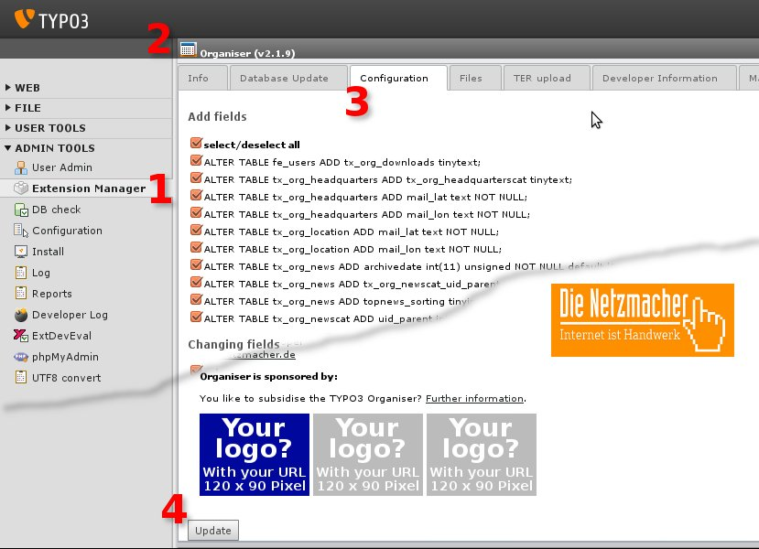Illustration 57: Update the Organiser within your Extension Manager
- Modul: Admin Tools > Extension Manager
- Edit area: Select the Organiser (org)
- Select the tab [Configuration]
- Click [Update]
Sometimes you don't see the list of "Add fields". Please click the [Update]button once: You will see the list "Add fields". If not, there is nothing to do.

Check included static templates!
There was a bug in version below 2.1: the paths to some TypoScript templates were without an ending slash.
This bug is fixed with version 2.1.
Because of this bugfix you must include some static templates again after an update to 2.1.x.
Please check your included templates!
Effected templates:
- static/calendar/201/expired +Org: Calendar +expired
- static/downloads/301 +Org: Downloads
- static/downloads/311 +Org: Downloads – Top 5
- static/downloads/302 +Org: Downloads categories
- static/headquarters/501 +Org: Headquarters
- static/headquarters/511 +Org: Headquarters – margin
- static/location/701 +Org: Locations
- static/location/711 +Org: Locations – margin
- static/news/401 +Org: News
- static/news/411 +Org: News – margin
- static/news/499 +Org: News (RSS)

TYPO3 < 4.7: Include the 4.6 template
If you are run TYPO3 with a version smaller than 4.7, you have to include the static template
- +Org: Basis for TYPO3 < 4.7 (obligate!)
Please include it below (after) all other Organiser templates!

Install cps_tcatree
Organisers news categories are ordered in a tree from version 3.0.
You need the extension
- Record tree for TCA (cps_tcatree)

Maintain the plugins / flexforms
The Organiser from version 3.0.1 doesn't need any own HTML template. See "Any own HTML template for list views and single views" on page 63 below. Up to version 2.1 the Organiser needs for each view two templates.
But you have to need update each plugin with an Organiser template.
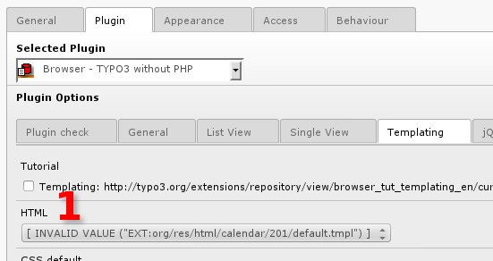Illustration 58: Invalid template value after the update
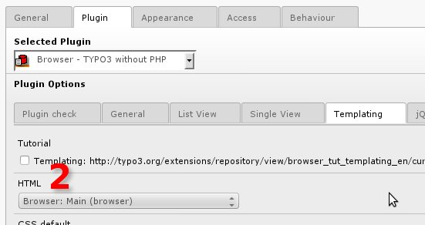Illustration 59: Please select the template "Main" or "Margin"
The Browser is provided with the two templates:
- Main and
- Margin
Main is the template for rich content: the plugin is placed in the content area of your website usually. The HTML code supports the styling by jQuery UI themes.
Margin is the template for reduced content: the plugin is placed in the marginal columns of your website usually. The HTML code is small. It doesn't support AJAX, the index browser, the page browser nor jQuery UI themes. The margin HTML template doesn't contain the needed HTML code for a single view.

Move from wt_cart to Caddy
It is recommended to move from the former shopping cart wt_cart to the current shopping cart Caddy.
Please replace all wt_cart plugins with Caddy plugins.
Remove wt_cart templates and include the static templates for Caddy.
Maybe the best is, to install the Organiser with the Organiser Installer, and move the generated Caddy pages near to the former wt_cart pages.
The Quick Shop manual has a section, how to update from wt_cart to Caddy manually. Please refer to
- Quick Shop (quick_shop)
http://typo3.org/extensions/repository/view/quick_shop/
Sorry for missing more detailed information.

Check the Browser-Update-Wizard!
Please check with the Update Wizard of the Browser – TYPO3 without PHP – if your configuration is proper.
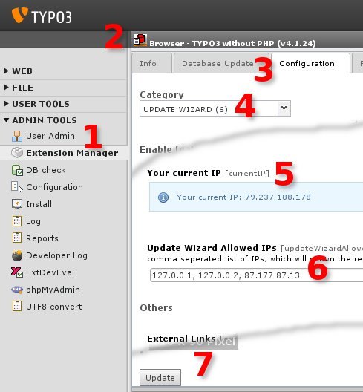Illustration 60: The TYPO3-Browser Update Wizard

- Modul: Admin Tools > Extension Manager
- Edit area: Select the Browser – TYPO3 without PHP (browser)
- Select the tab [Configuration]
- Select Category [UPDATE WIZARD]
- Copy your current IP and ...
- paste it into the field with the list of the allowed IPs
- Click [UPDATE]

If you reload your page with an Organiser content you will get a report.

+AOE link handler configurator
Please update the link handler configuration.

SEO Dynamic Tag 2
Please update the configuration of SEO Dynamic Tag 2.

SQL Migration
This section is relevant only, if you like to migrate data from a deprecated Organiser version into the Organiser 6.x.
This section is under construction.

From Organiser 4.x to 6.x

fe_groups, fe_users -> tx_org_staff, tx_org_staffgroup
The sample below is based on a fe_users table, which contains only Organiser users.

Remove users and groups
tx_org_staff and tx_org_staffgroup must be empty.
If they aren't empty, the best way is, to remove all records supported by the backend. See the folder "staff". If you are remove all records in this folder, all related files like images will remove too.
After removing please empty the recycler (see modul WEB > Recycler).
A SQL statement (not recommended):
- TRUNCATE tx_org_staff;
TRUNCATE tx_org_staffgroup;

Remove relations
Check, if relations are removed.
A SQL statement is:
- SELECT * FROM `tx_org_mm_all` WHERE `table_local` LIKE '%staff%' OR `table_foreign` LIKE '%staff%';
If this statement returns records, please remove this records with
- DELETE FROM `tx_org_mm_all` WHERE `table_local` LIKE '%staff%' OR `table_foreign` LIKE '%staff%';

Migrate groups
INSERT INTO tx_org_staffgroup (uid, pid, tstamp, crdate, cruser_id, title, hidden, deleted)
SELECT uid, pid, tstamp, crdate, cruser_id, title, hidden, deleted FROM fe_groups;

Migrate users
INSERT INTO tx_org_staff (crdate, cruser_id, deleted, hidden, contact_email, endtime, contact_fax, name_first, image, name_last, pid, starttime, contact_phone, title, tstamp, tx_org_downloads, tx_org_headquarters, imagecaption, imageseo, tx_org_news, bodytext, uid, tx_org_staffgroup, url)
SELECT crdate, cruser_id, deleted, disable, email, endtime, fax, first_name, image, last_name, pid, starttime, telephone, name, tstamp, tx_org_downloads, tx_org_headquarters, tx_org_imagecaption, tx_org_imageseo, tx_org_news, tx_org_vita, uid, usergroup, www FROM fe_users;
The SQL statement above doesn't copy all data from fe_users to tx_org_staff.
Don't remove fe_users records yet, because we will need it later probably.

Migrate relations
Groups
SELECT uid, usergroup FROM fe_users ORDER BY usergroup;
Copy the result into a calculator sheet like Excel or Libre Office.
If there is more than one relation per a record, please edit this record like in the sample below:
uid usergroup
3 4,15
will become
uid usergroup
3 4
3 15
Code a SQL statement ,like in the sample below:
INSERT INTO tx_org_mm_all (uid_local, uid_foreign, table_local, table_foreign) VALUES
(1, 4, 'tx_org_staff', 'tx_org_staffgroup'),
(4, 4, 'tx_org_staff', 'tx_org_staffgroup'),
...
(204, 25, 'tx_org_staff', 'tx_org_staffgroup');
News
Relation is from tx_org_news (local) to tx_org_staff (foreign).
INSERT INTO tx_org_mm_all (uid_local, uid_foreign, sorting, sorting_foreign, table_local, table_foreign)
SELECT uid_foreign, uid_local, sorting_foreign, sorting, 'tx_org_news', 'tx_org_staff' FROM fe_users_mm_tx_org_news;
Departments
In the sample below
- the former department groups become the parent object of all former departments
- all former department groups and all former departments will move to the companies table
- all former departments haven't any images
- all former companies will hide
Maybe this isn't true in your migration case.
Departmentscat
INSERT INTO tx_org_headquarters (migrateduid, migratedtable, pid, tstamp, crdate, cruser_id, sorting, deleted, hidden, title)
SELECT uid, 'tx_org_departmentcat', pid, tstamp, crdate, cruser_id, sorting, deleted, hidden, title FROM tx_org_departmentcat;
Departments
INSERT INTO tx_org_headquarters (crdate, cruser_id, deleted, description, documents, documents_from_path, documentscaption, documentslayout, documentssize, email, embeddedcode, fax, fe_group, fe_users, hidden, image, image_compression, image_effects, image_frames, image_link, image_noRows, image_zoom, imageborder, imagecaption, imagecaption_position, imagecols, imageheight, imageorient, imageseo, imagewidth, keywords, l10n_diffsource, l10n_parent, manager, pages, pid, sorting, sys_language_uid, telephone, title, tstamp, tx_org_cal, tx_org_news, migrateduid, url, migratedtable)
SELECT crdate, cruser_id, deleted, description, documents, documents_from_path, documentscaption, documentslayout, documentssize, email, embeddedcode, fax, fe_group, fe_users, hidden, image, image_compression, image_effects, image_frames, image_link, image_noRows, image_zoom, imageborder, imagecaption, imagecaption_position, imagecols, imageheight, imageorient, imageseo, imagewidth, keywords, l10n_diffsource, l10n_parent, manager, pages, pid, sorting, sys_language_uid, telephone, title, tstamp, tx_org_cal, tx_org_news, uid, url, 'tx_org_department' FROM tx_org_department;
uid_parent
Internal documentation: tx_org_departments.ods > uid_parent
manager
Internal documentation: tx_org_departments.ods > manager
news
Internal documentation: tx_org_departments.ods > news
staff
Internal documentation: tx_org_departments.ods > staff

Migrate images
SELECT image FROM fe_users WHERE image <> "" LIMIT 0 , 1000;
Copy the image values into a calculator sheet like Excel or Libre Office.
Get the copy statement for all images like in the sample below. The last row is the result of a formula like:
=CONCATENATE("cp -a ",B2,A2," ",C2)
my_image.jpg | uploads/pics/ | uploads/tx_org/ | cp -a uploads/pics/my_image.jpg uploads/tx_org/
Copy all formula into the console of your server.

From tt_news to Organiser

Precondition
The uids from tt_news will taken: your Organiser news table must be empty!
You must copy the news images and nes files to the organiser folder. Below there is only an example for a console. If there isn't any console available on your server, you must copy the images with ftp. If you have another idea, please contact me: I will update the manual.

Backup your Database
It is recommended to backup your database.

SQL-File
Resources/Private/Migration/tt_news/statements.sql

Categories

Overview

SQL statements
See: Resources/Private/Migration/tt_news/statements.sql

Relations

Overview

SQL statements
See: Resources/Private/Migration/tt_news/statements.sql

Images
If a news have more than one image, there is a list of images, separated by commas.
We need all images in one column. Therefor
- we are exporting images,
- put all in one column and
- generate a copy statement for the console by a formula.

SQL statements
# Get list of images and files for CSV export
SELECT image FROM tt_news_cat WHERE image != '';
SELECT image FROM tt_news WHERE image != '';
SELECT news_files FROM tt_news WHERE image != '';

CSV and Formula
Import result as comma separated values (CSV), cells devided by comma.
Move all columns to one column.
Add to the first row of the second column this formula:
=CONCATENATE("cp -a uploads/pics/",A1, " uploads/tx_org/",A1,";")

If you have this value in the first row of the first column:
typo3_quick_shop_icon_01.jpg

you will get this statement for your console:
cp -a uploads/pics/typo3_quick_shop_icon_01.jpg uploads/tx_org/typo3_quick_shop_icon_01.jpg;

News

Overview
tx_org_news | tt_news | Import | Note
uid | uid | x
pid | pid | x
tstamp | tstamp | x
crdate | crdate | x
cruser_id | cruser_id | x
sys_language_uid | sys_language_uid | x | <- Proper, if you have same language uids
l10n_parent | l18n_parent | x | <- Proper, if you have same language uids
l10n_diffsource | l18n_diffsource | x
deleted | deleted | x
archivedate | archivedate | x
bodytext | bodytext | x
datetime | datetime | x
documents_from_path
documents | news_files | x
documentscaption
documentslayout
documentssize
embeddedcode
endtime | endtime | x
fe_group | fe_group | x | <- Proper, if you have same frontend groups uids
hidden | hidden | x
marginal_title
marginal_subtitle
marginal_short
image | image | x
imagecaption | imagecaption | x
imageseo | imagetitletext | x
imageheight
imagewidth
imageorient
imagecols
imageborder
imagecaption_position
image_link
image_zoom
image_noRows
image_effects
image_compression
image_frames
page | page | x
pages
seo_keywords | keywords | x
seo_description
starttime | starttime | x
subtitle | short | x
teaser_title | tx_newscomfort_title | x | <- Proper in case of extension newscomfort
teaser_subtitle | tx_newscomfort_subheader | x | <- Proper in case of extension newscomfort
teaser_short | tx_newscomfort_short | x | <- Proper in case of extension newscomfort
title | title | x
topnews
topnews_sorting
tx_org_event
tx_org_headquarters
tx_org_newscat | category | x
tx_org_newscat_uid_parent
tx_org_staff
type | type | x
url | ext_url | x
 | author
 | author_email
 | editlock
 | imagealttext
 | links
 | no_auto_pb
 | related
 | t3_origuid
 | t3ver_count
 | t3ver_id
 | t3ver_label
 | t3ver_oid
 | t3ver_stage
 | t3ver_state
 | t3ver_tstamp
 | t3ver_wsid
 | tx_newscomfort_city |  | <- Only in case of extension newscomfort
 | tx_newscomfort_citylong |  | <- Only in case of extension newscomfort
 | tx_newscomfort_country |  | <- Only in case of extension newscomfort

SQL statements
See: Resources/Private/Migration/tt_news/statements.sql

What's new?

7.5

News: Group Table
[7.4.0]
Group table for news.
You have to update the Page TSConfig of the data folder and the news folder

PDF Controller: News Template
[7.5.0]
News template for PDF Controller
- list view
- single view

7.3

Backend filter
[7.3.0] Search form for items in the TYPO3 backend. See
- Screen shots > Backend Filter on page 7 above

7.2

Clearing lightbox
[7.1.0]
Clearing lightbox is running. Sorry, that there was a bug until version 7.0.7.

First Image only for List Views
[7.1.1]
The Browser – TYPO3 without PHP – supports the new feature: display the first image in list views only.
This property is configurable in the record of each news.
Organiser news is extended for this feature.

News Templates
[7.1.1/7.1.0]
News got some more templates:
- mini news
- simple news
- slick carousel news
- solo news
News templates got some more properties :
- top news (it's a query, you can enable it by the plugin)
- news margin is configurable by Constant Editor. See category [Browser Template] header and text 3
- news margin got a wrap <div class="row">|</div>

tt_news Migration
[7.1.0]
You can migrate tt_news to Organiser news. SQL statements are applicable. See:
- "From tt_news to Organiser" on page 56 above

vCard
[7.2.0]
You can download staff data as a vCard file.
The vCard is configurable by the Constant Editor.

7.0

Leaflet
[7.0.0]
Integration of Leaflet, a mobile-friendly interactive map (responsive). See details at
- http://leafletjs.com/features.html

RSS feeds
[7.0.6]
- jobs got a RSS feed
- calender got a RSS feed

6.0

Alias for showUid
[6.0.0]
The URL parameter showUid is moved to itemUid. This avoids conflicts, if you are using the TYPO3-frontend-engine Browser – TYPO3 without PHP – for other issues too.

Automatically installation of fixed extensions
[6.0.0]
The Organiser 6.x needs some extensions, that are broken in TYPO3 6.2 and can't update by a download of the TYPO3 Repository unfortunately.
The Organiser installs fixed versions of these extensions automatically. These extensions are:
- cps_devlib
- cps_tcatree
- linkhandler

One table for all relations
[6.0.0]
Relation management is simplified:
- tx_quickshop_products_category_mm
- tx_quickshop_products_dimension_mm
- tx_quickshop_products_material_mm
Are replaced by
- tx_quickshop_mm

Departments (tx_org_department) are removed
[6.0.0]
Departments (tx_org_department) are removed.

"Frontend users" (fe_users) are removed
[6.0.0]
Organiser staff was managed by the frontend users table fe_users. The Organiser 6.0 has the new table people (tx_org_staff). All Organiser fields in fe_users and all relations to the fe_users are removed.

Georeferencing automatically
[5.0.0]
The address data of the both tables headquarters and locations can georeferenced automatically.

Jobs
[6.0.0]
New table and templates (TypoScript and HTML) for managing jobs.

Newsletter for Jobs
[5.0.15]
The job table got a newsletter field. The Organiser got a template for a job newsletter. Newsletter is based on Direct Mail.

People
[6.0.0]
Own table for managing people and staff.

Responsive
[6.0.0]
Organiser (display of items) and Caddy (ordering and payment) are responsive. Both are using the responsive framework Foundation.

Services
[6.0.0]
New table and templates (TypoScript and HTML) for managing services.

Teaser fields
[6.0.0]
Teaser fields for list views. If a teaser field contains content, this content will display in list views. If it is empty, the content of the title and short will display.

Type is respected in maps
[5.0.10]
The value of the type field of an record is respected in Browser Maps automatically.
Values are: no link, single view, internal page and external URL.

Type No Link
[5.0.10]
All tables are extented with the type "no link". If "no link" is enabled, a record is visible in list views any link neither to a single view, a internal page nor an external URL.

TYPO3 6.2
[6.0.0]
Organiser is upgraded for TYPO3 6.2

4.0

Hierarchical Companies
[4.1.0]
You can order companies hierarchical (backend only).

Hierarchical Companies Categories
[4.1.0]
You can order companies categories hierarchical. The

Radial Search Sample (Umkreissuche)
[3.4.0]
Companies has a Radialsearch sample. You have to import the needed postal code data (one click). See:
- TER: http://typo3.org/extensions/repository/view/radialsearch
- Manual (PDF): http://typo3-route.de/typo3conf/ext/radialsearch/doc/manual.pdf
Look for the section "Import postal code data"

TYPO3 6.1
[4.0.0]
Fit it into TYPO3 6.1

3.0

Any own HTML template for list views and single views
[3.0.1]
The Organiser from version 3.0.1 doesn't need any own HTML template for a list view nor for a single view. Upto version 2.1 the Organisers has needed 15 HTML templates.
Any own HTML template is a big advantage, if you have a need to change something in the HTML code in the Organiser templates or in your templates.
Because of this new feature, unfortunately you have to update each plugin / flexform, which is using the Organiser.
See "Maintain the plugins / flexforms" on page 52 above.

Caddy
[3.3.3]
Caddy replaces wt_cart. Variants aren't buggy any longer, you don't need any inofficial fixed wt_cart version. Caddy has some new features like a powerful plugin and PDF attachments among others.

Flip it!
[3.1.0]
The Organiser has TYPO3 Flip it! integrated. You can page flip in PDF files like in real magazines.

jQuery theme support
[3.0.0]
All HTML templates and all TypoScript templates are improved for jQuery themes. You can select one of 23 themes with the plugin / flexform of the TYPO3 browser.

HTML5 support
[3.0.0]
The Organiser supports HTML5 from TYPO3 4.7 in principle. See "People" on page 20 above.

News categories as tree view
[3.0.0]
News categories are ordered in a tree view in the backend and in the frontend.

Powermail version 1.x and 2.x
[3.3.3]
The Organiser can handle Powermail in both versions – 1.x and 2.x.

SEO Dynamic Tag
[3.3.0]
The Organiser has SEO Dynamic Tag 2 integrated.

Smart Extension Manager
[3.0.0]
The extension manager checks your TYPO3 version. Depending on your version you will get helpful prompts.

2.1
Tip: See Change log from 2.0 to 2.1

BrowserMaps and OpenStreetMap
[2.1.7]
The tables companies and companiescat are ready for use with BrowserMaps. The got some fields in context with georeferencing.
See
- "Companies with categories, icons and offsets" on page 64 below
http://typo3-browser.de/en/browsermaps/

Departments with multiple managers
[2.1.5]
A department can get more than one manager. Relation to fe_users is moved from 1:1 to 1:n.

Download Manager
[2.0.15, 2.0.9]
Organiser manages your downloads. Visits and downloads will be counted. Download links are controlled by the fe_user access management. Organiser provides a TOP 5 plugin for the most downloaded documents.

Companies with categories, icons and offsets
[2.1.7, 2.1.4, 2.1.3]
The table companies got a category table and a field for a longitude and a latitude. It is best prepared for use BrowserMaps – the Maps modul of the Browser – TYPO3 without PHP. The companies category table manages icons. The icons are used in the map and in the filter for the map.

jQuery
[2.0.15]
Integration jQuery UI

2.0

fe_groups Relation
[2.0.1]
Relations between
- fe_user.usergroup -> fe_groups.uid
fe_groups.subgroup -> fe_groups.uid
can be configured by the extension manager and page TSconfig. See XXX.

Localisation
[2.0.0]
All Organiser tables are localised.

Record browser
[2.0.0]
All Organiser single views got a record browser.

FAQ

Bugs

I get a SQL-error reported by the Browser – TYPO3 without PHP
If you get this error after an update of the Organiser, please update the Organiser within the Extension Manager.
See
- TYPO3 6.x: "Update your database!" on page 50 above.
- TYPO3 4.x: "Add new Tables and Fields" on page 51 above.

I get an empty page
One possible cause can be less memory. Please increase the memory_limit of your PHP ini.

// TYPO3 organiser
php_admin_value memory_limit 60M

Enable display errors in the TYPO3 install tool.

Images are rendered without a caption
There are some changes in handling images from TYPO3 4.6 to 4.7. Please refer to ... [Sorry, no hint]

I get an unknown bug
If you get an unknown bug,
- please post a ticket on
http://forge.typo3.org/projects/extension-org
- or post it at the Organiser forum on
http://forum.typo3-organiser.de/

Configuration

How do I check the configuration?
You can check the configuration with this tools:
- Modul: Admin Tools > Configuration > $TCA (Table configuration array)
  - Look for the table, array 'columns', the field, array 'config' and the field 'foreign_table_where'
See example $TCA below
- Modul: Web > Info > page tree: some Organiser directory > edit area: page TSconfig > TCEform.
  - Look for the table, field and , array 'config' and PAGE_TSCONFIG_IDLIST or PAGE_TSCONFIG_ID
See example page TSconfig below

Example $TCA

$TCA['tx_org_repertoire']['columns']['actor']['config']['foreign_table_where'] =
'AND fe_users.pid IN (###PAGE_TSCONFIG_IDLIST###) ORDER BY fe_users.name';

Example page TSconfig

[tx_org_repertoire]
- [actor]
  - [PAGE_TSCONFIG_IDLIST] = 114,18

Has the order of TypoScript templates any effect?
The most of this section is applicable, but it regards to Organiser 4.x and is deprecated!
Yes, it has.
Below you see a default ordering.
- CSS Styled Content (css_styled_content)
- Browser (browser)
- Org: Basis (obligated) (org)
- +Org: Management (org)
- +Org: Management – Rand (org)
- +Org: ...
- Your Templates
- +Browser (no cache) (browser)
The rule for ordering is clear:
- If template A should override values in template B, you have to locate A below B.
The rules for ordering in the example above:
- The Browser is able to override properties in CSS Styled Content
- The Organiser basic template is overriding or extending properties in Browser
- The additional Organiser templates (+Org) are extending the Browser and Organiser templates
- You have to locate your templates below all Browser and Organiser templates.
- If you are using the Browser plugin for no caching, you need the template: Browser (no cache). This template has to be the last in every case!

Status

Why is TYPO3 Organiser beta?
The Organiser hasn't any own plugin and hasn't any PHP code for processing frontend data.
But the Organiser has a very complex TCA array. It wasn't possible to test all possibilities in different installations. We can't wave, that there will be errors in the backend like this: you can't link from one Organiser record to another.
If you get any bug, please report it to us. See section "Forum" on page 69 below.

Store record configuration
You can configure the "visibility" of organiser records in backend forms with the extension manager and in dependence on the extension manager in the page TSconfig.
Visibility means:
If you are linking from one Organiser record to another Organiser record, you will see all Organiser records of the current TYPO3 installation.
But if you have a website with different Organiser applications, you don't won't to see all Organiser records: you like to see only Organiser records of the current application.
See
- Controlling by the extension manager on page 32 above

Store fe_groups configuration
You can configure the "visibility" of fe_groups records in backend forms with the extension manager and in dependence on the extension manager in the page TSconfig.
Visibility means:
If you are adding a new fe_user or if you are editing a fe_user, all fe_groups will displayed in the fe_groups field.
But if you have a website with different Organiser applications, you don't won't to see all fe_groups records: you like to see only fe_groups records of the current Organiser application.
See
- Controlling by the extension manager on page 32 above

Helpful suggestions and benefits

Forum
If you have helpful suggestions, feel free to publish any question, bug or code snippet on
- TYPO3 Organiser forum at
http://forum.typo3-organiser.de/
Posts are welcome in English and German.


Packages for Sponsors
Your donation and sponsoring is welcome.
Please order a package for sponsors at
- English: http://typo3-organiser.de/en/sponsoring/
- German: http://typo3-organiser.de/sponsoring/

Fun – 50 EUR

You like to treat the TYPO3 Organiser project.
You don't expect any equivalent. No logo. No service.
Throw 50 EUR or any other old sum into the cash box.
You will get a receive. You can set the amount off against tax liability.

Logo – 150 EUR
You are treating the TYPO3 Organiser project and you like to be a guide for others.
Your logo will appear in the manual, at the website and in the extension manager of the Organiser.
The period of validity is limited to one year.
You will get a receive. You can set the amount off against tax liability.
You can pay more than 150 EUR.

Patron – 500 EUR
You are the patron. You are treating TYPO3 Organiser project and you like to pay the developer more than best for two hours service.
Your logo will appear in the manual, at the website and in the extension manager of the Organiser.
You can book the developer of the Organiser for two hours.
The period of validity for both – the logo and the two hours – is limited to one year. If you don't use the two hours in this period, you will lost it.
You will get a receive. You can set the amount off against tax liability.
You can pay more than 500 EUR.

Further Information

Demo website
You find a Organiser demo at
- http://typo3-organiser.de

Manual and tutorial in PDF
You find this manual and the tutorial in PDF format at
- doc/manual.pdf
- doc/tutorial.pdf

Professional Support
If you need professional support, please contact the Developer:
- Dirk Wildt
http://wildt.at.die-netzmacher.de/
E-Mails are welcome in English and German.

Other extensions published by Die Netzmacher
- +AOE Linkhandler Configurator: Configure the AOE linkhandler supported by userinterfaces. Out-of-the-box templates for cal, org, tt_news and tt_products. Don't edit page TSconfig any longer.
http://typo3.org/extensions/repository/view/linkhandlerconf/
- autositemap: A smart site-map optimised for the footer. It groups menus in columns. Great menus will get two columns. Configuration is based on TypoScript HMENU.
http://typo3.org/extensions/repository/view/autositemap/
- Browser – TYPO3 without PHP. Develop your TYPO3 extension 8 times faster! You need one line TypoScript for a result list with a search form, a record browser and an index browser. Images are wrapped self-acting. SEO, Search Engine Optimization, is integrated. http://typo3.org/extensions/repository/view/browser/
- Caddy – the TYPO3 shopping cart. You can use it for your own needs. You need a database with products or any other items only. You can install Caddy out of the box with one mouse click – see Quick Shop below.
http://typo3.org/extensions/repository/view/caddy/
- Deal! – TYPO3 Quick Shop interface for the marketplace ebay. Manage all items with TYPO3 and publish it on ebay. Amazon is under construction.
http://typo3.org/extensions/repository/view/deal/
- Duty – collection of helpful scheduler tasks. Here: remove deprecated files from directories.
http://typo3.org/extensions/repository/view/duty/
- Flip it! offers lovely and smooth page flip transitions. It enables you to run over pages in PDF documents like in a real magazine. It is based on flash. Flipt it! can convert PDF documents to swf files automatically.
http://typo3.org/extensions/repository/view/flipit/
- Jobmarket is a catalogue with job offers. Views, the a-z-browser, the page-browser, the search, social bookmarks and a lot of other stuff can configured by the Browser plugin with the mouse. Job Market hasn't any PHP code, it should be easy to adapt it to your needs.
http://typo3.org/extensions/repository/view/job_market/
- Organiser – TYPO3 for the lobby and the organisers. Handle news, events, staff, headquarters, locations, workshops and a calendar with one extension. Sell online tickets! Install the Organiser with one mouse click!
http://typo3-organiser.de/
- Quick Shop – the fastest shop in the history of TYPO3. Install it with one mouse click! Quick Shop is based on the browser (see above) and powermail.
http://typo3-quick-shop.de/
- PDF Controller: Easy to install. Add to your HTML page the PDF-controller-button. Link from the button to the controller. Adjust the controller by mouseclicks. The PDF Controller supports CSS 3.
http://typo3-pdfcontroller.de/
- Radial Search (Umkreissuche) – Enable the browsing through your data by geo location. 'Your data must have a latitude and a longitude. Address data can geocoded automatically by the Browser - TYPO3 without PHP.
http://typo3.org/extensions/repository/view/radialsearch/
- Route – Publish your routes with GoogleMaps or OpenStreetMap. Routes have points of interest (POI). You can categorise and filter both: routes and POI. Address data can geocoded automatically.
http://typo3.org/extensions/repository/view/route/
- seo_dynamic_tag: Search Engine Optimization for the title tag, the canonical tag and the meta tags author, description and keywords. Configuration by a user interface.
http://typo3.org/extensions/repository/view/seo_dynamic_tag/
- Slick - jQuery Carousel: Fully responsive. Scales with its container. Separate settings per breakpoint. Uses CSS3 when available. Swipe enabled. Desktop mouse dragging. Infinite looping. Fully accessible.
http://typo3.org/extensions/repository/view/slick/
- TSconfig Pages and Users by extManager (extkey: tsconf): Configure the the eight most commonly used TSconfig porperties with the mouse - like page tree uids, activated extended view, activated clipboard, ...
http://typo3.org/extensions/repository/view/tsconf/

Removing deprecated Relations
It is necessary, to remove records in the relation table tx_org_mm_all manually, if you have removed Organiser pages without removing Organiser records before.

Copy tx_org_mm_all
Copy tx_org_mm_all to tx_org_mm_all_source.
You need tx_org_mm_all_source for
- reference table for DELETE
- and as a backup

Get all tables
SELECT table_local FROM `tx_org_mm_all` GROUP BY table_local ORDER BY table_local;

tx_org_cal
SELECT * FROM tx_org_mm_all WHERE uid_local = ANY (SELECT left_tbl.uid_local AS left_tbl_uid FROM tx_org_mm_all left_tbl LEFT JOIN tx_org_cal right_tbl ON left_tbl.uid_local = right_tbl.uid WHERE right_tbl.uid IS NULL AND left_tbl.table_local = 'tx_org_cal') AND table_local = 'tx_org_cal' ORDER BY uid_local
DELETE FROM tx_org_mm_all WHERE uid_local = ANY (SELECT left_tbl.uid_local AS left_tbl_uid FROM tx_org_mm_all_source left_tbl LEFT JOIN tx_org_cal right_tbl ON left_tbl.uid_local = right_tbl.uid WHERE right_tbl.uid IS NULL AND left_tbl.table_local = 'tx_org_cal') AND table_local = 'tx_org_cal'

tx_org_downloads
SELECT * FROM tx_org_mm_all WHERE uid_local = ANY (SELECT left_tbl.uid_local AS left_tbl_uid FROM tx_org_mm_all left_tbl LEFT JOIN tx_org_downloads right_tbl ON left_tbl.uid_local = right_tbl.uid WHERE right_tbl.uid IS NULL AND left_tbl.table_local = 'tx_org_downloads') AND table_local = 'tx_org_downloads' ORDER BY uid_local
DELETE FROM tx_org_mm_all WHERE uid_local = ANY (SELECT left_tbl.uid_local AS left_tbl_uid FROM tx_org_mm_all_source left_tbl LEFT JOIN tx_org_downloads right_tbl ON left_tbl.uid_local = right_tbl.uid WHERE right_tbl.uid IS NULL AND left_tbl.table_local = 'tx_org_downloads') AND table_local = 'tx_org_downloads'

tx_org_event
SELECT * FROM tx_org_mm_all WHERE uid_local = ANY (SELECT left_tbl.uid_local AS left_tbl_uid FROM tx_org_mm_all left_tbl LEFT JOIN tx_org_event right_tbl ON left_tbl.uid_local = right_tbl.uid WHERE right_tbl.uid IS NULL AND left_tbl.table_local = 'tx_org_event') AND table_local = 'tx_org_event' ORDER BY uid_local
DELETE FROM tx_org_mm_all WHERE uid_local = ANY (SELECT left_tbl.uid_local AS left_tbl_uid FROM tx_org_mm_all_source left_tbl LEFT JOIN tx_org_event right_tbl ON left_tbl.uid_local = right_tbl.uid WHERE right_tbl.uid IS NULL AND left_tbl.table_local = 'tx_org_event') AND table_local = 'tx_org_event'

tx_org_headquarters
SELECT * FROM tx_org_mm_all WHERE uid_local = ANY (SELECT left_tbl.uid_local AS left_tbl_uid FROM tx_org_mm_all left_tbl LEFT JOIN tx_org_headquarters right_tbl ON left_tbl.uid_local = right_tbl.uid WHERE right_tbl.uid IS NULL AND left_tbl.table_local = 'tx_org_headquarters') AND table_local = 'tx_org_headquarters' ORDER BY uid_local
DELETE FROM tx_org_mm_all WHERE uid_local = ANY (SELECT left_tbl.uid_local AS left_tbl_uid FROM tx_org_mm_all_source left_tbl LEFT JOIN tx_org_headquarters right_tbl ON left_tbl.uid_local = right_tbl.uid WHERE right_tbl.uid IS NULL AND left_tbl.table_local = 'tx_org_headquarters') AND table_local = 'tx_org_headquarters'

tx_org_headquarters.manager
SELECT * FROM tx_org_mm_all WHERE uid_local = ANY (SELECT left_tbl.uid_local AS left_tbl_uid FROM tx_org_mm_all left_tbl LEFT JOIN tx_org_headquarters.manager right_tbl ON left_tbl.uid_local = right_tbl.uid WHERE right_tbl.uid IS NULL AND left_tbl.table_local = 'tx_org_headquarters.manager') AND table_local = 'tx_org_headquarters.manager' ORDER BY uid_local
DELETE FROM tx_org_mm_all WHERE uid_local = ANY (SELECT left_tbl.uid_local AS left_tbl_uid FROM tx_org_mm_all_source left_tbl LEFT JOIN tx_org_headquarters.manager right_tbl ON left_tbl.uid_local = right_tbl.uid WHERE right_tbl.uid IS NULL AND left_tbl.table_local = 'tx_org_headquarters.manager') AND table_local = 'tx_org_headquarters.manager'

tx_org_location
SELECT * FROM tx_org_mm_all WHERE uid_local = ANY (SELECT left_tbl.uid_local AS left_tbl_uid FROM tx_org_mm_all left_tbl LEFT JOIN tx_org_location right_tbl ON left_tbl.uid_local = right_tbl.uid WHERE right_tbl.uid IS NULL AND left_tbl.table_local = 'tx_org_location') AND table_local = 'tx_org_location' ORDER BY uid_local
DELETE FROM tx_org_mm_all WHERE uid_local = ANY (SELECT left_tbl.uid_local AS left_tbl_uid FROM tx_org_mm_all_source left_tbl LEFT JOIN tx_org_location right_tbl ON left_tbl.uid_local = right_tbl.uid WHERE right_tbl.uid IS NULL AND left_tbl.table_local = 'tx_org_location') AND table_local = 'tx_org_location'

tx_org_news
SELECT * FROM tx_org_mm_all WHERE uid_local = ANY (SELECT left_tbl.uid_local AS left_tbl_uid FROM tx_org_mm_all left_tbl LEFT JOIN tx_org_news right_tbl ON left_tbl.uid_local = right_tbl.uid WHERE right_tbl.uid IS NULL AND left_tbl.table_local = 'tx_org_news') AND table_local = 'tx_org_news' ORDER BY uid_local
DELETE FROM tx_org_mm_all WHERE uid_local = ANY (SELECT left_tbl.uid_local AS left_tbl_uid FROM tx_org_mm_all_source left_tbl LEFT JOIN tx_org_news right_tbl ON left_tbl.uid_local = right_tbl.uid WHERE right_tbl.uid IS NULL AND left_tbl.table_local = 'tx_org_news') AND table_local = 'tx_org_news'

tx_org_staff
SELECT * FROM tx_org_mm_all WHERE uid_local = ANY (SELECT left_tbl.uid_local AS left_tbl_uid FROM tx_org_mm_all left_tbl LEFT JOIN tx_org_staff right_tbl ON left_tbl.uid_local = right_tbl.uid WHERE right_tbl.uid IS NULL AND left_tbl.table_local = 'tx_org_staff') AND table_local = 'tx_org_staff' ORDER BY uid_local
DELETE FROM tx_org_mm_all WHERE uid_local = ANY (SELECT left_tbl.uid_local AS left_tbl_uid FROM tx_org_mm_all_source left_tbl LEFT JOIN tx_org_staff right_tbl ON left_tbl.uid_local = right_tbl.uid WHERE right_tbl.uid IS NULL AND left_tbl.table_local = 'tx_org_staff') AND table_local = 'tx_org_staff'

Known Bugs

AOE Link Handler

ERROR prompt
Oops, an error occurred!
Invalid form/module token detected. Access Denied!

Context
If you are clicking on an item in the page tree of the link wizard.

Details
https://forge.typo3.org/issues/63088

Change Log

7.8.2 Improvement
* #i0129: Update cps_tcatree from 0.4.3 to 0.4.4
* #i0128: Cal: type event got the TCA for list views, marginal views and images
Bugfix
* #i0130: .0. is moved to .6. for tx_org_event in
Configuration/TypoScript/calendar/201/plugin/tx_browser_pi1/list/navigation.ts
* #i0127: staff 111: list view: heder was configured with url.0 but is must be url.1
* #i0126: Headquarters TypoScript: Label fax was missing
7.8.1 Bugfix
* #i0125: Unproper headquarterUid is moved to proper headquartersUid in some TypoScript templates
* #i0124: Calendar: Filter: tx_org_location.mail_city isn't unique and is moved to tx_org_location.title
7.8.0 Features
* #i0123: Calendar: Filter can disabled by TypoScript Constant Editor. See: [ORGANISER - FILTER: CALENDAR]
* #i0122: Locations: new field city in filter form
* #i0120: Jobs: new field lengthoftime
* #i0119: Jobs: Frontend Editing:
* Only for inserting a new record.
* Editing of records isn't possible.
* No localisation support.
Improvement
* #i0121: Update cps_tcatree from 0.4.2 -> 0.4.3
* #i0120: Initialisation Extension linkhandler is removed.
7.7.0 Features
* #i0116: Caddy: new template for hidden fields
* #i0114: Path to flags is configurable by the constant editor. See [ORGANISER - ICONS] > Flags
* #i0113: New static template Bootstrap
* #i0111: Filter for Downloads can disabled by TypoScript Constant Editor.
See: [ORGANISER - FILTER: DOWNLOADS]
* #i0109: New TypoScript for download
* If downloads are available in several languages, it will display in each language
* Extra files for caddy
* #i0107: Bootstrap: Update for Browser 7.3.0 Bootstrap
Improvement
* #i0117: Template hidden: 'Org [3.1.2] + Downloads Caddy Flags'
* #i0112: linkhandler 1.1.0 is fixed. New version 1.1.1
* #i0110: locallang_db.xml is moved to Resources/Private/Language
* #i0108: If extension Flip it! isn't loaded, any Flip it! tab won't displayed in the TCA of the download records
Bugfix
* #i0118: SQL bug in case of an andWhere category statement and localisation (see #i0214 at TYPO3 Browser)
Workaround:
* The l10n_mode property in the TCA of the category fields of all tables
is moved from 'l10n_mode' => 'exclude' to 'l10n_mode' => 'mergeIfNotBlank'
* #i0115: PHP Warning: Missing argument 1 for tx_org_flexform::__construct()
in lib/flexform/class.tx_org_flexform.php line 88
7.6.1 Bugfix
* #i0106: double content in cal single view
7.6.0 Features
* #i0105: New CSS properties
* .tx-browser-pi1 .searchbox fieldset
* .tx-browser-pi1 .searchbox fieldset legend
See: Resources/Public/Css/org.css
* #i0104: New cal template: Org [2.3] Calendar (map only)
* #i0103: New cal template: Org [2.2] Calendar (map only)
* #71189: CSS inline for the new cal template
* #i0102: New cal template: Org [2.1.1] +list view with columns
* #i0100: tx_org_staff is extended with marginal fields
* #i0099: New staff template: Org [9.1.1] +list view with columns
* #i0098: Staff single view calendar get the more/less property
* #i0096: Staff single view is extended with a calendar list
* #i0095: Calendar single view is extended with a people list
* #i0094: Calendar list view is extended with a people filter
* #i0091: calender gets a relation to staff and staff gets a relation to calendar
Improvement
* #i0101: Resources/Private/RealUrl/realurl_conf.php got an update
* #71116: Get an ID for including a JavaScript inline
* #i0097: Staff single view: image height for company logo is decreased from 400 to 80
* #i0093: Downgrade property is removed in ext_conf_template.txt
* #i0092: TCA configuration got TYPO3 6.x structure
* TCA downgrade to Organiser 3.x isn't possible any longer.
7.5.5 Improvement
* #i0090: Location: TCA label and label_alt are switched
* #i0089: Calender: new TCA property useColumnsForDefaultValues
* #i0088: Calender TCE form: deprecated types are removed
* #i0087: Location template: calendar items got a date
* #i0086: CSS z-index for .clearing-blackout moved from 998 to 2.000
* Resources/Public/Css/org.css
* #i0085: CSS new class ul.vcard li.expired. See:
* Resources/Public/Css/org.css
7.5.4 Improvement
* #i0084: Leaflet control panel: new CSS property color. See:
* Resources/Public/Css/org.css
* #i0083: Calendar items: Pop ups in the map are extended with date and location. See:
* Configuration/TypoScript/calendar/201/tx_browser_pi1/list/navigation.ts
* #i0082: CSS .sub-nav. See:
* Resources/Public/Css/org.css
7.5.3 Improvement
* #i0081: Labeling TypoScript templates
7.5.3 Feature
* #i0081: Labeling TypoScript templates
7.5.2 Feature
* #70021: Staff:title field
Improvement
* #i0080: CSS .singleview padding:1em 0;
* #i0079: cal single: backbutton is moved from html to typoscript
7.5.1 Bugfix
* #i0078/#t0462: Update Organiser hfs-berlin.de
* 411: News margin view
* removed: wrap <div class="row">|</div>
7.5.0 Feature
* #i0077: News: template for PDF Controller single view
* #i0076: News: template for PDF Controller list view
7.4.1 Improvement
* #i0075: news single: backbutton is moved from html to typoscript
7.4.0 Feature
* #69272: Group table for news
ToDo:
* Page TSConfig of the data folder and the news folder must updated
Bugfix
* #i0074: TCA Labelling 1st image in list views
7.3.0 Feature
* #69257: Backend-Filter Documents
* #69256: Backend-Filter Staff
* #69255: Backend-Filter Service
* #69254: Backend-Filter Location
* #69253: Backend-Filter Job
* #69252: Backend-Filter Headquarters
* #69251: Backend-Filter Event
* #69250: Backend-Filter Calendar
* #69248: Backend-Filter News
Improvements
* #i0073: "pid=###CURRENT_PID###" is moved to "' . $str_store_record_conf . '"
* #i0072: "'###CURRENT_PID###'" is moved to "$str_marker_pid"
* #i0071: There is a conflict with BE filters and the TCA ctrl sortby
7.2.3 Bugfix
* #i0070: list view slick news (409) is overriding a constant of list view news (401). Move 0 to 6.
7.2.2 Improvement
* #i0069: Default PDF with a proper second page
7.2.1 Improvement
* #i0068: Clean up
* Configuration/TypoScript/staff/vCard/120/tx_browser_pi1/constants.txt
7.2.0 Major Feature
* #67210: vCard
* You need Browser version from 7.2.0
* NEW
* Configuration/TypoScript/staff/vCard/120/*
* constant editor
* [ORGANISER - PAGES] > vCard
plugin.org.pages.vCard
7.1.1 Feature
* #i0067: news template mini
* #i0065: news 1st image for list only
* #i0064: news add query top news
* #i0059: news simple
Improvement
* #i0066: SQL (all tables): imageseo is moved from tinytext to text
* #i0063: Migrate tt_news: new property source pid
* #i0062: news margin: is configured by Constant Editor [Browser Template] header and text 3
* #i0061: news margin: new file structure
* #i0060: news margin (411) got a wrap <div class="row">|</div>
7.1.0 Feature
* #i0058: news solo template
* #i0057: news template for slick carousel
* #i0056: clearing lightbox: update for Browser 7.0.7
See: Configuration/TypoScript/62037/tx_browser_pi1/constants.ts
* #i0054: Migrate tt_news
* SQL statements see: Resources/Private/Migration/tt_news/statements.sql
Improvement
* #i0055: state is set from alpha to beta
7.0.7 Improvement
* #i0053: Update the manual
7.0.6 Features
* #i0052: jobs got a RSS feed
* #i0051: calender got a RSS feed
Improvements
* #i0050: news: RSS feed runs proper
7.0.2 Bugfix
* #61797: Unproper results depending on search without zip
7.0.1 Improvements
* #i0049: SQL select of single views: image is extended with all image fields
7.0.0 Major Feature
* #65185: Integration of Leaflet - responsive map
6.0.1 Feature
* #63111: Categories for locations
Improvements
* #i0029: Optimise all maps for touchscreens
6.0.0 Major Features
* #62019: Staff management by tx_org_staff
* Relations to fe_users are replaced
* No support for fe_users any longer
* #62018: Improve tx_org_downloads
* for Browser 6.0
* Foundation
* #61827: tx_org_caltype: +icons
* #61826: + Events
* #61819: Improve cal (foundation, TypoScript)
* #61793: Improve Companies (Headquarters: Foundation, TypoScript)
* #61696: Improve templates
* #61248: Compatibility with TYPO3 CMS 6.2.x
* #61661: Extension Initialisation
Improvements
* #61856: Move all fields description and keywords to seo_description and seo_keywords
* #i0028: graded from beta to alpha
* #i0027: tx_org_departments is removed
5.0.15 Feature
* #60527: tx_org_job:
* newsletter template / view
* #i0026: tx_org_job:
* new field: newsletter
5.0.14 Feature
* #i0025: Configuration for the job application form (powermail).
5.0.13 Feature
* #i0024: SEO fields enabled for search: tx_org_job and tx_org_service got seo fields in the select for list views.
5.0.12 Feature
* #i0023: CSS foundation job and service
5.0.11 Feature
* #i0022: Jobs details view
5.0.10 Feature
* #60142: New type: nolink
5.0.9 Feature
* #i0021: Adaptings for the 2nd and 3rd image and url template of the Browser - TYPO3 without PHP (5.0.5)
5.0.8 Improvements
* #i0020: job and service got radialserach distance and radialsearch class
5.0.7 Feature
* #i0019: Got fields for icons:
* tx_org_jobcat
* tx_org_jobsector
* tx_org_jobworkinghours
Improvements
* #59361: Jobs Typoscript listview
5.0.6 Feature
* #i0018: Adapting template tx_org_service for Browser - TYPO3 without PHP (5.0.3)
5.0.5 Feature
* #i0017: Adapting template tx_org_service for Browser - TYPO3 without PHP (5.0.1)
5.0.4 Feature
* #i0016: Got backend thumbnails:
* tx_org_job
* tx_org_service
* tx_org_staff
5.0.3 Improvements
* #i0015: ext_tables.sql
* NOT NULL without default value is removed
* #i0014: tx_org_staff: TCA
Bugfix
* #i0013: tx_org_staff: TCA default_sortby
5.0.2 Improvements
* #i0012: tx_org_cal
* types (updated)
tx_org_headquarters
* New fields
* types (new)
tx_org_jobs
* New fields
* Removed fields
* types (new)
tx_org_location
* types (new)
tx_org_news
* types (updated)
tx_org_staff
* types (new)
tx_org_service
* New fields
* Removed fields
* types (new)
5.0.1 Major-Features
* #59362: Services
Improvement
* #i0010: tx_org_job: note is removed
Bugfix
* #i0011: tx_org_job: TCA for dateofentry
5.0.0 Major-Features
* #59361: Jobs
Features
* #59461: TCA Search Fields
* #59457 Georeferenced data for locations automatically
* #59456 Georeferenced data for headquarters automatically
Improvement
* #59377: Extension Manager Form: CSS
* #59373: Consolidate file structure
4.1.0 Feature
* #58885: Hierarchic headquarters categories
* #58884: Hierarchic companies (backend only)
4.0.0 Feature
* #58346: Fit it into TYPO3 6.1
3.4.1 Bug
* #53649: addTypoScriptSetup
3.4.0 Feature
* #53245: Radialsearch sample
3.3.6 Bugfix
* #52520: List view cal doesn't respect teaser values
Improvement
* #i0009: tx_browser_pi1[newsUid] > tx_browser_pi1[{$plugin.tx_browser_pi1.navigation.showUid}]
* #i0008: moved from 201/setup.txt to 201/caddy/setup.txt
* plugin.tx_browser_pi1.views.single.201.marker.my_form_begin
* plugin.tx_browser_pi1.views.single.201.marker.my_form_end
* plugin.tx_browser_pi1.views.single.201.tx_org_calentrance
3.3.5 Features
* #52475: Improved configuration of links in e-mails
Constant plugin.org.host is removed in constants.txt
Constant $plugin.org.host is replaced by getIndpEnv:TYPO3_REQUEST_HOST in setup.txt
3.3.4 Improvement
* #i0005: Update the manual
3.3.3 Features
* #i0004: template for caddy with flags
Improvements
* #i0006: remove wt_cart properties
* #i0005: shopping cart is replaced with caddy
3.3.2 Features
* #51830: Update for Browser 4.6
3.3.1 Feature
* #i0003: Integration of seo_dynamic_tag
3.3.0 Feature
* #50490: Simplify LinkHandlerConfiguration. Integration of linkhandlerconf.
* 01: tsConfig > de || default
> page.txt is moved to tsConfig > page > tx_linkhandler > de || default
* 02: tt_news isn't removed any longer
3.2.0 Feature
* #50445: Simplify PAGE_TSCONFIG_IDLIST and PAGE_TSCONFIG_ID
* #50236: Integration of caddy
Improvements
* #i0001: Removing dependency of static_info_tables
3.1.8 Feature
* #49525: Slider for news
3.1.7 Bugfix
* #48871: Form Download and Ordering
3.1.6 Feature
* #45712: Handle PDF > 1.3
3.1.5 Feature
* #45471: Property: Rendering a PDF as a bitmap
3.1.4 Bugfix
* #i0002: Flip it! TYPO3 < 4.7
3.1.3 Improvemnt
* #i0001: Adapting template 301.flipit to Organiser < 3.1
3.1.1 Feature
* #44654: Flip it! Browse in online documents
Flexform evaluation
Bugfix
* #00000: ERROR: Line 7965: An end brace is in excess.
3.1.0 Feature
* #44654: Flip it! Browse in online documents
* #44654: Extend the database and the TCA with fields needed by Flip it!
* #44657: Flip it! Extend the static template for the needs of Flip it!
3.0.3 Bug
* #00000: plugin.tx_browser_pi1.views.single.331 is moved from org to org_repertoire
3.0.2 Improvement
* #00000: ERROR: Line 8145: An end brace is in excess.
3.0.1 Improvement
* #44136: Remove HTML templates
3.0.0 New Features
* #43898: HTML5 / CSS Styles Content 4.7
* #43912: css_styled_content 4.7
* #43733: Integration of index browser in jQuery UI themes
* #43641: News categories are ordered in a tree
* #43636: TypoScript snippets for HTML templates
Improvements
* #43976: css_styled_content 4.7: improve rendering of download previews
* #43646: Update wt_cart 1.4.5
* #43662: Remove jq_fancybox
Bugfixes
* #43970: img-text: missing div-tag for text
* #43936: css_styled_content 4.7: caption is missing, because of changed rendering process
* #43922: Image object alt- and title tag: unproper HTML code
2.1.9 Improvements
* #00000: Updated dependencies
Manual
* #00000: Updated
Bugfixes
* #43507: Invalid argument supplied for foreach()
#35218: dito
Thanks to rbert dalien and Kay Strobach for repoting this bug
Effected files:
* ext_tables.php
* #39387: HTML template with wrong name for wt_cart
quantity -> qty
Thanks to Ulfried Herrmann / Die Netzmacher GbR
Effected files:
* static/calendar/201
* setup.txt
* #37456: $size_headquarters is not declared in the tca.php
Thanks to Tobias H. for report the bug
Effected files:
* tca.php
2.1.8 Manual
* #00000: Updated
2.1.7 New Features
* #42125: OpenStreetMap: offset for categories
New fields
* tx_org_headquarterscat.icon_offset_x
* tx_org_headquarterscat.icon_offset_y
Effected files:
* ext_tables.sql
* locallang_db.xml
* tca.php
* static/department/601
* constants.txt
* setup.txt
2.1.6 Improvement
* #00000: BrowserMaps
Effected files:
* static/headquarters/501/setup.txt
2.1.5 New Feature (see 0.5.1)
* #00000: departments are allowed to have more than one manager
Effected files:
* ext_tables.sql
* res/html/department/601/default.tmpl
* static/department/601/setup.txt
2.1.4 New Feature
* #00000: Category image for headquarters
Effected files:
* ext_tables.sql
* locallang_db.xml
* tca.php
* static/headquarters/501/constants.txt
* static/headquarters/501/setup.txt
2.1.3 New Feature
* #00000: Categories for headquarters
Effected files:
* ext_tables.php
* ext_tables.sql
* locallang_db.xml
* tca.php
* res/html/department/601/default.tmpl
* static/headquarters/501/constants.txt
* static/headquarters/501/setup.txt
2.1.2 Improvement
* #32267: new database fields 'archive date' and 'top news' in news
Ulfried Herrmann <http://herrmann.at.die-netzmacher.de>
2.1.1 Improvement
* #00000: $ICON_TYPES -> t3lib_SpriteManager::addTcaTypeIcon( ... )
Effected file: ext_tables.php
2.0.20 Update
* #00000: Update org.css for Browser 3.9.20: enable five tree views
2.0.19 Update
* #00000: Update to Browser version 3.9.14
filter.table.field.first_item.value_stdWrap is moved to cObject
Effected files:
* static/calendar/201/expired/setup.txt
* static/calendar/201/setup.txt
* static/downloads/301/setup.txt
* static/headquarters/501/setup.txt
* static/news/401/setup.txt
* static/staff/101/setup.txt
2.0.18 Improvement
* #34858: Usage of $ICON_TYPES is deprecated since 4.4.
2.0.17 Improvements
* #00000: a-z-browser is renamed as index browser
Effects
* CSS : azSelector -> indexBrowser
* HTML templates : AZSELECTOR -> INDEXBROWSER
Bugfix
* #34988: Buggy competition of thumbnail and download
* #27642: Calendar without search
2.0.16 Improvement
* #00000: removed: &###CHASH###, added: useCacheHash = 1
Bugfix
* #00000: Bugfix localisation for download icon and download label
2.0.15 New Feature
* #34121: TOP 5 template for downloads
* #32654: Integration of Open Street Map - Step I
Effected tables:
* tx_org_headquarters
* tx_org_location
Effected files:
* ext_tables.sql
* locallang.db
* tca.php
* #28562: Integration jQuery UI
Effected files:
* res/html/location/701/default.tmpl
Maintenance
* #31231: Download Manager
All userFunc = tx_browser_cssstyledcontent->render_uploads
get the drs property
* #00000: static/base/setup.txt: plugin.tx_browser_pi1.general_stdWrap >
2.0.14 Maintenance
* #00000: TypoScript is adapted to Browser version 3.9.6
Properties
* ... FILTER.first_item.stdWrap is moved to FILTER.first_item.value_stdWrap
* ... FILTER..wrap.item.stdWrap is moved to FILTER.wrap.item.wraps.value.stdWrap
Effected files
* calendar/201/setup.txt
* downloads/301/setup.txt
* news/401/setup.txt
Improvement
* #32440: Proper code
* #00000: Database field 'datetime end' in calendar is integrated in the TCA
2.0.13 Bugfix
* #00000: Download line contains data about the thumbnail and not the real document
2.0.12 Bugfix
* #32440: Unassigned array key may lead to a PHP Warning
Ulfried Herrmann <http://herrmann.at.die-netzmacher.de>
2.0.10 Bugfix
* #00000: Configuration for tx_linkhandler has missed
2.0.9 New Feature
* #31231: Download Manager
* HTML templates for downloads and the shopping cart
* TypoScript templates for downloads and the shopping cart
2.0.4 Improvement
* new database field 'datetime end' in calendar
2.0.3 Improvement
* #00000: fe_users relation to companies is simplified
2.0.2 Improvement
* #00000: TypoScript template is adapted to browser version 3.7
* a-z_Browser and pageBrowser are moved to navigation
2.0.1 New Features
* #00000: Relations to fe_groups are configurable by the extension manager and page TSconfig
Improvements
* #28939: Localization: Relations between tables are localized
2.0.0 New Features
* #27041: Record browser for the single view / Prev-next Switcher in the single view
* single views got the marker ###RECORD_BROWSER### in the HTML templates
* single views got an ID
* #28939: Localization
1.0.0 Initial release

Illustration index
Illustration 1: TYPO3 Organiser home page 3
Illustration 2: TYPO3 Organiser Calendar 3
Illustration 3: TYPO3 Organiser Caddy with 10 sponsor tickets 3
Illustration 4: Flip pages of PDF files with the TYPO3 Organiser! 3
Illustration 5: Home 4
Illustration 6: Home with open menu 4
Illustration 7: Calendar 4
Illustration 8: Caddy 4
Illustration 9: News (single view) 4
Illustration 10: People (single view) 4
Illustration 11: Donwload the vCard of Barack Obama 5
Illustration 12: TYPO3 Organiser home page 5
Illustration 13: Hochschule für Schauspiel "Ernst Busch" Berlin 5
Illustration 14: LEG Thüringen 5
Illustration 15: TYPO3 Usergroup Thuringia 5
Illustration 16: bat Studiotheater 6
Illustration 17: The Organiser has Flip it! integrated. 6
Illustration 18: Result after installing with the Organiser Installer. Here: folder with the calendar data. 7
Illustration 19: News list with backend filter 7
Illustration 20: The form for a calendar item 8
Illustration 21: You can link to every Organiser record by the link wizard. 9
Illustration 22: Install the Organiser with one click! Installer button (1). Result in the frontend (2) and the backend (3) 9
Illustration 23: Calendar on a desktop ... 13
Illustration 24: ... and on a smartphone 13
Illustration 25: Companies on a desktop ... 15
Illustration 26: ... and on a smartphone 15
Illustration 27: Documents on a desktop ... 16
Illustration 28: ... and on a smartphone 16
Illustration 29: Locations on a desktop ... 18
Illustration 30: ... and on a smartphone 18
Illustration 31: News on a desktop ... 19
Illustration 32: ... and on a smartphone 19
Illustration 33: People on a desktop ... 20
Illustration 34: ... and on a smartphone 20
Illustration 35: Donwload the vCard of Barack Obama 20
Illustration 36: Caddy on a desktop ... 21
Illustration 37: ... and on a smartphone 21
Illustration 38: Caddy e-payment (Paymill) in live mode 22
Illustration 39: Caddy e-payment (Paymill) in test mode 22
Illustration 40: Run over pages like in a real magazine. Flip it! application in the fancybox. 23
Illustration 41: Calculate the geocoding data of your address automatically. Here: example with TYPO3 Route. 24
Illustration 42: Radial search (1, 2) withihn the given radius (3) 26
Illustration 43: ... and without the given radius (4) 26
Illustration 44: Flip it! on a smartphone 27
Illustration 45: Link from everywhere to everywhere 28
Illustration 46: Integrated link handler 29
Illustration 47: Install the Organiser with one click! Installer button (1). Result in the frontend (2) and the backend (3) 31
Illustration 48: All excluded – the alignment in the extension manager 33
Illustration 49: All are excluded: editor has access to required fields only. Here: table repertoire 33
Illustration 50: Backend user configuration. The administrator can configure a lot. 33
Illustration 51: None excluded – the alignment in the extension manager 34
Illustration 52: None are excluded: editor has access to all fields. Here: table repertoire 34
Illustration 53: Backend user configuration. The administrator can't configure near by nothing. 34
Illustration 54: The Browser plugin 37
Illustration 55: TypoScript Constant Editor 39
Illustration 56: TypoScript Constant Editor 40
Illustration 57: Update the Organiser within your Extension Manager 51
Illustration 58: Invalid template value after the update 52
Illustration 59: Please select the template "Main" or "Margin" 52
Illustration 60: The TYPO3-Browser Update Wizard 53

Alphabetical Index

Backend
Filter 60
Demo 71
Documentation
Browser 11
Caddy 11
Flip it! 11
Foundation 11
Leaflet 11
PDF 71
Powermail 11
Radialsearch 11
SEO Dynamic Tag 11
E-Payment
live mode 22
test mode 22
Migration
Organiser 4.x to 6.x 54
tt_news to Organiser 56
sponsoring 70
Sponsoring
package 70
Support 71
tt_news
Migration 56
Versioning
non supported 11
Workspaces
non supported 11

Version 6.x
AOE Link Handler 1.1.0. See details at Known Bugs on page 75 below.
You should be a TYPO3 integrator!
AJAX isn't recommended!
AJAX isn't recommended!
AJAX isn't recommended!
Example is with Organiser 4.x
AJAX isn't recommended!
AJAX isn't recommended!
AJAX isn't recommended!
See Browser Tutorial CSV/RSS/vCard/XML (browser_tut_rss) at http://typo3.org/extensions/repository/view/browser_tut_rss_en/
Example is with Organiser 4.x
Example is with Organiser 4.x
All versions below 6.x are deprecated.
It's possible, that the fe_users table contains other users to – for example for frontend editing. Take care to not to remove these records.
Sorry, the latest version of the linkhandler has a bug too currently.

