dkd_staticupload_scp
Extension Key: dkd_staticupload_scp
Copyright 2005, Andreas Otto, <andreas.otto@dkd.de>

This document is published under the Open Content License
available from http://www.opencontent.org/opl.shtml

The content of this document is related to TYPO3
- a GNU/GPL CMS/Framework available from www.typo3.com

Table of Contents
dkd_staticupload_scp 1
Introduction 1
What does it do? 1
Screenshots 1
Users manual 2
Adminstration 2
Configuration 3
Overcoming “max_execution_time” 3
Reference 3
Changelog 3

Introduction

What does it do?
The “staticUpload: SCP” extension is a service that enables you to transfer files to a remote server using scp.

Screenshots
Below are some screendumps which show the installed and active upload services.

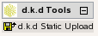Image 1: The module d.k.d Tools
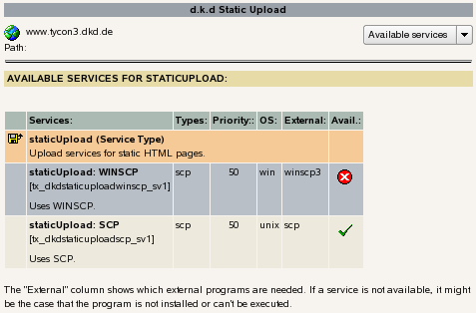Image 2: Overview of available upload services.

Users manual
After the module has been installed and configured the module will appear under “d.k.d Tools”.
Click on “d.k.d Static Upload” and if the module is used for the first time you will be taken to an overview of services which are available on your server.
If a service is marked as not available it might be that the specific service cannot be used on the OS of your server. It could also be the case that an external program is needed which is not installed on your server.
Select “Static upload” from the functions menu and you will be presented with a drop-down list containing all TYPO3 domain records from the current TYPO3 installation.
If you have selected one of the listed records, the upload process will be started. In case you wonder why you receive instant feedback on the screen – the upload process runs in the background. When the upload process has finished an eMail will be sent with more information.

Adminstration
After the extension “staticUpload: SCP” has been installed make sure that the upload service is activated.
Verify that a BE user named “_cli_staticupload” exists. Only this BE user can run the CLI of TYPO3.
The extension is implemented as a service and allows to transfer files from the TYPO3 server to a remote server using SCP.
During the installation of the services no configuration needs to be done. All configuration settings for the module “Static Upload” are done using TS.
To use a TS configuration for “Static Upload” two criteria must match:
- A TYPO3 domain record must exist on the root page.
- Inside the TS an object with the name of the domain must exist where “.” are replaced by “_”.
Using TS for the configuration has the advantage that a TYPO3 administrator can change settings without the need to change any PHP code.

Example TS configuration
0: service.staticUpload {
1: www_example_com {
2: server = www.example.com
3: username = root
4: path_to_php = /usr/bin
5: path_to_scp = /usr/bin
6: options = -i /var/lib/wwwrun/.ssh/www.example.com_dsa
7: local_dir = /srv/www.local.example.com/htdocs/publish/* /srv/www.local.example.com/htdocs/fileadmin /srv/www.local.example.com/htdocs/uploads /srv/www.local.example.com/htdocs/typo3temp
8: remote_dir = /srv/www.example.com/htdocs
9: logfile_dir = /tmp
10: service = scp
11: email = john.doe@example.com
12: }
13: }

Configuration

Overcoming “max_execution_time”
It was clear from the beginning that we had to find a way to overcome the limitiations imposed by script timeouts, server timeouts or browser timeouts.
To solve these problems we thought about moving the upload process into the background and sending a notification eMail to the address specified in the TS configuration.

Linux:
1: $cmd= sprintf( '%sphp "%scli/exec_bg_cli.php" "%s" 2>&1 &', $conf['path_to_php'], t3lib_extMgm::extPath( $this->extKey ), base64_encode( serialize($conf) ) );
2: exec( $cmd );

Reference
Property: | Data type: | Description: | Default:
www_example_com | string | Domain name, top level of the configuration. Must match a TYPO3 domain record. See “Example TS configuration”.
server | string | The name of the target server.
username | string | Username on the target server.
path_to_php | string | The path to the PHP cli executable.
path_to_scp | string | The path to the used scp executable.
options | string | Options for the scp executable.
local_dir | string | One or more local directories which should be transferred to the remote server.
remote_dir | string | Target directory on the remote server.
logfile_dir | string | Directory on the local server where logfiles should be stored.
service | string | Name of the service which should be used, e. g. scp.
email | string | Email address where the notification will be sent to when the upload process has been finished.
[tsref:service.staticUpload]

Changelog

