Log in
Insert your username and password to “Log in”

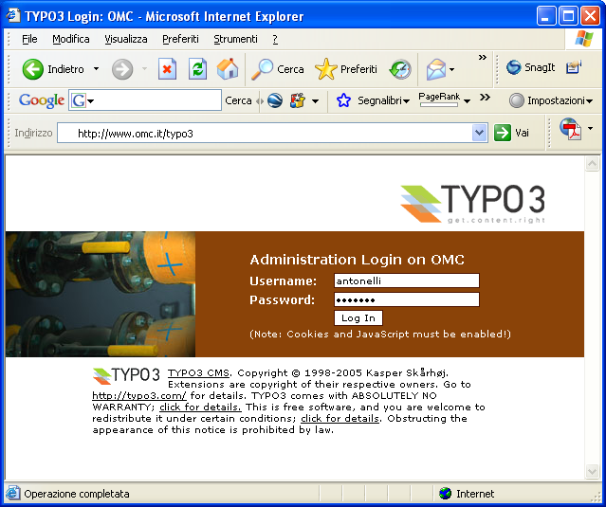

View and vote
You can view all abstracts and vote your categories (please refer to green traffic lights)

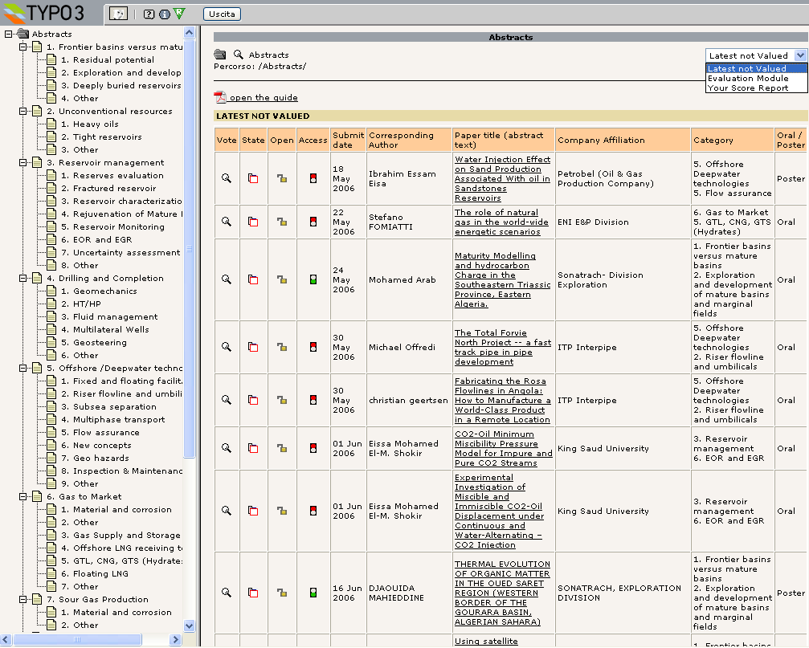

Click for help online

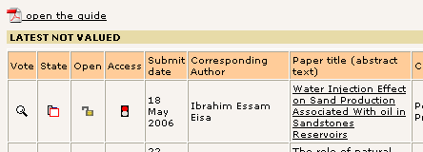
Click to view abstract
State: Not valued/Valued

you can evaluate or edit your score for this abstract

Select your category then choice from the top right menu
- “Evaluation Module” to see full list of abstracts
- “Latest not valued” (default choice) to view abstracts still to be rated
- “Your Score Report” to view a summary of your scoring

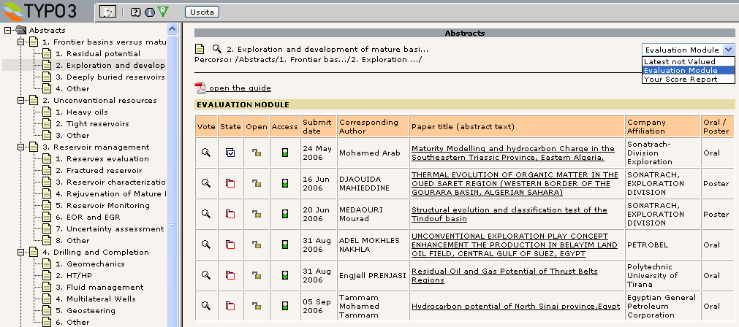
Click to select category

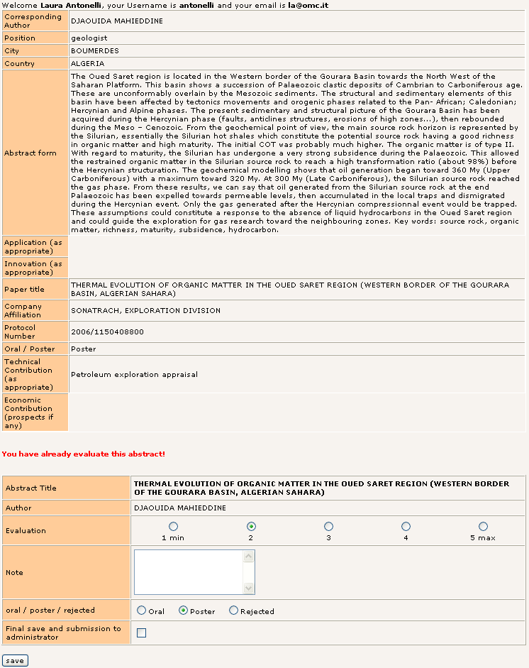
After saving you can still retrieve and modify your score

confirmation message

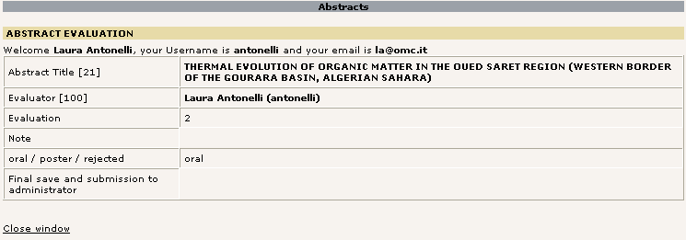

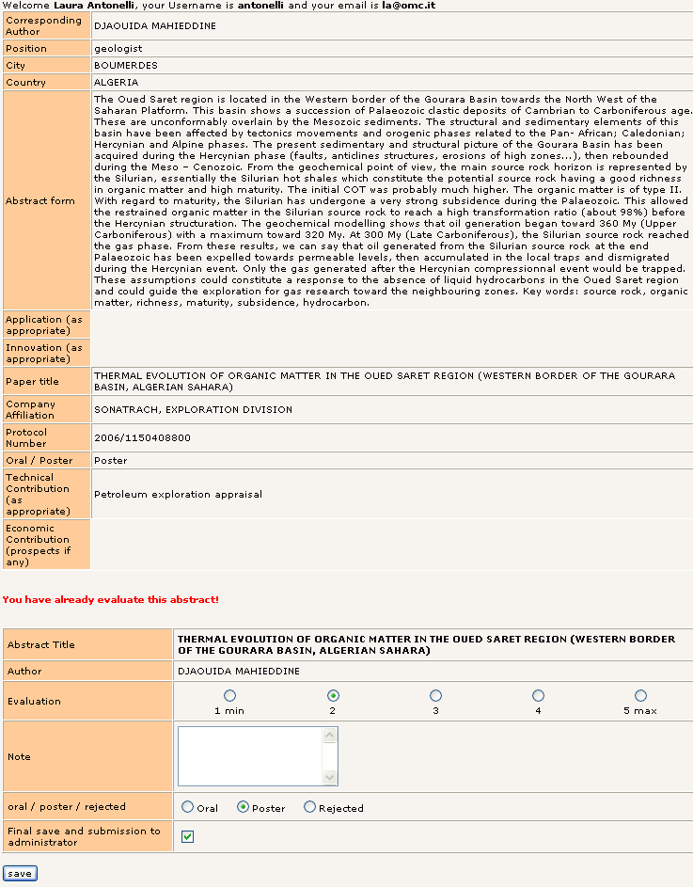
After “final save and submission to administrator” no more changes are allowed

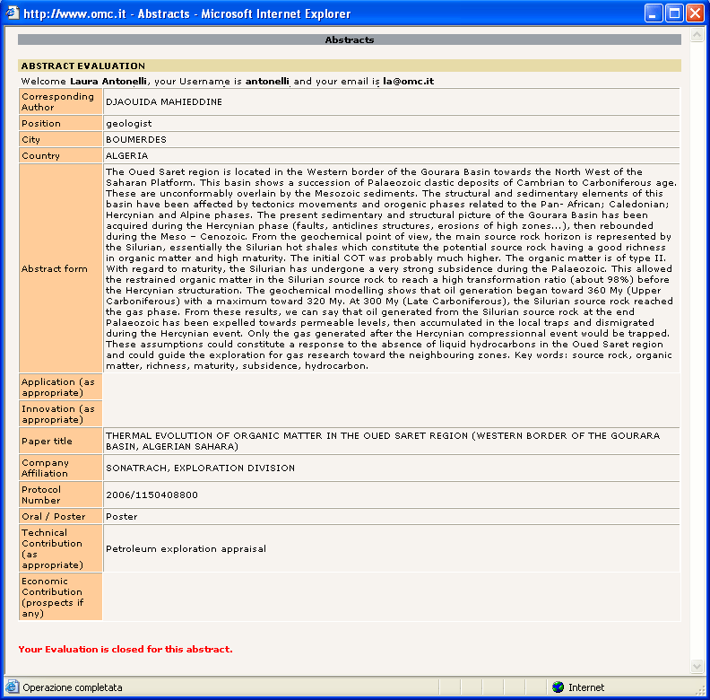
Evaluation already submitted

