Openx Banners
Extension Key: openx
Language: en
Keywords: forEditors, forAdmins, forBeginners, ad server, ad manager, online advertising, open source, banner management, rotate ads, phpadsnew, openads, openx, web publishers, optimise
Copyright 2000-2009, Cobweb, <typo3@cobweb.ch>

This document is published under the Open Content License
available from http://www.opencontent.org/opl.shtml

The content of this document is related to TYPO3
- a GNU/GPL CMS/Framework available from www.typo3.org
Table of Contents
Openx Banners 1
Introduction 3
What does it do? 3
What doesn't it do? 3
Screenshots 4
Openx Ad Server Login Panel in the Typo3 Backend 4
Plugin interface 4
Users manual 5
Installation 5
Installation checklist 5
Install the extension 5
Get the extension 5
Edit the config file 5
Activate the extension 5
Using the plugin 7
General Setup 7
Restrictions 9
Iframe Options 10
TypoScript 11
Update Openx content 12
Best practices 13
Anti Ads-blockers configuration 13
Step 1 : change the delivery folder and file names 13
Step 2 : change the Openx Ad Server configuration 13
Step 3 : change the Openx Extension configuration 13
… and you're done 13
Which Invocation Mode choose ? 13
Known problems 15
To-Do list 16
ChangeLog 17

Introduction

What does it do?
Openx Banners is a Typo3 extension that allows you to insert ads provided by an Openx Ad Server into Typo3 generated pages.
You can find every advertisers, campaigns or banners defined by the Openx Ad Server directly in the backend of Typo3. The invocation code is generated by the extension, without having to copy-paste it from the Openx Ad Server interface.
With this extension, you will be able to :
- access an Openx Ad Server administration directly from the backend of Typo3
- insert ads provided by an Openx Ad Server anywhere in Typo3's pages as a content element
- choose directly in Typo3 which advertiser, campaign or banner must be displayed in a specific page

What doesn't it do?
Managing das can only be done through Openx Ad Server Administration Backend. This includes the creation of advertisers, banners, campaign, and everything related to ads statistics, campaign monitoring or Openx user's management.
Openx Banners do not get images or flash ads directly from the Openx Ad Server. It just creates the invocation code that will ask the Openx Ad Server to serve the right ad.

Screenshots

Openx Ad Server Login Panel in the Typo3 Backend
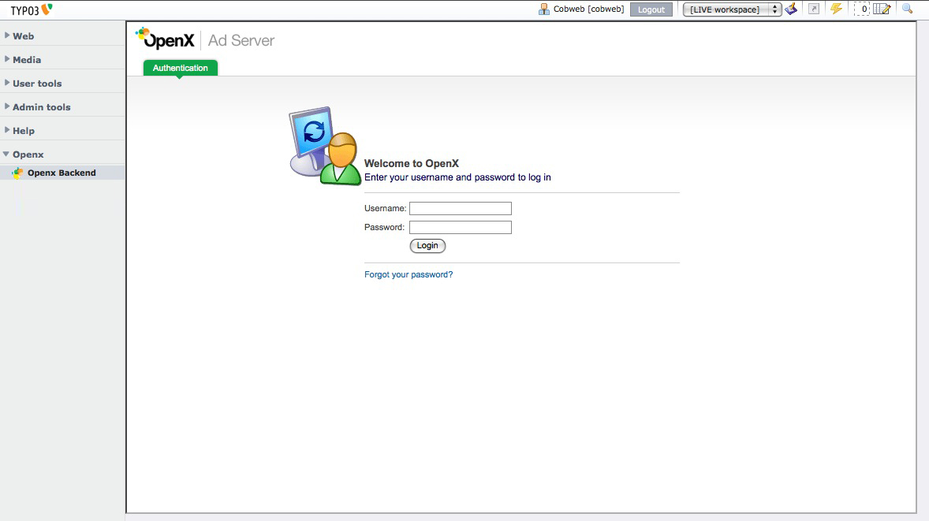
You can access to the Openx Ad Server Administration's panels without leaving the Typo3 Backend.

Plugin interface
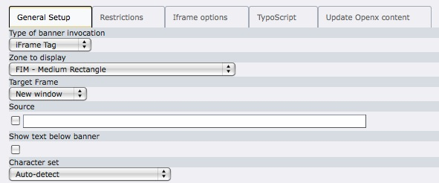
This is where the settings of the invocation code are defined.

Users manual

Installation
This guide describes how to install Openx Banners on your website.
Note: You may need to contact your website administrator or ISP in order to complete the installation checklist.

Installation checklist
An Openx Ad Server must already be installed.
For more informations about how to install an Openx Ad Server, please read the official instructions on http://www.openx.org/docs/installing-openx
PEAR must be installed with XML_RPC and XML_RPC2 packages.
If a PEAR installation is already running on the server, there is no need to install the "PEAR Manager" extension, as suggested by the extension.

Install the extension

Get the extension
Openx Banners extension can be found on the Typo3 Extension Repository. Use the Extension Manager to get it.
Do not activate it yet.

Edit the config file
In the typo3conf/ext/openx/ folder, Rename the "openx_default_config.php.default" file to "openx_default_config.php".
If needed, edit the file (see the “Anti-adsblockers configuration advices“ section for more information).

Activate the extension
Back to the Extension Manager. Activate Openx Banners.
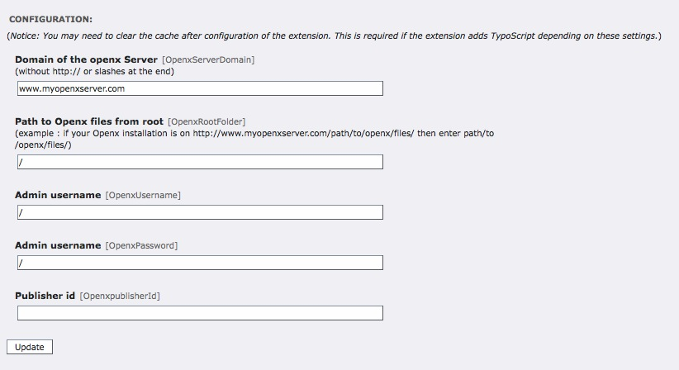
Example :
The Openx Ad Server is installed on http://www.mywebsite.com/openx/.
The admin account is “adminuser” and the password is “adminpass”.
In the Openx Ad Server, the Typo3 website has been configured as a new publisher and it has an id : 1.
Here is how to configure Openx Banners :
- Domaine of the openx Server : www.mywebsite.com
- Path to Openx files from root : openx/
- Admin username : adminuser
- Admin password : adminpass
- Publisher id : 1
Once activated, the extension should appear in the Typo3 backend as a new section in the left column.

Using the plugin
Create an instance of Openx Banners in your page.
The Openx Banner plugins interface has five tabs : General Setup, Restrictions, Iframe options, TypoScript and Update Openx content.

General Setup

Type of banner invocation (optional)
With Openx, you have three different methods to display a banner :
- Javascript Tag
- Local Mode Tag
- iFrame Tag
Javascript Tag will generate a script that will display ads from the Openx Ad Server. This is how it will look like :
<script type='text/javascript'><!--//<![CDATA[
var m3_u = (location.protocol=='https:'?'https://www.mywebsite.com/openx/www/delivery/ajs.php':'http://www.mywebsite.com/openx/www/delivery/ajs.php');
var m3_r = Math.floor(Math.random()*99999999999);
if (!document.MAX_used) document.MAX_used = ',';
document.write ("<scr"+"ipt type='text/javascript' src='"+m3_u);
document.write ("?zoneid=ZONEID");
document.write ('&amp;cb=' + m3_r);
if (document.MAX_used != ',') document.write ("&amp;exclude=" + document.MAX_used);
document.write (document.charset ? '&amp;charset='+document.charset : (document.characterSet ? '&amp;charset='+document.characterSet : ''));
document.write ("&amp;loc=" + escape(window.location));
if (document.referrer) document.write ("&amp;referer=" + escape(document.referrer));
if (document.context) document.write ("&context=" + escape(document.context));
if (document.mmm_fo) document.write ("&amp;mmm_fo=1");
document.write ("'><\/scr"+"ipt>");
//]]>--></script><noscript><a href='http://www.mywebsite.com/openx/www/delivery/ck.php?n=ac25d19a&amp;cb=INSERT_RANDOM_NUMBER_HERE' target='_blank'><img src='http://www.mywebsite.com/openx/www/delivery/avw.php?zoneid=ZONEID&amp;cb=INSERT_RANDOM_NUMBER_HERE&amp;n=ac25d19a' border='0' alt='' /></a></noscript>

Local Mode Tag can only be used if the Openx Ad Server is installed on the same folder as Typo3. It will include Openx classes and call function to output html code to display the ads. Here is the kind of code that will be generate :
<?php
define('MAX_PATH', '/data/home/mywebsite/public_html/ox-fim');
if (@include_once(MAX_PATH . '/www/delivery/alocal.php')) {
if (!isset($phpAds_context)) {
$phpAds_context = array();
}
$phpAds_raw = view_local('', ZONEID, 0, 0, '', '', '0', $phpAds_context, '');
}
echo $phpAds_raw['html'];
?>

iFrame Tag will create an iFrame in which the ad will be displayed. The code generated will look like this :
<iframe id='a66a70a4' name='a66a70a4' src='http://www.mywebsite.com/openx/www/delivery/afr.php?zoneid=ZONEID&amp;cb=INSERT_RANDOM_NUMBER_HERE' framespacing='0' frameborder='no' scrolling='no' width='955' height='280'><a href='http://www.mywebsite.com/openx/www/delivery/ck.php?n=a7804df3&amp;cb=INSERT_RANDOM_NUMBER_HERE' target='_blank'><img src='http://www.mywebsite.com/openx/www/delivery/avw.php?zoneid=ZONEID&amp;cb=INSERT_RANDOM_NUMBER_HERE&amp;n=a7804df3' border='0' alt='' /></a></iframe>
By choosing this invocation type, you may set more options in the “Iframe options” tab.
More information about differences between each invocation mode are detailed in the “Which Invocation Mode choose ?” section.

Zone to display (required)
Choose the zone to display.
PS : The zones are set in the Openx Ad Server and always belong to a publisher, so the zones available here are those that are owned by the actual publisher.
For more information about Zones, please read chapter “Zones” on the official Openx website : http://www.openx.org/en/docs/2.0/userguide/zones

Target Frame (optional)
The optional argument Target frame allow you to specify a frame target to be used when the user clicks on the ad. For example, use _blank to force a new browser window to open, _top to replace the current window (and break
frames), etc.
For more information about this parameter you can take a look at the target attribute in the HTML specifications.

Source (optional)
The optional argument Source allows you to specify the name of the current page (for example: mainpage or subpage1). You can add a delivery limitation later, using the administrator interface, to make sure the banner is only shown when the source parameter is equal to or different from a specific value.
If you want to know more about Delivery limitations, please read chapter “Delivery limitations” on the official Openx website : http://www.openx.org/en/docs/2.0/userguide/delivery-limitations

Character set (optional)
Select the character set you want ads to display in on your website. (In general it is only necessary to alter the default Auto-detect setting when local mode tag is used.)

Restrictions
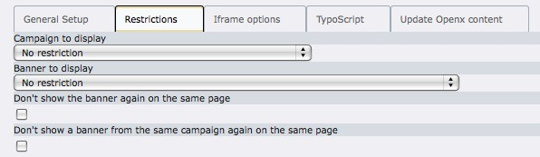

Campaign to display (optional)
If you want to restrict this zone to only display banners from a given campaign, just choose which campaign.

Banner to display (optional)
If you want to restrict this zone to only display a given banner, just choose the banner.

Don't show the banner again on the same page (optional - Invocation by Javascript or local mode only)
By enabling this parameter you can make sure the banner with this invocation code isn't displayed again on
the page.
There is one restriction to this feature; it will only block the banner if the other banner codes on the same page are also called by JavaScript. It also slows down page loading.

Don't show a banner from the same campaign again on the same page (optional - Invocation by Javascript or local mode only)
By checking this box, a campaign can only display once in a page .

Iframe Options
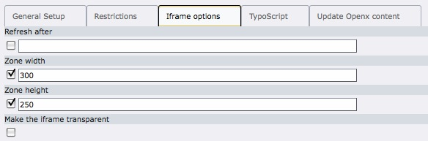

Refresh after (optional)
If you want to automatically refresh the banner you can specify the amount of seconds between each reload. After each refresh a new banner from this zone will be displayed.

Zone width (optional)
You can specify the width of the iframe (should be the width of the zone specified in the zone settings of the Openx Ad Server.

Zone height (optional)
You can specify the height of the iframe (should be the height of the zone specified in the zone settings of the Openx Ad Server.

Make the iFrame transparent (optional)
If you set this parameter to true the background of the iframe will become transparent, which means the background of the
original page will be visible. This feature will only work on Internet Explorer 5.5 or higher, on Firefox, Safari, and Chrome.

TypoScript
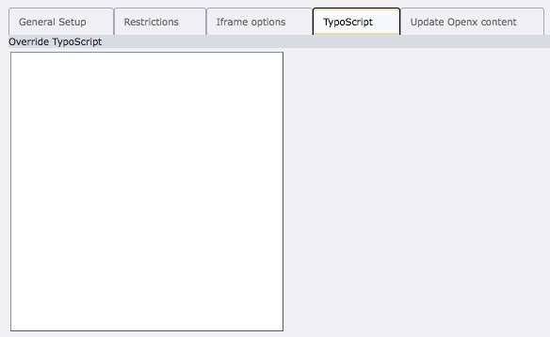

TypoScript override (optional)
Here you can change any value of the plugin with TypoScript

Update Openx content
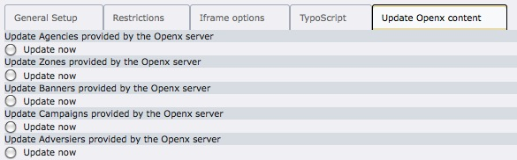
By clicking on any of these options he cache of the lists of Agencies, Zones, Banners, Campaigns or Advertisers will be reloaded.
This operation can take several minutes.

Best practices

Anti Ads-blockers configuration
In order to avoid the ads to be blocked by Ads-Blockers softwares or plugins, it is recommended to change the configuration of Openx. The changes must be done directly on files on the server, in the Openx Ad Server administration, and in the openx extension configuration.

Step 1 : change the delivery folder and file names
The following folders must be renamed :
- www/delivery
- www/images
You can change them to anything you want.
The following files should also be renamed :
- www/delivery/ck.php
- www/delivery/tv.php
- www/delivery/ac.php
- www/delivery/ti.php
- www/delivery/tjs.php
- www/delivery/afr.php
- www/delivery/ai.php
- www/delivery/lg.php
- www/delivery/apu.php
- www/delivery/avw.php
- www/delivery/axmlrpc.php
- www/delivery/alocal.php
- www/delivery/fc.php
- www/delivery/fl.js

Step 2 : change the Openx Ad Server configuration
Log into the Openx Ad Server Administration with the Administrator account, and get the Banner Delivery Settings page (Configuration > Global Settings > Banner Delivery Settings).
Modify the OpenX Server Access Paths and the Delivery File Names according to the modifications done in step 1.

Step 3 : change the Openx Extension configuration
Edit the openx/openx_default_config.php file and change the folder and file names according to the modifications done in step 1.

… and you're done
Changing those folder and file names will help the banners not to be considered as ads by the anti-ads softwares.

Which Invocation Mode choose ?
Tag formats
Apart from single page call, every tag type has multiple formats: IMG, JavaScript, iFrame, XML-RPC and Local Mode. You can use the table below to determine which are most useful for your website(s):
 | Remote invocation  for JavaScript | Remote  invocation  for Frames | Local mode
Basic Requirements
Requires cookies | no1) | no1) | no
Requires JavaScript | yes | no | no
Requires iframes/layers2) | no | yes | no
Requires PHP powered website | no | no | yes
Banner capabilities
Display regular banners | yes3) | yes | yes
Display Flash or HTML banners | yes3) | yes4) | yes
Append popups/interstitials5) | yes3) | yes4) | yes
Block based on previous banners | yes | no | yes
Block based on previous campaigns | yes | no | yes
1. Remote Invocation for JavaScript does not require cookies to be enabled, but in case JavaScript is disabled it turns into a regular Remote Invocation code which does require cookies. The same thing applies to Remote Invocation for Frames when the browser does not support iframes or layers.
2. Remote Invocation for Frames requires that the browser supports iframes. If you want to support Netscape 4 (which does not support iframes) you need to manually enable the layers compatibility mode during the generation of the invocation code.
3. Remote Invocation for JavaScript consists of two different codes. If JavaScript is enabled in the browser, this feature is supported. If JavaScript is disabled, the invocation code will turn into a regular remote invocation code, which does not support this feature.
4. Remote Invocation for Iframes consists of two different codes. If iframes and/or layer are supported by the browser this feature is supported. If iframes and layers are not supported, the invocation code will turn into a regular remote invocation code, which does not support this feature.
5. This feature allows you to append a popup or interstitial banner to a regular banner. For example, if a banner or zone using this feature is displayed it will automatically display the appended banner.
Notes
- JavaScript tags: Use for easy delivery of all banner types on any type of Javascript-enabled device or website. JavaScript tags can also block delivery based on other banners on page (i.e. do not show same banner/campaign again on same page).
- iFrame tag: This tag provides the easy delivery of all banner types, but doesn't allow blocking. The iFrame tag defers loading so that the website can load quickly while banners load in the background. This tag also allows 'refresh' - the tag refreshes every X seconds so a new banner is called without user moving pages. The iFrame tag can also be used to allow banner to refresh on Ajax pages where new page impressions aren't being made.
Note: the campaign positioning option (in the campaign properties tab) will not work with iFrame invocation tags.
Note 2 : In some cases, IE waits for iFrame to load before rendering the page content. This can slow the rendering process of pages.
- Local Mode tag: This is an advanced tag which allows a PHP-enabled website to include the OpenX files directly for delivery of banners. The publishing website and OpenX must be on the same server and TLD (top level domain).

Known problems
- The name of agencies, zones, banners, campaigns and advertisers that have accents are not supported.

To-Do list
- Implement last Openx Invocation code options
- Add support of others Invocation Code Tag, as XML-RPC Tag, No cookie image Tag, Image Tag
- Add support of accent names
- Add support of texts under ads

ChangeLog
- V1.0.0
Initial release

