Organiser +Repertoire
Publish your repertoire with Org +Repertoire. Org +Repertoire extends the Organiser (org) with a database for repertoire and all needed templates. The Organiser prvovides a calendar, locations, online-tickets and staff-management out of the box.



Version: 7.6.2, 2016-01-19
Extension Key: org_repertoire
Language: en
Keywords: lobby, organiser, repertoire
Copyright 2011-2016, Dirk Wildt - Die Netzmacher, <http://wildt.at.die-netzmacher.de>

This document is published under the Open Content License available from http://www.opencontent.org/opl.shtml
The content of this document is related to TYPO3 a GNU/GPL CMS/Framework available from www.typo3.org
Table of Contents
Organiser +Repertoire 1
Screenshots 3
Frontend 3
Backend 5
Introduction 7
What does it do? 7
What do you need? 7
Audience 7
Quick Installation 8
Installation 9
Manual: Installation details 10
Step 1 – Extension manager 10
Step 2 – Folder Repertoire 10
Step 3 – Page Repertoire 11
Step 4 – Repertoire record 11
Step 5 – Repertoire in the frontend 11
Step 6 – Page Calendar 11
Step 7 – Parent Organiser page 11
Step 8 – Calendar item with content of a Repertoire item 12
Upgrade 13
From < 6.x 13
From < 3.x 13
What's new? 14
Version 3.0 14
Helpful suggestions and benefits 15
Forum 15
TYPO3 Forge 15
Sponsoring 15
Further Information 16
Other extensions published by Die Netzmacher 16
Manual in PDF 17
Change Log 18
Illustration index 20
Alphabetical Index 21

Screenshots

Frontend
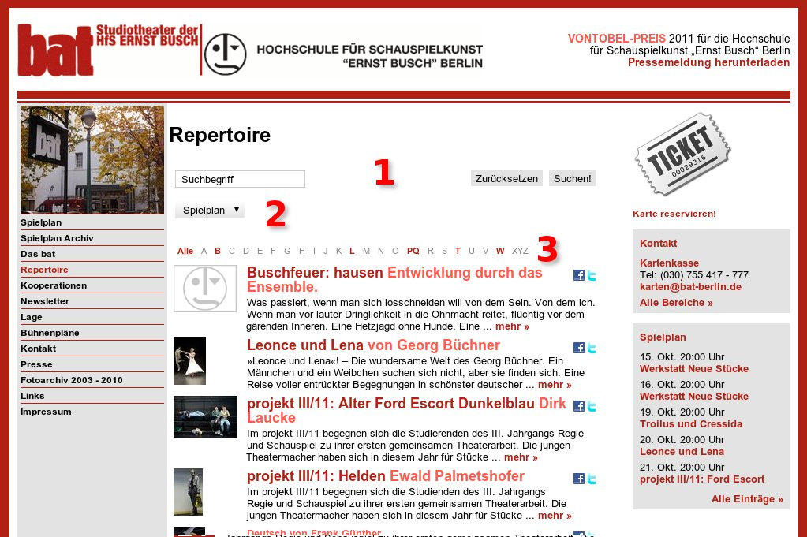Illustration 1: Repertoire list view
Live example: http://www.bat-berlin.de/repertoire/
- Search form
- Select box for categories. You can extend the categories i.e. with producers or types among others.
- A-Z-Browser
Some properties are configurable in the backend user interface with a mouse click.

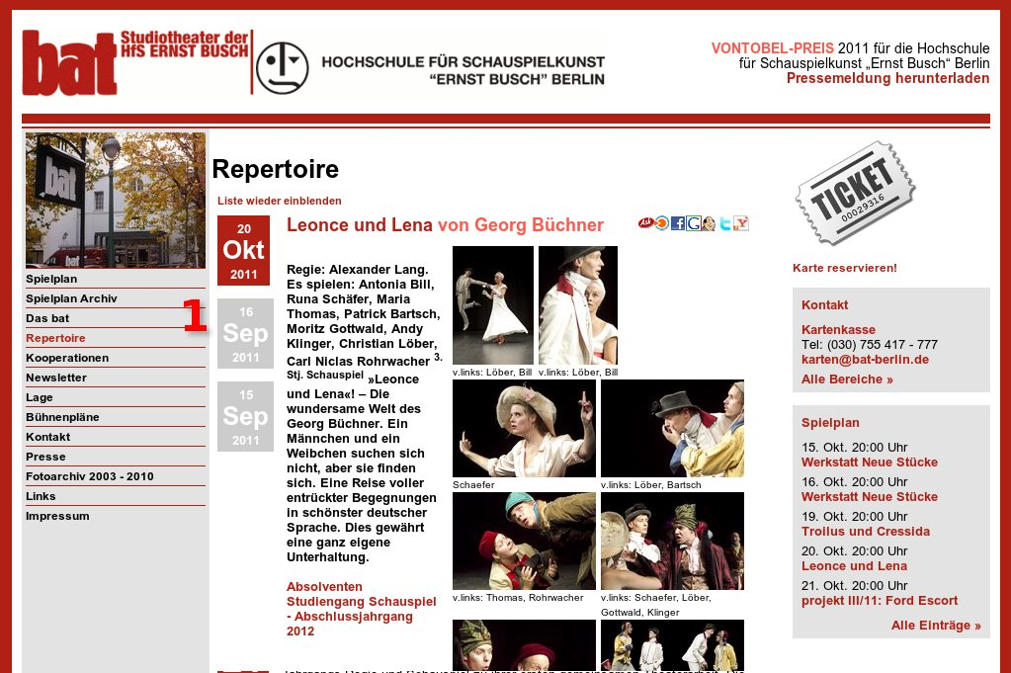Illustration 2: Repertoire single view
Live example: http://www.bat-berlin.de/repertoire/stueck/leonce-und-lena/
- Calendar items
Expired dates get another CSS class
You can design each record – each repertoire item – individually.

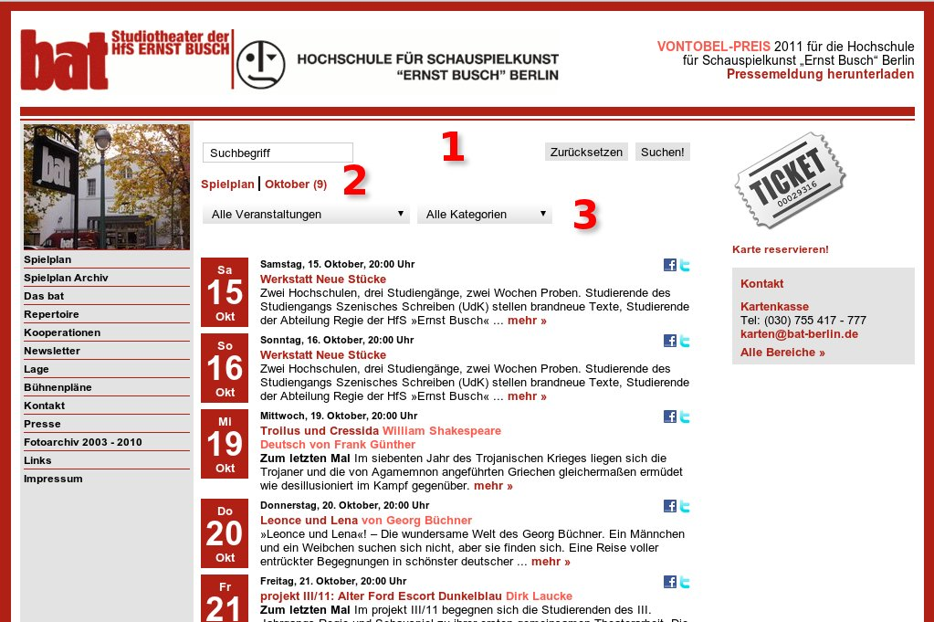Illustration 3: Calendar with repertoire items (list view)
Live example: http://www.bat-berlin.de/
- Search form
- Category menu. You can extend the categorie menu i.e. with producers or types among others.
- Select boxes with categories. You can extend it with more select boxes.

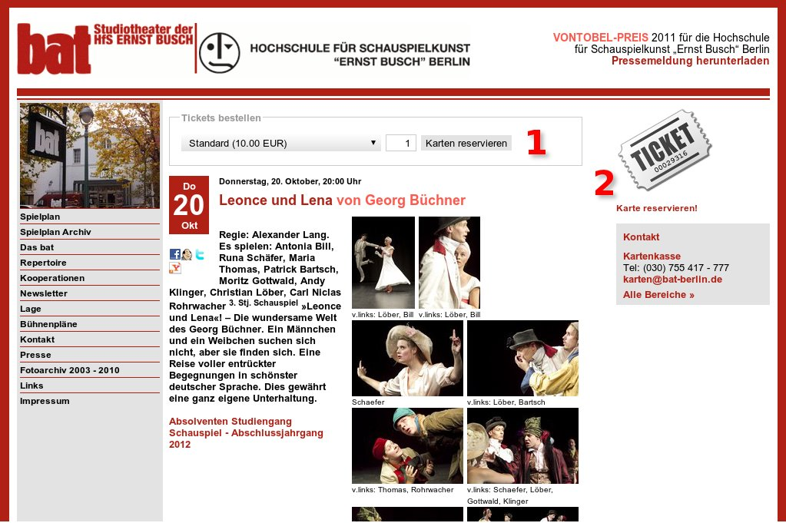Illustration 4: Calendar with repertoire item (single view)
Live example: http://www.bat-berlin.de/termin/leonce-und-lena-2/
- Form for ordering a reservation (online ticket).
- Link to the shopping cart.

Backend
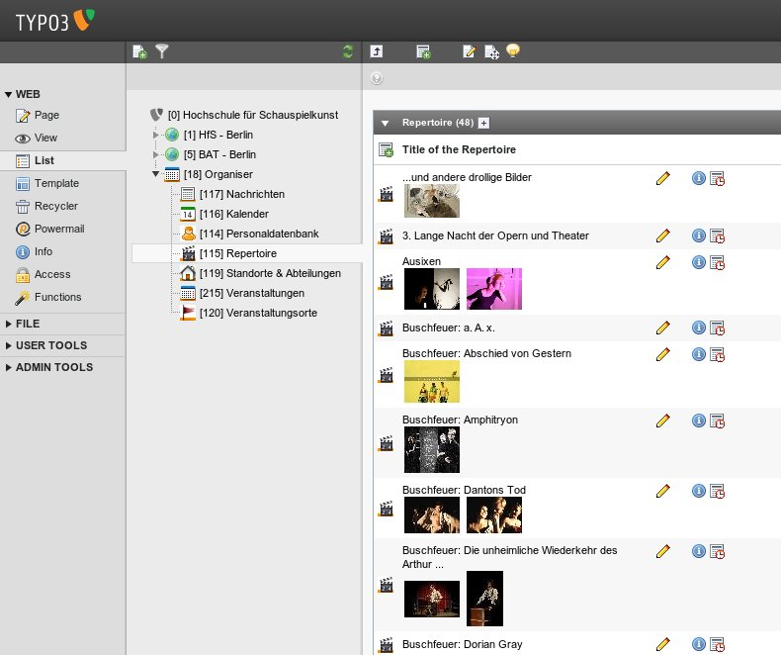Illustration 5: Repertoire list view
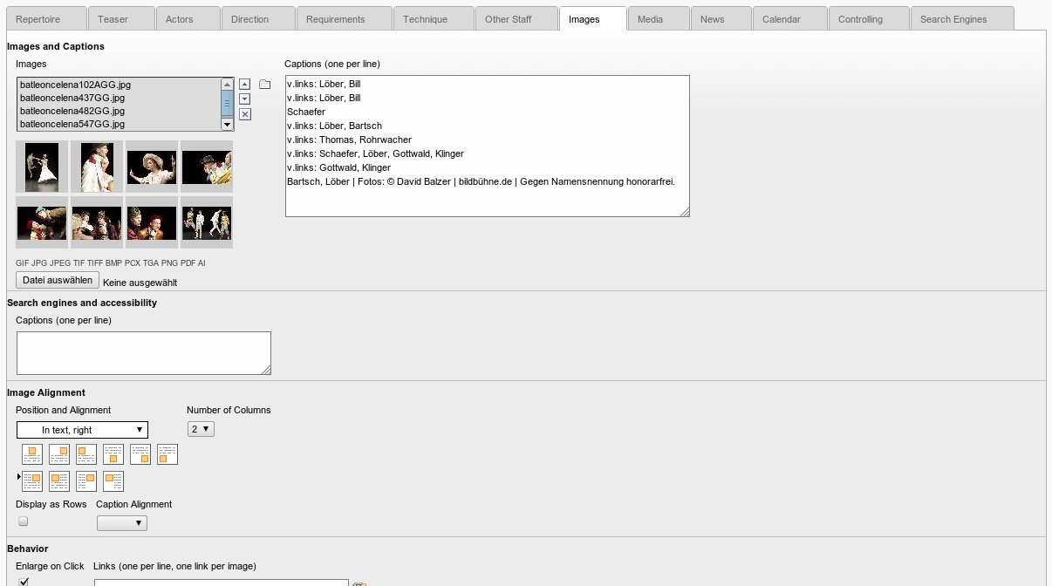Illustration 6: Repertoire single view
- Repertoire is based on a very complex database. You can take in a lot of data (see the amount of tabs!)
- The current tab (Images) demonstrates the design possibilities: there are 10 layouts.
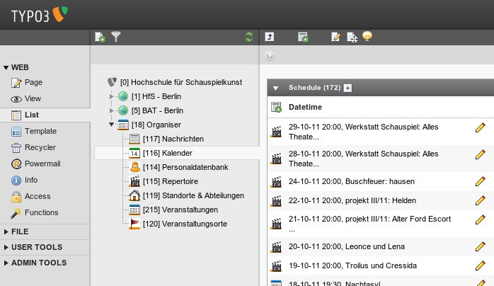Illustration 7: Calendar list view with repertoire items among others.
- Org +Repertoire extends the Organiser (org) with a database and a lot of properties for repertoire.

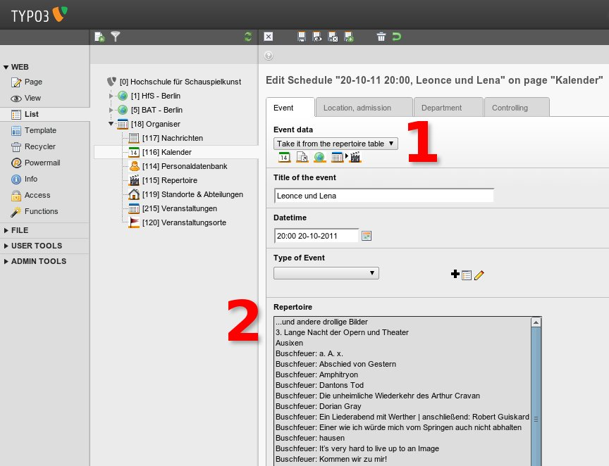Illustration 8: Calendar single view. You can link to a repertoire item directly
- Org +Repertoire extends the Organiser (org). After installation there is the new event data type "Take it from repertoire"
- If you have selected the event data type "Take it from repertoire", the select box with the repertoire items will appear.

Introduction

What does it do?
Organiser +Repertoire extends the Organiser with a database and properties for managing a repertoire.
A repertoire item is a special type of a calendar item like an event.
But it has additional appropriate fields like subject, requirements and actors.
It is connected with the fe_user table.
Workshops blends in the calender items both in the back-end and in the front-end. For that Organiser +Repertoire is distributed with default templates for HTML and TypoScript.
Organiser +Repertoire isn't localised.
Organiser +Repertoire supports HTML5.

What do you need?
- A TYPO3 installation with an entire Organiser installation.

Audience
- TYPO3 integrators
- Professional TYPO3 developers, TYPO3 agencies
- Actors, producers, organisers, theatres

Quick Installation
- Install Org +Repertoire and configure some options in the Extension Manager.
- Add and configure a sysfolder in the page tree.
- Complement your TypoScript configuration.
- Add a page in the page tree and insert the needed plugin "Browser – TYPO3 without PHP".
- Insert your workshop data.

Installation
There is another extension Org +Workshops, which is similar to Organiser +Repertoire.
Please refer to that manual. See:
- http://typo3.org/extensions/repository/view/org_workshops/current/
Thank you for your understanding, that we can save a lot of work.

Manual: Installation details

Step 1 – Extension manager

Install Organiser +Repertoire
Install this extension supported by the extension manager. Confirm the database updates.
Adapt the extension configuration to your needs:
- Store record configuration: [Clear presented: each record group in one directory at most]

Step 2 – Folder Repertoire
Add a new folder "Repertoire" to your page tree.
Don't add it within the Organiser data folder – it isn't possible.
Add it anywhere outside of this folder and then move it into the data folder of the Organiser.

Page TSconfig: folder Repertoire
Add in the field 'Page TSconfig'
mod {
web_list {
allowedNewTables (
tx_org_repertoire
)
}
}

Page TSconfig: parent folder Organiser data
...

// PID
// [3402] organiser
// ...
// [3408] news
// [3443] repertoire
// [3403] service
// ...

// organiser tables
TCEFORM {
tx_org_cal_all_tables {
tx_org_cal {
PAGE_TSCONFIG_IDLIST = 3402,3407
PAGE_TSCONFIG_ID = 3407
}
...
tx_org_repertoire {
PAGE_TSCONFIG_IDLIST = 3402,3443
PAGE_TSCONFIG_ID = 3443
}
...
}
tx_org_cal < .tx_org_cal_all_tables
...
tx_org_repertoire < .tx_org_cal_all_tables
...
}
// organiser tables
...

Step 3 – Page Repertoire
Add a page Repertoire.
Add it into the section with your other Organiser pages like News and Staff.

TypoScript
Add to this page a TypoSCript extension template.
Call it "+page_repertoire_102", where 102 is the ID of the template.
Include static (from extensions):
- Org +Repertoire [1.1] Basis (obligate!)
- Org +Repertoire [1.2] Repertoire

Browser-Plugin
Add a content element of the type [Plugin]. Select [Browser – TYPO3 without PHP]
- Call it: [Browser for Org + Repertoire]
- Set tab [Behaviour] field [Record Storage Page] to the parent folder of your Organiser data.
- Set "Recursive:" to [Infinite]

Step 4 – Repertoire record
Add a record to your Repertoire folder.
Enter some data.

Step 5 – Repertoire in the frontend
Visit your Repertoire page in the frontend.
There should be displayed the added record from above.

Step 6 – Page Calendar
Add to the TypoScript template of your page calendar the additional calender template of Org + Repertoire.
Probably the lost of your included static templates looks like thre list below:
- Org [2.1] Calendar (org)
- Org [2.1.3] + Calendar Caddy (org)
- Org [2.1.99] +Calendar Repertoire (org_repertoire)

Step 7 – Parent Organiser page
Maintain the TypoSCript template.
Enter the ID of your Repertoire folder and the ID of your Repertoire page like in the snippt below.
plugin.org {
...
sysfolder {
...
news = 183
repertoire = 224
service = 185
...
}
pages {
...
news = 205
repertoire = 225
service = 207
...
}
...
}

Step 8 – Calendar item with content of a Repertoire item
Add to your calendar folder a new item.
Set "Automatic link to ..." to [single view of a repertoire]
Enter a location.
Visit your Calendar page in the frontend.

Upgrade

From < 6.x

Migrate relations

Cal
Relation is from tx_org_cal (local) to tx_org_repertoire (foreign).
INSERT INTO tx_org_mm_all (uid_local, uid_foreign, sorting, sorting_foreign, table_local, table_foreign)
SELECT uid_foreign, uid_local, sorting_foreign, sorting, 'tx_org_cal', 'tx_org_repertoire' FROM tx_org_repertoire_mm_tx_org_cal;

From < 3.x

Maintain the plugins / flexforms
Organiser +Repertoire needs from version 3.0 any own HTML template. See "Any own HTML any longer" on page 14 below.
Because of this new feature, you have to need update each plugin with an Organiser template.
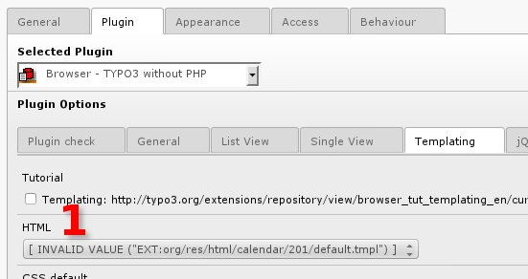Illustration 9: Invalid template value after the update
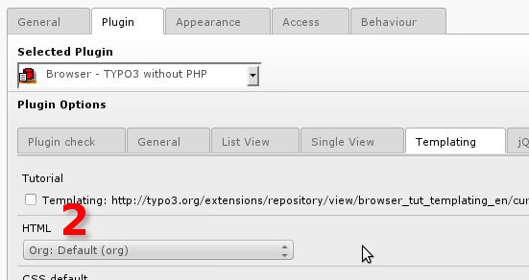Illustration 10: Please select the template "Default" or "Margin"
The Organiser has the two templates:
- Default
- Margin
Default is the template for rich content: the plugin is placed in the content area of your website usually.
Margin is the template for reduced content: the plugin is placed in the marginal columns of your website usually.

TYPO3 < 4.7: Include the 4.6 template
If you are run TYPO3 with a version smaller than 4.7, you have to include the static template
- +Org-Repertoire: Basis for TYPO3 < 4.7 (obligate!)
Please include it below (after) all other Organiser templates!

What's new?

Version 3.0

HTML5 support
[3.0.0]
Organiser +Repertoire supports HTML5 from TYPO3 4.7 in principle.

Any own HTML any longer
[3.0.0]
Organiser +Repertoire from version 3.0 doesn't need any longer an own HTML template. It is using the Organiser HTML templates.
This a big advantage, if you have a need to change anything in the HTML code.
Because of this new feature, unfortunately you have to update each plugin / flexform, which is using Organiser +Repertoire.

jQuery theme support
[3.0.0]
All HTML templates and all TypoScript templates are improved for jQuery themes. You can select one of 23 themes with the plugin / flexform of the TYPO3 browser.

Helpful suggestions and benefits

Forum
If you have helpful suggestions, feel free to publish any question or code snippet on
- TYPO3 Organiser forum at
http://typo3-browser-forum.de/
Posts are welcome in English and German.

TYPO3 Forge
Bugs and Feature requests can be posted on TYPO3 Forge too:
- http://forge.typo3.org/projects/show/extension-org_repertoire

Sponsoring
Do you like to subsidise the TYPO3 Organsier project? Please visit
- TYPO3 Organiser Sponsoring
http://typo3-organiser.de/sponsoring/
We would be very happy.

Further Information

Other extensions published by Die Netzmacher
- +AOE Linkhandler Configurator: Configure the AOE linkhandler supported by userinterfaces. Out-of-the-box templates for cal, org, tt_news and tt_products. Don't edit page TSconfig any longer.
http://typo3.org/extensions/repository/view/linkhandlerconf/
- autositemap: A smart site-map optimised for the footer. It groups menus in columns. Great menus will get two columns. Configuration is based on TypoScript HMENU.
http://typo3.org/extensions/repository/view/autositemap/
- Browser – TYPO3 without PHP. Develop your TYPO3 extension 8 times faster! You need one line TypoScript for a result list with a search form, a record browser and an index browser. Images are wrapped self-acting. SEO, Search Engine Optimization, is integrated. http://typo3-browser.de/
- Caddy – the TYPO3 shopping cart. You can use it for your own needs. You need a database with products or any other items only. You can install Caddy out of the box with one mouse click – see Quick Shop below.
http://typo3-caddy.de/
- Deal! – TYPO3 Quick Shop interface for the marketplace ebay. Manage all items with TYPO3 and publish it on ebay. Amazon is under construction.
http://typo3-deal.de/
- Duty – collection of helpful scheduler tasks. Here: remove deprecated files from directories.
http://typo3.org/extensions/repository/view/duty/
- Flip it! offers lovely and smooth page flip transitions. It enables you to run over pages in PDF documents like in a real magazine. It is based on flash. Flipt it! can convert PDF documents to swf files automatically.
http://typo3.org/extensions/repository/view/flipit/
- Jobmarket is a catalogue with job offers. Views, the a-z-browser, the page-browser, the search, social bookmarks and a lot of other stuff can configured by the Browser plugin with the mouse.
http://typo3-job-market.de/
- Organiser – TYPO3 for the lobby and the organisers. Handle news, events, staff, headquarters, locations, workshops and a calendar with one extension. Sell online tickets! Install the Organiser with one mouse click!
http://typo3-organiser.de/
- Quick Shop – the fastest shop in the history of TYPO3. Install it with one mouse click! Quick Shop is based on the browser (see above) and powermail.
http://typo3-quick-shop.de/
- PDF Controller: Offer a TYPO3 page for PDF download. Individual layout with background PDF file. TYPO3 sessions are supported. Handling of responsive backend layouts and grid elements possible. PDF engine is TCPDF. http://typo3-pdfcontroller.de/
- Radial Search (Umkreissuche) – Enable the browsing through your data by geo location. 'Your data must have a latitude and a longitude. Address data can geocoded automatically by the Browser - TYPO3 without PHP.
http://typo3.org/extensions/repository/view/radialsearch/
- Route – Publish your routes with GoogleMaps or OpenStreetMap. Routes have points of interest (POI). You can categorise and filter both: routes and POI. Address data can geocoded automatically.
http://typo3-route.de/
- seo_dynamic_tag: Search Engine Optimization for the title tag, the canonical tag and the meta tags author, description and keywords. Configuration by a user interface.
http://typo3.org/extensions/repository/view/seo_dynamic_tag/
- Slick - jQuery Carousel: Fully responsive. Scales with its container. Separate settings per breakpoint. Uses CSS3 when available. Swipe enabled. Desktop mouse dragging. Infinite looping. Fully accessible.
http://typo3-slick.de/
- Start extends TYPO3 with the responsive framework Foundation (Zurb). Provides a dozen ready-to-use backend layouts and some grid-layouts. Template is included for a responsive newsletter. Based on the responsive framework Foundation (Zurb). http://start-typo3-responsive.de/
- TSconfig Pages and Users by extManager (extkey: tsconf): Configure the the eight most commonly used TSconfig porperties with the mouse - like page tree uids, activated extended view, activated clipboard, ...
http://typo3.org/extensions/repository/view/tsconf/

Manual in PDF
You find this manual as PDF file at
- doc/manual.pdf

Change Log

7.6.2 Improvement
* #i0026: TCA: Event type: Repertoire got the field tx_org_headquarters
7.6.1 Improvement
* #i0025: Labelling
7.6.0 Feature
* #i0024: Repertoire view got filter for targetgroup and staff
* #i0023: New table: tx_org_repertoiretargetgroup
* #i0023: New template: Org +Repertoire [1.2.1] +list wiew with columns
* #i0022: Repertoire got marginal fields
* #i0021: organiser staff single view is extended with the repertoire list
New template: Org [9.1.99] +People Repertoire
* #i0020: Backend filter for tx_org_cal and tx_org_staff
* #i0019: repertoire gets a relation to staff and staff gets a relation to repertoire
* #i0018: Repertoire template is extended with location name and location city
Improvement
* #71132: Get an ID for including a JavaScript inline
* #i0017: Repertoire template: strftime is localised
* #i0016: Repertoire template: expired calender items are limited to two
* #i0015: Repertoire template: calender items are ordered by date ASC
6.0.9 Improvement
* #i0013: map/navigation: Link in the list view links to cal and not longer to repertoire
* #i0012: Labelling tabs linkhandler
* #i0011: Labelling TypoScript templates
Bugfix
* #i0014/#t0475: image_zoom was missing in the constants. See:
* Configuration/TypoScript
* Org/Calendar/201
* constants.txt
* single/sql.ts
* Repertoire/331/tx_browser_pi1/constants.ts
6.0.8 Improvement
* #i0010: Labelling TypoScript templates
* #i0009: Update manual
6.0.7 Feature
* #i0006: Fields for backend search are added
Improvement
* #i0008: moved
* description > seo_description
* keywords > seo_keywords
* #i0007: moved
* ext_icon is moved to Resources/Public/Images
* res/realurl_conf.php is moved to Resources/Private/RealUrl
* tsConfig is moved to Configuration/TsConfig/Page/TxLinkhandler
* static is moved to Configuration/TypoScript
Upgrade for Org 6.0.7
* #i0005: Removed: relations to fe_users: actor, advisor, assistant, dancer, director,
garment, light, makeup, musician, narrator, others, otherslabel,
puppeteer, requisite, sound, stage_design, stage_manager, tailoring,
technical_manager, technique, video, vocals
* #i0004: Removed: relation to headquarters
* #i0003: Removed: relation to news
* #i0002: Removed: static/base/typo3/4.6
3.0.2 Feature
* #i0001: use teaser_subtitle and teaser_title
3.0.1 Bug
* #00000: plugin.tx_browser_pi1.views.single.331 is moved from org to org_repertoire
3.0.0 Features
* #44024: Backwards compatibility < TYPO3 4.7
* #43982: tt_content.image: improve fields with ...orient
* #43981: TypoScript snippets for HTML templates
* #43980: tt_content.image: improve text property
* #43979: tt_content.image: improve caption property
Improvement
* #43978: tt_content.image: improve enable property
Bug
* #44004: TYPO3 4.7: page icon is missing
* #43983: tt_content.image: alt- and title tags aren't rendered proper
Effected Files:
* static/calendar/201/setup.txt
* static/repertoire/331/setup.txt
1.0.1 Improvement
* $ICON_TYPES replaced by SpriteManager method
Thanks to Ulfried Herrmann
1.0.0 Documentation and first publication
0.5.0 Improvement
css_style_content style like for
* documents
* images
0.4.5 New Feature
Extending calendar: expired dates only
* TypoScript affected
0.4.4 Improvement
Extension Manager
Consolidation
* Calendar
0.4.3 Bugfixes
Several Bugfixes
0.4.2 Initial Release
Dirk Wildt <http://wildt.at.die-netzmacher.de>

Illustration index
Illustration 1: Repertoire list view 3
Illustration 2: Repertoire single view 3
Illustration 3: Calendar with repertoire items (list view) 4
Illustration 4: Calendar with repertoire item (single view) 4
Illustration 5: Repertoire list view 5
Illustration 6: Repertoire single view 5
Illustration 7: Calendar list view with repertoire items among others. 6
Illustration 8: Calendar single view. You can link to a repertoire item directly 6
Illustration 9: Invalid template value after the update 13
Illustration 10: Please select the template "Default" or "Margin" 13

Alphabetical Index

