Proposal for the Axis2 core

The Goal
The Goal is to implements a core that supports pure one-way messaging build on top of handler/phases (extension mechanism/pipes and filters) and a configuration registry.

It should be possible to implements MEPS, Sync/Async such a way that all are transport neutral yet capable of the implementing at least IN-* MEPS for HTTP and SMTP transports

The client side messaging scenarios
- IN-only
- Robust-IN, Synchronous
- Robust-IN, Asynchronous (??)
- IN-Out, Synchronous, One-way transport
- IN-Out, Asynchronous, One-way transport
- IN-Out, Synchronous, Two-way transport, same connection
- IN-Out, Asynchronous, Two-way transport, same connection
- IN-Out, Synchronous, Two-way transport, two connections
- IN-Out, Asynchronous, Two-way transport, two connections

The server side messaging scenarios
- IN-only
- Robust-IN
- IN-Out, Synchronous, One-way transport
- IN-Out, Asynchronous, One-way transport
- IN-Out, Synchronous, Two-way transport, same connection
- IN-Out, Asynchronous, Two-way transport, same connection
- IN-Out, Synchronous, Two-way transport, two connections
- IN-Out, Asynchronous, Two-way transport, two connections

Proposal
The Client and the Server notation are insufficient to handle the Messaging style dataflow. Yet that does not necessarily mean we are having peer to peer network. The purposed architecture follows the SOAP terminology and defines Axis SOAP Node that can act as a SOAP Sender, SOAP Receiver or both.

Proposal for Axis2 Core has the following parts
- AxisRegistry, the registry of all the configurations
- Implementation of MessageBus that run the message through a Set of interceptors
- A messaging API that has MessageSender and MessageReciver
The messaging API provides MessageSender and MessageReciver classes that supports the sending and receiving the SOAP messages according to Addressing parameters given. See the org.apache.axis.messaging.* in the prototype.

- New Concepts of the Dialogs
- A OUT API that provides support for the above eight messaging scenarios
See the org.apache.axis.outtapi.* in the prototype.

- A IN API
See the org.apache.axis.inapi.* in the prototype.

The important parts to note in the proposal are Messaging API and Dialogs.

MessageBus

The Apache2 is built on top of a handler framework. This supports the resuming and restarting the handlers. The framework is based on the two types of classes, the Handlers and Phases.

There are two types of Handlers, the handlers that build in to the Apache Axis2 and the custom Handlers that are registered. The phase is ordered collection of Handlers. Each handler may contains rules explains the partial order of the Handler called Phased rules.

The configurations/Handler is stored in the AxisRegistry. The handler order is resolved at the deployment time based on the Phase rules and stored in the AxisRegistry.

When a MessageSender or a MessageReceiver is executed the Handlers (filters/pipes) are executed as specified in the AxisRegistry.

Messaging API
This is an effort to boil down all the interactions to one-way messaging architecture. It is important to note that the messaging goal is to implements all the interaction on top of way one-way messaging but not synchronous on top of asynchronous. The Messaging Architecture has MessageSender and MessageReciver that provides send () and receive () methods. Each do not know about the neither a SOAP level nor a transport level response. It is responsibility of the code that is “registered in” or “invoking MessageSender or MessageReciver” to handle/initiate a response.

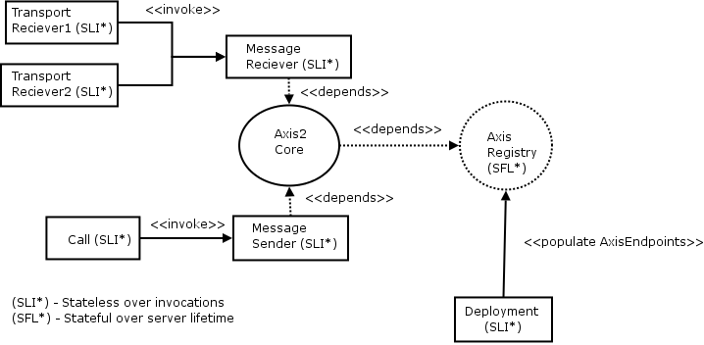

It is important to note that the MessageReciver and MessageSender are stateless across the different SOAP message executions. What are remaining across the SOAP message executions are what kept inside the AxisRegistry. What is registered as the Web Service is AxisServiceEndpoint or the AxisMessageEndpoint class added by the deployment. When the MessageReciver is executed the correct Axis*Endpoint is picked based on the addressing information.

Starting of Axis2 involves starting one or more TransportListeners and registering the Axis*Endpoints with the AxisRegsitry. The Service is usually not tied with a transport.
When a TransportReciver received a SOAPMessage a Axis*Endpoint is invoked based on the addressing information. With this approach one AxisEndpoint can be registered with more than one TransportRecivers.

Dialogs

The Proposal introduces new concepts called Dialogs to capture the concepts of a conversation. Each SOAPEndpoint (formally a Web Service) should associate itself with a dialog. What SOAPEndpoint does is to hand over the Message in to a Dialog. The Dialogs can be exsits in scopes, Global, Session and Service. The Dialog can be exists independent of the Services and the same dialog can be shared by more than one SOAPEndpoint. This follows the notation of more than one people talking in a conversation.
Receipt of each Message will add one more message in to the dialog. The dialogs can be longs or short, in the sense a dialog can expect a one message in fact making it one-way or it do something like accepting 100 messages and sending 200 messages. Axis2 implementation will provide Dialogs for the each well defined message exchange pattern. But Dialogs may be taking the form of N in M out.

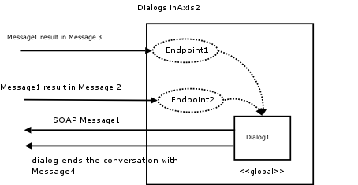

Dialogs are extending to Endpoint Dialogs to register with the SOAPEndpoint, which are initiated by receiving a SOAPMessage. But the dialogs that initiate with sending a SOAP message may take the any form as the user is one who executes them. Axis2 will provide inbuilt dialogs of both natures.

To capture the concepts in Axis1.x like providers, the Dialogs are extensible in the following way.
<dialog name=”abc” class=”pqr”>
<xxx class=”x1”/>
<yyy class=”x2”/>
</dialog>

Here the Dialog has a name and an implementation class. It may have zero or more child elements with any name and one attribute called class. The implementation class should have an attribute and getters and setters for each element name. Each class attribute should point to a Java class that is available in the classpath and have a default constructer.
e.g
public class pqr{
private x1 xxx;
private x2 yyy;
}

Using this method the InOutSyncDialog that uses a provider is shown as follows.

<service name =”echo” dialog=” InOutSyncDialog”/>

<dialog name=” InOutSyncDialog”>
<provider class=”provider-class”/>
</dialog>

OUT API

Client API tries to implement the message interaction patterns on top of the Messaging layer that explained above. If there are any Transport level responses the Client API impl code should handle them.

IN API
Server API tried to implements the message interaction patterns on top of the messaging layer in the Server side.

Issues
- When define phases order at the server.xml file we need, a way to define order in for inchain, out chain, fault chain separately
e.g.
<phaseOrder>
<phase name=”..” scope=” transport-in| transport-out
|global-in|service-in|fault-in
| global-out|service-out|fault-out”/>*
</phaseOrder>

Open Questions

- How much consideration should be give to the W3c architecture note? Should be having only Services end points or should be have both service and message endpoints? (the difference being the service end point find a operation based invocation and messaging is always given to one endpoint)
- There is two approaches for the Axis2, Using the AxisEngine with send() and recieve() methods or Have the MessageSender and MessgaeReciver having the send() and recieve() logic in the Sender and receiver?
- If an error occurred in the Receiver/Provider, do we NEED to revoke the handlers in the inflow or NOT?
- Do we need to support Out-* MEPS, is it sufficient to give them init () method in the service object so that the Out-* MEPS can be implemented if someone really need it.
- How the service dispatching should be done? The To EPR will decide the service, but if addressing does not specified what will be the value of EPR, for the
  - HTTP – URL
  - SMTP – email address
- How the operation dispatching should be done? Is it always based on the SOAPAction or does message style affect the decision? In the rpc case how significant is the first child element name of the body?
- When do we know the style of the SOAP message comes in, is it when we know the service or when we know the operation? If the operation is the answer what happens in the rpc style? (See #6).
- Should we have fault flow for the both in and out flow, or does the fault flow is executed for the both in/out flows, or is it only for out all the time.
- Should we have two phase chains in the server.xml file, inphasechain and outphasechain
- Should we need client.xml file?
- how about the following proposal for the transports
<tranportIn receiver =”class-name”>
<inflow/>
<parameter/>
</transportIn>

<tranportOut sender=”class-name”>
<out flow/>
<parameter/>
</transportOut>

When the new transportIn is added to the EngineRegistry and if the transport receiver is not null, engine will called the init method of the transport receiver. The Async messaging is taken care by assuming the callback as a Service and registering.
- Should we rename the EngineRegistry to AxisRegistry?

- We should identify and define the Types of phases to make the phase rules usable. How about the following

The basic ones are Authentication, encryption, signing, RM, transaction, Addressing. What are the others?

Inflow
  - Transport-in
  - Global- Authentication
  - Global- encryption
  - Global- Authorization
  - Global- signing
  - Global-Addressing
  - Global-RM
  - Global-Transaction
  - Dispatching
  - Service- Authentication
  - Service- encryption
  - Service- Authentication
  - Service- signing
  - Service-Addressing
  - Service-RM
  - Service-Transaction
  - Business-Logic

Outflow
  - Service-Transaction
  - Service-RM
  - Service-Addressing
  - Service- signing
  - Service- Authentication
  - Service- encryption
  - Service- Authorization
  - Global-Transaction
  - Global-RM
  - Global-Addressing
  - Global- signing
  - Global- Authentication
  - Global- Authentication
  - Global- encryption
  - Transport-in
  - Sending

