Inf2C Software Engineering 2018-19

Coursework 1

Capturing requirements for an

auction house system

Team members:

Li Kaiyu s1891130

Tai Yintao s1891075

# **1 Stakeholders**

1. **Auld Reekie Auction House**

Including auctioneers and all staff members related to the auctions. They want to create new auctions and add information to online catalogue and *lots* (*collections of objects being sold together*). They are responsible for the normal conduct of the auction and decide if the auction is over.

1. **Buyers**

Members of users who are interested in auctions and willing to bid. They expect to browse *lots* descriptions online and choose interested objects previously. During the auctions, They want to bid for items through their devices anywhere.

1. **Sellers**

Members of users who want to provide objects to sell. They hope their objects will be auctioned in reasonable prices and they are able to refuse the trade when the hammer price lower than their lowest expectation.

1. **Unregistered users**

All users who haven’t registered as buyers or sellers. They want to directly use their devices to view the online catalogue, but if they are willing, they can join auctions immediately by quick registration.

# **2 The system state**

1. **Buyers accounts information**
2. Personal information and bank account details
3. Marked interested objects
4. Current mode
   1. Browse mode
   2. Auction mode
   3. Pay mode
5. **Sellers accounts information**
6. Personal information and bank account details
7. Provided *lots* list
8. **Online catalogue**

A list of *lots* could be viewed online by everyone. Each item in the list has a description of the lot, including the estimated hammer price and multimedia information provided by the seller.

1. **Lot information**

A list of all *lots*, only authorized users can access. Each lot has the following items

1. Reserve price (*Only the corresponding seller and authorized staff can access*)
2. Final price (*if not been traded yet, shows pending*)
3. Auction count: record the auction times number of the lot
4. Current mode
   1. Waiting
   2. In auction
   3. Sold
5. Follower list: store all buyers who marked this lot for reminders
6. **Auction list**

A list of all auctions used for staff, including pending auctions, ongoing auctions and completed auction. Each auction has the following items

1. Current mode
   1. Pending
   2. Ongoing
   3. Countdown
   4. Pay
   5. Completed
2. Lot bids: all bids for each lot in this auction
3. Other information: such as auctioneer name, auction address, expected time and other information related to this auction

# **3 User cases**

1. **Browse online catalogue**

**Primary actor:** Any user (*including buyers, sellers and other unregistered users*)

**Description:** When the app is in browse mode, the user is able to scan the online catalogue of all *lots* for sale and search for a specific category of *lots* or even a specific item. Generally, only photos, brief descriptions and price are presented, but the user can get further information just by a simple click on the lot they are interested in.

1. **Register buyer**

**Primary actor:** Unregistered user, seller

**Description:** The user can’t note interest in lot or bid on lot online before finishing registration as a buyer. In this process, some personal information and bank account details for making payment must be fulfilled. Also, authorization should be given to the auction house to collect payment.

1. **Register seller**

**Primary actor:** Unregistered user, buyer

**Description:** The user can’t sell items through the auction house online before finishing registration as a seller. Similarly, some personal information and bank account details for gathering.

Noted that a user can register both buyer and seller simultaneously.

1. **Note/ cancel interest in lot**

**Primary actor:** Buyer

**Description:** When the buyer finds a desirable lot in the online catalogue, he can note interest in this lot by clicking a specific button provided. Then the buyer will receive a notification when the auction of this lot is going to open. The buyer should be able to check a list of all the *lots* he noted at any time and cancel any lot he is no more interested in.

1. **Sell lot**

**Primary actor:** Seller

**Supporting actor:** Auction house

**Description:** When the seller wants to sell an item through the auction house, he must produce a description of it and the item should be sent to the auction house premises. The staff in the auction house should check the description and enter it into system. Both a low and a high estimate should be set by seller to help the auctioneer decide the open bidding price. Meanwhile, a reserve price should be set and can only be seen and modified by seller to ensure the hammer price will not be below the lowest expectation.

1. **Bid on lot**

**Primary actor:** Buyer

**Supporting actor:** Auction house

**Summary:** Buyer bids on lot until the auctioneer closes the auction.

**Precondition:** User has already registered as buyer and noted interest in the lot in advance.

**Success Guarantee:** Buyer makes bids and receive a result at the end of auction.

**Failure Guarantee:** The system returns the buyer to the browse mode.

**Trigger:** The auctioneer opens the auction thus the system set the auction to ongoing mode.

**Main Success Scenario:**

1. System interacts with buyer and indicates buyer to the auction mode.
2. Buyer makes a bid, as instructions in Section 2.2, buyer makes an incremental bid or a jump bid by tapping a specific button.
3. Auctioneer set the auction to count down mode after no one makes a new bid in a while. The system sends notifications to buyer.

Step 2-3 are repeated until no one makes a bid during the countdown period.

Auctioneer declares the auction closed and the system sets the auction to pay mode, which means no more bids can be made.

**Failure Scenario:**

2a. If buyer cancels the bid, then the app will quit auction automatically. The buyer will not be allowed to make bid in this auction again.

**Extensions:**

2b. Considering some buyers who join in the auction on the auction house premises may prefer the traditional way, there should be staff recording their bids and inputting the bids to the system so that these buyers can make bids by raising paddles.

1. **Close lot auction**

**Primary actor:** Auction house

**Supporting actor:** Buyer

**Summary:** After the auctioneer declares the auction closed, the system sends notifications to relevant stakeholders as well as collects and transfers payment.

**Precondition:** The auctioneer closes the auction thus the system set the auction to pay mode.

**Success Guarantee:** Payment is collected from the buyer of hammer price and allocated to auction house and the seller.

**Minimal Guarantee:** The lot is not sold and system reset the lot to the waiting mode for next auction.

**Trigger:** System detects auction in completed mode.

**Main Success Scenario:**

1. System sends auction result notifications to all buyers involved in the auction.
2. System compares the hammer price with the reserve price. The hammer price is greater than or equal to the reserve price.
3. System sets the final buyer account to the pay mode, collects payment (*hammer price plus a buyer’s premium*)from the buyer’s bank account and sends a confirmation message. (*if the buyer doesn’t choose the payment method, the system will collect money from bank account as default method*)
4. System automatically distributes the payment money to auction house’s account and seller’s account, sending notifications.
5. System sets the auction to the completed mode.

**Failure Scenario:**

2a. System compares the hammer price with the reserve price. The hammer price is lower than the reserve price.

3a. System resets the lot to waiting mode for next auction, sending failure notifications to the final buyer, auction house and seller.

4a. System sets the auction to the completed mode.

3b. System sets the final buyer account to the pay mode, but there is not enough money remaining in the final buyer’s bank account.

4b. System reports the circumstance to the auction house, sending warning notifications to the final buyer.

5b. System freezes the final buyer’s account automatically.

**Extensions:**

3c. Considering some buyers who are in the site of the auction may prefer to pay by cash, they can choose this payment method on the app. Staff will help them verify their payment in the system.

# **4 Use-case diagram**

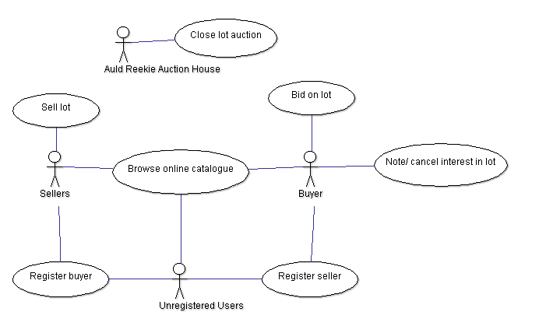

# **5 Non-functional requirements**

1. **Security**
2. Store sensitive and non-sensitive data separately. We distinguish the description of lot and other information of lot; everyone could access the former through the online catalogue, but accessing the latter need specific authorisation.
3. Set different permissions, specific data requires specific access, such as only the corresponding seller and related staff could access the reserve price.
4. Same data should be stored in the different server for backup.
5. When multiple users bid at the same time, the user should confirm the price, to avoid cumulate to an unexpected price.
6. When encountering a malicious bidder, the system can distinguish in time. Such as if a user provided an invalid payment method, once discovered, he will be forbidden to bid. If he refused to pay the auctioned lot, will face with a fine and his account will be frozen.
7. **Usability**
8. Users can operate online, through website or the application.
9. Support multiple parallel auctions at the same time by the auction list. Buyers could also bid in several auctions simultaneously.
10. Clearly designed user logic.
11. **Performance**
12. The notifications should be sent in time. And once the relevant auction starts or enters the countdown, the interested buyers should immediately know the situation, the delay time should not exceed 0.1 seconds.
13. The codes should be optimized to have better performance.
14. Must confirm the buyer knows the current price when bidding. The price should keep in sync from all devices, the delay time should not exceed 0.1 seconds.
15. **Running cost**
16. It shouldn’t load too many resources when users are browsing. Only load more resource after the user finished current content.
17. The users can set the quality of multimedia resource when browsing online catalogue to avoid consuming too many networks resource.
18. **Reliability**
19. The whole system should be divided into some sub-systems. When one or more sub-systems crashed other sub-systems could run normally. Such as when online catalogue crashed, the auction system could keep running.
20. If too many unregistered users access the online catalogue, the server will preferentially satisfy the registered buyers. And enough server and internet resource for all registered users should be satisfied.

# **6 Ambiguities and subtleties**

1. Can we satisfy the sync requirement? Will it cause conflicts when multiple buyers bid on same time and their devices show incorrect prices?
2. Will there be an issue where the on-site bidder is slower than online bidder when they have same expected price?
3. Should we advise the seller when the hammer price lower than the reserve price or auction the same lot again?
4. How to deal with the lot when the final buyer refused to pay or provided an invalid payment method?