**Assignment One**

|  |  |
| --- | --- |
| Name | 王一同 |
| Student number | 1552661 |

**Direction:**

Please answer all the questions below and hand in your answers before the due day. All work, must be handed in on time.

Due Date:

March. 27, 2017

**Please hand it in by the class time.**

**Questions:**

1. (20 marks) For each group of *f*(*n*) and *g*(*n*), determine *f(n)=O(g(n))*, *f(n)=Θ (g(n))*, or *f(n)= Ω(g(n))*. And why?

(a) *f*(n)=n1/3, *g*(n)=(ln n)2

(b) *f*(*n*)=2*n,* *g*(*n*)= *n*log*n*

2. (20 marks)

(a) Suppose the running time for some *AlgorithmA* is *T(n)=3×2n* at the input size of *n*. Its operation time on Computer1 is *t* seconds. Computer2 has the operation capability which is 64 times of Computer1. Then, the *AlgorithmA* can solve problem of what input size ***n1***on Computer2 in the same time *t*?

(b) If the time efficiency for *AlgorithmA* is promoted as *T(n)=n2*, and other conditions remain unchanged. Then, the *AlgorithmA* can solve problem of what input size ***n2***on Computer2 in the same time *t*?

3. (20 marks) Gaussian elimination, the classic algorithm for solving system of *n* linear equations in *n* unkowns, requires about multiplications, which is the algorithm’s basic operation.

(a) How much longer should you expect Gaussian elimination to work on a system of 1000 equations versus a system of 500 equations.

(b) You are considering buying a computer that is 1000 times faster than the one you currently have. By what factor will the faster computer increase the size of system solvable in the same amount of time as on the old computer?

4. (10 marks) Solve the following recurrence relations.

*x*(*n*)= *x*(*n* − 1)+ 2*n* for *n >* 0*, x*(0)= 0

5. (30 marks) Element uniqueness problem:

To determine whether all the elements in a given array are distinct.

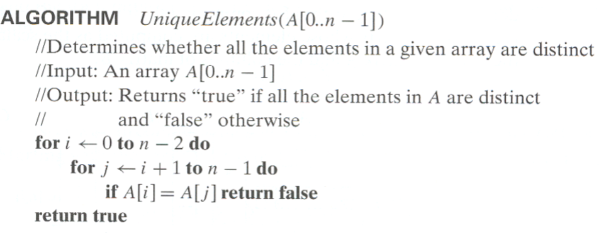

(a) Please define the input size;

(b) Set up summation for *C(n)* reflecting the number of times the algorithm’s basic operation is executed

(c) Estimate the order of growth for *C(n)*, and why? (give your deduction process)