The Third Assignment

1552661 王一同

**Answer:**

7.23:

**E-R diagram:**

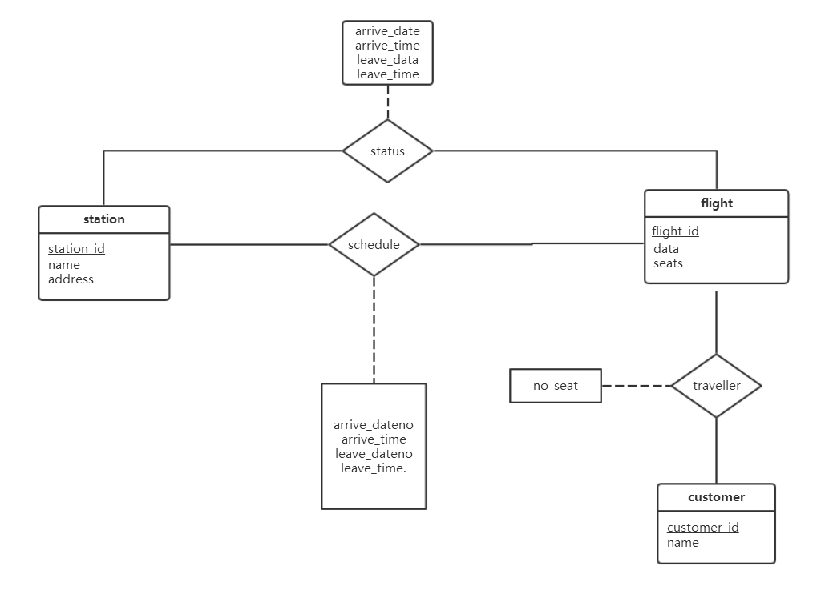

**Schemas:**

flight(flight_id,data,seats)

customer(customer_id,name)

station(station_id, name, address)

status(

flight_id,

station_id,

arrival_date,

arrival_time,

leave_date,

leave_time,

**foreign key** flight_id **references** flight,

**foreign key** station_id **references** station

)

schedule(

flight_id,

station_id,

order,

arrival_date,

arrival_time,

leave_date,

leave_time,

**foreign key** flight_id **references** flight,

**foreign key** station_id **references** station

)

traveller(

flight_id,

customer_id,

seat number,

**foreign key** flight_id **references** flight instance,

**foreign key** customer_id **references** customer

)

Explanation:

For every flight I record the times of leaving and arrival.And the schedule of a flight is fixed.Every plane has flights to be carried out.

8.20:

From Practice Exercise 8.1, we know that if we decompose the schema r(A,B,C,D,E) into r1(A,B,C) r2(A,D,E),this decomposition is a loss less decomposition.And then we generate the schema from the algorithm, we can get

R ‘= {(A, B,C),(C, D, E),(B, D),(E, A)}.

A,B,C contains a candidate key.So R’ is in 3NF. dependency-preserving lossless-join decomposition

8.28:

Suppose that the schema R is

|  |  |  |  |  |
| --- | --- | --- | --- | --- |
| A | B | C | D | E |
| a1 | b1 | c1 | d1 | e1 |
| a2 | b2 | c2 | d2 | e2 |

Suppose that the schema R1=(A,B,C) is

|  |  |  |
| --- | --- | --- |
| A | B | C |
| a1 | b1 | c1 |
| a2 | b2 | c2 |

Suppose that the schema R2=(C,D,E) is

|  |  |  |
| --- | --- | --- |
| C | D | E |
| c1 | d1 | e1 |
| c2 | d2 | e2 |

Then ∏ R 1 (R) ⋈∏ R 2 (R) is

|  |  |  |  |  |
| --- | --- | --- | --- | --- |
| A | B | C | D | E |
| a1 | b1 | c1 | d1 | e1 |
| a1 | b1 | c2 | d2 | e2 |
| a2 | b2 | c1 | d1 | e1 |
| a2 | b2 | c2 | d2 | e2 |

So ∏ R 1 (R) ⋈∏ R 2 (R) ≠ R.This decomposition is not a lossless decomposition.