The Third Assignment

1552661 王一同

**Answer:**

11.3:

In B+-tree,the node has fewer than ⌈n/2⌉ values and pointers.

1. **Four:**

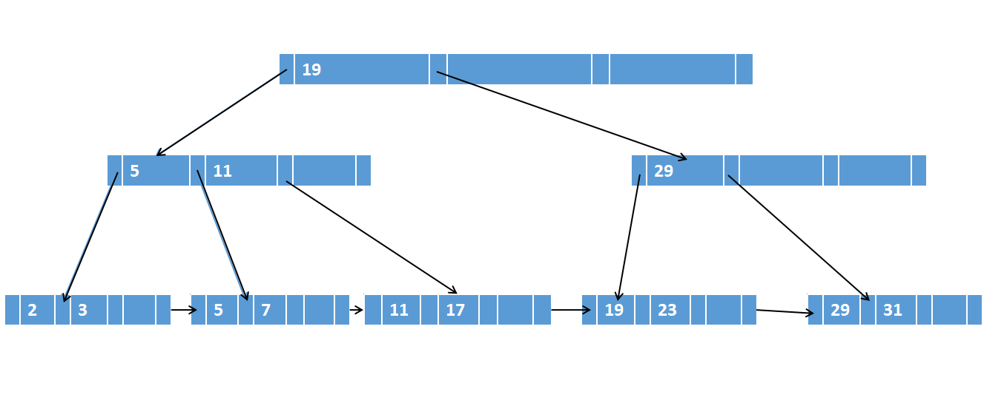

1. **Six:**

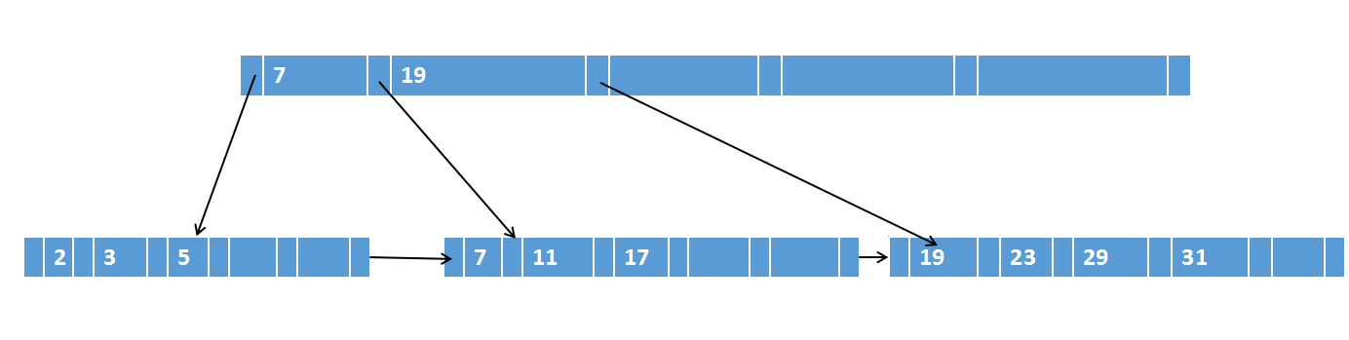

**c.Eight:**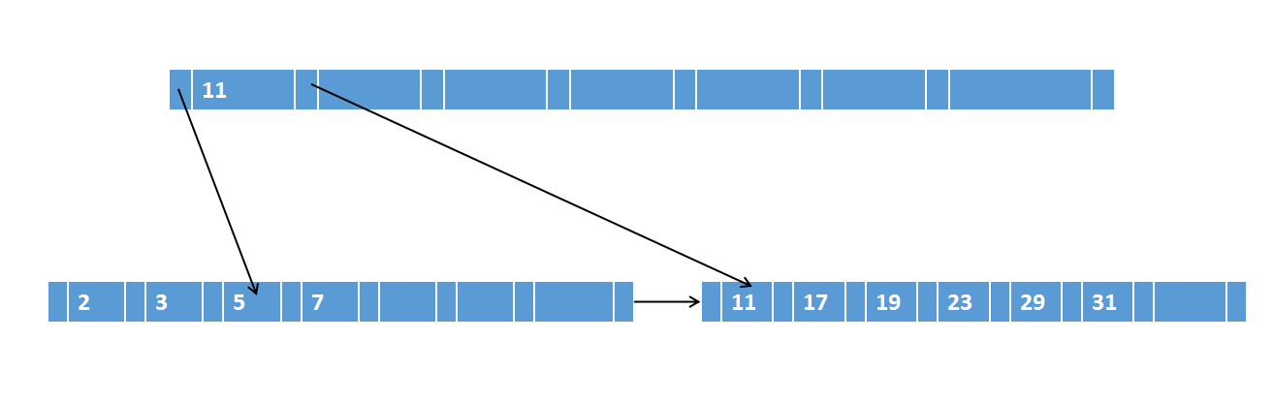

11.12:

If index entries are inserted in sorted order(descending order or ascending order,), the occupancy of each leaf node of a B+- tree is 50%.

If index entries are inserted in descending order, the entries get directed to the first leaf node.And then it split into two nodes.The right node will never be touched.The insertions takes place on the left node.

If index entries are inserted in ascending order, the entries get directed to the last leaf node.And then it split into two nodes.The left node will never be touched.The insertions takes place on the right node.

11.17:

**a. Find records with a search-key value of 11**

1. Follow the first pointer in the first level.

2. Follow the third pointer in the second level.

3. Follow the first pointer in the third level and find record with a search-key value of 11.

**b. Find records with a search-key value between 7 and 17,inclusive.**

1. Follow the first pointer in the first level.

2. Follow the second pointer in the second level.

3. Follow the second pointer in the third level and find record with a search-key value of 7.

4. Follow fourth pointer to next leaf block.

5. Follow first pointer to records with a search-key value of 11.

6. Follow second pointer to records with a search-key value of 17.