
Location and orientation of a pie

Background
This is put together as an outcome of small experiment for setting up GPS tracker amd IMU orientation for the animal counting project. Requirement was to provide location information (lat, long, timestamp, altitude, maybe speed) recorded at least once a second and orientation (3 angles and accelerations) as fast as possible (at least every 0.1 sec).

Unofficial goal was to make all this with minimal cost - both in terms of HW purchase and SW dev time.

General hardware
All components are attached to the RPi 3. The benefit of using v3 is that it has WiFi and Bluetooth onboard, and can be used as a hotspot. Also, it is powerful enough to query sensors at high frequency without visible hiccups. RPi can be fed by a battery for about 24 hrs.

Location

Hardware
Location sensor used in the experiment was GlobalSat BU-353-S4 USB GPS Receiver. This is USB plugin, with a long cable. Cost $31. It can also be used by most of the mapping software available on PC or MAC platforms. Downside is that start times for acquiring satellites may take a while - in one case I saw more than 10 min. But this was with obstructed horizon. In clear horizon it usually gets a fix in several seconds.

To check that the receiver is seen by the RPi, you can do
ls -l /dev/ttyUSB0
You should see something like:
crw-rw---- 1 root dialout 188,0 Jul 26 22:18 /dev/ttyUSB0

Software
The best description i found was here: https://raspberrypi.stackexchange.com/questions/547/how-do-i-attach-a-gps-receiver. Below are my steps, which slightly deviate from what is recommended there. You will need your RPi u and running, and connected to the internet. You can use WiFi or ethernet port.

GPSD
apt-get is a package management tool fo the RPi (and some other linux installations). First, install GPSD and clients:
sudo apt-get upgrade
This will ensure your package management is up-to-date.
sudo apt-get install gpsd gpsd-clients python-gps
Watch what happens. In my case there were some hiccups installing modules. If something fails, you can install modules one by one (rather than altogether as mentioned above), going left to right.

One thing that they don’t tell you is that you may need to update config file. The file is located at /etc/default/gpsd. I had to change devices line so that it would read
DEVICES=”/dev/ttyUSB0”

NNTPD
sudo apt-get install ntp
Once done, you can shut down your pi, disconnect from network, carry it out in the open, boot and see if it will set up the time correctly.

I experienced some startup problems for GPSD daemon - it was always started in a dead state. Being lazy I just restarted the daemon after strat. To do that I added the following line to crontab:
@reboot /home/pi/scripts/startgps.sh

To edit crontab run crontab -e. The startgps.sh script is in the ~/scripts folder, it is shown below. You can download it here.
#!/bin/sh

GPSDIR=/home/pi/gps # this is where kml files will go
PYDIR=/home/pi/code/py # this is where python scripts live
RUNFILE=${GPSDIR}/runno.txt # file to have new tracks on every reboot

RUNNO=`cat ${RUNFILE}`
RUNNO=`expr ${RUNNO} + 1`
echo ${RUNNO} > ${RUNFILE}

sleep 100 # 100 sec on start to let things settle
sudo service gpsd restart # restart the daemon
sleep 5 # and let it settle
# now start the client that will create .kml file
/usr/bin/python3 ${PYDIR}/agegps3.py ${RUNNO} &

IMPORTANT: there has to be a file ~/gps/runno.txt, which contains a single integer number. You can create such a file by running the following command:
echo 1 > ~/gps/runno.txt

Python client
All code that you may ever need is already written. If you install gps3 library, you’ll get interface to GPSD and also a nice client.
cd ~/code
git clone https://github.com/wadda/gps3.git
This is take from https://github.com/wadda/gps3. Once clone is complete, you will need to install the package:
cd ~/code/gps3
sudo python3 setup.py
Once this is done, your python3 scripts will have access to gps3 library. I believe there are no dependencies.
I copied ~/code/gps3/examples/agegps3.py to ~/code/py (don’t ask why) and slightly modified it. It is now used as kml logger. You can download updated script here.
The original script works by creating in-memory array of datapoints. Every time a datapoint can be read from the GPS (tries about every second), it is added to in-memory array of points and a kml file is written to disk. Same file is used at all times,and file is rewritten completely every time. Since RPi is mostly used as a headless device, and you can’t properly shut it down, this leads to several problems.
- If you restart RPi after recording session, previous (potentially useful) file will be overwritten. This is addressed by startgps.sh script that passes unique increasing integer on every reboot, and by looking at the parameters inside the script. W/o any parameters it will create same file over and over. With a parameter passed, it will use first parameter to create (hopefully) unique file name.
- Shutting down RPi by pulling power off the device before a file is flushed to SD card will cause the file loss. So I create two files - X and Y (no logic), and flip-flop between them. Since files are written each time a datapoint is read from GPS device, they will differ maximum by one GPS point, which is not a big deal.
Also, original script creates two output files - static and dynamic. Dynamic is just a reference to static, which may be useful for google earth, but not for our case.
Since the file grows in size and is rewritten every time, it is expected that the intervals between reading GPS will gradually increase. This would be one more reason to go with CSV, where a small record can be appended at constant time. Note that I didn’t do any measurement on how long it takes to write a file, and what the actual intervals between reading GPS are.
However, I think this is not the best approach. While kml files are nice, they don’t have speed and time information logged. I think it’s better to log as simple csv and party on it afterwards. But the script is a nice example of how to create kmls.
TODO: write csv script and provide link.

Orientation

Hardware
I used BerryIMUv2-10DOF. $27.50. You can find lots of documentation on OzzMaker site: http://ozzmaker.com/product/berryimu-accelerometer-gyroscope-magnetometer-barometricaltitude-sensor/. There are two ways of connecting IMU board to RPi, both require some soldering. I used the 6pin connector that goes into corner of IMU board and allows to mount it upside down on he RPi GPIO bus - see pic below. IMU board is on far upper right corner, with the skull.

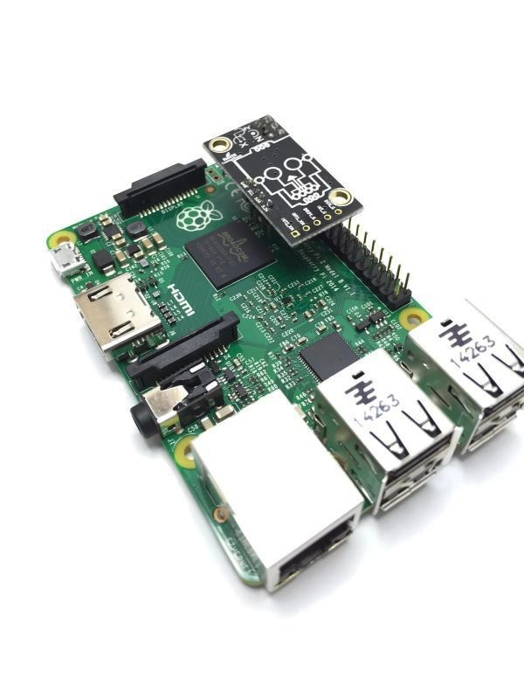
This might be not ideal solution if the board needs to be installed separately from RPi. But here are some reasons why I went with it:
- Less wires, mess, etc to track
- It fits nicely in the closed case
- It is unlikely that IMUs installed on the cameras will be well and constantly aligned with the axis of the camera. Having one RPi that is somewhat rigidly attached to the plane seems more reasonable solution.

But these are just thoughts. In any case, I don’t know how long the wires connecting IMU to RPi can be - I suspect they should not be longer than 1-2 m max.

Software
OzzMaker provides links, tons of docs, etc. If you’re adventurous, you can write C/C++ code. If you’re lazy - read on.

cd ~/code
git clone https://github.com/ozzmaker/BerryIMU.git
This will install library that you need. The samples that I used are in BerryIMU/python-BerryIMU-gryo-accel-compass-filters. They actually implemented Kalman filter that significantly reduces hardware noise. I tried to use python3 on the library, but decided it’s not worth the struggle. Both versions 2 and 3 come with RPi, so why bother?

You will need to calibrate compass and run the script to see the sensor orientation, etc. To calibrate start
cd ~/code/BerryIMU/python-BerryIMU-gryo-accel-compass-filters
python calibrateBerryIMU.py
Once started, twist, turn and shake your IMU until numbers on the screen stop changing much. Then press Ctrl-C to end the script. Client is - you guessed - in berryIMU.py. It will output stuff to the screen. I made no changes, so you’re welcome.

More reading
For the curious ones, here are some links I found useful. For scientists, consider this a references section.

IMU
https://learn.adafruit.com/bno055-absolute-orientation-sensor-with-raspberry-pi-and-beaglebone-black/overview
https://learn.adafruit.com/adafruit-bno055-absolute-orientation-sensor/overview
https://learn.adafruit.com/adafruit-bno055-absolute-orientation-sensor/circuitpython-code
https://learn.adafruit.com/bno055-ble-ios-app/uploading-and-testing
https://github.com/adafruit/Adafruit_BNO055
https://smile.amazon.com/Adafruit-Absolute-Orientation-Fusion-Breakout/dp/B017PEIGIG/ref=sr_1_1?ie=UTF8&qid=1531940520&sr=8-1&keywords=bno055+adafruit&dpID=51M-xkLfcNL&preST=_SX342_QL70_&dpSrc=srch#feature-bullets-btf
https://learn.adafruit.com/adafruit-ultimate-gps-on-the-raspberry-pi?view=all
https://www.adafruit.com/product/746?gclid=CjwKCAjwkMbaBRBAEiwAlH5v_s3yATH10asp3ciY_jVsB06KrAGnZS90eTOrtrFUpaZcVafZVH3pDxoCjVQQAvD_BwE
https://www.lp-research.com/lpms-cu/
https://www.raspberrypi.org/blog/real-time-orientation-display-with-the-minimu-9-v2/
http://wonderfulengineering.com/10-best-imu-modules-for-raspberry-pi/
http://ozzmaker.com/product/berryimu-accelerometer-gyroscope-magnetometer-barometricaltitude-sensor/
http://ozzmaker.com/berryimu/
http://ozzmaker.com/python-code-for-berryimu-accelerometer-gyroscope-magnetometer-pressure-sensor/
https://forum.dexterindustries.com/t/solved-python-library-for-6-axis-accelerometer-and-compass/1043
https://stackoverflow.com/questions/48891409/control-imu-sensor-with-raspberry-pi-python
http://ozzmaker.com

GPS
https://www.google.com/search?client=safari&rls=en&q=rpi+python+read+gps+usb&ie=UTF-8&oe=UTF-8
https://www.raspberrypi.org/forums/viewtopic.php?t=127480
https://www.sparkfun.com/tutorials/403
https://raspberrypi.stackexchange.com/questions/547/how-do-i-attach-a-gps-receiver
https://learn.adafruit.com/adafruit-ultimate-gps-on-the-raspberry-pi?view=all

IMU
https://www.adafruit.com/product/746?gclid=CjwKCAjwkMbaBRBAEiwAlH5v_s3yATH10asp3ciY_jVsB06KrAGnZS90eTOrtrFUpaZcVafZVH3pDxoCjVQQAvD_BwE
https://www.lp-research.com/lpms-cu/
https://www.raspberrypi.org/blog/real-time-orientation-display-with-the-minimu-9-v2/
http://wonderfulengineering.com/10-best-imu-modules-for-raspberry-pi/
https://www.google.com/search?client=safari&rls=en&q=Pullyshop%E2%80%99+IMU+Sensor+rpi+programming&ie=UTF-8&oe=UTF-8
http://ozzmaker.com/product/berryimu-accelerometer-gyroscope-magnetometer-barometricaltitude-sensor/
http://ozzmaker.com/berryimu/
https://www.google.com/search?client=safari&rls=en&ei=nMBSW8qjEfqr0PEPia6z8AM&q=usb+imu+sensor+for+rpi&oq=usb+imu+sensor+for+rpi&gs_l=psy-ab.3...82761.84482.0.85120.8.8.0.0.0.0.156.803.4j4.8.0....0...1c.1.64.psy-ab..0.7.659...0i22i30k1j33i22i29i30k1j33i21k1.0.atR_Db7QFzc

