Project - MPG Data Visualization

Panupon Sam

2024-05-06

## Explore data

## # A tibble: 6 × 11  
## manufacturer model displ year cyl trans drv cty hwy fl class   
## <chr> <chr> <dbl> <int> <int> <chr> <chr> <int> <int> <chr> <chr>   
## 1 audi a4 1.8 1999 4 auto(l5) f 18 29 p compa…  
## 2 audi a4 1.8 1999 4 manual(m5) f 21 29 p compa…  
## 3 audi a4 2 2008 4 manual(m6) f 20 31 p compa…  
## 4 audi a4 2 2008 4 auto(av) f 21 30 p compa…  
## 5 audi a4 2.8 1999 6 auto(l5) f 16 26 p compa…  
## 6 audi a4 2.8 1999 6 manual(m5) f 18 26 p compa…

### Relation between Highway MPG and City MPG by Count

set.seed(42)  
ggplot(sample_n(mpg,200), aes(hwy, cty)) +   
 geom_bin2d(bins=20) +   
 theme_minimal() +  
 labs(  
 title = "Relation between Highway MPG and City MPG by Count",  
 caption = "Data: Mpg from Cars",  
 y = "City miles per gallon",  
 x = "Highway miles per gallon"  
 )

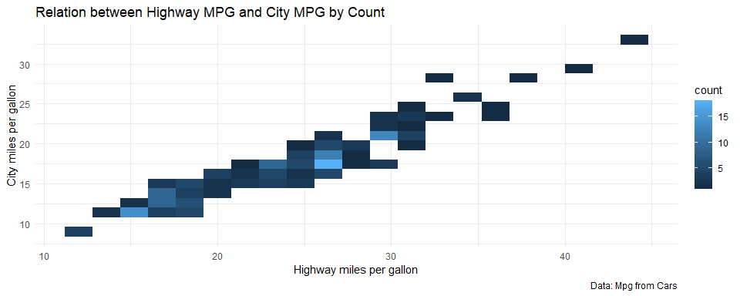

### Relationship between Count of Car and Vehicle Class

ggplot(mpg, aes(x = class, fill = class)) +  
 geom_bar() +   
 theme_minimal() +   
 scale_fill_brewer(palette = "Set2") +  
 labs(  
 title = "Relationship between Count of Car and Vehicle Class",  
 x = "Vehical Class",  
 y = "Count",  
 caption = "Data: Mpg from Cars"  
 )

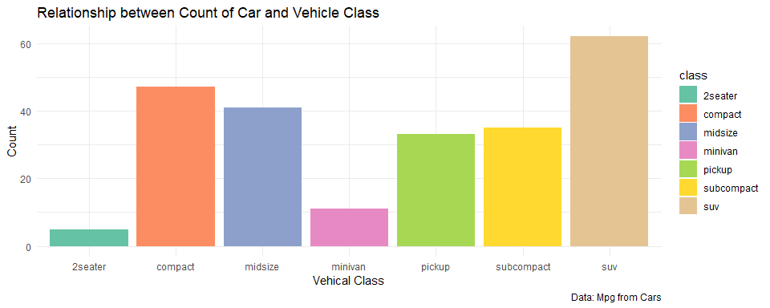

### Count of Cars by Model(Year)

car1 <- mpg %>%  
 filter(drv == "f") %>%  
 mutate(model = paste(model,year))  
  
ggplot(car1, aes(model)) +  
 geom_bar() +  
 theme_minimal() +  
 theme(axis.text.x = element_text(angle = 90)) +  
 labs(  
 title = "Count of Cars by Model(Year)",  
 x = "Model(Year)",  
 y = "Count",  
 caption = "Data: Mpg from Cars"  
 )

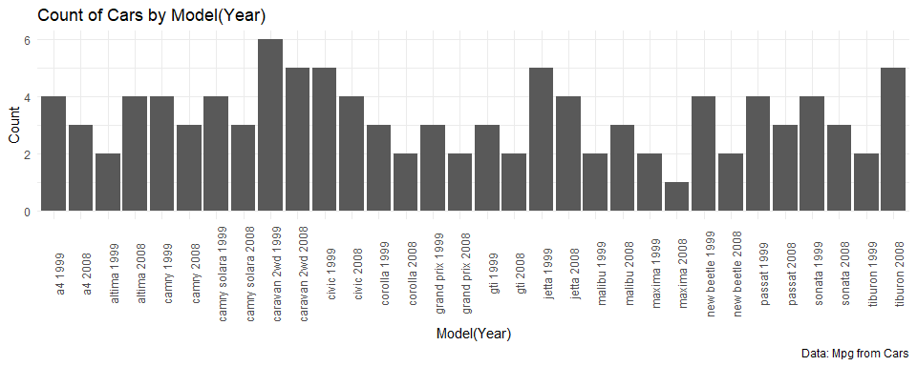

### Relationship between Fuel Type and MPG by City MPG and Highway MPG

ggplot(mpg, aes(fl, hwy)) +  
 geom_point() +   
 theme_minimal() +  
 labs(  
 title = "Relationship between Fuel Type and Highway MPG",  
 x = "Fuel Type",  
 y = "Highway miles/Gallon",  
 caption = "Data: Mpg from Cars"  
 )

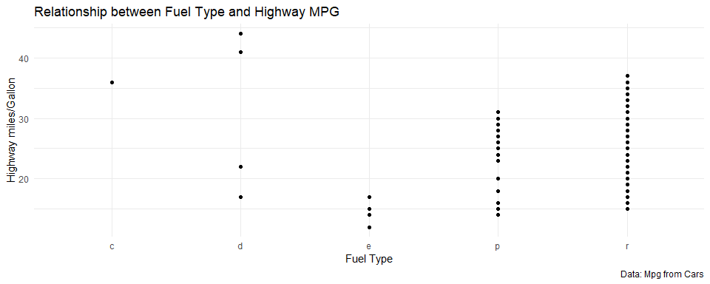

ggplot(mpg, aes(fl, cty)) +  
 geom_point() +  
 theme_minimal() +  
 labs(  
 title = "Relationship between Fuel Type and City MPG",  
 x = "Fuel Type",  
 y = "City miles/Gallon",  
 caption = "Data: Mpg from Cars"  
 )

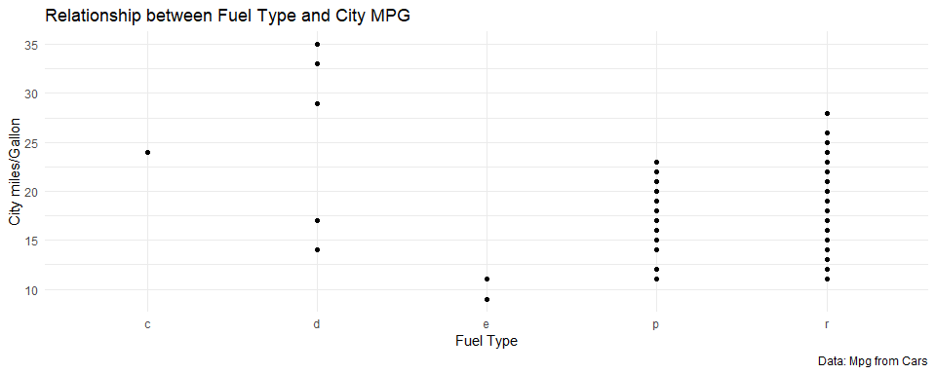

### Relationship between Count of Highway MPG by Trans

ggplot(mpg, aes(cty)) +  
 geom_density() +  
 theme_minimal() +  
 facet_wrap(~trans, ncol = 4) +  
 labs(  
 title = "Relationship between Count of Highway MPG by Trans",  
 x = "Highway Miles per Gallon",  
 y = "Density ( Range 0 to 1 )",  
 caption = "Data: Mpg from Cars"  
 )

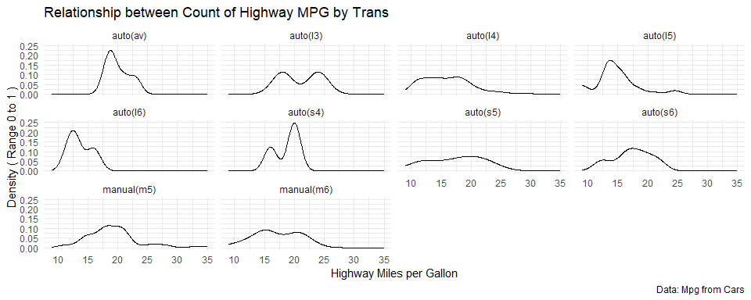

### Relationship between Vehical Class and MPG by Highway and City MPG

ggplot(mpg, aes(class, hwy)) +  
 geom_boxplot(aes(fill = "hwy")) +  
 geom_boxplot(aes(class, cty, fill = "cwy")) +  
 theme_minimal() +  
 labs(  
 title = "Relationship between Vehical Class and MPG by Highway and City MPG",  
 x = "Vehical Class",  
 y = "Miles / Gallon",  
 caption = "Data: Mpg from Cars"  
 )

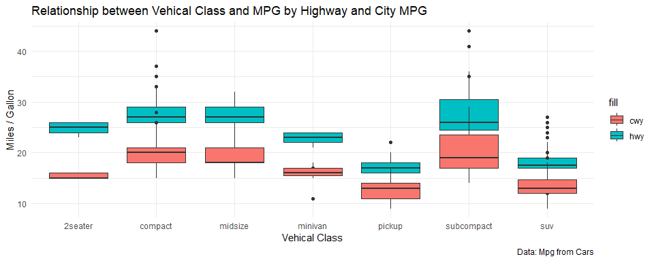

### Count of Displ

p1 <- ggplot(mpg, aes(displ)) +  
 geom_histogram(bins = 20)  
p2 <- ggplot(mpg, aes(displ)) +  
 geom_density()  
  
(p1 + p2)

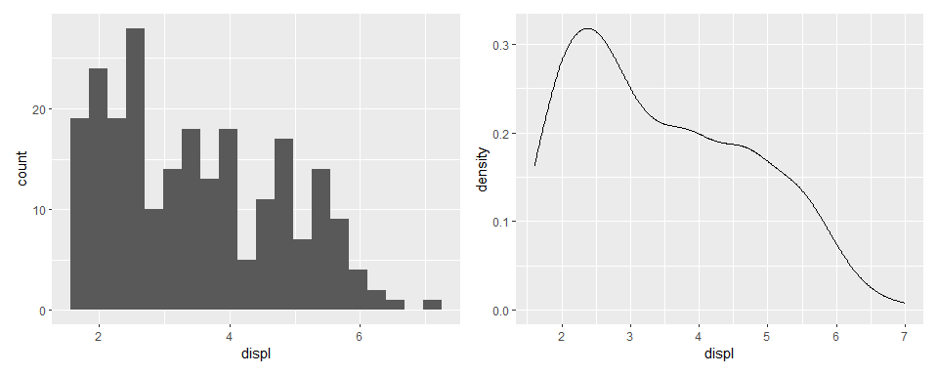

### Average City MPG by Car Type

# relevel คือ มาก -> น้อย  
# geom_col ใช้กับ data ที่ผ่าน agg  
mpg %>%  
 group_by(class) %>%  
 summarise(avg_cty = mean(cty)) %>%  
 ggplot(aes(x=reorder(class, avg_cty), y=avg_cty, label=sprintf("%0.2f", round(avg_cty, digits = 2)))) +  
 geom_col() +  
 labs(title = "Average City MPG by Car Type",  
 y = "Average City MPG",  
 x = "Car Type") +  
 geom_text(size = 3, vjust = 1.5, colour = "white") +  
 theme_minimal()

